PWG Meeting Notes – November 11, 2021
Via WebEx 9:30 AM
Attendees:

Sam Pak - Oncor | Jordan Troublefield – ERCOT | Eric Lotter – Grid Monitor | Diana Rehfeldt - TNMP
Sheri Wiegand - TXUE | Jim Lee – AEP | Carolyn Reed - CNP | Randy Roberts - ERCOT
Kathy Scott - CNP | Angela Ghormley – Calpine | John Schatz – Vistra | Kelly Brink - ERCOT

- Meeting notes for Sept 15th were reviewed and approved

- 2021 Weather Sensitivity Progress
  - On November 2nd ERCOT provided TDSPs initial Weather Sensitivity Report
  - Process ongoing for changes with a target completion by Jan 31 2022
  - Table below is monthly update as of Dec 2nd; ERCOT to provide update via PWG listserv in early Jan 2022 [Action Item]

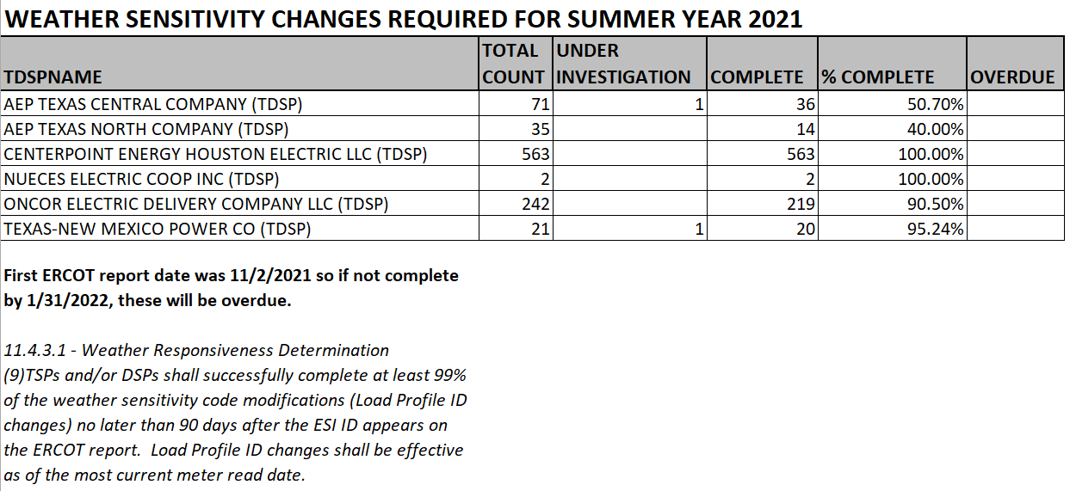

- Unaccounted For Energy (UFE) Holistic Review
  - Suggestion to utilize EMS transmission factors (more accurate) vs the current seasonal calculation for Transmission Loss Factors
  - Using these “more accurate” factors should minimize the swing of UFE calculations
  - Should NOIEs receive a % allocation of UFE – argument years ago was that they have only boundary meters and are already settled on interval data.
  - With the proliferation of AMS meters, 99.5% of competitive load is settled on interval data
  - What are the appropriate UFE allocation factors?
  - With Transmission Losses being a primary driver of UFE factors, NOIEs are subject to some transmission losses at boundary meters
  - Recommendation: WMS to take up this discussion as this falls under their purview.

- Proposed Enhancements to Data Loading Process for BUSLRG and BUSLRDG profiles
  - ERCOT has proposed additional Error Codes to help identify and alert TDSPs on their respective 867_03 Activity Report and Interval Data LSE Activity Report
  - 867_03 Activity Report:
    - ERROR Code 35 will distinguish BUSLRG/DG with submitted interval data on IDR867_03 transaction
    - ERROR Code 36 will provide notice when certain kwh/kW thresholds are exceeded on the IDR867_03 transaction
  - Interval Data LSE Activity Report:
    - ERROR Code 16 “Exceeds LOAD Threshold for BUSLRG/DG”
    - ERROR Code 17 “Exceeds GEN Threshold for BUSLRG/DG”

- Converting Appendix D, Profile Decision Tree, in Load Profiling Guide from Excel to Word Format
  - ERCOT gauged interest on potentially converting LPG Appendix D from Excel to Word format
  - Conversion will help with tracking changes and “find” keyword function
  - Updates such as ERCOT email addresses within Appendix D and additional clean up efforts were suggested
  - There was support and consensus to move forward. Jordan mentioned it efforts could begin later this year or early next

- Briefly previewed draft of 2021 PWG Goals/Accomplishments; follow up at next PWG meeting
- Reminded PWG on interest/nominations for 2022 Leadership
- Reviewed proposed PWG 2022 meeting schedule
- Cancelled Dec 8th meeting
- Next meeting January 12, 2022

