System Planning
Monthly Status Report

Report Highlights

- ERCOT is currently reviewing proposed transmission improvements with a total estimated cost of $1,543.31 million as of November 30, 2021.
- Transmission Projects endorsed in 2021 total $1,014.4 million as of November 30, 2021.
- All projects (in engineering, routing, licensing, and construction) total approximately $8.00 billion as of October 1, 2021.
- Transmission Projects energized in 2021 total approximately $1.438 billion as of October 1, 2021.

Regional Planning Group Reviews
RPG Projects under Review:
- Oncor has submitted the Nacogdoches Southeast Switch – Redland Switch – Lufkin Switch 345-kV Loop Project (RPG Project ID: 20RPG019). This is a Tier 2 project that is estimated to cost $71.26 million. This project is currently under ERCOT’s independent review.
- Oncor has submitted the Flat Iron – Barr Ranch – Pegasus South 138-kV Line Project (RPG Project ID: 21RPG010). This is a Tier 2 project that is estimated to cost $50.7 million. This project is currently under ERCOT’s independent review.
- ERCOT has submitted the Lower Rio Grande Valley System Enhancement Project (RPG Project ID: 21RPG017). This is a Tier 1 project that is estimated to cost $1.28 billion. This project is currently under ERCOT’s independent review.
- AEPSC has submitted the Bay City to Lane City 138-kV Line Rebuild Project (RPG Project ID: 21RPG018). This is a Tier 3 project that is estimated to cost $33 million. This project is currently in the RPG comment period.
- CPS has submitted the Howard Road 345/138-kV Switching Station Project (RPG Project ID: 21RPG019). This is a Tier 3 project that is estimated to cost $56.3 million. This project is currently in the RPG comment period.
- CNP has submitted the Galena Park Area 138-kV Conversion Project (RPG Project ID: 21RPG020). This is a Tier 3 project that is estimated to cost $52.05 million. This project is currently in the RPG comment period.

RPG Project Reviews Completed in 2021:
RPG Project ID | RPG Project Name | Submitted Entity | Tier | Estimated Cost  ($ Millions) | Review Completion Month
20RPG022 | Hamilton Road to Maxwell 138-kV Line Rebuild Project | AEPSC | Tier 3 | 34.0 | January
20RPG023 | Royse - Commerce 69-kV Line Conversion to 138-kV | Oncor | Tier 3 | 72.1 | January
21RPG003 | Midland East Area Projects | Oncor | Tier 3 | 88.5 | March
21RPG004 | Venus Switch-Cedar Hill Switch 345-kV Line Project | Oncor | Tier 3 | 10.3 | March
21RPG005 | Angleton to West Columbia 138-kV ckt 04 Rebuild Project | CNP | Reclassified from Tier 3 to Tier 4 per Protocol | 38.7 | April
21RPG006 | Algoa Corner to La Marque 138 138-kV ckt 93 Rebuild Project | CNP | Reclassified from Tier 3 to Tier 4 per Protocol | 34.56 | May
21RPG007 | Holliday - Seymour 69-kV Line Project | Oncor | Reclassified from Tier 3 to Tier 4 per Protocol | 44.3 | May
21RPG008 | Burnett – Bowie 69-kV Line Upgrade Project | Oncor | Tier 3 | 79.7 | June
21RPG009 | Waterfowl Substation Addition | CNP | Tier 3 | 42.4 | June
21RPG001 | Bakersfield to Big Hill 345‐kV Second Circuit Addition Project | STEC & LCRA TSC | Tier 2 | 83.2 | June
21RPG011 | Flewellen to Peters 138-kV ckt 25 Rebuild | CNP | Tier 3 | 76.2 | July
21RPG012 | Andrews North – Mustang – Paul Davis Tap 138-kV Line Section | Oncor | Reclassified from Tier 3 to Tier 4 per Protocol | 37 | August
21RPG013 | WA Parish to Nash 138-kV Ckt 02 Rebuild Project | CNP | Reclassified from Tier 3 to Tier 4 per Protocol | 71.75 | September
21RPG014 | Mason Switch to Yellowjacket 69-kV Line Transmission Project | AEPSC | Reclassified from Tier 3 to Tier 4 per Protocol | 36.9 | September
21RPG015 | Munday to Throckmorton 69-kV and Albany to Throckmorton 69-kV Line Rebuild Project | AEPSC | Reclassified from Tier 3 to Tier 4 per Protocol | 83.4 | September
21RPG016 | TH Wharton - White Oak 138-kV Conversion Project | CNP | Reclassified from Tier 3 to Tier 4 per Protocol | 79.9 | September
21RPG002 | Port Lavaca Area Improvement Project | AEPSC | Tier 1 | 101.5 | October

More information on current and past RPG projects can be found on the ERCOT MIS Secure (digital certificate required): https://mis.ercot.com/secure/data-products/grid/regional-planning
Past email communication on RPG projects can be found on the ERCOT listserv by signing up for the REGPLANGROUP list: http://lists.ercot.com/scripts/wa-ERCOT.exe?A0=REGPLANGROUP

Planning Model Activities
The short-term calendar of major planning model events is as follows:
- By March 1, 2022 21SSWG Update 2 cases, in PSS/E 35, and TPIT are posted
- By March 15, 2022 21SSWG Contingency definitions & Planning Data Dictionary are posted
The following table shows interconnection projects that met Planning Guide section 6.9(1) and 6.9(2) and were modeled in the SSWG cases as a full model or as a simple model in accordance with Planning Guide section 6.9.
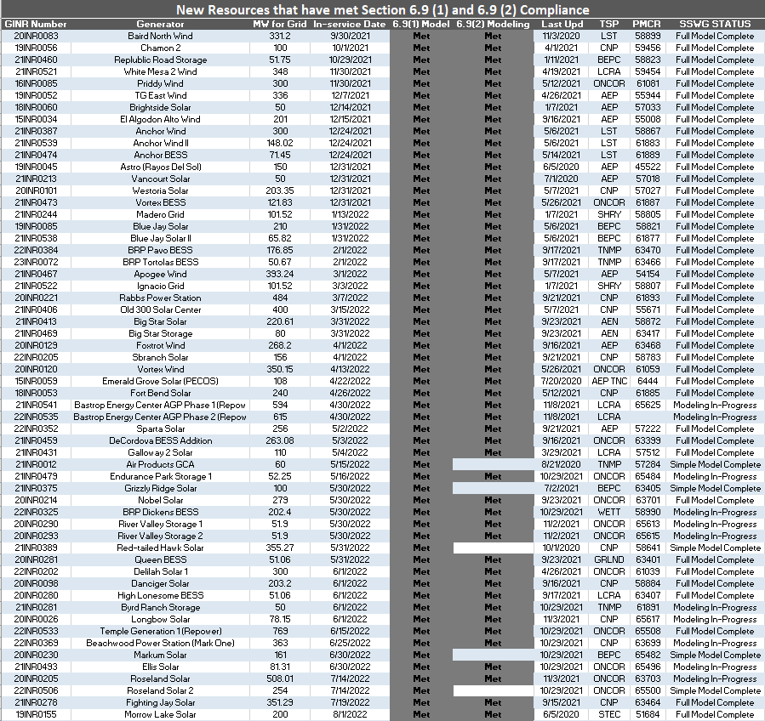
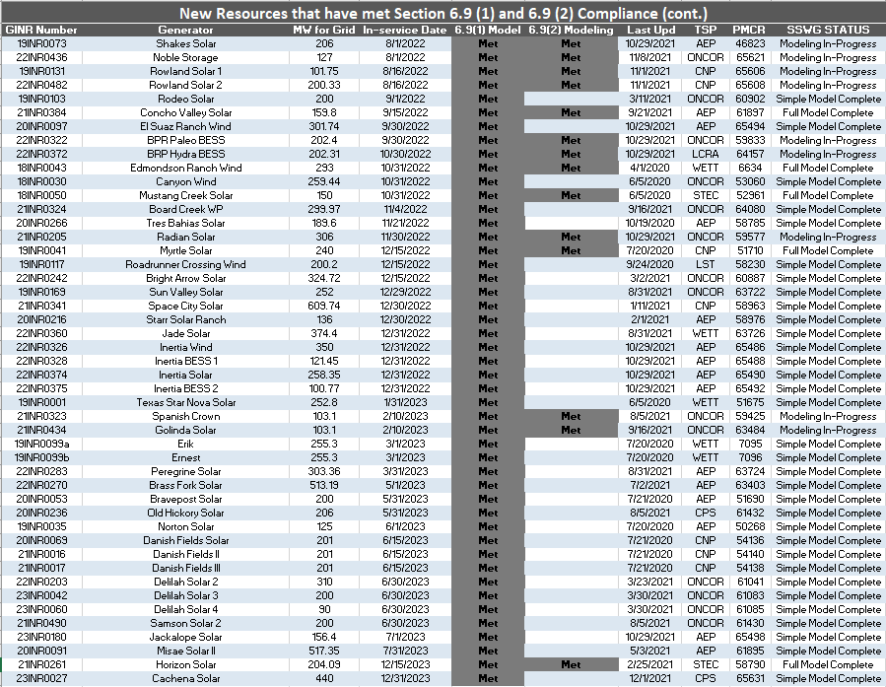

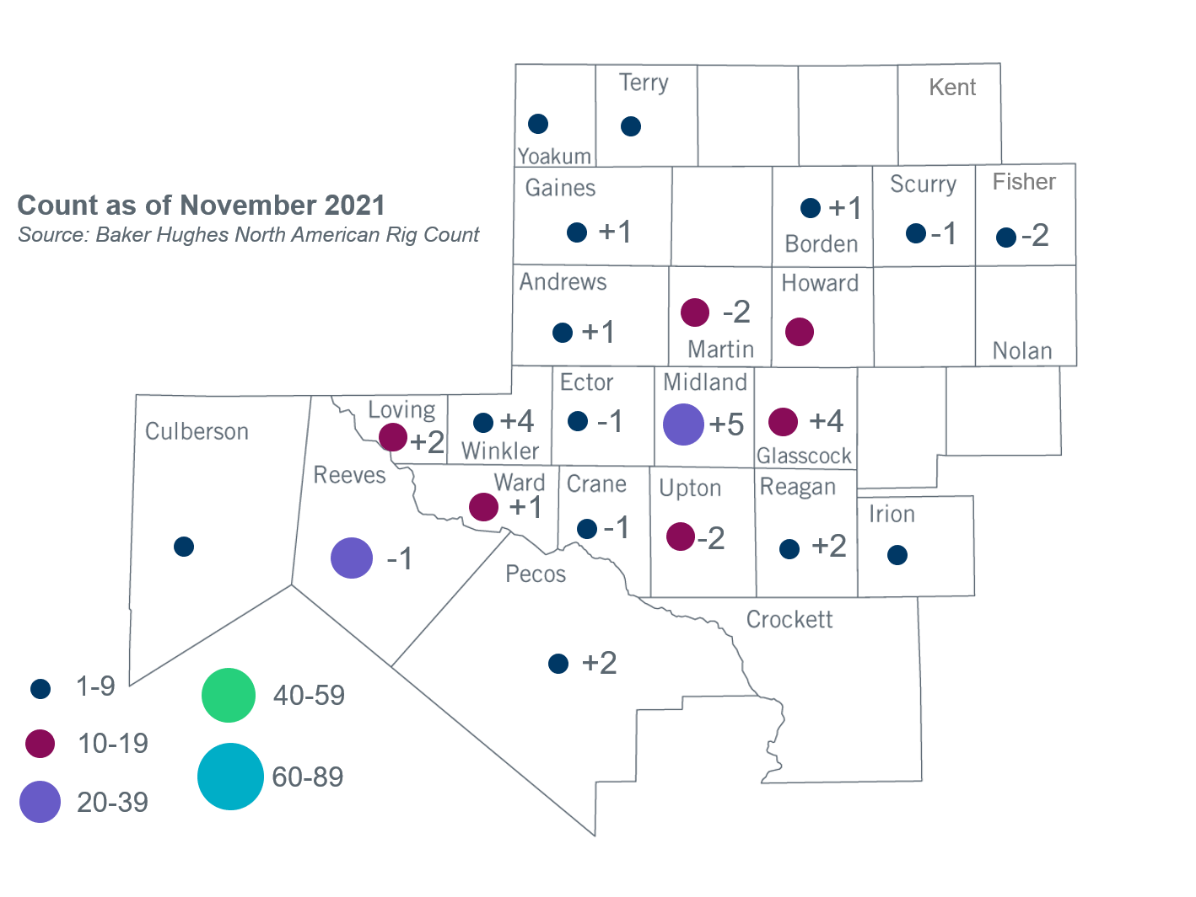
Permian Basin Oil Rig Count
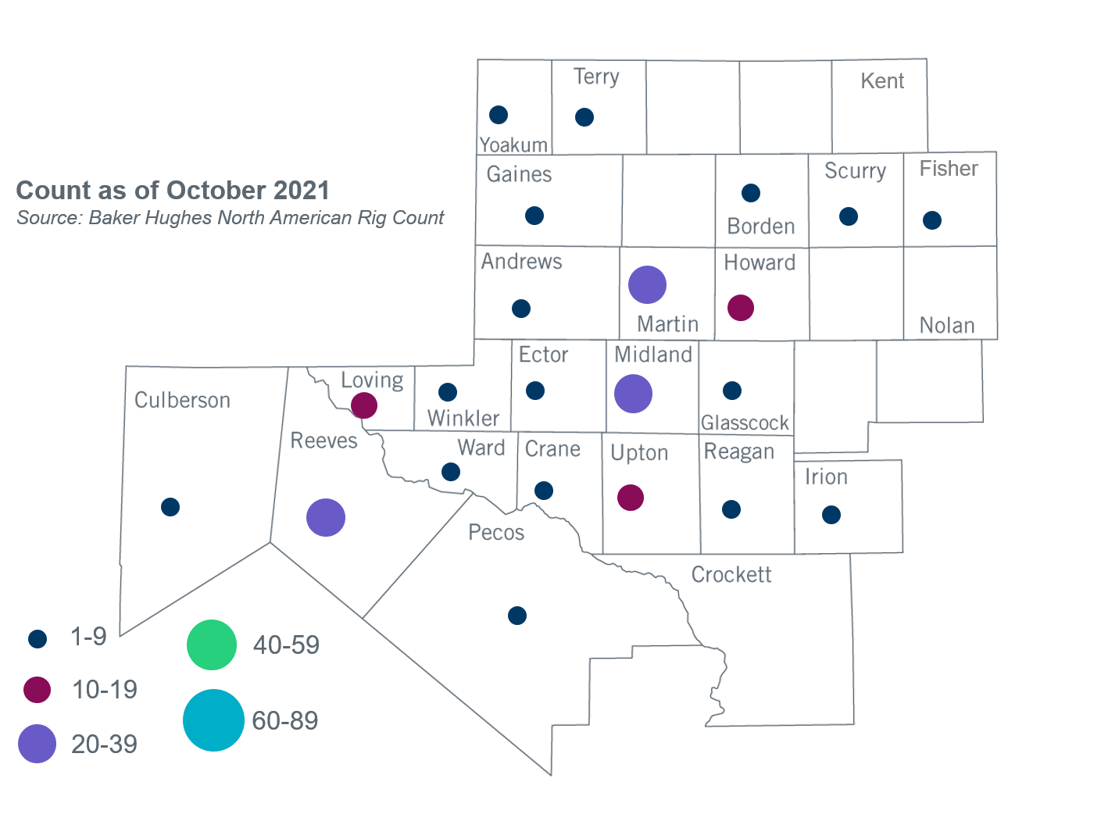

Other Notable Activities
- ERCOT posted short-circuit analysis results for the 2021 Regional Transmission Plan (RTP) to the MIS Secure Area on November 3, 2021.
- ERCOT completed a UFLS assessment in accordance with NERC Reliability Standard PRC-006-5 and posted a study report to the MIS Certified Area for TSPs on November 24, 2021.
- ERCOT will complete the assessments and post reports for the 2021 RTP, the 2021 NERC TPL-001-4 Stability Assessment, the 2021 Geomagnetic Disturbance Vulnerability Assessment (GMDVA), the 2021 Report on Existing and Potential Electric System Constraints and Needs, the Permian Basin Load Interconnection Study, and the West Texas Export Study by December 31, 2021.

Based on the Total Project Estimated Cost for all future projects listed in the Transmission Project Information and Tracking (TPIT) report. TPIT is updated three times each year based on information TSPs provide in Model on Demand (MOD) as specified in the ERCOT Steady State Working Group Procedure Manual. The latest TPIT is available at https://www.ercot.com/gridinfo/planning.
Based on the Total Project Estimated Cost for all completed projects with Projected In-Service Dates in 2021 listed in the TPIT.
+/- symbol indicates the increase or decrease from the previous month in oil rigs present in each county. There are 194 rigs, including an increase of 11 oil rigs, in the Permian Basin from October to November 2021.

