Emergency Response Service (ERS)

Submission Form Instructions
The ERS Submission Form in used for
Preliminary Baseline Review, Procurement ERIDs, Procurement Offers, Reinstatement ERIDs, Reinstatement Offers, Substitutions and Supplemental Submissions.
How to Read ERID Analysis Results
Form 21.1

Contents

General Instructions 2
Resource Identification Phase-ERID Submittals 2
Resource Identification Phase (ERID)-Error Books 6
Resource Identification Phase (ERID)-Approved Book 6
How to Read ERID Analysis Results 6
Offers and/or Self-Provision Offers 7

General Instructions
- Only the most current version of the ERS Submission Form will be accepted.
- The ERS Submission Form is used for all phases of the ERS procurement process.
  - Preliminary Baseline Review (optional service performed by ERS team only if time allows)
  - Procurement Resource Identification (ERID)
  - Procurement Offers
  - Reinstatement Resource Identification
  - Reinstatement Offers
  - Weather-Sensitive Updates
  - Substitutions
  - Supplementals
- All ERID and Offer submissions must be accompanied by a signed PDF copy of the ID page or digital signature.
- ERID and Offer Submissions may be sent in one or more workbooks.
- You may copy an R tab as many times as needed.
- An aggregated ERS Resource consists of two or more Sites which are obligated during all awarded Time Periods in a Standard Contract Term or Contract Period.
- ERS offers are specific to a Time Period within a Standard Contract Term or Contract Period. ERCOT will evaluate offers for each Time Period independently.
- All forms should be submitted to ERS@ercot.com.
- Authorized Representative must be a person registered with ERCOT as QSE Authorized Representative, pursuant to Section 16.2.3.2 of the ERCOT Protocols.
- Primary Contact 1 and the optional Primary Contact 2 and 3 should be personnel who are familiar with the QSE's participation in ERS and who can be relied upon to receive and answer email communication from ERCOT.

Resource Identification Phase-ERID Submittals
ERID submission is a required step during every Standard Contract Term and ERIDs are submitted using the ERS Submission Form posted on the ERS website.
ERS Pre-populated Workbooks
- ERCOT posts Pre-populated workbooks to the MIS for QSEs who participated in the last SCT.
  - Contains one tab with Resource information submitted during the previous SCT.
  - Data should be copied and pasted into the posted ERS Submission Form for ERID submission.

ERS Submission Form tabs:
- Identification tab:
  - Includes seven affirmations at top of page. By submitting ERIDs you are stating that you have read and understand the affirmations.
  - Cells C21 through C37 must be filled out (with one or two exceptions).
  - Cell C24 is a drop down; for this phase “Procurement ERID” should be selected.
  - Do not modify page by adding or deleting lines or columns.
ERS Submission Form
Version 21.1
By submitting this form, the QSE affirms that it has obtained a written affirmation from the controlling Entity of the ERS Resource(s) identified in this form that it has reviewed P.U.C. Substantive Rule 25.507 and all Protocols regarding ERS, and a written agreement by controlling Entity to comply with and be bound by those provisions.
By submitting this form, the QSE affirms that it and the controlling Entity of the ERS Resource(s) identified in this form are familiar with any applicable Federal, State or local environmental regulations that apply to the use of any generator in the provision of ERS, and that the use of such generator(s) in the provision of ERS would not violate those regulations. This provision applies to both ERS Generators and to the use of backup generation by ERS Loads.
By submitting this form, the QSE affirms that it has obtained written authorization from the controlling Entity of the ERS Resource(s) identified in this form to obtain the ERCOT provided historical usage analysis for those ERS Resources.
By submitting this form, the QSE affirms that each offered Resource satisfies at least one of the following conditions and that all of the ERS Resource's offered Demand response capacity will be available if deployed by ERCOT:
(a) The ERS Resource and each site within the ERS Resource are not located behind an ESI ID or unique meter identifier that corresponds to a Critical Load and are not used to support a Critical Load; or
(b) The ERS Resource or one or more sites within the ERS Resource are behind an ESI ID or unique meter identifier that corresponds to a Critical Load, but the ERS Resource and each site within the ERS Resource are not a Critical Load, do not include a Critical Load, and are not used to support a Critical Load; or
(c) The ERS Resource or one or more sites within the ERS Resource are behind an ESI ID or unique meter identifier that corresponds to a Critical Load, but electric service from the ERCOT System is not required for the provision of the critical service due to the availability of back-up generation or other technologies at the site, and neither the ERS Resource nor any site within the ERS Resource is used to support a Critical Load.
By submitting this form during the offer phase, the QSE affirms that no offered capacity from any site in an ERS Resource has been or will be committed to provide any other product, service, or program during any of the hours in the ERS Time Period in the Standard Contract Term for which the offer is submitted. Such prohibited products, services, or programs include, but are not limited to a different ERS Service Type, Ancillary Services, Security Constrained Economic Dispatch, or TDSP Standard Offer Programs. As an exception to the foregoing, a QSE may offer a site to provide ERS for an ERS Time Period in the Standard Contract Term even if the QSE has an offer pending for that same site to serve as a Must-Run Alternative (MRA) during that ERS Time Period and Standard Contract Term; however, if the site is selected to serve as an MRA it will not be permitted to serve as ERS during any ERS Time Period in the ERS Contract Term in which it is obligated to serve as an MRA.
By submitting this form during the offer phase, the QSE affirms that it has obtained written authorization from the controlling Entity of the ERS Resource(s) identified in this form to:
(1) Represent those ERS Resource(s) in all matters before ERCOT concerning the provision of ERS, and
(2) Submit offers to provide ERS on behalf of those ERS Resources.
The submitting QSE agrees to produce the above authorizations and agreements immediately upon request from ERCOT or the Public Utility Commission of Texas.

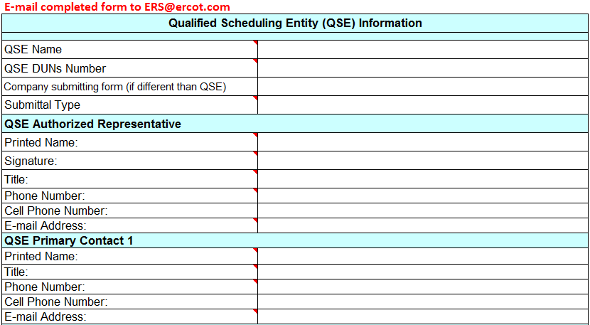

- R tabs (blue) are used to:
  - Obtain baseline options for a specific Resource.
    - Resource’s where a determination has already been made as to its composition (Individual, Aggregation, time periods being offered) should be submitted on an R tab.
  - Submit Resources seeking a Default (Drop by) baseline assignment.
    - If baseline selection is left blank; baseline analysis will be done on the Resource and baseline options will be provided.
    - Once an ERID number is assigned to a Default Resource on an R tab; the only changes to time period selection that will be allowed is dropping a time period when submitting the Resource’s Offer.
  - Submit Alternate (Drop to) Resources.
    - If the Alternate baseline is selected from the drop down box, it will be assigned and no baseline analysis will be done on the Resource.
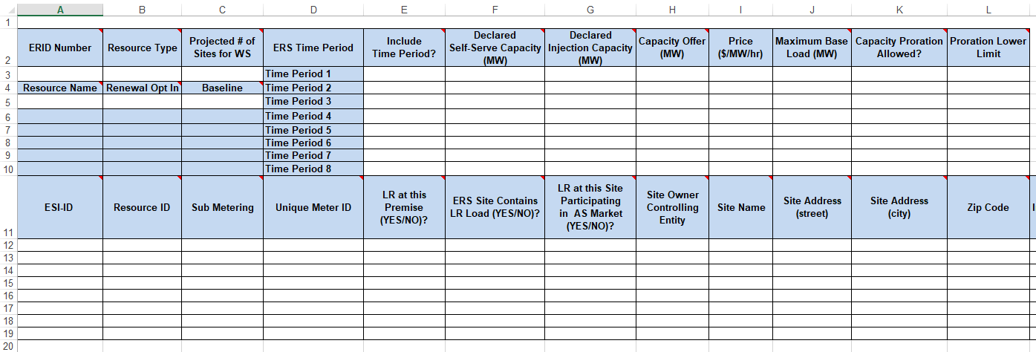
- Alt tab (yellow) are used to:
  - Identify Sites to be offered as alternate baseline Sites (as individuals or aggregations).
    - Sites that need flexibility in order to put an offer together should be submitted on the Alt tab.
    - All Sites on the Alt tab will receive the same ERID number and will become a “pool” from which you can pull to form Resources to offer.
It is ok to submit Resources on one or more R tabs and on the Alt tab in order to “cover all the bases” in case an issue arises when putting together offers.
Instructions for filling out R tabs in posted ERS Submission Form:
- R Tab should be renamed to match Resource Name (A5).
  - Tab name must be unique
  - No spaces or special characters in tab name
  - Limit tab names to 25 characters
- ERID Number (A3) - Identification Number assigned by ERCOT during ERID process.
  - For ERIDs leave blank
  - For Offers the ERID number must match the assigned ERID number received during the ERID process.
- Resource Type (B3) - Load, Generator or Weather-Sensitive; cannot be blank.
- Projected # of Sites for WS (C3) - QSEs initial projection of the maximum number of sites, number should not change when submitting WS monthly site updates.
- Resource Name (A5) - Should be the same as submitted in prior SCT.
  - You may change name if the aggregation has changed.
- Renewal Opt-In (B5) – May be left blank during ERID phase
- Baseline (C5) - Blank or Alternate
  - If seeking a Default baseline leave cell C5 blank but select Time Periods in cells E3 through E10.
  - If seeking an Alternate baseline select Alternate in cell C5 and leave Time Periods in cells E3 through E10 blank.
- Time Periods (E3-E10) - “Yes” or “No”; cannot be blank.
  - If seeking Default baseline select Time Periods
  - If seeking an Alternate baseline leave time periods blank.
- ESI-ID - Fill in this column for any ERS Resource with an ERCOT ESIID
  - If premise level site data for the ERCOT ESIID is to be used
  - If sub-meter site data is to be used for a premise with an ERCOT ESIID, the Sub Metering column must also be completed.
  - If sub-meter site data is to be used for a site within a Private Use Network (provide the PUN ESIID), the Sub Metering column must also be completed.
  - If the ERS Resource is a NOIE wholesale metering point
- Resource ID – filled out for Generators and Distributed Renewable Generators (DRG)
  - ERS Generators
    - Registered distributed generator - enter the RID on the Registration Form
    - Competitive area with an advanced meter measuring export - enter the ESIID
    - NOIE area and not registered with ERCOT - enter a QSE assigned unique identifier to be associated with export to the grid - must not match UMI
- Sub Metering – If yes, QSE will be responsible for submitting meter data as required in TRSOW.
  - If sub-metering is "Yes" then Unique Meter ID cannot be blank
  - If sub-metering is "No" and NOIE area is "No" then Unique Meter ID must be blank
- Unique Meter ID - UMI must be consistent from SCT to SCT. No commas in Unique Meter ID.
  - If sub-meter site data is to be used for a premise with an ERCOT ESIID; ESIID must also be completed.
  - If sub-meter site data is to be used for a site within a Private Use Network; ESIID must also be completed.
  - If the customer is inside a NOIE service area
- LR at this Premise (Yes or No) - If there is one or more LR at this premise must be "Yes"; otherwise must be "No".
- ERS Site Contains LR Load (Yes or No) - If LR at this Premise is "Yes" and this site includes some or all or the LR Load at this premise, must be "Yes"; otherwise must be "No".
- LR at this Site Participating in AS Market (Yes/No) - If ERS Load contains LR Load is "Yes" and one or more of the Load Resources will be participating in an AS market during the contract period, must be "Yes"; otherwise must be "No"
- Site Owner/Controlling Entity- Enter the name of the entity that has direct control of the load reduction. Cannot be blank.
- Site Name- Site names must be unique. Must match previous submissions. Cannot be blank.
- Site Address (street) - If NOIE Service Area is 'Yes" Site Address (street) cannot be blank
- Site Address (city) - If NOIE Service Area is 'Yes" Site Address (city) cannot be blank
- Zip Code - If NOIE Service Area is 'Yes" cannot be blank
- TDSP Interconnection Agreement – If ERS Generator or Distributed Renewable Generator must be "Yes". Other must be "No".
- TSP/DSP –Can be found in doc titled “List of all Market Participants”. Cannot be blank.
  - http://www.ercot.com/mktparticipants/index.html
- TSP/DSP Duns # –Can be found in doc titled “List of all Market Participants”. Cannot be blank.
  - http://www.ercot.com/mktparticipants/index.html
- NOIE Service Area
  - Must be "Yes" if the load is inside a NOIE area; otherwise must be "No".
  - If NOIE Area is "Yes" then Private Use Network must be "No"
- If NOIE Area is "Yes" & Wholesale Meter Point is "No" Unique Meter ID cannot be blank
- Wholesale Meter Point
  - If Wholesale Meter Point is "Yes" then ESIID cannot be blank
  - If Wholesale Meter Point is "Yes" then NOIE Area must be "Yes"
  - If NOIE Area is "Yes" & Wholesale Meter Point is "No" Unique Meter ID cannot be blank
- Private Use Network
  - If site is within a Private Use Network, must be "Yes"; otherwise must be "No".
  - If Private Use Network is "Yes" then neither ESIID nor Unique Meter ID can be blank; sub-metering must be "Yes"; NOIE Service Area & Wholesale Meter Point must be "No"
- On-Site Gen (Yes/No) - If on site generation will be used for all or some of the load response, must be "Yes"; otherwise must be "No".
- Distributed Renewable Generator (Yes/No) - If On-site Gen is "Yes", Enter "Yes" if it's a Distributed Renewable Generator; otherwise, enter "No", Contact ERCOT ERS Team to workout metering requirement
- Generator Name Plate Rating (MW) – If On-site Gen is "Yes" fill in Generator Name Plate MW; otherwise, leave blank
- Load and Type(s) of Processes to be Curtailed

Resource Identification Phase (ERID)-Error Books
Resources with Error exceptions will be posted to the MIS in an excel workbook which will contain:
- Resource information (all on one tab).
- Exceptions tab (warnings and errors)
  - Errors must be corrected and resources re-submitted until it receives an approved ERID number.
  - Delete Exceptions tab before resubmitting.

Resource Identification Phase (ERID)-Approved Book
ERIDs will be processed in batches. If two or more ERID books (same QSE) are processed in the same batch results will be returned in one Excel workbook posted to the MIS. Workbooks will contain the following information:
- Approved Resources with assigned ERID number (all on one tab).
- Baseline Info tab
- Availability Results tab
- Exceptions tab (warnings)

How to Read ERID Analysis Results
- Exceptions tab - contains any warnings of potential issues that will be encountered in offering or responsibilities that the QSE or ERS Resource must take care of prior to the start of the SCT, including various issues related to sub-metering or non-IDR metering.
  - Warnings do not prevent a Resource from getting an approved ERID number but should be reviewed/corrected prior to submitting offers.
- Availability Results tab - provides capacity pre-screening information for each prospective ERS Resource for the most recent, complete 12 months for which historical interval data is available. The results are summarized by Time Period, contract term (not necessarily contiguous) and for the most recent 12 month period.
  - Column I, “min_mw,” indicates the ERS Resource’s lowest 15-minute interval load level during the summarized period.
  - Column J, “mw_1st_pctile,” indicates the ERS Resource’s first percentile load level during the summarized period. The load for this resource was equal to or greater than this number for 99% of 15-minute intervals in the Time Period.
  - Column K, “mw_5th_pctile,” indicates the ERS Resource’s 5th percentile load level during the summarized period. The load for this resource was less than this number for 5% of 15-minute intervals in the Time Period, and equal to or greater than this number for 95% of 15-minute intervals in the Time Period.
  - Column L, “avg_mw,” represents the average actual Load during the summarized period.
  - Column M, “min_esiid_ct” for aggregations indicates the number of sites used to calculate the above quantities. Only sites with complete data are included in the calculations, so the number reported may be less than the number of sites submitted in an aggregation.
- Baseline Info tab - provides ERCOT’s baseline options for each resource for the upcoming SCT and, as a reference, assignments that would be available for other SCT.
  - Default Baselines
    - REG – Statistical Regression Model
    - MDP – Matching Day Pair Model
    - M810 – Middle 8-of-10 Preceding Like Days Model
    - MBMA – Meter Before/Meter After
    - Near20 – Nearest 20 Like Days
  - Alternate
This tab also provides additional summary statistical results of ERCOT’s historical interval meter data evaluation by SCT, if interval data was provided or available. If interval data was unavailable for a prospective ERS Resource, a blank tab will appear for this resource. If the resource was determined eligible for one or more of the default baseline models, the following results are listed specific to a Contract Period and are exclusive to the combination of Time Periods specified for the resource.
- RSquare - The percent of variation in actual load that is explained by variation in the baseline load. (100% indicates a perfect baseline)
- MAPE - Mean Absolute Percent Error—Average absolute difference between the actual load and the baseline estimate.
- P90 KW Confidence - Based on historical data, the kW amount by which a QSE may consider de-rating an offer to achieve a 90% probability of meeting event performance requirements.
- P95 kW Confidence - Based on historical data, the kW amount by which a QSE may consider de-rating an offer to achieve a 95% probability of meeting event performance requirements.
- P99 kW Confidence - Based on historical data, the kW amount by which a QSE may consider de-rating an offer to achieve a 99% probability of meeting event performance requirements.
- Capacity pre-screening values are provided by ERCOT strictly as a service to QSEs and ERS Resources, are non-binding, and are not intended to provide either a ceiling or a floor for ERS participants to adhere to in preparing an offer.
- MW offers should be submitted based entirely on the amount of interruptible load the ERS Resource is confident it can safely deliver according to its baseline assignment.
- ERCOT's pre-screened capacity analysis in no way substitutes for or replaces this judgment by the ERS Resource. Offers are submitted entirely at the risk of the QSE and the ERS Resource.
  - This information is intended to provide a high-level view of the baseline assignments results for a resource across a full year, to assist QSEs with making decisions regarding future offerings.

Offers and/or Self-Provision Offers
All offers are binding. All offers must be submitted with a signed pdf copy of the ID page or digital signature. ERS-10 and ERS-30 procurement offers must be submitted in separate books. QSEs may submit both ERS Self-Provision offers and competitive offers. In such cases, both the ERS Self-Provision offers and the competitive offers should be submitted simultaneously on separate sheets within the ERS Submission Form. All capacity within an ERS Resource must be either competitively offered or self-provided.
- All offers (default and alternate) must be submitted on an R tab and may be either:
  - An approved R tab that was assigned an ERID number during the ERID phase.
  - An R tab made up of any combination of Sites on the approved Alt tab; copy Site information and ERID number assigned to the Alt tab to the R tab.
- Renewal Opt In (B5) – “Yes” or “No”; cannot be blank.
- Projected # of Sites for WS (C3) – QSEs initial projection of the maximum number of sites, number should not change when submitting Weather Sensitive monthly site updates.
- Baseline (C5) - Select one of the approved baselines from drop down.
- Time Periods (E3-E10) - “Yes” or “No”; cannot be blank.
  - Default Baseline – can drop a time period but cannot add a time period.
  - Alternate Baseline – any change to time periods is permissible.
- Declared Self-Serve Capacity (F3-F10) – Generators only. MW value representing the amount of native Load that the generator will serve (the value may be zero).
- Declared Injection Capacity (G3-G10) – Generators only. MW value representing the amount of energy the generator will inject to the ERCOT System during hours outside of ERS events or ERCOT unannounced tests (the value may be zero).
- Capacity Offer (H3-H10) – Capacity offer values only for Time Periods with a “Yes”; otherwise leave blank.
  - Numeric value; no letters
  - Minimum offer for Weather-Sensitive is half MW (0.5).
  - Minimum offer for all other ERS is 100 kW (one-tenth or 0.1 MW).
  - Fractional offers above the 100 kW minimum are permitted to the nearest whole kW (one-thousandth or 0.001 MW) level.
- Price (I3-I10) - Should be filled in only for Time Periods with a “Yes”.
  - Numeric value; no dollar sign
  - Offer price should be formatted with only two (2) decimal places.
  - Self-Provision Offers should substitute the word “self” for a monetary price.
- Maximum Base Load (J3-J10)
  - If a Default Baseline is selected in C5 then leave blank or enter “0”.
  - If an Alternate Baseline is selected in C5 then enter a MW value
  - In event or test Resource must “drop to” value entered.
- Capacity Proration Allowed (K3-K10) - “Yes” or “No”; cannot be blank.
- Proration Lower Limit (L3-L10) – ERCOT may prorate the capacity awarded to an ERS Resource in an ERS Time Period if the capacity offered for that ERS Resource would cost more than the Emergency Response Service Procurement Methodology allows under the time period expenditure limit.
  - If proration would result in an award below an ERS Resource’s designated prorated capacity limit or below the minimum MW offer applicable to the ERS service type the offer will not be awarded.
  - If item 11 above is “Yes”; Proration Lower Limit cannot be blank.
  - In MW to the nearest tenth
- Offer book should contain ID page and R tabs; all other tabs should be removed.
- An ESIID/Unique Meter ID may participate in only one Resource.

