OBDRR Number | 036 | OBDRR Title | Related to NPRR1106, Deployment of Emergency Response Service (ERS) Prior to Declaration of Energy Emergency Alert (EEA)
Date of Decision |  | November 29, 2021
Action |  | Recommended Approval
Timeline |  | Urgent – to implement revisions to the Emergency Response Service (ERS) deployment process in time for the winter season.
Proposed Effective Date |  | Upon implementation of Nodal Protocol Revision Request (NPRR) 1106, Deployment of Emergency Response Service (ERS) Prior to Declaration of Energy Emergency Alert (EEA)
Priority and Rank Assigned |  | Not Applicable
Other Binding Document Requiring Revision |  | Emergency Response Service Procurement Methodology
Supporting Protocol or Guide Section(s) / Related Documents |  | NPRR1106  Nodal Operating Guide Revision Request (NOGRR) 237, Related to NPRR1106, Deployment of Emergency Response Service (ERS) Prior to Declaration of Energy Emergency Alert (EEA)  Nodal Operating Guide Section 4.5.3.3, EEA Levels  ERCOT Operating Procedures – Real-Time Desk  ERCOT Operating Procedures – Resource Desk  ERCOT Operating Procedures – Scripts  Emergency Response Service Technical Requirements & Scope of Work
Revision Description |  | This Other Binding Document Revision Request (OBDRR) revises the Emergency Response Service Procurement Methodology to state that ERCOT will make an initial allocation of the annual expenditure limit to each ERS Time Period in each ERS Standard Contract Term based on the expected risk of deploying ERS in that ERS Time Period, to remove outdated language pertaining to the ERS offer cap and its relationship to historical prices paid to the Transmission and/or Distribution Service Provider (TDSP) Load management programs, and to include language to clarify that ERCOT has discretion to revise and re-issue Requests for Proposal (RFPs) prior to the offer submission deadline.
Reason for Revision |  | Addresses current operational issues.  Meets Strategic goals (tied to the ERCOT Strategic Plan or directed by the ERCOT Board).  Market efficiencies or enhancements  Administrative  Regulatory requirements  Other: (explain)  (please select all that apply)
Business Case |  | This OBDRR proposes revisions necessary to implement changes proposed in NPRR1106 pursuant to Public Utility Commission of Texas (PUCT) Docket No. 52373, Review of Wholesale Electric Market Design, wherein PUCT Staff filed a Motion for Good Cause Exception that requested the PUCT grant ERCOT a good cause exception pursuant to P.U.C. Subst. R. 25.507, Electric Reliability Council of Texas (ERCOT) Emergency Response Service (ERS), “so that ERCOT may procure ERS that may be used prior to the declaration of an EEA, rather than being limited to use of the ERS during an EEA, as allowed by 16 TAC § 25.507(a).” The PUCT voted to grant this exception at its October 28, 2021 Open Meeting.
TAC Decision |  | On 11/29/21, TAC voted via roll call to recommend approval of OBDRR036 as submitted, and the Impact Analysis for OBDRR036. There was one opposing vote from the Independent Power Marketer (IPM) (Morgan Stanley) Market Segment, and one abstention from the Municipal (Garland) Market Segment. All Market Segments participated in the vote.
Summary of TAC Discussion |  | On 11/29/21, TAC reviewed the Impact Analysis, ERCOT Opinion, and ERCOT Market Impact Statement for OBDRR036.
ERCOT Opinion |  | ERCOT supports approval of OBDRR036.
ERCOT Market Impact Statement |  | ERCOT Staff has reviewed OBDRR036 and believes the market impact for OBDRR036 enhances ERCOT’s operational tools to address potential reliability outcomes by granting ERCOT Operators the discretion to deploy ERS when Physical Responsive Capability (PRC) falls below 3,000 MW and is not projected to be recovered above 3,000 MW within 30 minutes following the deployment of Non-Spinning Reserve (Non-Spin).

Sponsor
Name | Sandip Sharma
E-mail Address | Sandip.Sharma@ercot.com
Company | ERCOT
Phone Number | 512-248-4298
Cell Number
Market Segment | Not Applicable

Market Rules Staff Contact
Name | Brittney Albracht
E-Mail Address | Brittney.Albracht@ercot.com
Phone Number | 512-225-7027

Comments Received
Comment Author | Comment Summary
None

Market Rules Notes
None
Proposed Other Binding Document Language Revision


EMERGENCY RESPONSE SERVICE

Procurement Methodology

ERCOT Board approved TBD
Effective Date of TBD

Date Approved | Version | Description | Author(s) | Approved By | Effective Date
11/19/13 | 0.1 | ERCOT Board approved NPRR564, Thirty-Minute Emergency Response Service (ERS) and Other ERS Revisions, and associated OBD, Emergency Response Service Procurement Methodology | ERCOT | ERCOT Board | 11/20/13
4/8/14 | 0.2 | Revised Section G, Clearing Price. Language grey boxed until effective date of 5/1/14.  History:  - 3/11/14 – Notification of proposed revisions  - 3/27/14 – TAC recommended approval  - 4/8/14 – ERCOT Board of Directors approved  - 5/1/14 – Removed grey box from Section G | ERCOT | ERCOT Board | 5/1/14
10/14/14 | 0.3 | Revised Section G, Clearing Price. (Associated NPRR637, Clarification of ERS Language and ERCOT Process for Co-located Resources.) Language grey boxed until effective date of 11/1/14.  History:  - 8/21/14 – Notification of proposed revisions  - 8/28/14 – TAC recommended approval  - 10/14/14 – ERCOT Board of Directors approved  - 11/1/14 – Removed grey box from Section G | ERCOT | ERCOT Board | 11/1/14
6/12/18 | 0.4 | Revisions proposed by OBDRR004, Updates to Emergency Response Service Procurement Methodology | ERCOT | ERCOT Board | 7/1/18
10/13/20 | 0.5 | Revisions proposed by OBDRR023, Related to NPRR984, Change ERS Standard Contract Terms. Language grey boxed until effective date of 2/1/21 and upon system implementation of NPRR984  History:  - 8/5/20 – Notification of proposed revisions  - 8/26/20 – TAC recommended approval  - 10/13/20 – ERCOT Board of Directors approved  - 2/1/21 – Unboxed footnote in Section E;  - Unboxed remaining language due to system implementation of NPRR984; | ERCOT | ERCOT Board | 2/1/21
4/13/21 | 0.6 | Revisions proposed by OBDRR027, Clarify Implementation Timeline for OBDRR023 (changed effective date of OBDRR023)  History:  - 2/2/21 – Notification of proposed revisions  - 3/24/21 – TAC recommended approval  - 4/13/21 – ERCOT Board of Directors approved | ERCOT | ERCOT Board | 4/16/21

Table of Contents

A. Document Description 5
B. Change Control Process 5
C. ERS Capacity Demand Curve 5
D. ERS Offer Cap 6
E. ERS Expenditure Limit 6
F. Capacity Inflection Point 8
G. Clearing Price 10
H. ERS Capacity provided through ERS Self Provision 11

Electric Reliability Council of Texas, Inc. (ERCOT) administers Emergency Response Service (ERS) in accordance with Public Utility Commission of Texas (PUCT) Substantive Rule §25.507, Electric Reliability Council of Texas (ERCOT) Emergency Response Service (ERS) and the ERCOT Nodal Protocols. This document is intended to be consistent with these standards, but to the extent any conflict exists, the PUC Rule or Protocols control.

A. Document Description
This document describes the mechanism for procuring ERS and is considered an “Other Binding Document,” as that term is defined in the ERCOT Protocols.

B. Change Control Process
ERCOT Staff will provide a period for stakeholder review and comment for proposed revisions to this document as follows:
(1) ERCOT shall post proposed revisions to the Emergency Response Service Procurement Methodology to the ERCOT website.
(2) ERCOT shall also electronically notify stakeholders of the proposed revisions via the TAC and Others distribution list and define the comment period which shall be at least 14 days after initial posting.
(3) To receive consideration, comments should be submitted via email to ERS@ercot.com by the deadline set forth in the notification.
(4) Upon Market Participant written request, ERCOT will conduct a conference call and online review of the submitted comments.
(5) ERCOT will review proposed document revisions with the Technical Advisory Committee (TAC).
(6) ERCOT will submit proposed document revisions for ERCOT Board approval.
(7) Within three Business Days of ERCOT Board approval, ERCOT shall post the revised document to the ERCOT website.

C. ERS Capacity Demand Curve
ERCOT will develop a capacity demand curve for each ERS Time Period, and all ERS products will be procured together within the limits of that curve. ERCOT shall maximize the MW procured subject to the expenditure limit for the relevant Time Period. Each demand curve is derived from the three following parameters, which ERCOT will specify in the Request for Proposal (RFP) for ERS procurement:
(1) ERS Offer Cap
(2) ERS Time Period Capacity Inflection Point
(3) ERS Time Period Expenditure Limit

MW
$/MW/Hr
Offer Cap
Expenditure Limit
Capacity
Demand
Curve
Capacity
Inflection
Point

D. ERS Offer Cap
The ERS offer cap establishes a maximum possible procurement price of $80/MW/hr for every ERS Time Period during the ERS budget year. ERCOT will automatically reject any offers above the offer cap.

E. ERS Expenditure Limit
P.U.C. Substantive Rule 25.507 restricts ERCOT’s ERS expenditures to an annual cost cap of $50 million. ERCOT will allocate the $50 million available expenditure within its ERS budget year, which starts with the December through March Standard Contract Term and ends with the October through November Standard Contract Term.
[OBDRR023: Delete “Footnote 2” on December 1, 2021.]

No later than 60 days before each new ERS budget year, ERCOT will make an initial allocation of the annual expenditure limit to each ERS Time Period in each ERS Standard Contract Term based on the expected risk of deploying ERS in that ERS Time Period, in accordance with the formula detailed below. ERCOT will assign a high (H), moderate (M), or low (L) risk designation to each ERS Time Period and will assign a risk-weighting factor (a value from 1 to 100 with 1 being the lowest risk value and 100 being the highest risk value) for each risk designation. ERCOT’s risk assessment will consider a number of factors, including, but not limited to, forecasted operating reserves, forecasted Load, and Resource outage information.
Prior to issuing an RFP for an upcoming Standard Contract Term, ERCOT will update the ERS Time Period Expenditure Limits for each remaining ERS Time Period in the budget year to reflect updated forecasts and any expected remaining funds from ERS Standard Contract Terms within the same ERS budget year. Unless the offer submission deadline for the upcoming Standard Contract Term has passed, ERCOT may update the ERS Time Period Expenditure Limits and issue a revised RFP if funds originally allocated to the upcoming Standard Contract Term must be reallocated to fund an ERS renewal Contract Period in the current Standard Contract Term. ERCOT may revise and reissue the RFP for other reasons if the offer submission date has not yet passed. Any funds remaining at the end of an ERS budget year will not be carried forward into a new ERS budget year.
For each ERS Time Period, the expenditure limit is calculated as follows:
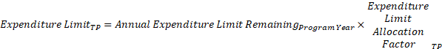
Where
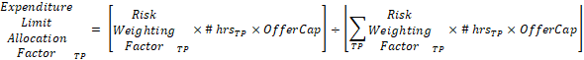

F. Capacity Inflection Point
The capacity inflection point establishes the point on the capacity demand curve where capacity can only be procured at an offer price less than the ERS Time Period offer cap while respecting the expenditure limit for that ERS Time Period. The capacity inflection point for each time period is calculated as follows:

Table A below provides hypothetical calculations of the expenditure limits and capacity inflection point for each ERS Time Period in each budget year.
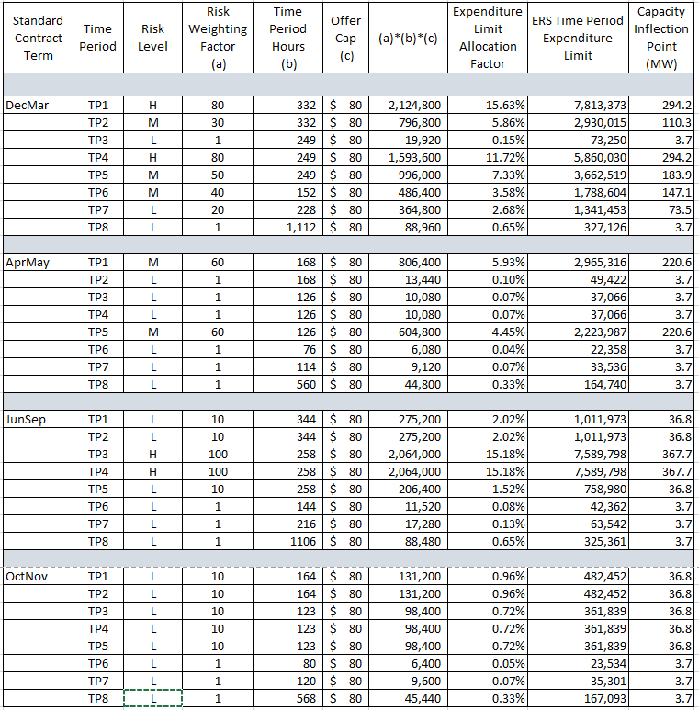
Table A. ERS Time Period Expenditure Limit Allocation and Capacity Inflection Point Calculations

G. Clearing Price
The highest offer accepted for an ERS Time Period from will set the clearing price for all ERS Resources cleared in that ERS Time Period. All ERS service types specified in the Protocols will be procured using a common ERS capacity demand curve for each ERS Time Period and the highest offer accepted for an ERS Time Period will set the clearing price for all ERS service types.
If the procurement of all offers at the same price for an ERS Time Period would exceed the ERS Expenditure Limit for that ERS Time Period, ERCOT shall consider each such offer in an order established at random.
If awarding an offer would not exceed the ERS Expenditure Limit that offer will be awarded for the full capacity offered.
If awarding an offer for the full amount of the offered capacity would exceed the ERS Expenditure Limit, the following steps will be taken:
(1) If awarding an offer for the full amount of the offered capacity would exceed the ERS Expenditure Limit, the following steps will be taken: If the QSE has indicated on its offer that capacity proration is not allowed for that ERS Resource, the offer will be rejected.
(2) If the QSE has indicated on its offer that capacity proration is allowed for that ERS Resource, and if the capacity following proration is greater than or equal to the Proration Lower Limit specified on the offer, the offer will be accepted and the prorated capacity will be awarded.
(3) If the QSE has indicated on its offer that capacity proration is allowed by the QSE for that ERS Resource, and if the prorated capacity is less than the Proration Lower Limit specified on the offer, the offer will be rejected.

H. ERS Capacity provided through ERS Self Provision
For any ERS self-provision, ERCOT will reduce the Time Period expenditure limit for any offers to self-provide part or all of a QSE’s ERS Obligation by the clearing price for ERS.

http://www.puc.state.tx.us/agency/rulesnlaws/subrules/electric/25.507/25.507ei.aspx
Due to the implementation of NPRR984, Change ERS Standard Contract Terms, the 2021 ERS budget year will be truncated and will include a February through May Standard Contract Term, a June through September Standard Contract Term, and an October through November Standard Contract Term. During this 10-month ERS budget year, ERCOT will allocate ERS spending based on an expenditure limit of $41.6 million (i.e., 10/12ths of the $50 million ERS annual spending limit).

