October 2021 ERCOT Monthly Operations Report
Reliability and Operations Subcommittee Meeting
December 02, 2021

Table of Contents
1. Report Highlights 2
2. Frequency Control 3
2.1. Frequency Events 3
2.2. Responsive Reserve Events 4
2.3. Load Resource Events 4
3. Reliability Unit Commitment 4
4. IRR, Wind, and Solar Generation as a Percent of Load 5
5. Largest Net-Load Ramp 7
6. COP Error Analysis 7
7. Congestion Analysis 9
7.1. Notable Constraints 9
7.2. Generic Transmission Constraint Congestion 13
7.3. Manual Overrides 13
7.4. Congestion Costs for Calendar Year 2021 13
8. System Events 14
8.1. ERCOT Peak Load 14
8.2. Load Shed Events 14
8.3. Stability Events 14
8.4. Notable PMU Events 15
8.5. DC Tie Curtailment 15
8.6. TRE/DOE Reportable Events 15
8.7. New/Updated Constraint Management Plans 15
8.8. New/Modified/Removed RAS 15
8.9. New Procedures/Forms/Operating Bulletins 15
9. Emergency Conditions 16
9.1. OCNs 16
9.2. Advisories 16
9.3. Watches 16
9.4. Emergency Notices 16
10. Application Performance 17
10.1. TSAT/VSAT Performance Issues 17
10.2. Communication Issues 17
10.3. Market System Issues 17
11. Model Updates 17
Appendix A: Real-Time Constraints 20

Report Highlights
- The unofficial ERCOT peak load was 62,461 MW.
- There were 2 frequency events.
- There were 3 instances where Responsive Reserves were deployed.
- There were 86 HRUC commitments.
- There were 20 days of congestion on the West Texas Export GTC, 24 days on the North Edinburg to Lobo GTC, 17 days on the Panhandle GTC, 15 days on the Raymondville to Rio Hondo, 8s days on the Valley Export GTC, 7 days on the Nelson Sharpe to Rio Hondo GTC, 2 days on the East Texas GTC, 3 days on the North to Houston GTC, 1 day on the Bearkat GTC, and 1 day on the McCamey GTC. There was no activity on the remaining GTCs during the month.

Frequency Control

Frequency Events
The ERCOT Interconnection experienced 2 frequency events, which resulted from unit’s trips. The average event duration was 00:04:01.

A summary of the frequency events is provided below. The reported frequency events meet one of the following criteria: Delta Frequency is 60 mHz or greater; the MW loss is 350 MW or greater; resource trip event triggered RRS deployment. Frequency events that have been identified as Frequency Measurable Events (FME) for purposes of BAL-001-TRE-1 analysis are highlighted in blue. When analyzing frequency events, ERCOT evaluates PMU data according to industry standards. Events with an oscillating frequency of less than 1 Hz are inter-area, while higher frequencies indicate local events. Industry standards specify that damping ratio for inter-area oscillations should be 3.0% or greater. For the frequency events listed below, the ERCOT system met these standards and transitioned well after each disturbance.

Date and Time | Delta Frequency | Max/Min Frequency | Duration of Event | PMU Data |  | MW Loss | Load | IRR | Inertia
 | (Hz) | (Hz) |  | Oscillation Mode (Hz) | Damping Ratio |  | (MW) | % | (GW-s)
10/1/2021 11:10:56 | 0.088 | 59.864 | 00:03:58 | 0.63 | 10% | 464.7 | 46,346 | 12% | 286,620
10/2/2021 5:51:11 | 0.122 | 59.848 | 00:04:04 | 0.63 | 10% | 648 | 37,198 | 5% | 250,260

(Note: All data on this graph encompasses frequency event analysis based on BAL-001-TRE-1.)

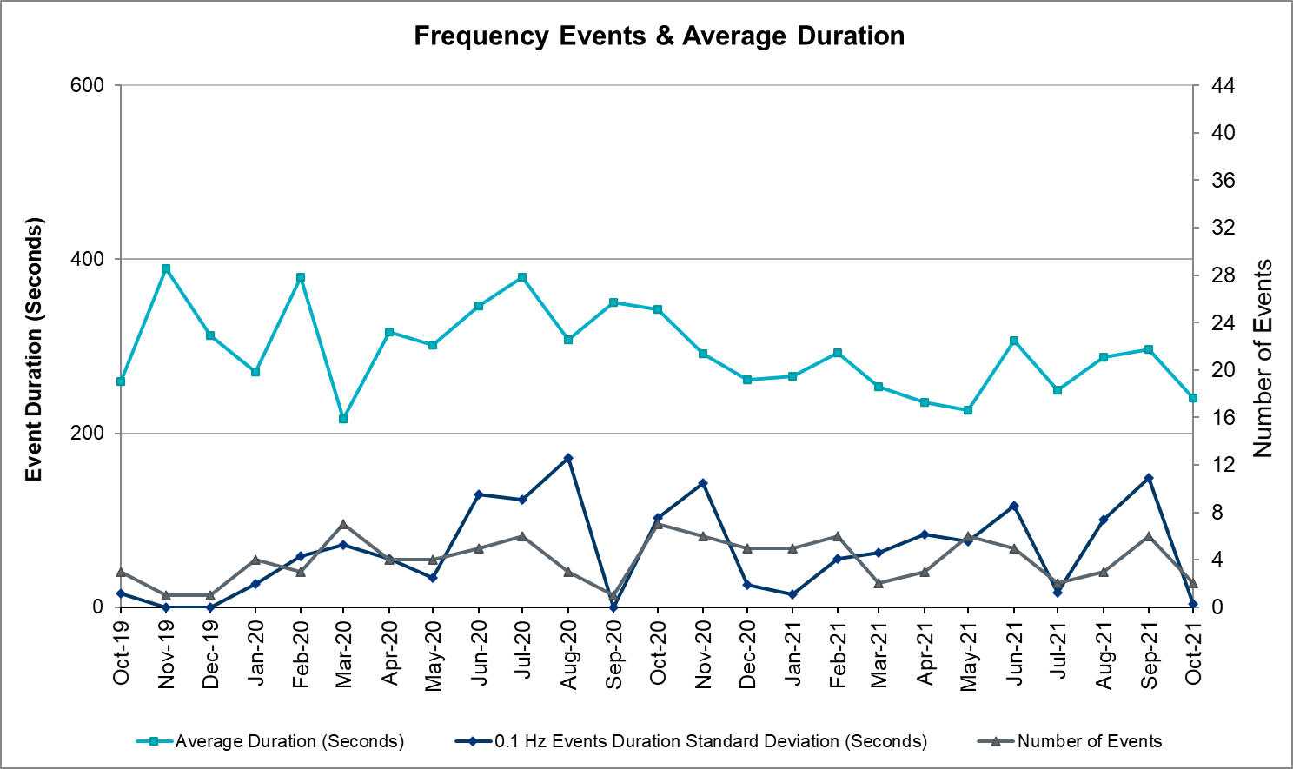

Responsive Reserve Events
There were 3 events where Responsive Reserve MWs were released to SCED. The events highlighted in blue were related to frequency events reported in Section 2.1 above.

Date and Time Released to SCED | Date and Time Recalled | Duration of Event | Maximum MWs Released | Comments
10/1/2021 11:11:06 | 10/1/2021 11:15:58 | 00:04:52 | 809
10/2/2021 5:51:18 | 10/2/2021 5:56:06 | 00:04:48 | 908
10/27/2021 1:11:45 | 10/27/2021 1:18:19 | 00:06:34 | 650

Load Resource Events
None

Reliability Unit Commitment
ERCOT reports on Reliability Unit Commitments (RUC) on a monthly basis. Commitments are reported grouped by operating day and weather zone. The total number of hours committed is the sum of the hours for all the units in the specified region. Additional information on RUC commitments can be found on the MIS secure site at Grid Generation Reliability Unit Commitment.

There were no DRUC commitments.

There were 86 HRUC commitments

Resource Location | # of Resources | Operating Day | Total # of Hours Committed | Total MWhs | Reason for Commitment
EAST, NORTH_CENTRAL, SOUTH_CENTRAL | 5 | October 1, 2021 | 30 | 11,158.0 | System Capacity
EAST, NORTH_CENTRAL, SOUTH_CENTRAL | 12 | October 2, 2021 | 77 | 19,469.0 | System Capacity
EAST, NORTH_CENTRAL, SOUTH_CENTRAL | 12 | October 3, 2021 | 107 | 29,749.0 | System Capacity
NORTH_CENTRAL, SOUTHERN | 4 | October 4, 2021 | 32 | 14,147.0 | Minimum Run Time, System Capacity
NORTH_CENTRAL, SOUTH_CENTRAL, SOUTHERN | 7 | October 6, 2021 | 74 | 25,466.0 | System Capacity
NORTH_CENTRAL | 3 | October 7, 2021 | 51 | 8,736.0 | Minimum Run Time, System Capacity
NORTH_CENTRAL | 2 | October 8, 2021 | 25 | 3,075.0 | Minimum Run Time
COAST, EAST, SOUTH_CENTRAL, SOUTHERN | 7 | October 12, 2021 | 40 | 8,939.0 | SJNWA1P5, DWAP_JN5,  SESPK8,  DCAGCO58,  DMBDRKC5,  DLONEQU8,  DWESNUE8
EAST, NORTH_CENTRAL, SOUTH_CENTRAL, SOUTHERN | 9 | October 13, 2021 | 64 | 20,845.0 | System Capacity
NORTH_CENTRAL | 1 | October 14, 2021 | 7 | 3,605.0 | System Capacity
EAST | 2 | October 20, 2021 | 16 | 5,232.0 | System Capacity
EAST | 1 | October 21, 2021 | 8 | 3,872.0 | System Capacity
SOUTH_CENTRAL | 1 | October 23, 2021 | 24 | 6,720.0 | OSA – Self Commitment
COAST, EAST, NORTH, NORTH_CENTRAL, SOUTH_CENTRAL, SOUTHERN | 14 | October 24, 2021 | 92 | 24,913.0 | System Capacity  OSA – Self Commitment
COAST, EAST, NORTH_CENTRAL, SOUTH_CENTRAL | 6 | October 25, 2021 | 69 | 15,622.0 | System Capacity  OSA – Self Commitment

IRR, Wind, and Solar Generation as a Percent of Load
Graph below shows the maximum, minimum and average aggregate solar, wind and IRR output as a percentage of total ERCOT load when evaluated as 10-minute averaged intervals, over the past 13 months. Current wind, solar generation and penetration records are listed in the footnote below. Maximum IRR penetration for the month was 60.2% on October 29, 2021 interval ending 03:00 and minimum IRR penetration for the month was 1.6% on October 3, 2021 interval ending 05:00.

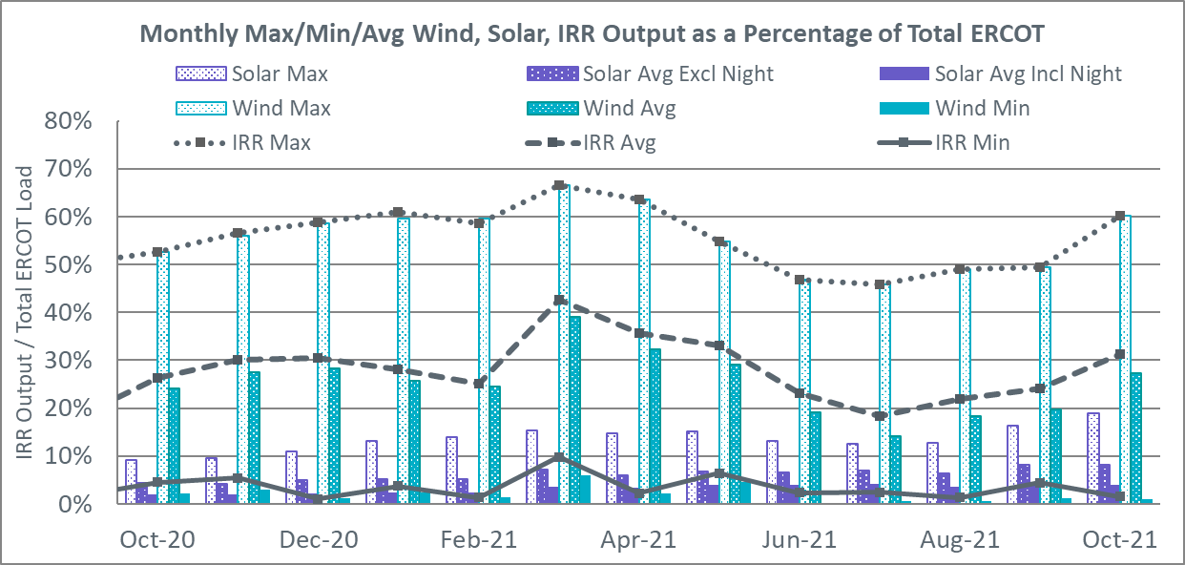

During the hour of peak load for the month, hourly integrated wind generation was 12,489 MW and solar generation was 5,784 MW. Graph below shows the wind and solar penetration percentage during the hour of the peak load in the last 13 months.

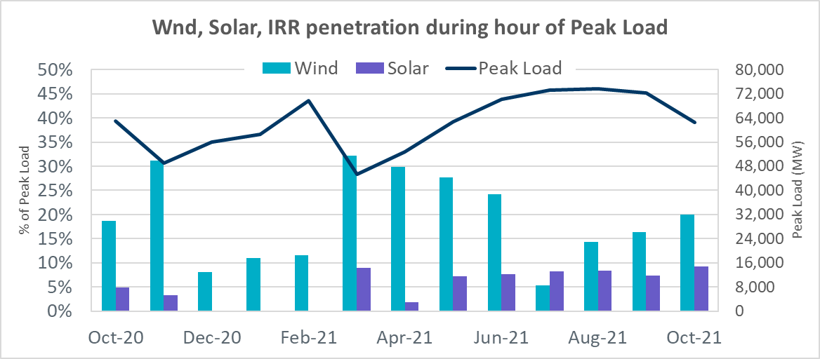

Lastly, the graph below shows the minimum wind, solar and IRR output during the peak load hour as a percentage of the daily peak load for every day in the month.

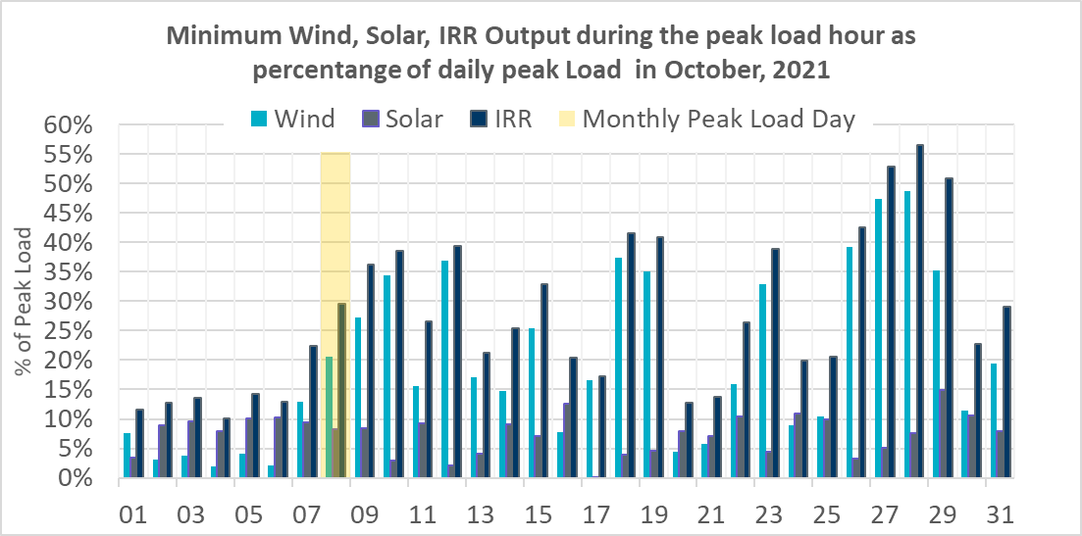

Largest Net-Load Ramp
The net-load ramp is defined as the change in net-load (load minus wind and PVGR generation) during the defined time horizon. Such a variation in net-load needs to be accommodated in grid operations to ensure that the reliability of the grid is satisfactorily maintained. The largest net-load ramp during 5-min, 10-min, 15-min, 30-min and 60-min in October 2021 are 1371 MW, 1949 MW, 2709 MW, 5037 MW, and 9438 MW, respectively. The comparison with respect to the historical values is given in the table below.

Month and Year | 5 min | 10 min | 15 min | 30 min | 60 min
October 2021 | 1371 MW | 1949 MW | 2709 MW | 5037 MW | 9438 MW
October 2014 | 780 MW | 1796 MW | 2152 MW | 2780 MW | 4579 MW
October 2015 | 1141 MW | 1553 MW | 1839 MW | 2779 MW | 4606 MW
October 2016 | 863 MW | 1543 MW | 2035 MW | 3213 MW | 5335 MW
October 2017 | 812 MW | 1338 MW | 1820 MW | 3029 MW | 5347 MW
October 2018 | 860 MW | 1386 MW | 1907 MW | 2824 MW | 5346 MW
October 2019 | 1192 MW | 1728 MW | 2465 MW | 3537 MW | 6408 MW
October 2020 | 1048 MW | 1600 MW | 2488 MW | 3578 MW | 6269 MW
All Months in 2014-2021 | 1494 MW | 1991 MW | 2780 MW | 5037 MW | 9438 MW

COP Error Analysis
COP Error is calculated as the capacity difference between the COP HSL and real-time HSL of the unit. Mean Absolute Error (MAE) stayed over 12,579 MW until Day-Ahead at 12:00, then dropped significantly to 2187 MW by Day-Ahead at 14:00. In the following chart, Under-Scheduling Error indicates that COP had less generation capacity than real-time and Over-Scheduling Error indicates that COP had more generation capacity than real-time.
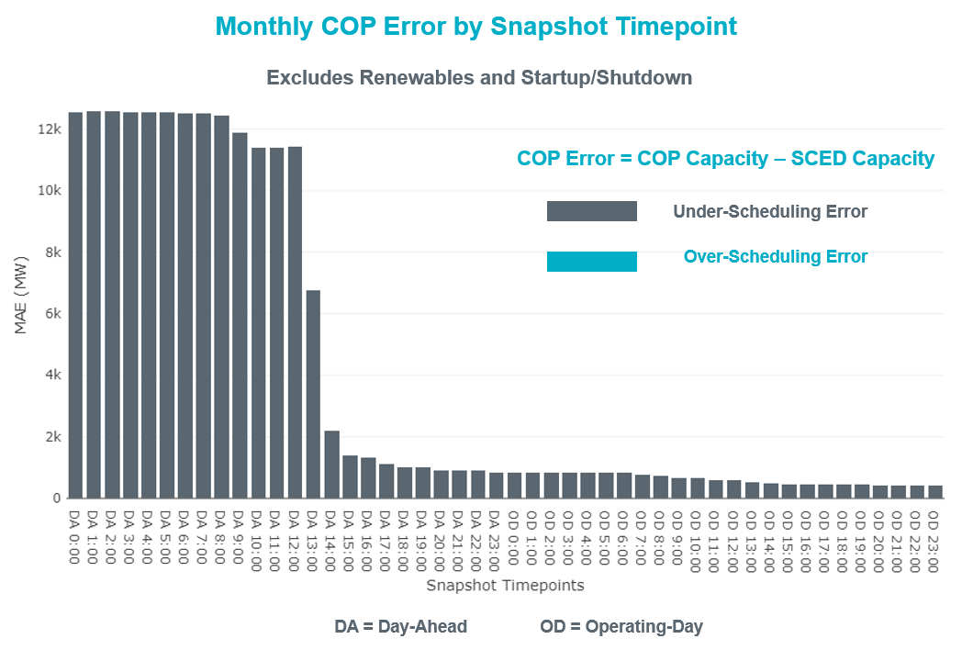

Monthly MAE for the Latest COP at the end of the Adjustment Period was 429 MW with median ranging from -766 MW for Hour-Ending (HE) 20 to 1.6 MW for HE 24. HE 13 on the 1st had the largest Over-Scheduling Error (1,999 MW) and HE 21 on the 3rd had the largest Under-Scheduling Error (-2,980 MW).

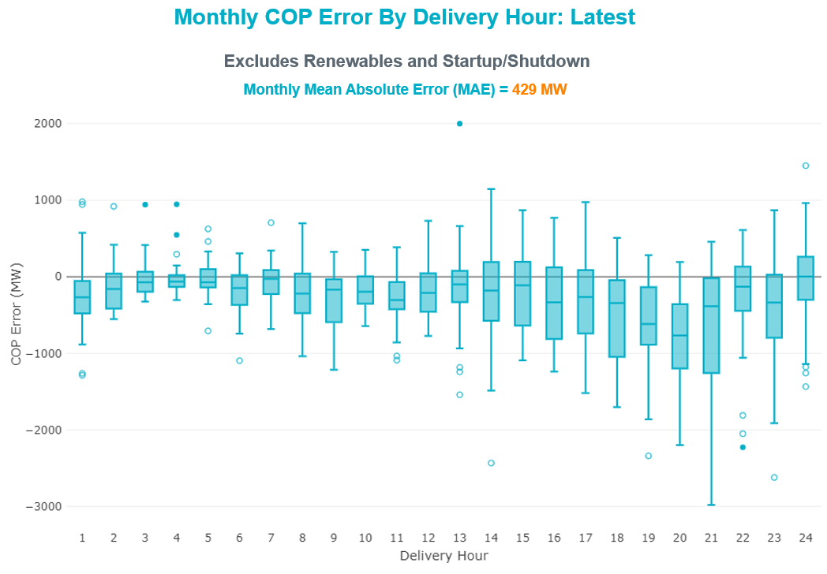

Monthly MAE for the Day-Ahead COP at 12:00 was 11,412 MW with median ranging from -16,926 MW for Hour-Ending (HE) 17 to -5,009 MW for HE 3. HE 20 on the 4th had the largest Under-Scheduling Error (-23,319 MW) and HE 24 on the 30th had the largest Over-Scheduling Error (-343 MW).

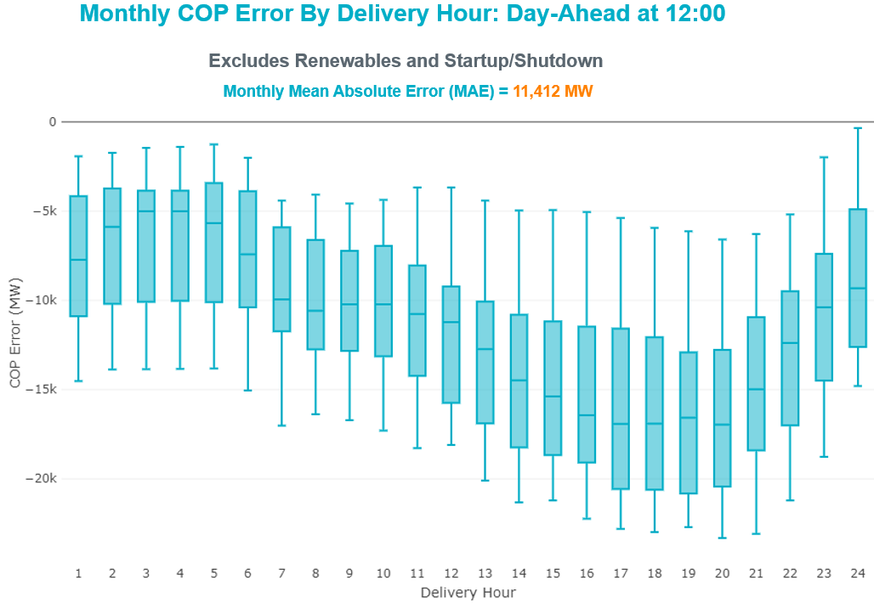

Congestion Analysis

Notable Constraints
Nodal protocol section 3.20 specifies that ERCOT shall identify transmission constraints that are binding in Real-Time three or more Operating Days within a calendar month. As part of this process, ERCOT reports congestion that meets this criterion to ROS. In addition, ERCOT also highlights notable constraints that have an estimated congestion rent exceeding $1,000 for a calendar month. These constraints are detailed in the table below, including approved transmission upgrades from TPIT that may provide some congestion relief based on ERCOT’s engineering judgement. Rows highlighted in blue indicate the congestion was affected by one or more outages. For a list of all constraints activated in SCED, please see Appendix A at the end of this report.

Contingency Name | Overloaded Element | # of Days Constraint Binding | Congestion Rent | Transmission Project
Basecase | WESTEX GTC | 19 | $31,851,264.02
SALSW TO KLNSW 345 DBLCKT | Harker Heights South - Killeen Switch 138kV | 12 | $13,133,407.06
WA PARISH to JEANETTA LIN A | Clodine - Obrien 138kV | 3 | $9,913,917.70
Basecase | NE_LOB GTC | 16 | $8,679,582.78
CRLNW TO LWSSW 345 DBLCKT | Lewisville Switch - Jones Street Tnp 138kV | 11 | $8,618,975.83
Manual dbl ckt for NEDIN-BONILLA 345kV & RIOH-PRIM138kV | Haine Drive - La Palma 138kV | 9 | $8,004,516.61 | Stewart Road: Construct 345 kV cut-in (5604)
Cagnon-Kendal 345 & Cico-Comfor 138 | Bergheim - Kendall 345kV | 13 | $6,805,857.95
ODEHV-MOSSW 345&ODEHV-WLFSW 345_DBLCKT | Midessa South Sw 345kV | 7 | $5,951,630.17
PGC_Sgl_ MDL-FLC_345_kV_w_MDL_XMFR1_FLC_AMR2 | Tall City - Telephone Road 138kV | 8 | $4,498,312.80 | Tall City - Telephone Road 138 kV Line Rebuild (57915)
PKRSW TO CPSES 345 DBLCKT | Parker Switch - Benbrook Switch 345kV | 4 | $4,200,588.14
MIDLAND EAST TRX MDLNE_3_1 345/138 | Tall City - Telephone Road 138kV | 5 | $3,958,398.98 | Tall City - Telephone Road 138 kV Line Rebuild (57915)
Basecase | PNHNDL GTC | 15 | $3,681,529.97
LNGSW TO MDSSW 345 AND MGSES TO QALSW 345 DBLCKT | Big Spring West - Stanton East 138kV | 3 | $3,353,037.38 | Natural Dam 138 kV Switch (52295)
Cagnon-Kendal 345 & Cico-Comfor 138 | Bergheim 345kV | 3 | $3,341,614.88
BOWMAN SWITCH TRX BOMSW_3_1 345/138 | Fisher Road Switch - Wichita Falls 138kV | 4 | $3,190,886.98
CPSES TO WOFHO 345 AND CPSES TO MBDSW 345 DBLCKT | Parker Switch - Benbrook Switch 345kV | 2 | $3,110,953.35
ODLAW SWITCHYARD to ASPHALT MINES LIN 1 | Hamilton Road - Maverick 138kV | 19 | $3,065,444.47 | Brackettville to Escondido: Construct 138 kV line (5206)
GRSES TO PKRSW 345 DBLCKT | Barton Chapel Wind Farm - Oran Sub 138kV | 9 | $2,942,165.90
BIG SPRING SWITCH to CHALK_69kV and McDonald Road_138kV | Tall City - Telephone Road 138kV | 4 | $2,501,774.93 | Tall City - Telephone Road 138 kV Line Rebuild (57915)
GRSES TO PKRSW 345 DBLCKT | Graham Switch - Barton Chapel Wind Farm 138kV | 6 | $2,428,641.46
EVRSW TO HLSES 138 DBLCKT | Mistletoe Heights - Hemphill 138kV | 2 | $2,219,856.42
Ctr-Phr&Cby 345kV | Bigvue - Lyondell 138kV | 2 | $2,189,598.14
EASTSIDE to POLK LIN A | Downtown - Polk 138kV | 1 | $2,092,511.14
Fowlerton to LOBO 345 LIN1 | Laredo Vft North - Las Cruces 138kV | 8 | $2,008,826.12 | Laredo VFT North to North Laredo Switch: Rebuild 138 kV Line (58008)
Cagnon-Kendal 345 & Cico-Comfor 138 | Bergheim 138kV | 2 | $1,724,409.93
DMTSW TO SCOSW 345 DBLCKT | Knapp - Scurry Chevron 138kV | 8 | $1,686,671.56
ODEHV-MOSSW 345&ODEHV-WLFSW 345_DBLCKT | General Tire Switch - Rexall 138kV | 2 | $1,595,237.57
Cagnon-Kendal 345 &Cico-Mengcr 138 | Medina Lake - Pipe Creek 138kV | 3 | $1,468,434.58
CHB-KG & CBY-JOR 345kV | Cedar Bayou Plant - Decker 138kV | 4 | $1,143,522.59
Bighil-Kendal 345kV | Yellow Jacket - Treadwell 138kV | 13 | $968,912.61
LOLITA to FORMOSA LIN 1 | Big Three - Victoria Dupont Switch 138kV | 4 | $952,563.75
COLETO - GRISSOM (345) & VICTORIA - FANNINS (69) | Warburton Road Switching Station - Victoria 138kV | 4 | $929,987.81
Fowlerton to LOBO 345 LIN1 | North Laredo Switch - Piloncillo 138kV | 7 | $917,013.30
Cagnon-Kendal 345 & Cico-Comfor 138 | Mason Creek - Bandera 138kV | 3 | $769,549.74
LON HILL to NELSON SHARPE LIN 1 | Celanese Bishop - Kleberg Aep 138kV | 4 | $737,881.74
DEEPWATER to GREENS BAYOU LIN A | Lydell - Greens Bayou 138kV | 4 | $720,368.03
HAYS ENERGY to ZORN LIN 1 | Zorn - Hays Energy 345kV | 7 | $710,322.49
KING RANCH GAS PLANT to FALFURRIAS LIN 1 | Falfurrias - Premont 69kV | 8 | $704,541.04
PARKER SWITCH to GRAHAM SES LIN _A | Graham Ses - Parker Switch 345kV | 4 | $613,455.96
MBDSW-CMBSW & MBDSW-RKCRK 345_DBLCKT | Parker Switch - Benbrook Switch 345kV | 3 | $478,891.64
ODLAW SWITCHYARD to ASPHALT MINES LIN 1 | Escondido - Ganso 138kV | 7 | $444,929.34 | Escondido to Ganso: Rebuild 138 kV line (55624)
LON HILL to NELSON SHARPE LIN 1 | Celanese Bishop - Nelson Sharpe 138kV | 4 | $438,566.72
MONTFORT SWITCH to TELICO LIN 1 | Trumbull 138kV | 3 | $431,943.75
Fowlerton to LOBO 345 LIN1 | Falfurrias - Premont 69kV | 3 | $322,280.82
Basecase | RV_RH GTC | 4 | $319,836.54
STP to HLJ & Anstrom345 KV DOUBLE | Sea Drift Coke - North Carbide 138kV | 3 | $230,152.31
JACKCNTY TO BOW 138 AND WISECNTY TO ALVRD 138 DBLCKT | Myra - Valley View Bepc 138kV | 6 | $200,256.82
COMANCHE SWITCH (Oncor) to COMANCHE PEAK SES LIN _A | Comanche Tap - Comanche Switch (Oncor) 138kV | 7 | $199,116.78 | Add Blanket South 138 kV Substation (61595)
Bighil-Kendal 345kV | San Angelo Power Station - Treadwell 138kV | 4 | $174,828.83
Basecase | VALEXP GTC | 6 | $143,941.29
White Point to Angstrom & Lon Hill 345KV DOUBLE | Blessing - Lolita 138kV | 3 | $143,028.14
FORT MASON to YELLOW JACKET LIN 1 | Mason Switching Station - Hext Lcra 69kV | 5 | $79,022.55 | Mason Switch to Yellowjacket: Rebuild 69 kV Line (65154)
COLEMAN LAKE IVIE TAP to EAST COLEMAN TAP LIN 1 | Santa Anna 138kV | 3 | $72,851.16
COLEMAN LAKE IVIE TAP to EAST COLEMAN TAP LIN 1 | Ballinger - Ballinger Humble Tap 69kV | 4 | $70,547.70
FIREROCK TO BRNWD 138 AND FIREROCK TO BANGS 69 DBLCKT | Cottonwood Road Switch - Olney Pod 69kV | 4 | $62,608.64
BRACKETTVILLE to HAMILTON ROAD LIN 1 | Hamilton Road - Maverick 138kV | 3 | $27,497.03 | Brackettville to Escondido: Construct 138 kV line (5206)
FORT MASON to YELLOW JACKET LIN 1 | Mason Switching Station - Hext Lcra 69kV | 5 | $19,793.02 | Mason Switch to Yellowjacket: Rebuild 69 kV Line (65154)

Generic Transmission Constraint Congestion
There were 20 days of congestion on the West Texas Export GTC, 24 days on the North Edinburg to Lobo GTC, 17 days on the Panhandle GTC, 15 days on the Raymondville to Rio Hondo, 8s days on the Valley Export GTC, 7 days on the Nelson Sharpe to Rio Hondo GTC, 2 days on the East Texas GTC, 3 days on the North to Houston GTC, 1 day on the Bearkat GTC, and 1 day on the McCamey GTC. There was no activity on the remaining GTCs during the month.

Note: This is how many times a constraint has been activated to avoid exceeding a GTC limit, it does not imply an exceedance of the GTC occurred or that the GTC was binding.

Manual Overrides
None

Congestion Costs for Calendar Year 2021
The following table represents the top twenty active constraints for the calendar year based on the estimated congestion rent attributed to the congestion. ERCOT updates this list on a monthly basis.

Contingency | Overloaded Element | # of 5-min SCED | Estimated | Transmission Project
Basecase | PNHNDL GTC | 24405 | 99573846.89
Elmcreek-Sanmigl 345kV | Pawnee Switching Station - Calaveras 345kV | 2558 | 76324705.77
Basecase | NE_LOB GTC | 24972 | 59130440.21
Manual dbl ckt for NEDIN-BONILLA 345kV & RIOH-PRIM138kV | Haine Drive - La Palma 138kV | 12252 | 53171604.22 | Stewart Road: Construct 345 kV cut-in with two 450 MVA 345/138 autotransformers connected to Stewart Rd 138 station (5604, 6382)
LOST PINES AEN to FAYETTE PLANT 1 LIN 1 | Winchester - Fayette Plant 1 And 2 345kV | 415 | 51438867.64
JOHNSON SWITCH (ONCOR) to CONCORD LIN G1 | Decordova Dam - Carmichael Bend Switch 138kV | 726 | 46614977.07 | DeCordova 345/138_Sw. (7129)
TWR(345) JCK-REF27 & JCK-STP18 | Oasis - Dow Chemical 345kV | 524 | 46495190.6 | Freeport - Master Plan (6668A)
Basecase | WESTEX GTC | 11298 | 40404862.72
Basecase | N_TO_H GTC | 3258 | 39691274.01
TWR(345) JCK-REF27 & JCK-STP18 | South Texas Project - Wa Parish 345kV | 1909 | 35934198.14 | Freeport - Master Plan (6668A)
HCKSW TO DENSW 138 DBLCKT | Deen Switch - Rosen Heights Tap 2 138kV | 5354 | 32160180.36
Hicross-Pilot & Garfield 138kV | Carson Creek - Pilot Knob 138kV | 803 | 30600531.85
Basecase | Colorado Bend Energy Center - Dyann 138kV | 242 | 26093025.3
MIDLAND EAST TRX MDLNE_3_1 345/138 | Tall City - Telephone Road 138kV | 5077 | 24146905.39 | Tall City - Telephone Road 138 kV Line Rebuild (57915)
CRLNW TO LWSSW 345 DBLCKT | West Tnp - Highlands Tnp 138kV | 8701 | 23171860.68
TWR(345) JCK-REF27 & JCK-STP18 | Blessing - Pavlov 138kV | 5259 | 22804722.55 | Blessing to Bay City Pumps: Rebuild 69 kV Line (52066)
CONCORD TRX CRD1 345/138 | Concord 345kV | 840 | 21139669.6
Lostpi-Austro&Dunlap 345kV | Sim Gideon - Winchester 138kV | 635 | 20472271.99 | Sim Gideon - Tahitian Village Transmission Line Storm Hardening (61438), Bastrop West - Split Transmission Line Storm Hardening (61436)
Lytton_S-Slaughte&Turner 138kV | Mccarty Lane - Zorn 138kV | 245 | 20185815.81
Basecase | Pawnee Switching Station - Calaveras 345kV | 27 | 17214426.04

System Events

ERCOT Peak Load
The unofficial ERCOT peak load for the month was 62,461 MW and occurred on the 8th, during hour ending 17:00.

Load Shed Events
None.

Stability Events
None.

Notable PMU Events
ERCOT analyzes PMU data for any significant system disturbances that do not fall into the Frequency Events category reported in section 2.1. The results are summarized in this section once the analysis has been completed.

There were no PMU events outside of those reported in section 2.1.

DC Tie Curtailment
Date | DC Tie | Curtailing Period | # of Tags Curtailed | Initiating Event | Curtailment Reason
10/22/2021 | DC-L | HE 17 – HE 21 | 6 | Unplanned Outage | Planned or Unplanned Outage
10/25/2021 | DC-L | HE 16 – HE 21 | 4 | Unplanned Outage | Planned or Unplanned Outage

TRE/DOE Reportable Events
- BPUB submitted an OE-417 for 10/03/2021. Reportable Event Type: Suspicious activity to its facility.
- Oncor submitted an OE-417 for 10/10/2021. Reportable Event Type: Loss of electric service to more than 50,000 customers for 1 hour or more.
- CenterPoint submitted an OE-417 for 10/28/2021. Reportable Event Type: Loss of electric service to more than 50,000 customers for 1 hour or more.
- Willow Springs WF submitted an EOP-004 for 10/28/2021. Reportable Event Type: Damage or destruction of its Facility that results from actual or suspected intentional human action.
- Oncor submitted an OE-417 for 10/28/2021. Reportable Event Type: Loss of electric service to more than 50,000 customers for 1 hour or more.

New/Updated Constraint Management Plans
There was one modified MP, MP_2021_08.

New/Modified/Removed RAS
None.

New Procedures/Forms/Operating Bulletins

Date | Subject | Bulletin No.
10/06/2021 | Transmission and Security Desk V1 Rev 88 | 1005
10/01/2021 | Communications Protocols V1 Rev 7 | 1004

Emergency Conditions

OCNs
Date and Time | Message
Oct 7, 2021  13:00 CPT | ERCOT issued an AAN due to possible future emergency condition of reserve capacity deficiency beginning Monday, October 11, 2021 HE 15 until Monday, October 11, 2021 HE 21.
Oct 8, 2021  13:00 CPT | ERCOT has updated the AAN due to changing conditions and a possible future emergency condition of reserve deficiency beginning Monday, October 11, 2021 HE 15 until Monday, October 11, 2021 HE 21.
Oct 9, 2021 13:00 CPT | ERCOT has updated the AAN due to changing conditions and a possible future emergency condition of reserve deficiency beginning Monday, October 11, 2021 HE 15 until Monday, October 11, 2021 HE 21.
Oct 18, 2021  13:00 CPT | ERCOT issued an AAN due to possible future emergency condition of reserve capacity deficiency beginning Wednesday October 20, 2021 through Friday October 22, 2021 HE1600 to 2000 daily.
Oct 19, 2021  13:00 CPT | ERCOT has updated the AAN due to changing conditions and a possible future emergency condition of reserve deficiency beginning Wednesday October 20, 2021 through Friday October 22, 2021 HE1600 to 2000 daily.
Oct 20, 2021  13:30 CPT | ERCOT has updated the AAN due to changing conditions and a possible future emergency condition of reserve deficiency beginning Wednesday October 20, 2021 through Friday October 22, 2021 HE1600 to 2000 daily.
Oct 20, 2021  15:30 CPT | ERCOT issued an AAN due to possible future emergency condition of reserve capacity deficiency beginning Monday, October 25, 2021 HE 1300 - HE 2100.
Oct 21, 2021  13:30 CPT | ERCOT has updated the AAN due to changing conditions and a possible future emergency condition of reserve deficiency beginning Wednesday October 20, 2021 through Friday October 22, 2021 HE1600 to 2000 daily.
Oct 21, 2021  15:30 CPT | ERCOT has updated the AAN due to changing conditions and a possible future emergency condition of reserve deficiency beginning Monday, October 25, 2021 HE 1300 - HE 2100.
Oct 22, 2021  15:30 CPT | ERCOT has updated the AAN due to changing conditions and a possible future emergency condition of reserve deficiency beginning Monday, October 25, 2021 HE 1300 - HE 2100. On Thursday, October 21, 2021 at 15:30 ERCOT executed the OSA process.
Oct 23, 2021  15:30 CPT | ERCOT has updated the AAN due to changing conditions and a possible future emergency condition of reserve deficiency beginning Monday, October 25, 2021 HE 1300 - HE 2100. On Thursday, October 21, 2021 at 15:30 ERCOT executed the OSA process.

Advisories
Date and Time | Message
Oct 11, 2021  13:30 CPT | ERCOT has postponed the deadline for the posting of the DAM solution for Operating Day 10/12/2021 due to delay in clearing DAM.

Watches
None.

Emergency Notices
None.

Application Performance

TSAT/VSAT Performance Issues
None.

Communication Issues
None.

Market System Issues
None.

Model Updates
The Downstream Production Change (DPC) process allows ERCOT to make changes in the on-line Network Operations Model without loading a completely new model. The purpose of this process is to allow for reliable grid operations as system conditions change between designated Network Operations Model database loads. The DPC process is limited in scope to just those items listed below, with equipment ratings updates being the most common. ERCOT has seen a rise in the use of the DPC process to make on-line updates to the Network Operations Model in recent years, instead of through the standard Network Operations Model Change Request process.

- Static Line ratings (Interim Update)
- Dynamic Line ratings (non-Interim Update)
- Autotransformer ratings (non-Interim Update)
- Breaker and Switch Normal status (Interim Update)
- Contingency Definitions (Interim Update)
- RAP and RAS changes or additions (Interim Update)
- Net Dependable and Reactive Capability (NDCRC) values (Interim Update)
- Impedance Updates (non-Interim)

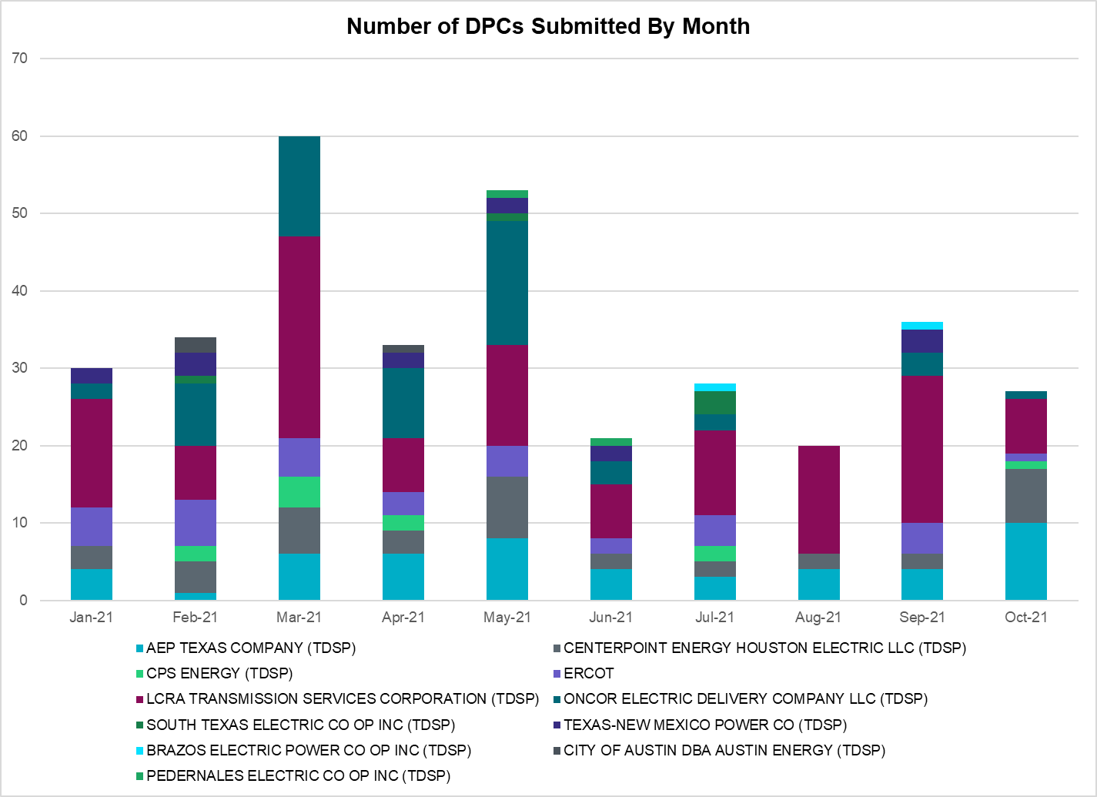

Transmission Operator | Number of DPCs
AEP TEXAS COMPANY (TDSP) | 10
BRAZOS ELECTRIC POWER CO OP INC (TDSP) | 0
BROWNSVILLE PUBLIC UTILITIES BOARD (TDSP) | 0
BRYAN TEXAS UTILITIES (TDSP) | 0
CENTERPOINT ENERGY HOUSTON ELECTRIC LLC (TDSP) | 7
CITY OF AUSTIN DBA AUSTIN ENERGY (TDSP) | 0
CITY OF COLLEGE STATION (TDSP) | 0
CITY OF GARLAND (TDSP) | 0
CPS ENERGY (TDSP) | 1
DENTON MUNICIPAL ELECTRIC (TDSP) | 0
ELECTRIC TRANSMISSION TEXAS LLC (TDSP) | 1
ERCOT | 1
LCRA TRANSMISSION SERVICES CORPORATION (TDSP) | 7
LONE STAR TRANSMISSION LLC (TSP) | 1
ONCOR ELECTRIC DELIVERY COMPANY LLC (TDSP) | 1
PEDERNALES ELECTRIC CO OP INC (TDSP) | 0
RAYBURN COUNTRY CO OP DBA RAYBURN ELECTRIC (TDSP) | 0
SHARYLAND UTILITIES LP (TDSP) | 0
SOUTH TEXAS ELECTRIC CO OP INC (TDSP) | 0
TEXAS MUNICIPAL POWER AGENCY (TDSP) | 3
TEXAS-NEW MEXICO POWER CO (TDSP) | 0

Appendix A: Real-Time Constraints
The following is a complete list of constraints activated in SCED. Full contingency descriptions can be found in the Standard Contingencies List located on the MIS secure site at Grid Generation Reliability Unit Commitment.

Contingency Name | Overloaded Element | From Station | To Station | Count of Days
BASE CASE | NE_LOB | n/a | n/a | 23
SBRAUVA8 | HAMILT_MAVERI1_1 | HAMILTON | MAVERICK | 21
BASE CASE | WESTEX | n/a | n/a | 20
DBIGKEN5 | TREADW_YELWJC1_1 | TREADWEL | YELWJCKT | 18
BASE CASE | PNHNDL | n/a | n/a | 16
SSPUSLT8 | SPUR_69_1 | SPUR | SPUR | 16
SKINFAL8 | FALFUR_PREMON1_1 | FALFUR | PREMONT | 16
DSALKLN5 | 630__B | KLNSW | HHSTH | 16
DCAGCO58 | 656T656_1 | KENDAL | BERGHE | 14
BASE CASE | LGD_SANTIA1_1 | LGD | SANTIAGO | 14
BASE CASE | RV_RH | n/a | n/a | 14
SSPUSLT8 | ROBY_ROTN1_1 | ROBY | ROTN | 13
SSPUSLT8 | ROBY_ROTN1_1 | ROTN | ROBY | 13
SCMNCPS5 | 651__B | CMNSW | CMNTP | 13
SFORYEL8 | HEXT_MASONS1_1 | HEXT | MASONSW | 13
DCRLLSW5 | 590__A | LWSSW | LWVJS | 13
SFORYEL8 | HEXT_MASONS1_1 | MASONSW | HEXT | 13
DGRSPKR5 | 6377__A | BRTSW | ORANS | 11
DJACALV8 | MYRA_VAL_1 | MYRA | VALYVIEW | 11
DMTSCOS5 | 6437__F | SCRCV | KNAPP | 10
SBRAUVA8 | ESCOND_GANSO1_1 | GANSO | ESCONDID | 10
DODEMOS5 | MDSSW_MR1H | MDSSW | MDSSW | 10
MHARNED5 | HAINE__LA_PAL1_1 | LA_PALMA | HAINE_DR | 10
SHAYZOR5 | 388T388_1 | HAYSEN | ZORN | 9
DFLCMDL5 | TALLCITY_TELPR_1 | TELPH_RD | TALLCITY | 9
SFORYEL8 | HEXT_YELWJC1_1 | YELWJCKT | HEXT | 9
SFORYEL8 | HEXT_YELWJC1_1 | HEXT | YELWJCKT | 9
SSPUSLT8 | GIRA_T_SPUR1_1 | GIRA_TAP | SPUR | 8
SSPUSLT8 | GIRA_T_SPUR1_1 | SPUR | GIRA_TAP | 8
SLOBSA25 | NLARSW_PILONC1_1 | NLARSW | PILONCIL | 8
SLOBSA25 | LARDVN_LASCRU1_1 | LARDVNTH | LASCRUCE | 8
SLOBSA25 | NLARSW_PILONC1_1 | PILONCIL | NLARSW | 8
DLONWAR5 | NCARBI_SEADRF1_1 | SEADRFTC | NCARBIDE | 7
SSCLWF28 | OLN_FMR2 | OLN | OLN | 7
BASE CASE | NELRIO | n/a | n/a | 7
DGRSPKR5 | 6376__A | GRMSW | BRTSW | 7
DLONWAR5 | NCARBI_SEADRF1_1 | NCARBIDE | SEADRFTC | 7
BASE CASE | VALEXP | n/a | n/a | 7
DCAGCO58 | 583T583_1 | BANDER | MASOCR | 6
XBOM58 | 6558__B | FSHSW | WFALS | 6
DBIGKEN5 | HAMILT_MAXWEL1_1 | MAXWELL | HAMILTON | 6
DWIRSTA8 | 51T376_1 | FERGUS | GRANMO | 6
SCOLBAL8 | BALLIN_HUMBLT1_1 | BALLINGE | HUMBLTAP | 6
SVICCO28 | COLETO_VICTOR2_1 | COLETO | VICTORIA | 6
DFLCMGS5 | TALLCITY_TELPR_1 | TELPH_RD | TALLCITY | 6
XMDL58 | TALLCITY_TELPR_1 | TELPH_RD | TALLCITY | 6
DGRMGRS8 | 6830__B | CRDSW | OLNEY | 6
SLOLFOR8 | BIGTRE_V_DUPS1_1 | V_DUPSW | BIGTRE | 5
DBIGKEN5 | SAPOWE_TREADW1_1 | SAPOWER | TREADWEL | 5
DCOLFA59 | CALLIC_LON_HI1_1 | LON_HILL | CALLICOA | 5
SN_SLON5 | CELANE_N_SHAR1_1 | N_SHARPE | CELANEBI | 5
DCHBJOR5 | CBYDKR83_A | CBY | DKR | 5
DCOLFA59 | VICTO_WARBU_1A_1 | VICTORIA | WARBURTN | 5
DCAGCI58 | 255T279_1 | PIPECR | MEDILA | 5
SGRSPKR5 | 6040__A | GRSES | PKRSW | 5
SSCLWF28 | 6830__B | CRDSW | OLNEY | 5
SGBYDPW5 | GBYLYD70_A | LYD | GBY | 5
DPKRCPS5 | 6042__A | PKRSW | BNBSW | 4
DGRSLNC5 | 6380__D | PAINTCRE | MURRAY | 4
SN_SLON5 | CELANE_KLEBER1_1 | CELANEBI | KLEBERG | 4
SBRAHAM8 | HAMILT_MAVERI1_1 | HAMILTON | MAVERICK | 4
SCOLBAL8 | SANA_FMR1 | SANA | SANA | 4
SSTAMDL8 | TALLCITY_TELPR_1 | TELPH_RD | TALLCITY | 4
DPHRCTR5 | BCVLY_03_A | BCV | LY | 4
SWRDYN8 | LAN_CT_PAVLOV1_1 | LAN_CTY | PAVLOV | 4
DSTPANS5 | NCARBI_SEADRF1_1 | SEADRFTC | NCARBIDE | 4
SGRILON5 | VICTO_WARBU_1A_1 | VICTORIA | WARBURTN | 4
DCAGCI58 | 656T656_1 | KENDAL | BERGHE | 4
SENSENS8 | TRU_UAT1 | TRU | TRU | 4
DMBDRKC5 | 6042__A | PKRSW | BNBSW | 4
SODLBRA8 | HAMILT_MAVERI1_1 | HAMILTON | MAVERICK | 4
SSCLWF28 | OLN_FMR1 | OLN | OLN | 3
DJACALV8 | SPR_VALY_1 | VALYVIEW | SPR | 3
SLUTVEA8 | 6144__A | BSPRW | STASW | 3
SLOBSA25 | ASHERT_CATARI1_1 | ASHERTON | CATARINA | 3
DWHILON5 | NCARBI_SEADRF1_1 | NCARBIDE | SEADRFTC | 3
DCOLFA59 | NORMAN_PETTUS1_1 | PETTUS | NORMANNA | 3
SMDLMOS5 | 6462__C | MCNSW | MKNGB | 3
DCAGCO58 | BERGHE_AT1H | BERGHE | BERGHE | 3
DCAGCO58 | BERGHE_AT1L | BERGHE | BERGHE | 3
DCOLFA59 | MELONC_RINCON1_1 | RINCON | MELONCRE | 3
DWHILON5 | NCARBI_SEADRF1_1 | SEADRFTC | NCARBIDE | 3
DEVRHLS8 | 6125__C | MSTLT | HMPHL | 3
DWHICOT5 | FARMLAND_LONGD_1 | FARMLAND | W_LD_345 | 3
BASE CASE | N_TO_H | n/a | n/a | 3
DMGSQAL5 | 6144__A | BSPRW | STASW | 3
DODEMOS5 | 6500__B | ODEHV | BTHOT | 3
DSKYCAL5 | CAGNON_MR3H | CAGNON | CAGNON | 3
SWRDYN8 | EL_CAM_LANCTY1_1 | LANCTYPM | EL_CAMPO | 3
SLOBSA25 | FALFUR_PREMON1_1 | FALFUR | PREMONT | 3
DSTPANS5 | MELONC_RINCON1_1 | RINCON | MELONCRE | 3
MCOLGRI5 | NCARBI_SEADRF1_1 | SEADRFTC | NCARBIDE | 3
DWHILON5 | BLESSI_LOLITA1_1 | BLESSING | LOLITA | 3
MCOLGRI5 | CALLIC_LON_HI1_1 | LON_HILL | CALLICOA | 3
DSCOTKW5 | 6215__A | BCKSW | CGRSW | 3
DCAGCI58 | BERGHE_AT1L | BERGHE | BERGHE | 3
SJNWA1P5 | CE_OB_73_A | OB | CE | 3
SLOLFOR8 | GREENL_WEAVER1_1 | WEAVERRD | GREENLK | 3
SBOMJC25 | 6085__E | WFSSW | NSTAR | 3
DKENCA58 | 255T279_1 | PIPECR | MEDILA | 2
SALIKIN8 | FALFUR_PREMON1_1 | FALFUR | PREMONT | 2
SSWCLNC5 | 6025__A | MULBERRY | LNCRK | 2
SGRAFER8 | 654T654_1 | WIRTZ | STARCK | 2
DSTPANS5 | BLESSI_PALACI1_1 | BLESSING | PALACIOS | 2
SLAQLOB8 | BRUNI_69_1 | BRUNI | BRUNI | 2
DBERNAR8 | CORONA_AT4 | CORONA | CORONA | 2
SLAMNAR8 | CORONA_AT4 | CORONA | CORONA | 2
DRILEDI5 | HAMLIN_PLST1_1 | PLST | HAMLIN | 2
DSALKLN5 | 630__C | HHSTH | BLTSW | 2
SLOLFOR8 | BLESSI_PALACI1_1 | BLESSING | PALACIOS | 2
SBLESTP5 | COLETO_VICTOR1_1 | COLETO | VICTORIA | 2
SGRICOL5 | NCARBI_SEADRF1_1 | SEADRFTC | NCARBIDE | 2
DMTFCRS8 | ROC_ROCK_1 | ROCKETT | ROCKETSW | 2
DDL_HOC8 | TM_WAP80_A | WAP | TM | 2
SGRSPK25 | 6041__A | GRSES | PKRSW | 2
DEVRCRT5 | 6435__F | HURST | EULSO | 2
DNB_JOR5 | BCVLY_03_A | BCV | LY | 2
DKENCA58 | BERGHE_AT1H | BERGHE | BERGHE | 2
DZORHAY5 | BERGHE_AT1L | BERGHE | BERGHE | 2
SCOLPAW5 | COLETO_VICTOR1_1 | COLETO | VICTORIA | 2
SBWDDBM5 | LPLMK_LPLNE_1 | LPLMK | LPLNE | 2
XWH2T58 | WHTNY_HT1L | WHTNY | WHTNY | 2
SGRMGRS8 | 6830__B | CRDSW | OLNEY | 2
DSWELNC5 | BLUF_C_MULBER1_1 | BLUF_CRK | MULBERRY | 2
MCOLGRI5 | MELONC_RINCON1_1 | RINCON | MELONCRE | 2
DCOLFA59 | NCARBI_SEADRF1_1 | SEADRFTC | NCARBIDE | 2
DMTFCRS8 | ROC_ROCK_1 | ROCKETSW | ROCKETT | 2
DSWETKW5 | 6036__A | TKWSW | MGSES | 2
DCPSMBD5 | 6042__A | PKRSW | BNBSW | 2
SCMNCPS5 | 651__C | CMNTP | SHILO | 2
DKENCA58 | BERGHE_AT1L | BERGHE | BERGHE | 2
DWHILON5 | BLESSI_PALACI1_1 | BLESSING | PALACIOS | 2
DREFSTP5 | BLESSI_PAVLOV1_1 | BLESSING | PAVLOV | 2
DDAVGB25 | GBYLYD70_A | LYD | GBY | 2
DSALHUT5 | 270__A | KNBSW | TMPSW | 2
DCAGCI58 | 460T460_1 | MEDILA | W1 | 2
DODEMOS5 | 6350__A | RXALL | GNTSW | 2
SRICGRS8 | 6840__B | NVKSW | ANARN | 2
SRDODES8 | 940__C | ENWSW | WXHCH | 2
SMDOOAS5 | BCVLY_03_A | BCV | LY | 2
DMTFCRS8 | TRU_UAT1 | TRU | TRU | 2
DVLYANA5 | 1580__B | PNKHL | PAYNE | 2
DKENCA58 | 656T656_1 | KENDAL | BERGHE | 2
DEAB_WR8 | BLESSI_PAVLOV1_1 | PAVLOV | BLESSING | 2
DSTPRED5 | BLESSI_PAVLOV1_1 | BLESSING | PAVLOV | 2
BASE CASE | EASTEX | n/a | n/a | 2
DBIGKEN5 | HAMILT_MAVERI1_1 | HAMILTON | MAVERICK | 2
DODEMOS5 | ODEHV_MR2H | ODEHV | ODEHV | 2
DVLYANA5 | VLSES_MR1H | VLSES | VLSES | 2
DAUSLOS5 | 197T171_1 | GIDEON | AUSTRO | 2
DMGSBTR5 | 6036__A | TKWSW | MGSES | 2
DCAGCO58 | 654T654_1 | WIRTZ | STARCK | 2
DCAGCI58 | BERGHE_AT1H | BERGHE | BERGHE | 2
SLOBSA25 | BRUNI_69_1 | BRUNI | BRUNI | 2
SWIRFE28 | 51T376_1 | FERGUS | GRANMO | 2
DMLSTYG5 | 1775__C | TYLNE | DLPOI | 1
DBEEPAL8 | 415T415_1 | MILLER | HENLY | 1
DBAKSOL5 | 442T442_1 | LCRANE | ARCO__ | 1
DGRSPKR5 | 6085__E | WFSSW | NSTAR | 1
S127STA8 | 6620__A | STASW | MRCAP | 1
SZEPCMN8 | 670__C | CMPBW | BRNSO | 1
SHAYZO25 | 6T227_1 | HAYSEN | ZORN | 1
DCOLFA59 | CALLIC_HAISLE1_1 | CALLICOA | HAISLEY | 1
SGRICOL5 | CALLIC_HAISLE1_1 | CALLICOA | HAISLEY | 1
SVICCO28 | CALLIC_LON_HI1_1 | LON_HILL | CALLICOA | 1
SODLBRA8 | ESCOND_GANSO1_1 | GANSO | ESCONDID | 1
SN_SAJO5 | HAINE__LA_PAL1_1 | LA_PALMA | HAINE_DR | 1
SN_SLON5 | KINGSV_KLEBER1_1 | KLEBERG | KINGSVIL | 1
SMV_RI28 | LAUREL_MARCON1_1 | MARCONI | LAURELES | 1
SPLUFLA8 | MAGRUD_VICTOR2_1 | VICTORIA | MAGRUDER | 1
SBRAUVA8 | SANTIA_SAPOWE1_1 | SANTIAGO | SAPOWER | 1
SCRNLC38 | TALLCITY_TELPR_1 | TELPH_RD | TALLCITY | 1
SENSEN28 | 940__C | ENWSW | WXHCH | 1
XCBY58 | CBY_AT3 | CBY | CBY | 1
SCOLPAW5 | COLETO_ROSATA1_1 | COLETO | ROSATA | 1
DMELRIN8 | COLETO_VICTOR1_1 | COLETO | VICTORIA | 1
SBGLTWI8 | CONCHO_SAMATH1_1 | CONCHO | SAMATHIS | 1
SEBALAM8 | CORONA_AT4 | CORONA | CORONA | 1
SCOLBAL8 | DRSY_SANA_T1_1 | SANA_TAP | DRSY | 1
SESPK8 | DT_PK_91_A | DT | PK | 1
SI_DI_48 | I_DUPP_I_DUPS2_1 | I_DUPP1 | I_DUPSW | 1
DMOLLO58 | MELONC_RINCON1_1 | RINCON | MELONCRE | 1
DCOLFA59 | MELONC_SEADRF1_1 | MELONCRE | SEADRFTC | 1
SSTABS18 | 6144__A | BSPRW | STASW | 1
DWLFMOS5 | 6350__A | RXALL | GNTSW | 1
DSALKLN5 | 641__A | KLNSW | STAGE | 1
DCPSST58 | 651__B | CMNSW | CMNTP | 1
DCAGCI58 | 654T654_1 | WIRTZ | STARCK | 1
DFERGRM8 | 654T654_1 | WIRTZ | STARCK | 1
SSCLWF28 | 6855_D_1 | SMR | SMRTP | 1
BASE CASE | 942__A | ETCCS | ENWSW | 1
SCBEDYN8 | BLESSI_PAVLOV1_1 | BLESSING | PAVLOV | 1
DBIGKEN5 | COMSTO_CORRAL1_1 | CORRAL | COMSTOCK | 1
DCHBJOR5 | DKREXN83_A | DKR | EXN | 1
DTWIDIV5 | HARGRO_TWINBU1_1 | TWINBU | HARGROVE | 1
DWHILON5 | MELONC_SEADRF1_1 | MELONCRE | SEADRFTC | 1
SL_4RAY8 | RAYBURN_69_2 | RAYBURN | RAYBURN | 1
DRNS_TB5 | THWZEN98_A | ZEN | THW | 1
DFERSTA8 | 33T218_1 | WIRTZ | BURNET | 1
DFER_WI8 | 55T207_1 | GILLES | WOLFCR | 1
SFTWW_D8 | 589_C_1 | CRLNW | LWSVS | 1
DCRLLSW5 | 590__B | LWVJS | LKPNT | 1
DRILEDI5 | 6025__A | MULBERRY | LNCRK | 1
DMTSCOS5 | 6240__C | SACRC | DPCRK | 1
DSALKLN5 | 630__A | BLTSW | BLTON | 1
SLAKMA28 | 654T654_1 | WIRTZ | STARCK | 1
BASE CASE | BEARKT | n/a | n/a | 1
SOWLBIG8 | BISON_STRS1_1 | BISON | STRS | 1
SCARFRI8 | HARGRO_TWINBU1_1 | TWINBU | HARGROVE | 1
DDUPHE18 | I_DUPS_MCCAMP2_1 | I_DUPSW | MCCAMPBE | 1
SBRAUVA8 | MAXWEL_WHITIN1_1 | MAXWELL | WHITING | 1
DLONWAR5 | MELONC_SEADRF1_1 | MELONCRE | SEADRFTC | 1
DELMSAN5 | PAWNEE_SPRUCE_1 | CALAVERS | PAWNEE | 1
SCARFRI8 | SANTIA_SAPOWE1_1 | SANTIAGO | SAPOWER | 1
DNORSD85 | 3150__A | OKCLS | CDCSW | 1
DHKBNOR5 | 710__A | CRLNW | NLSES | 1
SBRLBRL8 | 800__E | CMBSW | GODLY | 1
SRDODES8 | 940__F | WXHCH | WXNTH | 1
SMGIENW8 | 943__A | ENWSW | ENSSW | 1
SWRDYN8 | BLESSI_PAVLOV1_1 | PAVLOV | BLESSING | 1
XBOM358 | BOMSW_MR1H | BOMSW | BOMSW | 1
SBRAHAM8 | ESCOND_GANSO1_1 | GANSO | ESCONDID | 1
SSTRBES8 | FALFUR_PREMON1_1 | FALFUR | PREMONT | 1
SDICFR28 | G138_8B_1 | HDNLAKES | LEAGCITY | 1
SMCEABS8 | HAMLIN_PLST1_1 | PLST | HAMLIN | 1
SCOLPAW5 | MAGRUD_VICTOR2_1 | VICTORIA | MAGRUDER | 1
SGRICOL5 | MELONC_SEADRF1_1 | MELONCRE | SEADRFTC | 1
SGDNTEL5 | 6094__D | ANDNR | EXMTP | 1
DLNCSWE5 | 6380__D | PAINTCRE | MURRAY | 1
XGRS58 | 6635__G | ESTLD | MRVLY | 1
SCAGKEN5 | BERGHE_AT1H | BERGHE | BERGHE | 1
DCD_CBY8 | BT_CBY88_A | CBY | BT | 1
DEAB_WR8 | EL_CAM_LANCTY1_1 | LANCTYPM | EL_CAMPO | 1
DBIGKEN5 | FRIR_ROCKSP1_1 | FRIR | ROCKSPRS | 1
SBRAUVA8 | GANSO_MAVERI1_1 | MAVERICK | GANSO | 1
SCRNJFS8 | GBYGP_17_A | GBY | GP | 1
BASE CASE | MAXWEL_WHITIN1_1 | MAXWELL | WHITING | 1
BASE CASE | MCADO_SPUR_1A_1 | MWEC | SPUR | 1
SN_SLON5 | N_SHARPE_PS3 | N_SHARPE | N_SHARPE | 1
SBIGSCH5 | SANTIA_SAPOWE1_1 | SANTIAGO | SAPOWER | 1
DRNS_TB5 | THWZEN71_A | ZEN | THW | 1
DBAKSOL5 | 421T441_1 | LCRANE | CRANEA | 1
DLNCGRS5 | 6380__D | PAINTCRE | MURRAY | 1
SSCLWF28 | 6840__B | NVKSW | ANARN | 1
DMCOPHA8 | AZTECA_HEC1_1 | HEC | AZTECA | 1
DSTPANS5 | BLESSI_LOLITA1_1 | BLESSING | LOLITA | 1
SGRICOL5 | CALLIC_LON_HI1_1 | LON_HILL | CALLICOA | 1
SGRILON5 | CALLIC_LON_HI1_1 | LON_HILL | CALLICOA | 1
DWIRSTA8 | CORONA_AT4 | CORONA | CORONA | 1
DBAKSOL5 | CROSSO_NORTMC1_1 | NORTMC | CROSSOVE | 1
SFTLMES8 | CROSSO_NORTMC1_1 | NORTMC | CROSSOVE | 1
SLAQLOB8 | FALFUR_PREMON1_1 | FALFUR | PREMONT | 1
XLA2_89 | HAINE__LA_PAL1_1 | LA_PALMA | HAINE_DR | 1
DMCEBUT8 | HAMLIN_PLST1_1 | PLST | HAMLIN | 1
DBIGKEN5 | HEXT_MASONS1_1 | HEXT | MASONSW | 1
DLONWAR5 | MELONC_RINCON1_1 | RINCON | MELONCRE | 1
SMV_RI28 | P_ISAB_SCARBI1_1 | SCARBIDE | P_ISABEL | 1
SSANFOW5 | SNMIG_AEPCHKCN_1 | SANMIGL | CHOKCNYN | 1
DAUSLOS5 | 190T152_1 | WINCHES | GIDEON | 1
DNAVLEG5 | 50__A | BBSES | JEWET | 1
DSTABUF8 | 6144__A | STASW | BSPRW | 1
DCRLNO25 | 710__A | CRLNW | NLSES | 1
DWHILON5 | COLETO_VICTOR1_1 | COLETO | VICTORIA | 1
DVICVI89 | COLETO_VICTOR2_1 | COLETO | VICTORIA | 1
SSANFOW5 | COTULA_COTULL1_1 | COTULLA | COTULAS | 1
SSANFOW5 | COTULL_REVEIL1_1 | REVEILLE | COTULLA | 1
DBIGKEN5 | FORTMA_YELWJC1_1 | YELWJCKT | FORTMA | 1
SPOMNED5 | FREER_LOBO1_1 | LOBO | FREER | 1
XMDO58 | G138_8B_1 | HDNLAKES | LEAGCITY | 1
SHOLWES8 | HOLLY4_SOUTH_1_1 | HOLLY4 | SOUTH_SI | 1
SCOMHA38 | MAXWEL_WHITIN1_1 | MAXWELL | WHITING | 1
BASE CASE | MCCAMY | n/a | n/a | 1
SGRICOL5 | MELONC_RINCON1_1 | RINCON | MELONCRE | 1
DSTPANS5 | MELONC_SEADRF1_1 | MELONCRE | SEADRFTC | 1

Current Wind Generation Record: 23,657 MW on 10/12/2021 at 21:14 | Current Wind Penetration Record: 66.47% on 03/22/2021 at 00:46 Current Solar Generation Record: 7,077 MW on 10/16/2021 at 15:29 | Current Solar Penetration Record: 19.01% on 10/30/2021 at 10:29
This is the hourly integrated peak demand as published in the ERCOT D&E report.
All DC Tie Curtailments are posted publicly on the ERCOT Market Information System. See that posting for additional details for the event(s) in question.
See DC Tie Operating Procedure (http://www.ercot.com/mktrules/guides/procedures) for more details.

