System Planning
Monthly Status Report

Report Highlights

- ERCOT is currently reviewing proposed transmission improvements with a total estimated cost of $1,401.96 million as of October 31, 2021.
- Transmission Projects endorsed in 2021 total $1,014.4 million as of October 31, 2021.
- All projects (in engineering, routing, licensing, and construction) total approximately $8.00 billion as of October 1, 2021.
- Transmission Projects energized in 2021 total about $1.438 billion as of Oct 1, 2021.

Regional Planning Group Reviews
RPG Projects under Review:
- Oncor has submitted the Nacogdoches Southeast Switch – Redland Switch – Lufkin Switch 345-kV Loop Project (RPG Project ID: 20RPG019). This is a Tier 2 project that is estimated to cost $71.26 million. This project is currently under ERCOT’s independent review.
- AEPSC has submitted the Port Lavaca Area Improvement Project (RPG Project ID: 21RPG002). This is a Tier 2 project that is estimated to cost $97.8 million. ERCOT has completed the independent review and the recommended project is classified as a Tier 1 project that is estimated to cost $101.5 million. TAC voted unanimously to endorse the project on September 29. The ERCOT Board of Directors endorsed the project on October 22.
- Oncor has submitted the Flat Iron – Barr Ranch – Pegasus South 138-kV Line Project (RPG Project ID: 21RPG010). This is a Tier 2 project that is estimated to cost $50.7 million. This project is currently under ERCOT’s independent review.
- ERCOT has submitted the Lower Rio Grande Valley System Enhancement Project (RPG Project ID: 21RPG017). This is a Tier 1 project that is estimated to cost $1.28 billion. This project is currently under ERCOT’s independent review.

RPG Project Reviews Completed in 2021:
RPG Project ID | RPG Project Name | Submitted Entity | Tier | Estimated Cost  ($ Millions) | Review Completion Month
20RPG022 | Hamilton Road to Maxwell 138-kV Line Rebuild Project | AEPSC | Tier 3 | 34.0 | January
20RPG023 | Royse - Commerce 69-kV Line Conversion to 138-kV | Oncor | Tier 3 | 72.1 | January
1RPG003 | Midland East Area Projects | Oncor | Tier 3 | 88.5 | March
21RPG004 | Venus Switch-Cedar Hill Switch 345-kV Line Project | Oncor | Tier 3 | 10.3 | March
21RPG005 | Angleton to West Columbia 138-kV ckt 04 Rebuild Project | CNP | Reclassified from Tier 3 to Tier 4 per Protocol | 38.7 | April
21RPG006 | Algoa Corner to La Marque 138 138-kV ckt 93 Rebuild Project | CNP | Reclassified from Tier 3 to Tier 4 per Protocol | 34.56 | May
21RPG007 | Holliday - Seymour 69-kV Line Project | Oncor | Reclassified from Tier 3 to Tier 4 per Protocol | 44.3 | May
21RPG008 | Burnett – Bowie 69-kV Line Upgrade Project | Oncor | Tier 3 | 79.7 | June
21RPG009 | Waterfowl Substation Addition | CNP | Tier 3 | 42.4 | June
21RPG001 | Bakersfield to Big Hill 345‐kV Second Circuit Addition Project | STEC & LCRA TSC | Tier 2 | 83.2 | June
21RPG011 | Flewellen to Peters 138-kV ckt 25 Rebuild | CNP | Tier 3 | 76.2 | July
21RPG012 | Andrews North – Mustang – Paul Davis Tap 138-kV Line Section | Oncor | Reclassified from Tier 3 to Tier 4 per Protocol | 37 | August
21RPG013 | WA Parish to Nash 138-kV Ckt 02 Rebuild Project | CNP | Reclassified from Tier 3 to Tier 4 per Protocol | 71.75 | September
21RPG014 | Mason Switch to Yellowjacket 69-kV Line Transmission Project | AEPSC | Reclassified from Tier 3 to Tier 4 per Protocol | 36.9 | September
21RPG015 | Munday to Throckmorton 69-kV and Albany to Throckmorton 69-kV Line Rebuild Project | AEPSC | Reclassified from Tier 3 to Tier 4 per Protocol | 83.4 | September
21RPG016 | TH Wharton - White Oak 138-kV Conversion Project | CNP | Reclassified from Tier 3 to Tier 4 per Protocol | 79.9 | September
21RPG002 | Port Lavaca Area Improvement Project | AEPSC | Tier 1 | 101.5 | October

More information on current and past RPG projects can be found on the ERCOT MIS Secure (digital certificate required): https://mis.ercot.com/public/data-products/grid/regional-planning
Past email communication on RPG projects can be found on the ERCOT listserv by signing up for the REGPLANGROUP list: http://lists.ercot.com/scripts/wa-ERCOT.exe?A0=REGPLANGROUP

Planning Model Activities
The short-term calendar of major planning model events is as follows:
- By March 1, 2022 21SSWG Update 2 cases, in PSS/E 35, and TPIT are posted
- By March 15, 2022 21SSWG Contingency definitions & Planning Data Dictionary are posted
The following table shows interconnection projects that met Planning Guide section 6.9(1) and 6.9(2) and were modeled in the SSWG cases as a full model or as a simple model in accordance with Planning Guide section 6.9.
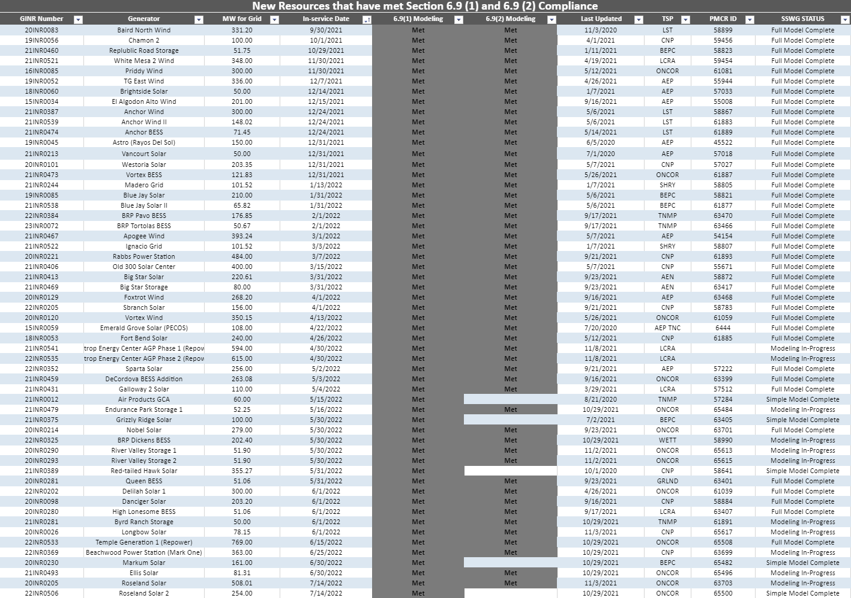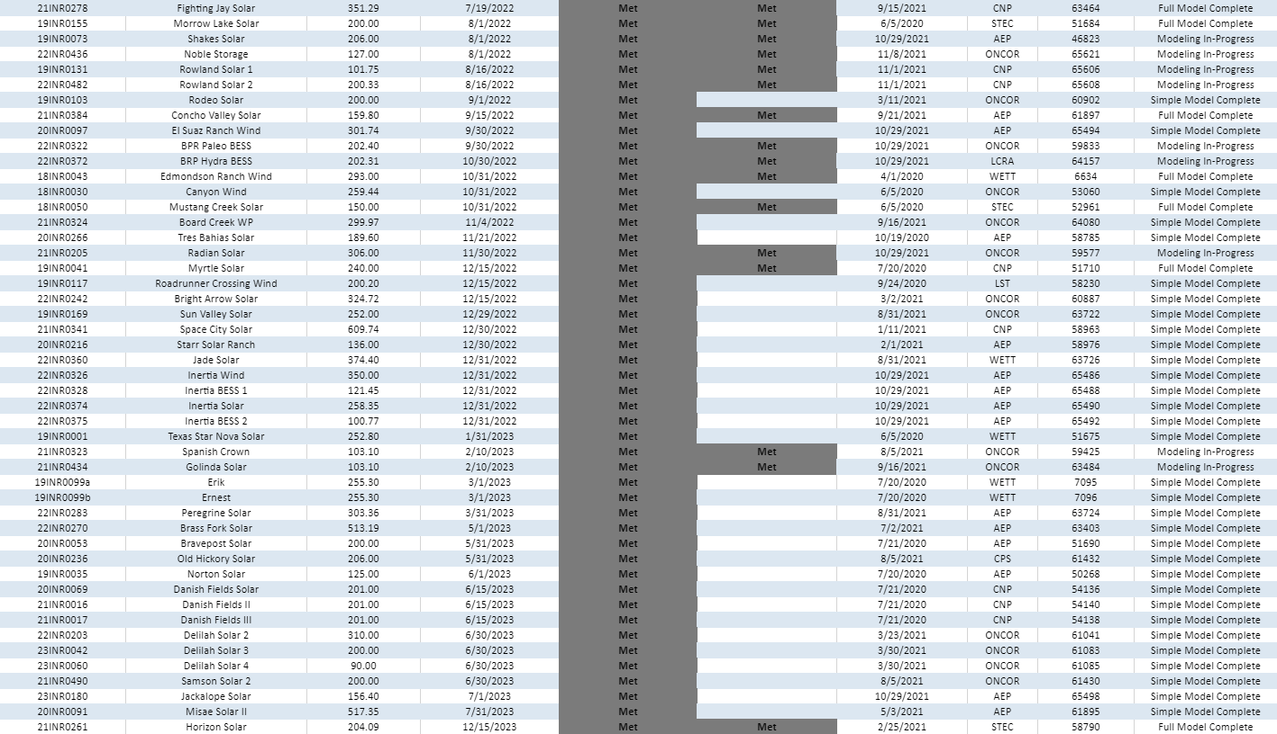

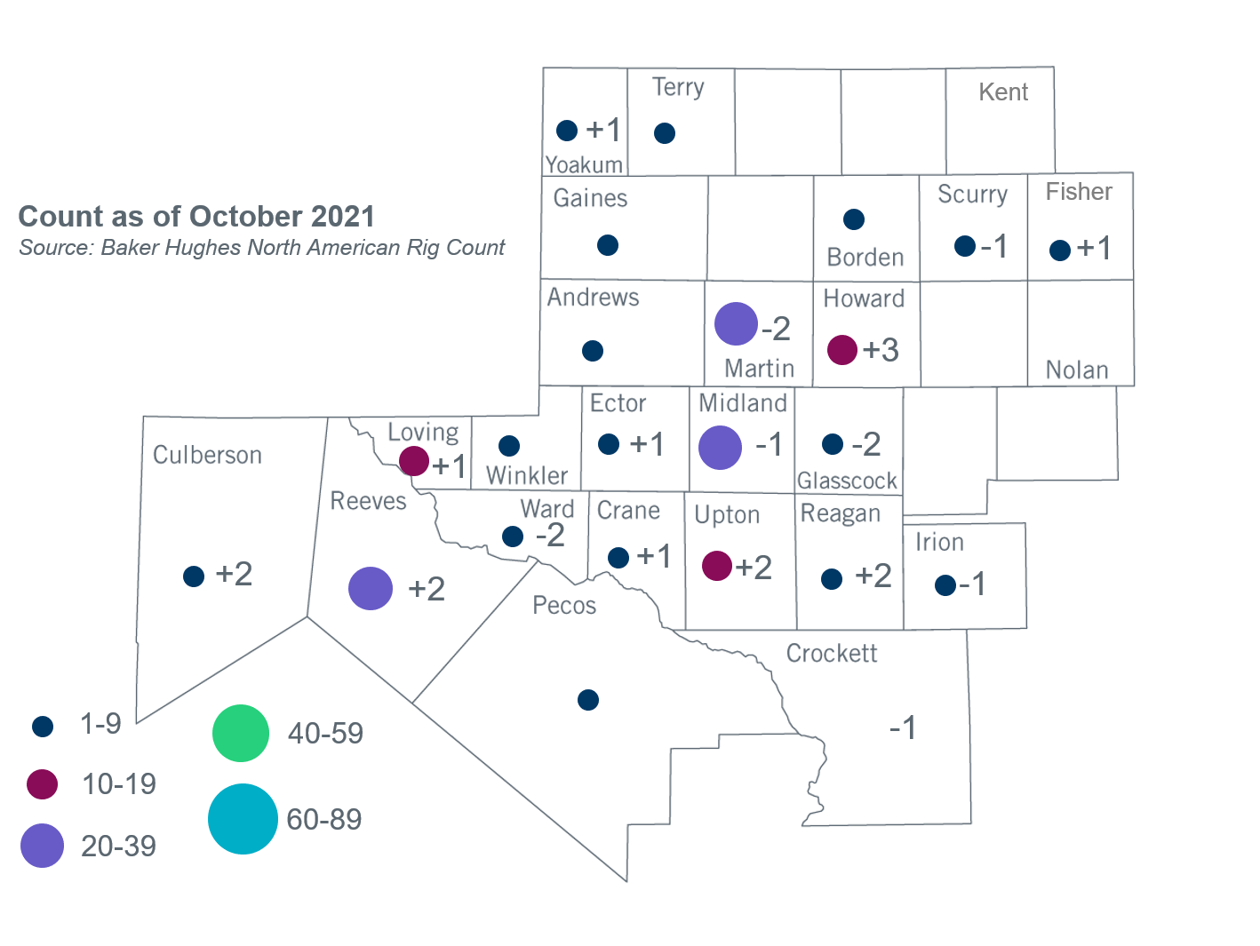

Permian Basin Oil Rig Count
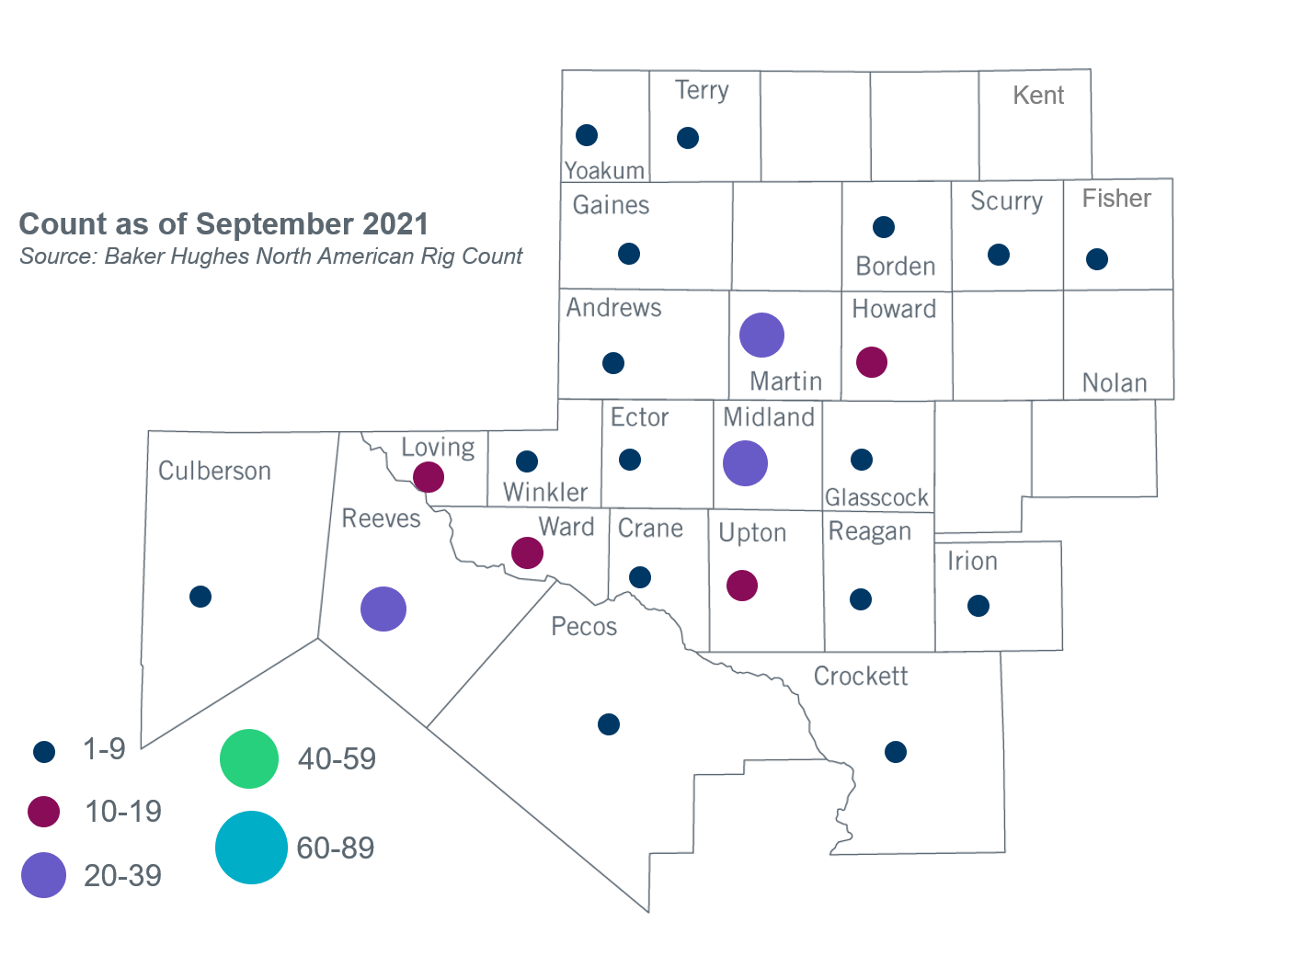

Other Notable Activities
- ERCOT presented a proposal for steady-state voltage performance criteria for the benchmark and supplemental Geomagnetic Disturbance Vulnerability Assessments (GMDVA) at the October Regional Planning Group (RPG) meeting. ERCOT will seek Technical Advisory Committee (TAC) approval of the proposed criteria at the November meeting.
- ERCOT presented final results for the GMDVA at the October RPG meeting.
- ERCOT provided an update on the 2022 Long-Term System Assessment (LTSA) at the October RPG meeting.
- ERCOT is conducting the West Texas Export Study and plans to complete the study in Q4, 2021.
- ERCOT presented the results of the Permian Basin Load Integration Study at the October 2021 RPG meeting and plans to publish a final report in Q4, 2021.

Based on the Total Project Estimated Cost for all future projects listed in the Transmission Project Information and Tracking (TPIT) report. TPIT is updated three times each year based on information TSPs provide in Model on Demand (MOD) as specified in the ERCOT Steady State Working Group Procedure Manual. The latest TPIT is available at http://www.ercot.com/gridinfo/planning.
Based on the Total Project Estimated Cost for all completed projects with Projected In-Service Dates in 2021 listed in the TPIT.
+/- symbol indicates the increase or decrease from the previous month in oil rigs present in each county. There are 183 rigs, including an increase of 6 oil rigs, in the Permian Basin from September to October 2021.

