PWG Meeting Notes – September 15, 2021
Via WebEx 9:30 AM
Attendees:

Sam Pak - Oncor | Calvin Opheim - ERCOT | John Schatz – Vistra | Mansoor Khanmohamed - EDF
Sheri Wiegand - TXUE | Eric Broach - Gexa | Nicholas Jowlobar - RWE
Kathy Scott - CNP | Jordan Troublefield – ERCOT | Eric Lotter – Grid Monitor
Randy Roberts - ERCOT | Jim Lee – AEP | Andrea Couch – TNMP
Amar Khalifeh - ERCOT | Angela Ghormley – Calpine | Diana Rehfeldt - TNMP

- Meeting notes for July 14th were reviewed and approved

- Annual Validation Status
  - ERCOT stated as 2021 RES/BUS AVs are complete as of 9/13
  - ERCOT will provide an update to the Progress Report Task List Matrix to PWG leadership as an update to PWG’s update to RMS

- Converting Appendix D, Profile Decision Tree, in Load Profiling Guide from Excel to Word Format
  - ERCOT gauged interest on potentially converting LPG Appendix D from Excel to Word format
  - Conversion will help with tracking changes and “find” keyword function
  - Updates such as ERCOT email addresses within Appendix D and additional clean up efforts were suggested
  - There was support and consensus to move forward. Jordan mentioned it efforts could begin later this year or early next

- Reviewed Protocol 18.5.1, ERCOT Responsibilities, related to adding language for ERCOT’s discretion in adjusting NIDR Backcasted Load Profiles in the event of prolonged widespread power outages
  - Example: Market Notice M-A030821-01 Adjustment to NIDR Backcasted Load Profiles for Operating Days February 15, 2021 through February 18, 2021
  - Review suggested language additions in future NPRR
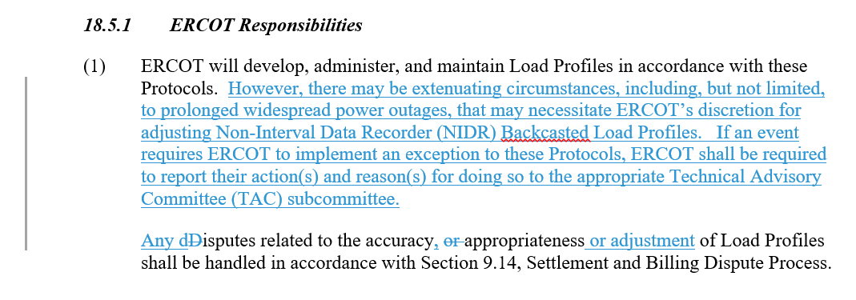
- Reviewed ERCOT’s preliminary analysis of remaining BUSIDRRQ load post Feb 2022 implementation of LPGRR068, Add BUSLRG and BUSLRGDG profiles
  - TDSPs provided ERCOT a list of ESIs to remain on BUSIDRRQ profile post Feb 2022 (EPS meters were not included). With this data, ERCOT estimated overall remaining BUSIDRRQ load to be around 10% of overall market load. The majority of the 10% was transmission vs distribution load which brings into question whether the need to revise ERCOT estimation methodologies are needed given transmission load may not be subject to load shed.
  - Analysis and data will be presented and discussed at October 13th AMS IDR Workshop for further discussion

- AMS IDR Workshop for Oct 13th
  - Outline of topics and subject matter was discussed and reviewed

- October 13th PWG afternoon meeting will be tentatively based on Oct 13th AMS IDR Workshop

