September 2021 ERCOT Monthly Operations Report
Reliability and Operations Subcommittee Meeting
November 04, 2021

Table of Contents
1. Report Highlights 2
2. Frequency Control 3
2.1. Frequency Events 3
2.2. Responsive Reserve Events 4
2.3. Load Resource Events 4
3. Reliability Unit Commitment 4
4. IRR, Wind, and Solar Generation as a Percent of Load 7
5. Largest Net-Load Ramp 8
6. COP Error Analysis 8
7. Congestion Analysis 11
7.1. Notable Constraints 11
7.2. Generic Transmission Constraint Congestion 14
7.3. Manual Overrides 14
7.4. Congestion Costs for Calendar Year 2021 14
8. System Events 15
8.1. ERCOT Peak Load 15
8.2. Load Shed Events 15
8.3. Stability Events 16
8.4. Notable PMU Events 16
8.5. DC Tie Curtailment 16
8.6. TRE/DOE Reportable Events 16
8.7. New/Updated Constraint Management Plans 16
8.8. New/Modified/Removed RAS 16
8.9. New Procedures/Forms/Operating Bulletins 16
9. Emergency Conditions 17
9.1. OCNs 17
9.2. Advisories 17
9.3. Watches 17
9.4. Emergency Notices 17
10. Application Performance 17
10.1. TSAT/VSAT Performance Issues 17
10.2. Communication Issues 17
10.3. Market System Issues 17
11. Model Updates 17
Appendix A: Real-Time Constraints 20

Report Highlights
- The unofficial ERCOT peak load was 72,339 MW.
- There were 6 frequency events.
- There were 4 instances where Responsive Reserves were deployed.
- There were 78 HRUC commitments.
- There were 10 days of congestion on the West Texas Export GTC, 12 days on the Panhandle GTC, 20 days on the North Edinburg to Lobo GTC, 17 days on the Raymondville to Rio Hondo, 9 days on the Nelson Sharpe to Rio Hondo GTC, 1 day on the Valley Export GTC, 1 day on Bearkat GTC, and 3 days on the North to Houston GTC. There was no activity on the remaining GTCs during the month.

Frequency Control

Frequency Events
The ERCOT Interconnection experienced 6 frequency events, which resulted from unit’s trips. The average event duration was 00:04:57.

A summary of the frequency events is provided below. The reported frequency events meet one of the following criteria: Delta Frequency is 60 mHz or greater; the MW loss is 350 MW or greater; resource trip event triggered RRS deployment. Frequency events that have been identified as Frequency Measurable Events (FME) for purposes of BAL-001-TRE-1 analysis are highlighted in blue. When analyzing frequency events, ERCOT evaluates PMU data according to industry standards. Events with an oscillating frequency of less than 1 Hz are inter-area, while higher frequencies indicate local events. Industry standards specify that damping ratio for inter-area oscillations should be 3.0% or greater. For the frequency events listed below, the ERCOT system met these standards and transitioned well after each disturbance.

Date and Time | Delta Frequency | Max/Min Frequency | Duration of Event | PMU Data |  | MW Loss | Load | IRR | Inertia
 | (Hz) | (Hz) |  | Oscillation Mode (Hz) | Damping Ratio |  | (MW) | % | (GW-s)
9/3/2021 2:49:15 | 0.105 | 59.911 | 00:09:23 | 0.105 | 16% | 601.2 | 46,466 | 30% | 274,833
9/9/2021 17:11:20 | 0.070 | 59.908 | 00:04:21 | 0.07 | 13% | 493.23 | 67,528 | 15% | 348,192
9/12/2021 23:17:44 | 0.178 | 59.832 | 00:03:56 | 0.178 | 10% | 847.46 | 47,800 | 29% | 233,712
9/14/2021 7:55:50 | 0.080 | 59.938 | 00:06:10 | 0.08 | 5% | 398.55 | 39,535 | 24% | 263,820
9/22/2021 9:15:10 | 0.088 | 59.891 | 00:02:44 | 0.088 | 16% | 604.49 | 41,615 | 27% | 263,433
9/25/2021 15:39:15 | 0.103 | 59.903 | 00:03:06 | 0.103 | 10% | 498.53 | 55,498 | 18% | 295,724

(Note: All data on this graph encompasses frequency event analysis based on BAL-001-TRE-1.)

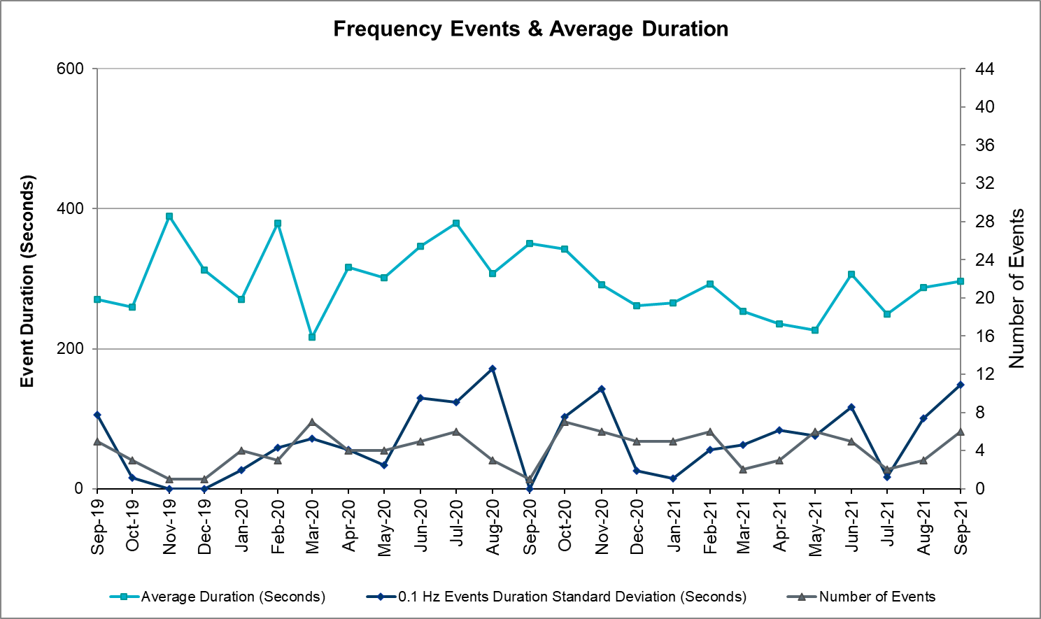

Responsive Reserve Events
There were 4 events where Responsive Reserve MWs were released to SCED. The events highlighted in blue were related to frequency events reported in Section 2.1 above.

Date and Time Released to SCED | Date and Time Recalled | Duration of Event | Maximum MWs Released | Comments
9/9/2021 17:11:20 | 9/9/2021 17:18:04 | 00:06:44 | 644
9/12/2021 23:17:44 | 9/12/2021 23:21:28 | 00:03:44 | 1187
9/22/2021 9:15:10 | 9/22/2021 9:17:54 | 00:02:44 | 359
9/25/2021 15:39:15 | 9/25/2021 15:42:07 | 00:02:52 | 374

Load Resource Events
None

Reliability Unit Commitment
ERCOT reports on Reliability Unit Commitments (RUC) on a monthly basis. Commitments are reported grouped by operating day and weather zone. The total number of hours committed is the sum of the hours for all the units in the specified region. Additional information on RUC commitments can be found on the MIS secure site at Grid Generation Reliability Unit Commitment.

There were no DRUC commitments.

There were 78 HRUC commitments
Resource Location | # of Resources | Operating Day | Total # of Hours Committed | Total MWhs | Reason for Commitment
EAST, NORTH_CENTRAL, SOUTH_CENTRAL | 5 | September 2, 2021 | 39 | 8,760.0 | System Capacity
EAST, NORTH_CENTRAL, SOUTH_CENTRAL | 6 | September 5, 2021 | 26 | 4,744.0 | System Capacity
NORTH_CENTRAL | 4 | September 6, 2021 | 30 | 3,180.0 | Minimum Run Time, System Capacity
NORTH_CENTRAL | 6 | September 7, 2021 | 50 | 6,259.0 | Minimum Run Time, System Capacity
EAST, NORTH_CENTRAL | 5 | September 8, 2021 | 54 | 7,120.0 | Minimum Run Time, System Capacity
NORTH_CENTRAL | 2 | September 9, 2021 | 28 | 5,636.0 | Minimum Run Time, System Capacity
COAST, EAST, NORTH_CENTRAL | 4 | September 12, 2021 | 25 | 5,266.0 | System Capacity
COAST, SOUTHERN | 4 | September 14, 2021 | 20 | 7,970.0 | System Capacity
EAST, NORTH_CENTRAL | 2 | September 16, 2021 | 8 | 2,512.0 | System Capacity
NORTH_CENTRAL, SOUTH_CENTRAL | 4 | September 17, 2021 | 20 | 1,948.0 | System Capacity
EAST, NORTH_CENTRAL, SOUTH_CENTRAL | 6 | September 18, 2021 | 36 | 4,941.0 | System Capacity
EAST, NORTH_CENTRAL | 3 | September 19, 2021 | 13 | 774.5 | System Capacity
COAST, EAST, NORTH_CENTRAL | 4 | September 20, 2021 | 21 | 4,031.5 | System Capacity
COAST, NORTH_CENTRAL, SOUTH_CENTRAL | 9 | September 21, 2021 | 55 | 10,658.0 | N TO H, West TX Base Case
COAST, NORTH | 4 | September 27, 2021 | 18 | 1,905.0 | System Capacity
SOUTHERN | 1 | September 28, 2021 | 7 | 2,118.0 | DHIWARC8
NORTH_CENTRAL | 1 | September 29, 2021 | 3 | 1,305.0 | System Capacity
NORTH_CENTRAL, SOUTH_CENTRAL, SOUTHERN | 7 | September 30, 2021 | 44 | 15,440.0 | Commit, System Capacity

IRR, Wind, and Solar Generation as a Percent of Load
Graph below shows the maximum, minimum and average aggregate solar, wind and IRR output as a percentage of total ERCOT load when evaluated as 10-minute averaged intervals, over the past 13 months. Current wind, solar generation and penetration records are listed in the footnote below. Maximum IRR penetration for the month was 49.5% on September 24, 2021 interval ending 02:10 and minimum IRR penetration for the month was 4.5% on September 22, 2021 interval ending 19:30.

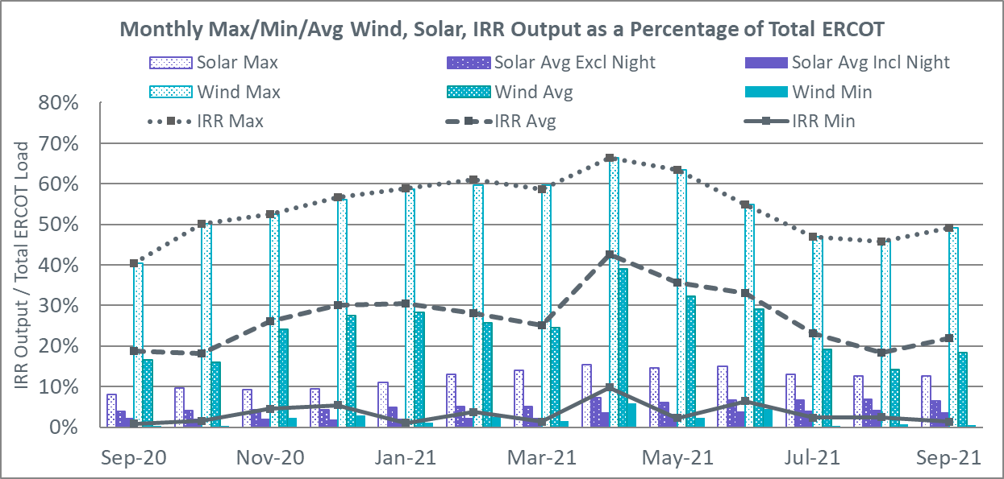

During the hour of peak load for the month, hourly integrated wind generation was 11,826 MW and solar generation was 5,358 MW. Graph below shows the wind and solar penetration percentage during the hour of the peak load in the last 13 months.

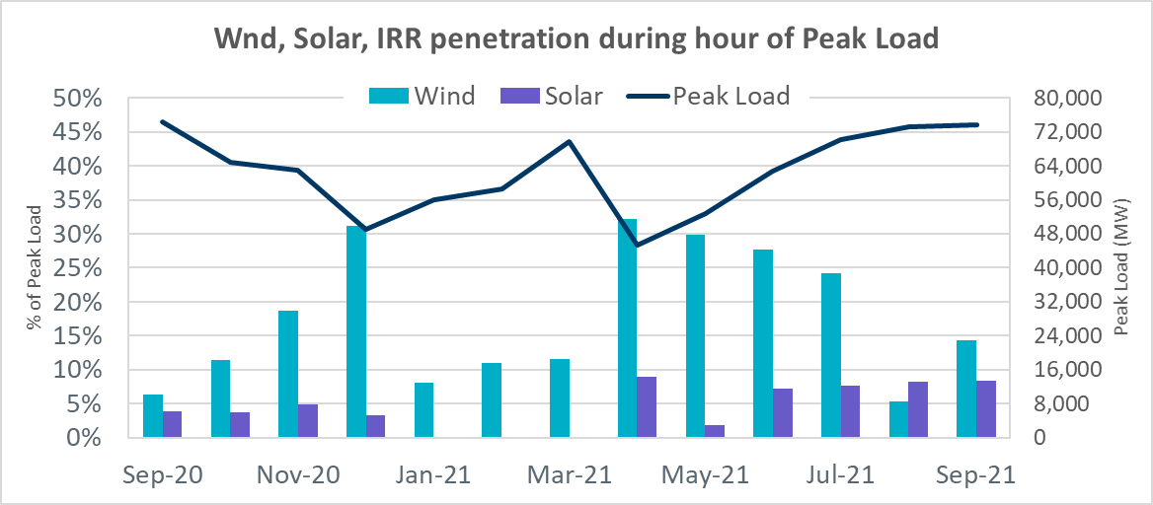

Lastly, the graph below shows the minimum wind, solar and IRR output during the peak load hour as a percentage of the daily peak load for every day in the month.

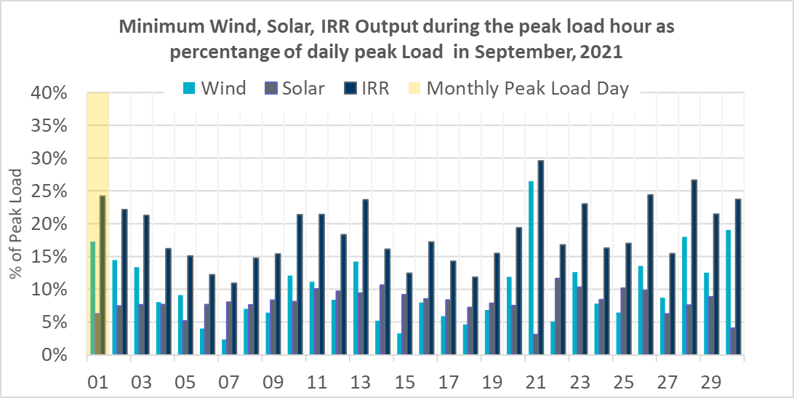

Largest Net-Load Ramp
The net-load ramp is defined as the change in net-load (load minus wind and PVGR generation) during the defined time horizon. Such a variation in net-load needs to be accommodated in grid operations to ensure that the reliability of the grid is satisfactorily maintained. The largest net-load ramp during 5-min, 10-min, 15-min, 30-min and 60-min in September 2021 is 1251 MW, 1655 MW, 1972 MW, 3519 MW, and 6629 MW, respectively. The comparison with respect to the historical values is given in the table below.

Month and Year | 5 min | 10 min | 15 min | 30 min | 60 min
September 2021 | 1251 MW | 1655 MW | 1972 MW | 3519 MW | 6629 MW
September 2014 | 1054 MW | 1531 MW | 1695 MW | 2628 MW | 4898 MW
September 2015 | 993 MW | 1457 MW | 1779 MW | 2952 MW | 5659 MW
September 2016 | 827 MW | 1260 MW | 1688 MW | 2880 MW | 5464 MW
September 2017 | 730 MW | 1251 MW | 1758 MW | 3298 MW | 5716 MW
September 2018 | 1129 MW | 1991 MW | 2372 MW | 3391 MW | 6015 MW
September 2019 | 867 MW | 1207 MW | 1643 MW | 3134 MW | 5716 MW
September 2020 | 776 MW | 1285 MW | 1763 MW | 2728 MW | 5087 MW
2014-2020 | 1251 MW | 1991 MW | 2372 MW | 3519 MW | 6629 MW

COP Error Analysis
COP Error is calculated as the capacity difference between the COP HSL and real-time HSL of the unit. Mean Absolute Error (MAE) stayed over 13,557 MW until Day-Ahead at 12:00, then dropped significantly to 2151 MW by Day-Ahead at 14:00. In the following chart, Under-Scheduling Error indicates that COP had less generation capacity than real-time and Over-Scheduling Error indicates that COP had more generation capacity than real-time.

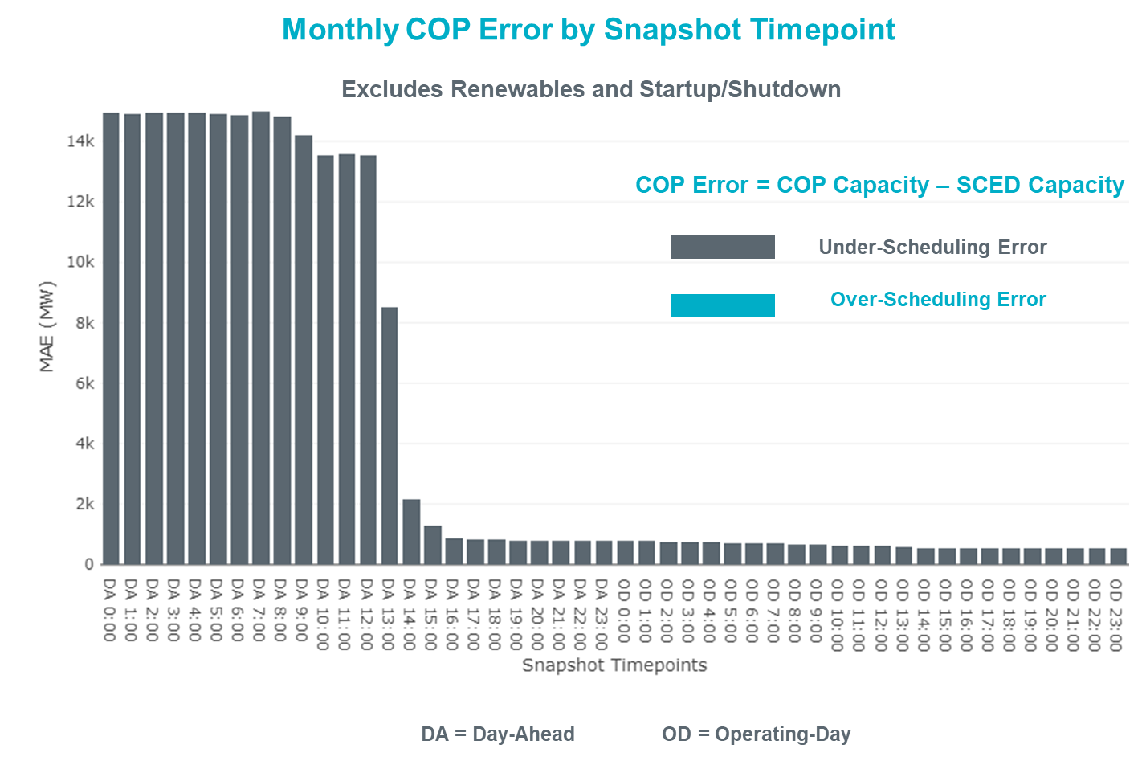

Monthly MAE for the Latest COP at the end of the Adjustment Period was 553 MW with median ranging from -1,032 MW for Hour-Ending (HE) 21 to -94 MW for HE 7. HE 22 on the 25th had the largest Over-Scheduling Error (1,161 MW) and HE 21 on the 7th had the largest Under-Scheduling Error (-3,338 MW).

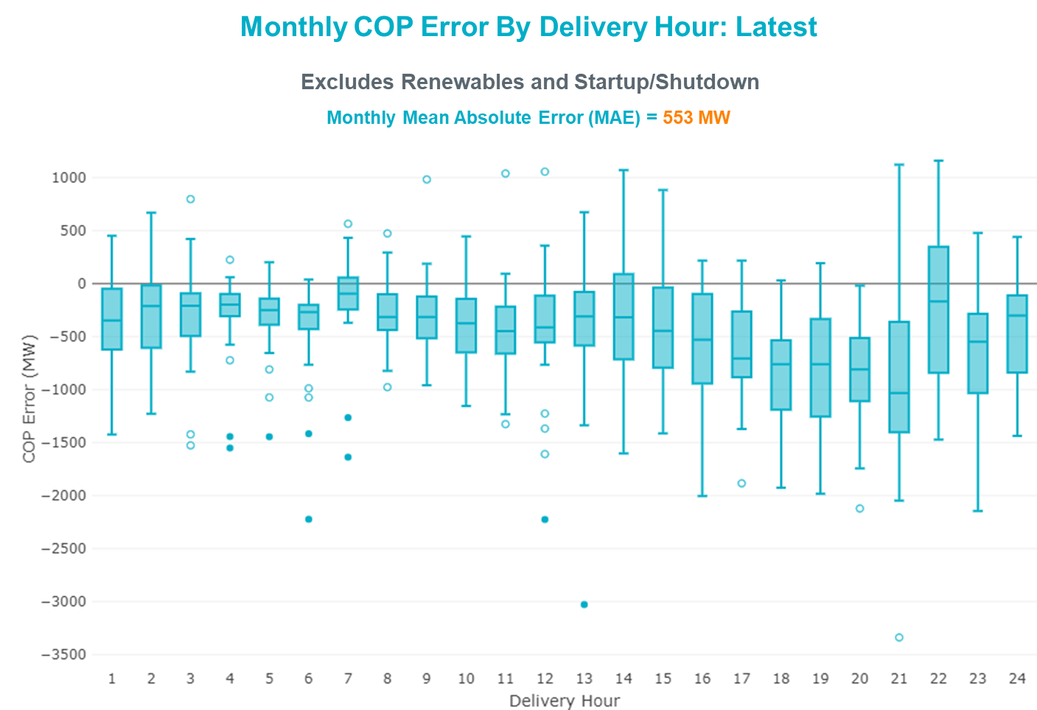

Monthly MAE for the Day-Ahead COP at 12:00 was 13,557 MW with median ranging from -20,491 MW for Hour-Ending (HE) 17 to -7,519 MW for HE 5. HE 18 on the 20th had the largest Under-Scheduling Error (-26,012 MW) and HE 2 on the 11th had the largest Over-Scheduling Error (-1,981 MW).

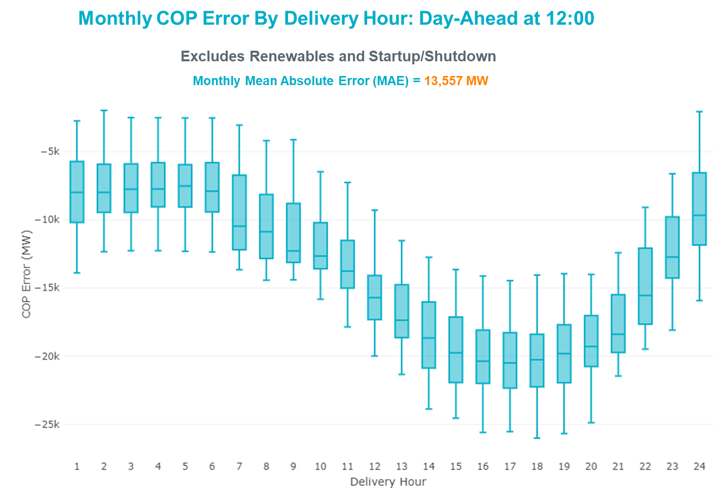

Congestion Analysis

Notable Constraints

Nodal protocol section 3.20 specifies that ERCOT shall identify transmission constraints that are binding in Real-Time three or more Operating Days within a calendar month. As part of this process, ERCOT reports congestion that meets this criterion to ROS. In addition, ERCOT also highlights notable constraints that have an estimated congestion rent exceeding $1,000 for a calendar month. These constraints are detailed in the table below, including approved transmission upgrades from TPIT that may provide some congestion relief based on ERCOT’s engineering judgement. Rows highlighted in blue indicate the congestion was affected by one or more outages. For a list of all constraints activated in SCED, please see Appendix A at the end of this report.

Contingency Name | Overloaded Element | # of Days Constraint Binding | Congestion Rent | Transmission Project
Manual dbl ckt for NEDIN-BONILLA 345kV & RIOH-PRIM138kV | Haine Drive - La Palma 138kV | 15 | $8,744,309.65 | Stewart Road: Construct 345 kV cut-in (5604)
MIDLAND EAST TRX MDLNE_3_1 345/138 | Tall City - Telephone Road 138kV | 11 | $8,432,057.03 | Tall City - Telephone Road 138 kV Line Rebuild (57915)
BIG SPRING SWITCH to CHALK_69kV and McDonald Road_138kV | Tall City - Telephone Road 138kV | 17 | $8,059,882.61 | Tall City - Telephone Road 138 kV Line Rebuild (57915)
TWR (345) HLJ-WAP64 & BLY-WAP72 | Jones Creek - South Texas Project 345kV | 5 | $7,500,720.15 | Freeport - Master Plan (6668B)
HCKSW TO DENSW 138 DBLCKT | Deen Switch - Rosen Heights Tap 2 138kV | 5 | $5,228,226.31
CRLNW TO LWSSW 345 DBLCKT | West Tnp - Highlands Tnp 138kV | 5 | $4,957,669.52
Basecase | NE_LOB GTC | 18 | $4,072,612.41
OASIS to MEADOW LIN A | Blodgett - Garrott 138kV | 1 | $4,057,846.13
PGC_Sgl_ MDL-FLC_345_kV_w_MDL_XMFR1_FLC_AMR2 | Tall City - Telephone Road 138kV | 5 | $3,092,320.59 | Tall City - Telephone Road 138 kV Line Rebuild (57915)
Man_Sgl_ MDL-FLC_345_kV_w_MDL_XMFR1_FLC_AMR2 | Tall City - Telephone Road 138kV | 4 | $3,063,628.56 | Tall City - Telephone Road 138 kV Line Rebuild (57915)
BOWMAN SWITCH TRX BOMSW_3_2 345/138 | Bowman Switch 345kV | 3 | $2,480,654.21
TWR (345) HLJ-WAP64 & BLY-WAP72 | Refuge - South Texas Project 345kV | 4 | $1,776,942.96 | Freeport - Master Plan (6668B)
TWR (345) WAP-BI50 & SMITHERS-BI98 | Bellaire - Sharpstown 138kV | 1 | $1,695,898.53 | Bellaire to Smithers Ckt.98A Upgrade (64491), Bellaire to WAP Ckt.50A Upgrade (64493)
DMTSW TO SCOSW 345 DBLCKT | Knapp - Scurry Chevron 138kV | 6 | $1,589,516.36
Cagnon-Kendal 345 & Cico-Comfor 138 | Bergheim - Kendall 345kV | 1 | $1,430,398.72
TWR(345) JCK-REF27 & JCK-STP18 | Blessing - Pavlov 138kV | 4 | $1,419,329.30 | Blessing to Bay City Pumps: Rebuild 69 kV Line (52066)
Bighil-Kendal 345kV | Rocksprings - Friess Ranch 69kV | 5 | $1,253,672.60 | Rocksprings to Friess Ranch: Rebuild 69 kV line (51005)
Basecase | PNHNDL GTC | 9 | $1,238,438.42
Man_dbl_FLCNS-MDLNE_345KV_and_FLCNS-MGSES_345_KV | Tall City - Telephone Road 138kV | 4 | $1,228,369.69 | Tall City - Telephone Road 138 kV Line Rebuild (57915)
Fowlerton to LOBO 345 LIN1 | Laredo Vft North - Las Cruces 138kV | 10 | $1,121,129.95 | Laredo VFT North to North Laredo Switch: Rebuild 138 kV Line (58008)
BOWMAN SWITCH TRX BOMSW_3_1 345/138 | Bowman Switch 345kV | 3 | $951,775.49
DUPONT SWITCH - INGLESIDE to GREGORY POWER LIN 1 | Dupont Switch - Ingleside - Lge 138kV | 4 | $914,088.52
CRLNW TO LWSSW 345 DBLCKT | Lewisville Switch - Jones Street Tnp 138kV | 4 | $855,138.52
LNGSW TO MDSSW 345 AND MGSES TO QALSW 345 DBLCKT | Big Spring West - Stanton East 138kV | 7 | $807,323.87 | Natural Dam 138 kV Switch (52295)
MGSES TO CCRSW 345 AND BTRCK TO MGSES 345 DBLCKT | Tonkawa Switch - Morgan Creek Ses 345kV | 3 | $740,102.91
ODLAW SWITCHYARD to ASPHALT MINES LIN 1 | Hamilton Road - Maverick 138kV | 10 | $629,471.81 | Brackettville to Escondido: Construct 138 kV line (5206)
Basecase | WESTEX GTC | 3 | $502,901.66
COLETO - GRISSOM (345) & VICTORIA - FANNINS (69) | Warburton Road Switching Station - Victoria 138kV | 3 | $277,734.93
TWINBU-DVIDE 345KV | Carterville - Einstein 138kV | 3 | $240,881.33
PH ROBINSON to MEADOW LIN A | Magnolia Tnp - Seminole Tnp 138kV | 4 | $193,119.21 | Alvin Area 138kV Conversions (63834D)
Fowlerton to LOBO 345 LIN1 | North Laredo Switch - Piloncillo 138kV | 6 | $181,115.79
Basecase | NELRIO GTC | 6 | $146,535.94
CRSCN TO FERIS 69 AND ENSSW TO ENWSW 138 DBLCKT | Ennis West Switch - Waxahachie 138kV | 3 | $98,931.66
Fowlerton to LOBO 345 LIN1 | Asherton - Catarina 138kV | 3 | $87,839.01
LAQUINTA to LOBO LIN 1 | Bruni Sub 138kV | 7 | $85,736.09
LAQUINTA to LOBO LIN 1 | Falfurrias - Premont 69kV | 7 | $51,671.37
Fowlerton to LOBO 345 LIN1 | North Laredo Switch - Piloncillo 138kV | 6 | $24,381.87

Generic Transmission Constraint Congestion
There were 10 days of congestion on the West Texas Export GTC, 12 days on the Panhandle GTC, 20 days on the North Edinburg to Lobo GTC, 17 days on the Raymondville to Rio Hondo, 9 days on the Nelson Sharpe to Rio Hondo GTC, 1 day on the Valley Export GTC, 1 day on Bearkat GTC, and 3 days on the North to Houston GTC. There was no activity on the remaining GTCs during the month.

Note: This is how many times a constraint has been activated to avoid exceeding a GTC limit, it does not imply an exceedance of the GTC occurred or that the GTC was binding.

Manual Overrides
None

Congestion Costs for Calendar Year 2021
The following table represents the top twenty active constraints for the calendar year based on the estimated congestion rent attributed to the congestion. ERCOT updates this list on a monthly basis.

Contingency | Overloaded Element | # of 5-min SCED | Estimated | Transmission Project
Basecase | PNHNDL GTC | 23723 | 98,460,875.75
Elmcreek-Sanmigl 345kV | Pawnee Switching Station - Calaveras 345kV | 2476 | 76,307,872.64
Basecase | NE_LOB GTC | 24154 | 55,952,054.69
LOST PINES AEN to FAYETTE PLANT 1 LIN 1 | Winchester - Fayette Plant 1 And 2 345kV | 415 | 51,438,867.64
JOHNSON SWITCH (ONCOR) to CONCORD LIN G1 | Decordova Dam - Carmichael Bend Switch 138kV | 726 | 46,614,977.07 | DeCordova 345/138_Sw. (7129)
TWR(345) JCK-REF27 & JCK-STP18 | Oasis - Dow Chemical 345kV | 524 | 46,495,190.60 | Freeport - Master Plan (6668A)
Basecase | WESTEX GTC | 11190 | 45,691,080.20
Manual dbl ckt for NEDIN-BONILLA 345kV & RIOH-PRIM138kV | Haine Drive - La Palma 138kV | 11017 | 44,765,877.31 | Stewart Road: Construct 345 kV cut-in with two 450 MVA 345/138 autotransformers connected to Stewart Rd 138 station (5604, 6382)
Basecase | N_TO_H GTC | 2999 | 39,343,345.38
TWR(345) JCK-REF27 & JCK-STP18 | South Texas Project - Wa Parish 345kV | 1909 | 35,934,198.14 | Freeport - Master Plan (6668A)
Hicross-Pilot & Garfield 138kV | Carson Creek - Pilot Knob 138kV | 803 | 30,600,531.85
HCKSW TO DENSW 138 DBLCKT | Deen Switch - Rosen Heights Tap 2 138kV | 4847 | 26,927,370.83
Basecase | Colorado Bend Energy Center - Dyann 138kV | 242 | 26,093,025.30
TWR(345) JCK-REF27 & JCK-STP18 | Blessing - Pavlov 138kV | 4383 | 21,362,696.58
CONCORD TRX CRD1 345/138 | Concord 345kV | 840 | 21,139,669.60
Lostpi-Austro&Dunlap 345kV | Sim Gideon - Winchester 138kV | 635 | 20,472,271.99 | Sim Gideon - Tahitian Village Transmission Line Storm Hardening (61438), Bastrop West - Split Transmission Line Storm Hardening (61436)
Lytton_S-Slaughte&Turner 138kV | Mccarty Lane - Zorn 138kV | 245 | 20,185,815.81
MIDLAND EAST TRX MDLNE_3_1 345/138 | Tall City - Telephone Road 138kV | 4390 | 19,665,398.49
CRLNW TO LWSSW 345 DBLCKT | West Tnp - Highlands Tnp 138kV | 8178 | 18,211,455.15
Basecase | Pawnee Switching Station - Calaveras 345kV | 27 | 17,214,426.04

System Events

ERCOT Peak Load
The unofficial ERCOT peak load for the month was 72,339 MW and occurred on the 1st, during hour ending 17:00.

Load Shed Events
None.

Stability Events
None.

Notable PMU Events
ERCOT analyzes PMU data for any significant system disturbances that do not fall into the Frequency Events category reported in section 2.1. The results are summarized in this section once the analysis has been completed.

There were no PMU events outside of those reported in section 2.1.

DC Tie Curtailment
Date | DC Tie | Curtailing Period | # of Tags Curtailed | Initiating Event | Curtailment Reason
9/29/2021 | DC-R | HE 23 | 2 | Unplanned Outage | Planned or Unplanned Outage

TRE/DOE Reportable Events
- CenterPoint submitted an OE-417 for 09/13/2021. Reportable Event Type: Loss of electric service to more than 50,000 customers for 1 hour or more.
- Oncor submitted an EOP-004 for 09/13/2021. Reportable Event Type: Damage or Destruction of a Facility.
- Oncor submitted an OE-417 for 09/13/2021. Reportable Event Type: Damage or Destruction of a Facility.
- CenterPoint submitted an OE-417 for 09/14/2021. Reportable Event Type: Loss of electric service to more than 50,000 customers for 1 hour or more.
- ERCOT ISO submitted an OE-417 for 09/14/2021. Reportable Event Type: Islanding.
- RWE submitted an EOP-004 for 09/22/2021. Reportable Event Type: Damage or Destruction of a Facility.

New/Updated Constraint Management Plans
None.

New/Modified/Removed RAS
None.

New Procedures/Forms/Operating Bulletins
None.

Emergency Conditions

OCNs
Date and Time | Message
Sep 12, 2021  11:00 CPT | ERCOT issued an OCN for Tropical Storm Nicholas due to a probability of making landfall in the ERCOT Region on Monday afternoon September 13th.
Sep 16, 2021  16:00 CPT | OCN for modifying the Panhandle Generic Transmission Constraint due to the current transmission outage topology.

Advisories
Date and Time | Message
Sep 13, 2021  9:00 CPT | ERCOT issued an Advisory for Potential Hurricane Nicholas due to a probability of making landfall in the ERCOT Region on Monday afternoon September 13th.
Sep 19, 2021  13:30 CPT | ERCOT has postponed the deadline for the posting of the DAM solution for Operating Day 09/20/2021 due to delay in clearing DAM.
Sep 29, 2021  13:30 CPT | ERCOT has postponed the deadline for the posting of the DAM solution for Operating Day 09/30/2021 due to delay in clearing DAM.

Watches
Date and Time | Message
Sep 13, 2021  19:15 CPT | ERCOT issued a Watch for Potential Hurricane Nicholas due to a probability of making landfall in the ERCOT Region on Monday night September 13th.

Emergency Notices
None.

Application Performance

TSAT/VSAT Performance Issues
None.

Communication Issues
None.

Market System Issues
None.

Model Updates
The Downstream Production Change (DPC) process allows ERCOT to make changes in the on-line Network Operations Model without loading a completely new model. The purpose of this process is to allow for reliable grid operations as system conditions change between designated Network Operations Model database loads. The DPC process is limited in scope to just those items listed below, with equipment ratings updates being the most common. ERCOT has seen a rise in the use of the DPC process to make on-line updates to the Network Operations Model in recent years, instead of through the standard Network Operations Model Change Request process.

- Static Line ratings (Interim Update)
- Dynamic Line ratings (non-Interim Update)
- Autotransformer ratings (non-Interim Update)
- Breaker and Switch Normal status (Interim Update)
- Contingency Definitions (Interim Update)
- RAP and RAS changes or additions (Interim Update)
- Net Dependable and Reactive Capability (NDCRC) values (Interim Update)
- Impedance Updates (non-Interim)

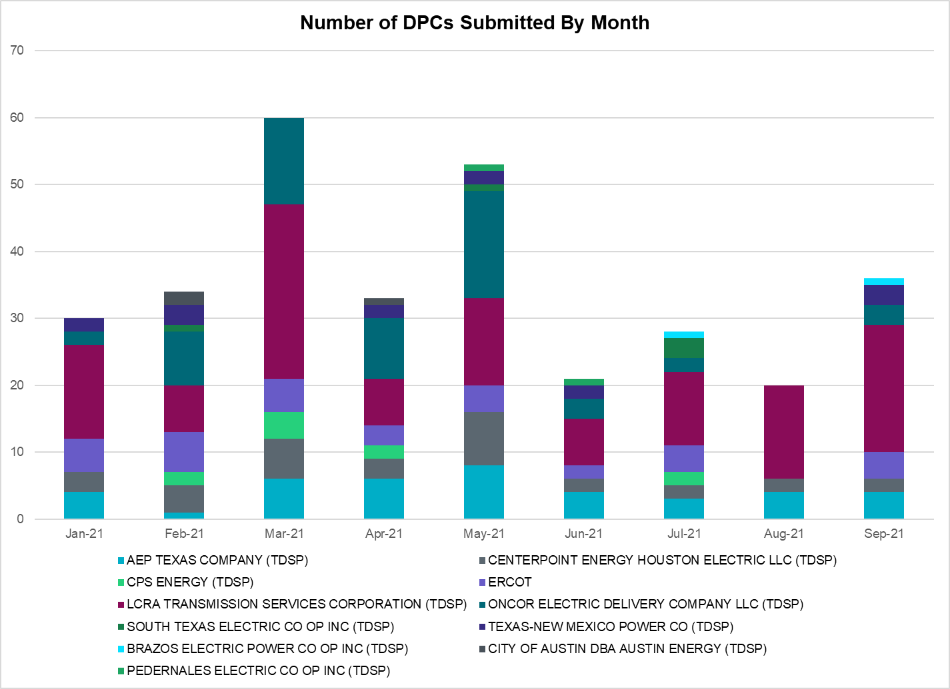

Transmission Operator | Number of DPCs
AEP TEXAS COMPANY (TDSP) | 4
BRAZOS ELECTRIC POWER CO OP INC (TDSP) | 1
BROWNSVILLE PUBLIC UTILITIES BOARD (TDSP) | 0
BRYAN TEXAS UTILITIES (TDSP) | 0
CENTERPOINT ENERGY HOUSTON ELECTRIC LLC (TDSP) | 2
CITY OF AUSTIN DBA AUSTIN ENERGY (TDSP) | 0
CITY OF COLLEGE STATION (TDSP) | 0
CITY OF GARLAND (TDSP) | 0
CPS ENERGY (TDSP) | 0
DENTON MUNICIPAL ELECTRIC (TDSP) | 0
ELECTRIC TRANSMISSION TEXAS LLC (TDSP) | 4
ERCOT | 4
LCRA TRANSMISSION SERVICES CORPORATION (TDSP) | 19
LONE STAR TRANSMISSION LLC (TSP) | 0
ONCOR ELECTRIC DELIVERY COMPANY LLC (TDSP) | 3
PEDERNALES ELECTRIC CO OP INC (TDSP) | 0
RAYBURN COUNTRY CO OP DBA RAYBURN ELECTRIC (TDSP) | 0
SHARYLAND UTILITIES LP (TDSP) | 0
SOUTH TEXAS ELECTRIC CO OP INC (TDSP) | 0
TEXAS MUNICIPAL POWER AGENCY (TDSP) | 0
TEXAS-NEW MEXICO POWER CO (TDSP) | 3

Appendix A: Real-Time Constraints
The following is a complete list of constraints activated in SCED. Full contingency descriptions can be found in the Standard Contingencies List located on the MIS secure site at Grid Generation Reliability Unit Commitment.

Contingency Name | Overloaded Element | From Station | To Station | Count of Days
BASE CASE | NE_LOB | n/a | n/a | 20
DFLCMGS5 | TALLCITY_TELPR_1 | TELPH_RD | TALLCITY | 18
XMDL58 | TALLCITY_TELPR_1 | TELPH_RD | TALLCITY | 17
BASE CASE | RV_RH | n/a | n/a | 17
MHARNED5 | HAINE__LA_PAL1_1 | LA_PALMA | HAINE_DR | 15
SLAQLOB8 | FALFUR_PREMON1_1 | FALFUR | PREMONT | 12
BASE CASE | PNHNDL | n/a | n/a | 12
SBRAUVA8 | HAMILT_MAVERI1_1 | HAMILTON | MAVERICK | 11
SLOBSA25 | LARDVN_LASCRU1_1 | LARDVNTH | LASCRUCE | 11
SLGEI_D8 | I_DUPS_LGE1_1 | LGE | I_DUPSW | 10
BASE CASE | WESTEX | n/a | n/a | 10
BASE CASE | NELRIO | n/a | n/a | 9
SENSENS8 | 940__C | ENWSW | WXHCH | 9
SLOBSA25 | NLARSW_PILONC1_1 | PILONCIL | NLARSW | 8
DFLCMDL5 | TALLCITY_TELPR_1 | TELPH_RD | TALLCITY | 8
SLOBSA25 | NLARSW_PILONC1_1 | NLARSW | PILONCIL | 8
DWAPHLJ5 | JCKSTP18_A | STP | JCK | 8
DMGSQAL5 | 6144__A | BSPRW | STASW | 7
SMDOPHR5 | G138_10B_1 | SEMINOLE | MAGNO_TN | 7
SLAQLOB8 | BRUNI_69_1 | BRUNI | BRUNI | 7
DSTPRED5 | BLESSI_PAVLOV1_1 | BLESSING | PAVLOV | 7
SLUTVEA8 | 6144__A | BSPRW | STASW | 7
DENSENW8 | 940__C | ENWSW | WXHCH | 6
SFORYEL8 | HEXT_YELWJC1_1 | YELWJCKT | HEXT | 6
SGDNTEL5 | 6094__D | ANDNR | EXMTP | 6
DCRLLSW5 | 588_B_1 | LWSVH | LWSVW | 6
DMTSCOS5 | 6437__F | SCRCV | KNAPP | 6
SLOBSA25 | ASHERT_CATARI1_1 | ASHERTON | CATARINA | 6
MFLCMDL5 | TALLCITY_TELPR_1 | TELPH_RD | TALLCITY | 5
DCOLFA59 | VICTO_WARBU_1A_1 | VICTORIA | WARBURTN | 5
DBIGKEN5 | FRIR_ROCKSP1_1 | FRIR | ROCKSPRS | 5
DHCKDEN8 | 6265__E | RHTP2 | DENSW | 5
DHWIND89 | MORRIS_NUECES1_1 | NUECES_B | MORRIS | 5
DCRLLSW5 | 590__A | LWSSW | LWVJS | 5
DWAPHLJ5 | REFSTP27_A | STP | REF | 4
SGRILON5 | VICTO_WARBU_1A_1 | VICTORIA | WARBURTN | 4
DMGSBIT5 | 6036__A | TKWSW | MGSES | 4
MFLCMG25 | TALLCITY_TELPR_1 | TELPH_RD | TALLCITY | 4
BASE CASE | LGD_SANTIA1_1 | LGD | SANTIAGO | 4
SLOBSA25 | FALFUR_PREMON1_1 | FALFUR | PREMONT | 4
DMGSBTR5 | 6036__A | TKWSW | MGSES | 4
DPRSVLS5 | 870__A | COMSW | COMSO | 4
XBOM58 | BOMSW_MR2H | BOMSW | BOMSW | 4
DBIGKEN5 | TREADW_YELWJC1_1 | TREADWEL | YELWJCKT | 4
SSKYSB28 | TALLCITY_TELPR_1 | TELPH_RD | TALLCITY | 4
DTWIDIV5 | CRTVLE_EINSTEN_1 | EINSTEIN | CRTRVLLE | 3
DCOLFA59 | NORMAN_PETTUS1_1 | PETTUS | NORMANNA | 3
SODLBRA8 | HAMILT_MAVERI1_1 | HAMILTON | MAVERICK | 3
SFTLMES8 | CROSSO_NORTMC1_1 | NORTMC | CROSSOVE | 3
DDUPHE18 | I_DUPS_MCCAMP2_1 | I_DUPSW | MCCAMPBE | 3
MBLEESP8 | BLESSI_PAVLOV1_1 | BLESSING | PAVLOV | 3
SLOBSA25 | BRUNI_69_1 | BRUNI | BRUNI | 3
SPOMNED5 | FREER_LOBO1_1 | LOBO | FREER | 3
DELMSAN5 | PAWNEE_SPRUCE_1 | PAWNEE | CALAVERS | 3
SN_SLON5 | CELANE_N_SHAR1_1 | N_SHARPE | CELANEBI | 3
DFLCMDL5 | 6144__A | BSPRW | STASW | 3
DSTPRED5 | CKT_3124_1 | STP | HLJ | 3
DBIGKEN5 | HAMILT_MAXWEL1_1 | MAXWELL | HAMILTON | 3
BASE CASE | N_TO_H | n/a | n/a | 3
SSTAMDL8 | TALLCITY_TELPR_1 | TELPH_RD | TALLCITY | 3
DAUSDUN8 | 608T608_1 | GIDEON | BASTCI | 3
XBOM358 | BOMSW_MR1H | BOMSW | BOMSW | 3
DWAPHLJ5 | JCKREF27_A | REF | JCK | 3
DREFSTP5 | CKT_3124_1 | STP | HLJ | 3
SMLSSCS5 | 1350__E | NCSTP | LFKSW | 2
SORE2B8 | GEBWA_65_A | GEB | WA | 2
SCALBAN9 | FALFUR_PREMON1_1 | FALFUR | PREMONT | 2
SPLUFLA8 | MAGRUD_VICTOR2_1 | VICTORIA | MAGRUDER | 2
DBUCKLN5 | 651__B | CMNSW | CMNTP | 2
DCAGCO58 | 656T656_1 | KENDAL | BERGHE | 2
DLYTTUN8 | CKT_943_1 | LYTTON_S | PILOT | 2
DWAPHLJ5 | STPWAP39_1 | STP | WAP | 2
DSALKLN5 | 630__B | KLNSW | HHSTH | 2
SCOLBAL8 | BALLIN_HUMBLT1_1 | BALLINGE | HUMBLTAP | 2
SOWLBIG8 | BISON_STRS1_1 | BISON | STRS | 2
XTRS258 | 1920__B | ATHNS | TRNDD | 2
SENSEN28 | 940__C | ENWSW | WXHCH | 2
SCOLBAL8 | DRSY_SANA_T1_1 | SANA_TAP | DRSY | 2
DWIRSTA8 | SANDCR_AT1 | SANDCR | SANDCR | 2
DTWIDIV5 | 15010__B | BLISS | ESTILES | 2
DFLCMGS5 | 6144__A | BSPRW | STASW | 2
XBOM58 | BOMSW_MR2L | BOMSW | BOMSW | 2
XCAG158 | CAGNON_MR4H | CAGNON | CAGNON | 2
SENSEN28 | 940__C | WXHCH | ENWSW | 2
DBIGKEN5 | BONDRO_SONR1_1 | SONR | BONDROAD | 2
SORE2B8 | GEBWA_65_A | WA | GEB | 2
DSTPRED5 | LAN_CT_PAVLOV1_1 | PAVLOV | LAN_CTY | 2
SCOLPAW5 | MAGRUD_VICTOR2_1 | VICTORIA | MAGRUDER | 2
DHCKDEN8 | 6260__A | RHTP1 | BLMND | 2
SCOLPAW5 | COLETO_ROSATA1_1 | COLETO | ROSATA | 2
SN_SLON5 | CELANE_KLEBER1_1 | CELANEBI | KLEBERG | 2
DREAPWE8 | 1610__A | PWEST | RCHAT | 1
SREDRAT8 | 699T699_1 | MCCALA | RNRD12 | 1
SRDODES8 | 940__C | ENWSW | WXHCH | 1
MCOLGRI5 | CALLIC_LON_HI1_1 | LON_HILL | CALLICOA | 1
SMSHJCH8 | DEN_IND_1 | DENTON | INDUSTRL | 1
DBIGKEN5 | SAPOWE_TREADW1_1 | SAPOWER | TREADWEL | 1
SSANFOW5 | SNMIG_AEPCHKCN_1 | SANMIGL | CHOKCNYN | 1
DWAP_BI5 | WO_AT3 | WO | WO | 1

Current Wind Generation Record: 23,596 MW on 06/25/2021 at 22:32 | Current Wind Penetration Record: 66.47% on 03/22/2021 at 00:46 Current Solar Generation Record: 7,036 MW on 08/03/2021 at 12:45 | Current Solar Penetration Record: 16.27% on 09/25/2021 at 09:57
This is the hourly integrated peak demand as published in the ERCOT D&E report.
All DC Tie Curtailments are posted publicly on the ERCOT Market Information System. See that posting for additional details for the event(s) in question.
See DC Tie Operating Procedure (http://www.ercot.com/mktrules/guides/procedures) for more details.

