System Planning
Monthly Status Report

Report Highlights

- ERCOT is currently reviewing proposed transmission improvements with a total estimated cost of $1,499.76 Million as of September 30, 2021.
- Transmission Projects endorsed in 2021 total $912.9 Million as of September 30, 2021.
- All projects (in engineering, routing, licensing, and construction) total approximately $7.44 Billion as of June 1, 2021.
- Transmission Projects energized in 2021 total about $999.2 Million as of June 1, 2021.

Regional Planning Group Reviews
RPG Projects under Review:
- AEPSC has submitted a request to withdraw the LRGV Import Project (RPG Project ID: 18RPG001). This project is no longer under ERCOT’s independent review.
- STEC has submitted a request to withdraw the Lower Rio Grande Valley Transmission Expansion Project (RPG Project ID: 19RPG009). This project is no longer under ERCOT’s independent review.
- Oncor has submitted the Nacogdoches Southeast Switch – Redland Switch – Lufkin Switch 345-kV Loop Project (RPG Project ID: 20RPG019). This is a Tier 2 project that is estimated to cost $71.26 million. This project is currently under ERCOT’s independent review.
- AEPSC has submitted the Port Lavaca Area Improvement Project (RPG Project ID: 21RPG002). This is a Tier 2 project that is estimated to cost $97.8 million. ERCOT has completed the independent review and the recommended project is classified as a Tier 1 project that is estimated to cost $101.5 million. TAC voted unanimously to endorse the project on September 29. ERCOT will seek BOD endorsement at a future BOD meeting.
- Oncor has submitted the Flat Iron – Barr Ranch – Pegasus South 138-kV Line Project (RPG Project ID: 21RPG010). This is a Tier 2 project that is estimated to cost $50.7 million. This project is currently under ERCOT’s independent review.
- CNP has submitted the WA Parish to Nash 138-kV Ckt 02 Rebuild Project (RPG Project ID: 21RPG013). This is a Tier 3 project that is estimated to cost $71.75 million. The RPG review of this project was completed on September 10. Pursuant to Protocol Section 3.11.4.3.1 (d), this project has been reclassified as a Tier 4 neutral project.
- AEPSC has submitted the Mason Switch to Yellowjacket 69-kV Line Transmission Project (RPG Project ID: 21RPG014). This is a Tier 3 project that is estimated to cost $36.9 million. The RPG review of this project was completed on September 15. Pursuant to Protocol Section 3.11.4.3.1 (d), this project has been reclassified as a Tier 4 neutral project.
- AEPSC has submitted the Munday to Throckmorton 69-V and Albany to Throckmorton 69-kV Line Rebuild Project (RPG Project ID: 21RPG015). This is a Tier 3 project that is estimated to cost $83.4 million. The RPG review of this project was completed on September 28. Pursuant to Protocol Section 3.11.4.3.1 (d), this project has been reclassified as a Tier 4 neutral project.
- CNP has submitted the TH Wharton - White Oak 138-kV Conversion Project (RPG Project ID: 21RPG016). This is a Tier 3 project that is estimated to cost $79.9 million. The RPG review of this project was completed on September 30. Pursuant to Protocol Section 3.11.4.3.1 (d), this project has been reclassified as a Tier 4 neutral project.
- ERCOT has submitted the Lower Rio Grande Valley System Enhancement Project (RPG Project ID: 21RPG017). This is a Tier 1 project that is estimated to cost $1.28 billion. This project is currently under ERCOT’s independent review.

RPG Project Reviews Completed in 2021:
RPG Project ID | RPG Project Name | Submitted Entity | Tier | Estimated Cost  ($ Millions) | Review Completion Month
20RPG022 | Hamilton Road to Maxwell 138-kV Line Rebuild Project | AEPSC | Tier 3 | 34.0 | January
20RPG023 | Royse - Commerce 69-kV Line Conversion to 138-kV | Oncor | Tier 3 | 72.1 | January
1RPG003 | Midland East Area Projects | Oncor | Tier 3 | 88.5 | March
21RPG004 | Venus Switch-Cedar Hill Switch 345-kV Line Project | Oncor | Tier 3 | 10.3 | March
21RPG005 | Angleton to West Columbia 138-kV ckt 04 Rebuild Project | CNP | Reclassified from Tier 3 to Tier 4 per Protocol | 38.7 | April
21RPG006 | Algoa Corner to La Marque 138 138-kV ckt 93 Rebuild Project | CNP | Reclassified from Tier 3 to Tier 4 per Protocol | 34.56 | May
21RPG007 | Holliday - Seymour 69-kV Line Project | Oncor | Reclassified from Tier 3 to Tier 4 per Protocol | 44.3 | May
21RPG008 | Burnett – Bowie 69-kV Line Upgrade Project | Oncor | Tier 3 | 79.7 | June
21RPG009 | Waterfowl Substation Addition | CNP | Tier 3 | 42.4 | June
21RPG001 | Bakersfield to Big Hill 345‐kV Second Circuit Addition Project | STEC & LCRA TSC | Tier 2 | 83.2 | June
21RPG011 | Flewellen to Peters 138-kV ckt 25 Rebuild | CNP | Tier 3 | 76.2 | July
21RPG012 | Andrews North – Mustang – Paul Davis Tap 138-kV Line Section | Oncor | Reclassified from Tier 3 to Tier 4 per Protocol | 37 | August
21RPG013 | WA Parish to Nash 138-kV Ckt 02 Rebuild Project | CNP | Reclassified from Tier 3 to Tier 4 per Protocol | 71.75 | September
21RPG014 | Mason Switch to Yellowjacket 69-kV Line Transmission Project | AEPSC | Reclassified from Tier 3 to Tier 4 per Protocol | 36.9 | September
21RPG015 | Munday to Throckmorton 69-kV and Albany to Throckmorton 69-kV Line Rebuild Project | AEPSC | Reclassified from Tier 3 to Tier 4 per Protocol | 83.4 | September
21RPG016 | TH Wharton - White Oak 138-kV Conversion Project | CNP | Reclassified from Tier 3 to Tier 4 per Protocol | 79.9 | September

More information on current and past RPG projects can be found on the ERCOT MIS Secure (digital certificate required): https://mis.ercot.com/public/data-products/grid/regional-planning
Past email communication on RPG projects can be found on the ERCOT listserv by signing up for the REGPLANGROUP list: http://lists.ercot.com/scripts/wa-ERCOT.exe?A0=REGPLANGROUP

Planning Model Activities
The short-term calendar of major planning model events is as follows:
- By Oct 25, 2021 21SSWG Update cases, in PSS/E 35, and TPIT are posted
- By Nov 16, 2021 21SSWG Contingency definitions and Planning Data Dictionary are posted
The following table shows interconnection projects that met Planning Guide section 6.9(1) and 6.9(2) and were modeled in the SSWG cases as a full model or as a simple model in accordance with Planning Guide section 6.9.
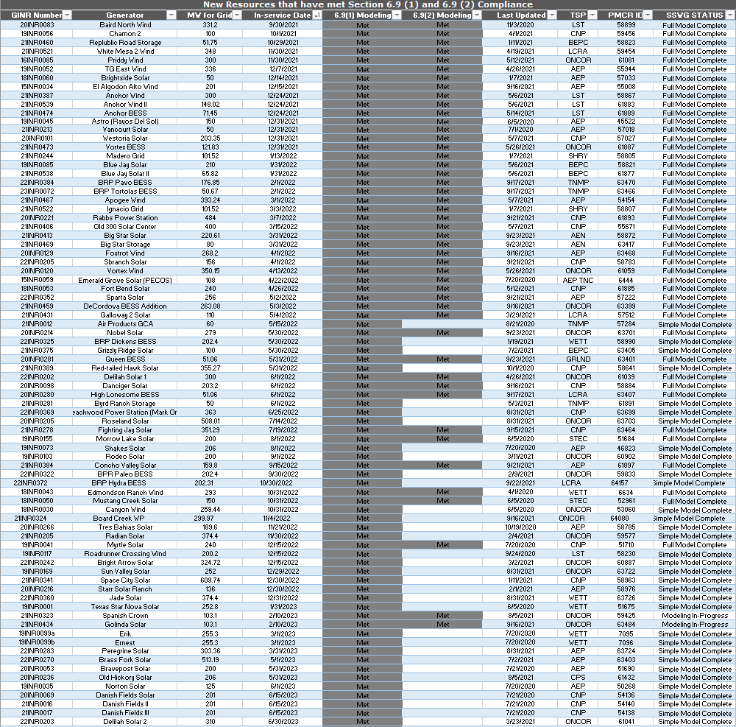
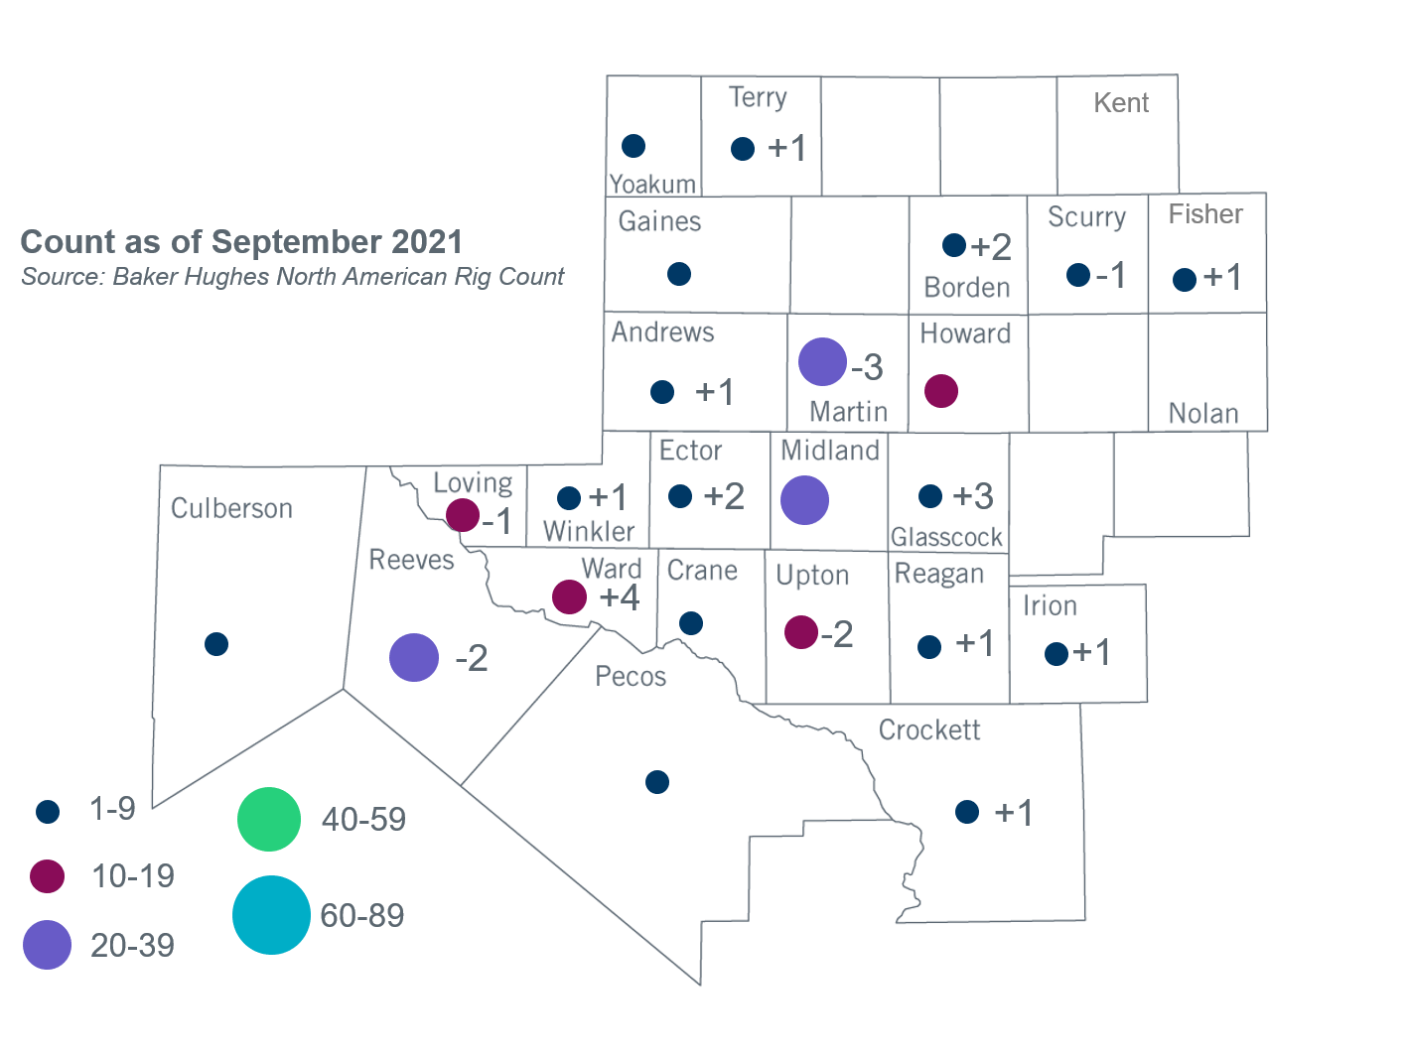

Permian Basin Oil Rig Count
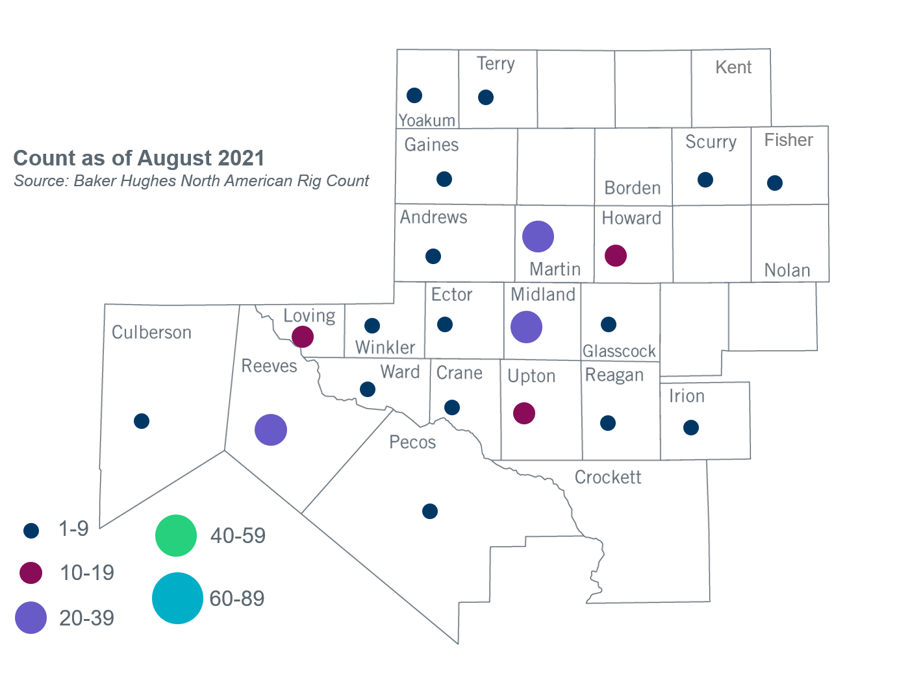

Other Notable Activities
- ERCOT presented plans for 2021 Regional Transmission Plan (RTP) off-peak reliability sensitivity analysis at the September 15, 2021 Regional Planning Group (RPG) meeting.
- ERCOT presented a proposal for steady-state voltage performance criteria for the benchmark and supplemental Geomagnetic Disturbance Vulnerability Assessments (GMDVA) at the September 21, 2021 Planning Geomagnetic Disturbance Task Force (PDGTF) meeting. The proposed criteria will also be presented at the October RPG and October Technical Advisory Committee (TAC) meetings.
- ERCOT is conducting the West Texas Export Study and plans to complete the study in Q4, 2021.
- ERCOT is conducting the Permian Basin Load Integration Study and plans to complete the study in Q4, 2021.

.

Based on the Total Project Estimated Cost for all future projects listed in the Transmission Project Information and Tracking (TPIT) report. TPIT is updated three times each year based on information TSPs provide in Model on Demand (MOD) as specified in the ERCOT Steady State Working Group Procedure Manual. The latest TPIT is available at http://www.ercot.com/gridinfo/planning.
Based on the Total Project Estimated Cost for all completed projects with Projected In-Service Dates in 2021 listed in the TPIT.
+/- symbol indicates the increase or decrease from the previous month in oil rigs present in each county. There are 177 rigs, including an increase of 9 oil rigs, in the Permian Basin from August to September 2021.

