Dynamics Working Group
Procedure Manual

Revision 17

ROS Approved: TBD

TABLE OF CONTENTS

Foreword 4
1 Activities of the Dynamics Working Group (DWG) 5
2 Administrative Procedures 5
2.1 Membership 5
2.2 Duties of Chair and Vice-Chair 6
2.3 Meetings 6
2.4 Reports to ROS 6
2.5 Dynamic Data Sharing Rules 6
3 Dynamic Data 7
3.1 General 7
3.1.1 Software 7
3.1.2 Dynamic Models – General 7
3.1.3 Standard Dynamic Models 8
3.1.4 User-Written Dynamic Models 8
3.1.5 Dynamic Model Quality Test Guideline 8
3.1.6 Unit Model Validation 22
3.1.7 Maintenance of Dynamic Models 24
3.1.8 Dynamic Data for Existing Equipment 24
3.1.9 Dynamic Data for Planned Equipment 24
3.1.10 Unacceptable Dynamic Models 24
3.2 Dynamic Data for Equipment Owned by Resource Entities (REs) 25
3.2.1 Dynamic Data Requirements for New Equipment 25
3.2.2 Updates to Existing Dynamic Data 27
3.3 Data for Load Resource 27
3.4 Dynamic Data for Equipment Owned by Transmission Service Providers (TSPs) 28
3.4.1 Under Frequency Firm Load Shedding (UFLS) Relay Data 28
3.4.2 Under Voltage Load Shedding (UVLS) Relay Data 28
3.4.3 Protective Relay Data 29
3.4.4 Load Model Data 29
3.4.5 Other Types of Dynamic Data 30
3.4.6 Missing or Problematic Dynamics Data 30
3.4.7 Dynamic Data and Stability Book Storage 31
4 Overview of DWG Activities 32
4.1 Updating Dynamic Data and Flat Starts 32
4.1.1 Schedule for Dynamic Data Updates and Flat Start Cases 32
4.1.2 Dynamic Data Updates 33
4.1.3 Dynamic Data Screening 33
4.1.4 Flat Start Criteria 33
4.2 Post Flat Start Activities 34
4.2.1 Distribution of Flat Start Results and the Dynamic Data Base 34
4.2.2 Stability Book 34
4.2.3 DWG Coordination with the Steady State Working Group 34
4.2.4 DWG Dynamic Contingency Assumptions List 35
4.2.5 DWG Dynamic Contingency Database 35
4.3 Other DWG Activities 36
4.3.1 Event Simulation 36
4.3.2 Procedure Manual Revision Guidelines 37
4.4 Recommended DWG Study Methodologies 37
4.4.1 Voltage Instability Identification in Stability Studies 37
4.4.2 Cascading Identification in Stability Studies 37
4.4.3 Uncontrolled Islanding Identification in Stability Studies 38
4.4.4 Generator Protection Assumptions 38

Foreword
This Procedure Manual is intended for use by the stakeholder members of the Electric Reliability Council of Texas (ERCOT) for the purpose of creating and maintaining the dynamics database and dynamics simulation cases which are used to evaluate the dynamic performance of the ERCOT system.
The majority of ERCOT members utilize Siemens Power Technologies Inc. (PTI) Power System Simulator (PSS/E) software. Consequently, the various activities in the procedure manual incorporate PSS/E procedures and nomenclature in describing these activities. Wherever possible, a description of the PSS/E activity is given so users of software other than PSS/E may implement similar actions. ERCOT Operations utilizes Powertech DSATools™ Transient Security Assessment Tool (TSAT) software to evaluate real-time dynamic performance.

Activities of the Dynamics Working Group (DWG)
- The DWG builds dynamic data sets and dynamic study cases for the ERCOT system from data supplied by equipment owners. ERCOT coordinates the compilation and publication of dynamics data and dynamics study cases. The dynamics data are published in the form of dynamics study cases (flat start cases) as described within this document.
- The DWG prepares the annual update of the Stability Book that documents dynamic data used in the flat start cases.
- The DWG provides a forum for discussing dynamic modeling and system dynamic performance issues and questions.
- The DWG performs other activities as directed by the Reliability and Operating Subcommittee (ROS).

Administrative Procedures

Membership
The DWG is a non-voting working group whose members include representatives from ERCOT, Transmission Service Providers (TSPs), and Texas Reliability Entity (TRE).
Each NERC Transmission Planner within the ERCOT footprint and each ERCOT TSP with an assigned area in the Steady State Working Group (SSWG) and DWG base cases, shall have at least one designated DWG member. The designated DWG member(s) shall be an employee(s) of an ERCOT Registered TSP. A Designated Agent that is not a DWG member may represent a DWG member. Designated Agents are permitted on the DWG email exploder list at the discretion of the sponsoring DWG member under the stipulation that a Non-Disclosure Agreement (NDA) is in place with the sponsoring DWG member and proper notification has been provided to ERCOT. It is the responsibility of the sponsoring DWG member to inform ERCOT of Designated Agents acting on their behalf. It is also the responsibility of the sponsoring DWG member to inform ERCOT of Designated Agents that no longer represent them and to have them removed from the email exploder list. The DWG will review the participating Designated Agents annually.
DWG members and any Designated Agents shall be identified in the DWG roster, and the roster will be updated as needed by the DWG. The DWG shall notify ROS (in the monthly report) of any TSPs that are required to have a designated DWG member but do not have a DWG representative identified on the DWG roster.

The DWG will nominate a chair and vice-chair to be approved by the ROS annually.

Duties of Chair and Vice-Chair
The chair will coordinate the activities of the DWG and represent the DWG at the ROS meetings and other working group meetings as required.
The vice chair will support the chair and fulfill the duties of the chair in the absence of the chair.

Meetings
The DWG will meet at least quarterly. DWG meetings are closed meetings. DWG members and Designated Agents of DWG members may attend. If a Designated Agent is not on the DWG roster, the sponsoring DWG member shall inform ERCOT and the DWG chair and vice chair of the name of the Designated Agent attending one week prior to the meeting.
The chair may coordinate additional meetings as needed to facilitate the activities of the DWG. The vice chair will track attendance and document meeting minutes for in-person meetings.
Agendas and meeting schedules should be published at least two weeks prior to the meeting. The minutes of each meeting will be distributed to DWG members.

Reports to ROS
Each month, the DWG chair will provide a written report to the ROS if needed.

Dynamic Data Sharing Rules
Dynamic data and dynamic study cases are considered confidential and protected information pursuant to Protocol Section 1.3, Confidentiality. They shall be provided to the DWG members only.

Dynamic Data

General
Dynamic data is the network data, mathematical models, and supporting information required for simulation of dynamic and transient events in the ERCOT System.

Software
The current planning model software is PSS/E version 33 and PSCAD version 4.5 or higher. A planning model software transition from PSS/E version 33 to version 35 is in progress. Models compatible with version 35 are required to be provided by July 1, 2022. During years where a PSS/E version change is being conducted, the previous PSS/E version user defined models shall also be provided until a full transition is completed. The current operations model software Powertech DSATools™ Transient Security Assessment Tool (TSAT) version 21.

Dynamic Models – General
Dynamic models compatible with the software(s) and version(s) listed in Section 3.1.1 shall be submitted to both ERCOT and the interconnecting TSP. In addition to the requirements described in the Planning Guide Section 6.2, Dynamics Model Development, providers of dynamic models shall also adhere to the following requirements:
- Each dynamic device requires a model with model parameters that accurately represent the dynamics of the device over the entire range of operating conditions.
- PSCAD models shall be submitted to ERCOT for all inverter-based equipment installed on or after January 2015; for equipment installed before 2015 PSCAD models shall be submitted to ERCOT upon request.
- Where multiple models are provided (e.g. PSS/E, TSAT, PSCAD), the model response shall be consistent across software platforms to the extent of platform capability.
- Dynamic models shall utilize proper memory management within the software. Data must only be written to allocated memory locations so that other models within the system are not affected.
- All associated per unit dynamic model parameters for a given generating unit shall be provided using a base MVA (MBASE) in accordance with appropriate modeling techniques for the software platform, where the MBASE is typically the generator MVA rating.
- No model shall restrict the DWG from using any integration time-step less than or equal to a ¼ cycle in simulations when using positive sequence simulation tools.
- No model in the DWG’s Unacceptable Model List shall be used. Refer to Section 3.1.10.

Standard Dynamic Models
The use of standard dynamic models provided by the software is preferred when they can accurately represent the dynamic performance of the device being modeled.

User-Written Dynamic Models
A user written model is any model that is not a standard library model within the software(s) and version(s) listed in Section 3.1.1. When no compatible standard dynamic model(s) provided within the software can be used to represent the dynamics of a device, accurate and appropriate user written models can be used, if accepted by ERCOT and the DWG after being tested for compatibility with the flat start cases. A model guideline checksheet is provided by ERCOT for PSS/E and PSCAD models to help determine compatibility; this checksheet shall be completed and submitted along with the model.
PSS/E User-written models for the dynamic equipment and associated data must be in dynamic linked library (DLL) format and must include a model manual. The model manual must show control block diagrams, design logic, descriptions of all model parameters, a list of which parameters are commonly tuned for site-specific settings, and a description of procedures for using the model in dynamic simulations.
TSAT User-written models for the dynamic equipment and associated data must be in TSAT User Defined Model (UDM) format with or without a dynamic linked library (DLL). The TSAT UDM or DLL shall be able to directly read and support the PSS/E format data (.dyr).
All PSCAD models are considered to be user-written models.

Dynamic Model Quality Test Guideline
Submitted dynamic planning models must be accompanied with results from model quality tests performed by the facility owner as required in paragraph (5)(c) of Planning Guide Section 6.2. These results shall include the case simulation files as well as the simulation plots of relevant quantities for each test. Guidelines on how these tests should be performed and the expected model performance are provided in the following sub-sections. All tests are required for both PSS/E and PSCAD models with the exception of the Phase Angle Jump Test in Section 3.1.5.9, which is only required for PSCAD models. A sample report is posted under ‘Model Quality’ on the ERCOT Resource Integration webpage.
3.1.5.1 Simulation Set Up
To examine the dynamic performance of a Generation Facility or dynamic transmission element, all site-specific dynamic models needed to represent the facility shall be included in the test. The following model guidelines apply:
- The facility model is connected to a controllable infinite bus whose voltage and frequency can be adjusted for testing. No explicit ERCOT transmission system models are required for this testing. The tests shall be performed with the current planning model software.
- For generation resources, the generator is dispatched at full real power output and the Point of Interconnection (POI) bus voltage is initialized to nominal 1.0 per-unit unless the test requires otherwise. The initial reactive power exchange at the POI should be near zero unless the test requires otherwise.
- Behind the POI, the generator(s) and step-up transformer(s) shall be represented along with any additional planned or installed static and dynamic reactive equipment.
- Station transformer taps static switched shunts should be initialized to a nominal position appropriate for the initial POI voltage and real power dispatch.
- Any switching controls that are expected to provide a response within 10 seconds (e.g. automatic switched shunts or on-load transformer tap changers) should be reflected in the dynamic model for the resource.
- Aggregate Generation Resources, such as wind and solar, should be represented by a single equivalent aggregate model per registered Resource (i.e. allowed aggregation) and include a representation for the collector impedance and pad-mount transformer. All dynamic control systems should be modeled (generator, exciter, governor, power system stabilizer, automatic voltage regulator, power plant controller, voltage and frequency protection, etc. as applicable).
- Simulations should be run until facility response has stabilized for a minimum of 10 seconds.
Example test cases for an Intermittent Renewable Resource (IRR) with a STATCOM and a synchronous generator are shown below.
≈ Zero Impedance
Controllable
Infinite Bus
POI
Equivalent Collector Impedance
PPC
Plant controller/exciter configured for voltage regulation
Aggregate Model
For example, PLBVFU1 model
STATCOM

Zero Impedance Line
Controllable
Infinite Bus
POI
For example, PLBVFU1 model
Generator model including Exciter, Governor, PSS, etc
3.1.5.2 Flat Start Test
Perform a no-disturbance test of the prepared simulation case as described in Section 3.1.5.1 above for a minimum of 10 seconds. Flat responses of voltage, MW, MVAR, and frequency, as shown in the figure below, are expected to remain very close to the initial system condition.
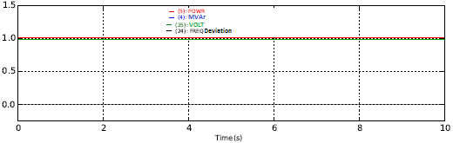

-- Voltage
-- Real Power
-- Frequency Deviation

ower
3.1.5.3 Small Voltage Disturbance Test
Apply a 3% step increase, and in a separate simulation, a 3% step decrease of voltage at the POI. The plant Automatic Voltage Regulator (AVR) and the associated droop and deadband settings (if applicable) should transition the plant to/near maximum leading power factor, or in the latter case, maximum lagging power factor in an attempt to regulate the original voltage set point. Any oscillations should be well damped. The figures below include examples of acceptable and unacceptable responses.
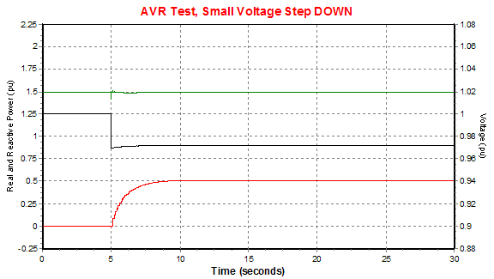
In response to the POI voltage being stepped from 1 pu to 0.97 pu, the plant’s AVR increased the reactive output to maximum, near 0.95 power factor lagging at the POI. This response is considered acceptable.
Acceptable Response: Small Voltage Step Down
-- Real Power
-- Reactive Power
-- Voltage

ower

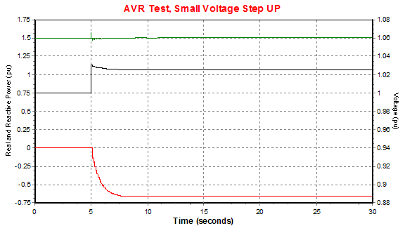
Acceptable Response: Small Voltage Step Up
In response to the POI voltage being stepped from 1 pu to 1.03 pu, the plant’s AVR decreased the reactive output to minimum, near 0.95 power factor leading at the POI. This response is considered acceptable.
-- Real Power
-- Reactive Power
-- Voltage

ower
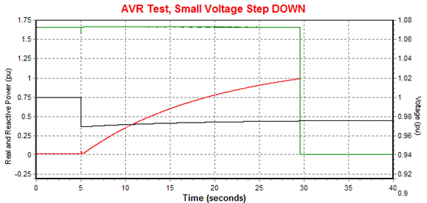
Unacceptable Response: Small Voltage Step Down
Here, the model increased reactive output raising the terminal voltage above 1.1 per unit, at which point the generator improperly tripped itself offline.
-- Real Power
-- Reactive Power
-- Voltage

ower
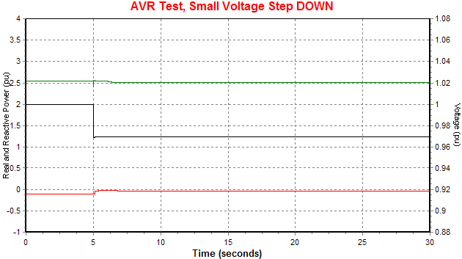
Unacceptable Response: Small Voltage Step Down
This model lacks an AVR response and so is considered unacceptable.
-- Real Power
-- Reactive Power
-- Voltage

ower

3.1.5.4 Large Voltage Disturbance Test (Low Voltage Ride-Through for IRRs, Inverter-Based Resources and Inverter-Based Transmission Elements)
Apply the low voltage profile boundary illustrated in ERCOT Operating Guide Section 2.9.1, Voltage Ride-Through Requirements for Generation Resources, to the POI. The profile starts at 1.0 per-unit and ends at 0.9 per-unit. This test shall be performed for two initial conditions: with the facility operating at a 0.95 lagging power factor (at the POI) and with the facility operating at 0.95 leading power factor (at the POI). The model shall exhibit appropriate dynamic reactive response, AVR response, and the model shall not exhibit momentary cessation.
- For the low voltage transient, the model should inject reactive current throughout the voltage recovery period. At the POI, both P and Q are necessarily zero during zero voltage. Q injection at the POI should be observable immediately or very shortly after voltage begins ramp up from zero.
- For 0.9 pu sustained POI voltage, the AVR should provide voltage support that moves the resource towards nearly full reactive production (significantly lagging).
- Real power recovery should start prior to the POI voltage recovering to 0.9 pu.
- Real power should recover to full output within 1.0 seconds of POI voltage recovery to 0.9 pu. A modest real power reduction may be acceptable to accommodate greater reactive power injection.
- An explanation, including a reference to any exempt status per ERCOT Operating Guide Section 2.9.1, Outage Coordination, shall be provided for models which indicate that the unit trips or fails to meet any of the above performance criteria.
The figures below include the examples of acceptable and unacceptable responses:
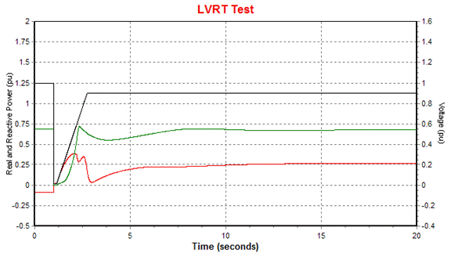
Acceptable Response: LVRT
This model exhibited acceptable voltage recovery, dynamic reactive power response during the low voltage transient, and AVR reactive response during the settling period. Although the reactive power temporarily dipped at 3 seconds, this was considered acceptable as the AVR quickly responded, providing additional reactive power soon after.
-- Real Power
-- Reactive Power
-- Voltage

ower
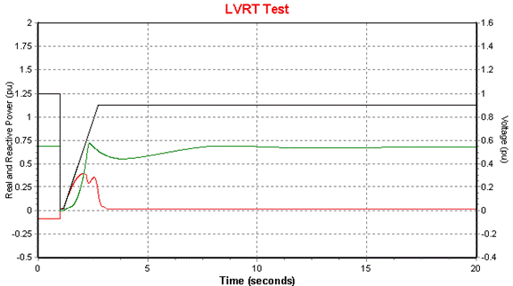
Unacceptable Response: LVRT
-- Real Power
-- Reactive Power
-- Voltage

ower
The reactive power of this model quickly diminished as soon as the POI voltage reached 0.9 pu. Because the final POI voltage is below the initial 1.0 pu voltage, the AVR should have continued to increase reactive power towards maximum. This model is lacking correct AVR response and so is considered unacceptable.

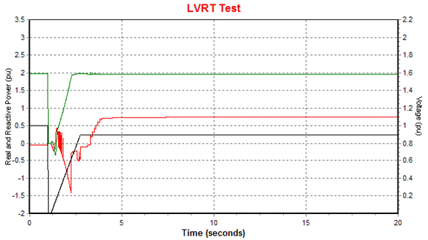
Unacceptable Response: LVRT
This model absorbed reactive power during the low voltage transient, which could be detrimental for grid voltage recovery. This model does not exhibit dynamic reactive power control, thus the response is considered unacceptable.
-- Real Power
-- Reactive Power
-- Voltage

ower

3.1.5.5 Large Voltage Disturbance Test (High Voltage Ride-Through for IRRs, Inverter-Based Resources, and Inverter-Based Transmission Elements)
Apply the high voltage profile boundary illustrated in ERCOT Operating Guide Section 2.9.1 to the POI. The profile starts at 1.0 per-unit voltage and ends at 1.1 per-unit. This test shall be performed for two initial conditions: with the facility operating at a 0.95 lagging power factor (at the POI) and with the facility operating at 0.95 leading power factor (at the POI). The model shall exhibit appropriate dynamic reactive response, AVR response, and the model shall not exhibit momentary cessation.
- During the high voltage transient, the model should provide a fast dynamic response to absorb reactive power. The resource should be absorbing a significant amount of reactive power at the POI during the high voltage transient, and ideally within 0.5 seconds of the transient inception.
- For 1.1pu sustained POI voltage, the AVR should move the resource towards nearly full reactive absorbing (significantly leading).
- Real power should be sustained during high voltage condition. A modest real power reduction may be acceptable to accommodate greater reactive power absorption
- An explanation, including a reference to any exempt status per ERCOT Operating Guide Section 2.9.1, shall be provided for models which indicate that the unit trips or fails to meet any of the above performance criteria.
The figures below include examples of acceptable and unacceptable responses.

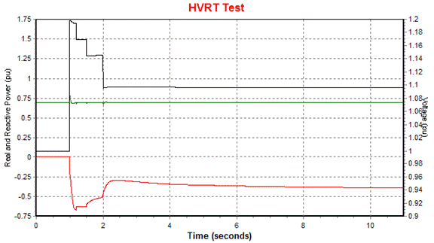
-- Real Power
-- Reactive Power
-- Voltage

ower
Acceptable HVRT Response
Illustration of an acceptable HVRT response. Real power is maintained and there is a good Reactive power response for voltage support: There is a large amount of reactive absorption during the high voltage transient, followed by the AVR responding to the sustained 1.1 pu POI voltage.

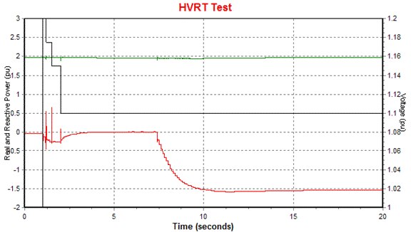
Unacceptable HVRT Response
-- Real Power
-- Reactive Power
-- Voltage

ower
Illustration of an unacceptable HVRT response. There is very little dynamic reactive response during the high voltage transient. This would not be helpful in arresting a high voltage grid condition. The facility should quickly transition deeply into reactive absorption, ideally within 0.5 seconds of the high voltage inception.
3.1.5.6 Large Voltage Disturbance Test (for Resources other than IRR or inverter-based Resources)
Apply a three-phase fault at the POI for 4 cycles (i.e. apply a step change to zero voltage at the POI for 4 cycles and then a step change back to nominal voltage). The facility should inject reactive power during the fault. Following the fault the facility should return to a stable operating point with full real power output. Any oscillations should be well damped.
3.1.5.7 Small Frequency Disturbance Test
Apply a 0.3 Hz step increase, and in a separate simulation, a 0.3 Hz step decrease of system frequency from nominal frequency (60Hz). Any governor or frequency controller should lower or raise the real power dispatch according to the droop and deadband characteristic. A frequency response is required for all Generation Resources assuming there is sufficient headroom to respond to frequency changes. The real power should initially be dispatched at 80% of maximum. In the case of IRR resources, two frequency drop simulations shall be performed: One where the resource is modeled in a curtailed (with headroom) state, and another simulation where the resource is modeled in a power availability state (no headroom). A description of how to set up the IRR model for each case (headroom vs. no headroom) should be included. Non-exempt IRR resource models operating with headroom should provide a real power increase in response to a frequency drop. An explanation, including a reference to any exempt status per ERCOT Nodal Protocol 8.5.1 shall be provided for models that fail to exhibit sufficient frequency response.
The figures below include the examples of acceptable and unacceptable responses.

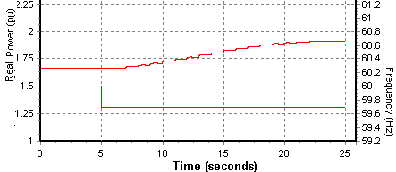
Acceptable Frequency Drop Response
(IRR in a Curtailed State)
-- Real Power
-- Frequency

ower
This IRR model correctly responds to the low frequency condition by boosting output. The model had headroom because it was initialized in a curtailed (power withheld) state.

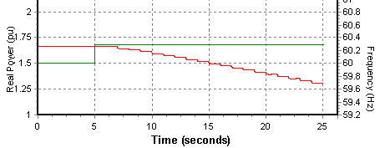
-- Real Power
-- Frequency

ower
Acceptable Frequency Rise Response
This IRR model correctly responds to the high frequency condition by reducing output.

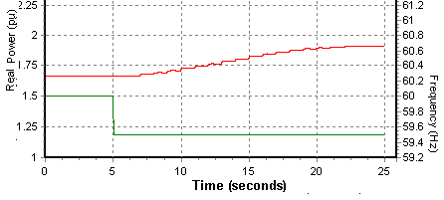
Unacceptable Frequency Drop Response
(IRR in a Power Availability State)
-- Real Power
-- Frequency

ower
This IRR was modeled in a power availability state, meaning that the power dispatch was limited as a result of wind or solar availability. Despite not having any headroom to increase power output, the model did so anyway and so is considered unacceptable.
3.1.5.8 System Strength Test (for IRRs, Inverter-Based Resources, and Inverter-Based Transmission Elements)
This test considers the model performance under varying short circuit ratios (SCR). The SCR of the electric grid can vary over time due to line contingencies, nearby generator status, etc., so it is important for a model to behave well under a range of SCR conditions.
The model shall be tested under at least four different short circuit ratios listed in the table below. If there are concerns about model accuracy under certain lower short circuit ratios, a written explanation of the reason should be provided.

Test | SCR
1 | 5
2 | 3
3 | 1.5
4 | 1.2

Method for Testing SCR:
A test case is set up where the plant model POI is connected to a controllable infinite bus by a branch whose impedance can be programmatically changed during the simulation. Initially, the branch impedance is set to X_{pu} where X_{pu} represents the per-unit reactance necessary to achieve the desired short circuit ratio. After applying a 4 cycle bolted three phase fault to the POI, the branch impedance is changed to reflect a post-disturbance system with higher impedance. A series of short circuit ratios can be tested in the same simulation by progressively increasing the value of X_{pu}, so long as sufficient run time is provided between changes for the model to reach steady state.

Line impedance initially Xpu; increased after clearing fault
Controllable
Infinite Bus
Plant Model Including Transformers and any Collector System
POI
Fault
Calculation of X_{pu}, the Per-Unit Line Impedance:
The short circuit ratio is defined as the measured short circuit MVA (MVA_{fault}) contribution from the system divided into the total generator MW capacity. The measured short circuit MVA is defined as the short circuit current contribution from the system multiplied by the nominal system voltage. Refer to the formula below, assuming a system base MVA of 100.

$$SCR=\frac{{MVA}_{Fault}}{{MW}_{Capacity}}$$

$$SCR=\frac{{100}/{X_{pu}}}{{MW}_{Capacity}}$$

Rearranging,
$$X_{pu}=\frac{100}{{MW}_{Capacity}*SCR}$$

Where
${MW}_{Capacity}$= Total MW capacity of generator(s) under study
$SCR$ = Desired short circuit ratio to test
X_{pu} = Per unit line reactance, on a 100 MVA system base

Example:
- A wind farm consisting of one-hundred 2.0 MW wind turbines is to be tested under short circuit ratios of 5, 3, 1.5, and 1.2. Thus, for the windfarm,
${MW}_{Capacity}$= 200 MW

- Using the equation above, the line impedance (X_{pu}) is calculated for each of the test short circuit ratios.
  - When testing SCR = 5, the line reactance is X_{pu} = 0.1
  - When testing SCR = 3, the line reactance is X_{pu} = 0.17
  - When testing SCR = 1.5, the line reactance is X_{pu} = 0.33
  - When testing SCR = 1.2, the line reactance is X_{pu} = 0.42

For each increase in line reactance, the plant reactive power controller should adjust to restore voltage schedule and compensate for the increase in reactive losses. After applying the fault disturbance, the X_{pu} is modified to a value corresponding to the next lower SCR level to be tested. Models shall provide acceptable responses for an SCR of 3 and higher. If the responses are not acceptable for an SCR of 1.5, then a technical reason for the limitation should be provided, and a model enhancement should be considered.
The figures below include examples of acceptable and unacceptable responses.

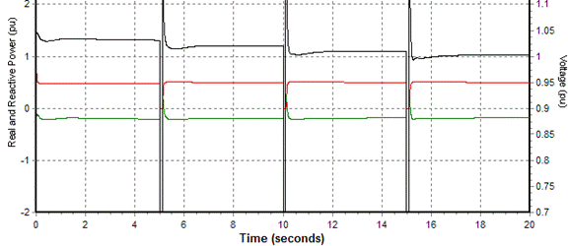
-- Real Power
-- Reactive Power
-- Voltage

ower
Acceptable SCR Response
Model SCR is tested repeatedly starting with SCR = 5 down to SCR = 1.2. This model is stable in all situations.
SCR=5
SCR=3
SCR=1.5
SCR=1.2
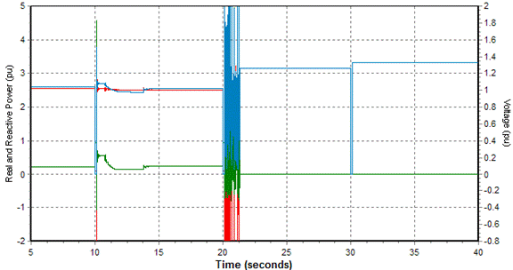
Acceptable SCR Response
Model SCR is tested repeatedly starting with SCR = 5 down to SCR = 1.2. This model goes unstable and trips at SCR 1.5. A technical reason for the poor behavior should be provided.
-- Real Power
-- Reactive Power
-- Voltage

ower
SCR=5
SCR=3
SCR=1.5
Model Trips

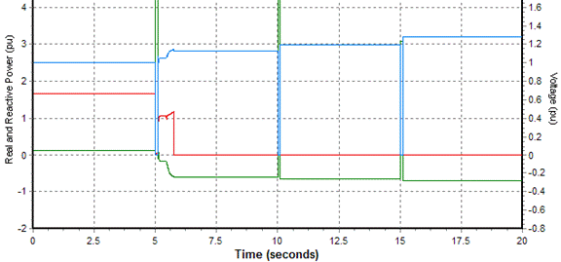
Unacceptable SCR Response
-- Real Power
-- Reactive Power
-- Voltage

ower
SCR=5
SCR=3
Model Trips
Model SCR is tested repeatedly starting with SCR = 5 down to SCR = 1.2. This model trips at SCR = 3, which would be considered unacceptable.
3.1.5.9 Phase Angle Jump Test (for IRRs and Inverter-Based Resources)
This test considers the model performance under a sudden increase or decrease in voltage phase angle as can sometimes occur on the electrical grid under disturbances. The test consists of exposing the model to an instantaneous voltage phase angle increase, and separately, an instantaneous voltage phase angle decrease, to determine the maximum phase angle jump the model can withstand and still remain online and recover to normal operation. The test should be conducted starting with a 180 degree jump, and if the model cannot ride through, decreasing by 30 degrees each time until the model is able to ride through. This test is only required for PSCAD models of inverter-based resources and is currently only intended to provide greater understanding of the device capability (no criterion has been established).

Unit Model Validation
PSCAD models must be accompanied with results from the unit model validation tests performed by the Interconnecting Entity or Resource Entity as required in paragraph (5)(d) of Planning Guide Section 6.2. These validations shall demonstrate the accuracy of the PSCAD models against actual inverter testing and should be performed for all inverter-based device types within the facility. The testing is inverter specific but need not be site-specific. The report should include a description of the test set up as well as the simulation plots of relevant quantities for each test. Guidelines on how these tests should be performed and the expected model performance are provided in the following sub-sections.

3.1.6.1 PSCAD Model Setup

Because the purpose of validation is to test the PSCAD inverter model, it is not necessary to model any balance-of-plant equipment, transformers, collector system, power plant controllers, etc., however any auxiliary inverter-based equipment should also be tested (for example, statcoms). In simulation software, the PSCAD model(s) should be connected to a controllable voltage source whose voltage and frequency can be adjusted for testing. The inverter should be dispatched at full real power unless the test requires otherwise. Energy storage devices should be tested under both charging and discharging modes. Simulations should be run for a minimum of 10 seconds.

3.1.6.2 Inverter Hardware Testbench Setup

The testbench should utilize actual inverter hardware programmed with typical default settings. Thus the test should be representative for all inverter devices under the same hardware and control implementation.

3.1.6.3 Testing

The tests are designed to measure the inverter and model response to small and large magnitude disturbances of frequency and voltage as well as the subsynchronous response to gauge model accuracy. Many of the tests closely parallel those used in the Model Quality Guideline Section 3.1.5. The following tests should be performed on both the PSCAD model and the actual inverter hardware:

  - Step change in voltage, as specified in Section 3.1.5.3
  - Voltage Ride Through, as specified in Section 3.1.5.4 and 3.1.5.5.
  - System Strength Test similar to Section 3.1.5.8. Note: A proposed method to conduct this test is included in Section 3.1.5.8, however other methods can be used so long as they provide comparable results.
  - Voltage Angle Step Test as in Section 3.1.5.9.
  - Subsynchronous Test: Perform a frequency scan sweep to measure the subsynchronous impedance as seen looking into the inverter over the range 5 to 55 Hz in 1 Hz increments. This test is generally conducted by adding a small voltage perturbation of variable frequency superimposed on the fundamental (60 Hz) voltage, and measuring the complex impedance as seen looking into the inverter. The results should be provided both as a plot and as a table and should display Resistance and Reactance plotted over 5 to 55 Hz. Values should be in per-unit on the inverter MVA base. This test should be conducted under the following conditions: Strong system (short circuit ratio = 10), unity power factor, Weak System Lagging (short circuit ratio = 1.5, 0.95 lagging power factor), and Weak System Leading (short circuit ratio = 1.5, 0.95 leading power factor).

Maintenance of Dynamic Models
Maintenance of the models is the responsibility of the device owner. Models shall be maintained in accordance with Section 3.2. Any user-written dynamic models shall also be maintained to fulfill the requirements as described in the Planning Guide Section 6.2 and Section 3.1.4 in this manual.

Dynamic Data for Existing Equipment
“As-built” data is required for all completed facilities in accordance with Section 3.2. To help ensure that dynamic model data is kept up to date with site-specific settings, paragraph (5)(b) of Planning Guide Section 6.2 introduces a “plant verification” requirement. The plant verification reports should confirm that the model correctly reflects site-specific settings by presenting evidence such as delivery and testing reports, screenshots or pictures of actual hardware settings, attestations from the equipment manufacturer, etc.

Dynamic Data for Planned Equipment
The development of future year case data may require an entity to submit the best available information for the planned equipment prior to development of a detailed design. In such cases, estimated or typical manufacturer’s dynamic data, based on units of similar design and characteristics, may be submitted. However, the Resource Entity shall update the model information upon completion of the detailed design and again upon commissioning the equipment. Dynamic data for planned equipment shall be submitted in accordance with Planning Guide Section 6.2 and Section 3.2 in this manual.

Unacceptable Dynamic Models
The DWG adopted a list of unacceptable dynamic models developed by the NERC System Analysis and Modeling Subcommittee (SAMS) with exception of those models for which DWG has a technical justification not to adopt.
- Unacceptable models that already exist in the ERCOT dynamic dataset shall be phased out through dynamic model updates including updates received via the NERC MOD-026-1 and MOD-027-1 processes.
- If a generation interconnection or dynamic model update has begun prior to a model being identified as unacceptable by NERC, the model may be allowed.
- The list of acceptable/unacceptable dynamic models are published on the NERC website.

Dynamic Data for Equipment Owned by Resource Entities (REs)

Dynamic Data Requirements for New Equipment
Note: This section addresses the requirements stated in R1 of NERC Standard MOD-032-1 (effective July 1, 2015).
REs are responsible for providing models with model parameters resulting in a tuned model that represents the dynamic performance of the device. Final responsibility for the submission and the accuracy of the dynamic data lies on the RE. ERCOT and the DWG will provide voluntary assistance if requested by REs to complete parameter tuning and prepare model records. The DWG member representing the TSP to which the RE is connected is responsible for working with ERCOT to incorporate the dynamic data received from the RE into the DWG Flat Start cases (dyre file) during annual updates.
The RE shall fulfill its interconnection data requirement by including acceptable dynamic data and models for their facilities. The RE may have additional model and data reporting obligations to ensure compliance with NERC reliability standards and/or other requirements.
The following two subsections describe data requirements for two distinct categories of generation facilities:
  - Synchronous Generation Facilities :
- The model data shall include, at minimum, a generator model, a governor model, an exciter model, and if applicable, a power system stabilizer model and an excitation limiter model.
- Explicit frequency protection relay models shall be provided for all generators where relays are set to trip the generating unit within the “no trip zone” of NERC Standard PRC-024 Attachment 1.
- Explicit voltage protection relay models shall be provided for all generators where relays are set to trip the generating unit within the “no trip zone” of NERC Standard PRC-024 Attachment 2.
- A governor model is not required for the steam turbine(s) of combined cycle plants.
  - Inverter-based Generation Facilities:
The RE shall provide the following data as applicable to the generator technology:
- Model, data and description of voltage control method.
- Model, data and description of how they will meet ERCOT reactive requirements.
- A one-line diagram of the proposed facility.
- Data for all transformers. The data should include:
  - MVA rating.
  - High and low-side rated voltage.
  - Number of taps, and step size.
  - Impedance, including base values if different from rated values listed above.
- Dynamic modeling data including:
- Wind generator or solar inverter manufacturer and type.
- Rated voltage.
- Rated MVA.
- Reactive capability, leading and lagging.
- Rated MW output.
- Net MW output.
- Transient or subtransient reactance, including base values, if applicable.
- Transient or subtransient time constant, if applicable.
- Total inertia constant, H, of generator, including the shaft and gearbox, if applicable.
- Number of machines by manufacturer types.
- Reactive resource data such as capacitor banks, STATCOMS, etc. Provide the number of devices, location of the devices, step size, speed of switching, location where voltage is monitored and controlled, control strategy, and voltage limits. For dynamic reactive devices, provide the appropriate model and data.
- Line data from the POI to each generator shall include:
- Line type (overhead or underground)
- Line length
- Line resistance in ohms/1000 ft
- Line reactance in ohms/1000 ft
- Line susceptance in mhos/1000 ft
- Wind turbine models shall account for rotor mass, aerodynamic energy conversion, and pitch control.
- Explicit frequency protection relay models shall be provided for all IRRs where relays are set to trip the resource within the “no trip zone” of NERC Standard PRC-024 Attachment 1.
- Explicit voltage protection relay models shall be provided for all IRRs where relays are set to trip the resource within the “no trip zone” of NERC Standard PRC-024 Attachment 2.

Updates to Existing Dynamic Data
The RE shall submit dynamic model updates to ERCOT and the TSP to which they are connected within 30 days of any facility change and/or test result that necessitates a model update to accurately reflect dynamic performance. The data requirements specified in section 3.2.1 for new equipment also apply to all submitted model updates. Obsolete data should be deleted or commented out as appropriate in the dynamic data.

Data for Load Resource
ERCOT will prepare the dynamic model using a standard model for Load Resource that is qualified to provide Responsive Reserve (RRS) through under frequency relay models. Data for the Load Resource model shall be documented in the Stability Book.

Dynamic Data for Equipment Owned by Transmission Service Providers (TSPs)

Under Frequency Firm Load Shedding (UFLS) Relay Data
UFLS data shall be prepared annually in accordance with ERCOT and NERC standards. TSPs are responsible for preparing the UFLS relay model records for their respective loads. The TSP shall submit the UFLS relay data to ERCOT in the form of a data file using an appropriate model compatible with the software listed in Section 3.1.1. The models should contain the necessary information to properly represent the UFLS relay actions in a dynamic study, including:
- Location (bus number and/or load ID) of load to be interrupted.
- Fraction of load to be interrupted.
- Corresponding frequency set points.
- Overall scheme clearing times (including all time delays, breaker clearing times, etc.)
Also, the TSP should indicate any other schemes that are part of or impact the UFLS programs such as related generation protection, islanding schemes, automatic load restoration schemes, automatic capacitor/reactor switching, and Remedial Action Scheme (RAS).
All UFLS data will be documented in the annual Stability Book.

Under Voltage Load Shedding (UVLS) Relay Data
An ERCOT TSP which has UVLS relays in its service area designed to mitigate under voltage conditions potentially impacting the system reliability is to establish and maintain a UVLS Program consistent with NERC Standards.
The TSP owning an UVLS Program will submit the corresponding relay model to ERCOT during the annual Stability Book update. The DWG member shall submit the UVLS relay data in the form of a data file using an appropriate model compatible with the software listed in Section 3.1.1.
It is the responsibility of the TSP to ensure the UVLS program model submitted has been tested through an assessment as per NERC standards.
Also, the TSP shall indicate any other schemes that are part of or impact the UVLS programs such as related generation protection, islanding schemes, automatic load restoration schemes, automatic capacitor/reactor switching, and RASs.
The model shall contain the necessary information to properly represent the under voltage relay actions in a dynamic study, including:
- Location (bus number and/or load ID) of load to be interrupted.
- Fraction of load to be interrupted.
- Corresponding voltage set points.
- Overall scheme clearing times (including all time delays, breaker clearing times, etc.).
All UVLS data from the responsible entities will be documented in the annual Stability Book.

Protective Relay Data
The operation of protection, control, and RAS systems can affect the dynamic performance of the ERCOT system during and following contingencies. Planning, documenting, maintaining, or other activities associated with these systems is outside the scope of the DWG. However, because they can affect dynamic performance, the DWG should, on an as needed basis, identify and document protection, control, and RAS systems for inclusion to its dynamic data sets. Identification of these protection systems will normally require the assistance of individuals or groups outside the DWG. The specific information to be considered for inclusion will depend on the type, purpose, and scope of study.
Protection, control, and RAS systems included in the DWG dynamic data should be in the form of a dynamic model and shall be compatible with the software listed in section 3.1.1. Protection, control, and RAS systems adequately modeled for dynamic purposes by other working groups only need to be referenced in the DWG study reports.
The DWG member, as part of the annual dynamic data update, shall review and update as necessary protection, control, and RAS systems already in the DWG database. This review should include evaluating the existing data for applicability and accuracy.
Protective relay data included in a DWG flat start case shall be documented in the Stability Book.

Load Model Data
Note: This section addresses the requirements stated in R1 of NERC Standard MOD 032-1 and R2.4.1 of NERC Standard TPL-001-4.
Another key component of any dynamic study is the load model and its representation as a function of changing frequency or voltage. The load model can have a significant effect on results of dynamic analysis. For this reason, it is important to use an appropriate load model during the study.
The DWG shall review and update static load models for each area, composed of a mix of constant impedance (Z), constant current (I), and constant power (P) representations, known as ZIP models. PSS/E CONL activity is used to incorporate the ZIP models into a PSS/E study.
Additional detailed data for dynamic load modeling (large motor MW, small motor MW, etc.) is provided in the Annual Load Data Request (ALDR). ALDR information can be used with generic motor model parameters for screening purposes.
The DWG recommends the use of a composite load model to represent various typical dynamic load elements, and in particular, modeling of Air Conditioning load as needed for studies. These load dynamic models are not included in the DWG flat start cases.
Within 30 days of a written request from ERCOT, a TSP shall provide load dynamic models compatible with the software listed in Section 3.1.1 with documentation explaining the process to derive such models.
The DWG shall review the standard load-frequency dependency model (LDFRAL) and update the model if necessary. The model shall be documented in the Stability Book.

Other Types of Dynamic Data
Note: This section addresses requirements stated in R1 of NERC Standard MOD 032-1 (effective July 1, 2015).
All elements with dynamic response capabilities (such as SVC, STATCOM, Superconducting Magnetic Energy Storage (SMES), DC tie, fast switchable shunts, and Variable-Frequency Transformer) that are in service and/or modeled in the SSWG base cases shall be represented with an appropriate dynamic model compatible with the software listed in Section 3.1.1. The DWG member of the TSP owning the equipment shall submit the model to ERCOT during the annual dynamic database update or as needed for studies.

Missing or Problematic Dynamics Data
The DWG is responsible for reviewing the dynamic data on an annual basis and reporting to the ROS any missing data or unresolved issues relating to data submission requirements. DWG will report select data problems to the respective ERCOT working group per Section 4.2.3.
If the DWG and/or ERCOT identifies inappropriate or incomplete dynamic data, the appropriate DWG member and/or ERCOT shall request that the equipment owner resolves the discrepancies by following processes established by existing NERC Standards or ERCOT requirements. The final responsibility for the submission and the accuracy of the data lies with the equipment owner. All of the data and the revisions requested by ERCOT shall be resolved by the entity owning the equipment within 30 days. Until valid data becomes available, ERCOT or the DWG member to whose system the equipment is connected shall recommend an interim solution to the missing or problematic data.

Dynamic Data and Stability Book Storage
ERCOT shall make available to the DWG members in electronic format the dynamic data described in this document. ERCOT shall maintain a repository of dynamic data approved by the DWG and will maintain the submitted revisions.

3.5 Dynamic Models for Distributed Generation

3.5.1 Distribution Generation Resource (DGR) and Distribution Energy Storage Resource (DESR)
RE provided models will be used to represent inverter-based DGRs and DESRs. If the RE is not required to provide a model and/or an adequate model is not available to DWG, the DER_A model will be used. Parameterization will be based on DWG approved parameters in the ERCOT DWG DG Parameterization Guideline for the DER_A model and will represent capabilities consistent with the DGR/DESR requirements in the ERCOT Nodal Operating Guide.
RE provided models will be used to represent synchronous DGRs. If the RE is not required to provide a model and/or an adequate model is not available to DWG, a generic model with DWG approved parameters in the ERCOT DWG DG Parameterization Guideline will be used with capabilities consistent with the DGR requirements in the ERCOT Nodal Operating Guide.

3.5.2 Settlement Only Distribution Generator (SODG)
RE provided models will be used to represent inverter-based SODGs with nameplate capacity of 5 MW or greater. If the RE is not required to provide a model and/or an adequate model is not available to DWG, the DER_A model with DWG approved parameters in the ERCOT DWG DG Parameterization Guideline will be used.
RE provided models will be used to represent synchronous SODGs with nameplate capacity of 5 MW or greater. If the RE is not required to provide a model and/or an adequate model is not available to DWG, a generic model with DWG approved parameters in the ERCOT DWG DG Parameterization Guideline will be used.
SODGs less than 5 MW will be represented as negative load (with GNET) in DWG base cases.

3.5.3 Unregistered Distributed Generation (UDG)
UDG dynamics will not be explicitly represented in DWG base cases. DWG will not modify UDG representation from the SSWG case - UDG will be embedded or reflected in the load according to current TSP conventions.

Overview of DWG Activities

Updating Dynamic Data and Flat Starts

Schedule for Dynamic Data Updates and Flat Start Cases
Note: This section addresses requirements stated in R2 of NERC Standards TPL-001-4.

Each June, the DWG shall prepare a detailed schedule for developing flat start cases and providing associated dynamic contingencies. The DWG shall begin the flat start case development process as soon as practicable after SSWG base cases are posted – normally July 1. The DWG shall prepare flat start cases for near term on-peak, near term off-peak and long-term on-peak conditions to facilitate planning assessments required by NERC Standard TPL-001-4. It is intended that the three dynamic data sets be developed concurrently to be utilized in planning assessments for the next year (YR+1). The following diagram presents a schedule as a reference for DWG flat start case development:
YR (YR=Current Year) |  |  |  |  |  |  |  |  | YR + 1
Apr | May | Jun | Jul | Aug | Sep | Oct | Nov | Dec | Jan | Feb | Mar
YR SSWG Build Process
July 1 - Cases Posted
 |  | Prepare DWG Flat Start Schedule | DWG Dynamic Flat Start Case Development  Near Term On-Peak Case  Near Term Off-Peak Case  Long Term On-Peak Case
 |  |  |  |  |  |  |  | Final DWG Data Sets Posted
 |  |  |  |  |  |  |  |  | Submit Dynamic Contingency Files and Dynamic Load Models
 |  |  |  |  |  |  |  |  | Stability Book Finalized and Posted

The DWG flat start case development process adds detailed dynamic models to network elements represented in an SSWG base case that reflect behavior during and following system disturbances. The DWG shall normally prepare dynamic flat start cases based on the following SSWG steady state cases:
- Near-Term On-Peak Case: (Y+3) SUM1
- Near-Term Off-Peak Case: (Y+4) HWLL
- Long-Term On-Peak Case: (Y+7) SUM1
For example, the following flat start cases would be developed during the period from July 2017 through January 2018: 2020 SUM1, 2021 HWLL, and 2024 SUM1. These cases could then be used for planning assessments performed in 2018. The DWG may choose to develop dynamic flat start data sets for alternative cases that meet the same objectives with respect to facilitating the completion of NERC TPL planning assessments.
After January 1st, 2015, ERCOT shall serve as the flat start coordinator for all DWG flat start cases.

Dynamic Data Updates
Each DWG member shall review the dynamic data from the prior year for its portion of the ERCOT System and provide necessary updates according to the schedule established in section 4.1.1. The changes in the data must be identified and submitted with the updated data.
Data for mothballed units shall be retained. Obsolete data should be deleted or commented.
Other revisions of data that should be submitted to the flat start coordinator include updates to the load model, Zsource corrections, generation netting, or any other modifications to the network necessary for dynamic studies.

Dynamic Data Screening
The DWG members should review the dynamic data for equipment connected to their system for completeness and applicability. The data should be appropriate for the model, and the model should be appropriate for the equipment. Before submitting data for inclusion in updated dynamic base cases, each DWG member should perform dynamic data screening.

Flat Start Criteria
DWG Flat Start cases shall:
- Initialize with no errors;
- Demonstrate that simulation output channels for frequency, voltage and power do not deviate from an acceptable range for a ten-second run with no disturbance.
- The product of a successful flat start will be a planning model software simulation-ready base case (the unconverted base case) with its associated dynamic data files including user models (.dyr, .obj, .lib, and .dll files), stability data change documentation, python (.py) files and response files (.idv) files. The product of a successful flat start also includes the steps taken to build the flat start case such as network model changes (i.e. changing the schedule of the North DC, tuning voltages, etc.).

Post Flat Start Activities

Distribution of Flat Start Results and the Dynamic Data Base
Upon completion of each flat start, all dynamic data and final data files shall be posted on the ERCOT MIS so that it is accessible to all DWG members and to ERCOT. This posting shall be within the schedule established by the DWG for the given flat start.

Stability Book
The Stability Book is an annual document used to record dynamic data changes and/or corrections required during the flat start processes. The flat start coordinator shall prepare the annual stability book. Recommendations to revise load flow data are also included in the book. DWG Members are required to communicate these recommendations to other respective working groups, including Steady State Working Group, Operations Working Group, and Network Data Support Working Group, to eliminate recurring problems.
The following information is included in Stability Book:
- Deviation tables or plots of the flat start results are included to verify the successful completion of the flat start process.
- Dynamic data. This data is in the DOCU ALL PSS/E activity format.
- Under frequency and under voltage load shedding relay data submitted by each of the appropriate DWG members.
- Additional information identified for inclusion by Section 3.4

DWG Coordination with the Steady State Working Group
To support coordination with the Steady State Working Group, Operations Working Group, and Network Data Support Working Group a list of changes made to the following steady-state power flow data shall be reported to the ERCOT Steady State Working Group representative:
- Unit MVA Base: this is also known as MBASE and is used as the base quantity for many dynamic model parameters associated with generating units.
- Zsource: reactive machine impedance that is required to match the subtransient reactance specified in the dynamic generator model for proper initialization of dynamic simulations.
ERCOT shall compile the list of data changes following finalization of the flat start DWG shall coordinate with SSWG to assure that conflicting data is corrected during future SSWG case building activities.

DWG Dynamic Contingency Assumptions List
The DWG shall construct a dynamic contingency assumptions list detailing contingency assumptions for each TSP for the purpose of screening studies conducted by ERCOT and the DWG members. ERCOT and the DWG members shall annually review and update the dynamic contingency assumption list. Upon completion of the annual review, ERCOT shall collect the contingency assumptions and submit the finalized dynamic contingency assumptions list to the DWG.

The assumptions shall include:
- Breaker trip time for normal clearing,
- Breaker trip time for delayed clearing due to stuck breaker
- Breaker trip time for delayed clearing due to relay failure
- Relay characteristic assumptions to assess generic apparent impedance swings that can trip any transmission system elements
- Other assumptions deemed necessary by DWG as specified during the annual review

DWG Dynamic Contingency Database
The DWG shall prepare a Dynamic Contingency Database according to a standard spreadsheet format. The spreadsheet format will be reviewed annually. The dynamic contingency database will be posted on the ERCOT Market Information System (MIS) so that it is accessible to all DWG members and to ERCOT.

Other DWG Activities

Event Simulation
Note: This section addresses NERC MOD-033-1.
ERCOT will compare dynamic system model performance to that of actual system response data at least once every 24 calendar months.
If no significant dynamic event occurs within the 24 calendar months, the next dynamic event that occurs will be used to validate system performance.
- An event will be selected based on its impact to the network and availability of recorded data. ERCOT will request Market Participants affected by the event to supply the actual network performance data records in electronic format.
- ERCOT will create a reasonable replica of the system configuration and power flow conditions at the time the event occurred in a dynamic system model, with contingencies replicating the sequence of switching activities that occurred during the event.
- ERCOT will determine the acceptable fidelity of the dynamic system model by comparing system performance simulations to that of actual system performance.

A system validation simulation will be deemed not acceptable if:
- The simulation crashes or does not produce data output.
- The signals simulated do not trace actual system performance for the selected measured signals.
- The post-event steady-state power flow of selected 345 kV lines deviate more than 10% from their actual measured values.

A difference in performance will be resolved as follows:
- ERCOT will identify deficient models and suggest replacements or corrections to achieve acceptable fault performance.
- Faulty data or modeling information will be reported back to the data owner. When existing NERC standards are applicable (i.e.: MOD-026, MOD-027, MOD-032, TPL-001), data correction shall follow such process.
- Section 3.4.6 applies while data is being corrected. Section 4.2.2 applies to communicate these finding to other respective working groups.

The DWG will review recent significant events to determine their suitability for an event simulation. For a selected event, the affected TSP will provide actual system behavior data (or a written response that it does not have the requested data) to ERCOT within 30 calendar days of a written request.

Procedure Manual Revision Guidelines
The DWG is responsible for maintaining and updating this Procedure Manual. Revisions, additions and/or deletions to this Procedure Manual may be undertaken at such times that the DWG feels it is necessary due to changes in dynamic simulation software or to meet new and/or revised requirements of NERC, ERCOT, or any other organization having oversight or regulatory authority.
At least annually, the DWG chair shall request a thorough review of the current Procedure Manual for any needed revisions. The notification will request that proposed revisions be submitted to the DWG chair (or the chair’s designate) for consolidation and distribution to all DWG members for comment and/or additional revision.
The DWG chair may seek approval of any revision, addition, or deletion to the Procedure Manual in the regular DWG meetings, or called special meeting as deemed necessary or requested by DWG membership.
All proposed Procedure Manual revisions shall be submitted to ROS for approval.

Recommended DWG Study Methodologies
Note: This section addresses, in part, requirements R4, R5 and R6 of NERC Standard TPL-001-4
Voltage stability margin, transient voltage criteria, and damping criteria are described in the ERCOT Planning Guide Section 4.

Voltage Instability Identification in Stability Studies
Voltage Instability is indicated by severely low bus voltage or bus voltage collapse.
Voltage Instability could cause:
- Motor stalling leading to significant amount of customer initiated motor tripping.
- Loss of generator(s) due to low voltage
- Voltage collapse of an area

Cascading Identification in Stability Studies
Cascading Definition - Cascading is defined as the uncontrolled loss of any system facilities or load, whether because of thermal overload, voltage collapse, or loss of synchronism, except those occurring as a result of fault isolation. Cascading is indicated by one or more of the following conditions:
- Uncontrolled sequential loss of generators
- Uncontrolled sequential loss of load
- Uncontrolled sequential loss of branches.
Cascading could cause conditions like:
- Voltage collapse of an area
- Expanding number of buses with voltage instability
- System islanding, frequency instability due to power-load unbalance
NERC Definition: The uncontrolled successive loss of system elements triggered by an incident at any location. Cascading results in widespread electric service interruption that cannot be restrained from sequentially spreading beyond an area predetermined by studies.

Uncontrolled Islanding Identification in Stability Studies
Uncontrolled islanding is the separation and loss of synchronism between a portion of the interconnection and the remaining interconnected system. Islanding originates with uncontrolled loss of branches, ending with the formation of sub-network islands.
Generators disconnected from the System by fault clearing action or by a RAS are not considered out of synchronism. Similarly, islands formed from being disconnected from the System by fault clearing action or by a RAS are not considered an uncontrolled island.
Sub-network islands have the following characteristics:
- The sub-network islands have both generation and load to support the continuation of the island.
- The sub-networks formed are not connected to each other.
Uncontrolled islanding in a screening study could cause:
- Out-of-step generators
- Off-nominal frequency disturbances
- Eventual collapse of an island due to frequency or voltage instabilities caused by the generation-load unbalance in the sub-network island.

Generator Protection Assumptions
Note: This section addresses, in part, requirements R3.3.1.1 and R4.3.1.2 of NERC Standard TPL-001-4 (effective January 1, 2016).

If dynamic models are not provided for Generator protection schemes, generic generator protection may be assumed for screening purposes
- For synchronous generators, a rotor angle swing greater than 180 degrees may be considered an unstable generator.
- Generators may be assumed to be compliant with the minimum requirements of Section 2.9 Voltage Ride-Through Requirements for Generation Resources of the ERCOT Nodal Operating Guide.
- Generators may be assumed to be compliant with the minimum requirements of Section 2.6 Requirements for Under/Over-Frequency Relaying of the ERCOT Nodal Operating Guide.

Refer to the UDM Model Guideline and PSCAD Model Guideline posted under ‘Model Quality’ on the ERCOT Resource Registration webpage for helpful details about compatibility.
https://www.nerc.com/pa/RAPA/ModelAssessment/Pages/default.aspx
For ERCOT resource definitions and acronyms, reference “Resource” in Section 2 of the Current Protocols: http://www.ercot.com/mktrules/nprotocols/current
For information on SSWG case assumptions, please reference the SSWG Procedure Manual: http://www.ercot.com/committee/sswg

