Key Topic Concept (KTC) Number | 15.3 | KTC Title | 15.3 Switchable Energy Storage Resources (SWESRs)
Date Posted |  | October 22, 2021 -- Draft version for discussion at the 10-25-21 WMWG meeting
Executive Summary |  | KTC 15.3 Switchable Energy Storage Resources (SWESRs) was assigned to ROS and WMS in April 2021. This KTC Recommendation reflects the discussion and conclusions from those subcommittees and underlying Working Groups on various subtopics and questions related to SWESRs. Before a SWESR could be connected, there are several key legal/policy questions that need to be addressed by the PUCT and FERC. Assuming a positive resolution and clarification of those issues, protocol language and system changes would be necessary. Today, there are several Market Participants actively exploring the concept of interconnecting a SWESR.  Currently there is existing protocol language and Coordination Plans between ERCOT and SPP and ERCOT and MISO that address the existing 5 sites with Switchable Generation Resources (SWGRs). The basic approach outlined below is to leverage the existing framework and broaden the capability to Switchable Resources (therefore including switchable ESRs). There will need to be modifications to protocols and Coordination Plans to address issues unique to SWESRs.  In general, there are not any major reliability or operational concerns. Operator staffing levels at ERCOT will need to be monitored if there is a material increase in switchable Resources.  Settlement for SWESRs is expected to be very similar to settlement for the existing SWGRs.
Recommendation Description |  | The following is a summary of the recommendations:  Reliability and Operations: Operating instructions and procedures for all Switchable Resources (SWRs) should be how they are done today for the SWGRs and technology type should not matter. Revise Protocols, procedures and coordination agreements as necessary to account for the limited duration issues. Adjust ERCOT staffing if required due to a material increase in SWRs and/or limit the number of new SWRs.  Legal/Policy: Clarification from the PUC will be needed as to whether a CCN is needed, and a declaratory order from FERC will be needed to address whether charging in another region and discharging in ERCOT (or vice versa) constitutes transmission in interstate commerce. ERCOT will need these issues to be appropriately clarified before SWESRs will be allowed to interconnect. Dual Mode: DC-Tie/ESR configurations present jurisdictional issues and cannot be allowed. WSL treatment is not available for consumption by SWESRs unless appropriate Protocol language and system changes are developed and implemented.  Settlements:  Protocol language and any required system changes for implementation are needed prior to WSL treatment availability for SWESRs charging energy.  The bulk of the other Settlement for SWESRs is expected to be very similar to settlement for the existing SWGRs. A few details are noted.
Discussion Summary |  | This KTC was discussed at the OWG and ROS several times. At the 9-2-21 ROS meeting, the information from OWG was presented to ROS and after some discussion, ROS marked KTC 15-3 as “closed”. This KTC was “re-introduced” at the September WMWG meeting and briefly discussed. ERCOT requested comments by the end of September, and none were received.  ERCOT staff prepared the initial draft of the KTC and presented it at the 10-25-21 WMWG meeting.
TAC Action Requested |  | WMS and ROS plan to request at the dd/mm/yyyy TAC meeting a vote to approve KTC 15-3. If the KTC is approved by TAC, TAC will need to provide direction on the priority for an NPRR to be drafted.
TAC Action Summary |  | TBD

Proposed KTC Recommendation Language

Key Topic/Concept recommendation Language for TAC Approval
Operational and Reliability Issues
- In general, ERCOT and ROS did not see any reliability issues with having switchable ESRs and did not identify any major issues assuming current rules for SWGRs apply to switchable ESRs.
- The suggested approach is to add two new terms to go with the existing term SWGR. Add a broader term such as Switchable Resources (SWRs) and add another term (on the same level as SWGR) for switchable ESRs (SWESRs). There would be three terms SWRs, SWGRs and SWESRs. (SWRs would be used when referring to SWGRs and SWESRs.)
- In general, SWESRs will be instructed to switch and “handled” like SWGRs.
- Existing Coordination Plans with SPP and MISO will need to be slightly modified.
- ERCOT would be informed of the State of Charge (SoC) of the battery when it is operating in a Non-ERCOT control area due to the requirement that the ESR shall continue to provide telemetry and COP information even when interconnected to a non-ERCOT area. SoC is data required to be telemetered by all ESRs. This should provide ERCOT Operators the situational awareness needed to maintain reliability.
- ERCOT staffing levels will likely need to be increased if there’s a significant increase of Switchable Resources. May want to consider initially limiting the total number of new switchable resources. ERCOT will need to discuss with SPP & MISO and adjust coordination plans as necessary.
- The procedure for a SWR to switch from one area to another area will likely need to be reviewed and adjusted to accommodate potentially more voluntary switching. The procedure should be well communicated so QSEs representing SWRs are aware of the timing.
- SWESRs will need to be considered in planning studies using the approach used for switchable resources and the approach used for limited duration resources.

Legal/Policy Issues
- Would a SWESR need a CCN?
  - PURA § 37.056(c-1) requires a CCN for “a facility . . . that enables additional power to be imported into or exported out of the ERCOT power grid.”
  - SWESRs would draw power from another grid and inject that power into ERCOT (or vice versa) through use of a storage medium, raising a question of the applicability of this provision.
  - PUC direction would be needed on this issue.

- Would charging in another grid and discharging in ERCOT (or vice versa) constitute a transmission or sale of electric energy in interstate commerce?
  - This issue was raised, but not decided, in Alternative Transmission, Inc., FERC Docket No. EL19-69-000.
  - FERC would need to clarify this through a declaratory order before ERCOT could allow any SWESR to interconnect.

- Any site configuration that could allow the flow of electric energy (through an AC-DC-AC interconnection or otherwise) between ERCOT and another interstate power grid without being converted by the ESR into chemical energy or another form of energy would raise a jurisdictional concern because that flow would constitute a transmission of electric energy in interstate commerce.
  - ERCOT rules should require that each SWESR site be configured in such a way that
    - the site cannot maintain a simultaneous electrical connection to ERCOT and another grid, or
    - energy withdrawn by the ESR from another grid cannot be injected into ERCOT (or vice versa) without first going through the ESR’s chemical storage medium or other energy conversion process.
- This risk could also be addressed if FERC were to issue an order under Sections 210 and 211 of the Federal Power Act requiring interconnection and transmission service. But an order may not be available in many cases due to certain conditions in the statute.

- Is energy consumed by a SWESR eligible for Wholesale Storage Load Treatment?
  - Protocol language and system changes for implementation are needed prior to WSL treatment availability for SWESRs when charging from the ERCOT grid.
  - Protocol language could be developed to specify that the quantity of energy withdrawn from the ERCOT grid that is eligible for WSL treatment is limited to the quantity of energy injected into the ERCOT grid.
  - System changes required could build on the “Generation Accumulator” concept in NPRR995 (which has been approved by the ERCOT Board).
  - Additionally, under this approach, all metering requirements and exclusions of energy consumed for thermal management of the ESR should apply.

Settlement Issues

- If a SWESR is directed to switch to ERCOT from a non-ERCOT Control Area, the QSE for the SWESR should be eligible for electricity costs incurred to charge the ESR to comply with the switch instruction, regardless of where (non-ERCOT control area or at ERCOT control area) the ESR charged.

- The switchable cost guarantee for SWESRs should not include Startup or minimum energy costs.

- The SWESR should be made whole to approved switchable costs above ERCOT calculated Real-Time revenues, similar to SWGRs.

Key Topic/Concept recommendation Language Previously APProved by tac

Key Topic/Concept recommendation Language IN DISCUSSION AT ROS and WMS
None.

Future Decision Points and Issues for Developing Key topic/Concept recommendation Language
None.
Applicable Protocol Section(s)
Impacted System(s) / Application(s)

Appendix:

Figure 1: One Inverter Configuration
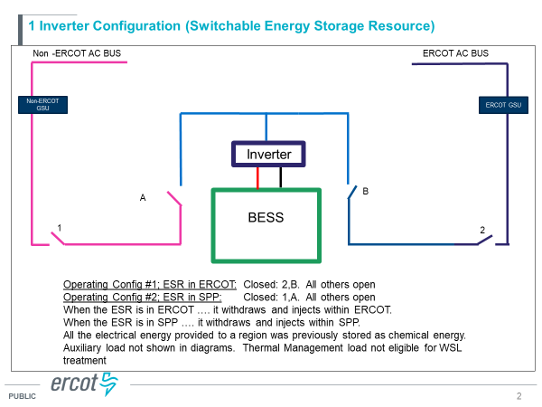

Figure 2: Two Inverter Configuration: (This Configuration is “out of scope” and not allowed.)

