RECTF
September 28th, 2021
WebEx only

Attendee | Company | Attendee | Company |  | Attendee | Company
Jim Lee | AEP | Eric Goodwin Jr |  | CNP | Amy Quintero | CNP
Jordan Troublefield | ERCOT | Martin Ramirez |  | CNP | Chris Hendrix | Demand Control
Sam Pak | Oncor | Marilyn Hudson |  | CNP | Eric Broach | Gexa
Kyle Patrick | NRG | Lee Doehring |  | CNP | Eric Lotter | GridMonitor
Norm Levine | NRG | Terri Wilson Lester |  | CNP | Sheri Wiegand | Vistra
Angela Ghormley | Calpine | Alberto Lopez |  | CNP | John Schatz | Vistra
Scott Smith | Tenaska | Chris Dominguez |  | CNP | Deb Belin | Marketwise
John Varnell | Tenaska | Kathy Scott |  | CNP | Kim Dew | ?
Richard Beasely | CNP | Carolyn Reed |  | CNP | Tony March | Legends Unity
John Hudson | CNP | Jill Bell |  | CNP | Mansoor Khanmohamed | EDF

Jim Lee opened the meeting reading the Antitrust Admonition.
Meeting minutes from August 31st were reviewed and approved.

Emergency Conditions List (ECL)
Jim reviewed the ECL noting revisions to any item. A few notables:
- #18 – Meter Data and Estimations
#126 – TDSP Data Practices During Prolonged Widespread Outages
AMS Data Practices matrix including the addendum questions regarding prolonged widespread outages were finalized and will be presented by RECTF at the upcoming RMS in October. Matrix will reside on RMS home page under Key Documents. These items will then be complete.
- #125 – Demand Billing Considerations – much discussion on the ‘out of market’ PUC directive for TSDPs to reset Demand billing for Customers impacted by cold load pickup during Winter Storm Uri (Feb 2021). TDSP tariffs do not allow for resetting/revising demand billing unless otherwise directed by the PUCT, so modifying the demand required manual intervention for all impacted TDSPs. Additionally, the TDSPs have differing systems and system constraints; therefore, yielding differing results for impacted MPs. In the end, it was the RECTF recommendation that in future instances where out of market directives occur, for all impacted market participants (ERCOT, TDSPs, REPs, PUCT Staff) to collaborate to find a workable solution mitigating any unintended consequences.
- #20 – “Should there be modifications for Validation, Editing and Estimation of meter data? What is the extent of billing errors caused by this?” ACTION item for Randy Roberts was to provide data received by ERCOT on OD + 1. Below is a graph of the timeliness of AMS data received by ERCOT on Day 1 from March through August 2021.
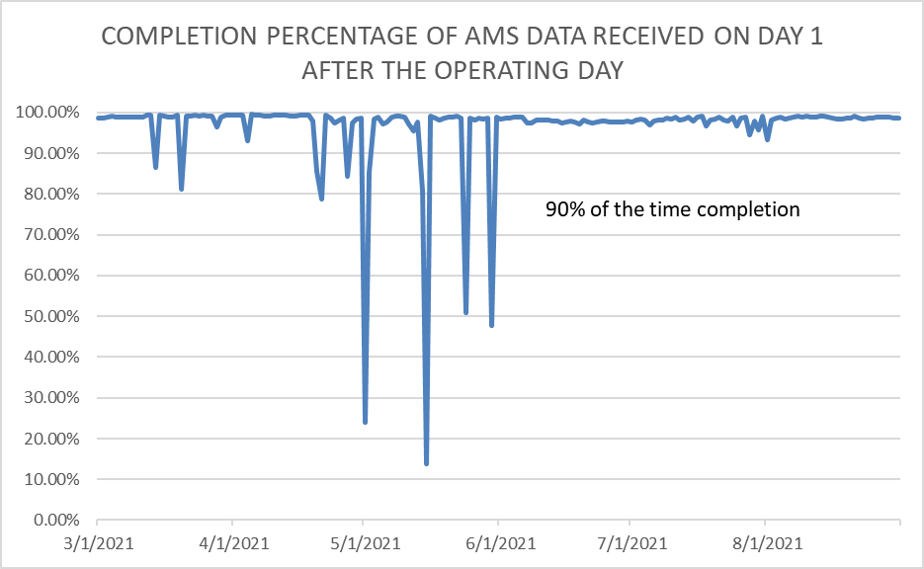
Jim will report to TAC confirming the following regarding AMS Data received on Day 1 from the TDSPs:
90% of the time, 97% of the data is received
95% of the time, 85% of the data is received.
- #118 – New REP requirements – this item has officially been removed from the RECTF action items.

TDSP AMS Data Practices Matrix
Jim reviewed the final edits as discussed at the last RECTF meeting, particularly #13 adding the following comment:
TDSPs will make all reasonable attempts to provide market notice(s) when Gap Retrieval process has been initiated outside of normal Gap Retrieval processing, for potential impacts to Time of Use customer’s billing.
All other edits were approved.

Weather Preparedness – Q & A – Updated Matrix
Both the Energy Emergency Alert definition and the Emergency Operations Plan definition placed at the top of each matrix were reviewed and approved. These matrices will be utilized during the Winter Weather Preparedness Workshop to be held November 2nd after RMS.
Energy Emergency Alert:
Energy Emergency Alert (EEA) is a series of emergency procedures ERCOT utilizes when operating reserves drop below specified levels. These procedures are designed to protect the reliability of the electric system as a whole and prevent an uncontrolled system-wide outage. When ERCOT issues an EEA, it is able to take advantage of additional tools & resources that are only available during scarcity conditions. However, if all of the available EEA tools are insufficient, ERCOT will instruct Transmission & Distribution Service Providers (TDSPs) to shed load, which may result in rotating outages. EEA procedures are pre-defined and prescribed in ERCOT Nodal Protocols, and TDSPs respond to ERCOT EEA instructions as directed by ERCOT. The matrix below outlines Retail market procedures during an EEA event.

Emergency Operations Plan:
Emergency Operations Plan (EOP), are TDSP operating procedures in the event of widespread emergency events such as hurricanes or ice storms. Because each Transmission & Distribution Service Provider (TDSP) operates in varying geographical regions resulting in varying emergency situations, the TDSP may elect to activate EOP procedures at their discretion. It is important to note that EOP may be implemented concurrently with ERCOT Energy Emergency Alerts (EEA), if necessary.

Note: TDSPs will utilize the RMS listserv as the primary method of communication with Market Participants during an EOP event. To receive these email notifications and communications, Market Participants should subscribe to the RMS listserv by going to ERCOT.com “Committees and Groups – RMS” and click on “Subscribe to this email list”.

Agenda Review for Nov 2nd Winter Preparedness Workshop
The following DRAFT agenda was reviewed.
- Antitrust Admonition
- Scope/Purpose of Workshop
- ERCOT Energy Emergency Alerts (EEA)
  - ERCOT Role & Responsibilities
  - TDSP Role & Responsibilities
- Critical Care/Chronic Condition Customer Impacts (PUCT Subst. Rule §25.497)
http://www.puc.texas.gov/agency/rulesnlaws/subrules/electric/25.497/25.497.pdf
  - Critical Load Industrial & Public Safety
  - Critical Care & Chronic Condition Residential
- Review of TDSP AMS Data Practices Matrix + EEA Matrix + EOP Matrix
- Baseline review & preparation of Mass Transition Processes (RMG 7.11)
- Q&A
- Adjourn
ACTION ITEM: Jim and Sheri will work to prepare materials for November 2nd meeting to be reviewed by the RECTF at their October meeting to ensure all topics align with goals.
Discussion around Mass Transition Process was aimed to cover the process at a high level, provide direction on resources (RMG 7.11 and LMS on line module for Mass Transition), and offer tips on how market participants can prepare should a mass transition event occur at any time.

Next Steps/Next Meeting
Next meeting is scheduled for October 26th.

Proposed Agenda topics:
- Final review of outstanding ECL items
- Final review of Winter Preparedness Workshop Agenda and materials
- Sunsetting of RECTF

It was discussed that the October meeting may be the final meeting for the RECTF if all objectives have been met. Jim will present updates to TAC for any additional direction.

