**TDTMS**

**September 24th, 2021**

**WebEx only**

|  |  |  |  |  |  |
| --- | --- | --- | --- | --- | --- |
| Attendee | Company | Attendee | Company | Attendee | Company |
| Jim Lee | AEP | Dave Michelson | ERCOT | Mick Hanna | ERCOT |
| Sam Pak | Oncor | Stephen Wilson | Vistra | Jordan Troublefield | ERCOT |
| Kathy Scott | CNP | Eric Lotter | GridMonitor | Karen Malkey | CNP |
| Sheri Wiegand | TXU | Carolyn Reed | CNP | Diana Rehfeldt | TNMP |
| Kyle Patrick | NRG | Eric **Broach** | Gexa Energy |  |  |
|  |  |  |  |  |  |

**Minutes, Antitrust**

* Antitrust Admonition was read by Sheri
* Minutes from 8/19/21 were reviewed and approved

**ERCOT System Instances & MarkeTrak Monthly Performance Review**

* All Retail Market IT SLAs for August were met
  + 8/1 Siebel upgrade
  + 2 incidents around vendor installation of digital certificates
* MarkeTrak performance response times all normal and trending “flat”
* Retail SLOs (including new listserv SLO) were not quite ready to publish a DRAFT
  + Adding “break glass” back up plan documentation into SLOs
  + Mick intends to bring forth DRAFT at October RMS. The preference would be to bring it back to TDMTS for final review and endorsement, then to RMS in November for a vote.
  + Pointed out extended outage (creeping into Saturday operations) scheduled for the end of July might see higher volumes of MVI transactions that weekend due to end of month moves, however, that is not a deal-breaker for consideration of that scheduled weekend in July.

**ERCOT MarkeTrak Upgrade & SCR815 MarkeTrak Administrative Enhancements**

* Not a lot of changes to report
* Expectations are for GO LIVE to occur in Q3 of 2022. Both projects will require outages to MarkeTrak (likely the extended outage period mentioned above).
* Early to mid Q2, ERCOT should have some “solid” information to share with the market and we would look to May/June timeframe for training
* One note is any testing in RMTE for this effort does not like to coincide with scheduled flight

**Market Metric & PUCT Project links on TDTMS main meeting page**

As a task from RMS, the link was discussed:

* This is an active link, yet an inactive group
* Project numbers referenced are out of date - #24462 & #33049
* ACTION ITEM: Sheri is to send an email to Dave Michelson requesting to move new related project #s to the link; however still want to retain the old project numbers.

**RMGRR 167 - Switch Hold Removal Documentation**

* With clarification, the TAC approved RMGRR does not require Board approval and will be reviewed by PUCT at the 10/7 Open Meeting. With that being said, the revised New Occupant Statements (English, Appendices J2 and Spanish, Appendices J3) will become effective 10/8 pending PUCT approval. The new NOS forms will be enforced on 11/1/21 allowing market participants time to integrate into business processes.
* ACTION ITEM: a reminder of updated NOS forms will be sent via market notice upon PUCT approval to ensure market participants are utilizing the latest form with the above effective dates noted.

**SCR 817 MarkeTrak Validation Revisions Aligning w/ TXSET V5.0**

Submitted to Market Rules @RevisionRequests for consideration at 10/5 RMS meeting. Will be presented as a “package” with NPRR1095 and RMGRR169. The NPRR will be guiding the governance process. Upon RMS endorsement, PRS will consider “package” at 10/14 meeting. Following that, the TXSET IA may not be ready immediately and the SCR will not approve until the TXSET NPRR governance has completed

**RMGRR 166 – Switch Hold Repository Extract**

WG understood public display of SH master files on ercot.com does not meet the definition of “secure” as stated in the PUCT Sub. Rule 25.480. Realizing there was still some merit with improving timelines for SH file availability, the WG elected to modify the language thus removing the extract repository and submit to RMS as TDTMS comments.

ACTION ITEM: Sheri will submit newly drafted language as comments to Market Rules for consideration at the 10/5 RMS meeting.

If approved, a proposed governance schedule is as such:

10/5 RMS comments

11/2 RMS IA

11/17 TAC

PUCT after Nov TAC

RMS suggested effective date January 1. 2022

**Semi-Annual Review of Overall MT Subtype Volumes – January 2021 – June 2021**

The below table and graph were reviewed with the following observations:



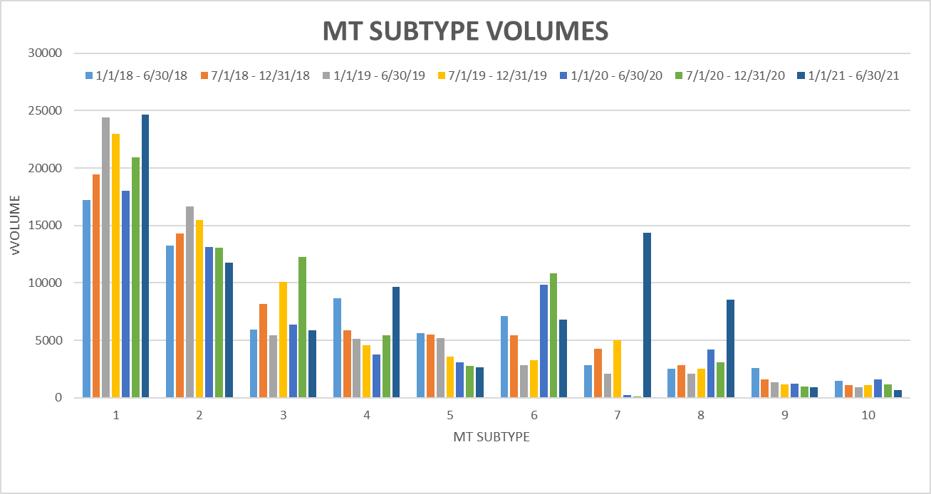

* *Inadvertent Losing* MT volume continues to rise – will track against transaction volume
* *IAL* vs *IAG* trajectory continues to widen
* *Usage & Billing Dispute* and *AMS LSE Dispute* increases attributed to URI
* *Other* increases likely due to Oncor efforts to transition BUSIDRRQ to BUSLO profiles
* *Switch Hold Removals* seemed to move back to seasonal volumes
* Increase in *ERCOT Initiated* MTs are due to special character transaction awareness and some for POLR Drops

**MT Validations Revisions Item #2 – Unexecutable Reasons**

Dave M had suggested TDTMS be very clear on their requested drop down unexecutable reasons for various subtypes. The following initial list was briefly reviewed with the ACTION ITEM for all market participants to review various subtypes and desired common ‘unexecutable reasons’.

|  |  |  |  |  |
| --- | --- | --- | --- | --- |
| **Inadvertent Gains** | | | | |
|  | | None | | |
|  | | Authorized Enrollment Confirmed | | |
|  | | Duplicate Issue | | |
|  | | 3rd Party CR has regained/transaction completed | | |
|  | | Other | | |
| **Inadvertent Losses** | | | |
|  | 3rd Party CR has regained/transaction completed | | |
|  | Duplicate Issue | | |
|  | Other (comments)   |  |  | | --- | --- | | **Rescissions** |  | |  | None | |  | Authorized Enrollment Confirmed | |  | Duplicate Issue | |  | 3rd Party CR has regained/transaction completed | |  | Other | | **Cancel w/ & w/o Approval** | | |  | Unable to Cancel (similar to Unexecutable) - no reasons | | **Missing Enrollment Transactions -** need clarity on Complete vs executable | |   **Switch Hold Removal**   |  |  | | --- | --- | | o       Issue is not filed for the reason of inadequate time for market participants as outlined in RMG | | | o       Further review of original Switch Hold Removal issue, verified through State Change History, reveals both the Losing CR and TDSP were each given the required one business hour, as Responsible MP, to review the issue | | | o       Losing CR did not assign the original Switch Hold Removal issue to the Gaining CR within one business hour as required by the RMG, verified by the issue’s State Change History | | | o       Losing CR used the Return to Submitter transition within the original Switch Hold Removal issue, preventing the TDSP from again becoming Responsible MP | | | | | |

**AGENDA for 10/20/21 Meeting - Wednesday**

1. System instances and MarkeTrak Monthly Performance Review
2. Market Data Transparency 2022 SLOs
3. MarkeTrak Upgrade status
4. Review Monthly IAG Report
5. Status of proposed SCRs and RMGRRs
6. RMGRR 166 – Switch Hold Extract Repository – comments
7. SCR817 – MT Validation Revisions – common list of Unexecutable Reasons
8. Checkpoint on Goals for 2021