

August 2021 ERCOT Monthly Operations Report

Reliability and Operations Subcommittee Meeting

October 07, 2021

Table of Contents

1. Report Highlights 2

2. Frequency Control 3

2.1. Frequency Events 3

2.2. Responsive Reserve Events 4

2.3. Load Resource Events 4

3. Reliability Unit Commitment 4

4. IRR, Wind, and Solar Generation as a Percent of Load 7

5. Largest Net-Load Ramp 8

6. COP Error Analysis 8

7. Congestion Analysis 11

7.1. Notable Constraints 11

7.2. Generic Transmission Constraint Congestion 14

7.3. Manual Overrides 14

7.4. Congestion Costs for Calendar Year 2021 14

8. System Events 15

8.1. ERCOT Peak Load 15

8.2. Load Shed Events 15

8.3. Stability Events 16

8.4. Notable PMU Events 16

8.5. DC Tie Curtailment 16

8.6. TRE/DOE Reportable Events 16

8.7. New/Updated Constraint Management Plans 16

8.8. New/Modified/Removed RAS 16

8.9. New Procedures/Forms/Operating Bulletins 16

9. Emergency Conditions 17

9.1. OCNs 17

9.2. Advisories 17

9.3. Watches 17

9.4. Emergency Notices 17

10. Application Performance 17

10.1. TSAT/VSAT Performance Issues 17

10.2. Communication Issues 17

10.3. Market System Issues 17

11. Model Updates 17

Appendix A: Real-Time Constraints 20

# Report Highlights

* The unofficial ERCOT peak load was 73,651 MW.
* There were 3 frequency events**.**
* There were 2 instances where Responsive Reserves were deployed.
* There were 92 HRUC commitments.
* There were 12 days of congestion on the West Texas Export GTC, 16 days on the Panhandle GTC, 26 days on the North Edinburg to Lobo GTC, 23 days on the Raymondville to Rio Hondo, 13 days on the Nelson Sharpe to Rio Hondo GTC, and 3 days on the North to Houston GTC. There was no activity on the remaining GTCs during the month.
* In section 2.1 (Frequency Control), the wind penetration column in the table was removed and a column to track Intermittent Renewable Resource (IRR) penetration during a frequency event was added. Section 4 (IRR, Wind, and Solar Generation as a Percent of Load) was changed to include statistics and graphs about wind, solar and IRR generation during the month.

# Frequency Control

## Frequency Events

The ERCOT Interconnection experienced 3 frequency events, which resulted from unit’s trips. The average event duration was 00:04:48.

A summary of the frequency events is provided below. The reported frequency events meet one of the following criteria: Delta Frequency is 60 mHz or greater; the MW loss is 350 MW or greater; resource trip event triggered RRS deployment. Frequency events that have been identified as Frequency Measurable Events (FME) for purposes of BAL-001-TRE-1 analysis are highlighted in blue. When analyzing frequency events, ERCOT evaluates PMU data according to industry standards. Events with an oscillating frequency of less than 1 Hz are inter-area, while higher frequencies indicate local events. Industry standards specify that damping ratio for inter-area oscillations should be 3.0% or greater. For the frequency events listed below, the ERCOT system met these standards and transitioned well after each disturbance.

|  |  |  |  |  |  |  |  |  |  |
| --- | --- | --- | --- | --- | --- | --- | --- | --- | --- |
| **Date and Time** | **Delta Frequency** | **Max/Min Frequency** | **Duration of Event** | **PMU Data** | | **MW Loss** | **Load** | **IRR** | **Inertia** |
| **(Hz)** | **(Hz)** | **Oscillation Mode (Hz)** | **Damping Ratio** | **(MW)** | **%** | **(GW-s)** |
| 8/10/2021 13:34 | 0.086 | 59.887 | 0:02:53 | 0.05 | 11% | 563.6 | 69,847 | 33% | 327,909 |
| 8/28/2021 7:07 | 0.123 | 59.894 | 0:05:57 | 0.05 | 13% | 781.47 | 42,187 | 16% | 293,174 |
| 8/31/2021 17:40 | 0.088 | 59.915 | 0:05:34 | 0.02 | 9% | 502 | 73,198 | 16% | 379,073 |

(Note: All data on this graph encompasses frequency event analysis based on BAL-001-TRE-1.)

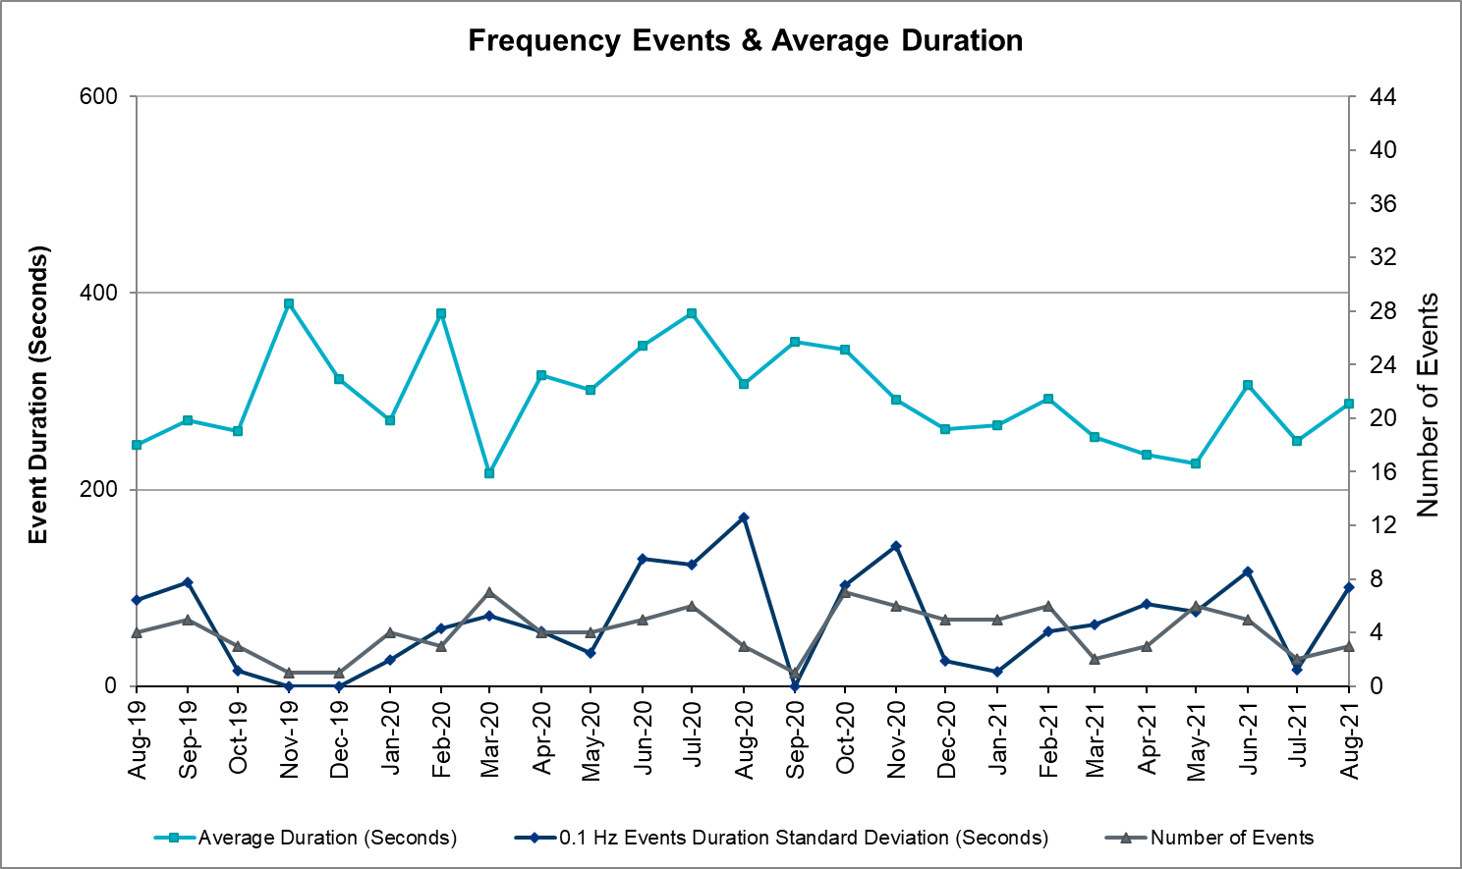

## Responsive Reserve Events

There were 2 events where Responsive Reserve MWs were released to SCED. The events highlighted in blue were related to frequency events reported in Section 2.1 above.

|  |  |  |  |  |
| --- | --- | --- | --- | --- |
| Date and Time Released to SCED | Date and Time Recalled | Duration of Event | Maximum MWs Released | Comments |
| 8/10/2021 13:34:23 | 8/10/2021 13:37:16 | 00:02:53 | 624 |  |
| 8/16/2021 13:37:16 | 8/16/2021 13:44:28 | 00:07:12 | 797 |  |

## Load Resource Events

None

# Reliability Unit Commitment

ERCOT reports on Reliability Unit Commitments (RUC) on a monthly basis. Commitments are reported grouped by operating day and weather zone. The total number of hours committed is the sum of the hours for all the units in the specified region. Additional information on RUC commitments can be found on the MIS secure site at Grid 🡪 Generation 🡪 Reliability Unit Commitment.

There were no DRUC commitments.

There were 92 HRUC commitments

|  |  |  |  |  |  |
| --- | --- | --- | --- | --- | --- |
| **Resource Location** | **# of Resources** | **Operating Day** | **Total # of Hours Committed** | **Total MWhs** | **Reason for Commitment** |
| NORTH, NORTH_CENTRAL | 4 | August 1, 2021 | 18 | 3,490.0 | System Capacity |
| EAST, NORTH_CENTRAL, SOUTH_CENTRAL | 8 | August 3, 2021 | 51 | 14,672.0 | System Capacity |
| EAST, NORTH_CENTRAL, SOUTH_CENTRAL | 11 | August 4, 2021 | 106 | 32,752.0 | System Capacity |
| EAST, NORTH_CENTRAL, SOUTH_CENTRAL | 6 | August 5, 2021 | 32 | 10,679.0 | System Capacity |
| EAST, NORTH_CENTRAL | 3 | August 6, 2021 | 9 | 3,822.0 | System Capacity |
| EAST, NORTH_CENTRAL | 2 | August 11, 2021 | 11 | 3,968.0 | System Capacity |
| EAST, NORTH_CENTRAL, SOUTH_CENTRAL | 6 | August 13, 2021 | 35 | 7,696.0 | System Capacity |
| EAST, NORTH_CENTRAL | 3 | August 15, 2021 | 6 | 2,238.0 | System Capacity |
| EAST, NORTH_CENTRAL, SOUTH_CENTRAL | 5 | August 16, 2021 | 27 | 6,879.0 | System Capacity |
| EAST, NORTH_CENTRAL | 3 | August 17, 2021 | 13 | 6,176.0 | System Capacity |
| EAST | 1 | August 18, 2021 | 4 | 1,968.0 | System Capacity |
| NORTH_CENTRAL | 2 | August 19, 2021 | 6 | 2,229.0 | System Capacity |
| COAST, NORTH_CENTRAL | 3 | August 20, 2021 | 12 | 2,176.0 | System Capacity |
| EAST, NORTH_CENTRAL, SOUTH_CENTRAL | 8 | August 24, 2021 | 55 | 10,351.5 | System Capacity |
| NORTH_CENTRAL, SOUTH_CENTRAL | 6 | August 25, 2021 | 67 | 18,864.0 | System Capacity, To Meet Minimum Run Time |
| EAST, NORTH_CENTRAL | 5 | August 26, 2021 | 51 | 10,091.0 | System Capacity, To Meet Minimum Run Time |
| NORTH_CENTRAL, SOUTH_CENTRAL | 3 | August 27, 2021 | 16 | 5,290.0 | System Capacity |
| NORTH_CENTRAL | 1 | August 29, 2021 | 7 | 2,744.0 | System Capacity |
| EAST, NORTH_CENTRAL | 4 | August 30, 2021 | 36 | 9,315.0 | System Capacity |
| EAST, NORTH_CENTRAL | 3 | August 31, 2021 | 27 | 7,785.0 | System Capacity |

# IRR, Wind, and Solar Generation as a Percent of Load

Graph below shows the maximum, minimum and average aggregate solar, wind and IRR output as a percentage of total ERCOT load when evaluated as 10-minute averaged intervals, over the past 13 months. Current wind, solar generation and penetration records are listed in the footnote below[1]. Maximum IRR penetration for the month was 49.1% on August 08, 2021 interval ending 03:40 and minimum IRR penetration for the month was 1.3% on August 15, 2021 interval ending 06:20.

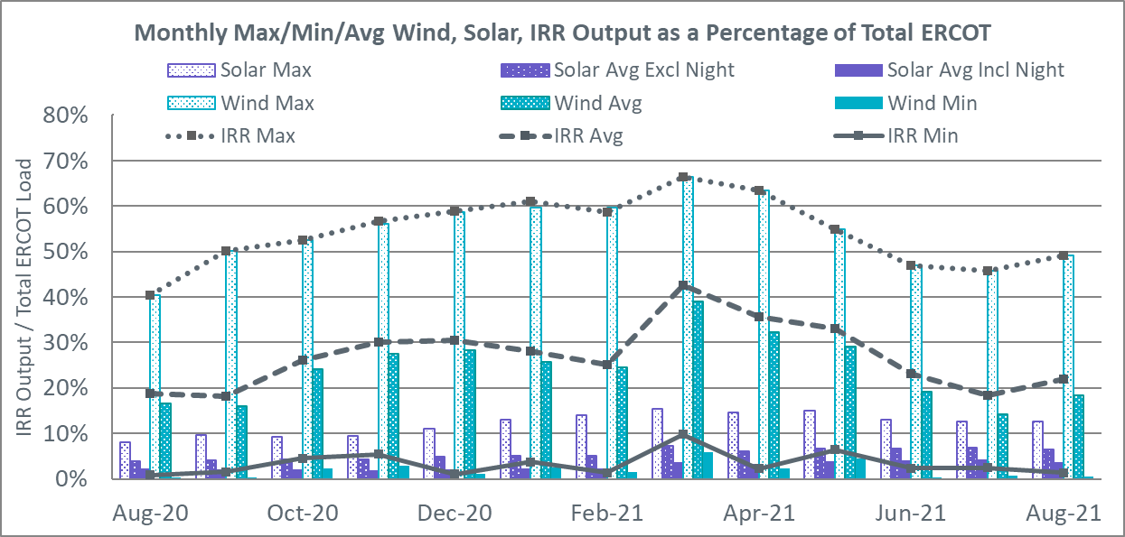

During the hour of peak load for the month, hourly integrated wind generation was 10,573 MW and solar generation was 6,143 MW. Graph below shows the wind and solar penetration percentage during the hour of the peak load in the last 13 months.



Lastly, the graph below shows the minimum wind, solar and IRR output during the peak load hour as a percentage of the daily peak load for every day in the month.

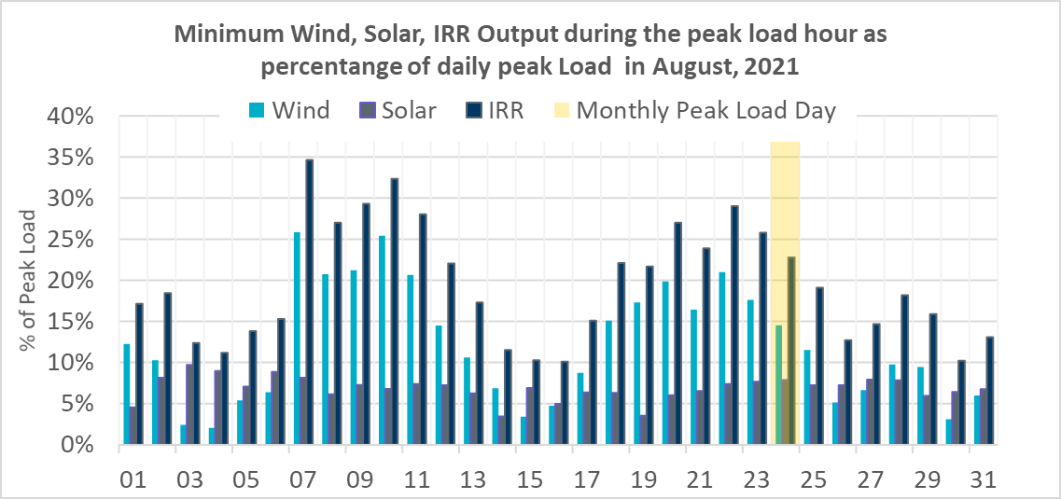

# Largest Net-Load Ramp

The net-load ramp is defined as the change in net-load (load minus wind and PVGR generation) during the defined time horizon. Such a variation in net-load needs to be accommodated in grid operations to ensure that the reliability of the grid is satisfactorily maintained. The largest net-load ramp during 5-min, 10-min, 15-min, 30-min and 60-min in August 2021 is 1323 MW, 1596 MW, 2081 MW, 3614 MW, and 6761 MW, respectively. The comparison with respect to the historical values is given in the table below.

|  |  |  |  |  |  |
| --- | --- | --- | --- | --- | --- |
| **Month and Year** | **5 min** | **10 min** | **15 min** | **30 min** | **60 min** |
| August 2021 | 1323 MW | 1596 MW | 2081 MW | 3614 MW | 6761 MW |
| August 2014 | 674 MW | 1169 MW | 1589 MW | 2854 MW | 5201 MW |
| August 2015 | 776 MW | 1231 MW | 1754 MW | 3303 MW | 6260 MW |
| August 2016 | 834 MW | 1350 MW | 1881 MW | 3230 MW | 6319 MW |
| August 2017 | 797 MW | 1421 MW | 1953 MW | 3167 MW | 5798 MW |
| August 2018 | 1333 MW | 1854 MW | 2780 MW | 3205 MW | 6604 MW |
| August 2019 | 830 MW | 1460 MW | 2084 MW | 3795 MW | 7375 MW |
| August 2020 | 954 MW | 1536 MW | 2221 MW | 4101 MW | 7690 MW |
| 2014-2020 | 1333 MW | 1596 MW | 2780 MW | 4101 MW | 7690 MW |

# COP Error Analysis

COP Error is calculated as the capacity difference between the COP HSL and real-time HSL of the unit. Mean Absolute Error (MAE) stayed over 15,924 MW until Day-Ahead at 12:00, then dropped significantly to 1970 MW by Day-Ahead at 14:00. In the following chart, Under-Scheduling Error indicates that COP had less generation capacity than real-time and Over-Scheduling Error indicates that COP had more generation capacity than real-time.

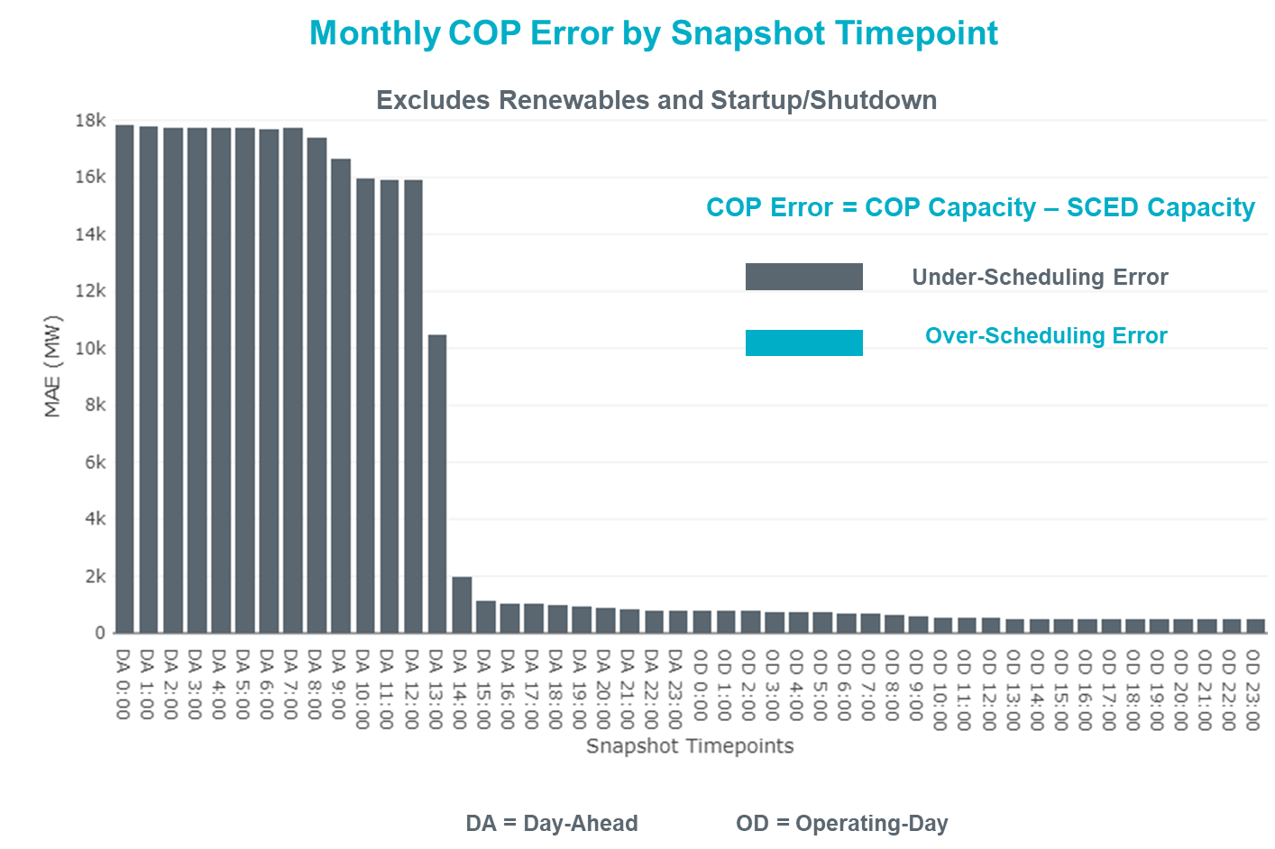

Monthly MAE for the Latest COP at the end of the Adjustment Period was 503 MW with median ranging from -890.2 MW for Hour-Ending (HE) 21 to -55.2 MW for HE 4. HE 9 on the 28th had the largest Over-Scheduling Error (1085.4 MW) and HE 22 on the 3rd had the largest Under-Scheduling Error (-3,881.6 MW).

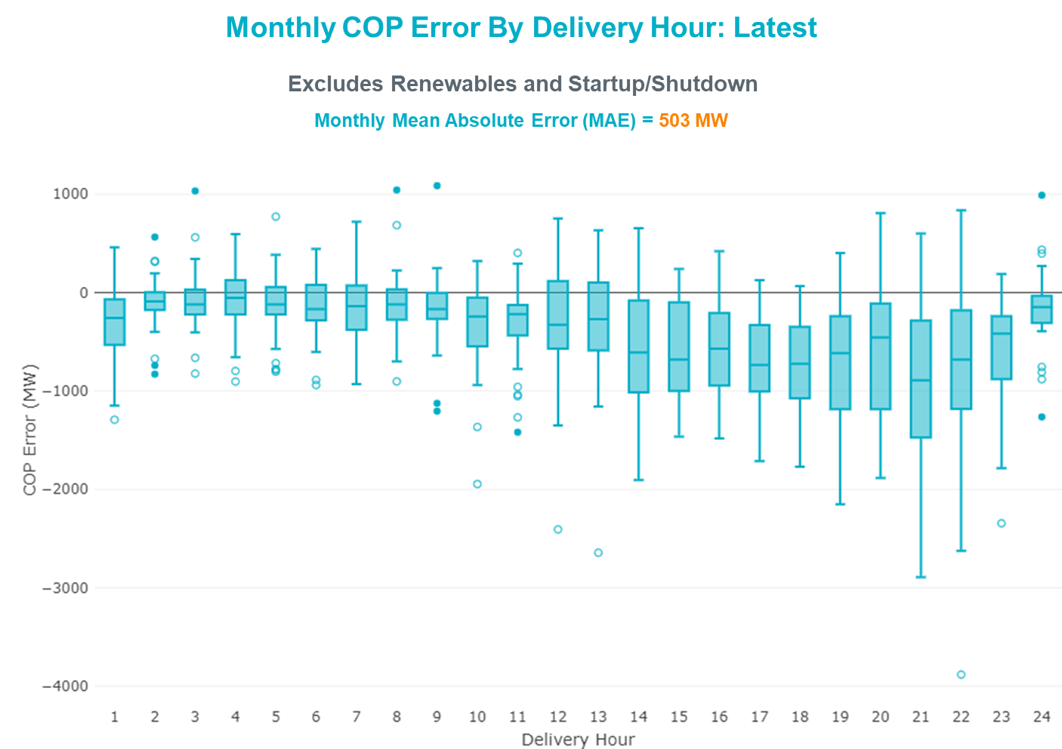

Monthly MAE for the Day-Ahead COP at 12:00 was 15,924 MW with median ranging from -21,423 MW for Hour-Ending (HE) 16 to -10,498 MW for HE 4. HE 15 on the 25th had the largest Under-Scheduling Error (-27,411 MW) and HE 8 on the 11th had the largest Over-Scheduling Error (-6,069 MW).

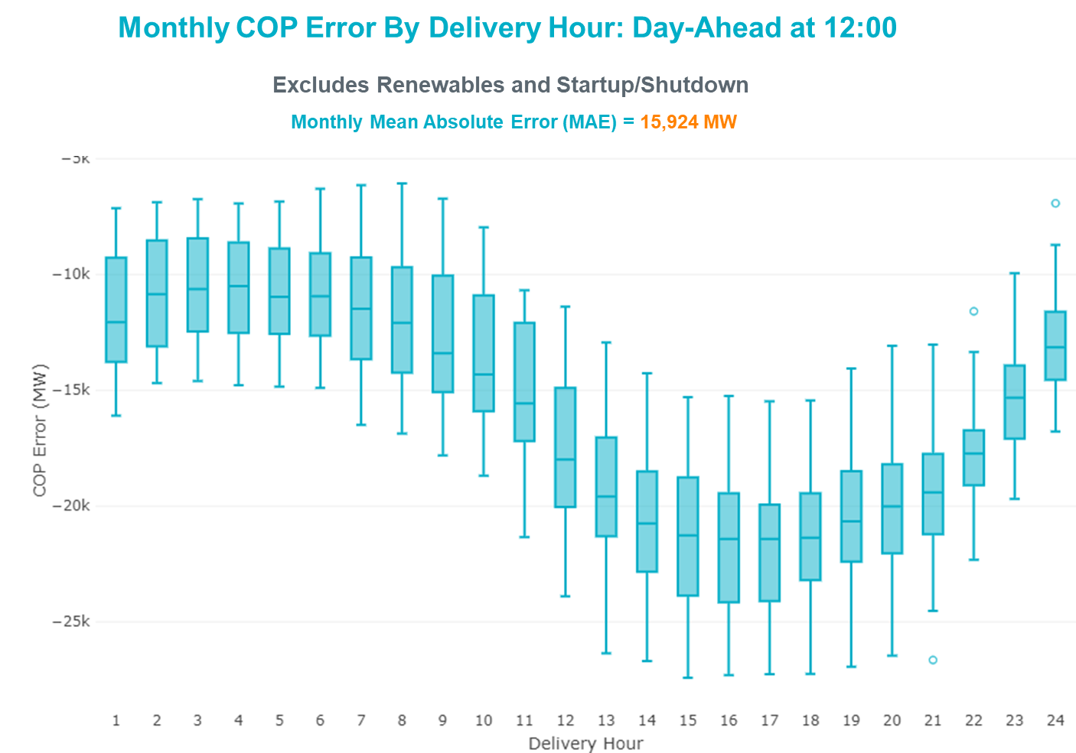

# Congestion Analysis

## Notable Constraints

Nodal protocol section 3.20 specifies that ERCOT shall identify transmission constraints that are binding in Real-Time three or more Operating Days within a calendar month. As part of this process, ERCOT reports congestion that meets this criterion to ROS. In addition, ERCOT also highlights notable constraints that have an estimated congestion rent exceeding $1,000 for a calendar month. These constraints are detailed in the table below, including approved transmission upgrades from TPIT that may provide some congestion relief based on ERCOT’s engineering judgement. Rows highlighted in blue indicate the congestion was affected by one or more outages. For a list of all constraints activated in SCED, please see Appendix A at the end of this report.

|  |  |  |  |  |
| --- | --- | --- | --- | --- |
| **Contingency Name** | **Overloaded Element** | **# of Days Constraint Binding** | **Congestion Rent** | **Transmission Project** |
|  |
| Manual dbl ckt for NEDIN-BONILLA 345kV & RIOH-PRIM138kV | Haine Drive - La Palma 138kV | 19 | $11,958,066.14 | Stewart Road: Construct 345 kV cut-in (5604) |  |
| Basecase | NE_LOB GTC | 22 | $11,047,763.72 |  |  |
| Basecase | PNHNDL GTC | 15 | $6,006,057.00 |  |  |
| CRLNW TO LWSSW 345 DBLCKT | West Tnp - Highlands Tnp 138kV | 11 | $5,560,409.71 |  |  |
| Man_dbl_FLCNS-MDLNE_345KV_and_FLCNS-MGSES_345_KV | Tall City - Sharyland Utilities - Telephone Road - Sharyland Utilities 138kV | 12 | $4,258,988.87 | Tall City - Telephone Road 138 kV Line Rebuild (57915) |  |
| HCKSW TO DENSW 138 DBLCKT | Rosen Heights Tap 1 - Blue Mound 138kV | 7 | $4,227,949.05 |  |  |
| TWR (345) HLJ-WAP64 & BLY-WAP72 | South Texas Project - Wa Parish 345kV | 12 | $3,928,045.79 |  |  |
| ROANOKE SWITCH to HICKS SWITCH LIN _A | Hicks Switch - Alliance 345kV | 4 | $3,468,285.10 |  |  |
| Fowlerton to LOBO 345 LIN1 | Laredo Vft North - Las Cruces 138kV | 16 | $3,313,167.13 | Laredo VFT North to North Laredo Switch: Rebuild 138 kV Line (58008) |  |
| Man_Sgl_ MDL-FLC_345_kV_w_MDL_XMFR1_FLC_AMR2 | Tall City - Sharyland Utilities - Telephone Road - Sharyland Utilities 138kV | 10 | $2,973,018.57 | Tall City - Telephone Road 138 kV Line Rebuild (57915) |  |
| Basecase | WESTEX GTC | 7 | $2,654,810.13 |  |  |
| HCKSW TO DENSW 138 DBLCKT | Deen Switch - Rosen Heights Tap 2 138kV | 13 | $2,323,559.57 |  |  |
| COMANCHE SWITCH (Oncor) to COMANCHE PEAK SES LIN _A | Comanche Tap - Comanche Switch (Oncor) 138kV | 6 | $1,976,200.10 |  |  |
| ODLAW SWITCHYARD to ASPHALT MINES LIN 1 | Hamilton Road - Maverick 138kV | 13 | $1,354,029.15 | Brackettville to Escondido: Construct 138 kV line (5206) |  |
| MIDLAND EAST TRX MDLNE_3_1 345/138 | Tall City - Sharyland Utilities - Telephone Road - Sharyland Utilities 138kV | 4 | $1,149,387.71 | Tall City - Telephone Road 138 kV Line Rebuild (57915) |  |
| CDHSW TO VENSW 345 AND CDHSW TO EVRSW 345 DBLCKT | Park Row - Sherry Switch 138kV | 4 | $819,734.93 |  |  |
| Elmcreek-Sanmigl 345kV | Magruder - Victoria 138kV | 4 | $645,305.28 |  |  |
| Fowlerton to LOBO 345 LIN1 | North Laredo Switch - Piloncillo 138kV | 3 | $642,618.28 |  |  |
| Fowlerton to LOBO 345 LIN1 | Falfurrias - Premont 69kV | 4 | $554,020.02 |  |  |
| DUPONT SWITCH - INGLESIDE to GREGORY POWER LIN 1 | Dupont Switch - Ingleside - Lge 138kV | 3 | $538,024.82 |  |  |
| LAQUINTA to LOBO LIN 1 | Bruni Sub 138kV | 11 | $390,113.46 |  |  |
| SHRSW TO VENSW 345 AND SHRSW TO EVRSW 345 DBLCKT | Handley Ses - Lakewood (Oncor) 138kV | 3 | $345,633.62 |  |  |
| LON HILL to NELSON SHARPE LIN 1 | Celanese Bishop - Nelson Sharpe 138kV | 3 | $326,493.40 |  |  |
| LAQUINTA to LOBO LIN 1 | Falfurrias - Premont 69kV | 7 | $298,201.97 |  |  |
| BAKERSFIELD SWITCHYARD to SCHNEEMAN DRAW LIN 1 | Cedar Hills - Silver Tap 69kV | 4 | $295,247.45 |  |  |
| Basecase | NELRIO GTC | 6 | $283,608.54 |  |  |
| Bighil-Kendal 345kV | Yellow Jacket - Treadwell 138kV | 5 | $207,987.27 |  |  |
| COLETO CREEK to VICTORIA LIN 1 | Coleto Creek - Victoria 138kV | 4 | $165,313.63 |  |  |
| Koch Upriver - Tortuga & Lon Hill - Nueces Bay 138KV | Champlin - Weil Tract 138kV | 6 | $119,068.34 | Champlin to Weil Tract: Rebuild 138 kV Line (57912) |  |
| MESA VIEW SWITCH to FORT LANCASTER LIN 1 | North Mccamey - Crossover 138kV | 3 | $83,652.92 |  |  |
| Ferguson-Sherwood Shores & Ferguson-Granite Mountain 138kV | Sandy Creek 138kV | 4 | $71,904.89 | Sandy Creek Autotransformer Upgrade (61591) |  |
| GARDENDALE SWITCH to TELEPHONE ROAD - Sharyland Utilities LIN _A | Andrews North - Exxon Means Tap 138kV | 3 | $43,510.55 |  |  |

## Generic Transmission Constraint Congestion

There were 12 days of congestion on the West Texas Export GTC, 16 days on the Panhandle GTC, 26 days on the North Edinburg to Lobo GTC, 23 days on the Raymondville to Rio Hondo, 13 days on the Nelson Sharpe to Rio Hondo GTC, and 3 days on the North to Houston GTC. There was no activity on the remaining GTCs during the month.

Note: This is how many times a constraint has been activated to avoid exceeding a GTC limit, it does not imply an exceedance of the GTC occurred or that the GTC was binding.

## Manual Overrides

None

## Congestion Costs for Calendar Year 2021

The following table represents the top twenty active constraints for the calendar year based on the estimated congestion rent attributed to the congestion. ERCOT updates this list on a monthly basis.

|  |  |  |  |  |
| --- | --- | --- | --- | --- |
| **Contingency** | **Overloaded Element** | **# of 5-min SCED** | **Estimated** | **Transmission Project** |
| Basecase | PNHNDL GTC | 21,842 | 92,302,188.90 |  |
| Elmcreek-Sanmigl 345kV | Pawnee Switching Station - Calaveras 345kV | 2,277 | 76,226,056.60 |  |
| LOST PINES AEN to FAYETTE PLANT 1 LIN 1 | Winchester - Fayette Plant 1 And 2 345kV | 415 | 51,438,867.64 |  |
| JOHNSON SWITCH (ONCOR) to CONCORD LIN G1 | Decordova Dam - Carmichael Bend Switch 138kV | 726 | 46,614,977.07 | DeCordova 345/138_Sw. (7129) |
| TWR(345) JCK-REF27 & JCK-STP18 | Oasis - Dow Chemical 345kV | 524 | 46,495,190.60 | Freeport - Master Plan (6668A) |
| Basecase | NE_LOB GTC | 21,052 | 45,846,630.05 |  |
| Basecase | N_TO_H GTC | 2,843 | 39,257,119.42 |  |
| Basecase | WESTEX GTC | 9,522 | 37,236,441.81 |  |
| TWR(345) JCK-REF27 & JCK-STP18 | South Texas Project - Wa Parish 345kV | 1,909 | 35,934,198.14 | Freeport - Master Plan (6668A) |
| Manual dbl ckt for NEDIN-BONILLA 345kV & RIOH-PRIM138kV | Haine Drive - La Palma 138kV | 9,543 | 35,569,449.34 | Stewart Road: Construct 345 kV cut-in with two 450 MVA 345/138 autotransformers connected to Stewart Rd 138 station (5604, 6382) |
| Hicross-Pilot & Garfield 138kV | Carson Creek - Pilot Knob 138kV | 803 | 30,600,531.85 |  |
| Basecase | Colorado Bend Energy Center - Dyann 138kV | 242 | 26,093,025.30 |  |
| HCKSW TO DENSW 138 DBLCKT | Deen Switch - Rosen Heights Tap 2 138kV | 3,559 | 24,716,949.03 |  |
| TWR(345) JCK-REF27 & JCK-STP18 | Blessing - Pavlov 138kV | 4,383 | 21,362,696.58 |  |
| CONCORD TRX CRD1 345/138 | Concord 345kV | 840 | 21,139,669.60 |  |
| Lostpi-Austro&Dunlap 345kV | Sim Gideon - Winchester 138kV | 635 | 20,472,271.99 | Sim Gideon - Tahitian Village Transmission Line Storm Hardening (61438), Bastrop West - Split Transmission Line Storm Hardening (61436) |
| Lytton_S-Slaughte&Turner 138kV | Mccarty Lane - Zorn 138kV | 245 | 20,185,815.81 |  |
| Basecase | Pawnee Switching Station - Calaveras 345kV | 27 | 17,214,426.04 |  |
| ASHERTON to Bevo Substation LIN 1 | Hamilton Road - Maverick 138kV | 525 | 17,023,560.36 | Brackettville to Escondido: Construct 138 kV line (5206) |
| NORTH EDINBURG TRX 1382 345/138 | North Edinburg 345kV | 294 | 16,777,302.97 | Stewart Road: Construct 345 kV cut-in with two 450 MVA 345/138 autotransformers connected to Stewart Rd 138 station (5604, 6382) |

# System Events

## ERCOT Peak Load

The unofficial ERCOT peak load[2] for the month was 73,651 MW and occurred on the 24th, during hour ending 17:00.

## Load Shed Events

None.

## Stability Events

None.

## Notable PMU Events

ERCOT analyzes PMU data for any significant system disturbances that do not fall into the Frequency Events category reported in section 2.1. The results are summarized in this section once the analysis has been completed.

There were no PMU events outside of those reported in section 2.1.

## DC Tie Curtailment

None.

## TRE/DOE Reportable Events

* LCRA submitted an OE-417 for 08/02/2021. Reportable Event Type: Transmission loss.
* BPUB submitted an OE-417 for 08/03/2021. Reportable Event Type: Suspicious activity to its facility.
* Oncor submitted an OE-417 for 08/18/2021. Reportable Event Type: Complete loss of monitoring or control capability.
* Oncor submitted an EOP-004 for 08/18/2021. Reportable Event Type: Complete loss of monitoring or control capability.

## New/Updated Constraint Management Plans

None.

## New/Modified/Removed RAS

None.

## New Procedures/Forms/Operating Bulletins

|  |  |  |
| --- | --- | --- |
| **Date** | **Subject** | **Bulletin No.** |
| 9/1/2021 | Real Time Desk V1 Rev 76 | 998 |
| 9/1/2021 | Resource Desk Operating Procedure V1 Rev 24 | 999 |
| 9/1/2021 | Reliability Unit Commitment Desk V1 Rev 64 | 1000 |
| 9/1/2021 | Resource Desk Operating Procedure V1 Rev 65 | 1001 |
| 9/1/2021 | Scripts V1 Rev 37 | 1002 |
| 9/1/2021 | Transmission and Security Desk V1 Rev 87 | 1003 |

# Emergency Conditions

## OCNs

None.

## Advisories

|  |  |
| --- | --- |
| **Date and Time** | **Message** |
| August 6, 2021 13:30 CPT | ERCOT has postponed the deadline for the posting of the DAM solution for Operating Day 08/07/2021 due to delay in clearing DAM. |

## Watches

None.

## Emergency Notices

None.

# Application Performance

## TSAT/VSAT Performance Issues

None.

## Communication Issues

None.

## Market System Issues

None.

# Model Updates

The Downstream Production Change (DPC) process allows ERCOT to make changes in the on-line Network Operations Model without loading a completely new model. The purpose of this process is to allow for reliable grid operations as system conditions change between designated Network Operations Model database loads. The DPC process is limited in scope to just those items listed below, with equipment ratings updates being the most common. ERCOT has seen a rise in the use of the DPC process to make on-line updates to the Network Operations Model in recent years, instead of through the standard Network Operations Model Change Request process.

* Static Line ratings (Interim Update)
* Dynamic Line ratings (non-Interim Update)
* Autotransformer ratings (non-Interim Update)
* Breaker and Switch Normal status (Interim Update)
* Contingency Definitions (Interim Update)
* RAP and RAS changes or additions (Interim Update)
* Net Dependable and Reactive Capability (NDCRC) values (Interim Update)
* Impedance Updates (non-Interim)

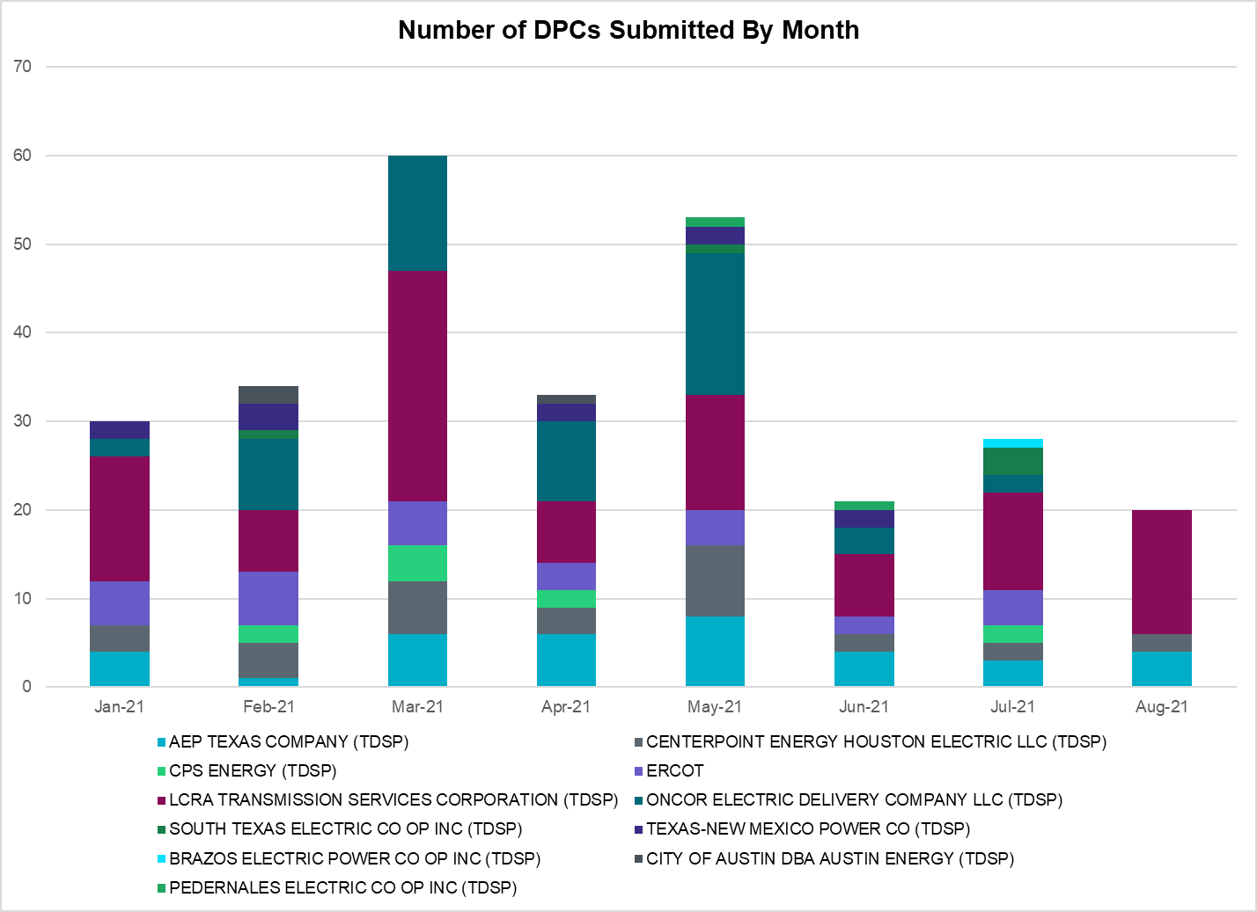

|  |  |
| --- | --- |
| **Transmission Operator** | **Number of DPCs** |
| AEP TEXAS COMPANY (TDSP) | 4 |
| BRAZOS ELECTRIC POWER CO OP INC (TDSP) | 0 |
| BROWNSVILLE PUBLIC UTILITIES BOARD (TDSP) | 0 |
| BRYAN TEXAS UTILITIES (TDSP) | 1 |
| CENTERPOINT ENERGY HOUSTON ELECTRIC LLC (TDSP) | 0 |
| CITY OF AUSTIN DBA AUSTIN ENERGY (TDSP) | 0 |
| CITY OF COLLEGE STATION (TDSP) | 0 |
| CITY OF GARLAND (TDSP) | 0 |
| CPS ENERGY (TDSP) | 0 |
| DENTON MUNICIPAL ELECTRIC (TDSP) | 0 |
| ELECTRIC TRANSMISSION TEXAS LLC (TDSP) | 0 |
| ERCOT | 0 |
| LCRA TRANSMISSION SERVICES CORPORATION (TDSP) | 14 |
| LONE STAR TRANSMISSION LLC (TSP) | 0 |
| ONCOR ELECTRIC DELIVERY COMPANY LLC (TDSP) | 0 |
| PEDERNALES ELECTRIC CO OP INC (TDSP) | 0 |
| RAYBURN COUNTRY CO OP DBA RAYBURN ELECTRIC (TDSP) | 0 |
| SHARYLAND UTILITIES LP (TDSP) | 0 |
| SOUTH TEXAS ELECTRIC CO OP INC (TDSP) | 0 |
| TEXAS MUNICIPAL POWER AGENCY (TDSP) | 0 |
| TEXAS-NEW MEXICO POWER CO (TDSP) | 0 |

# Appendix A: Real-Time Constraints

The following is a complete list of constraints activated in SCED. Full contingency descriptions can be found in the Standard Contingencies List located on the MIS secure site at Grid 🡪 Generation 🡪 Reliability Unit Commitment.

|  |  |  |  |  |
| --- | --- | --- | --- | --- |
| Contingency Name | Overloaded Element | From Station | To Station | Count of Days |
| BASE CASE | NE_LOB | n/a | n/a | 26 |
| BASE CASE | RV_RH | n/a | n/a | 23 |
| SLGEI_D8 | I_DUPS_LGE1_1 | LGE | I_DUPSW | 19 |
| MHARNED5 | HAINE__LA_PAL1_1 | LA_PALMA | HAINE_DR | 19 |
| BASE CASE | PNHNDL | n/a | n/a | 16 |
| SLOBSA25 | LARDVN_LASCRU1_1 | LARDVNTH | LASCRUCE | 16 |
| XMDL58 | TALLCITY_TELPR_1 | TELPH_RD | TALLCITY | 15 |
| SLAQLOB8 | BRUNI_69_1 | BRUNI | BRUNI | 14 |
| MFLCMG25 | TALLCITY_TELPR_1 | TELPH_RD | TALLCITY | 14 |
| DHCKDEN8 | 6265__E | RHTP2 | DENSW | 14 |
| DWAPHLJ5 | STPWAP39_1 | STP | WAP | 14 |
| SBRAUVA8 | HAMILT_MAVERI1_1 | HAMILTON | MAVERICK | 13 |
| DCRLLSW5 | 588_B_1 | LWSVH | LWSVW | 13 |
| BASE CASE | NELRIO | n/a | n/a | 13 |
| BASE CASE | WESTEX | n/a | n/a | 12 |
| SLAQLOB8 | FALFUR_PREMON1_1 | FALFUR | PREMONT | 12 |
| MFLCMDL5 | TALLCITY_TELPR_1 | TELPH_RD | TALLCITY | 10 |
| DELMSAN5 | MAGRUD_VICTOR2_1 | VICTORIA | MAGRUDER | 9 |
| DBIGKEN5 | TREADW_YELWJC1_1 | TREADWEL | YELWJCKT | 8 |
| DHCKDEN8 | 6260__A | RHTP1 | BLMND | 7 |
| SCMNCPS5 | 651__B | CMNSW | CMNTP | 7 |
| SLOBSA25 | FALFUR_PREMON1_1 | FALFUR | PREMONT | 7 |
| DKOCNUE8 | CHAMPL_WEIL_T1_1 | WEIL_TRC | CHAMPLIN | 7 |
| SHCKRNK5 | 106__A | HCKSW | ALLNC | 6 |
| SGDNTEL5 | 6094__D | ANDNR | EXMTP | 6 |
| DSTEXP12 | BLESSI_LOLITA1_1 | LOLITA | BLESSING | 5 |
| SBRAHAM8 | HAMILT_MAVERI1_1 | HAMILTON | MAVERICK | 5 |
| DGRSPKR5 | 6377__A | BRTSW | ORANS | 5 |
| DELMSAN5 | PAWNEE_SPRUCE_1 | PAWNEE | CALAVERS | 5 |
| DCDHVEN5 | 6200__D | SHRSW | PRKRW | 5 |
| SILLFTL8 | HAMILT_MAXWEL1_1 | MAXWELL | HAMILTON | 5 |
| SVICCO28 | COLETO_VICTOR2_1 | COLETO | VICTORIA | 5 |
| SBAKCED5 | CEDRHI_SILT1_1 | CEDRHILL | SILT | 4 |
| SN_SLON5 | CELANE_N_SHAR1_1 | N_SHARPE | CELANEBI | 4 |
| DBIGKEN5 | HAMILT_MAXWEL1_1 | MAXWELL | HAMILTON | 4 |
| BASE CASE | RANDAD_ZAPATA1_1 | RANDADO | ZAPATA | 4 |
| DVICVI89 | COLETO_VICTOR2_1 | COLETO | VICTORIA | 4 |
| SHOLWES8 | HOLLY4_SOUTH_1_1 | HOLLY4 | SOUTH_SI | 4 |
| DFERGRM8 | SANDCR_AT1 | SANDCR | SANDCR | 4 |
| SSTAMDL8 | TALLCITY_TELPR_1 | TELPH_RD | TALLCITY | 4 |
| DSWELNC5 | BLUF_C_MULBER1_1 | BLUF_CRK | MULBERRY | 4 |
| SFTLMES8 | CROSSO_NORTMC1_1 | NORTMC | CROSSOVE | 4 |
| DNUEGIL8 | MCKENZ_WESTSI1_1 | WESTSIDE | MCKENZIE | 4 |
| SLOBSA25 | NLARSW_PILONC1_1 | NLARSW | PILONCIL | 3 |
| DCAGCO58 | 583T583_1 | BANDER | MASOCR | 3 |
| SREDRAT8 | 699T699_1 | MCCALA | RNRD12 | 3 |
| DCAGCI58 | BERGHE_AT1H | BERGHE | BERGHE | 3 |
| DCAGCO58 | BERGHE_AT1H | BERGHE | BERGHE | 3 |
| SLWVLWS8 | 588_B_1 | LWSVH | LWSVW | 3 |
| SODLBRA8 | HAMILT_MAVERI1_1 | HAMILTON | MAVERICK | 3 |
| SMDOOAS5 | GN_PZ_08_A | GN | PZ | 3 |
| DVICEDN8 | MAGRUD_VICTOR2_1 | VICTORIA | MAGRUDER | 3 |
| DSHREVR5 | 6415__C | HLSES | LKWOD | 3 |
| SWEILON8 | CHAMPL_WEIL_T1_1 | WEIL_TRC | CHAMPLIN | 3 |
| SSCLWF28 | 6840__B | NVKSW | ANARN | 3 |
| BASE CASE | N_TO_H | n/a | n/a | 3 |
| SCOLBAL8 | BALLIN_HUMBLT1_1 | BALLINGE | HUMBLTAP | 2 |
| SBRIJAC8 | MYRA_VAL_1 | MYRA | VALYVIEW | 2 |
| SCOMHA38 | HAMILT_MAXWEL1_1 | MAXWELL | HAMILTON | 2 |
| SCT2CAR8 | HAMILT_MAXWEL1_1 | MAXWELL | HAMILTON | 2 |
| SLOBSA25 | BRUNI_69_1 | BRUNI | BRUNI | 2 |
| DDUPHE18 | I_DUPS_MCCAMP2_1 | I_DUPSW | MCCAMPBE | 2 |
| DWHILON5 | MELONC_RINCON1_1 | RINCON | MELONCRE | 2 |
| SPORNCA9 | NCARBI_PV_TAP1_1 | NCARBIDE | PV_TAP | 2 |
| DBIGKEN5 | SAPOWE_TREADW1_1 | SAPOWER | TREADWEL | 2 |
| SSKYSB28 | TALLCITY_TELPR_1 | TELPH_RD | TALLCITY | 2 |
| SILLFTL8 | OZNR_OZONA1_1 | OZONA | OZNR | 2 |
| DVICEDN8 | LOOP_VICTORIA_1 | VICTORIA | L_463S | 2 |
| BASE CASE | RAMBLER_GENTIE_1 | RAMBLER | TWINBU | 2 |
| DGRMGRS8 | 6830__B | CRDSW | OLNEY | 2 |
| SABSBLU8 | ABNTHW_CALLAH1_1 | CALLAHAN | ABNTHWST | 2 |
| DCHBJOR5 | CBYCD_84_A | CBY | CD | 2 |
| DKENNO89 | COLETO_ROSATA1_1 | COLETO | ROSATA | 2 |
| SMDOPHR5 | 138_ALV_MNL_1 | ALVIN | MAINLAND | 2 |
| SCOLBAL8 | SANA_FMR1 | SANA | SANA | 2 |
| SALLHCK5 | 107__A | HCKSW | RNKSW | 2 |
| SLOLBLE8 | NCARBI_PV_TAP1_1 | NCARBIDE | PV_TAP | 2 |
| DCAGCI58 | 255T279_1 | PIPECR | MEDILA | 2 |
| SORE2B8 | FOSPT_25_A | PT | FOS | 2 |
| SRICGRS8 | 6840__B | NVKSW | ANARN | 1 |
| SFORYEL8 | HEXT_MASONS1_1 | MASONSW | HEXT | 1 |
| DBAKSOL5 | FTST_SOLSTI1_1 | FTST | SOLSTICE | 1 |
| DSKYCAL5 | N5_R5_1 | CALAVERS | CAGNON | 1 |
| DHLSLIG8 | 6405__C | HLSES | RMTPW | 1 |
| XCAG158 | CAGNON_MR4H | CAGNON | CAGNON | 1 |
| DFRIILL8 | HAMILT_MAXWEL1_1 | MAXWELL | HAMILTON | 1 |
| SSGVTRC5 | 175__A | TRCNR | FORSW | 1 |
| SLOBSA25 | ASHERT_CATARI1_1 | ASHERTON | CATARINA | 1 |
| SCBYCBY8 | BT_CBY88_A | CBY | BT | 1 |
| SSPUSLT8 | GIRA_T_SPUR1_1 | SPUR | GIRA_TAP | 1 |
| SN_SLON5 | HOLLY4_SOUTH_1_1 | HOLLY4 | SOUTH_SI | 1 |
| SPAWCAL5 | MAGRUD_VICTOR2_1 | VICTORIA | MAGRUDER | 1 |
| DKENCA58 | 460T460_1 | MEDILA | W1 | 1 |
| SSPUASP8 | SCKR_SPUR1_1 | SPUR | SCKR | 1 |
| SBEVASH8 | BIG_COTU_1 | COTULAS | BIGWELS | 1 |
| SCRNJFS8 | GBYGP_17_A | GBY | GP | 1 |
| SCRNLC38 | TALLCITY_TELPR_1 | TELPH_RD | TALLCITY | 1 |
| DWLV89N8 | 3750__A | MSLSW | MSHLN | 1 |
| DWCSHCK5 | 6060__A | PKRSW | EMSES | 1 |
| XGRS58 | 6840__B | NVKSW | ANARN | 1 |
| SHAYZO25 | 6T227_1 | HAYSEN | ZORN | 1 |
| DTWIDIV5 | CEDRHI_SILT1_1 | CEDRHILL | SILT | 1 |
| DBIGKEN5 | FRIR_ROCKSP1_1 | FRIR | ROCKSPRS | 1 |
| BASE CASE | LGD_SANTIA1_1 | LGD | SANTIAGO | 1 |
| DSALHUT5 | 1710__C | BELCNTY | SALSW | 1 |
| XSH1R58 | 6415__C | HLSES | LKWOD | 1 |
| SMGPBRN8 | 650__A | CMNSW | BRNWD | 1 |
| SZEPCMN8 | 650__A | CMNSW | BRNWD | 1 |
| SCRDLOF9 | 6626__F | BTTSW | HENWE | 1 |
| SBIGSCH5 | CROSSO_NORTMC1_1 | NORTMC | CROSSOVE | 1 |
| XVIC89 | MAGRUD_VICTOR2_1 | VICTORIA | MAGRUDER | 1 |
| DMCNMKD8 | TALLCITY_TELPR_1 | TELPH_RD | TALLCITY | 1 |
| DSHREVR5 | 6410__D | HLSES | LKWOD | 1 |
| DCS_CHS8 | BCVLY_03_A | BCV | LY | 1 |
| DNUEGIL8 | CHAMPL_WEIL_T1_1 | WEIL_TRC | CHAMPLIN | 1 |
| SSPUSLT8 | GIRA_T_SPUR1_1 | GIRA_TAP | SPUR | 1 |
| DCHBJOR5 | CBY_AT1 | CBY | CBY | 1 |

1. Current Wind Generation Record: 23,596 MW on 06/25/2021 at 22:32 | Current Wind Penetration Record: 66.47% on 03/22/2021 at 00:46

   Current Solar Generation Record: 7,036 MW on 08/03/2021 at 12:45 | Current Solar Penetration Record: 15.47% on 03/28/2021 at 15:01
2. This is the hourly integrated peak demand as published in the ERCOT D&E report.