Mass Transitions

1. Mass Transitions

1.1 Introduction

Notes:
Welcome to ERCOT’s Market Training course on Mass Transitions.

1.2 Course Objectives
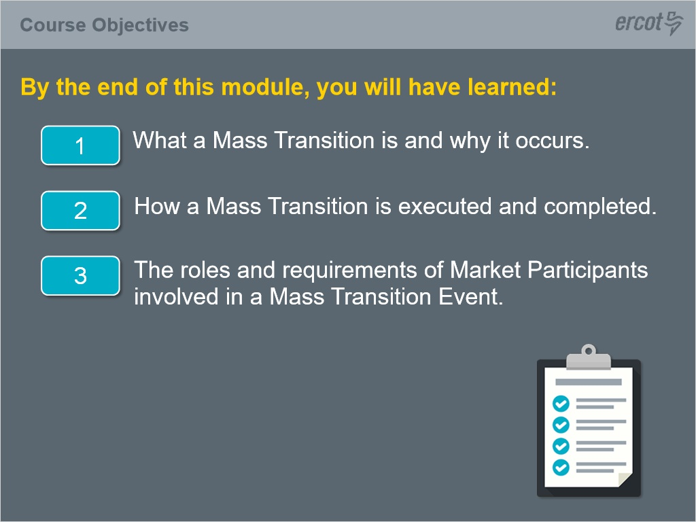
Notes:
This lesson covers the definition of a Mass Transition, why it occurs, and the process by which it is executed and completed.

It will also discuss the roles and requirements of Market Participants involved in a Mass Transition.

Included in this training are reference links to provide more detailed information.

1.3 Mass Transition Process
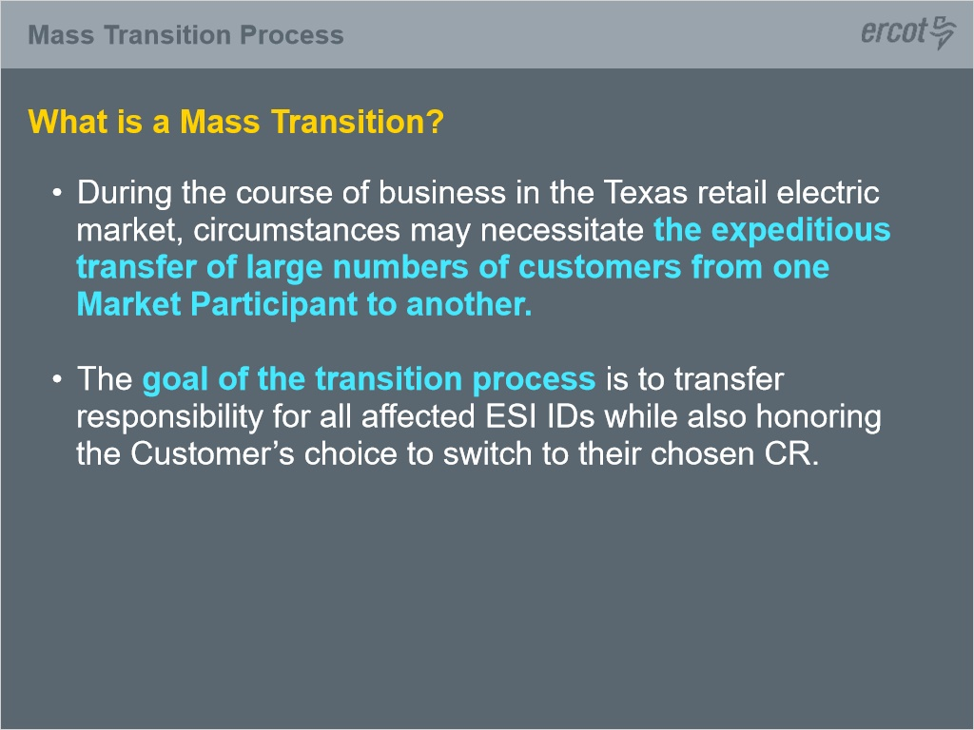
Notes:
What is a Mass Transition?

During the course of business in the Texas retail electric market, circumstances may necessitate the expeditious transfer of large numbers of customers from one Market Participant to another.
The goal of the transition process is to transfer responsibility for all affected customer premises, or ESI IDs while also honoring the Customer’s choice to switch to their chosen Competitive Retailer, also known as a CR.
This lesson will follow a typical Mass Transition process focusing on the transition of ESI IDs from a Losing/Defaulting CR to a designated Gaining Provider of Last Resort (or POLR REP).
Note, CRs (or Competitive Retailers) and REPs (or Retail Electric Providers) can be used interchangeably in the context of this lesson.

1.4 Who are the Market Participants involved?
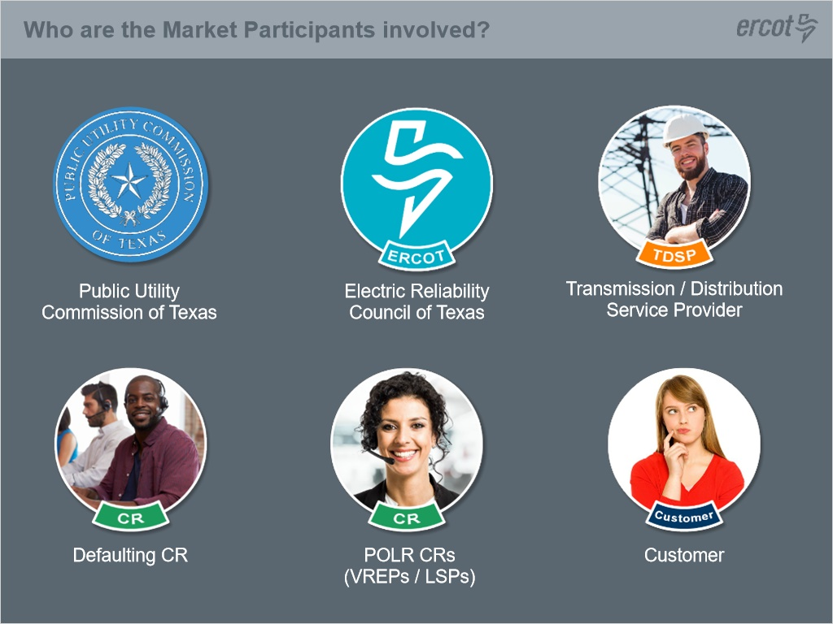
Notes:
The following parties are involved during a Mass Transition event: The Public Utility Commission of Texas (PUCT), the Electric reliability Council of Texas (ERCOT) the Transmission and Distribution Service Providers (TDSPs), the Defaulting CR, which is the CR exiting the market, the POLR CRs, and finally the impacted Customers.

They each play a role in the transfer of Customers during a Mass Transition event.

1.5 Definitions
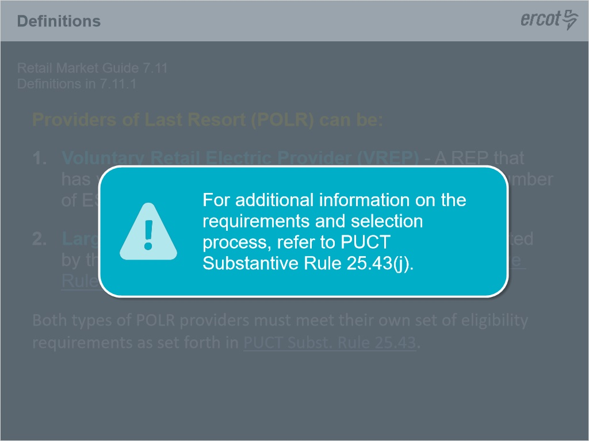
Notes:
Let’s define the Gaining POLR REPs.

There are two types of POLR providers: V-REPs and LSPs.

A V-REP, which stands for Volunteer REP, must apply and be approved by the PUCT to serve a select number of ESIIDs for each customer class in each POLR area (TDSP territory).

For example, a VREP may apply to serve 100 medium non-residential ESI IDs in CenterPoint’s service territory and 200 small non-residential ESI IDs in Oncor’s service territory.

For additional information on the application process, please refer to PUCT substantive rule 25.43(i).

A Large Service Provider (or LSP) is a REP designated by the PUCT to provide POLR service for each customer class in each POLR area (TDSP territory).

In each POLR area, the PUCT shall designate up to 15 LSPs.

The eligible REPs that have the greatest market share based upon retail sales in megawatt-hours, by customer class, and POLR area shall be designated as an LSP for that area.

For additional information on the requirements and selection process, refer to PUCT Substantive Rule 25.43(j).

It is also important to note that both types of POLR providers must meet their own set of eligibility requirements as set forth in PUCT Subst. Rule 25.43.

1.6 Four Customer Classes
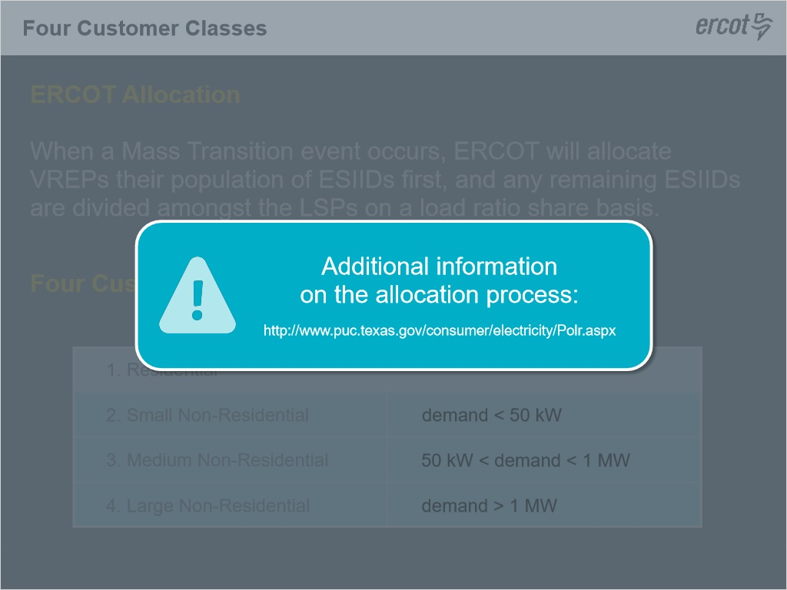
Notes:
When a Mass Transition event occurs, ERCOT will allocate VREPs their population of ESIIDs first, and any remaining ESIIDs are divided amongst the LSPs on a load ratio share basis.
For additional information on the allocation process, please refer to the following link.
Lastly, a VREP or LSP may be designated to serve any or all of the four customer classes in a POLR area or TDSP territory.
The four customer classes are Residential, Small Non-Residential, Medium Non-Residential, and Large Non-Residential.
Small, medium and large non-residential are defined by their peak demands.
Small non-residential customers have demands below 50 kilowatts while large non-residential are over 1 megawatt.
Medium are defined as those in between 50 kW and 1 megawatt.

1.7 PUCT Responsabilities
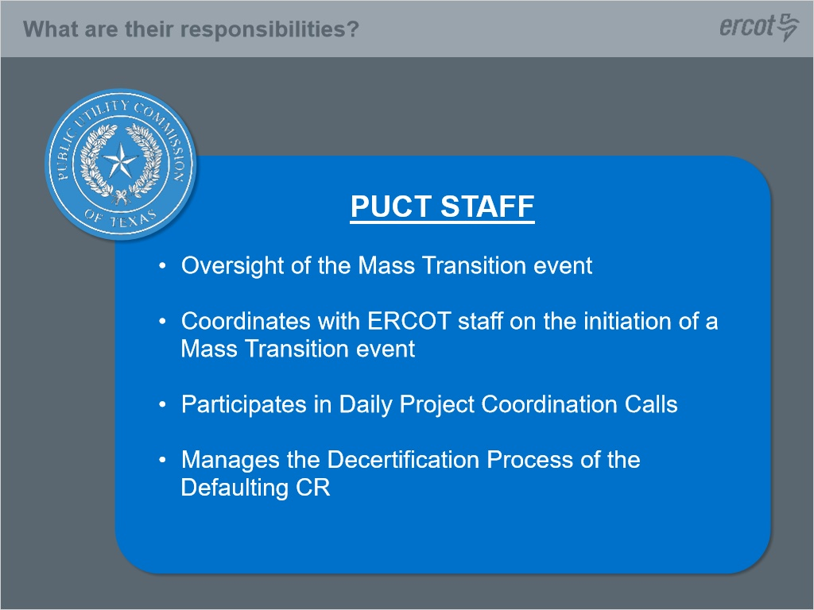
Notes:
Let’s now explore the roles and responsibilities of each of the Market participants involved during a Mass Transition event.

We’ll start with the Public Utility Commission of Texas.

They serve as the oversight body, and coordinates with ERCOT staff on the initiation of the mass transition event.

The PUCT oversees the entire event and participates in the daily project coordination calls to ensure all parties involved are performing their assigned tasks.

Administratively, the PUCT also manages the decertification process of the Defaulting CR exiting the market.

1.8 ERCOT Responsabilities
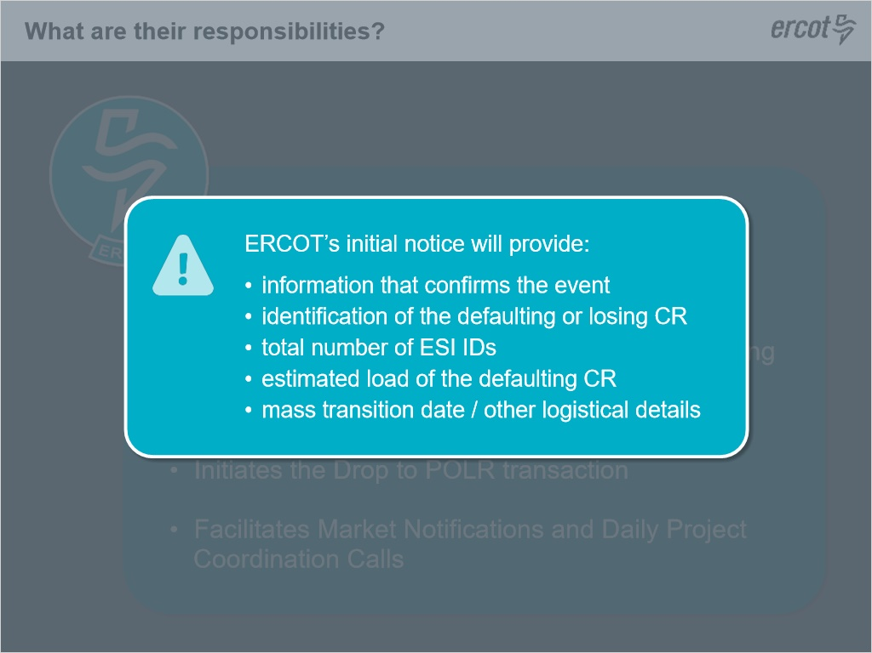
Notes:
Let’s look at the many responsibilities of ERCOT.
ERCOT’s responsibility is to manage the entire Mass Transition event from initiation to conclusion.
ERCOT is responsible for managing the daily activities and transactions of Market Participants throughout the event. We will discuss transactions later in this training
They coordinate communications with PUCT Staff before, during, and after a Mass Transition Event, and serve as the initiator of the Drop to POLR transaction with the TDSPs.
ERCOT is responsible for informing the market of the POLR event.
If it is determined that a Mass transition event will occur due to the default of a CR, ERCOT then will provide a Market Notice to affected TDSPs, POLR REPs, the defaulting, or losing CR, OPUC which is the Office of Public Utility Counsel, as well as PUCT Staff.
ERCOT will also initiate coordination calls with the market.
In the first notification of a Mass Transition event, ERCOT’s initial notice will provide information that confirms the event, the identification of the defaulting or losing CR, the total number of ESI IDs that are being transitioned, the estimated load of the defaulting CR, the mass transition date and other logistical details.

1.9 ERCOT Responsabilities
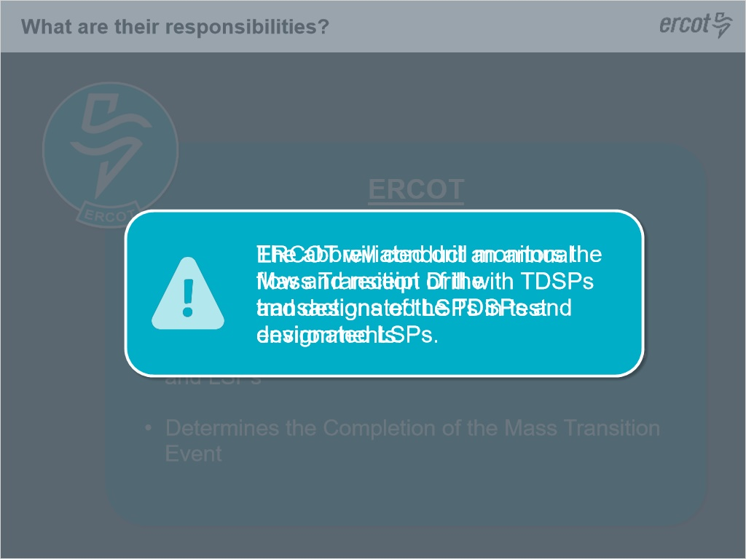
Notes:
ERCOT is also responsible for communications to the affected customers through multiple means such as email, phone call, text messages, and postcards,based on the contact information provided by the defaulting CR.

ERCOT will calculate the ESI ID allocation between the VREPs and LSPs and send respective ESI ID lists to each VREP and LSP impacted.
Finally, ERCOT coordinates all daily project coordination calls until conclusion of the event, and will make the final determination of the completion of the Mass Transition Event - ensuring all impacted ESI IDs have been transitioned and communicates that to the market.
To ensure the process performs as designed, ERCOT will conduct an annual Mass Transition Drill with TDSPs and designated LSPs in test environments, typically performed in the Spring, to test the functionality and market processes ensuring an efficient transition of a large number of ESI IDs.
The abbreviated drill monitors the flow and receipt of the transactions of the TDSPs and designated LSPs.

1.10 TDSP Responsabilities
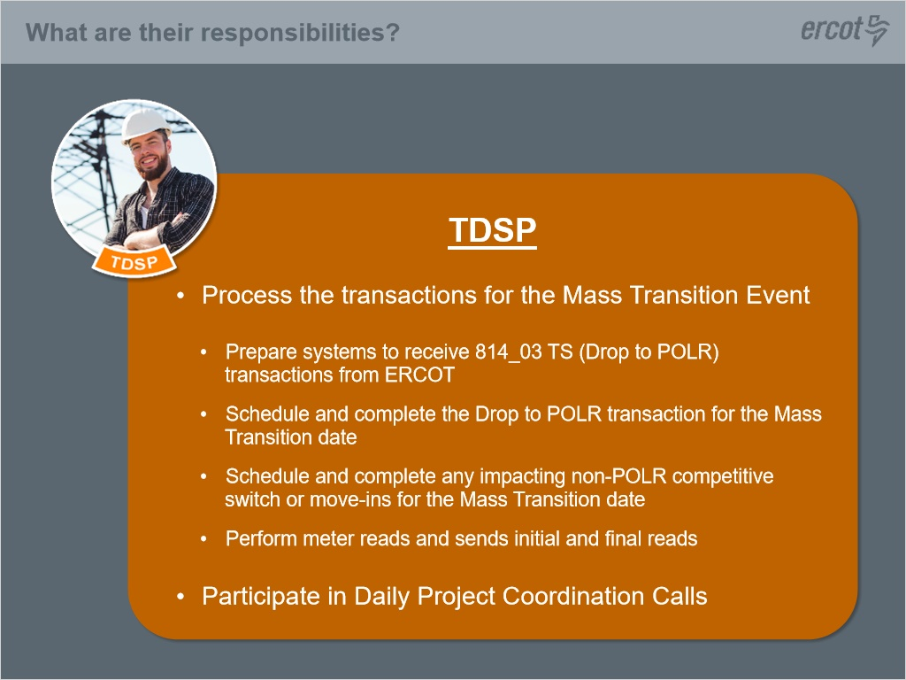
Notes:
TDSPs also have an important role.

They are responsible for processing the transactions during a Mass Transition event.

Initially, they will prepare their systems to be able to receive the Drop to POLR transaction from ERCOT (an 814_03TS), including the removal of any remaining switch holds on transitioning ESI IDs

The TDSP schedules the Drop to POLR transaction for the Mass Transition event according to the timelines prescribed for this process.

The TDSP will also schedule and complete any non-POLR “competitive” switch or Move-Ins scheduled up to 7 PM of the Mass transition effective date.

For all remaining, scheduled Drop to POLR transactions, the TDSPs will perform meter reads on the Mass Transition Effective date.

Lastly, to complete the Business Process Instance for the Mass Transition event, the TDSPs will send to ERCOT the Final meter read (as an 867_03 transaction) which will be forwarded to the Losing/Defaulting CR, and the Initial read (as an EDI 867_04 transaction) which will be forwarded to the new/Gaining CR.

Along with the other Market Participants, TDSPs will also participate on the daily Project Coordination Calls to ensure all transition activities are executed as planned.

1.11 Defaulting CR Responsabilities
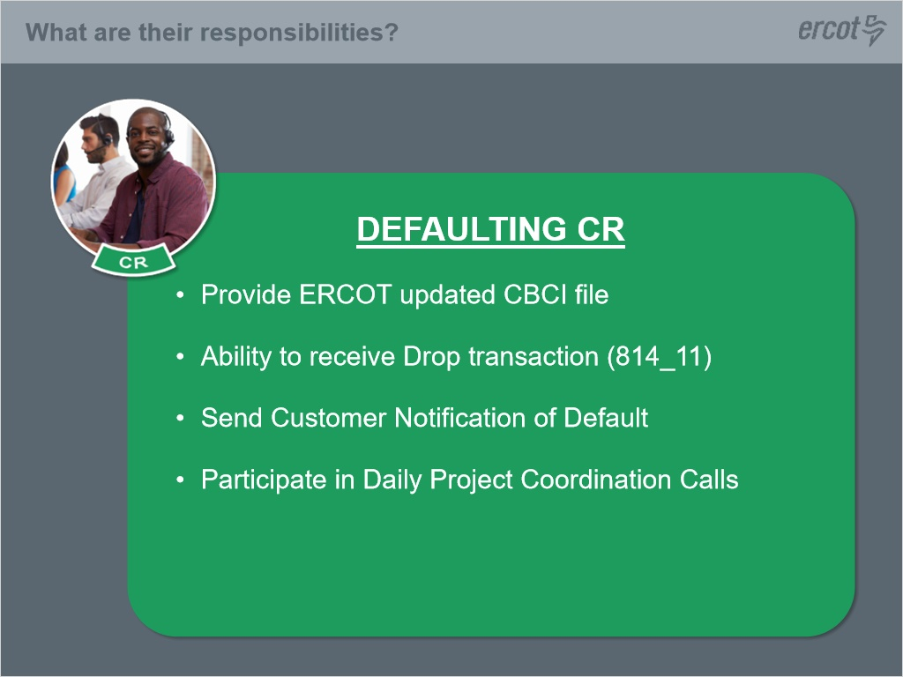
Notes:
The Defaulting CR also has responsibilities during the mass transition event.
They are required by the PUCT to send their Customers a Notification of Default.

The Defaulting CR must remove switch holds on all transitioning ESIID.

They must also provide ERCOT an updated Customer Billing Contact Information (CBCI) file which includes any and all contact information such as phone numbers and email addresses for ERCOT & POLR provider customer outreach.

The Defaulting CR must also be able to receive and process the Drop Response (as an EDI 814_11 transaction) from ERCOT ending their liability for the ESIID.

Lastly, the Defaulting CR must participate on the Daily Project Coordination Calls.

1.12 POLR CR Responsabilities
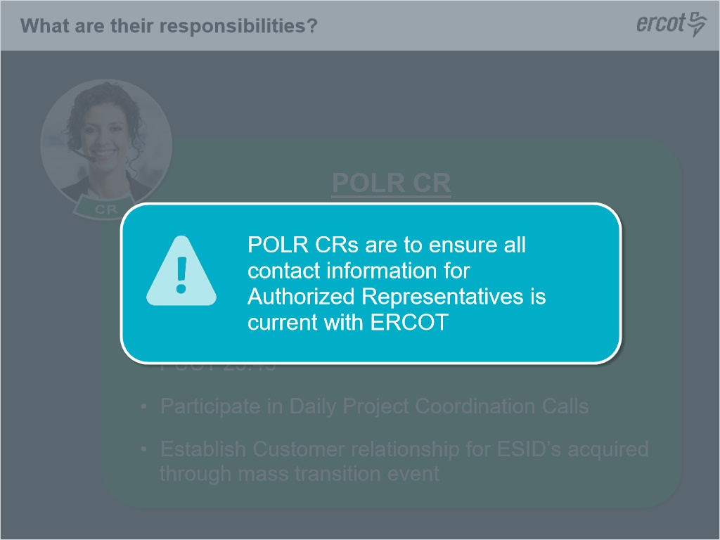
Notes:
VREPs and LSPs (the POLR REPs) must prepare their systems to receive the Drop Enrollment Request transaction (as an EDI 814_14 transaction) from ERCOT.

POLR REPs will integrate the Customer contact information received on the CBCI file from ERCOT.

POLR REPs are also responsible for providing communications and outreach to impacted customers as required in PUCT Substantive Rule 25.43.

They must also participate in the Daily Project Coordination Calls, and are ultimately responsible for establishing a relationship with the Customer acquired through the Mass Transition event.

As a reminder, the POLR CRs are to ensure all contact information for Authorized Representatives is current with ERCOT as communications regarding the event will be distributed using that information.
POLR CRs are to remain engaged throughout the entire process to ensure all assigned ESIs have successfully transitioned.

1.13 Customer Responsabilities
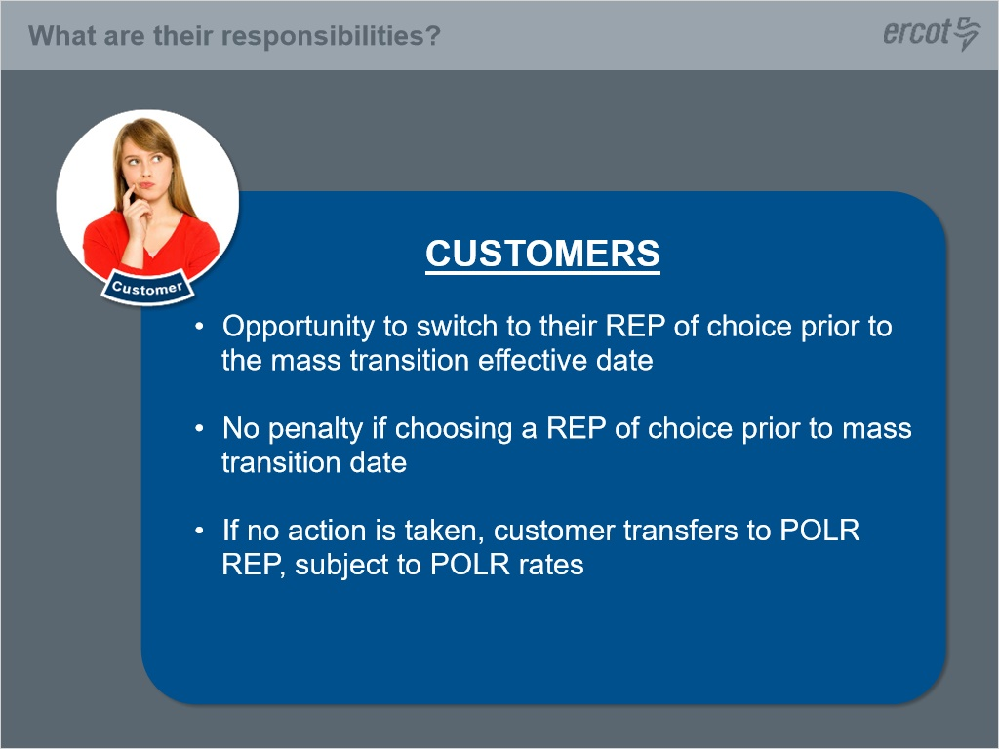
Notes:
Customer also play a role during the Mass Transition event.

When informed of the event by ERCOT, customers have the opportunity to switch to their REP of choice prior to the Mass Transition Effective Date.

If the Customer chooses another REP, they may do so without penalty from the Defaulting/Losing CR or POLR/Gaining CR.

If a customer does chose a new REP prior to the Mass Transition effective date, ERCOT will monitor the scheduling of a non-POLR (or “competitive”) switch or Move In, and will initiate a cancel transaction (as an EDI 814_08 transaction) to the impacted Market participants - which will cancel the associated scheduled Drop to POLR transaction.
If no action is taken by the Customer, they will be transitioned to the POLR REP, and subject to POLR rates.

1.14 Timeline
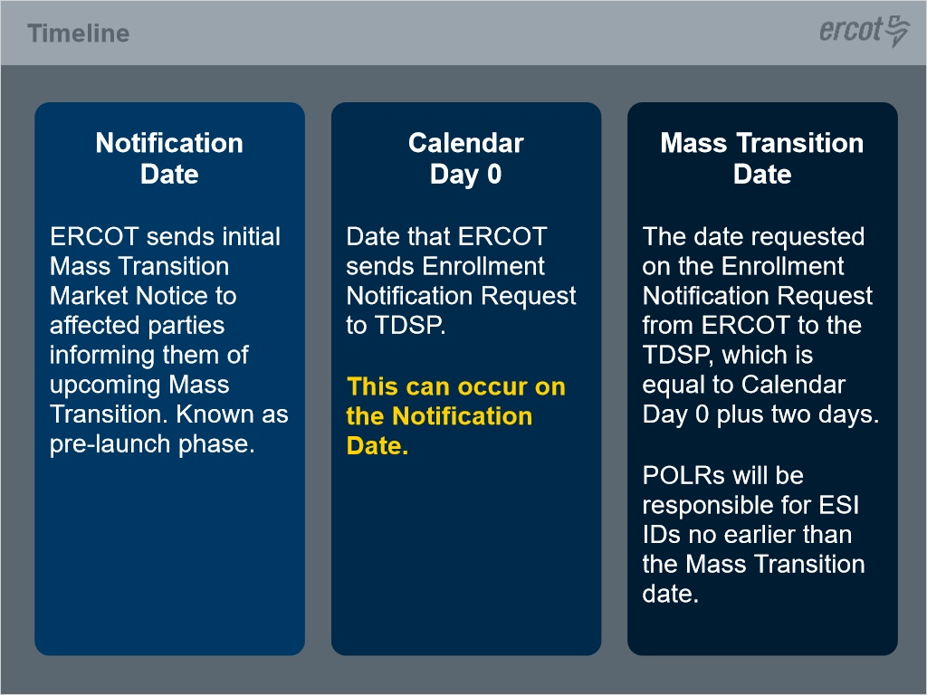
Notes:
Now that market participants and their roles have been defined, we can look at the timeline for executing a mass transition event.

For the purpose of the timeline, let’s define the following dates:

First is the Notification date.

This is the date on which ERCOT sends the initial Mass Transition Market Notice to affected parties informing them that a Mass Transition will occur as a result of a Market participant default, also known as the pre-launch stage in the process.

Next, is Calendar Day 0. This is the date that ERCOT sends the Enrollment Notifications Request (as an EDI 814_03TS transaction) to the TDSPs.

This can occur on the Notification date.

The Mass Transition Date is the date requested in the Enrollment Notifications Request ( or 814_03TS) transaction from ERCOT to the TDSPs.

This is the Scheduled Meter Read or SMRD that will be equal to Calendar Day 0 plus two days.

POLR CRs will be responsible for impacted ESI IDs no earlier than the Mass Transition effective date during a POLR event.

1.15 Timeline of a Mass Transition
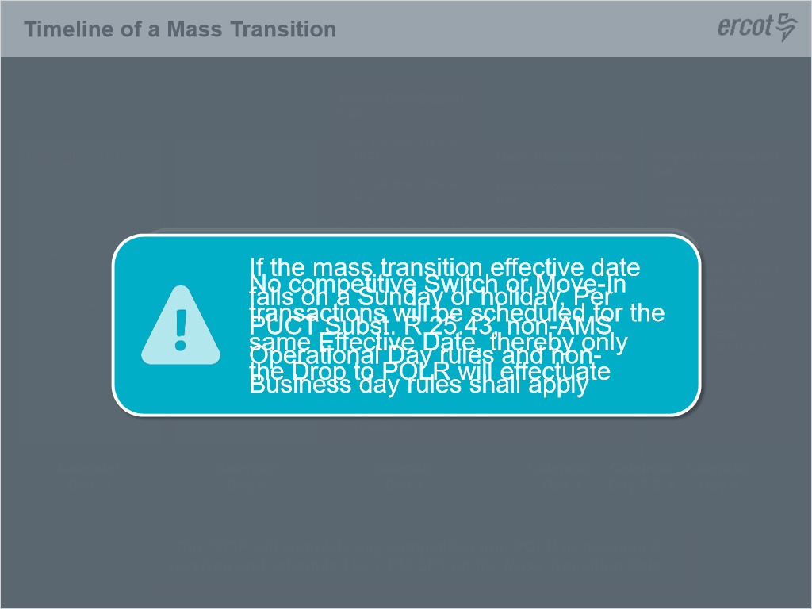
Notes:
The following diagram can be found in the Retail Market Guide, Section 9, Appendix F2.

On Calendar Day -1, (also known as Notification Date), ERCOT provides notice of the Mass Transition event to impacted Competitive Retailers, transmission Distribution Service Providers, and the Public Utility Commission of Texas.

If the notification occurs prior to 3 PM Central Prevailing Time, the initial Project Coordination Call will be facilitated by ERCOT by 5 PM that same day.

If the notification occurs after 3 PM, the initial Project Coordination Call will be held the next morning.

Keep in mind, a default can only occur on a business and banking day.

Once a default is confirmed and communicated to PUCT Staff, ERCOT will provide impacted TDSPs with the Defaulting CR’s DUNS Number in order to prepare their systems for the Mass transition event.

On Calendar Day 0, which may also be the Notification date, ERCOT sends the Drop to POLR transaction to TDSPs with an effective date two calendar days.

This is known as the Mass Transition Date.

TDSPs will schedule the DROP to POLR transactions accordingly.

And the Defaulting CR must provide their CBCI (customer billing and contact information) file to ERCOT for processing.
On Calendar Day 1, A Daily Project Coordination call will be held to discuss the status of transactions and address any questions market participants may have.
ERCOT will provide a list of respective ESIs noting the expected transaction which will include a Drop to POLR, and may include a move in, or move out, or switch request.)
The ESIID list will be provided to each impacted market participant’s authorized contacts via an email. ERCOT sends the Customer Billing Contact Information (CBCI) file to affected POLR CR’s via NAESB (an electronic file delivery) to assist the REP with customer outreach. The list is also sent to the TDSP’s
ERCOT will send an ‘ERCOT Initiated’ MarkeTrak to impacted CRs, both POLR and Non-POLR, listing any in flight transactions involving the defaulting CR.. The list will include ESIID, requested date or scheduled date. CR’s should take action to work with the customer to expediate the switch in order to minimize the time the customer is served by the POLR CR.
Therefore, the assigned POLR CR will receive customer information on their allocated ESI IDs only.
For more information on the format and attributes of the CBCI file see Section 9 of the Retail Market Guide.
It is important each market participant has current information for the Transition/Acquisition contacts on file with ERCOT.
Any updates are to be made with ERCOT Client Services via a “Notice of Change of Information” form.
ERCOT will initiate the process to transition the impacted ESI IDs to the Gaining POLR REP and also forward any non-POLR or ‘competitive’ switch or move in transactions to the TDSP for scheduling.
TDSPs will execute the ‘competitive’ non-POLR transactions in lieu of the scheduled DROP to POLR transaction.
Once a non-POLR transaction is completed for a given ESIID, ERCOT will send a cancel transactions to all impacted parties to cancel the scheduled DROP to POLR transaction.
In addition to managing the transactions between Market Participants, on Calendar Day 1, ERCOT also begins outreach to impacted customers to inform them of the Mass Transition event via email, phone, or text and sends out the required Commission sealed postcard.
Day 2, known as the Mass Transition Date, a Daily Project Coordination call will be held to update the market on the status of the event and allow market participants the opportunity to address any questions.
ERCOT will continue forwarding any “competitive” non-POLR switch or move in transactions to the TDSPs for processing.
The TDSP will complete any ‘competitive’ non-POLR switch or move in transaction if received and scheduled by 7 PM CPT on the Mass Transition Date.
Otherwise, beginning, 7:01 PM CPT, TDSPs will process any remaining Drop to POLR transactions that have not been cancelled and customers will transition to the POLR REP.
TDSPs will perform meter reads on Day 2 for the Mass Transition Date which is included within the Final and Initial meter read notifications.
ERCOT will continue to monitor to ensure all impacted ESI IIDs have transitioned to either a REP of their choice or the designated POLR REP.
NOTE: if the mass transition effective date falls on a Sunday or holiday which is a non-AMS Operational Day, then, Per PUCT Subst. R 25.43, non-AMS Operational Day rules and non-Business day rules shall apply - meaning, no competitive Switch or Move-In transactions will be scheduled for the same Effective Date, thereby only the Drop to POLR will effectuate.
Days 3 and 4 will continue with Daily Project Coordination calls with market participants hosted by ERCOT.
By Day 5, TDSPs will send to ERCOT the final meter read which is fowarded to the Defaulting CR as the final invoice.
TDSPs will also send the initial meter reads to ERCOT who will forward to the POLR CR confirming the new relationship with the customer.
Once all impacted ESI IDs have been transitioned, ERCOT will conclude the Mass Transition process.

1.16 Transaction Flow of a Mass Transition
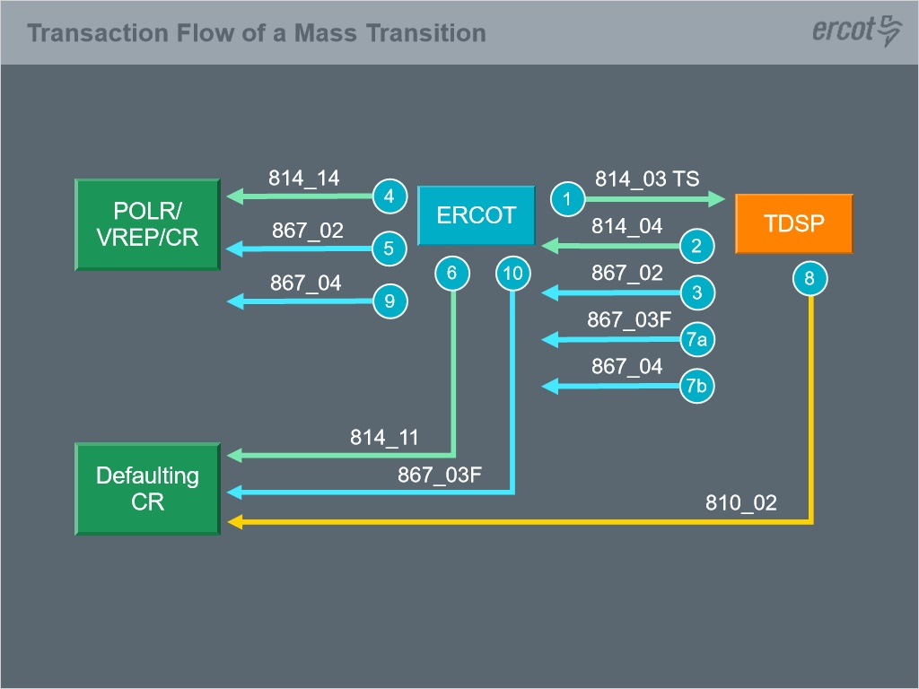
Notes:
The previous slide covered the process of a Mass transition.

Now let’s review the sequencing of the electronic transactions that effectuate that process.
These transactions are all transmitted via the North American Energy Standards Board (NAESB) Electronic Delivery Mechanism (EDM) formatted per the Texas Standard Electronic Transactions (TX SET) guidelines.
Each transaction has a specific number associated with it to identify the transaction.
The first transaction to initiate the mass transition process is the 814_03 TS Enrollment Notification Request transaction sent from ERCOT to the appropriate TDSP.
This appears as a standard 814_03 Enrollment Request transaction; however, only ERCOT can initiate the “TS” transaction resulting in the initiation of the Mass transition event.
ERCOT will also cancel all scheduled Move In or Switch transactions associated with the Defaulting CR.
Once the TDSP receives the 814_03 “TS”, they will respond with an 814_04 Enrollment Notification Response scheduling transaction confirming the mass transition date and also send an 867_02 Historical Usage transaction to ERCOT to be forwarded to the new POLR REP (if available).
ERCOT then sends corresponding scheduling transactions to the POLR CR, as an 814_14 Drop Enrollment Request confirming the mass transition date and forwards the 867_02 Historical Usage provided by the TDSPs.
ERCOT then sends the Defaulting CR an 814_11 Drop Response ending the relationship on the mass transition effective date.
Once the meter read is obtained by the TDSP on the Mass Transition Date, the TDSP will send the 867_03 Final Meter Read to ERCOT and the 810_02 TDSP invoice to the Defaulting CR.
The TDSP then sends the 867_04 Initial Meter Read transaction to ERCOT who forwards to the gaining POLR REP to establish a relationship with the customer.
ERCOT forwards the 867_03 Final to the defaulting CR, ending their relationship with the customer.

1.17 Checkpoint Question 1
(True/False, 10 points, 1 attempt permitted)
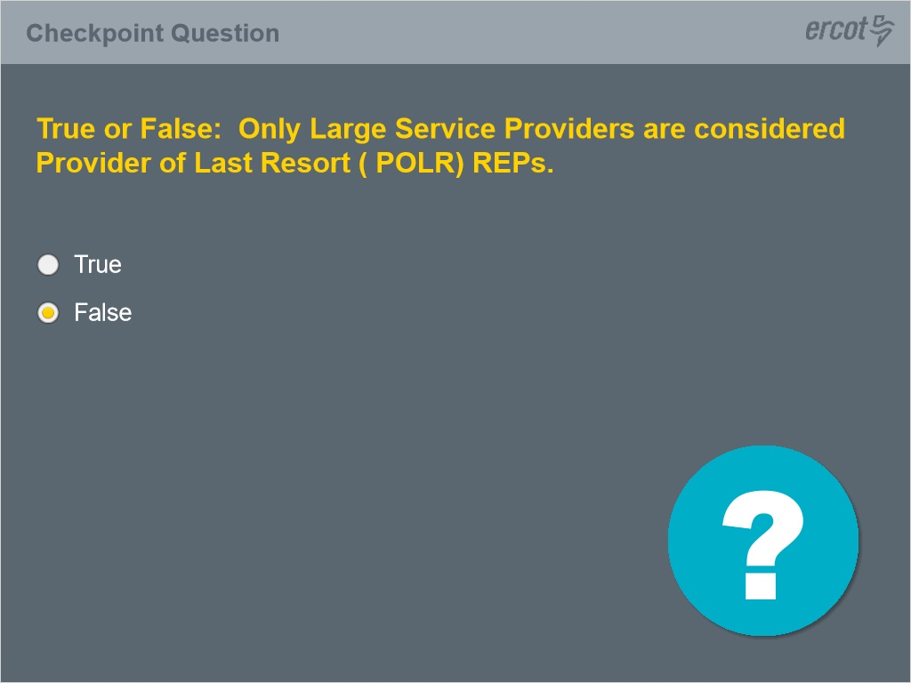
Correct | Choice
 | True
X | False

Notes:
Let’s review the Mass Transition Process with a few checkpoint questions.

Correct (Slide Layer)
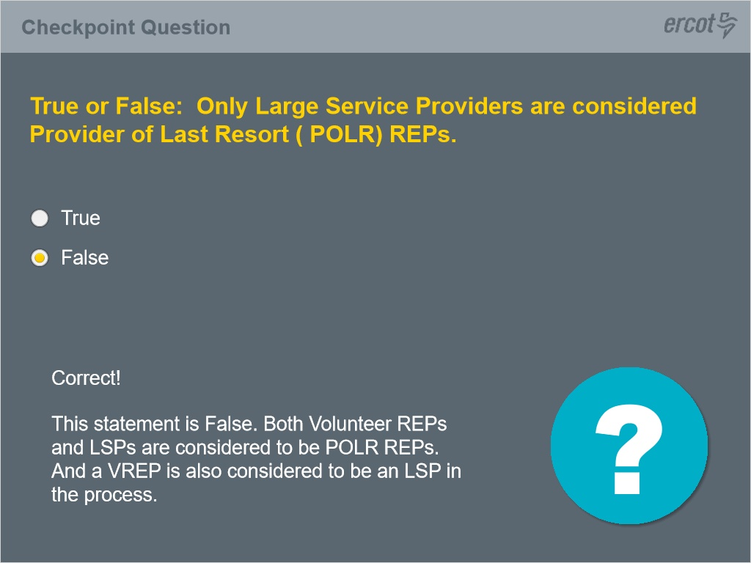

Incorrect (Slide Layer)
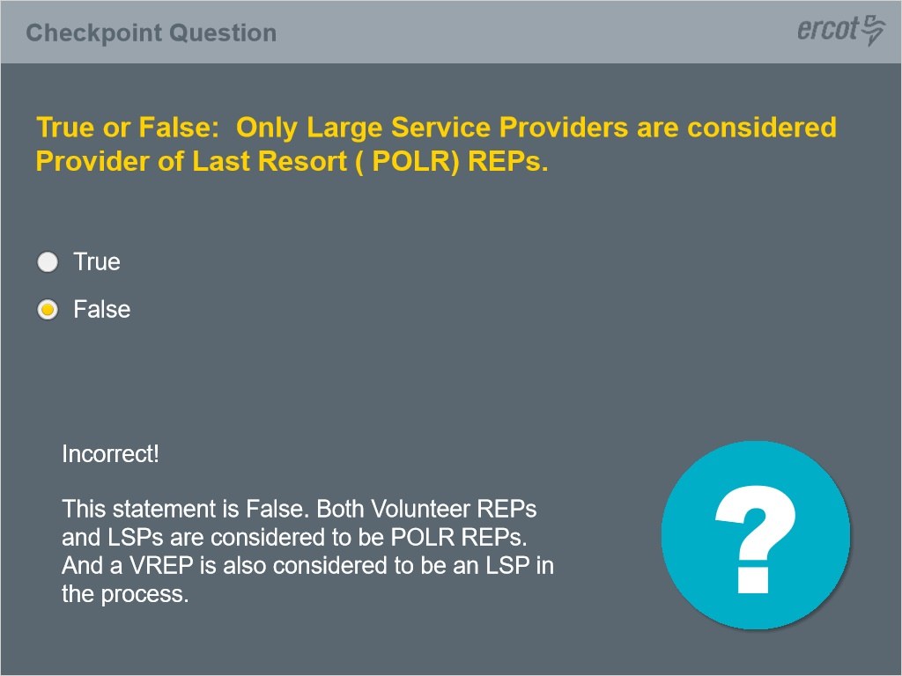

1.18 Checkpoint Question 2
(True/False, 10 points, 1 attempt permitted)
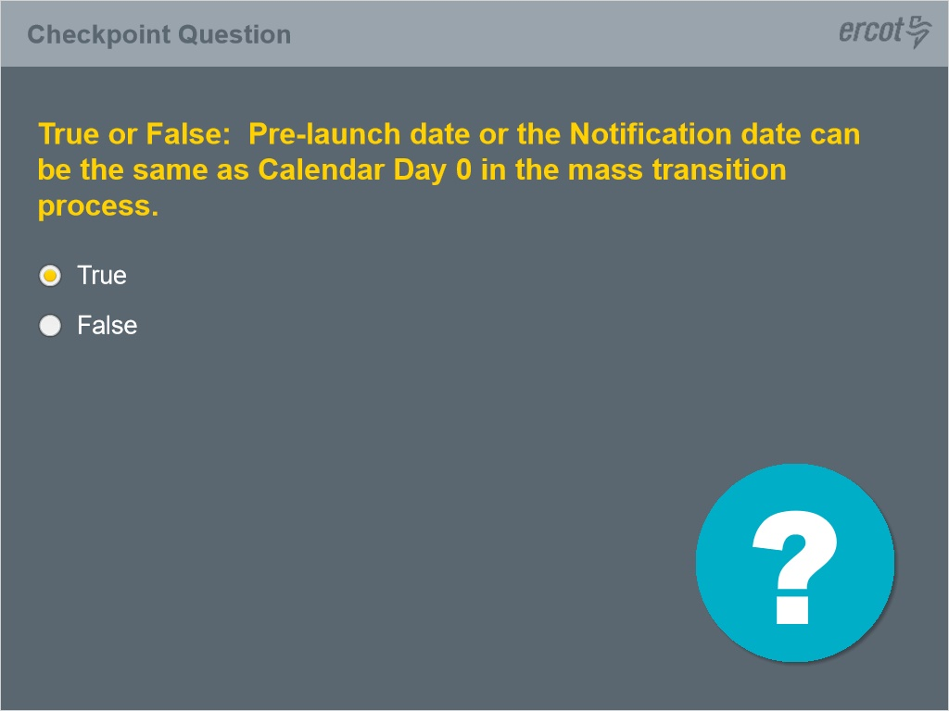
Correct | Choice
X | True
 | False

Correct (Slide Layer)
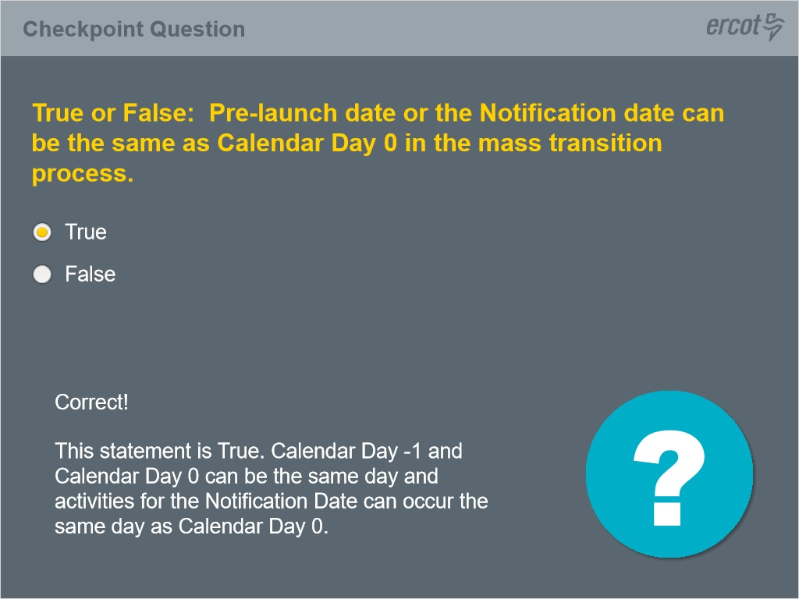

Incorrect (Slide Layer)
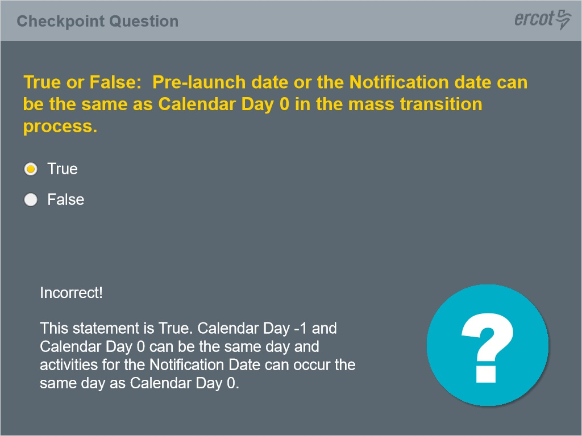

1.19 Checkpoint Question 3
(Multiple Choice, 10 points, 1 attempt permitted)
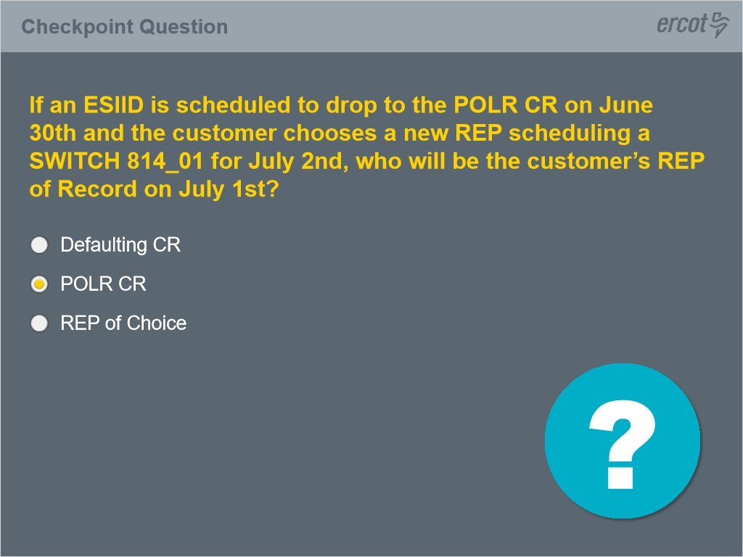
Correct | Choice
 | Defaulting CR
X | POLR CR
 | REP of Choice

Correct (Slide Layer)
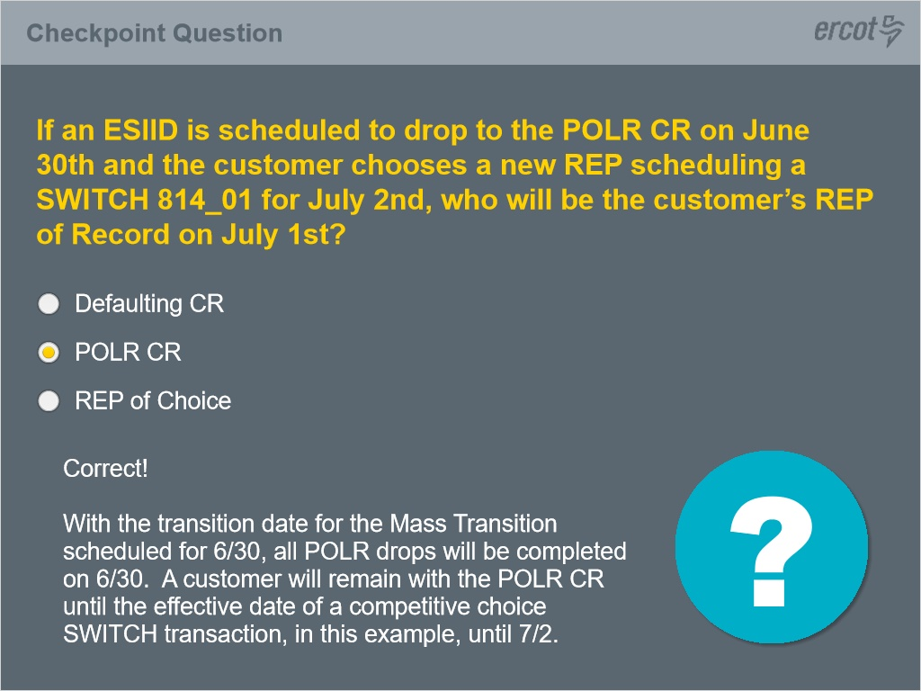

Incorrect (Slide Layer)
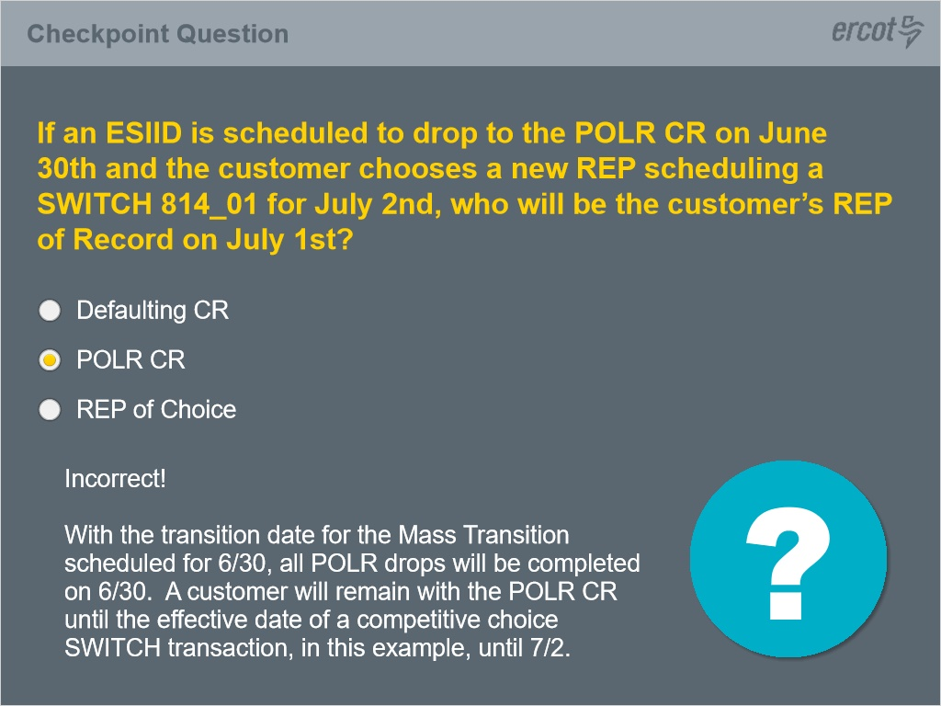

1.20 Checkpoint Question 4
(Multiple Choice, 10 points, 1 attempt permitted)
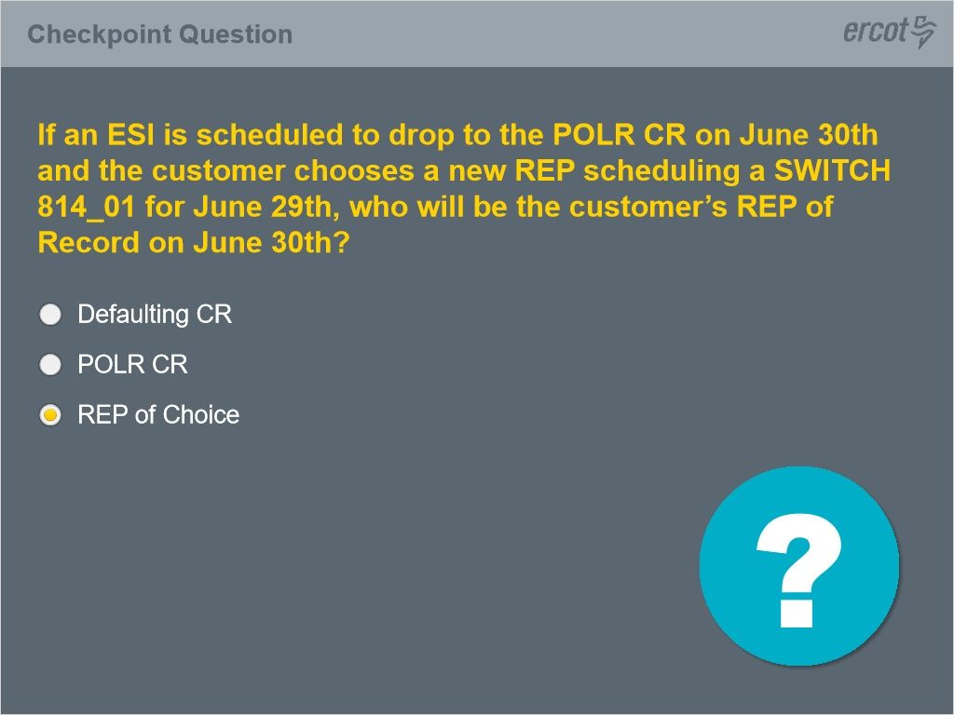
Correct | Choice
 | Defaulting CR
 | POLR CR
X | REP of Choice

Correct (Slide Layer)
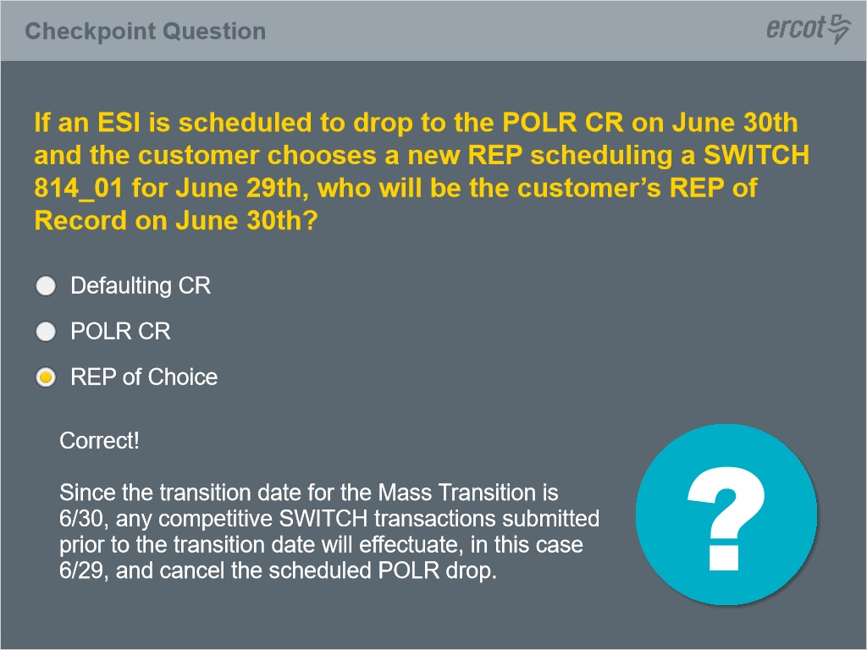

Incorrect (Slide Layer)
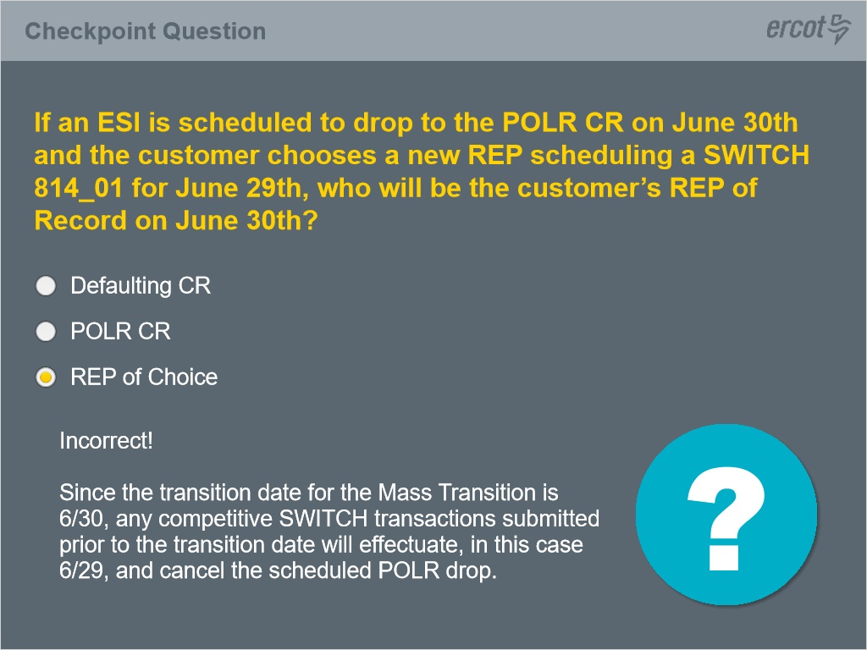

1.21 Conclusion

Notes:

