July 2021 ERCOT Monthly Operations Report
Reliability and Operations Subcommittee Meeting
Sep 02, 2021

Table of Contents
1. Report Highlights 2
2. Frequency Control 3
2.1. Frequency Events 3
2.2. Responsive Reserve Events 4
2.3. Load Resource Events 4
3. Reliability Unit Commitment 4
4. Wind Generation as a Percent of Load 5
5. Largest Net-Load Ramp 7
6. COP Error Analysis 7
7. Congestion Analysis 9
7.1. Notable Constraints 9
7.2. Generic Transmission Constraint Congestion 15
7.3. Manual Overrides 16
7.4. Congestion Costs for Calendar Year 2021 16
8. System Events 17
8.1. ERCOT Peak Load 17
8.2. Load Shed Events 17
8.3. Stability Events 17
8.4. Notable PMU Events 17
8.5. DC Tie Curtailment 17
8.6. TRE/DOE Reportable Events 18
8.7. New/Updated Constraint Management Plans 18
8.8. New/Modified/Removed RAS 18
8.9. New Procedures/Forms/Operating Bulletins 18
9. Emergency Conditions 19
9.1. OCNs 19
9.2. Advisories 19
9.3. Watches 19
9.4. Emergency Notices 19
10. Application Performance 19
10.1. TSAT/VSAT Performance Issues 19
10.2. Communication Issues 19
10.3. Market System Issues 19
11. Model Updates 20
Appendix A: Real-Time Constraints 22

Report Highlights
- The unofficial ERCOT peak load was 73,098 MW.
- There were 2 frequency events.
- There were 1 instance where Responsive Reserves were deployed.
- There were 167 HRUC commitments.
- There were 2 days of congestion on the West Texas Export GTC, 6 days on the Panhandle GTC, 17 days on the North Edinburg to Lobo GTC, 19 days on the Raymondville to Rio Hondo, 10 days on the Nelson Sharpe to Rio Hondo GTC, 5 days on the Valley Export GTC, and 1 day on the North to Houston GTC. There was no activity on the remaining GTCs during the month.

Frequency Control

Frequency Events

The ERCOT Interconnection experienced 2 frequency events, which resulted from unit’s trips. The average event duration was 00:04:10.

A summary of the frequency events is provided below. The reported frequency events meet one of the following criteria: Delta Frequency is 60 mHz or greater; the MW loss is 350 MW or greater; resource trip event triggered RRS deployment. Frequency events that have been identified as Frequency Measurable Events (FME) for purposes of BAL-001-TRE-1 analysis are highlighted in blue. When analyzing frequency events, ERCOT evaluates PMU data according to industry standards. Events with an oscillating frequency of less than 1 Hz are inter-area, while higher frequencies indicate local events. Industry standards specify that damping ratio for inter-area oscillations should be 3.0% or greater. For the frequency events listed below, the ERCOT system met these standards and transitioned well after each disturbance.

Date and Time | Delta Frequency | Max/Min Frequency | Duration of Event | PMU Data |  | MW Loss | Load | Wind | Inertia
 | (Hz) | (Hz) |  | Oscillation Mode (Hz) | Damping Ratio |  | (MW) | % | (GW-s)
7/6/2021 17:04 | 0.071 | 59.909 | 0:03:58 | 0.52 | 11% | 383.45 | 61,479 | 6% | 335,421
7/20/2021 8:46 | 0.134 | 59.858 | 0:04:22 | 0.64 | 6% | 800.9 | 46,020 | 4% | 306,168

(Note: All data on this graph encompasses frequency event analysis based on BAL-001-TRE-1.)

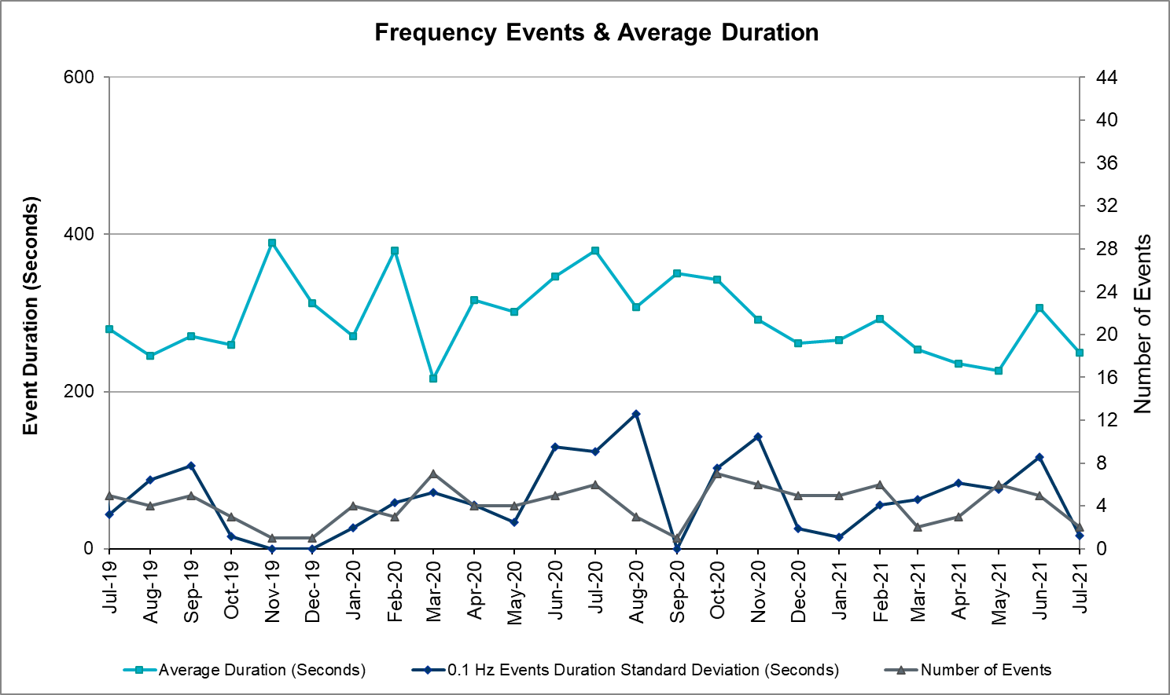

Responsive Reserve Events
There was 1 event where Responsive Reserve MWs were released to SCED. The events highlighted in blue were related to frequency events reported in Section 2.1 above.

Date and Time Released to SCED | Date and Time Recalled | Duration of Event | Maximum MWs Released | Comments
7/20/2021 8:46 | 7/20/2021 8:50:27 | 00:04:22 | 696

Load Resource Events
None

Reliability Unit Commitment
ERCOT reports on Reliability Unit Commitments (RUC) on a monthly basis. Commitments are reported grouped by operating day and weather zone. The total number of hours committed is the sum of the hours for all the units in the specified region. Additional information on RUC commitments can be found on the MIS secure site at Grid Generation Reliability Unit Commitment.

There were no DRUC commitments.

There were 167 HRUC commitments

Resource Location | # of Resources | Operating Day | Total # of Hours Committed | Total MWhs | Reason for Commitment
EAST, NORTH_CENTRAL, SOUTH_CENTRAL | 12 | July 1, 2021 | 122 | 24,366.0 | System Capacity
COAST, EAST, NORTH_CENTRAL | 11 | July 2, 2021 | 100 | 19,884.0 | System Capacity
EAST, NORTH, NORTH_CENTRAL, SOUTH_CENTRAL | 8 | July 3, 2021 | 60 | 17,206.7 | System Capacity
EAST, NORTH_CENTRAL | 2 | July 4, 2021 | 8 | 3,708.0 | System Capacity
EAST, NORTH_CENTRAL, SOUTH_CENTRAL | 12 | July 5, 2021 | 90 | 31,059.0 | System Capacity
COAST, EAST, NORTH_CENTRAL, SOUTH_CENTRAL, SOUTHERN | 15 | July 6, 2021 | 49 | 10,128.5 | System Capacity
EAST, NORTH_CENTRAL, SOUTH_CENTRAL | 16 | July 7, 2021 | 149 | 48,948.0 | System Capacity
EAST, NORTH_CENTRAL, SOUTH_CENTRAL, SOUTHERN | 18 | July 8, 2021 | 122 | 28,367.0 | System Capacity
EAST, NORTH_CENTRAL, SOUTH_CENTRAL | 5 | July 11, 2021 | 43 | 13,052.0 | System Capacity
EAST, NORTH_CENTRAL, SOUTH_CENTRAL | 12 | July 12, 2021 | 92 | 28,829.0 | System Capacity
NORTH_CENTRAL | 2 | July 13, 2021 | 21 | 7,926.0 | System Capacity
EAST, NORTH_CENTRAL | 4 | July 16, 2021 | 15 | 6,061.0 | System Capacity
EAST | 1 | July 17, 2021 | 3 | 714.0 | System Capacity
EAST, NORTH_CENTRAL, SOUTH_CENTRAL | 5 | July 18, 2021 | 21 | 6,426.0 | System Capacity
EAST, NORTH_CENTRAL | 2 | July 19, 2021 | 17 | 2,290.0 | System Capacity
NORTH_CENTRAL | 1 | July 20, 2021 | 24 | 1,440.0 | System Capacity
EAST, NORTH_CENTRAL | 7 | July 21, 2021 | 45 | 9,427.0 | Minimum Run Time, System Capacity
EAST, NORTH_CENTRAL | 6 | July 24, 2021 | 30 | 7,429.0 | System Capacity
EAST, NORTH_CENTRAL, SOUTH_CENTRAL | 3 | July 25, 2021 | 20 | 5,110.0 | System Capacity
EAST, NORTH_CENTRAL | 4 | July 26, 2021 | 40 | 10,439.0 | System Capacity
EAST, NORTH_CENTRAL | 4 | July 27, 2021 | 36 | 9,315.0 | System Capacity
EAST, NORTH_CENTRAL | 4 | July 28, 2021 | 33 | 8,604.0 | System Capacity
EAST, NORTH_CENTRAL | 5 | July 29, 2021 | 45 | 14,022.0 | System Capacity
EAST, NORTH_CENTRAL, SOUTHERN | 5 | July 30, 2021 | 37 | 9,932.0 | System Capacity
EAST, NORTH_CENTRAL | 3 | July 31, 2021 | 12 | 3,188.0 | System Capacity

Wind Generation as a Percent of Load
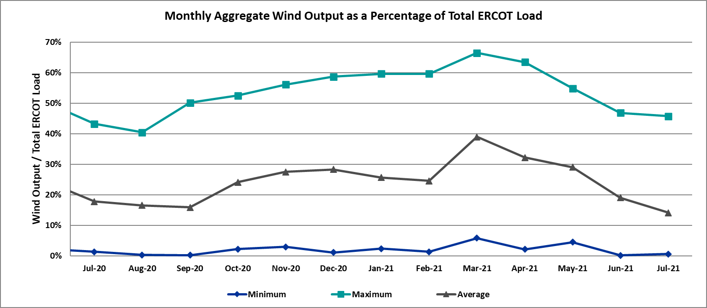

Wind Generation Record: 23,596 MW on 06/25/2021 at 22:32
Wind Penetration Record: 66.47% on 03/22/2021 at 00:46

Largest Net-Load Ramp
The net-load ramp is defined as the change in net-load (load minus wind and PVGR generation) during the defined time horizon. Such a variation in net-load needs to be accommodated in grid operations to ensure that the reliability of the grid is satisfactorily maintained. The largest net-load ramp during 5-min, 10-min, 15-min, 30-min and 60-min in July 2021 is 859 MW, 1464 MW, 1804 MW, 3352 MW, and 6132 MW, respectively. The comparison with respect to the historical values is given in the table below.

Month and Year | 5 min | 10 min | 15 min | 30 min | 60 min
July 2021 | 859 MW | 1464 MW | 1804 MW | 3352 MW | 6132 MW
July 2014 | 1074 MW | 1424 MW | 1713 MW | 2809 MW | 5392 MW
July 2015 | 905 MW | 1257 MW | 1688 MW | 3075 MW | 5843 MW
July 2016 | 863 MW | 1660 MW | 1885 MW | 3390 MW | 5900 MW
July 2017 | 880 MW | 1243MW | 1756 MW | 3048 MW | 5738 MW
July 2018 | 1399 MW | 1779 MW | 2202 MW | 3572 MW | 6698 MW
July 2019 | 1120 MW | 1699 MW | 2291 MW | 3561 MW | 6546 MW
2014-2020 | 1399 MW | 1779 MW | 2291 MW | 3572 MW | 6698 MW

COP Error Analysis
COP Error is calculated as the capacity difference between the COP HSL and real-time HSL of the unit. Mean Absolute Error (MAE) stayed over 15,724 MW until Day-Ahead at 12:00, then dropped significantly to 1713 MW by Day-Ahead at 14:00. In the following chart, Under-Scheduling Error indicates that COP had less generation capacity than real-time and Over-Scheduling Error indicates that COP had more generation capacity than real-time.

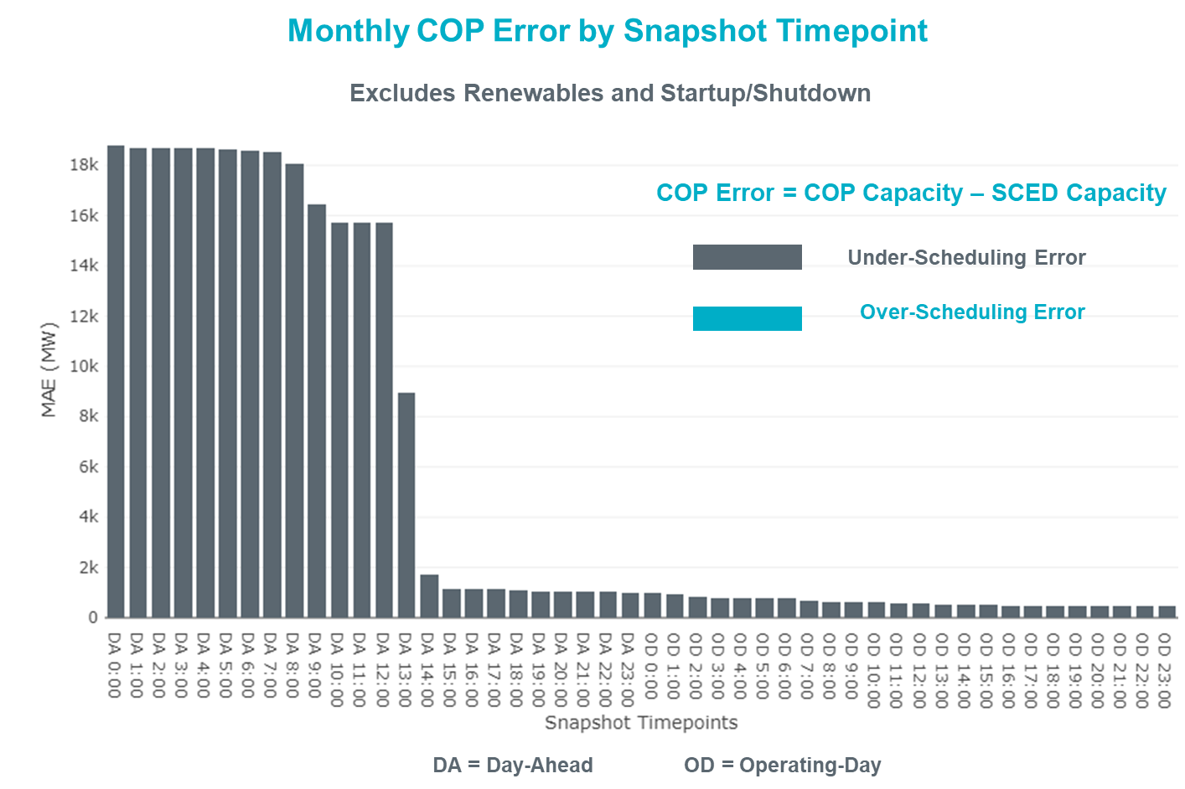

Monthly MAE for the Latest COP at the end of the Adjustment Period was 481 MW with median ranging from -657.1 MW for Hour-Ending (HE) 21 to 241.9 MW for HE 13. HE 19 on the 4th had the largest Over-Scheduling Error (1397 MW) and HE 21 on the 7^{h} had the largest Under-Scheduling Error (-2,884.3 MW).

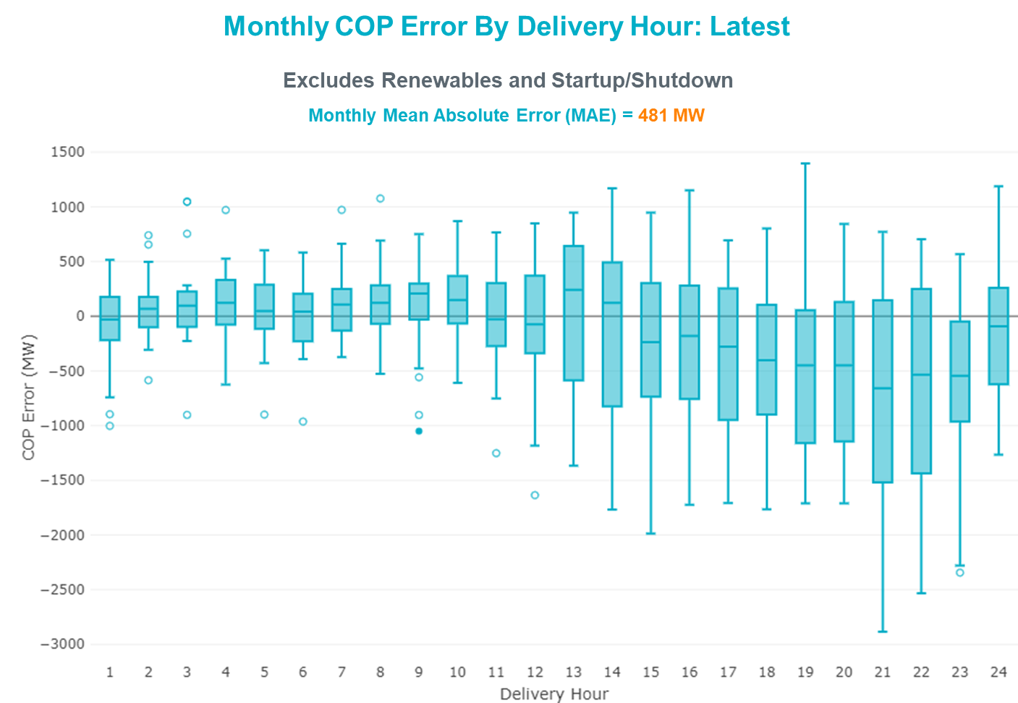

Monthly MAE for the Day-Ahead COP at 12:00 was 15,724 MW with median ranging from -22,233 MW for Hour-Ending (HE) 18 to -10,816 MW for HE 3. HE 17 on the 2nd had the largest Under-Scheduling Error (-25,814 MW) and HE 7 on the 14th had the largest Over-Scheduling Error (-5,112 MW).

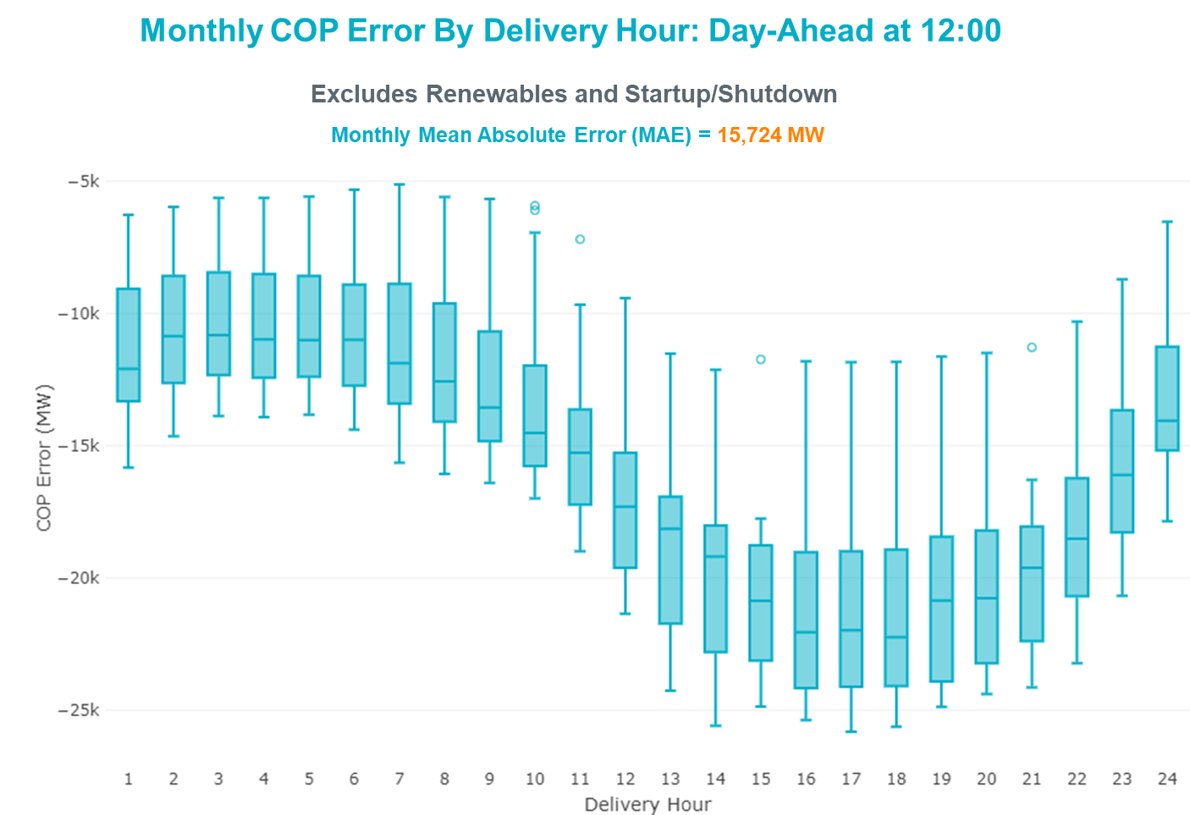

Congestion Analysis

Notable Constraints
Nodal protocol section 3.20 specifies that ERCOT shall identify transmission constraints that are binding in Real-Time three or more Operating Days within a calendar month. As part of this process, ERCOT reports congestion that meets this criterion to ROS. In addition, ERCOT also highlights notable constraints that have an estimated congestion rent exceeding $1,000 for a calendar month. These constraints are detailed in the table below, including approved transmission upgrades from TPIT that may provide some congestion relief based on ERCOT’s engineering judgement. Rows highlighted in blue indicate the congestion was affected by one or more outages. For a list of all constraints activated in SCED, please see Appendix A at the end of this report.

Contingency Name | Overloaded Element | # of Days Constraint Binding | Congestion Rent | Transmission Project
HCKSW TO DENSW 138 DBLCKT | Deen Switch - Rosen Heights Tap 2 138kV | 6 | $10,733,264.71
Emses-Pkrsw & Hcksw-Rnksw 345kV | Dfw Southeast - Dfw E-East 138kV | 1 | $7,544,222.66
MIDLAND EAST TRX MDLNE_3_1 345/138 | Tall City - Sharyland Utilities - Telephone Road - Sharyland Utilities 138kV | 8 | $6,360,246.19 | Tall City - Telephone Road 138 kV Line Rebuild (57915)
Man_Sgl_ MDL-FLC_345_kV_w_MDL_XMFR1_FLC_AMR2 | Tall City - Sharyland Utilities - Telephone Road - Sharyland Utilities 138kV | 14 | $6,301,042.64 | Tall City - Telephone Road 138 kV Line Rebuild (57915)
LIGSW TO HKBRY 138 DBLCKT | Dfw Southeast - Dfw E-East 138kV | 1 | $5,006,304.49
Man_dbl_FLCNS-MDLNE_345KV_and_FLCNS-MGSES_345_KV | Tall City - Sharyland Utilities - Telephone Road - Sharyland Utilities 138kV | 14 | $4,957,596.89 | Tall City - Telephone Road 138 kV Line Rebuild (57915)
Basecase | NE_LOB GTC | 14 | $4,905,686.20
CRLNW TO IRVND 138 DBLCKT | Dfw Southeast - Dfw E-East 138kV | 1 | $4,364,006.60
LIGGETT SWITCH to EULESS LIN _D | Dfw Southeast - Dfw E-East 138kV | 4 | $4,075,892.70
Fowlerton to LOBO 345 LIN1 | Laredo Vft North - Las Cruces 138kV | 8 | $3,168,251.89 | Laredo VFT North to North Laredo Switch: Rebuild 138 kV Line (58008)
Manual dbl ckt for NEDIN-BONILLA 345kV & RIOH-PRIM138kV | Haine Drive - La Palma 138kV | 13 | $2,450,505.72 | Stewart Road: Construct 345 kV cut-in (5604)
TWR (345) HLJ-WAP64 & BLY-WAP72 | South Texas Project - Wa Parish 345kV | 5 | $1,410,076.20
LON HILL to NELSON SHARPE LIN 1 | Celanese Bishop - Nelson Sharpe 138kV | 8 | $1,228,062.94
HUTTO TO RNDRK 138 AND HUTTO TO GEORSO 138 DBLCKT | Gilleland Creek - Mcneil 138kV | 1 | $1,064,200.89
Fowlerton to LOBO 345 LIN1 | North Laredo Switch - Piloncillo 138kV | 6 | $747,961.16
Basecase | PNHNDL GTC | 3 | $726,711.93
Fowlerton to LOBO 345 LIN1 | Bruni Sub 138kV | 5 | $402,056.68
COMANCHE SWITCH (Oncor) to COMANCHE PEAK SES LIN _A | Comanche Tap - Comanche Switch (Oncor) 138kV | 4 | $377,717.12
ODLAW SWITCHYARD to ASPHALT MINES LIN 1 | Hamilton Road - Maverick 138kV | 4 | $282,290.72 | Brackettville to Escondido: Construct 138 kV line (5206)
LAQUINTA to LOBO LIN 1 | Bruni Sub 138kV | 5 | $215,437.50
Tri Corner to SEAGOVILLE SWITCH LIN _B | Forney Switch - Tri Corner 345kV | 5 | $175,109.14
Bighil-Kendal 345kV | Rocksprings - Friess Ranch 69kV | 4 | $153,073.96 | Rocksprings to Friess Ranch: Rebuild 69 kV line (51005)
Basecase | NELRIO GTC | 5 | $143,808.74
SWESW TO MULBERRY AND SWESW TO LNCRK 345 DBLCKT | Bluff Creek - Abilene Mulberry Creek 345kV | 4 | $101,036.72
Basecase | VALEXP GTC | 3 | $98,326.21
VICTORIA TRX 69A2 138/69 | Magruder - Victoria 138kV | 3 | $74,710.82
CITGO N OAK PARK to NUECES BAY LIN 1 | Morris Street - Nueces Bay 138kV | 4 | $70,051.52

Generic Transmission Constraint Congestion
There were 2 days of congestion on the West Texas Export GTC, 6 days on the Panhandle GTC, 17 days on the North Edinburg to Lobo GTC, 19 days on the Raymondville to Rio Hondo, 10 days on the Nelson Sharpe to Rio Hondo GTC, 5 days on the Valley Export GTC, and 1 day on the North to Houston GTC. There was no activity on the remaining GTCs during the month.

Note: This is how many times a constraint has been activated to avoid exceeding a GTC limit, it does not imply an exceedance of the GTC occurred or that the GTC was binding.

Manual Overrides
None

Congestion Costs for Calendar Year 2021
The following table represents the top twenty active constraints for the calendar year based on the estimated congestion rent attributed to the congestion. ERCOT updates this list on a monthly basis.

Contingency | Overloaded Element | # of 5-min SCED | Estimated | Transmission Project
Basecase | PNHNDL GTC | 21,262 | 91,559,950.24
Elmcreek-Sanmigl 345kV | Pawnee Switching Station - Calaveras 345kV | 2,079 | 76,199,104.65
LOST PINES AEN to FAYETTE PLANT 1 LIN 1 | Winchester - Fayette Plant 1 And 2 345kV | 415 | 51,438,867.64
JOHNSON SWITCH (ONCOR) to CONCORD LIN G1 | Decordova Dam - Carmichael Bend Switch 138kV | 726 | 46,614,977.07
TWR(345) JCK-REF27 & JCK-STP18 | Oasis - Dow Chemical 345kV | 524 | 46,495,190.60
Basecase | N_TO_H GTC | 2,902 | 39,257,119.42
Basecase | NE_LOB GTC | 18,244 | 39,054,754.07
Basecase | WESTEX GTC | 9,272 | 36,776,000.37
TWR(345) JCK-REF27 & JCK-STP18 | South Texas Project - Wa Parish 345kV | 1,866 | 35,934,198.14
Hicross-Pilot & Garfield 138kV | Carson Creek - Pilot Knob 138kV | 803 | 30,600,531.85
Manual dbl ckt for NEDIN-BONILLA 345kV & RIOH-PRIM138kV | Haine Drive - La Palma 138kV | 8,237 | 30,513,674.78 | Stewart Road: Construct 345 kV cut-in (5604)
Basecase | Colorado Bend Energy Center - Dyann 138kV | 242 | 26,093,025.30
TWR(345) JCK-REF27 & JCK-STP18 | Blessing - Pavlov 138kV | 4,383 | 21,362,696.58
CONCORD TRX CRD1 345/138 | Concord 345kV | 840 | 21,139,669.60
Lostpi-Austro&Dunlap 345kV | Sim Gideon - Winchester 138kV | 635 | 20,472,271.99 | Sim Gideon - Tahitian Village Transmission Line Storm Hardening (61438), Bastrop West - Split Transmission Line Storm Hardening (61436)
Lytton_S-Slaughte&Turner 138kV | Mccarty Lane - Zorn 138kV | 245 | 20,185,815.81
Basecase | Pawnee Switching Station - Calaveras 345kV | 27 | 17,214,426.04
ASHERTON to Bevo Substation LIN 1 | Hamilton Road - Maverick 138kV | 525 | 17,023,560.36 | Brackettville to Escondido: Construct 138 kV line (5206)
NORTH EDINBURG TRX 1382 345/138 | North Edinburg 345kV | 294 | 16,777,302.97 | Stewart Road: Construct 345 kV cut-in with two 450 MVA 345/138 autotransformers connected to Stewart Rd 138 station (5604, 6382)
KILLEEN SWITCH TRX KLNSW_3_2 345/138 | Killeen Switch 345kV | 234 | 16,301,132.28

System Events

ERCOT Peak Load
The unofficial ERCOT peak load for the month was 73,098 MW and occurred on the 26th, during hour ending 17:00.

Load Shed Events
None.

Stability Events
None.

Notable PMU Events
ERCOT analyzes PMU data for any significant system disturbances that do not fall into the Frequency Events category reported in section 2.1. The results are summarized in this section once the analysis has been completed.

There were no PMU events outside of those reported in section 2.1.

DC Tie Curtailment
None.

TRE/DOE Reportable Events
- AEP Regulated submitted an OE-417 for 07/20/2021. Reportable Event Type: Complete loss of monitoring or control capability.

New/Updated Constraint Management Plans
There was one new CMPs, MP_2021_28.
There were two updated CMPs, MP_2021_05 and MP_2021_08.

There was one updated PCAP, PCAP_2010_02.

New/Modified/Removed RAS
Retirement of Wirtz RAS

New Procedures/Forms/Operating Bulletins

Date | Subject | Bulletin No.
07/12/2021 | Real Time Desk V1 Rev 74 | 988
07/12/2021 | Reliability Unit Commitment Desk V1 Rev 62 | 989
07/12/2021 | Resource Desk Operating Procedure V1 Rev 63 | 990
07/12/2021 | Shift Supervisor Desk V1 Rev 72 | 991
07/31/2021 | Real Time Desk V1 Rev 75 | 992
07/31/2021 | Reliability Unit Commitment Desk V1 Rev 63 | 993
07/31/2021 | Resource Desk Operating Procedure V1 Rev 64 | 994
07/31/2021 | Scripts V1 Rev 36 | 995
07/31/2021 | Shift Supervisor Desk V1 Rev 73 | 996
07/31/2021 | Transmission and Security Desk V1 Rev 86 | 997

Emergency Conditions

OCNs
Date and Time | Message
July 1, 2021 22:00 CPT | ERCOT issued an OCN due to a potential projected capacity shortage for Friday, July 2, 2021 [HE 12 – HE 24].
July 2, 2021 22:00 CPT | ERCOT issued an OCN due to a potential projected capacity shortage for Saturday, July 3, 2021 [HE 13 – HE 22].
July 4, 2021 00:00 CPT | ERCOT issued an OCN due to a potential projected capacity shortage for Sunday, July 4, 2021 [HE 16 – HE 19].
July 5, 2021 00:00 CPT | ERCOT issued an OCN due to a potential projected capacity shortage for Monday, July 5, 2021 [HE 14 – HE 22].
July 6, 2021 14:00 CPT | ERCOT issued an OCN due to a potential projected capacity shortage for Tuesday, July 6, 2021 [HE 15 – HE 24].
July 7, 2021 00:00 CPT | ERCOT issued an OCN due to a potential projected capacity shortage for Wednesday, July 7, 2021 [HE 13 – HE 23]
July 7, 2021 22:00 CPT | ERCOT issued an OCN due to a potential projected capacity shortage for Thursday, July 8, 2021 [HE 12 – HE 22]
July 10, 2021 23:00 CPT | ERCOT issued an OCN due to a potential projected capacity shortage for Sunday, July 11, 2021 [HE 16 – HE 24].

Advisories
None.

Watches
Date and Time | Message
July 28, 2021 11:02 CPT | ERCOT issued a Watch due to the failure of the SCED process.

Emergency Notices
None.

Application Performance

TSAT/VSAT Performance Issues
None.

Communication Issues
None.

Market System Issues
None.

Model Updates
The Downstream Production Change (DPC) process allows ERCOT to make changes in the on-line Network Operations Model without loading a completely new model. The purpose of this process is to allow for reliable grid operations as system conditions change between designated Network Operations Model database loads. The DPC process is limited in scope to just those items listed below, with equipment ratings updates being the most common. ERCOT has seen a rise in the use of the DPC process to make on-line updates to the Network Operations Model in recent years, instead of through the standard Network Operations Model Change Request process.

- Static Line ratings (Interim Update)
- Dynamic Line ratings (non-Interim Update)
- Autotransformer ratings (non-Interim Update)
- Breaker and Switch Normal status (Interim Update)
- Contingency Definitions (Interim Update)
- RAP and RAS changes or additions (Interim Update)
- Net Dependable and Reactive Capability (NDCRC) values (Interim Update)
- Impedance Updates (non-Interim)

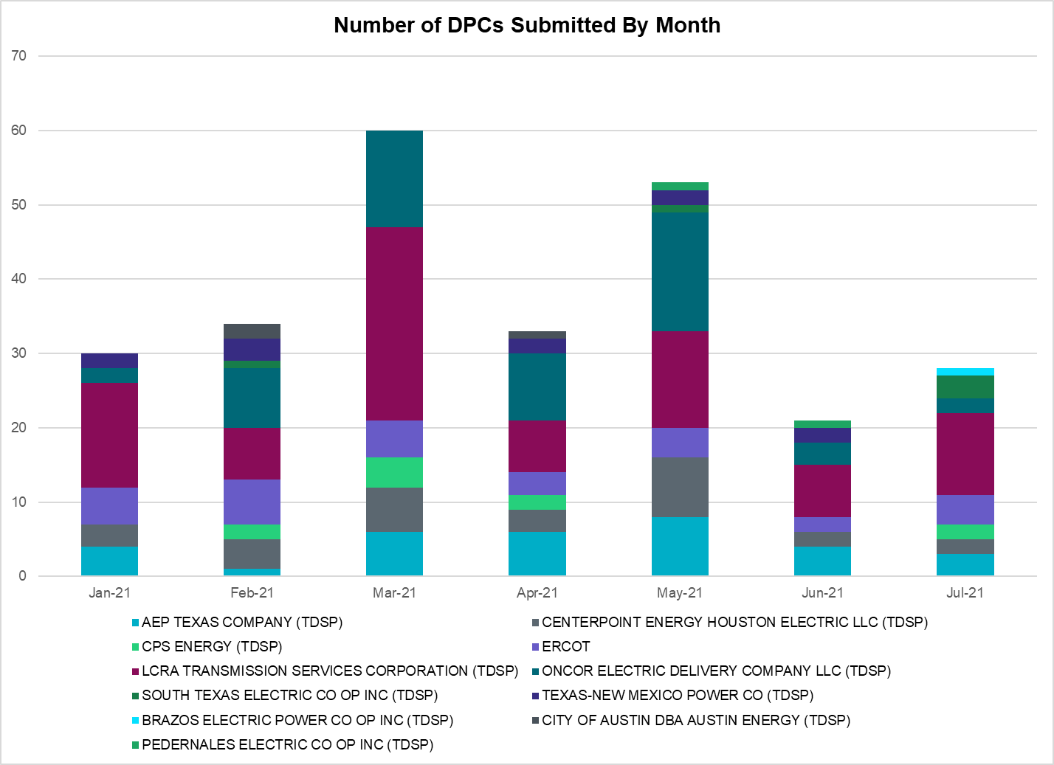

Transmission Operator | Number of DPCs
AEP TEXAS COMPANY (TDSP) | 3
BRAZOS ELECTRIC POWER CO OP INC (TDSP) | 1
BROWNSVILLE PUBLIC UTILITIES BOARD (TDSP) | 0
BRYAN TEXAS UTILITIES (TDSP) | 0
CENTERPOINT ENERGY HOUSTON ELECTRIC LLC (TDSP) | 2
CITY OF AUSTIN DBA AUSTIN ENERGY (TDSP) | 0
CITY OF COLLEGE STATION (TDSP) | 0
CITY OF GARLAND (TDSP) | 0
CPS ENERGY (TDSP) | 2
DENTON MUNICIPAL ELECTRIC (TDSP) | 0
ELECTRIC TRANSMISSION TEXAS LLC (TDSP) | 0
ERCOT | 4
LCRA TRANSMISSION SERVICES CORPORATION (TDSP) | 11
LONE STAR TRANSMISSION LLC (TSP) | 0
ONCOR ELECTRIC DELIVERY COMPANY LLC (TDSP) | 2
PEDERNALES ELECTRIC CO OP INC (TDSP) | 0
RAYBURN COUNTRY CO OP DBA RAYBURN ELECTRIC (TDSP) | 0
SHARYLAND UTILITIES LP (TDSP) | 0
SOUTH TEXAS ELECTRIC CO OP INC (TDSP) | 3
TEXAS MUNICIPAL POWER AGENCY (TDSP) | 0
TEXAS-NEW MEXICO POWER CO (TDSP) | 0

Appendix A: Real-Time Constraints
The following is a complete list of constraints activated in SCED. Full contingency descriptions can be found in the Standard Contingencies List located on the MIS secure site at Grid Generation Reliability Unit Commitment.

Contingency Name | Overloaded Element | From Station | To Station | Count of Days
BASE CASE | RV_RH | n/a | n/a | 19
BASE CASE | NE_LOB | n/a | n/a | 17
MFLCMDL5 | TALLCITY_TELPR_1 | TELPH_RD | TALLCITY | 16
MHARNED5 | HAINE__LA_PAL1_1 | LA_PALMA | HAINE_DR | 15
MFLCMG25 | TALLCITY_TELPR_1 | TELPH_RD | TALLCITY | 15
XMDL58 | TALLCITY_TELPR_1 | TELPH_RD | TALLCITY | 14
SLGEI_D8 | I_DUPS_LGE1_1 | LGE | I_DUPSW | 12
SLOBSA25 | LARDVN_LASCRU1_1 | LARDVNTH | LASCRUCE | 11
BASE CASE | NELRIO | n/a | n/a | 10
SSGVTRC5 | 175__A | TRCNR | FORSW | 8
SLOBSA25 | NLARSW_PILONC1_1 | NLARSW | PILONCIL | 8
SN_SLON5 | CELANE_N_SHAR1_1 | N_SHARPE | CELANEBI | 8
SVICCO28 | COLETO_VICTOR2_1 | COLETO | VICTORIA | 8
SLAQLOB8 | BRUNI_69_1 | BRUNI | BRUNI | 7
DHCKDEN8 | 6265__E | RHTP2 | DENSW | 7
SLOBSA25 | BRUNI_69_1 | BRUNI | BRUNI | 7
SGDNTEL5 | 6094__D | ANDNR | EXMTP | 6
BASE CASE | PNHNDL | n/a | n/a | 6
DWAPHLJ5 | STPWAP39_1 | STP | WAP | 6
DVICEDN8 | LOOP_VICTORIA_1 | VICTORIA | L_463S | 5
SCMNCPS5 | 651__B | CMNSW | CMNTP | 5
DSWELNC5 | BLUF_C_MULBER1_1 | BLUF_CRK | MULBERRY | 5
SSTAMDL8 | TALLCITY_TELPR_1 | TELPH_RD | TALLCITY | 5
BASE CASE | VALEXP | n/a | n/a | 5
DVICVI89 | COLETO_VICTOR2_1 | COLETO | VICTORIA | 4
SDFWLI28 | 1040__D | DFWEE | DFWSE | 4
SBRAUVA8 | HAMILT_MAVERI1_1 | HAMILTON | MAVERICK | 4
SABSBLU8 | ABNTHW_CALLAH1_1 | CALLAHAN | ABNTHWST | 4
DELMSAN5 | PAWNEE_SPRUCE_1 | PAWNEE | CALAVERS | 4
SCITNUE8 | MORRIS_NUECES1_1 | NUECES_B | MORRIS | 4
DBIGKEN5 | FRIR_ROCKSP1_1 | FRIR | ROCKSPRS | 4
XSGV58 | 175__A | TRCNR | FORSW | 4
DHWIND89 | MORRIS_NUECES1_1 | NUECES_B | MORRIS | 3
SFTLMES8 | CROSSO_NORTMC1_1 | NORTMC | CROSSOVE | 3
SN_SLON5 | CELANE_KLEBER1_1 | CELANEBI | KLEBERG | 3
DFERGRM8 | SANDCR_AT1 | SANDCR | SANDCR | 3
XVIC89 | MAGRUD_VICTOR2_1 | VICTORIA | MAGRUDER | 3
SLAQLOB8 | FALFUR_PREMON1_1 | FALFUR | PREMONT | 3
SODLBRA8 | HAMILT_MAVERI1_1 | HAMILTON | MAVERICK | 3
SKINFAL8 | FALFUR_PREMON1_1 | FALFUR | PREMONT | 3
DEMSPKR5 | 1040__D | DFWEE | DFWSE | 2
SGILNU78 | GILA_HIWAY_1_1 | GILA | HIWAY_9 | 2
DDUPHE18 | I_DUPS_MCCAMP2_1 | I_DUPSW | MCCAMPBE | 2
SCOLBAL8 | SANA_FMR1 | SANA | SANA | 2
DCOLFA59 | NORMAN_PETTUS1_1 | PETTUS | NORMANNA | 2
SBRAHAM8 | HAMILT_MAVERI1_1 | HAMILTON | MAVERICK | 2
DCOLFA59 | VICTO_WARBU_1A_1 | VICTORIA | WARBURTN | 2
XBSP89 | 6615__E | MGSES | WBROK | 2
SREVDIL8 | BRUNI_69_1 | BRUNI | BRUNI | 2
DSTEXP12 | BLESSI_LOLITA1_1 | LOLITA | BLESSING | 2
BASE CASE | WESTEX | n/a | n/a | 2
DCRLLSW5 | 588_B_1 | LWSVH | LWSVW | 2
SRDODES8 | 940__C | ENWSW | WXHCH | 2
SBAKCED5 | CEDRHI_SILT1_1 | CEDRHILL | SILT | 2
DBIGKEN5 | TREADW_YELWJC1_1 | TREADWEL | YELWJCKT | 2
DBIGKEN5 | BONDRO_SONR1_1 | SONR | BONDROAD | 2
SFORYEL8 | MASNPH_MASN1_1 | MASN | MASNPHT | 2
SILLFTL8 | HAMILT_MAXWEL1_1 | MAXWELL | HAMILTON | 2
DSTPRED5 | STPWAP39_1 | STP | WAP | 2
DABPAB98 | SOUTHA_VINSON1_1 | SOUTHABI | VINSON | 2
DSGVTRC5 | 175__A | TRCNR | FORSW | 2
SCARFRI8 | SANTIA_SAPOWE1_1 | SANTIAGO | SAPOWER | 2
DREFSTP5 | STPWAP39_1 | STP | WAP | 2
DCPSST58 | 651__B | CMNSW | CMNTP | 1
SLOBSA25 | ASHERT_CATARI1_1 | ASHERTON | CATARINA | 1
DHIWARC8 | MORRIS_WESTSI1_1 | MORRIS | WESTSIDE | 1
BASE CASE | N_TO_H | n/a | n/a | 1
SBOSWHT8 | OLSEN_NAT1 | OLSEN | OLSEN | 1
BASE CASE | RANDAD_ZAPATA1_1 | RANDADO | ZAPATA | 1
SSILRIO8 | SILASRAY_T1 | SILASRAY | SILASRAY | 1
DSKYNAC8 | WEIDER_RAND_1 | WEIDER | W2 | 1
DSALHUT5 | 1710__C | BELCNTY | SALSW | 1
SHIGSAL8 | 276T350_1 | GAYHIL | SANDHI | 1
SCOLBAL8 | BALLIN_HUMBLT1_1 | BALLINGE | HUMBLTAP | 1
DWO5_EU8 | DV_HT_24_A | HT | DV | 1
SSKYSB28 | TALLCITY_TELPR_1 | TELPH_RD | TALLCITY | 1
DLFKSCS8 | 1170__B | NCDSE | REDSW | 1
SBCESND5 | 421__A | BCESW | SNDSW | 1
DBUZLME8 | 6610__D | BSPSW | BSCTP | 1
SRICGRS8 | 6840__B | NVKSW | ANARN | 1
DZORHAY5 | BERGHE_AT1L | BERGHE | BERGHE | 1
SCOSMGS8 | CEDRHI_SILT1_1 | CEDRHILL | SILT | 1
SN_SAJO5 | FALFUR_PREMON1_1 | FALFUR | PREMONT | 1
SMOOPEA8 | FRI_PEAR_1 | PEARSALL | FRIOTOS | 1
SN_SAJO5 | HAINE__LA_PAL1_1 | LA_PALMA | HAINE_DR | 1
DWHILON5 | NCARBI_SEADRF1_1 | NCARBIDE | SEADRFTC | 1
DWHILON5 | NCARBI_SEADRF1_1 | SEADRFTC | NCARBIDE | 1
DCOLFA59 | REFUG_VICTO_1C_1 | VICTORIA | OCONNOR | 1
DLIGHKB8 | 1040__D | DFWEE | DFWSE | 1
DCPSJON5 | 6017__B | MBDSW | CMBSW | 1
SENSEN28 | 940__C | ENWSW | WXHCH | 1
SBRAUVA8 | ESCOND_GANSO1_1 | GANSO | ESCONDID | 1
DABPAB98 | ESTES_PECAN_1_1 | PECAN_BY | ESTES | 1
SFORYEL8 | HEXT_YELWJC1_1 | YELWJCKT | HEXT | 1
SGRILON5 | VICTO_WARBU_1A_1 | VICTORIA | WARBURTN | 1
DCRLIRV8 | 1040__D | DFWEE | DFWSE | 1
DAUSSND5 | 211T147_1 | GILLCR | MCNEIL_ | 1
DODESLT8 | 6465__C | MDLNE | MDDTN | 1
DZORHAY5 | BERGHE_AT1H | BERGHE | BERGHE | 1
SORE2B8 | FOSPT_25_A | PT | FOS | 1
SCOMHA38 | HAMILT_MAXWEL1_1 | MAXWELL | HAMILTON | 1
BASE CASE | LGD_SANTIA1_1 | LGD | SANTIAGO | 1
DWHILON5 | REFUG_VICTO_1C_1 | VICTORIA | OCONNOR | 1
DBIGKEN5 | SAPOWE_TREADW1_1 | SAPOWER | TREADWEL | 1
XMAG289 | VICTORIA_69A2 | VICTORIA | VICTORIA | 1
DHUTGEA8 | 211T147_1 | GILLCR | MCNEIL_ | 1
DCOLFA59 | 2992_1 | OCONNOR | GRETA | 1
SBIGSCH5 | CROSSO_NORTMC1_1 | NORTMC | CROSSOVE | 1
SLEABAN9 | FRIR_ROCKSP1_1 | FRIR | ROCKSPRS | 1
BASE CASE | MAXWEL_WHITIN1_1 | MAXWELL | WHITING | 1
DSALKLN5 | 630__A | BLTON | BLTSW | 1
DGRSLNC5 | 6380__D | PAINTCRE | MURRAY | 1
DGRMGRS8 | 6830__B | CRDSW | OLNEY | 1
BASE CASE | RAMBLER_GENTIE_1 | RAMBLER | TWINBU | 1
SDENHLT8 | 1040__D | DFWEE | DFWSE | 1
DSTPANS5 | 2992_1 | OCONNOR | GRETA | 1
DSALKLN5 | 630__C | BLTSW | HHSTH | 1
SHAYZO25 | 6T227_1 | HAYSEN | ZORN | 1
SILLFTL8 | OZNR_OZONA1_1 | OZONA | OZNR | 1
SLOBSA25 | BRUNI_69_1 | BRUNI | BRUNI | 7

This is the hourly integrated peak demand as published in the ERCOT D&E report.

