System Planning
Monthly Status Report

Report Highlights

- ERCOT is currently reviewing proposed transmission improvements with a total estimated cost of $1,161.36 Million as of July 31, 2021.
- Transmission Projects endorsed in 2021 total $603.95 Million as of July 31, 2021.
- All projects (in engineering, routing, licensing, and construction) total approximately $7.44 Billion as of June 1, 2021.
- Transmission Projects energized in 2021 total about $999.2 Million as of June 1, 2021.

Regional Planning Group Reviews
RPG Projects under Review:
- AEPSC has submitted the LRGV Import Project (RPG Project ID: 18RPG001). This is a Tier 1 project that is estimated to cost $73.4 million. AEPSC has also requested that ERCOT provide a conditional endorsement for an additional $357.2 million project. ERCOT’s independent review has been conducted in accordance with Protocol Section 3.11.4.9(3), and this project is currently placed on hold until the LNG loads are confirmed.
- STEC has submitted the Lower Rio Grande Valley Transmission Expansion Project (RPG Project ID: 19RPG009). This is a Tier 1 project that is estimated to cost $511 million. ERCOT’s independent review has been conducted in accordance with Protocol Section 3.11.4.9(3), and this project is currently placed on hold until the LNG loads are confirmed.
- Oncor has submitted the Nacogdoches Southeast Switch – Redland Switch – Lufkin Switch 345-kV Loop Project (RPG Project ID: 20RPG019). This is a Tier 2 project that is estimated to cost $71.26 million. This project is currently under ERCOT’s independent review.
- AEPSC has submitted the Port Lavaca Area Improvement Project (RPG Project ID: 21RPG002). This is a Tier 2 project that is estimated to cost $97.8 million. This project is currently under ERCOT’s independent review.
- Oncor has submitted the Flat Iron – Barr Ranch – Pegasus South 138 kV Line Project (RPG Project ID: 21RPG010). This is a Tier 2 project that is estimated to cost $50.7 million. This project is currently under ERCOT’s independent review.
- CNP has submitted the Flewellen to Peters 138 kV ckt 25 Rebuild Project (RPG Project ID: 21RPG011). This is a Tier 3 project that is estimated to cost $76.19 million. RPG review of this project was completed on July 2, and ERCOT has issued the acceptance letter.

RPG Project Reviews Completed in 2021:
RPG Project ID | RPG Project Name | Submitted Entity | Tier | Estimated Cost  ($ Millions) | Review Completion Month
20RPG022 | Hamilton Road to Maxwell 138-kV Line Rebuild Project | AEPSC | Tier 3 | 34.0 | January
20RPG023 | Royse - Commerce 69-kV Line Conversion to 138-kV | Oncor | Tier 3 | 72.1 | January
1RPG003 | Midland East Area Projects | Oncor | Tier 3 | 88.5 | March
21RPG004 | Venus Switch-Cedar Hill Switch 345-kV Line Project | Oncor | Tier 3 | 10.3 | March
21RPG005 | Angleton to West Columbia 138-kV ckt 04 Rebuild Project | CNP | Reclassified from Tier 3 to Tier 4 per Protocol | 38.7 | April
21RPG006 | Algoa Corner to La Marque 138 138-kV ckt 93 Rebuild Project | CNP | Reclassified from Tier 3 to Tier 4 per Protocol | 34.56 | May
21RPG007 | Holliday - Seymour 69-kV Line Project | Oncor | Reclassified from Tier 3 to Tier 4 per Protocol | 44.3 | May
21RPG008 | Burnett – Bowie 69 kV Line Upgrade Project | Oncor | Tier 3 | 79.7 | June
21RPG009 | Waterfowl Substation Addition | CNP | Tier 3 | 42.4 | June
21RPG001 | Bakersfield to Big Hill 345‐kV Second Circuit Addition Project | STEC & LCRA TSC | Tier 2 | 83.2 | June
21RPG011 | Flewellen to Peters 138 kV ckt 25 Rebuild | CNP | Tier 3 | 76.2 | July

More information on current and past RPG projects can be found on the ERCOT MIS Secure (digital certificate required): https://mis.ercot.com/public/data-products/grid/regional-planning
Past email communication on RPG projects can be found on the ERCOT listserv by signing up for the REGPLANGROUP list: http://lists.ercot.com/scripts/wa-ERCOT.exe?A0=REGPLANGROUP

Planning Model Activities
The short-term calendar of major planning model events is as follows:
- By Oct 15, 2021 21SSWG Update cases, in PSS/E 35, and TPIT are posted
- By Nov 4, 2021 21SSWG Contingency definitions and Planning Data Dictionary are posted
The following table shows interconnection projects that met Planning Guide section 6.9(1) and 6.9(2) and were modeled in the SSWG cases as a full model or as a simple model in accordance with Planning Guide section 6.9.
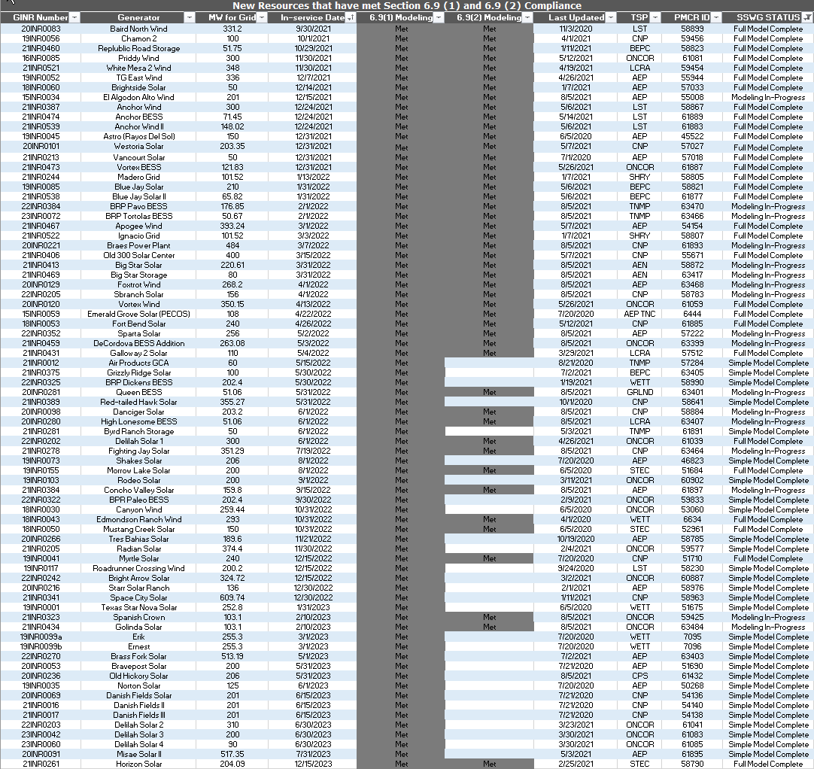

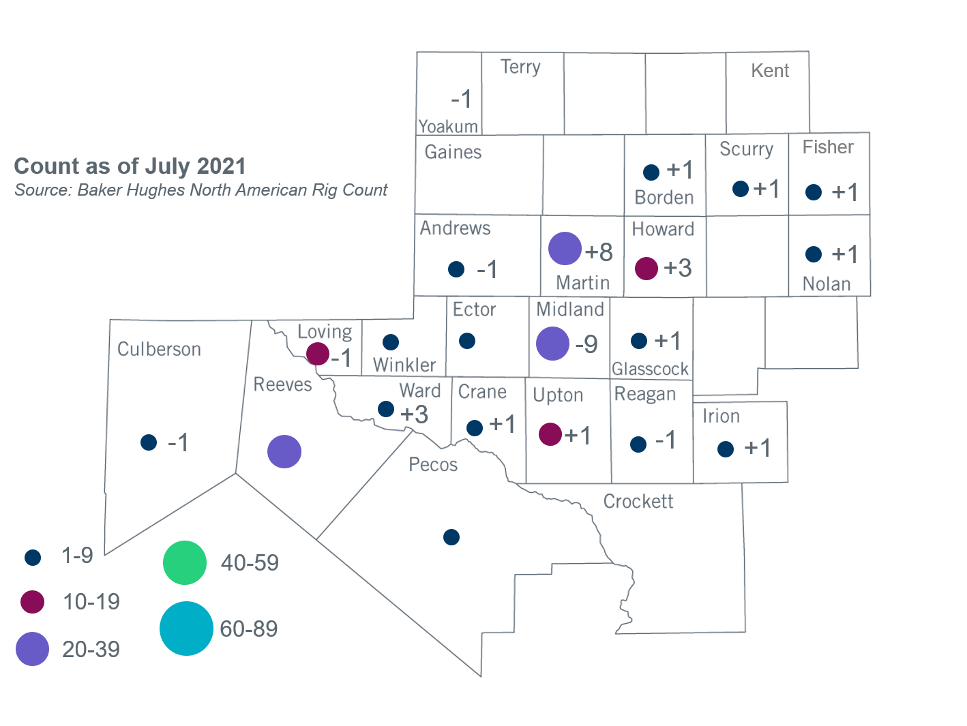
Permian Basin Oil Rig Count
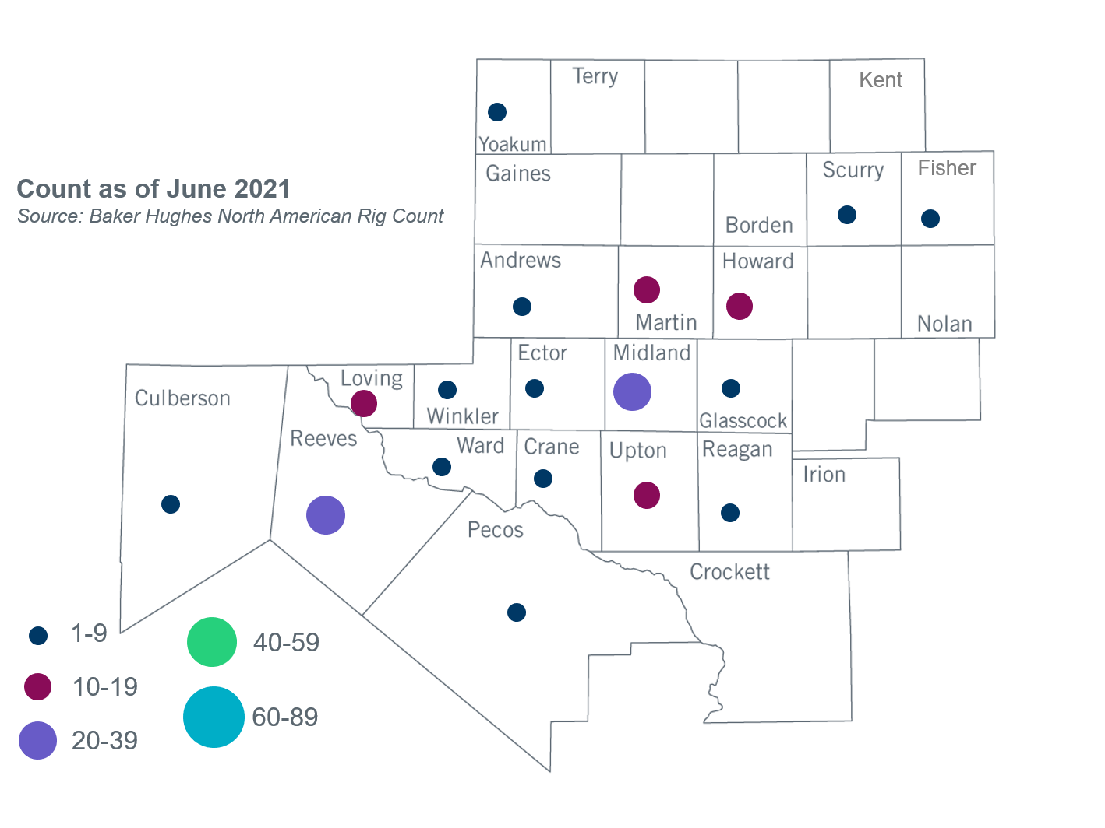

Other Notable Activities
- ERCOT is conducting the West Texas Export Study and plans to complete the study in Q3, 2021.
- ERCOT is conducting the South Texas Stability Study and plans to complete the stability study in Q3, 2021.
- ERCOT is conducting the Permian Basin Load Integration Study and plans to complete the study in Q3, 2021.
- The SPWG has completed and posted 2021 FY base cases.
- The 2020/2021 DWG Stability Book, documenting the 2020/2021 DWG flat start process and supplemental dynamic data submissions, was completed and posted to MIS Certified on July 6, 2021.
- 2021 Regional Transmission Plan economic start cases were posted to MIS Secure on July 30, 2021.
.

Based on the Total Project Estimated Cost for all future projects listed in the Transmission Project Information and Tracking (TPIT) report. TPIT is updated three times each year based on information TSPs provide in Model on Demand (MOD) as specified in the ERCOT Steady State Working Group Procedure Manual. The latest TPIT is available at http://www.ercot.com/gridinfo/planning.
Based on the Total Project Estimated Cost for all completed projects with Projected In-Service Dates in 2021 listed in the TPIT.
+/- symbol indicates the increase or decrease from the previous month in oil rigs present in each county. There are 167 rigs, including an increase of 8 oil rigs, in the Permian Basin from June to July 2021.

