NOGRR Number | 231 | NOGRR Title | Update ERCOT Regional Map
Date Posted |  | August 17, 2021
Requested Resolution |  | Normal
Nodal Operating Guide Sections Requiring Revision |  | 1.1, Document Purpose
Related Documents Requiring Revision/Related Revision Requests |  | None
Revision Description |  | This Nodal Operating Guide Revision Request (NOGRR) updates the ERCOT Regional Map in Section 1.1 to reflect the current boundaries of the ERCOT Region.
Reason for Revision |  | Addresses current operational issues.  Meets Strategic goals (tied to the ERCOT Strategic Plan or directed by the ERCOT Board).  Market efficiencies or enhancements  Administrative  Regulatory requirements  Other: (explain)  (please select all that apply)
Business Case |  | The Nodal Operating Guide should accurately reflect the boundaries of the ERCOT Region.

Sponsor
Name | Jimmy Hartmann
E-mail Address | Jimmy.Hartmann@ercot.com
Company | ERCOT
Phone Number | 512-248-6986
Cell Number | 512-694-4558
Market Segment | Not Applicable

Market Rules Staff Contact
Name | Phillip Bracy
E-Mail Address | Phillip.Bracy@ercot.com
Phone Number | 512-248-6917

Proposed Guide Language Revision

1.1 Document Purpose
(1) These ERCOT Operating Guides supplement the Protocols. The Operating Guides provide more detail and establish additional operating requirements for those organizations and Entities operating in, or potentially impacting the reliability of the ERCOT Transmission Grid in the ERCOT Region, as shown below in Figure 1, ERCOT Regional Map.

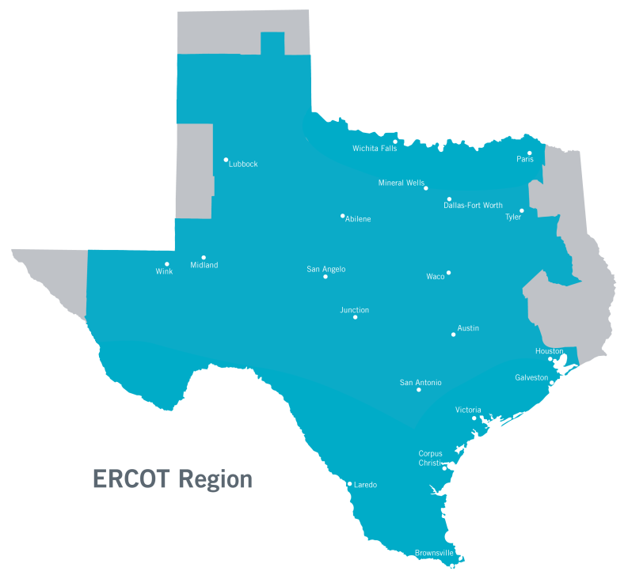

(2) The title “Operating Guide” is not to be construed as presenting merely a recommendation. Organizations and Entities are obligated to comply with the Operating Guides. Specific practices described in the Operating Guides for the ERCOT Region are consistent with North American Electric Reliability Corporation (NERC) Reliability Standards and the Protocols.

