TAC Emergency Conditions List
Items/Actions Assigned to PDCWG
Discussion Summary from 7/16/21 PDCWG

6 Resource Telemetry: Ensure accurate exchange of Resource telemetry information related to PRC to enhance situational awareness during EEA events.
Recommendation – create a new Resource Status Code (ONHOLD), to indicate a unit is experiencing an issue, all telemetry and capability to follow dispatch are uncertain
Suggestion – if the ONHOLD status can be automated, it would offer many benefits
Suggestion – ERCOT should investigate additional metrics in addition to PRC that inform operators of grid conditions
NPRR1085 relates to this topic

30 Frequency Relay Points: Analyze load shed responsibilities related to frequencies for generation and load and ensure alignment.
Mostly still asking/collecting questions –
- Is 59.3 Hz the optimal value for UFLS?
- Should there be additional frequency points where some automatic load shed occurs (59.4)?
- What are the risks of damaging generator turbines when frequency remains below 59.4 Hz (refer to Item 45 for some answers)?
- Can FFR frequency triggers be changed and/or tied to ROCOF? (Probably not tied to ROCOF – measurement capabilities are lacking – see NPRR863)
- Is it appropriate and necessary for some Load Shed orders to be allowed up to 30 minutes to execute?
Suggestion – ERCOT could consider sending an RFI to GOs or QSEs to ask about turbine damage risk when operating frequency is below 59.4 Hz.
NOGRR224 relates to this topic

44 Ancillary Service Products: Review existing ancillary service products and determine if existing suite of products and amounts is adequate based on lessons learned from the February 2021 winter weather event.
What about the ongoing ERCOT/consultant study of AS distribution (regional, technology type)? Study results not expected until Q1 2022. The results should be valuable in responding to this issue/question. Nitika will provide status on this study at September PDCWG.
Most PDCWG discussion under this topic revolves around ESRs so far.
Can ESR-RRS deployment and charging rules be improved (Shams)?
ROS questions from 7/8 were discussed – the questions directly relate to this topic/issue. It was explained in the 7/16 PDCWG that the PDCWG does not have any tools to assess AS sufficiency – ERCOT brings a summary of results of the Ancillary Service Methodology to PDCWG every fall for review and approval (before going to ROS & TAC), but the tools and analysis are all run by ERCOT.

45 Frequency: Analyze system frequency leading up to EEA conditions and determine impact of low frequency on generation and load tripping.
LP turbine blades and end windings have a natural frequency that makes them vulnerable to operating at frequencies below 59.4 Hz – particularly true for larger generators. PDCWG is pursuing more specific and technical details from turbine OEMs.
There were also issues dealing with interactions between generator control system tuning and the Interconnection frequency on 2/15, prior to the major frequency event. Steam drum type generators are particularly vulnerable to this issue. 2,000 MW of thermal generation was negatively impacted by frequency instability between 01:30 and 03:00 on 2/15. One particular, and important factor here is generator tuning that is specifically designed to maximize BAL-001-TRE frequency response scoring – that tuning design had very harmful impacts to performance of some generators on 2/15.
PDCWG is requesting more detailed information about how ERCOT calculates PRC in order to investigate more options to improve system reliability with regard to frequency stability and generator telemetry.
Open question – could sub 59.4 Hz frequency have been avoided on 2/15 if Load Shed, or other actions to recover undeployed Ancillary Services had been taken earlier? PDCWG is investigating whether it makes sense to recommend that ERCOT use more conditions than just PRC to make EEA, Load Shed, and other reliability decisions. Another question to be investigated at August PDCWG – what was the behavior of all Ancillary Service deployment/undeployment and delivery performance for 2 hours prior to major frequency excursion?
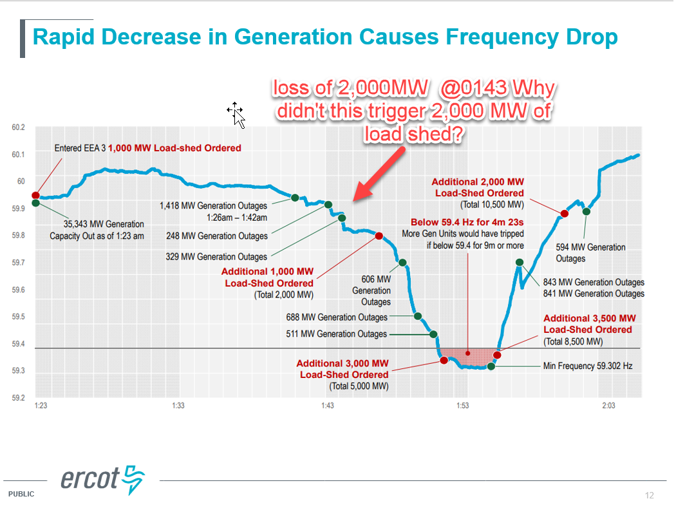
91 Could FFR play a bigger role?
Suggestion – modify FFR offer values and reassess FFR frequency triggers. (Likely needs WMS and/or OWG involvement) Additional FFR frequency triggers may facilitate increasing FFR allocation above 450 MW.
Open questions – Is it good or bad for reliability that we are steadily replacing Load Resources with FFR? Do ESRs provide the service as reliably as traditional Load Resources? Is the 450 MW bucket restriction for FFR included in the ongoing ERCOT consultant study of Ancillary Services? (No)

100 How did batteries providing FFR perform? Were FFR providers allowed to charge and if not, what penalties did they get charged?
No ESR had bid for FFR during the time of the Feb 14/15 winter event.

10X How batteries qualify for AS and the impact of their duration limits.
ESR qualifications for AS and duration/charging requirements were defined by a set of 9 NPRRs that stakeholders developed in the Battery Energy Storage Task Force.

10Y Assessment of dynamic stability had the underfrequency relays asserted during the winter storm event. Given the amount of non-underfrequency load shed, the percentage of underfrequency load in-service had increased. If the increased percentage of underfrequency load had been shed would generation remain stable?
Topic not started yet – can’t find an assignee. And the question seems murky, unclear.

