NOGRR Number | 226 | NOGRR Title | Revision to 5% Transmission Operator (TO) Load Shedding Relay Set Point

Date | August 2, 2021

Submitter’s Information
Name | Andy Nguyen
E-mail Address | Andy.Nguyen@lcra.org
Company | Lower Colorado River Authority
Phone Number | 512-578-2003
Cell Number
Market Segment | Cooperative (CO-OP)

Comments
LCRA appreciates the opportunity to provide comments to Nodal Operating Guide Revision Request (NOGRR) 226. LCRA also thanks ERCOT for their presentations at the June 16, 2021 Performance, Disturbance, Compliance Working Group (PDCWG), the June 17, 2021 Operations Working Group (OWG), and June 24, 2021 Dynamics Working Group (DWG) on this issue. As presented in ERCOT’s materials, LCRA is especially concerned with the February 15, 2021 “slow frequency event” scenario where the frequency remained below 59.4 Hz for an extended period. If we were to experience a slow frequency event that exceeded nine minutes, it would start triggering generators with automatic relays to trip Off-Line (covered in Section 2.6.2, Generators, as well as North American Electric Reliability Corporation (NERC) Standard PRC-024-2, Generator Frequency and Voltage Protective Relay Settings) which would further exacerbate the low frequency conditions and weaken the reliability of the grid. This relay setting misalignment between loads and generators can be seen on the 81-Frequency Protection graph below.
LCRA requests that ROS continue to table NOGRR226 in order to provide ERCOT and the working groups more time to develop a holistic approach to understanding and analyzing the pending issues. Some pending questions that will help assess the impacts would be to identify how many generators have automatic relays set to trip at nine minutes below 59.4 Hz? Additionally, how many generators were online with relays during Uri? How many generators in total have this relay and what are their trigger points? This data will be crucial in determining potentially how many MWs of generation would be taken offline in this scenario and the subsequent reliability impacts.
Tabling this NOGRR will also provide time to evaluate other alternative solutions that could be used to protect against triggering these generator relays.

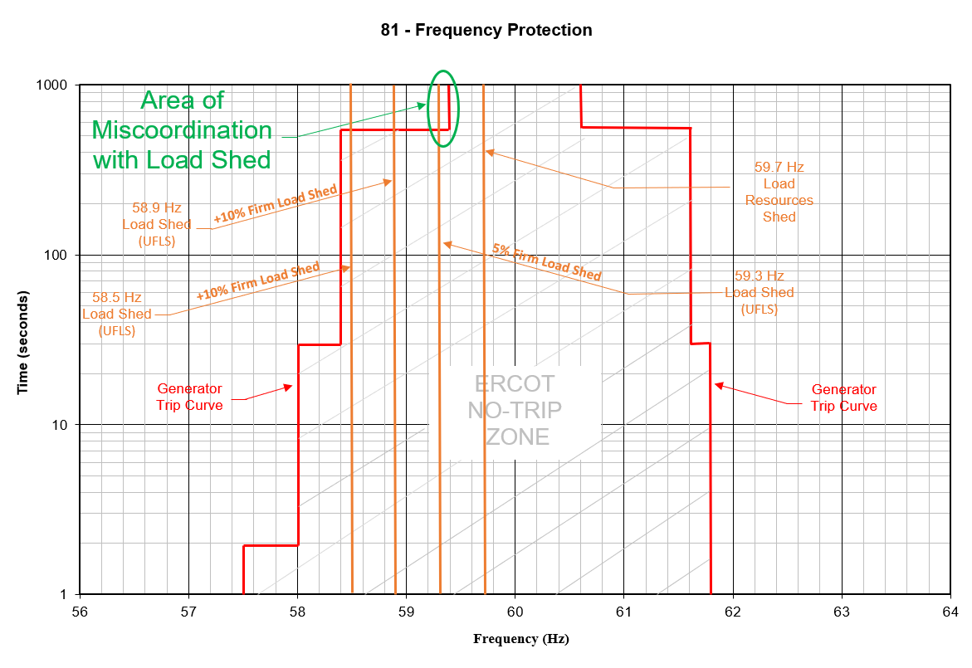

Revised Cover Page Language
None

Revised Proposed Guide Language
None

