June 2021 ERCOT Monthly Operations Report
Reliability and Operations Subcommittee Meeting
August 05, 2021

Table of Contents
1. Report Highlights 2
2. Frequency Control 3
2.1. Frequency Events 3
2.2. Responsive Reserve Events 4
2.3. Load Resource Events 4
3. Reliability Unit Commitment 4
4. Wind Generation as a Percent of Load 5
5. Largest Net-Load Ramp 7
6. COP Error Analysis 7
7. Congestion Analysis 9
7.1. Notable Constraints 9
7.2. Generic Transmission Constraint Congestion 15
7.3. Manual Overrides 16
7.4. Congestion Costs for Calendar Year 2021 16
8. System Events 17
8.1. ERCOT Peak Load 17
8.2. Load Shed Events 17
8.3. Stability Events 17
8.4. Notable PMU Events 17
8.5. DC Tie Curtailment 17
8.6. TRE/DOE Reportable Events 18
8.7. New/Updated Constraint Management Plans 18
8.8. New/Modified/Removed RAS 18
8.9. New Procedures/Forms/Operating Bulletins 18
9. Emergency Conditions 19
9.1. OCNs 19
9.2. Advisories 19
9.3. Watches 19
9.4. Emergency Notices 19
10. Application Performance 19
10.1. TSAT/VSAT Performance Issues 19
10.2. Communication Issues 19
10.3. Market System Issues 19
11. Model Updates 20
Appendix A: Real-Time Constraints 22

Report Highlights
- The unofficial ERCOT peak load was 70,219 MW.
- There were 5 frequency events.
- There were 2 instances where Responsive Reserves were deployed.
- There were 59 HRUC commitments.
- There were 12 days of congestion on the West Texas Export GTC, 17 days on the Panhandle GTC, 17 days on the North Edinburg to Lobo GTC, 19 days on the Raymondville to Rio Hondo, 17 days on the Nelson Sharpe to Rio Hondo GTC, 3 days on the Valley Export GTC, 1 day on the North to Houston GTC, and 1 day on the Bearkat GTC. There was no activity on the remaining GTCs during the month.

Frequency Control

Frequency Events

The ERCOT Interconnection experienced 5 frequency events, which resulted from unit’s trips. The average event duration was 00:05:07.

A summary of the frequency events is provided below. The reported frequency events meet one of the following criteria: Delta Frequency is 60 mHz or greater; the MW loss is 350 MW or greater; resource trip event triggered RRS deployment. Frequency events that have been identified as Frequency Measurable Events (FME) for purposes of BAL-001-TRE-1 analysis are highlighted in blue. When analyzing frequency events, ERCOT evaluates PMU data according to industry standards. Events with an oscillating frequency of less than 1 Hz are considered to be inter-area, while higher frequencies indicate local events. Industry standards specify that damping ratio for inter-area oscillations should be 3.0% or greater. For the frequency events listed below, the ERCOT system met these standards and transitioned well after each disturbance.

Date and Time | Delta Frequency | Max/Min Frequency | Duration of Event | PMU Data |  | MW Loss | Load | Wind | Inertia
 | (Hz) | (Hz) |  | Oscillation Mode (Hz) | Damping Ratio |  | (MW) | % | (GW-s)
6/7/2021 15:26 | 0.241 | 59.770 | 0:05:25 | 0.68 | 14 | 1324.3 | 56,442 | 10% | 294,509
6/12/2021 13:23 | 0.083 | 59.906 | 0:05:59 | 0.63 | 4 | 503.39 | 60,352 | 7% | 329,949
6/14/2021 9:55 | -0.092 | 60.101 | 0:07:00 | 0.63 | 7 | 566 | 56,253 | 7% | 318,342
6/20/2021 22:53 | 0.114 | 59.894 | 0:05:19 | 0.56 | 3 | 555.6 | 55,886 | 38% | 244,065
6/26/2021 11:14 | 0.088 | 59.927 | 0:01:51 | 0.88 | 14 | 518 | 56,958 | 21% | 278,944

(Note: All data on this graph encompasses frequency event analysis based on BAL-001-TRE-1.)

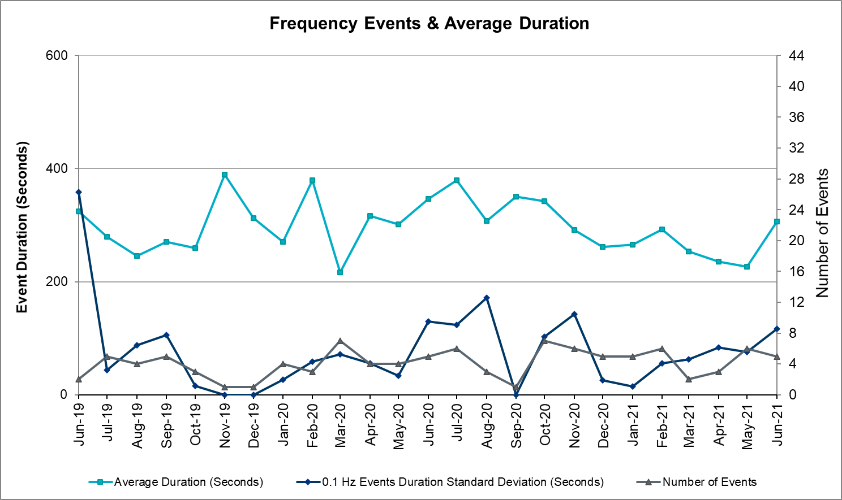

Note that the large standard deviation in June 2019 is due to coincidental extreme high and low durations for a small set of events (2).

Responsive Reserve Events

There were 2 events where Responsive Reserve MWs were released to SCED. The events highlighted in blue were related to frequency events reported in Section 2.1 above.

Date and Time Released to SCED | Date and Time Recalled | Duration of Event | Maximum MWs Released | Comments
6/7/2021 15:26 | 6/7/2021 15:32:08 | 00:05:25 | 1420
6/20/2021 22:53 | 6/20/2021 22:58:52 | 00:05:19 | 588

Load Resource Events
None

Reliability Unit Commitment
ERCOT reports on Reliability Unit Commitments (RUC) monthly. Commitments are reported grouped by operating day and weather zone. The total number of hours committed is the sum of the hours for all the units in the specified region. Additional information on RUC commitments can be found on the MIS secure site at Grid Generation Reliability Unit Commitment.

There were no DRUC commitments.

There were 59 HRUC commitments

Resource Location | # of Resources | Operating Day |  | Total # of Hours Committed | Total MWhs | Reason for Commitment
SOUTH CENTRAL | 1 | June 13, 2021 | 3 |  | 655 | System Capacity
NORTH CENTRAL  SOUTH CENTRAL  &  EAST | 9 | June 14, 2021 | 47 |  | 14,986 | System Capacity
NORTH CENTRAL &  EAST | 3 | June 15, 2021 | 16 |  | 2,245 | System Capacity
NORTH CENTRAL &  EAST | 3 | June 16, 2021 | 9 |  | 1,742 | System Capacity
NORTH CENTRAL &  EAST | 3 | June 17, 2021 | 9 |  | 2,403 | System Capacity
NORTH CENTRAL  &  EAST | 3 | June 18, 2021 | 12 |  | 3,196 | System Capacity
NORTH CENTRAL, SOUTH CENTRAL, & EAST | 3 | June 23, 2021 | 26 |  | 11,136 | System Capacity
NORTH CENTRAL  &  SOUTH CENTRAL | 5 | June 25, 2021 | 20 |  | 7,526 | System Capacity
NORTH CENTRAL | 1 | June 26, 2021 | 4 |  | 1,740 | System Capacity
NORTH CENTRAL | 1 | June 27, 2021 | 3 |  | 1,170 | System Capacity
EAST | 1 | June 28, 2021 | 4 |  | 1,968 | System Capacity
NORTH CENTRAL  SOUTH CENTRAL  &  EAST | 9 | June 29, 2021 | 62 |  | 25,395 | System Capacity
FAR WEST  EAST  NORTH CENTRAL  &  SOUTH  CENTRAL | 17 | June 30, 2021 | 155 |  | 40,077 | System Capacity

Wind Generation as a Percent of Load
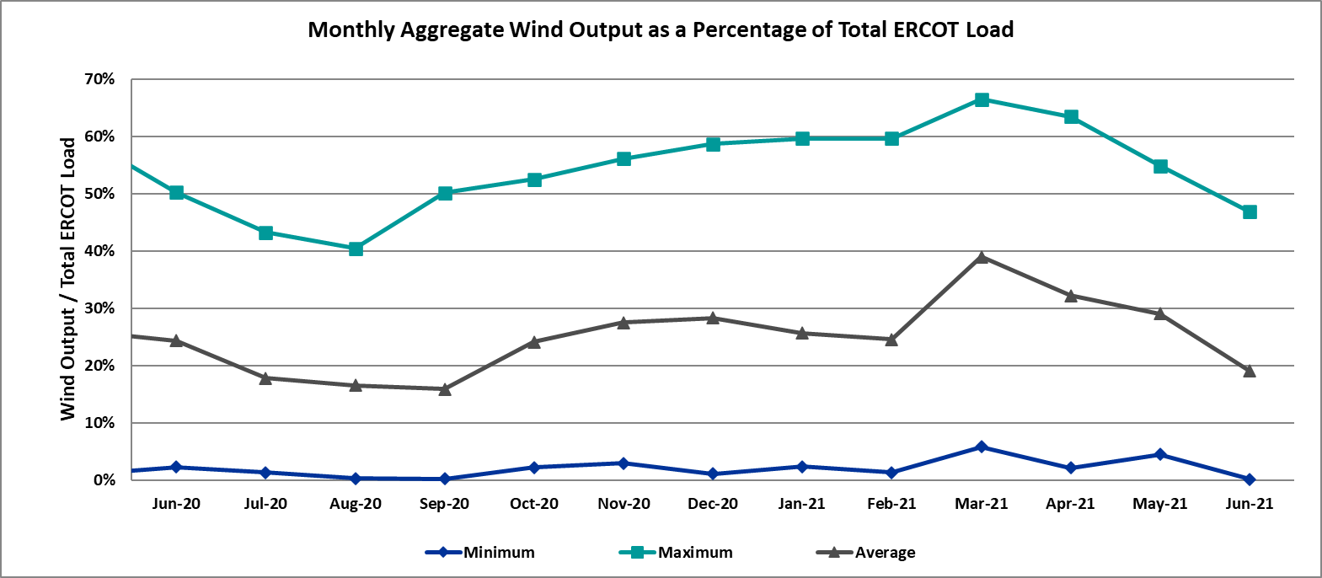

Wind Generation Record: 23,596 MW on 06/25/2021 at 22:32
Wind Penetration Record: 66.47% on 03/22/2021 at 00:46

Largest Net-Load Ramp
The net-load ramp is defined as the change in net-load (load minus wind and PVGR generation) during the defined time horizon. Such a variation in net-load needs to be accommodated in grid operations to ensure that the reliability of the grid is satisfactorily maintained. The largest net-load ramp during 5-min, 10-min, 15-min, 30-min and 60-min in June 2021 is 1442 MW, 2157 MW, 2646 MW, 3468 MW, and 5963 MW, respectively. The comparison with respect to the historical values is given in the table below.

Month and Year | 5 min | 10 min | 15 min | 30 min | 60 min
June 2021 | 1442 MW | 2157 MW | 2646 MW | 3468 MW | 5963 MW
June 2014 | 919 MW | 1329 MW | 1873 MW | 3516 MW | 5724 MW
June 2015 | 1038 MW | 1771 MW | 2489 MW | 3119 MW | 5360 MW
June 2016 | 1183 MW | 1716 MW | 2148 MW | 3131 MW | 5975 MW
June 2017 | 751 MW | 1287 MW | 1772 MW | 3106 MW | 5573 MW
June 2018 | 1029 MW | 1413 MW | 2035 MW | 3590 MW | 6320 MW
June 2019 | 824 MW | 1284 MW | 1706 MW | 2985 MW | 5684 MW
June 2020 | 902 MW | 1615 MW | 2340 MW | 3726 MW | 7015 MW
2014-2020 | 1494 MW | 2157 MW | 2780 MW | 4227 MW | 7786 MW

COP Error Analysis
COP Error is calculated as the capacity difference between the COP HSL and real-time HSL of the unit. Mean Absolute Error (MAE) stayed over 13,913 MW until Day-Ahead at 12:00, then dropped significantly to 1713 MW by Day-Ahead at 14:00. In the following chart, Under-Scheduling Error indicates that COP had less generation capacity than real-time and Over-Scheduling Error indicates that COP had more generation capacity than real-time.

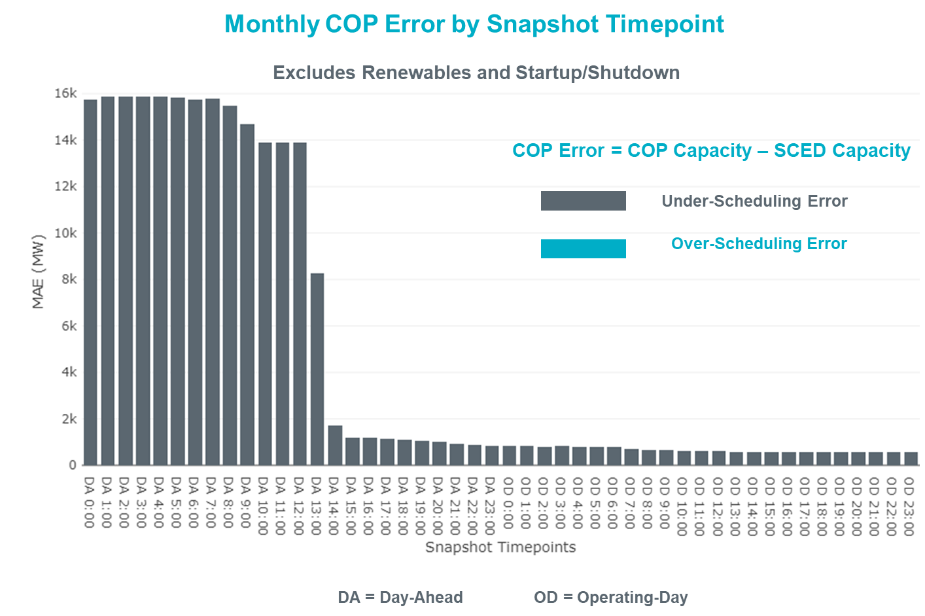

Monthly MAE for the Latest COP at the end of the Adjustment Period was 569 MW with median ranging from -1,196.6 MW for Hour-Ending (HE) 21 to -12.6 MW for HE 2. HE 16 on the 7th had the largest Over-Scheduling Error (1,149 MW) and HE 16 on the 4^{h} had the largest Under-Scheduling Error (-2,854 MW).

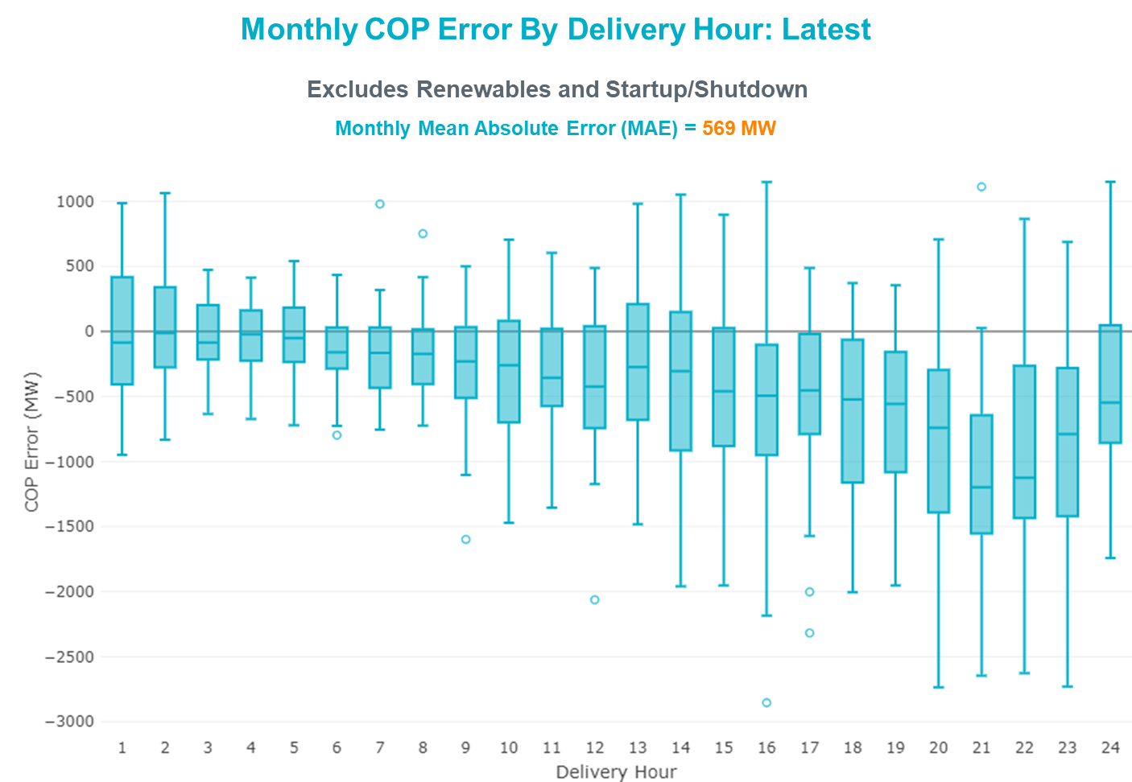

Monthly MAE for the Day-Ahead COP at 12:00 was 13,913 MW with median ranging from -19,245 MW for Hour-Ending (HE) 16 to -8,111 MW for HE 5. HE 17 on the 14th had the largest Under-Scheduling Error (-26,222 MW) and HE 7 on the 6th had the largest Over-Scheduling Error (-2,256 MW).

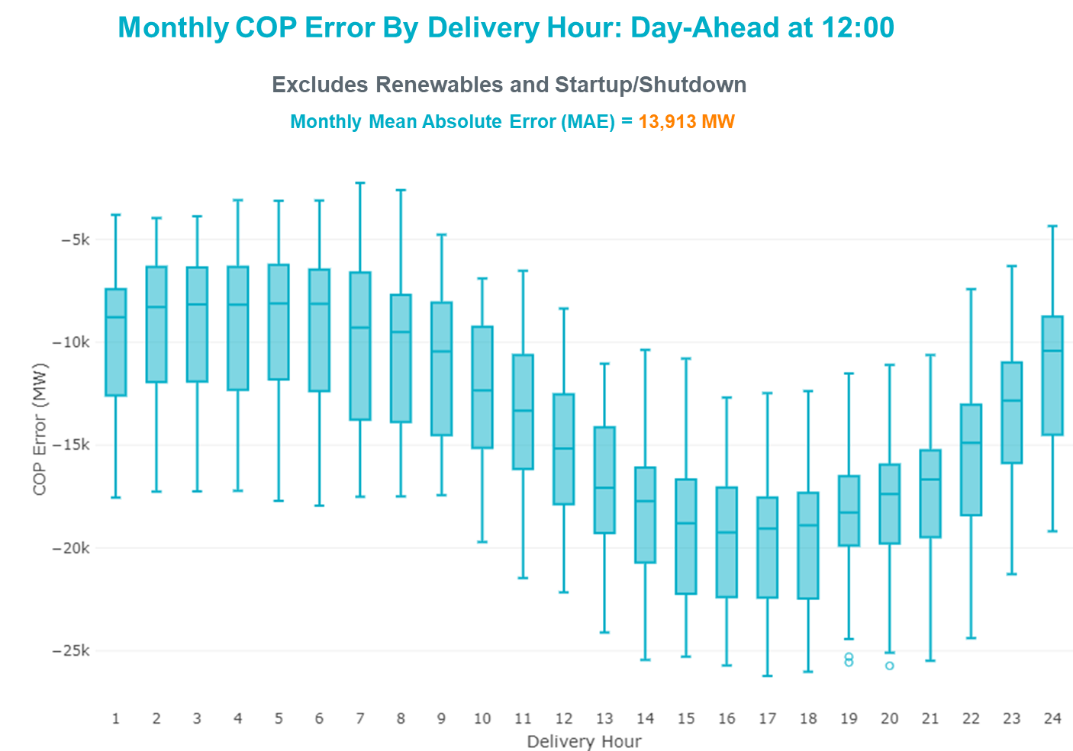

Congestion Analysis

Notable Constraints
Nodal protocol section 3.20 specifies that ERCOT shall identify transmission constraints that are binding in Real-Time three or more Operating Days within a calendar month. As part of this process, ERCOT reports congestion that meets this criterion to ROS. In addition, ERCOT also highlights notable constraints that have an estimated congestion rent exceeding $1,000 for a calendar month. These constraints are detailed in the table below, including approved transmission upgrades from TPIT that may provide some congestion relief based on ERCOT’s engineering judgement. Rows highlighted in blue indicate the congestion was affected by one or more outages. For a list of all constraints activated in SCED, please see Appendix A at the end of this report.

Contingency Name | Overloaded Element | # of Days Constraint Binding | Congestion Rent | Transmission Project
Basecase | NE_LOB GTC | 17 | $8,753,166.14
MIDLAND EAST TRX MDLNE_3_1 345/138 | Tall City - Sharyland Utilities - Telephone Road - Sharyland Utilities 138kV | 11 | $6,699,767.83 | Tall City - Telephone Road 138 kV Line Rebuild (57915)
Manual dbl ckt for NEDIN-BONILLA 345kV & RIOH-PRIM138kV | Haine Drive - La Palma 138kV | 11 | $5,554,305.88 | Luna 138 kV Station (44858)
Basecase | WESTEX GTC | 7 | $4,930,077.87
Basecase | PNHNDL GTC | 15 | $4,402,315.82
HCKSW TO DENSW 138 DBLCKT | Deen Switch - Rosen Heights Tap 2 138kV | 8 | $3,488,117.23 | Eagle Mountain 138kV Switch Rebuild (62445)
GARDENDALE SWITCH to TELEPHONE ROAD - Sharyland Utilities LIN _A | Andrews North - Exxon Means Tap 138kV | 3 | $3,423,520.34
Man_dbl_FLCNS-MDLNE_345KV_and_FLCNS-MGSES_345_KV | Tall City - Sharyland Utilities - Telephone Road - Sharyland Utilities 138kV | 5 | $3,223,312.10 | Tall City - Telephone Road 138 kV Line Rebuild (57915)
COMANCHE SWITCH (Oncor) to COMANCHE PEAK SES LIN _A | Comanche Tap - Comanche Switch (Oncor) 138kV | 11 | $3,130,143.56
SALSW TO KLNSW 345 DBLCKT | Killeen Switch 345kV | 3 | $2,699,402.47
LON HILL to NELSON SHARPE LIN 1 | Celanese Bishop - Nelson Sharpe 138kV | 5 | $2,603,148.45
RINCON TRX 69A1 138/69 | Whitepoint 138kV | 8 | $2,427,259.51 | Whitepoint: Add Second Auto (50954), Corpus North Shore Project , Corpus North Shore Project
DUPONT SWITCH - INGLESIDE to GREGORY POWER LIN 1 | Dupont Switch - Ingleside - Lge 138kV | 5 | $2,386,074.78
CRLNW TO LWSSW 345 DBLCKT | West Tnp - Highlands Tnp 138kV | 5 | $1,236,826.76
Man_Sgl_ MDL-FLC_345_kV_w_MDL_XMFR1_FLC_AMR2 | Tall City - Sharyland Utilities - Telephone Road - Sharyland Utilities 138kV | 3 | $1,161,665.28 | Tall City - Telephone Road 138 kV Line Rebuild (57915)
MIDLAND EAST to MIDLAND COUNTY NORTHWEST SWITCH LIN _A | Midland County Northwest Switch - Mockingbird 138kV | 1 | $1,274,695.51
MIDLAND EAST to MIDLAND COUNTY NORTHWEST SWITCH LIN _A | Tall City - Sharyland Utilities - Telephone Road - Sharyland Utilities 138kV | 1 | $1,096,400.69 | Tall City - Telephone Road 138 kV Line Rebuild (57915)
ODLAW SWITCHYARD to ASPHALT MINES LIN 1 | Hamilton Road - Maverick 138kV | 10 | $876,729.48 | Brackettville to Escondido: Construct 138 kV line (5206)
TWR (345) HLJ-WAP64 & BLY-WAP72 | Jones Creek - South Texas Project 345kV | 3 | $552,626.72 | Freeport - Master Plan (6668B)
Fowlerton to LOBO 345 LIN1 | North Laredo Switch - Piloncillo 138kV | 6 | $545,850.94
HIWAY_9 - CITGO_NO & INDUSTRI 69kV & 138 kV | Morris Street - Nueces Bay 138kV | 4 | $505,300.26
SWESW TO MULBERRY AND SWESW TO LNCRK 345 DBLCKT | Bluff Creek - Abilene Mulberry Creek 345kV | 5 | $409,043.60
Basecase | NELRIO GTC | 9 | $404,673.27
Bighil-Kendal 345kV | Yellow Jacket - Treadwell 138kV | 9 | $340,248.48
Fowlerton to LOBO 345 LIN1 | Laredo Vft North - Las Cruces 138kV | 3 | $160,074.69 | Laredo VFT North to North Laredo Switch: Rebuild 138 kV Line (58008)
Tri Corner to SEAGOVILLE SWITCH LIN _B | Forney Switch - Tri Corner 345kV | 3 | $112,162.39
COLETO CREEK to VICTORIA LIN 1 | Coleto Creek - Victoria 138kV | 5 | $73,427.02
GILA to HIWAY 9 LIN 1 | Gila - Hiway 9 138kV | 4 | $42,859.67
Bighil-Kendal 345kV | San Angelo Power Station - Treadwell 138kV | 3 | $40,240.12

Generic Transmission Constraint Congestion
There were 12 days of congestion on the West Texas Export GTC, 17 days on the Panhandle GTC, 17 days on the North Edinburg to Lobo GTC, 19 days on the Raymondville to Rio Hondo, 17 days on the Nelson Sharpe to Rio Hondo GTC, 3 days on the Valley Export GTC, 1 day on the North to Houston GTC, and 1 day on the Bearkat GTC. There was no activity on the remaining GTCs during the month.

Note: This is how many times a constraint has been activated to avoid exceeding a GTC limit, it does not imply an exceedance of the GTC occurred or that the GTC was binding.

Manual Overrides
None

Congestion Costs for Calendar Year 2021
The following table represents the top twenty active constraints for the calendar year based on the estimated congestion rent attributed to the congestion. ERCOT updates this list on a monthly basis.

Contingency | Overloaded Element | # of 5-min SCED | Estimated | Transmission Project
Basecase | PNHNDL GTC | 19,753 | 87,084,581.92
Elmcreek-Sanmigl 345kV | Pawnee Switching Station - Calaveras 345kV | 2,079 | 76,199,104.65
LOST PINES AEN to FAYETTE PLANT 1 LIN 1 | Winchester - Fayette Plant 1 And 2 345kV | 415 | 51,438,867.64
JOHNSON SWITCH (ONCOR) to CONCORD LIN G1 | Decordova Dam - Carmichael Bend Switch 138kV | 726 | 46,614,977.07 | DeCordova 345/138kV_Sw. (7129)
TWR(345) JCK-REF27 & JCK-STP18 | Oasis - Dow Chemical 345kV | 524 | 46,495,190.60 | Freeport - Master Plan (6668B)
Basecase | N_TO_H GTC | 2,759 | 39,236,592.39
TWR(345) JCK-REF27 & JCK-STP18 | South Texas Project - Wa Parish 345kV | 1,866 | 35,934,198.14 | Freeport - Master Plan (6668B)
Basecase | WESTEX GTC | 8,208 | 31,843,294.10
Hicross-Pilot & Garfield 138kV | Carson Creek - Pilot Knob 138kV | 803 | 30,600,531.85
Basecase | NE_LOB GTC | 15,774 | 30,482,786.26
Basecase | Colorado Bend Energy Center - Dyann 138kV | 242 | 26,093,025.30
Manual dbl ckt for NEDIN-BONILLA 345kV & RIOH-PRIM138kV | Haine Drive - La Palma 138kV | 6,798 | 24,607,256.31 | Luna 138 kV Station (44858)
TWR(345) JCK-REF27 & JCK-STP18 | Blessing - Pavlov 138kV | 4,383 | 21,362,696.58 | Freeport - Master Plan (6668B)
CONCORD TRX CRD1 345/138 | Concord 345kV | 840 | 21,139,669.60
Lostpi-Austro&Dunlap 345kV | Sim Gideon - Winchester 138kV | 635 | 20,472,271.99 | Sim Gideon - Tahitian Village Transmission Line Storm Hardening (61438), Bastrop West - Split Transmission Line Storm Hardening (61436)
Lytton_S-Slaughte&Turner 138kV | Mccarty Lane - Zorn 138kV | 245 | 20,185,815.81
Basecase | Pawnee Switching Station - Calaveras 345kV | 27 | 17,214,426.04
ASHERTON to Bevo Substation LIN 1 | Hamilton Road - Maverick 138kV | 525 | 17,023,560.36 | Brackettville to Escondido: Construct 138 kV line (5206)
NORTH EDINBURG TRX 1382 345/138 | North Edinburg 345kV | 294 | 16,777,302.97 | Stewart Road: Construct 345 kV cut-in with two 450 MVA 345/138 autotransformers connected to Stewart Rd 138 station (5604, 6382)
KILLEEN SWITCH TRX KLNSW_3_2 345/138 | Killeen Switch 345kV | 234 | 16,301,132.28

System Events

ERCOT Peak Load
The unofficial ERCOT peak load for the month was 70,219 MW and occurred on the 23rd, during hour ending 17:00.

Load Shed Events
None.

Stability Events
None.

Notable PMU Events
ERCOT analyzes PMU data for any significant system disturbances that do not fall into the Frequency Events category reported in section 2.1. The results are summarized in this section once the analysis has been completed.

There were no PMU events outside of those reported in section 2.1.

DC Tie Curtailment
None.

TRE/DOE Reportable Events
- ERCOT ISO submitted an OE-417 for 06/14/2021. Reportable Event Type: Media Appeal.
- Oncor submitted an OE-417 for 06/14/2021. Reportable Event Type: Media Appeal.
- Luminant QSE submitted an OE-417 for 06/15/2021. Reportable Event Type: Cyber Event.

New/Updated Constraint Management Plans
There were seven new CMPs, MP_2021_04, MP_2021_05, MP_2021_06, MP_2021_07, MP_2021_08, MP_2021_09, MP_2021_27.

Nine modified CMPs, MP_2011_08, MP_2012_07, MP_2012_08, MP_2013_27, MP_2016_12, MP_2020_01, MP_2020_05, MP_2021_02, MP_2021_03.

There was one modified PCAP, PCAP_2010_01.

New/Modified/Removed RAS
None.

New Procedures/Forms/Operating Bulletins

Date | Subject | Bulletin No.
06/16/2021 | Real Time Desk V1 Rev 73 | 983
06/16/2021 | Reliability Risk Desk Operating Procedure V1 Rev 23 | 984
06/16/2021 | Reliability Unit Commitment Desk V1 Rev 61 | 985
06/16/2021 | Resource Desk Operating Procedure V1 Rev 62 | 986
07/01/2021 | DC Tie Desk V1 Rev 67 | 987

Emergency Conditions

OCNs
Date and Time | Message
June 13 2021 19:00 CPT | ERCOT issued an OCN due to a potential projected capacity shortage for Monday, June 14, 2021 [HE 12 – HE 22].
June 14 2021 22:00 CPT | ERCOT issued an OCN due to a potential projected capacity shortage for Tuesday, June 15, 2021 [HE 13 – HE 21].
June 16 2021 06:45 CPT | ERCOT issued an OCN due to a potential projected capacity shortage for Wednesday, June 16, 2021 [HE 15 – HE 16].
June 17 2021 04:10 CPT | ERCOT issued an OCN due to a potential projected capacity shortage for Thursday, June 17, 2021 [HE 16 – HE 17].
June 18 2021 05:30 CPT | ERCOT issued an OCN due to a potential projected capacity shortage for Friday, June 18, 2021 [HE 15 – HE 17].
June 23 2021 07:00 CPT | ERCOT issued an OCN due to a potential projected capacity shortage for Wednesday, June 23, 2021 [HE 14 – HE 22].
June 24 2021 14:40 CPT | ERCOT issued an OCN due to a potential projected capacity shortage for Thursday, June 24, 2021 [HE 17 – HE 22].
June 25 2021 11:15 CPT | ERCOT issued an OCN due to a potential projected capacity shortage for Friday, June 25, 2021 [HE 16 – HE 20].
June 26 2021 02:15 CPT | ERCOT issued an OCN due to a potential projected capacity shortage for Saturday, June 26, 2021 [HE 17 – HE 20].
June 27 2021 11:15 CPT | ERCOT issued an OCN due to a potential projected capacity shortage for Sunday, June 27, 2021 [HE 15 – HE 20].
June 28 2021 03:00 CPT | ERCOT issued an OCN due to a potential projected capacity shortage for Monday, June 28, 2021 [HE 13 – HE 20].
June 28 2021 22:20 CPT | ERCOT issued an OCN due to a potential projected capacity shortage for Tuesday, June 29, 2021 [HE 13 – HE 23].
June 29 2021 20:00 CPT | ERCOT issued an OCN due to a potential projected capacity shortage for Wednesday, June 30, 2021 [HE 13 – HE 24].
June 30 2021 20:00 CPT | ERCOT issued an OCN due to a potential projected capacity shortage for Thursday, July 1, 2021 [HE 13 – HE 24].

Advisories
Date and Time | Message
June 02 2021 15:40 CPT | ERCOT issued an Advisory due to Physical Responsive Capability being below 3000 MW.
June 13 2021 15:10 CPT | ERCOT issued an Advisory due to Physical Responsive Capability being below 3000 MW.
June 14 2021 14:05 CPT | ERCOT issued an Advisory due to Physical Responsive Capability being below 3000 MW.

Watches
None.

Emergency Notices
None.

Application Performance

TSAT/VSAT Performance Issues
None.

Communication Issues
None.

Market System Issues
None.

Model Updates
The Downstream Production Change (DPC) process allows ERCOT to make changes in the on-line Network Operations Model without loading a completely new model. The purpose of this process is to allow for reliable grid operations as system conditions change between designated Network Operations Model database loads. The DPC process is limited in scope to just those items listed below, with equipment ratings updates being the most common. ERCOT has seen a rise in the use of the DPC process to make on-line updates to the Network Operations Model in recent years, instead of through the standard Network Operations Model Change Request process.

- Static Line ratings (Interim Update)
- Dynamic Line ratings (non-Interim Update)
- Autotransformer ratings (non-Interim Update)
- Breaker and Switch Normal status (Interim Update)
- Contingency Definitions (Interim Update)
- RAP and RAS changes or additions (Interim Update)
- Net Dependable and Reactive Capability (NDCRC) values (Interim Update)
- Impedance Updates (non-Interim)

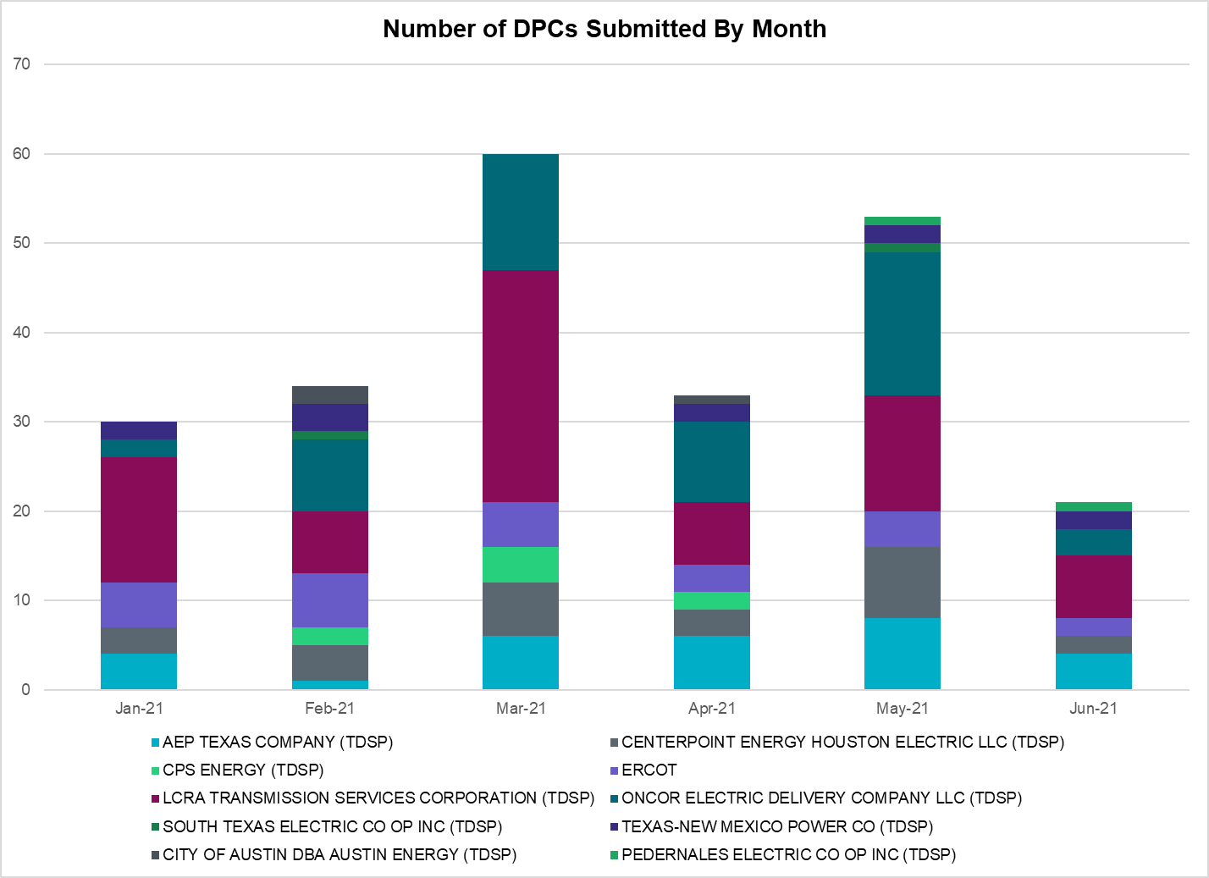

Transmission Operator | Number of DPCs
AEP TEXAS COMPANY (TDSP) | 4
BRAZOS ELECTRIC POWER CO OP INC (TDSP) | 0
BROWNSVILLE PUBLIC UTILITIES BOARD (TDSP) | 0
BRYAN TEXAS UTILITIES (TDSP) | 0
CENTERPOINT ENERGY HOUSTON ELECTRIC LLC (TDSP) | 2
CITY OF AUSTIN DBA AUSTIN ENERGY (TDSP) | 0
CITY OF COLLEGE STATION (TDSP) | 0
CITY OF GARLAND (TDSP) | 0
CPS ENERGY (TDSP) | 0
DENTON MUNICIPAL ELECTRIC (TDSP) | 0
ELECTRIC TRANSMISSION TEXAS LLC (TDSP) | 0
ERCOT | 2
LCRA TRANSMISSION SERVICES CORPORATION (TDSP) | 7
LONE STAR TRANSMISSION LLC (TSP) | 1
ONCOR ELECTRIC DELIVERY COMPANY LLC (TDSP) | 3
PEDERNALES ELECTRIC CO OP INC (TDSP) | 1
RAYBURN COUNTRY CO OP DBA RAYBURN ELECTRIC (TDSP) | 0
SHARYLAND UTILITIES LP (TDSP) | 0
SOUTH TEXAS ELECTRIC CO OP INC (TDSP) | 0
TEXAS MUNICIPAL POWER AGENCY (TDSP) | 0
TEXAS-NEW MEXICO POWER CO (TDSP) | 2

Appendix A: Real-Time Constraints
The following is a complete list of constraints activated in SCED. Full contingency descriptions can be found in the Standard Contingencies List located on the MIS secure site at Grid Generation Reliability Unit Commitment.

Contingency Name | Overloaded Element | From Station | To Station | Count of Days
BASE CASE | RV_RH | n/a | n/a | 19
BASE CASE | NE_LOB | n/a | n/a | 17
BASE CASE | PNHNDL | n/a | n/a | 17
BASE CASE | NELRIO | n/a | n/a | 17
SLGEI_D8 | I_DUPS_LGE1_1 | LGE | I_DUPSW | 16
XMDL58 | TALLCITY_TELPR_1 | TELPH_RD | TALLCITY | 16
SCMNCPS5 | 651__B | CMNSW | CMNTP | 13
XRIN89 | WHITE_PT_69A1 | WHITE_PT | WHITE_PT | 12
BASE CASE | WESTEX | n/a | n/a | 12
MHARNED5 | HAINE__LA_PAL1_1 | LA_PALMA | HAINE_DR | 12
DHCKDEN8 | 6265__E | RHTP2 | DENSW | 11
SGDNTEL5 | 6094__D | ANDNR | EXMTP | 11
SBRAUVA8 | HAMILT_MAVERI1_1 | HAMILTON | MAVERICK | 11
DBIGKEN5 | TREADW_YELWJC1_1 | TREADWEL | YELWJCKT | 10
SLOBSA25 | LARDVN_LASCRU1_1 | LARDVNTH | LASCRUCE | 9
SLOBSA25 | NLARSW_PILONC1_1 | NLARSW | PILONCIL | 9
SGILNU78 | GILA_HIWAY_1_1 | GILA | HIWAY_9 | 8
SKINFAL8 | FALFUR_PREMON1_1 | FALFUR | PREMONT | 8
SVICCO28 | COLETO_VICTOR2_1 | COLETO | VICTORIA | 8
DHWIND89 | MORRIS_NUECES1_1 | NUECES_B | MORRIS | 8
DGRSPKR5 | 6377__A | BRTSW | ORANS | 7
SSTAMDL8 | TALLCITY_TELPR_1 | TELPH_RD | TALLCITY | 7
DZORHAY5 | BERGHE_AT1L | BERGHE | BERGHE | 7
MFLCMG25 | TALLCITY_TELPR_1 | TELPH_RD | TALLCITY | 6
DBIGKEN5 | SAPOWE_TREADW1_1 | SAPOWER | TREADWEL | 6
SLAQLOB8 | BRUNI_69_1 | BRUNI | BRUNI | 6
SILLFTL8 | HAMILT_MAXWEL1_1 | MAXWELL | HAMILTON | 6
DCRLLSW5 | 588_B_1 | LWSVH | LWSVW | 6
SBRAHAM8 | HAMILT_MAVERI1_1 | HAMILTON | MAVERICK | 6
DSWELNC5 | BLUF_C_MULBER1_1 | BLUF_CRK | MULBERRY | 6
SSGVTRC5 | 175__A | TRCNR | FORSW | 5
DCPSST58 | 651__B | CMNSW | CMNTP | 5
SCITNUE8 | MORRIS_NUECES1_1 | NUECES_B | MORRIS | 5
SN_SLON5 | CELANE_N_SHAR1_1 | N_SHARPE | CELANEBI | 5
BASE CASE | LGD_SANTIA1_1 | LGD | SANTIAGO | 5
DHIWARC8 | MORRIS_WESTSI1_1 | MORRIS | WESTSIDE | 5
DCDHVEN5 | 6200__D | SHRSW | PRKRW | 4
SLOBSA25 | BRUNI_69_1 | BRUNI | BRUNI | 4
DVICVI89 | COLETO_VICTOR2_1 | COLETO | VICTORIA | 4
MFLCMDL5 | TALLCITY_TELPR_1 | TELPH_RD | TALLCITY | 4
DGRMGRS8 | 6830__B | CRDSW | OLNEY | 4
SENSENS8 | 940__C | ENWSW | WXHCH | 4
DDUPHE18 | I_DUPS_MCCAMP2_1 | I_DUPSW | MCCAMPBE | 4
SBRAUVA8 | ESCOND_GANSO1_1 | GANSO | ESCONDID | 4
XSGV58 | 175__A | TRCNR | FORSW | 3
SLOBSA25 | ASHERT_CATARI1_1 | ASHERTON | CATARINA | 3
SODLBRA8 | HAMILT_MAVERI1_1 | HAMILTON | MAVERICK | 3
SHIWCIT8 | MORRIS_NUECES1_1 | NUECES_B | MORRIS | 3
DSTPRED5 | BAY_SARG_1 | BAYCTYS | SARGNTS | 3
BASE CASE | VALEXP | n/a | n/a | 3
SFORYEL8 | HEXT_MASONS1_1 | MASONSW | HEXT | 3
SABSBLU8 | ABNTHW_CALLAH1_1 | CALLAHAN | ABNTHWST | 3
DWAPHLJ5 | JCKSTP18_A | STP | JCK | 3
DSALKLN5 | KLNSW_MR1H | KLNSW | KLNSW | 3
DBIGKEN5 | HAMILT_MAXWEL1_1 | MAXWELL | HAMILTON | 3
SFORYEL8 | HEXT_MASONS1_1 | HEXT | MASONSW | 3
DCAGCO58 | 656T656_1 | KENDAL | BERGHE | 2
XDAN89 | TAB_DANS_1 | DANSBY | TABOR | 2
DBAKSOL5 | FTST_SOLSTI1_1 | FTST | SOLSTICE | 2
SFLCMDL5 | 6462__C | MCNSW | MKNGB | 2
SMDLMOS5 | 6462__C | MCNSW | MKNGB | 2
SFTLMES8 | CROSSO_NORTMC1_1 | NORTMC | CROSSOVE | 2
DLCRKIN8 | LCRANE_RIOPEC1_1 | RIOPECOS | LCRANE | 2
DABPAB98 | SOUTHA_VINSON1_1 | SOUTHABI | VINSON | 2
SHCKRNK5 | 106__A | HCKSW | ALLNC | 2
SCOLBAL8 | BALLIN_HUMBLT1_1 | BALLINGE | HUMBLTAP | 2
XMAG289 | VICTORIA_69A2 | VICTORIA | VICTORIA | 2
DFLCMGS5 | 6462__C | MCNSW | MKNGB | 2
DWAPHLJ5 | STPWAP39_1 | STP | WAP | 2
DVENLIG5 | 530__C | VENSW | BRTRD | 2
SALIKIN8 | FALFUR_PREMON1_1 | FALFUR | PREMONT | 2
SN_SAJO5 | FALFUR_PREMON1_1 | FALFUR | PREMONT | 2
DWAPHLJ5 | JCKREF27_A | REF | JCK | 2
XVIC89 | MAGRUD_VICTOR2_1 | VICTORIA | MAGRUDER | 2
SCISPUT8 | SOUTHA_VINSON1_1 | SOUTHABI | VINSON | 2
SSPUSLT8 | SPUR_69_1 | SPUR | SPUR | 2
DCBYRN28 | CBYDKR83_A | CBY | DKR | 2
SGILHIW8 | GILA_HIWAY_2_1 | GILA | HIWAY_9 | 2
SN_SLON5 | CELANE_KLEBER1_1 | CELANEBI | KLEBERG | 2
SAVMBSP8 | 6610__A | BUZSW | CHATP | 1
DVICEDN8 | LOOP_VICTORIA_1 | VICTORIA | L_463S | 1
MCHBJOR5 | CBY_AT1L | CBY | CBY | 1
SLOLBLE8 | LOOP_VICTORIA_1 | VICTORIA | L_463S | 1
BASE CASE | REROCK_TLINE_1 | REROCK | LINTERNA | 1
SSKYSB28 | TALLCITY_TELPR_1 | TELPH_RD | TALLCITY | 1
DTRSENT5 | 1255__B | SCSES | STCKY | 1
DCAGTA58 | 656T656_1 | KENDAL | BERGHE | 1
SRDODES8 | 940__C | ENWSW | WXHCH | 1
DNUEGIL8 | CHAMPL_WEIL_T1_1 | WEIL_TRC | CHAMPLIN | 1
SCRMSAR8 | CONCHO_VRBS1_1 | CONCHO | VRBS | 1
SBIGSCH5 | CROSSO_NORTMC1_1 | NORTMC | CROSSOVE | 1
DGIBZEN5 | SNGZEN98_A | SNG | ZEN | 1
DSALHUT5 | 1710__C | BELCNTY | SALSW | 1
DTRCTYG5 | 1920__B | ATHNS | TRNDD | 1
BASE CASE | BEARKT | n/a | n/a | 1
DMCEBUT8 | ESKSW_TRNT1_1 | ESKSW | TRNT | 1
SMIDLO28 | FALFUR_PREMON1_1 | FALFUR | PREMONT | 1
SDTG2S9 | HE_WO_34_A | WO | HE | 1
DMGSLNG5 | TALLCITY_TELPR_1 | TELPH_RD | TALLCITY | 1
DCAGCI58 | 656T656_1 | KENDAL | BERGHE | 1
DBWN_AM5 | CONCHO_VRBS1_1 | CONCHO | VRBS | 1
SMV_RI28 | CP_MVCNT_1 | MV_CNTRA | COFFPORT | 1
SLAQLOB8 | FALFUR_PREMON1_1 | FALFUR | PREMONT | 1
SGANVIC8 | LOOP_VICTORIA_1 | VICTORIA | L_463S | 1
SPORNCA9 | NCARBI_PV_TAP1_1 | NCARBIDE | PV_TAP | 1
BASE CASE | N_TO_H | n/a | n/a | 1
DFERGRM8 | SANDCR_AT1 | SANDCR | SANDCR | 1
DCPSJON5 | 6017__B | MBDSW | CMBSW | 1
DRALDHI8 | 6094__D | ANDNR | EXMTP | 1
DSTPANS5 | BLESSI_LOLITA1_1 | LOLITA | BLESSING | 1
SWEILON8 | CHAMPL_WEIL_T1_1 | WEIL_TRC | CHAMPLIN | 1
SPHRCTR5 | DIBMNT21_A | DIB | MNT | 1
SCOLBAL8 | DRSY_SANA_T1_1 | SANA_TAP | DRSY | 1
SN_SAJO5 | HAINE__LA_PAL1_1 | LA_PALMA | HAINE_DR | 1
SCOLPAW5 | LOOP_VICTORIA_1 | VICTORIA | L_463S | 1
DNUEGIL8 | MCKENZ_WESTSI1_1 | WESTSIDE | MCKENZIE | 1
SBIGSCH5 | SANTIA_SAPOWE1_1 | SANTIAGO | SAPOWER | 1
SMDLMOS5 | TALLCITY_TELPR_1 | TELPH_RD | TALLCITY | 1
XNCD58 | 1340__D | SCSES | DGLAS | 1
DMGSMDS5 | 6512__B | ODEHV | TROTP | 1
SLOBSA25 | CATARI_PILONC1_1 | PILONCIL | CATARINA | 1
MCHBJOR5 | CTRPHR97_A | CTR | PHR | 1
SOXYIN28 | I_DUPP_I_DUPS1_1 | I_DUPP1 | I_DUPSW | 1
SSILRIO8 | SILASRAY_T1 | SILASRAY | SILASRAY | 1
SMDOPHR5 | 138_ALV_MNL_1 | ALVIN | MAINLAND | 1
DSCOTKW5 | 6215__A | BCKSW | CGRSW | 1
DBWNAMO5 | SAPOWE_SAST1_1 | SAPOWER | SAST | 1
SPLDLME8 | 6135__A | GUNSW | GYVLM | 1
DBLUBUF8 | ABNTHW_CALLAH1_1 | CALLAHAN | ABNTHWST | 1
SASPPAI8 | ASPM_69T1 | ASPM | ASPM | 1
MCHBJOR5 | CBYDKR83_A | CBY | DKR | 1
DRINCBY8 | DKREXN83_A | DKR | EXN | 1
DWHILON5 | GRETA_REFUGI1_1 | REFUGIO | GRETA | 1
DBIGKEN5 | HAMILT_MAVERI1_1 | HAMILTON | MAVERICK | 1
DWHILON5 | BLESSI_LOLITA1_1 | LOLITA | BLESSING | 1

This is the hourly integrated peak demand as published in the ERCOT D&E report.

