System Planning
Monthly Status Report

Report Highlights

- ERCOT is currently reviewing proposed transmission improvements with a total estimated cost of $1,237.55 Million as of June 30, 2021.
- Transmission Projects endorsed in 2021 total $527.76 Million as of June 30, 2021.
- All projects (in engineering, routing, licensing and construction) total approximately $7.44 Billion as of June 1, 2021.
- Transmission Projects energized in 2021 total about $999.2 Million as of June 1, 2021.

Regional Planning Group Reviews
RPG Projects under Review:
- AEPSC has submitted the LRGV Import Project (RPG Project ID: 18RPG001). This is a Tier 1 project that is estimated to cost $73.4 million. AEPSC has also requested that ERCOT provide a conditional endorsement for an additional $357.2 million project. ERCOT’s independent review has been conducted in accordance with Protocol Section 3.11.4.9(3), and this project is currently placed on hold until the LNG loads are confirmed.
- STEC has submitted the Lower Rio Grande Valley Transmission Expansion Project (RPG Project ID: 19RPG009). This is a Tier 1 project that is estimated to cost $511 million. ERCOT’s independent review has been conducted in accordance with Protocol Section 3.11.4.9(3), and this project is currently placed on hold until the LNG loads are confirmed.
- Oncor has submitted the Nacogdoches Southeast Switch – Redland Switch – Lufkin Switch 345-kV Loop Project (RPG Project ID: 20RPG019). This is a Tier 2 project that is estimated to cost $71.26 million. This project is currently under ERCOT’s independent review.
- STEC and LCRA TSC have jointly submitted the Bakersfield to Big Hill 345‐kV Second Circuit Addition Project (RPG Project ID: 21RPG001). This is a Tier 2 project that is estimated to cost $83.2 million. ERCOT has completed the independent review on June 10. ERCOT has issued the ERCOT endorsement letter.
- AEPSC has submitted the Port Lavaca Area Improvement Project (RPG Project ID: 21RPG002). This is a Tier 2 project that is estimated to cost $97.8 million. This project is currently under ERCOT’s independent review.
- Oncor has submitted the Burnett – Bowie 69-kV Line Upgrade Project (RPG Project ID: 21RPG008). This is a Tier 3 project that is estimated to cost $79.7 million. This project completed the RPG review on June 9, and ERCOT has issued the acceptance letter.
- CNP has submitted the Waterfowl Substation Addition Project (RPG Project ID: 21RPG009). This is a Tier 3 project that is estimated to cost $42.4 million. This project completed the RPG review on June 16, and ERCOT has issued the acceptance letter.
- Oncor has submitted the Flat Iron – Barr Ranch – Pegasus South 138 kV Line Project (RPG Project ID: 21RPG010). This is a Tier 2 project that is estimated to cost $50.7 million. This project is currently under ERCOT’s independent review.
- CNP has submitted the Flewellen to Peters 138 kV ckt 25 Rebuild Project (RPG Project ID: 21RPG011). This is a Tier 3 project that is estimated to cost $76.19 million. This project is currently in the RPG comment period.
RPG Project Reviews Completed in 2021:
RPG Project ID | RPG Project Name | Submitted Entity | Tier | Estimated Cost  ($ Millions) | Review Completion Month
20RPG022 | Hamilton Road to Maxwell 138-kV Line Rebuild Project | AEPSC | Tier 3 | 34.0 | January
20RPG023 | Royse - Commerce 69-kV Line Conversion to 138-kV | Oncor | Tier 3 | 72.1 | January
21RPG003 | Midland East Area Projects | Oncor | Tier 3 | 88.5 | March
21RPG004 | Venus Switch-Cedar Hill Switch 345-kV Line Project | Oncor | Tier 3 | 10.3 | March
21RPG005 | Angleton to West Columbia 138-kV ckt 04 Rebuild Project | CNP | Reclassified from Tier 3 to Tier 4 per Protocol | 38.7 | April
21RPG006 | Algoa Corner to La Marque 138 138-kV ckt 93 Rebuild Project | CNP | Reclassified from Tier 3 to Tier 4 per Protocol | 34.56 | May
21RPG007 | Holliday - Seymour 69-kV Line Project | Oncor | Reclassified from Tier 3 to Tier 4 per Protocol | 44.3 | May
21RPG008 | Burnett – Bowie 69 kV Line Upgrade Project | Oncor | Tier 3 | 79.7 | June
21RPG009 | Waterfowl Substation Addition | CNP | Tier 3 | 42.4 | June
21RPG001 | Bakersfield to Big Hill 345‐kV Second Circuit Addition Project | STEC & LCRA TSC | Tier 2 | 83.2 | June

More information on current and past RPG projects can be found on the ERCOT MIS Secure (digital certificate required): https://mis.ercot.com/public/data-products/grid/regional-planning
Past email communication on RPG projects can be found on the ERCOT listserv by signing up for the REGPLANGROUP list: http://lists.ercot.com/scripts/wa-ERCOT.exe?A0=REGPLANGROUP

Planning Model Activities
The short-term calendar of major planning model events is as follows:
- By July 1, 2021 21SSWG Update cases and TPIT are posted
- By July 21, 2021 21SSWG Contingency definitions and Planning Data Dictionary are posted
The following table shows interconnection projects that met Planning Guide section 6.9(1) and 6.9(2) and were modeled in the SSWG cases as a full model or as a simple model in accordance with Planning Guide section 6.9.

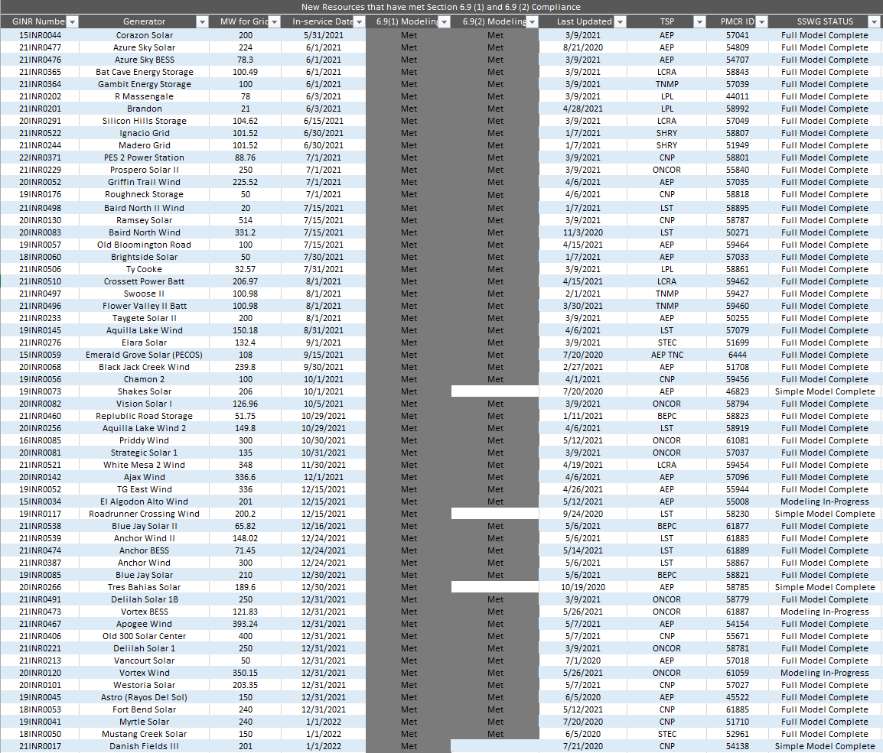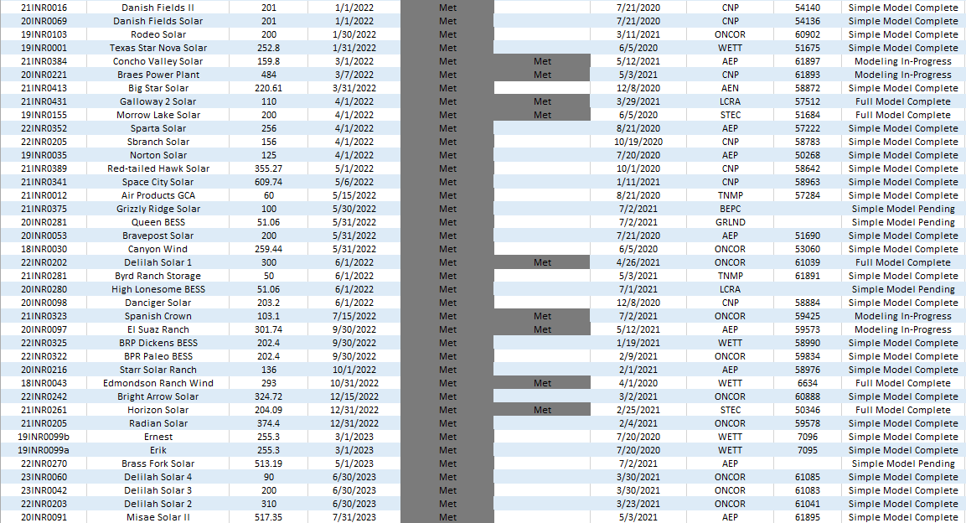

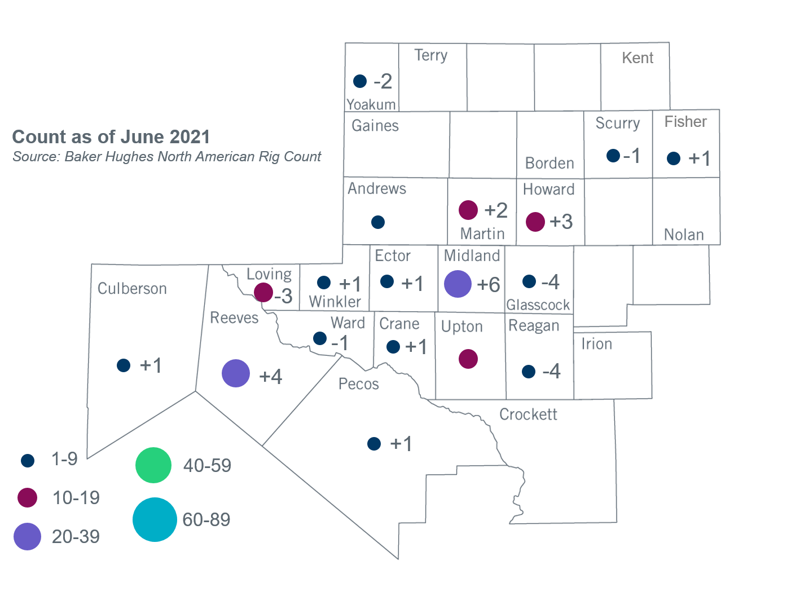
Permian Basin Oil Rig Count
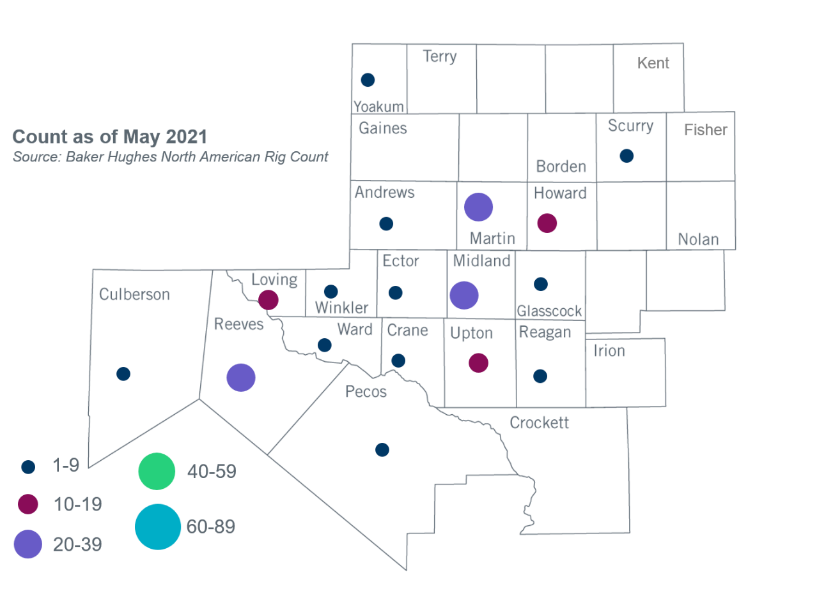

Other Notable Activities
- ERCOT is conducting the West Texas Export Study and plans to complete the study in Q3, 2021.
- ERCOT is conducting the South Texas Stability Study and plans to complete the stability study in Q3, 2021.
- ERCOT is conducting the Permian Basin Load Integration Study and plans to complete the study in August, 2021.
- The SPWG is currently building 2021 FY base cases.
- The 2020/2021 DWG Stability Book, documenting the 2020/2021 DWG flat start process and supplemental dynamic data submissions, was completed and posted to MIS Certified on July 6, 2021.
- Corrective Action Plans (CAPs) related to the 2020 Regional Transmission Plan short circuit analysis were updated based on additional feedback from impacted Resource Entities. Updated reports were posted to the ERCOT website and to MIS Secure on June 29, 2021.
.

Based on the Total Project Estimated Cost for all future projects listed in the Transmission Project Information and Tracking (TPIT) report. TPIT is updated three times each year based on information TSPs provide in Model on Demand (MOD) as specified in the ERCOT Steady State Working Group Procedure Manual. The latest TPIT is available at http://www.ercot.com/gridinfo/planning.
Based on the Total Project Estimated Cost for all completed projects with Projected In-Service Dates in 2021 listed in the TPIT.
+/- symbol indicates the increase or decrease from the previous month in oil rigs present in each county. There are 159 rigs, including no increase or decrease in oil rigs, in the Permian Basin from May to June 2021.

