

Study to Identify Impact of Southern Cross DC on ERCOT’s Ancillary Services

(Southern Cross Transmission - Directive 9)

**Operations Analysis**

**ERCOT**

Report Date: Feb. 18, 2019

Executive Summary

In PUC Docket No. 45624, the Public Utility Commission of Texas (PUCT) approved the City of Garland's application for a certificate of convenience and necessity to build a new 38-mile-long, 345kV transmission line connecting ERCOT to a direct-current converter station—the Southern Cross Transmission, LLC (SCT) DC Tie—in Louisiana. SCT is proposed to be a bidirectional bipole DC Tie line which can support imports of up-to 2,000 MW and exports of up-to 2,100 MW. In PUC Project No. 46304, the PUCT issued an [Order](https://interchange.puc.texas.gov/Documents/46304_4_941374.PDF) that directs ERCOT to complete a number of tasks—set forth in 14 separate [directives](http://www.ercot.com/mktrules/puctDirectives/southernCross)—that the PUCT deemed necessary to accommodate the new DC Tie. This study focuses on one of the directives, namely, Directive 9, determination regarding modifications to Ancillary Services (AS).

***Directive 9, Determination regarding modifications to Ancillary Services***

*As ordered by the Public Utility Commission of Texas (PUCT) in Project No. 46304: ERCOT shall (a) evaluate what modifications to existing and additional ancillary services, if any, are necessary for the reliable interconnection of the Southern Cross DC tie, (b) implement any needed modifications to ancillary-services procurement, (c) recommend how the costs of such required ancillary services are to be allocated, and (d) certify to the Commission when it has completed these actions.*

The specific aim of this study is to examine the impacts of interconnection of the SCT DC Tie over three Ancillary Service products, namely, Regulation Service, Non-spinning Reserve Services (NSRS) and Responsive Reserve (RRS) and to investigate the reliability risk regarding the loss of SCT DC Tie. The analysis carried is based on 2019 AS methodology approved by the ERCOT Board of Directors on December 11, 2018 and current grid operation practices. Moving forward, the impacts need to be re-examined if the relevant changes are brought in the future. At present, ERCOT Most Severe Single Contingency (MSSC)[1] is 1,375 MW and Resource Contingency Criteria (RCC)[2] is 2,750 MW. After incorporation of SCT DC Tie, both of them could change, depending on the amount of power imported by SCT DC Tie. This is the main driver for potential changes which SCT DC Tie will bring to existing Ancillary Services.

The study conclusions on the impacts of interconnection of the SCT DC Tie over three Ancillary Service products are summarized as follows.

1. Interconnection of the SCT DC Tie will not have any impact on the quantities of Regulation Service if other changes can be approved. These changes are 1) to impose ramp restrictions (these are addressed in [Directive 3](http://www.ercot.com/mktrules/puctDirectives/southernCross/159967) and 2) to fully integrate DC Tie schedules into ERCOT’s Generation To Be Dispatched (GTBD) calculation.
2. The interconnection of the SCT DC Tie will not have any impact on the quantities of NSRS.
3. The impact of the SCT DC Tie over RRS will be contingent upon the amount of power import, which can be better explained in two scenarios.
   1. Scenario 1: The addition of the 2,000 MW SCT DC Tie import would increase ERCOT’s Resource Contingency Criteria (RCC) from the current 2750 MW to 3375 MW, per BAL-003-1 Standard. ERCOT studies show additional RRS would be needed to protect against the larger RCC. Using the 2019 expected system inertia, ERCOT studies show an additional 5,270,536 MWh of RRS would be required for 2019.
   2. Scenario 2: If SCT DC Tie imports are limited to the current ERCOT-defined MSSC (i.e. not considering the SCT DC Tie), then ERCOT’s Resource Contingency Criteria (RCC) would not change and there would be no incremental RRS requirement.

The reliability risk for the frequency overshoot at the loss of SCT DC Tie export has also been examined and the key finding are given as follows.

* + 1. Instantaneous trip of a 2100 MW SCT DC Tie export during certain low inertia hours could cause frequency overshoot.
    2. Without an export limit for low inertia conditions, a new ancillary service would be required to protect against possible frequency overshoot.
    3. During certain low inertia hours, an export limit for the SCT DC Tie would address the potential overshoot problem and would eliminate the need for new ancillary services. ERCOT studies of the modeled scenarios showed the export limit to be as low as 1,488 MW. This limit could be higher or lower under system conditions that differ from the ones studied.

Note that this study was conducted between October 2018 and February 2019.

Table of Contents

Executive Summary 1

Table of Contents 3

1. Background 5

2. Ancillary Services in ERCOT 6

2.1. Regulation Service 6

2.2. Non-Spin Reserve Service (NSRS) 6

2.3. Responsive Reserve Service (RRS) 7

3. Impacts of integrating SCT DC Tie on ERCOT’s Ancillary Service 9

3.1. Regulation Service 9

3.2. Non-Spin Reserve Service (NSRS) 9

3.3. Responsive Reserve Service (RRS) 10

3.3.1. Scenario 1 - SCT DC Tie import is limited to existing ERCOT MSSC 11

3.3.2. Scenario 2 - SCT DC Tie import is above existing ERCOT MSSC 11

3.3.2.1. Case Selection 11

3.3.2.2. Modeling Assumptions 12

3.3.2.3. Study Methodology 12

3.3.2.4. Study Results 13

3.4. Frequency Overshoot Study – Impact of SCT DC Tie trips when exporting 16

3.4.1. Case Selection and Case Setup 16

3.4.2. Study Methodology and Assumptions 18

3.4.3. Study Results 18

4. Conclusion/Recommendation 21

Background

In PUC Docket No. 45624, the Public Utility Commission of Texas (PUCT) approved the City of Garland's application for a certificate of convenience and necessity to build a new 38-mile-long, 345kV transmission line connecting ERCOT to a direct-current converter station—the Southern Cross Transmission, LLC (SCT) DC Tie—in Louisiana. SCT is proposed to be a bidirectional bipole DC Tie line which can support imports of up-to 2,000 MW and exports of up-to 2,100 MW. In PUC Project No. 46304, the PUCT issued an [Order](https://interchange.puc.texas.gov/Documents/46304_4_941374.PDF) that directs ERCOT to complete a number of tasks—set forth in 14 separate [directives](http://www.ercot.com/mktrules/puctDirectives/southernCross)—that the PUCT deemed necessary to accommodate the new DC Tie. This report focuses on one of the directives, namely, directive 9, determination regarding modifications to Ancillary Services (AS).

***Directive 9, Determination regarding modifications to Ancillary Services***

*As ordered by the Public Utility Commission of Texas (PUCT) in Project No. 46304: ERCOT shall (a) evaluate what modifications to existing and additional ancillary services, if any, are necessary for the reliable interconnection of the Southern Cross DC tie, (b) implement any needed modifications to ancillary-services procurement, (c) recommend how the costs of such required ancillary services are to be allocated, and (d) certify to the Commission when it has completed these actions.*

The following sections will provide a high level introduction to ERCOT’s current AS and will describe the study/approaches used to evaluate impacts of integrating the SCT DC Tie to ancillary services and recommend any modifications to existing AS and/or the need for additional AS for reliable interconnection of the SCT DC Tie into ERCOT’s grid.

Ancillary Services in ERCOT

Ancillary Services (AS) are procured in the Day-Ahead Market to ensure sufficient resource capacity is reserved which can be deployed in a timely manner to restore the balance between the load and generation. ERCOT currently has three types of AS namely, Regulation Service, Responsive Reserve Service (RRS) and Non-Spin Reserve Service (NSRS).

## Regulation Service

Regulation Service is deployed every 4 seconds to maintain frequency (i.e. maintain generation & demand balance) between 5-min Security Constrained Economic Dispatch (SCED) intervals as depicted in Figure 1. This service is provided by Generation Resources or resources providing Fast Responding Regulation Service (FRRS). CPS1 is the performance metric used to gauge efficacy of procured Regulation reserves. Per ERCOT’s current AS Methodology minimum quantities of Regulation Up/Down Service are established based on historic (last two years) five-minute net-load variability and adjusted for growth in installed of wind generation capacity – see Figure 1.

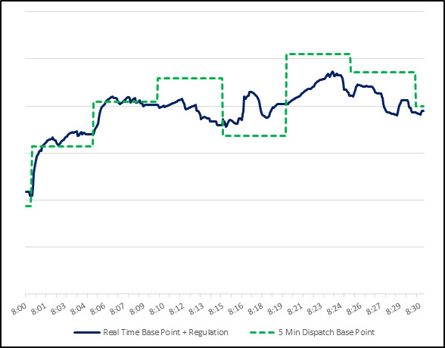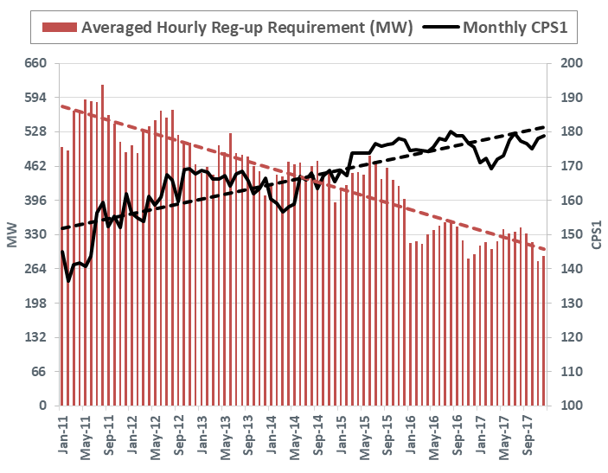

Figure 1 Regulation Service deployment & Regulation Service performance

## Non-Spin Reserve Service (NSRS)

Non-Spin Reserve Service is procured/used to ensure sufficient capacity is available to cover large Load/Wind/Solar forecast errors, or replace deployed RRS. This reserve is provided by generation resource capacity that can be started in 30 minutes or by unloaded on-line generation.

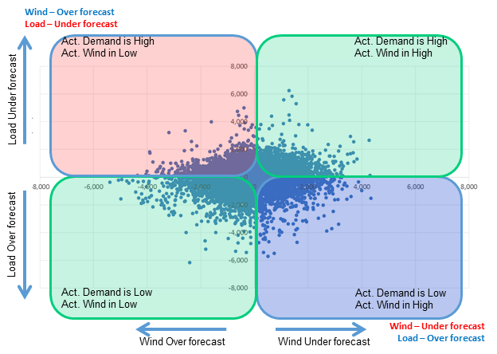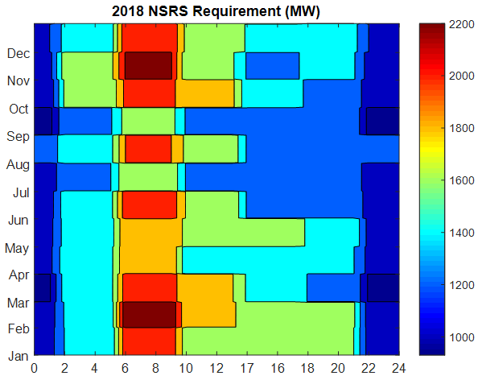

Figure 2 NSRS requirement establishment using net load errors and NSRS quantities in 2018

Per ERCOT’s current AS Methodology minimum quantities of NSRS are established based on historic (last three years) net-load forecast error and risk of net-load up ramps. NSRS quantities are also adjusted for expected growth in installed wind generation capacity. One such example of NSRS quantities in 2018 is provided in Figure 2.

## Responsive Reserve Service (RRS)

Responsive Reserve Service are procured to ensure sufficient capacity is available to respond to frequency excursions during generation resource trips. This reserve is provided by capacity reserved from online generation resources via governor response and load resources via under-frequency relays. Currently up to 60% of RRS can be provided by load resources with under-frequency relays.

 

Figure 3 RRS requirement establishment using historic system inertia in 2017 (left) and RRS quantities in 2018 (right)

This reserve is designed such that for a generation resource trip that is equal to ERCOT’s Resource Contingency Criteria (RCC) as established by BAL-003, Under Frequency Load Shed (UFLS) is not triggered. ERCOT’s current RCC is 2,750 MW. Per ERCOT’s current AS Methodology minimum quantities of RRS are established based on historic (last two years) system inertia conditions and RRS studies (most recently [conducted in 2017](http://www.ercot.com/content/wcm/key_documents_lists/108744/05._RRS_Study_2017_Methodology_11022017.docx)).

Impacts of integrating SCT DC Tie on ERCOT’s Ancillary Service

This section assesses the impacts of integrating the SCT DC Tie to ERCOT’s Ancillary Services. There are broadly two flavors of discussion. First few subsections will detail the impacts on existing AS and then the last subsection will delve into assessing the impact on Frequency due to forced outage of the SCT DC Tie while exporting (frequency overshoot study).

## Regulation Service

Per the current methodology, two factors influence the minimum amount of Regulation Up/Down service will be needed, namely, 5-min variations of net-load and historical regulation resource deployment. With the interconnection of the SCT DC Tie, ERCOT believes that the ideal solution would be to impose ramp restrictions (these are addressed in [Directive 3](http://www.ercot.com/mktrules/puctDirectives/southernCross/159967)) and to fully integrate DC Tie schedules into ERCOT’s Generation To Be Dispatched (GTBD) calculation. Although this approach will need to be formally approved by stakeholders as part of a broader evaluation of Directive 3 along with the Regulation Service component of Directive 9, these changes would ensure that the interconnection of the SCT DC Tie will not have any impact on the quantities of Regulation Service.

## Non-Spin Reserve Service (NSRS)

Upon interconnection of the SCT DC Tie, there is a potential that ERCOT’s Most Severe Single Contingency (MSSC) may change. On December 11, 2018, the ERCOT Board of Directors approved the 2019 ERCOT Methodologies for Determining Ancillary Service Requirements (2019 AS Methodology). Per ERCOT’s 2019 AS Methodology, a floor equal to ERCOT’s MSSC, which was previously applied during on-peak hours (namely, hour ending 7 through 22) when determining NSRS quantities, is removed. In this regard, regardless of where MSSC will change, the interconnection of the SCT DC Tie will not have any impact on the quantities of NSRS.

## Responsive Reserve Service (RRS)

Per ERCOT’s current AS Methodology minimum quantities of RRS are established based on historic (last two years) system inertia conditions and RRS studies (most recently [conducted in 2017](http://www.ercot.com/content/wcm/key_documents_lists/108744/05._RRS_Study_2017_Methodology_11022017.docx)). RRS Studies are setup such that for a generation resource trip that is equal to ERCOT’s Resource Contingency Criteria (RCC) as established by BAL-003, Under Frequency Load Shed (UFLS) is not triggered.

In its [petition for approval of BAL-003-1](https://www.nerc.com/FilingsOrders/us/NERC%20Filings%20to%20FERC%20DL/Petition%20and%20Exhibits%20A-J_FINAL.pdf#page=162) North American Electric Reliability Council (NERC) has explained that ERCOT’s RCC is based on largest N-2 loss-of-resource event criteria. Currently loss of 2 South Texas Project Units is recognized as the largest N-2 loss-of-resource event and as a result ERCOT’s current RCC is 2,750 MW. Upon interconnection of the SCT DC Tie there is a potential that ERCOT’s RCC may change.[3]

Hence using OWG’s [recommendation](http://www.ercot.com/content/wcm/key_documents_lists/139277/08._Directive9_MSSC_Whitepaper__OWG_071318.docx) on Directive 9, impacts on RRS quantities upon interconnection of SCT DC Tie will be evaluated under two scenarios namely,

* Scenario 1 - SCT DC Tie import is limited to be equal to or less than existing ERCOT MSSC (1375 MW)
* Scenario 2 - SCT DC Tie import is above existing ERCOT MSSC up to 2,000 MW

In Scenario 2, the introduction of the Southern Cross DC Tie would change the largest N-2 event in the ERCOT System to be the loss of the Southern Cross DC Tie at full import (contingency event one) plus the loss of one of the STP units (contingency event two), which totals 3,375 MW. Under the current language of BAL-003, it is appropriate to view the loss of the Southern Cross DC Tie as a single event because it presents a single point of failure on the system. This approach is also consistent with Attachment A to BAL-003, which explains that “[t]he default [Interconnection Frequency Reserve Obligation (“IFRO”)] listed in Table 1 is based on the resource contingency criteria (RCC), which is the largest category C (N-2) event identified except for the Eastern Interconnection, which uses the largest event in the last 10 years.”

### Scenario 1 - SCT DC Tie import is limited to existing ERCOT MSSC

If SCT DC Tie is limited to imports equal to or less than the existing ERCOT MSSC (1,375 MW), then ERCOT’s RCC upon interconnection of SCT DC Tie will remain unchanged (i.e. ERCOT’s RCC = 2,750 MW). As a result of this, per ERCOT’s current AS Methodology wherein RRS quantities are established to cover the risk for instantaneous loss of 2,750 MW, there will not be any additional impact to ERCOT’s RRS requirements upon interconnection of SCT DC Tie.

### Scenario 2 - SCT DC Tie import is above existing ERCOT MSSC

If the SCT DC Tie is allowed to import above existing ERCOT MSSC (1,375 MW) up to 2,000 MW then ERCOT’s RCC will change upon interconnection of the SCT DC Tie. As a result of this, per ERCOT’s current AS Methodology RRS quantities will need to be established to cover the risk for instantaneous loss of 3,375 MW (1,375 MW + 2,000 MW). Consequently, there would be an impact to ERCOT’s RRS requirements and additional RRS quantities will be needed upon interconnection of the SCT DC Tie. In order to obtain insights into the additional RRS quantities needed in 2019 under the hypothetical scenario that the SCT DC Tie was already integrated and operational prior to start of 2019, a new RRS study will be conducted. The rest of this subsection summarizes the new RRS study and its results.

#### Case Selection

Recent real-time cases between 2013 and 2017 with inertia levels varying between 134 GW·s thru 380 GW·s will be used to identify a total of eleven cases representing eleven different inertia conditions to determine the corresponding RRS requirements. The 130 GW·s case (Case 1) was built from a 134 GW·s real time TSAT case by turning off some of the on-line generators and reducing loads. Detailed information of the selected cases is summarized in Table 1.

Table 1 Information for the cases selected to be included in the new RRS Study

|  |  |  |
| --- | --- | --- |
| Scenario Name | Power Flow Seed Time Stamp | Inertia (GW·s) |
| Case 1 | 10-Feb-17 01:00:00 | 130 |
| Case 2 | 31-Mar-14 02:00:00 | 140 |
| Case 3 | 21-Mar-14 02:00:00 | 150 |
| Case 4 | 23-Oct-16 00:00:00 | 160 |
| Case 5 | 28-Oct-13 00:00:00 | 180 |
| Case 6 | 24-Nov-16 15:00:00 | 200 |
| Case 7 | 02-Apr-14 10:00:00 | 220 |
| Case 8 | 05-Oct-13 18:00:00 | 260 |
| Case 9 | 28-May-14 18:00:00 | 290 |
| Case 10 | 03-Sep-13 18:00:00 | 359 |
| Case 11 | 07-Aug-13 17:00:00 | 376 |

#### Modeling Assumptions

In this study, initial conditions including but not limited to Generation Resources with online governors, Load Resource (LR) trip settings and tripped resource will be setup consistently across all Cases listed in Table 1. The following modelling assumptions will be applied in all the cases.

1. Governors will be activated for those Generation Resources that are needed to provide the minimum PFR of 1150 MW. The response from each Generation Resource that is used to contribute to the minimum PFR will be limited to 20% of its High Sustained Limit (i.e. this assumes that the governors have 5% droop). Governors for all other Generation Resources which will not provide PFR will be disabled.
   * In Cases where total inertia was lower than 250 GW·s, approximately 30% of the minimum PFR responsibility was provided by coal units and in Cases with an inertia greater than or equal to 250 GW·s, approximately 15% of the minimum PFR responsibility was provided by coals units. The remaining PFR responsibility was provided by gas units. This configuration is consistent with recent trends observed in the system operations.
2. In these studies, it was assumed that all Load Resources providing RRS will trip at 59.7 Hz, with a delay of 0.416 s (relay delay = 0.333 s; breaker action = 0.083 s). This assumption is consistent with the 2017 RRS Study conducted in 2017.
3. Load damping factor will be assumed to be 2% at the system level, consistent with Dynamics Working Group (DWG) flat start cases.

#### Study Methodology

The following study methodology will be applied on each of Cases in Table 1 to identify the minimum RRS requirement.

1. Trip 3,375 MW of generation and SCT DC Tie simultaneously.
2. Identify the minimum amount of LRs with a PFR of 1150 MW required to ensure that the frequency nadir remains at/or above 59.40 Hz in response to the loss of 3,375 MW of generation.
3. Repeat Step 1 and Step 2 with varying minimum PFR amounts to identify LRs/PFR Equivalency Ratio. This Equivalency Ratio will then be used to compare the effectiveness of 1 MW of LRs relative to 1 MW of PFR in arresting the frequency decline in the response to 3,375 MW generation loss.

#### Study Results

Table 2 below summarizes the simulation results for all eleven cases obtained from TSAT dynamic simulations. For comparison purposes, 2017 RRS Study results (denoted as w/o SCDCT) are included in Table 2 for reference. In Case 1, the response speed of LRs has to be changed in order to protect the grid integrity against the fast frequency drop as a result of 3,375 MW generation loss.

Table 2 RRS Study Simulation Results

|  |  |  |  |  |  |  |  |  |
| --- | --- | --- | --- | --- | --- | --- | --- | --- |
| Case No. | INERTIA (GW·s) | PFR  (MW) | LR (MW) | | LR/PFR Ratio | | PFR[4] (No LR) (MW) | |
| w/o SCDCT | w/ SCDCT | w/o SCDCT | w/ SCDCT | w/o SCDCT | w/ SCDCT |
| *Case1[5] | 130 | 1150 | 1900 | 2650 | 2.39 | 2.94 | 5691 | 8941 |
| Case2 | 140 | 1150 | 1800 | 3250 | 2.17 | 3.29 | 5056 | 11843 |
| Case3 | 150 | 1150 | 1750 | 2900 | 1.85 | 2.59 | 4388 | 8661 |
| Case4 | 160 | 1150 | 1700 | 2550 | 1.85 | 2.43 | 4295 | 7347 |
| Case5 | 180 | 1150 | 1650 | 2375 | 1.71 | 1.98 | 3972 | 5853 |
| Case6 | 200 | 1150 | 1450 | 2100 | 1.43 | 1.53 | 3224 | 4363 |
| Case7 | 220 | 1150 | 1500 | 2150 | 1.55 | 1.68 | 3475 | 4762 |
| Case8 | 260 | 1150 | 1450 | 2150 | 1.10 | 1.17 | 2745 | 3666 |
| Case9 | 290 | 1150 | 1300 | 1950 | 1.00 | 1.06 | 2450 | 3217 |
| Case10 | 359 | 1150 | 1150 | 1800 | 1.00 | 1.12 | 2300 | 3166 |
| Case11 | 376 | 1150 | 1050 | 1700 | 1.00 | 0.95 | 2085 | 2765 |

As documented in [RRS study conducted in 2017](http://www.ercot.com/content/wcm/key_documents_lists/108744/05._RRS_Study_2017_Methodology_11022017.docx), both PFR (No LR) and LR/PFR ratio were observed to be strongly correlated with inertia. Therefore a post-processing was applied to derive PFR (No LR) and LR/PFR ratio for a given inertia. In this study, a similar approach is adopted to calculate PFR(No LR), LR/PFR ratio and RRS quantities at various inertia conditions with an incremental change of 10 GW·s. Table 3 summarizes all the derived quantities. For comparison, 2017 RRS Study results (referred as w/o SCDCT) are included in Table 3 as well. Note that quantities associated with Case 1 are not included in the post-processing.

Table 3 RRS Table Comparison

|  |  |  |  |  |  |  |
| --- | --- | --- | --- | --- | --- | --- |
| INERTIA (GW*s) | PFR (No LR) (MW) | | LR/PFR Ratio | | RRS (MW) | |
| w/o SCDCT | w/ SCDCT | w/o SCDCT | w/ SCDCT | w/o SCDCT | w/ SCDCT |
| 130 | 8941 | 5246 | 2.94 | 2.25 | 4132 | 2998 |
| 140 | 11164 | 4916 | 3.13 | 2.11 | 4901 | 2951 |
| 150 | 9298 | 4620 | 2.72 | 1.99 | 4576 | 2898 |
| 160 | 7843 | 4361 | 2.39 | 1.87 | 4277 | 2867 |
| 170 | 6694 | 4132 | 2.12 | 1.77 | 4004 | 2835 |
| 180 | 5762 | 3927 | 1.89 | 1.69 | 3756 | 2793 |
| 190 | 5001 | 3743 | 1.70 | 1.61 | 3522 | 2760 |
| 200 | 4373 | 3576 | 1.53 | 1.54 | 3318 | 2725 |
| 210 | 4051 | 3424 | 1.50 | 1.47 | 3116 | 2697 |
| 220 | 3898 | 3285 | 1.44 | 1.41 | 3084 | 2664 |
| 230 | 3757 | 3157 | 1.40 | 1.36 | 3029 | 2626 |
| 240 | 3626 | 3040 | 1.35 | 1.30 | 2997 | 2604 |
| 250 | 3505 | 2932 | 1.31 | 1.26 | 2956 | 2564 |
| 260 | 3393 | 2831 | 1.27 | 1.22 | 2920 | 2528 |
| 270 | 3288 | 2737 | 1.23 | 1.17 | 2890 | 2507 |
| 280 | 3191 | 2650 | 1.20 | 1.14 | 2851 | 2466 |
| 290 | 3099 | 2569 | 1.17 | 1.10 | 2816 | 2440 |
| 300 | 3013 | 2492 | 1.14 | 1.07 | 2784 | 2405 |
| 310 | 2932 | 2421 | 1.11 | 1.04 | 2756 | 2372 |
| 320 | 2856 | 2353 | 1.08 | 1.01 | 2729 | 2341 |
| 330 | 2784 | 2290 | 1.06 | 1.00 | 2691 | 2290 |
| 340 | 2716 | 2230 | 1.03 | 1.00 | 2670 | 2230 |
| 350 | 2651 | 2173 | 1.01 | 1.00 | 2636 | 2173 |
| 360 | 2590 | 2119 | 1.00 | 1.00 | 2590 | 2119 |
| 370 | 2532 | 2068 | 1.00 | 1.00 | 2532 | 2068 |

The RRS need, which is updated in Table 3 under the condition of 3,375 MW RCC, is applied to calculate the RRS quantities in 2019, in comparison to those with RCC equal to 2,750 MW. The hourly incremental change in RRS requirement is shown in Figure 5. A positive value represents an increase in MW compared with the current 2019 RRS requirement which does not take into account the impact of SCDCT. It can be observed that the large increase in RRS quantities coincides with low inertia conditions. As a consequence of interconnection of SCT DC tie, RCC increases from 2,750 MW to 3,375 MW, which thus leads to a total of 5,270,536 MWh increase in RRS for the entire year of 2019.

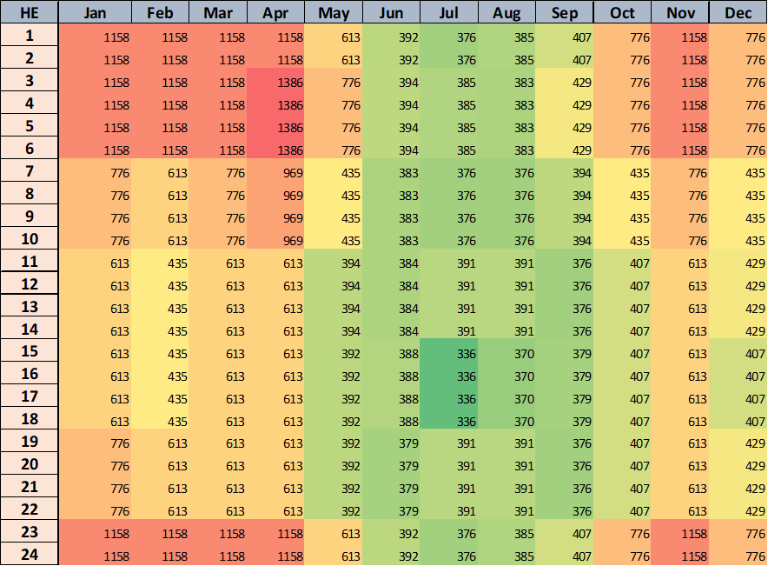

Figure 4 Additional hourly RRS needed (MW) for the year of 2019 if RCC becomes 3,375 MW

## Frequency Overshoot Study – Impact of SCT DC Tie trips when exporting

Sudden instantaneous trip of SCT DC Tie when exporting power could cause ERCOT grid frequency to overshoot. If the resulting frequency overshoot is too high, the high overshoot values could trigger other generation resources within ERCOT to trip on over-frequency protection, thus leading to cascading effects. The risk of this reliability concern will be evaluated in this subsection. For the purposes of this evaluation, a series of dynamic simulations will be conducted to examine the impacts on grid frequency that results from tripping SCT DC Tie when it is exporting power at 2,100 MW. Note that the magnitude of frequency overshoot will depend on system inertia conditions, number of generators with governor response capability, and the capacity available to provide downward frequency response.

### Case Selection and Case Setup

In order to represent a worst case scenario, a case that represents 130 GW·s inertia (lowest inertia condition) will be built using the power flow from a recent real-time operating condition from October 27, 2017 at 1:00 am. General information from Scenario 0 summarized in Table 4 below.

Table 4 Scenario 0 - General Information

|  |  |  |  |  |  |
| --- | --- | --- | --- | --- | --- |
| Scenario Name | Power Flow Seed Time Stamp | Inertia (GW·s) | Load  (GW) | Wind  (GW) | Synchronous Gen (GW) |
| Scenario 0 | 10/27/2017 1:00 AM | 130 | 34 | 15.5 | 19 |

Headroom-Up (defined as HSL - MW) and Headroom-Down (defined as MW - LSL) represent the maximum capacity for a generation resource can provide in upward and downward direction, respectively. A breakdown of Headroom-Up and Headroom-Down from Scenario 0 by resource category is summarized in Table 5 below. Note that as nuclear units do not provide response to frequency events (over or under), hence the Headroom up/down for these resources is tracked as zero in the Table 5 below. Also note that in Table 5 below the total Headroom-Down from wind resources includes contribution from only the wind resources that have primary frequency response (PFR) capability (approximately 80% of wind portfolio) and Headroom-Up from wind is 0 MW when no curtailment of wind generation is assumed.

Table 5 Scenario 0 – Headroom-up and Headroom-down by resource category

|  |  |  |  |
| --- | --- | --- | --- |
| Unit Type | Headroom-up  (MW) | Headroom-Down  (MW) | Output  (MW) |
| Coal | 7,707 | 1,716 | 7,876 |
| Gas Steam | 1,316 | 63 | 180 |
| Simple Cycle | 448 | 588 | 1,999 |
| Combined Cycles | 3,210 | 1,533 | 5,191 |
| Nuclear | 0 | 0 | 4,028 |
| Hydro | 283 | 0 | 0 |
| Wind | 0 | 13,014 | 15,511 |
| Total | **12,964** | **16,914** | **34,784** |

For this study, additional Scenarios 1-3 will be built as modifications from the Scenario 0 to simulate primary frequency response of wind generation at 3,500 MW, 5,000 MW and 10,000 MW and with the SCT DC Tie exporting at 2,100 MW. In each of these cases, the reduction in wind generation will be compensated by increasing the power output from existing synchronous generation resources. To maintain system inertia at 130 GW∙s, Scenarios 1-3 with low wind generation (less than 15 GW) will be built without changing unit commitment status. As an example, for Scenario 1, the wind generation from Scenario 0 is reduced from 15,511 MW to 10,000 MW and the power output from Coal, Hydro, Gas, Single Cycle and Combined Cycle units is increased from 15,245 MW to 20,755 MW. Power output of these units is scaled based on participation factors of these units in Scenario 0. Two more Scenarios 4-5 with even lower inertia conditions (120 GW·s and 110 GW·s) combined with low wind generation (3,500 MW) will also be developed for the study. Table 6 below summarizes the general power-flow information of Scenario 0 and other five scenarios that will be used for Frequency Overshoot Study. Note that a breakdown of Headroom-Up and Headroom-Down by resource category for each of these cases in Table 6 is summarized in Appendix A.

Table 6 Summary of Scenarios that will be used for Frequency Overshoot Study

|  |  |  |  |  |
| --- | --- | --- | --- | --- |
| Scenario Name | Inertia (GW·s) | Load  (GW) | Wind  (GW) | Synchronous Gen (GW) |
| Scenario 0 | 130 | 34 | 15.5 | 19 |
| Scenario 1 | 130 | 34 | 10 | 24.5 |
| Scenario 2 | 130 | 32 | 5 | 27.5 |
| Scenario 3 | 130 | 32 | 3.5 | 29 |
| Scenario 4 | 120 | 29.9 | 3.5 | 26.9 |
| Scenario 5 | 110 | 27.2 | 3.5 | 24.2 |

### Study Methodology and Assumptions

For each case listed in Table 6 above, all governors of on-line synchronous generation resources will be enabled to provide frequency response; all on-line wind farms with PFR capability will be modeled to provide downward response to over frequency; and SCT DC Tie will be assumed to be exporting 2,100 MW prior to the trip. The following study methodology will then be applied to each of the cases in Table 6 above.

1. Trip SCT DC Tie while exporting 2,100 MW.
2. The sensitivity study with load damping factor assumed to be 0% and 2% will be conducted for each case.
3. Record frequency trend and identify any frequency overshoot that exceeds 60.6 Hz.
4. In the cases where frequency overshoot exceeds 60.6 Hz, additional sensitivity studies will be conducted to identify an export limit on the SCT DC Tie such that frequency overshoot will not exceed 60.6 Hz.

### Study Results

The frequency responses for Scenario 0-5 are shown in Figure 5, when the ERCOT grid is subject to a loss of SCT DC Tie export at 2,100 MW, while the highest frequency overshoots are given in Table 7. When the amount of power produced by wind generation is reduced, the highest frequency overshoot becomes higher. The highest frequency overshoot also shows an upward trend as the system inertia decreases, which exceeds 60.6 Hz at an inertia level of 110 GW·s with wind power production at 3.5 GW.

A noticeable impact of load damping ratio (DR) is also observed when it is reduced from 2.0 to 0.0, which drives the highest frequency overshoot above 60.6 Hz for Scenario 3-5. The value of load damping is highly depending on the characteristics of load consuming electricity so it will vary with time of day, week, or season. This makes it hard to estimate how much DR is at time when SCT DC Tie is tripped off. There is another concern that load’s contributions to frequency response are declining as end-use equipment, such as motor drives, is increasingly electronically coupled, rather than direct-coupled, to the grid. Thus, it is imperative to make a conservative assumption that load is not responsive to changes in frequency[6].

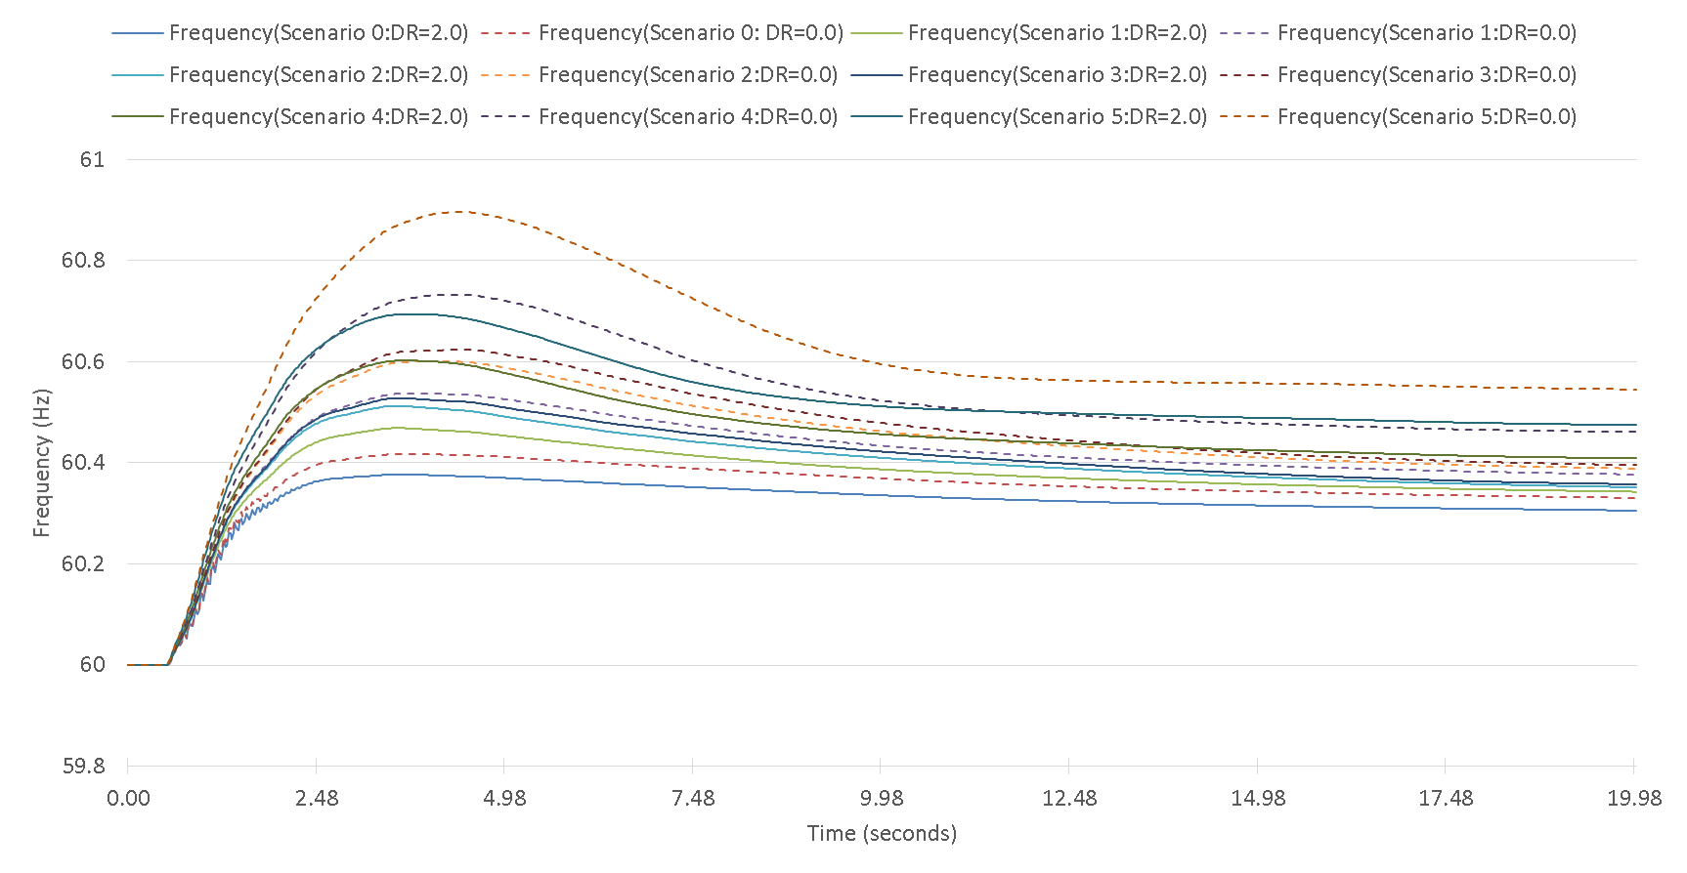

Figure 5 Frequency response for Scenario 0-5 when subject to a loss of SCT DC Tie export at 2,100 MW

Table 7 Highest frequency overshoot

|  |  |  |  |  |  |  |
| --- | --- | --- | --- | --- | --- | --- |
|  | Scenario 0 | Scenario 1 | Scenario 2 | Scenario 3 | Scenario 4 | Scenario 5 |
| Highest Frequency Overshoot (Hz) DR=2.0 | 60.38 | 60.47 | 60.51 | 60.53 | 60.60 | 60.70 |
| Highest Frequency Overshoot (Hz) DR=0.0 | 60.42 | 60.54 | 60.60 | 60.62 | 60.73 | 60.89 |

For those scenarios where the frequency overshoot is greater 60.6 Hz, the associated reliability risk should be addressed and mitigated. One remedy to this is to reduce SCT DC Tie export in order to limit the corresponding maximum frequency overshoot below 60.6 Hz. The sensitivity study performed found the maximum SCT DC Tie export should be constrained at 2,000 MW, 1,745 MW and 1,488 MW for Scenario 3-5, respectively, as shown in Table 8. Once the maximum SCT DC Tie export is reduced, the resulting frequency response will be within the acceptable range - see Figure 6.

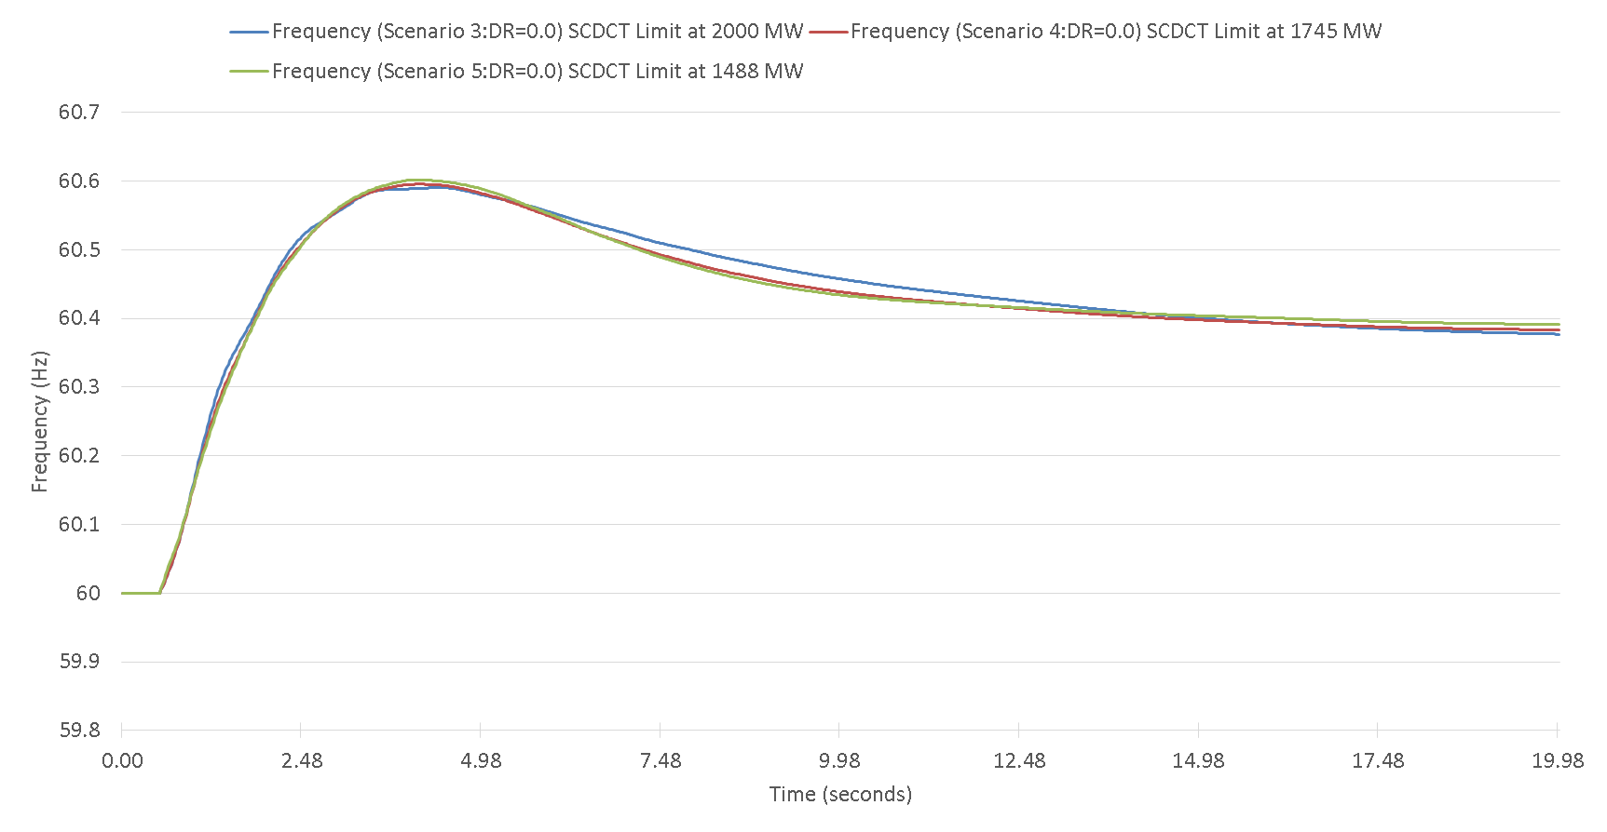

Figure 6 Frequency response for Scenario 3-5 when SCT DC Tie export is reduced

Table 8 Limit on SCT DC Tie to ensure the frequency overshoot below 60.6 Hz

|  |  |  |  |
| --- | --- | --- | --- |
|  | **Scenario 3** | **Scenario 4** | **Scenario 5** |
| Limit on SC DC Tie export | 2,000 MW | 1,745 MW | 1,488 MW |

Conclusion/Recommendation

This study examined the impacts of interconnection of the SCT DC Tie over three Ancillary Service products, namely, Regulation Service, NSRS and RRS and investigated the reliability risk regarding the loss of SCT DC Tie. The analysis carried is based on 2019 AS methodology approved by the ERCOT Board of Directors on December 11, 2018 and current grid operation practices. Moving forward, the impacts need to be re-examined if the relevant changes are brought in the future.

At present, ERCOT MSSC is 1,375 MW and RCC is 2,750 MW. After incorporation of SCT DC Tie, both of them could change, depending on the amount of power imported by SCT DC Tie. This is the main driver for potential changes which SCT DC Tie will bring to Ancillary Services. The study conclusions on the impacts of interconnection of the SCT DC Tie over three Ancillary Service products are summarized as follows.

1. Interconnection of the SCT DC Tie will not have any impact on the quantities of Regulation Service if other changes can be approved. These changes are 1) to impose ramp restrictions (these are addressed in [Directive 3](http://www.ercot.com/mktrules/puctDirectives/southernCross/159967) and 2) to fully integrate DC Tie schedules into ERCOT’s Generation To Be Dispatched (GTBD) calculation.
2. The interconnection of the SCT DC Tie will not have any impact on the quantities of NSRS.
3. The impact of the SCT DC Tie over RRS will be contingent upon the amount of power import, which can be better explained in two scenarios.
   1. Scenario 1: The addition of the 2,000 MW SCT DC Tie import would increase ERCOT’s Resource Contingency Criteria (RCC) from the current 2750 MW to 3375 MW, per BAL-0031 Standard. ERCOT studies show additional RRS would be needed to protect against the larger RCC. Using the 2019 expected system inertia, ERCOT studies show an additional 5,270,536 MWh of RRS would be required for 2019.
   2. Scenario 2: If SCT DC Tie imports are limited to the current ERCOT-defined MSSC (i.e. not considering the SCT DC Tie), then ERCOT’s Resource Contingency Criteria (RCC) would not change and there would be no incremental RRS requirement.

The reliability risk for the frequency overshoot at the loss of SCT DC Tie export has also been examined and the key finding are given as follows.

1. Instantaneous trip of a 2100 MW SCT DC Tie export during certain low inertia hours could cause frequency overshoot.
2. Without an export limit for low inertia conditions, a new ancillary service would be required to protect against possible frequency overshoot.
3. During certain low inertia hours, an export limit for the SCT DC Tie would address the potential overshoot problem and would eliminate the need for new ancillary services. ERCOT studies of the modeled scenarios showed the export limit to be as low as 1,488 MW. This limit could be higher or lower under system conditions that differ from the ones studied.

Appendix A – Headroom Information from 5 Scenario Cases

Table 9 to 13 below summarize Headroom-Up and headroom-Down in each of the five Scenario cases.

Table 9 Scenario 1 – Headroom-up and Headroom-down by resource category

|  |  |  |  |
| --- | --- | --- | --- |
| Unit Type | Headroom-up  (MW) | Headroom-Down  (MW) | Output  (MW) |
| Coal | 4,381 | 4,144 | 11,202 |
| Gas Steam | 1,003 | 229 | 494 |
| Simple Cycle | 151 | 837 | 2,296 |
| Combined Cycles | 1,697 | 2,669 | 6,704 |
| Nuclear | 0 | 0 | 3823 |
| Hydro | 222 | 10 | 61 |
| Wind | 0 | 8,522 | 10,000 |
| Total | **7,453** | **16,412** | **34,579** |

Table 10 Scenario 2 – Headroom-up and Headroom-down by resource category

|  |  |  |  |
| --- | --- | --- | --- |
| Unit Type | Headroom-up  (MW) | Headroom-Down  (MW) | Output  (MW) |
| Coal | 2,298 | 5,622 | 13,284 |
| Gas Steam | 801 | 405 | 696 |
| Simple Cycle | 97 | 880 | 2,349 |
| Combined Cycles | 1,075 | 3,145 | 7,326 |
| Nuclear | 0 | 0 | 3,796 |
| Hydro | 181 | 17 | 102 |
| Wind | 0 | 4,392 | 5,000 |
| Total | **4,453** | **14,462** | **32,552** |

Table 11 Scenario 3 – Headroom-up and Headroom-down by resource category

|  |  |  |  |
| --- | --- | --- | --- |
| Unit Type | Headroom-up  (MW) | Headroom-Down  (MW) | Output  (MW) |
| Coal | 1,217 | 6,475 | 14,365 |
| Gas Steam | 680 | 525 | 816 |
| Simple Cycle | 74 | 902 | 2,372 |
| Combined Cycles | 826 | 3,325 | 7,575 |
| Nuclear | 0 | 0 | 3,799 |
| Hydro | 156 | 23 | 127 |
| Wind | 0 | 3094 | 3,500 |
| Total | **2,953** | **14,344** | **32,555** |

Table 12 Scenario 4 – Headroom-up and Headroom-down by resource category

|  |  |  |  |
| --- | --- | --- | --- |
| Unit Type | Headroom-up  (MW) | Headroom-Down  (MW) | Output  (MW) |
| Coal | 839 | 5,069 | 12,288 |
| Gas Steam | 680 | 525 | 816 |
| Simple Cycle | 74 | 902 | 2,372 |
| Combined Cycles | 826 | 3,325 | 7,575 |
| Nuclear | 0 | 0 | 3,799 |
| Hydro | 156 | 23 | 127 |
| Wind | 0 | 3094 | 3,500 |
| Total | **2,575** | **12,938** | **30,479** |

Table 13 Scenario 5 – Headroom-up and Headroom-down by resource category

|  |  |  |  |
| --- | --- | --- | --- |
| Unit Type | Headroom-up  (MW) | Headroom-Down  (MW) | Output  (MW) |
| Coal | 654 | 3,165 | 9,580 |
| Gas Steam | 680 | 525 | 816 |
| Simple Cycle | 74 | 902 | 2,372 |
| Combined Cycles | 826 | 3,325 | 7,575 |
| Nuclear | 0 | 0 | 3,799 |
| Hydro | 156 | 23 | 127 |
| Wind | 0 | 3094 | 3,500 |
| Total | **2,390** | **11,034** | **27,770** |

1. As of January, 2020 ERCOT’s MSSC is 1,430 MW and Resource Contingency Criteria is 2,805 MW. ([Market Notice Link](http://lists.ercot.com/scripts/wa-ERCOT.exe?A2=NOTICE_OPERATIONS;9c6a340.2001&S=))
2. NERC has adopted BAL-003-2 effective December 2, 2020. Per this new revision the RCC has been renamed to Resource Loss Protection Criteria (RLPC). ERCOT’s current RLPC is 2,805 MW.
3. \
4. PFR (No LR) = PFR + LR * LR/ PFR
5. With RCC increased to 3,375 MW, ERCOT’s critical inertia goes above 130 GW·s. As a result, current RRS mix is insufficient to arrest system frequency above 59.4 Hz. Therefore, for case 1 with 130 GW·s inertia, LRs’ response time are shortened to 15 cycles to improve frequency nadir.
6. “Frequency Control Requirements for Reliable Interconnection Frequency Response,” Joseph H. Eto, John Undrill, Ciaran Roberts, Peter Mackin, and Jeffrey Ellis, Lawrence Berkeley National Laboratory, February 2018