May 2021 ERCOT Monthly Operations Report
Reliability and Operations Subcommittee Meeting
July 08, 2021

Table of Contents
1. Report Highlights 2
2. Frequency Control 3
2.1. Frequency Events 3
2.2. Responsive Reserve Events 4
2.3. Load Resource Events 4
3. Reliability Unit Commitment 4
4. Wind Generation as a Percent of Load 5
5. Largest Net-Load Ramp 7
6. COP Error Analysis 7
7. Congestion Analysis 9
7.1. Notable Constraints 9
7.2. Generic Transmission Constraint Congestion 15
7.3. Manual Overrides 16
7.4. Congestion Costs for Calendar Year 2021 16
8. System Events 17
8.1. ERCOT Peak Load 17
8.2. Load Shed Events 17
8.3. Stability Events 17
8.4. Notable PMU Events 17
8.5. DC Tie Curtailment 17
8.6. TRE/DOE Reportable Events 18
8.7. New/Updated Constraint Management Plans 18
8.8. New/Modified/Removed RAS 18
8.9. New Procedures/Forms/Operating Bulletins 18
9. Emergency Conditions 19
9.1. OCNs 19
9.2. Advisories 19
9.3. Watches 19
9.4. Emergency Notices 19
10. Application Performance 19
10.1. TSAT/VSAT Performance Issues 19
10.2. Communication Issues 19
10.3. Market System Issues 19
11. Model Updates 20
Appendix A: Real-Time Constraints 22

Report Highlights
- The unofficial ERCOT peak load was 62,821 MW.
- There were 6 frequency events.
- There were 5 instances where Responsive Reserves were deployed.
- There were no HRUC commitments.
- There were 18 days of congestion on the West Texas Export GTC, 20 days on the Panhandle GTC, 26 days on the North Edinburg to Lobo GTC, 27 days on the Raymondville to Rio Hondo, 22 days on the Nelson Sharpe to Rio Hondo GTC, 9 days on the Valley Export GTC, 5 days on the North to Houston GTC, and 9 days on the Bearkat GTC. There was no activity on the remaining GTCs during the month.
- There were 4 DC tie curtailments, due to unplanned outages.

Frequency Control

Frequency Events
The ERCOT Interconnection experienced 6 frequency events, which resulted from unit’s trips. The average event duration was 00:03:47.

A summary of the frequency events is provided below. The reported frequency events meet one of the following criteria: Delta Frequency is 60 mHz or greater; the MW loss is 350 MW or greater; resource trip event triggered RRS deployment. Frequency events that have been identified as Frequency Measurable Events (FME) for purposes of BAL-001-TRE-1 analysis are highlighted in blue. When analyzing frequency events, ERCOT evaluates PMU data according to industry standards. Events with an oscillating frequency of less than 1 Hz are considered to be inter-area, while higher frequencies indicate local events. Industry standards specify that damping ratio for inter-area oscillations should be 3.0% or greater. For the frequency events listed below, the ERCOT system met these standards and transitioned well after each disturbance.

Date and Time | Delta Frequency | Max/Min Frequency | Duration of Event | PMU Data |  | MW Loss | Load | Wind | Inertia
 | (Hz) | (Hz) |  | Oscillation Mode (Hz) | Damping Ratio |  | (MW) | % | (GW-s)
5/5/2021 12:39 | 0.093 | 59.909 | 0:04:45 | 0.63 | 7% | 362 | 42,200 | 14% | 228,253
5/9/2021 11:21 | 0.174 | 59.817 | 0:02:43 | 0.66 | 6% | 1299 | 47,341 | 34% | 227,246
5/19/2021 12:06 | 0.090 | 59.887 | 0:03:14 | 1.22 | 13 % | 420.15 | 41,658 | 15% | 223,178
5/24/2021 20:03 | 0.138 | 59.851 | 0:05:13 | 0.81 | 8% | 823.57 | 47,599 | 42% | 212,045
5/25/2021 7:02 | 0.120 | 59.850 | 0:04:40 | 0.8 | 11% | 470.97 | 39,853 | 23% | 217,438
5/26/2021 23:14 | 0.092 | 59.864 | 0:02:07 | 0.95 | 6% | 485.11 | 48,442 | 42% | 197,971

(Note: All data on this graph encompasses frequency event analysis based on BAL-001-TRE-1.)

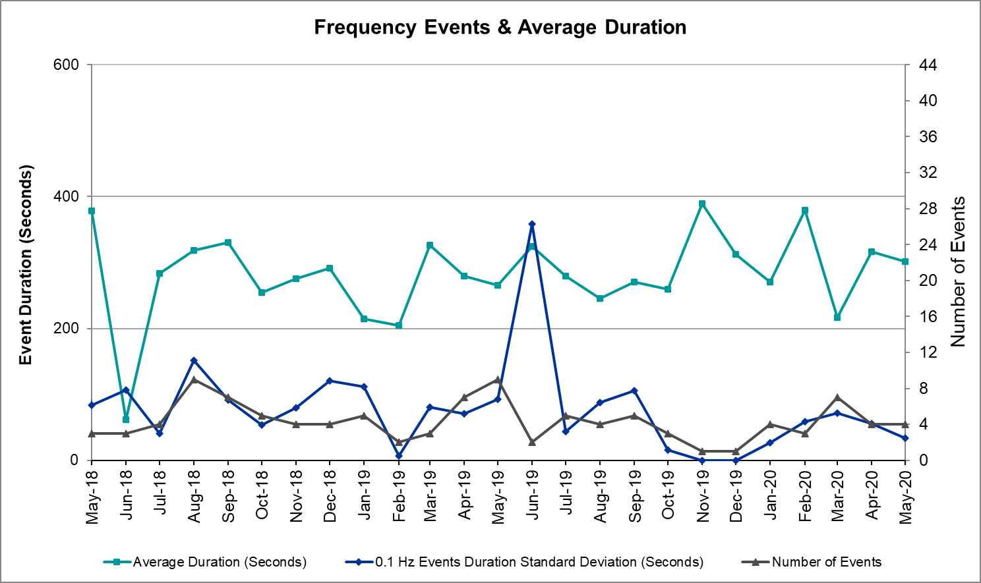

Note that the large standard deviation in June 2019 is due to coincidental extreme high and low durations for a small set of events (2).

Responsive Reserve Events
There were 5 events where Responsive Reserve MWs were released to SCED. The events highlighted in blue were related to frequency events reported in Section 2.1 above.

Date and Time Released to SCED | Date and Time Recalled | Duration of Event | Maximum MWs Released | Comments
5/9/2021 11:21 | 5/9/2021 11:24:03 | 00:02:26 | 859
5/19/2021 12:06 | 5/19/2021 12:10:28 | 00:03:32 | 514
5/24/2021 20:03 | 5/24/2021 20:08:21 | 00:05:08 | 913
5/25/2021 7:02 | 5/25/2021 7:06:57 | 00:04:40 | 1146
5/26/2021 23:14 | 5/26/2021 23:17:32 | 00:03:04 | 955

Load Resource Events
None

Reliability Unit Commitment
ERCOT reports on Reliability Unit Commitments (RUC) on a monthly basis. Commitments are reported grouped by operating day and weather zone. The total number of hours committed is the sum of the hours for all the units in the specified region. Additional information on RUC commitments can be found on the MIS secure site at Grid Generation Reliability Unit Commitment.

There were no DRUC commitments.

There were no HRUC commitment.

Wind Generation as a Percent of Load

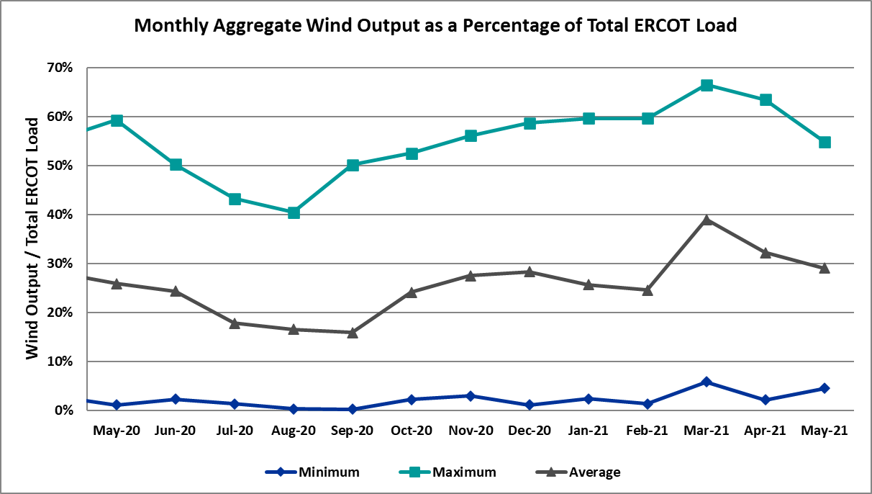

Wind Generation Record: 22,893 MW on 01/14/2021 at 07:27
Wind Penetration Record: 66.47% on 03/22/2021 at 00:46

Largest Net-Load Ramp
The net-load ramp is defined as the change in net-load (load minus wind and PVGR generation) during the defined time horizon. Such a variation in net-load needs to be accommodated in grid operations to ensure that the reliability of the grid is satisfactorily maintained. The largest net-load ramp during 5-min, 10-min, 15-min, 30-min and 60-min in May 2021 is 1414 MW, 1664 MW, 1967 MW, 2874 MW, and 4860 MW, respectively. The comparison with respect to the historical values is given in the table below.

Month and Year | 5 min | 10 min | 15 min | 30 min | 60 min
May 2021 | 1414 MW | 1664 MW | 1967 MW | 2874 MW | 4860 MW
May 2014 | 914 MW | 1468 MW | 2264 MW | 3123 MW | 4331 MW
May 2015 | 1156 MW | 1770 MW | 2088 MW | 3242 MW | 5318 MW
May 2016 | 871 MW | 1324 MW | 1804 MW | 2945 MW | 4897 MW
May 2017 | 1109 MW | 1422 MW | 1883 MW | 3149 MW | 5348 MW
May 2018 | 1173 MW | 1330 MW | 1845 MW | 3382 MW | 6508 MW
May 2019 | 1066 MW | 1767 MW | 2483 MW | 4227 MW | 5146 MW
May 2020 | 988 MW | 1529 MW | 1852 MW | 3104 MW | 5757 MW
2014-2020 | 1494 MW | 1991 MW | 2780 MW | 4227 MW | 7786 MW

COP Error Analysis
COP Error is calculated as the capacity difference between the COP HSL and real-time HSL of the unit. Mean Absolute Error (MAE) stayed over 8,915 MW until Day-Ahead at 12:00, then dropped significantly to 974 MW by Day-Ahead at 15:00. In the following chart, Under-Scheduling Error indicates that COP had less generation capacity than real-time and Over-Scheduling Error indicates that COP had more generation capacity than real-time.

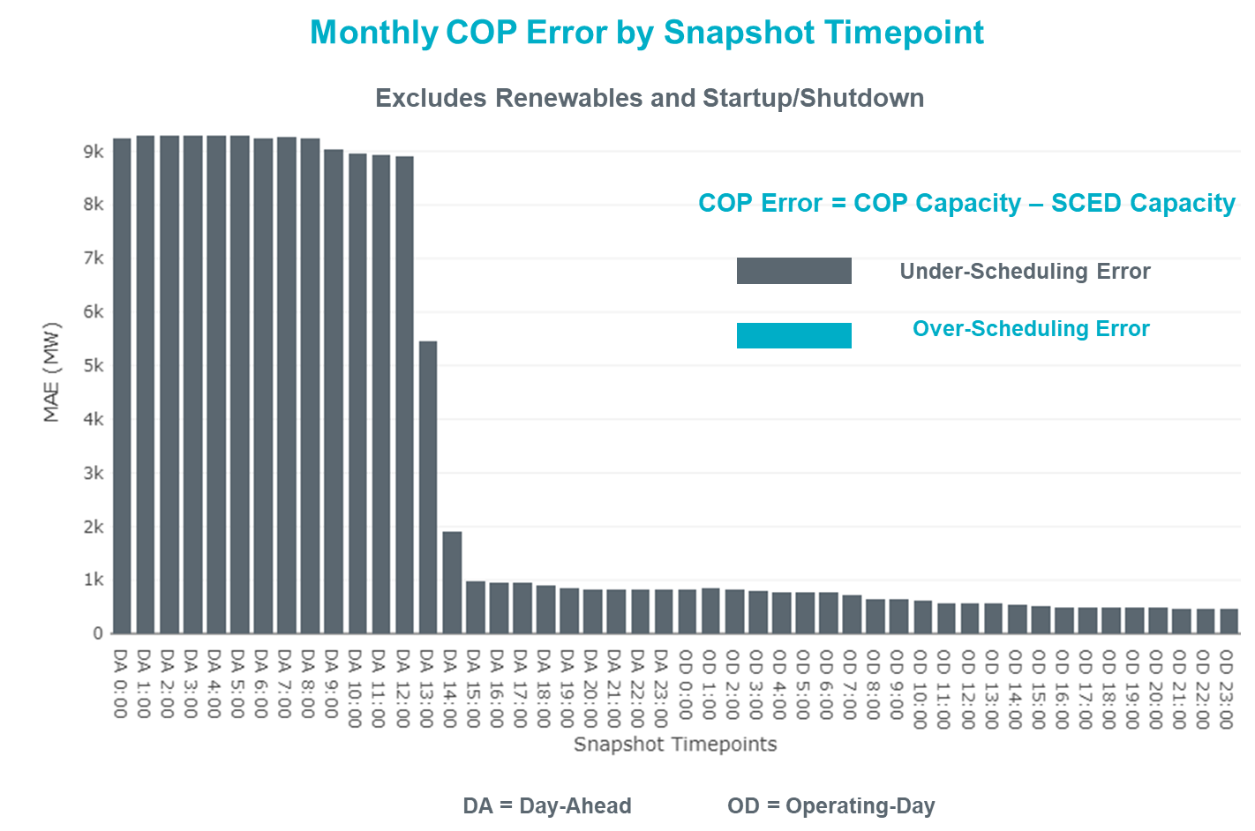

Monthly MAE for the Latest COP at the end of the Adjustment Period was 471 MW with median ranging from -694.5 MW for Hour-Ending (HE) 19 to 2.2 MW for HE 8. HE 14 on the 5th had the largest Over-Scheduling Error (1,136 MW) and HE 22 on the 4^{h} had the largest Under-Scheduling Error (-2,916 MW).

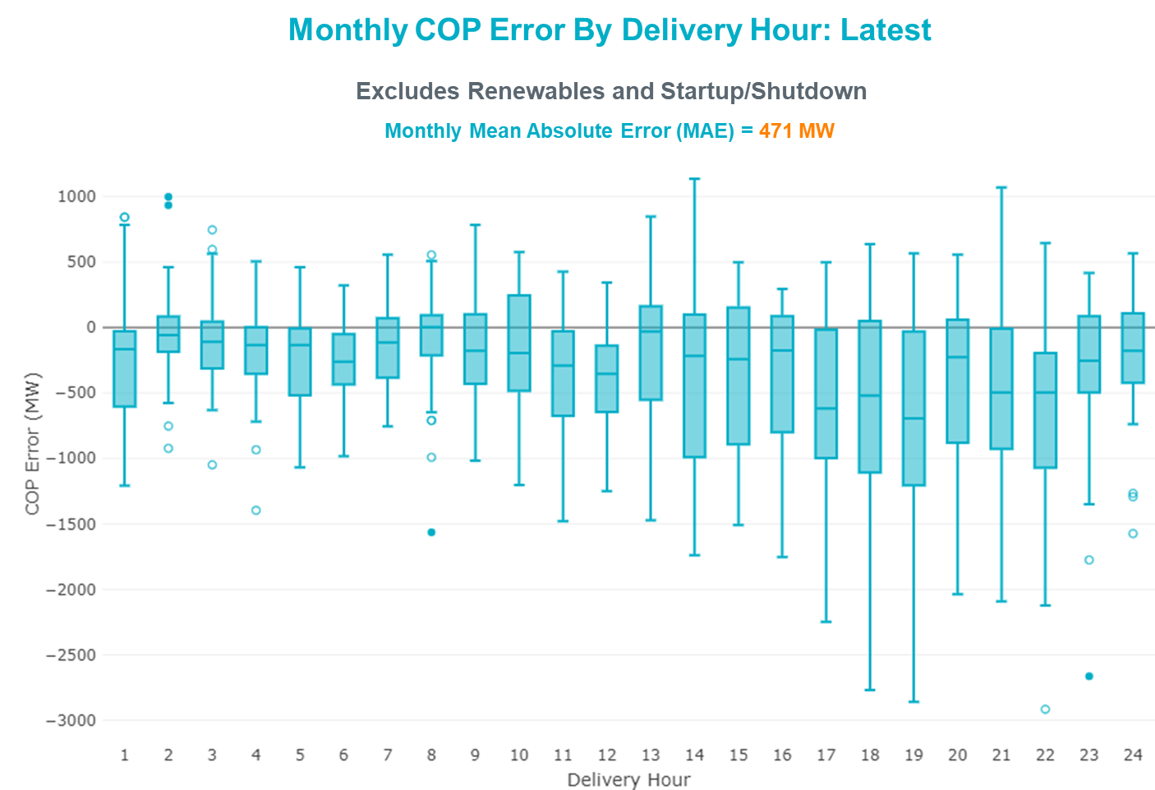

Monthly MAE for the Day-Ahead COP at 12:00 was 8,915 MW with median ranging from -11,953 MW for Hour-Ending (HE) 18 to -4,820 MW for HE 4. HE 18 on the 27th had the largest Under-Scheduling Error (-17,657 MW) and HE 1 on the 3rd had the largest Over-Scheduling Error (-495 MW).
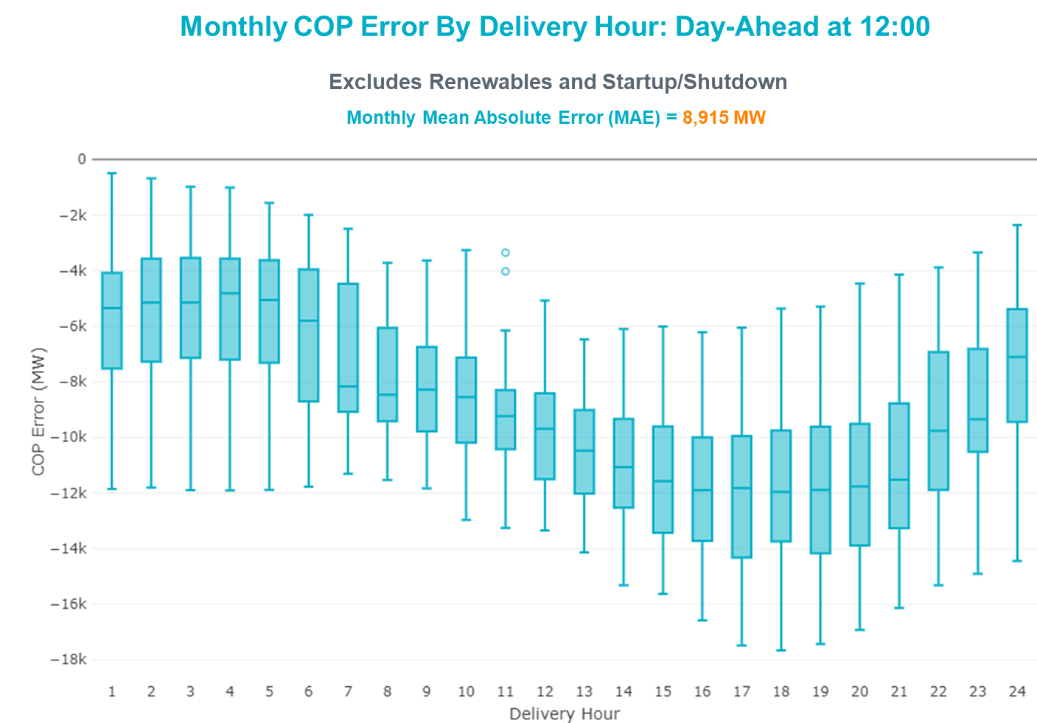

Congestion Analysis

Notable Constraints
Nodal protocol section 3.20 specifies that ERCOT shall identify transmission constraints that are binding in Real-Time three or more Operating Days within a calendar month. As part of this process, ERCOT reports congestion that meets this criterion to ROS. In addition, ERCOT also highlights notable constraints that have an estimated congestion rent exceeding $1,000 for a calendar month. These constraints are detailed in the table below, including approved transmission upgrades from TPIT that may provide some congestion relief based on ERCOT’s engineering judgement. Rows highlighted in blue indicate the congestion was affected by one or more outages. For a list of all constraints activated in SCED, please see Appendix A at the end of this report.

Contingency Name | Overloaded Element | # of Days Constraint Binding | Congestion Rent | Transmission Project
Basecase | WESTEX GTC | 10 | $11,321,730.92
HCKSW TO DENSW 138 DBLCKT | Deen Switch - Rosen Heights Tap 2 138kV | 8 | $10,346,386.47 | North Main - Denton Ave/Springdale Loop (6019)
Basecase | PNHNDL GTC | 17 | $8,724,664.74
Basecase | NE_LOB GTC | 24 | $6,991,003.57
Manual dbl ckt for NEDIN-BONILLA 345kV & RIOH-PRIM138kV | Haine Drive - La Palma 138kV | 18 | $5,227,639.62 | Luna 138 kV Station (44858)
EVRSW TO HLSES 138 DBLCKT | Mistletoe Heights - Hemphill 138kV | 4 | $4,091,256.23 | Everman Switch - Marrs Switch 138 kV DCKT Line (45543), Everman 345 kV Sw. Sta. (7118)
TWR(345) JCK-REF27 & JCK-STP18 | Oasis - Wa Parish 345kV | 5 | $2,883,077.66 | Freeport - Master Plan (6668B)
HCKSW TO DENSW 138 DBLCKT | Carswell - Calmont Switch 138kV | 1 | $2,740,552.73
ANNA SWITCH to COLLIN SWITCH 345 kV LIN _A | Allen Switch - Plano Custer Road 138kV | 1 | $2,420,058.37 | Carrollton Northwest 345/138 kV Autotransformer (57758)
Cagnon-Kendal 345 & Cico-Comfor 138 | Bergheim - Kendall 345kV | 8 | $2,375,801.66 | Kendall-Welfare Transmission Line Upgrade (61406), Bergheim-Fair Oaks Ranch Transmission Line Upgrade (61392)
RINCON TRX 69A1 138/69 | Whitepoint 138kV | 9 | $2,094,342.23 | Whitepoint: Add Second Auto (50954), Corpus North Shore Project , Corpus North Shore Project
ODLAW SWITCHYARD to ASPHALT MINES LIN 1 | Hamilton Road - Maverick 138kV | 17 | $2,011,202.77 | Brackettville to Escondido: Construct 138 kV line (5206)
Loss of (White Point & Nueces Bay 138kV) and (White Point & Portland & Gibbs 138kV) | Hecker - Whitepoint 138kV | 4 | $2,104,067.59 | Whitepoint Area Improvements (50950)
CRLNW TO LWSSW 345 DBLCKT | West Tnp - Highlands Tnp 138kV | 10 | $1,726,322.60
HCKSW TO DENSW 138 DBLCKT | Eagle Mountain Ses - Morris Dido 138kV | 1 | $1,548,883.50
LAREDO VFT NORTH to LOBO LIN 1 | Molina - Sierra Vista 138kV | 7 | $1,491,703.24
MIDLAND EAST TRX MDLNE_3_1 345/138 | Tall City - Sharyland Utilities - Telephone Road - Sharyland Utilities 138kV | 6 | $1,485,563.25 | Tall City - Telephone Road 138 kV Line Rebuild (57915)
Pig Creek to Solstice LIN 1 | Wickett Tnp - Pyote Tnp 138kV | 1 | $1,265,251.75
MIDLAND EAST to Buffalo - Sharyland Utilities LIN _A | Tall City - Sharyland Utilities - Telephone Road - Sharyland Utilities 138kV | 7 | $1,231,199.41 | Tall City - Telephone Road 138 kV Line Rebuild (57915)
Fowlerton to LOBO 345 LIN1 | North Laredo Switch - Piloncillo 138kV | 10 | $1,198,228.51
Fowlerton to LOBO 345 LIN1 | Laredo Vft North - Las Cruces 138kV | 6 | $1,079,775.68
Manual TWR(345) CHB-KG97 & JOR-NB99 | Cedar Bayou Plant 345kV | 3 | $980,950.15 | Jordan Area Load Addition (19RPG017, 52197)
Manual dbl ckt for NEDIN-BONILLA 345kV & RIOH-PRIM138kV | Burns Sub - Rio Hondo 138kV | 6 | $985,926.81 | Stewart Road: Construct 345 kV cut-in with two 450 MVA 345/138 autotransformers connected to Stewart Rd 138 station (5604, 6382)
COMANCHE SWITCH (Oncor) to COMANCHE PEAK SES LIN _A | Comanche Tap - Comanche Switch (Oncor) 138kV | 6 | $851,879.42
TWR (345) HLJ-WAP64 & BLY-WAP72 | Jones Creek - South Texas Project 345kV | 4 | $848,840.68 | Freeport - Master Plan (6668B)
RINCON to RINCON LIN 1 | Whitepoint 138kV | 5 | $824,628.01 | Whitepoint: Add Second Auto (50954), Corpus North Shore Project
Twinbu-Sarc&Amoscr 345kV | San Angelo Power Station - San Angelo South Tap 138kV | 5 | $617,287.89
Twinbu-Sarc&Amoscr 345kV | Schkad - San Angelo Power Station 138kV | 5 | $495,951.44
MANUAL SINGLE ENWSW-ENSSW 138 (943) | Ennis West Switch - Waxahachie 138kV | 3 | $485,788.26 | Ennis Switch 138 kV Rebuild (57855)
LONG DRAW-FARADAY& SCOSW 345kV | Luther Sub - Sharyland Utilities - Vealmoor - Sharyland Utilities 138kV | 6 | $427,530.37
BRACKETTVILLE to HAMILTON ROAD LIN 1 | Hamilton Road - Maverick 138kV | 4 | $364,188.85 | Brackettville to Escondido: Construct 138 kV line (5206)
FORT MASON to YELLOW JACKET LIN 1 | Mason Switching Station - Hext Lcra 69kV | 4 | $282,582.28 | Rebuild 69-kV lines: Mason to North Brady (50900), Mason - Mason Switch (59197), Mason Phillips Tap - Mason Phillips (59260)
W_CW_345-DMTSW 345kV | Farmland - Wett_Long_Draw 345kV | 4 | $303,293.79
LON HILL to NELSON SHARPE LIN 1 | Celanese Bishop - Nelson Sharpe 138kV | 6 | $299,102.14
TWR (345) HLJ-WAP64 & BLY-WAP72 | Jones Creek - Refuge 345kV | 3 | $241,172.57 | Freeport - Master Plan (6668B)
COLETO CREEK to VICTORIA LIN 1 | Coleto Creek - Victoria 138kV | 4 | $212,142.68
AJO to NELSON SHARPE LIN 1 | Falfurrias - Premont 69kV | 5 | $213,018.68
PORTLAND to Gibbs LIN 1 | Hecker - Whitepoint 138kV | 4 | $219,125.00 | Whitepoint Area Improvements (50950), Corpus North Shore Project
SALSW TO KLNSW 345 DBLCKT | Harker Heights South - Killeen Switch 138kV | 4 | $200,710.43
GARDENDALE SWITCH to TELEPHONE ROAD - Sharyland Utilities LIN _A | Andrews North - Exxon Means Tap 138kV | 9 | $102,659.40
KING RANCH GAS PLANT to FALFURRIAS LIN 1 | Falfurrias - Premont 69kV | 5 | $125,552.18
LCRANE TO KINGMO AND CASTIL 138 KV | Rio Pecos - Crane Lcra 138kV | 3 | $98,417.92
I_Dupsw-Rincon 138kV | Whitepoint 138kV | 3 | $120,939.12 | Whitepoint: Add Second Auto (50954), Corpus North Shore Project
Fergus-Granmo&Wirtz-Starck 138kV | Flat Rock Lcra - Wirtz 138kV | 3 | $23,327.03 | Wirtz to FlatRock to Paleface Transmission Line Upgrade (4465)
Fowlerton to LOBO 345 LIN1 | Falfurrias - Premont 69kV | 4 | $93,756.42
TWR(345) JCK-REF27 & JCK-STP18 | Bay City Sub - Sargent Sub 69kV | 3 | $49,742.79
FORT MASON to YELLOW JACKET LIN 1 | Mason Switching Station - Hext Lcra 69kV | 4 | $42,691.95 | Rebuild 69-kV lines: Mason to North Brady (50900), Mason - Mason Switch (59197), Mason Phillips Tap - Mason Phillips (59260)
Hecker_White_Pt 138kv | Whitepoint 138kV | 3 | $41,995.28 | Whitepoint: Add Second Auto (50954), Corpus North Shore Project
LOBO TRX AUTO 138/69 | Falfurrias - Premont 69kV | 3 | $23,133.92

Generic Transmission Constraint Congestion
There were 18 days of congestion on the West Texas Export GTC, 20 days on the Panhandle GTC, 26 days on the North Edinburg to Lobo GTC, 27 days on the Raymondville to Rio Hondo, 22 days on the Nelson Sharpe to Rio Hondo GTC, 9 days on the Valley Export GTC, 5 days on the North to Houston GTC, and 9 days on the Bearkat GTC. There was no activity on the remaining GTCs during the month.

Note: This is how many times a constraint has been activated to avoid exceeding a GTC limit, it does not imply an exceedance of the GTC occurred or that the GTC was binding.

Manual Overrides
None

Congestion Costs for Calendar Year 2021
The following table represents the top twenty active constraints for the calendar year based on the estimated congestion rent attributed to the congestion. ERCOT updates this list on a monthly basis.

Contingency | Overloaded Element | # of 5-min SCED | Estimated | Transmission Project
Basecase | PNHNDL GTC | 19,582 | 87,084,581.92
Elmcreek-Sanmigl 345kV | Pawnee Switching Station - Calaveras 345kV | 2,079 | 76,199,104.65
LOST PINES AEN to FAYETTE PLANT 1 LIN 1 | Winchester - Fayette Plant 1 And 2 345kV | 415 | 51,438,867.64
JOHNSON SWITCH (ONCOR) to CONCORD LIN G1 | Decordova Dam - Carmichael Bend Switch 138kV | 726 | 46,614,977.07 | DeCordova 345/138kV_Sw. (7129)
TWR(345) JCK-REF27 & JCK-STP18 | Oasis - Dow Chemical 345kV | 524 | 46,495,190.60 | Freeport - Master Plan (6668B)
Basecase | N_TO_H GTC | 2,759 | 39,236,592.39
TWR(345) JCK-REF27 & JCK-STP18 | South Texas Project - Wa Parish 345kV | 1,866 | 35,934,198.14 | Freeport - Master Plan (6668B)
Basecase | WESTEX GTC | 8,208 | 31,843,294.10
Hicross-Pilot & Garfield 138kV | Carson Creek - Pilot Knob 138kV | 803 | 30,600,531.85
Basecase | NE_LOB GTC | 15,360 | 30,284,988.05
Basecase | Colorado Bend Energy Center - Dyann 138kV | 242 | 26,093,025.30
Manual dbl ckt for NEDIN-BONILLA 345kV & RIOH-PRIM138kV | Haine Drive - La Palma 138kV | 6,540 | 24,407,316.75 | Luna 138 kV Station (44858)
TWR(345) JCK-REF27 & JCK-STP18 | Blessing - Pavlov 138kV | 4,383 | 21,362,696.58 | Freeport - Master Plan (6668B)
CONCORD TRX CRD1 345/138 | Concord 345kV | 840 | 21,139,669.60
Lostpi-Austro&Dunlap 345kV | Sim Gideon - Winchester 138kV | 635 | 20,472,271.99 | Sim Gideon - Tahitian Village Transmission Line Storm Hardening (61438), Bastrop West - Split Transmission Line Storm Hardening (61436)
Lytton_S-Slaughte&Turner 138kV | Mccarty Lane - Zorn 138kV | 245 | 20,185,815.81
Basecase | Pawnee Switching Station - Calaveras 345kV | 27 | 17,214,426.04
ASHERTON to Bevo Substation LIN 1 | Hamilton Road - Maverick 138kV | 525 | 17,023,560.36 | Brackettville to Escondido: Construct 138 kV line (5206)
NORTH EDINBURG TRX 1382 345/138 | North Edinburg 345kV | 294 | 16,777,302.97 | Stewart Road: Construct 345 kV cut-in with two 450 MVA 345/138 autotransformers connected to Stewart Rd 138 station (5604, 6382)
KILLEEN SWITCH TRX KLNSW_3_2 345/138 | Killeen Switch 345kV | 234 | 16,301,132.28

System Events

ERCOT Peak Load
The unofficial ERCOT peak load for the month was 62,821 MW and occurred on the 26th, during hour ending 17:00.

Load Shed Events
None.

Stability Events
None.

Notable PMU Events
ERCOT analyzes PMU data for any significant system disturbances that do not fall into the Frequency Events category reported in section 2.1. The results are summarized in this section once the analysis has been completed.

There were no PMU events outside of those reported in section 2.1.

DC Tie Curtailment
Date | DC Tie | Curtailing Period | # of Tags Curtailed | Initiating Event | Curtailment Reason
5/18/2021 | DC-L | HE 16 – HE 18 | 1 | Unplanned Outage | Planned or Unplanned Outage
5/18/2021 | DC-L | HE 22 – HE 24 | 3 | Unplanned Outage | Planned or Unplanned Outage
5/19/2021 | DC-L | HE 15 – HE 16 | 1 | Unplanned Outage | Planned or Unplanned Outage
5/19/2021 | DC-L | HE 24 | 1 | Unplanned Outage | Planned or Unplanned Outage

TRE/DOE Reportable Events
- CenterPoint submitted an OE-417 for 05/18/2021. Reportable Event Type: Loss of electric service to more than 50,000 customers for 1 hour or more.

New/Updated Constraint Management Plans
None.

New/Modified/Removed RAS
None.

New Procedures/Forms/Operating Bulletins

Date | Subject | Bulletin No.
05/06/2021 | DC Tie Desk V1 Rev 66 | 976
05/06/2021 | Real Time Desk V1 Rev 72 | 977
05/06/2021 | Reliability Risk Desk Operating Procedure V1 Rev 22 | 978
05/06/2021 | Resource Desk Operating Procedure V1 Rev 61 | 979
05/06/2021 | Shift Supervisor Desk V1 Rev 71 | 980
05/06/2021 | Transmission and Security Desk V1 Rev 84 | 981
05/28/2021 | Transmission and Security Desk V1 Rev 85 | 982

Emergency Conditions

OCNs
None.

Advisories
None

Watches
None.

Emergency Notices
None.

Application Performance

TSAT/VSAT Performance Issues
None.

Communication Issues
None.

Market System Issues
None.

Model Updates
The Downstream Production Change (DPC) process allows ERCOT to make changes in the on-line Network Operations Model without loading a completely new model. The purpose of this process is to allow for reliable grid operations as system conditions change between designated Network Operations Model database loads. The DPC process is limited in scope to just those items listed below, with equipment ratings updates being the most common. ERCOT has seen a rise in the use of the DPC process to make on-line updates to the Network Operations Model in recent years, instead of through the standard Network Operations Model Change Request process.

- Static Line ratings (Interim Update)
- Dynamic Line ratings (non-Interim Update)
- Autotransformer ratings (non-Interim Update)
- Breaker and Switch Normal status (Interim Update)
- Contingency Definitions (Interim Update)
- RAP and RAS changes or additions (Interim Update)
- Net Dependable and Reactive Capability (NDCRC) values (Interim Update)
- Impedance Updates (non-Interim)

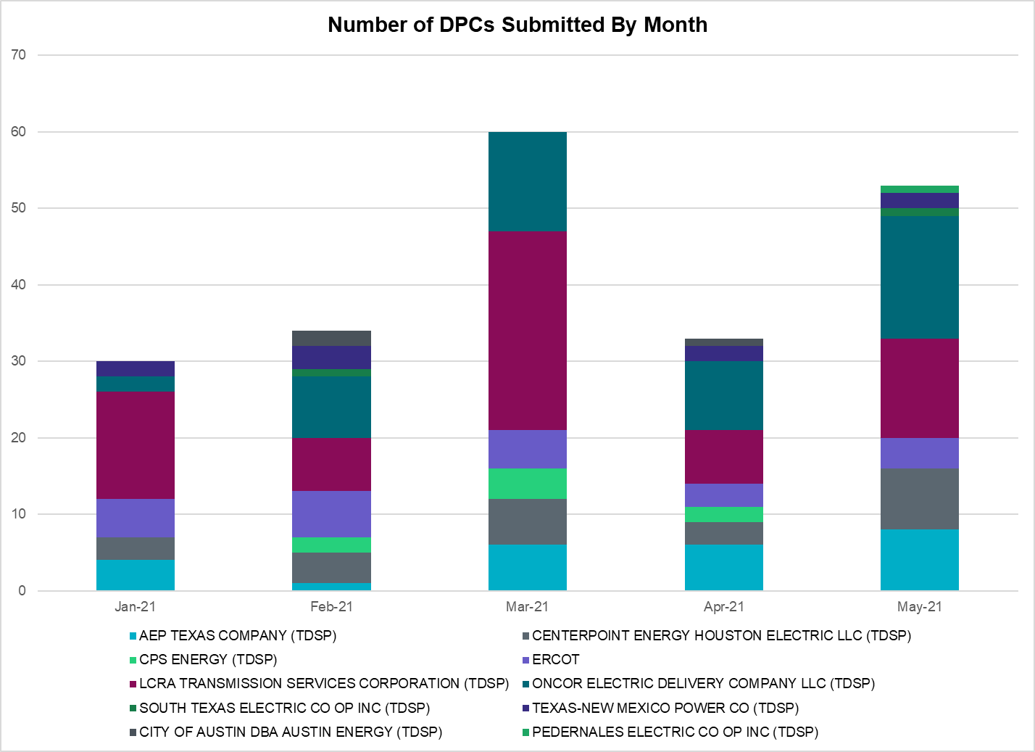

Transmission Operator | Number of DPCs
AEP TEXAS COMPANY (TDSP) | 8
BRAZOS ELECTRIC POWER CO OP INC (TDSP) | 0
BROWNSVILLE PUBLIC UTILITIES BOARD (TDSP) | 0
BRYAN TEXAS UTILITIES (TDSP) | 0
CENTERPOINT ENERGY HOUSTON ELECTRIC LLC (TDSP) | 8
CITY OF AUSTIN DBA AUSTIN ENERGY (TDSP) | 0
CITY OF COLLEGE STATION (TDSP) | 0
CITY OF GARLAND (TDSP) | 0
CPS ENERGY (TDSP) | 0
DENTON MUNICIPAL ELECTRIC (TDSP) | 1
ELECTRIC TRANSMISSION TEXAS LLC (TDSP) | 2
ERCOT | 4
LCRA TRANSMISSION SERVICES CORPORATION (TDSP) | 13
LONE STAR TRANSMISSION LLC (TSP) | 0
ONCOR ELECTRIC DELIVERY COMPANY LLC (TDSP) | 16
PEDERNALES ELECTRIC CO OP INC (TDSP) | 1
RAYBURN COUNTRY CO OP DBA RAYBURN ELECTRIC (TDSP) | 1
SHARYLAND UTILITIES LP (TDSP) | 0
SOUTH TEXAS ELECTRIC CO OP INC (TDSP) | 1
TEXAS MUNICIPAL POWER AGENCY (TDSP) | 0
TEXAS-NEW MEXICO POWER CO (TDSP) | 2

Appendix A: Real-Time Constraints
The following is a complete list of constraints activated in SCED. Full contingency descriptions can be found in the Standard Contingencies List located on the MIS secure site at Grid Generation Reliability Unit Commitment.

Contingency Name | Overloaded Element | From Station | To Station | Count of Days
BASE CASE | RV_RH | n/a | n/a | 27
BASE CASE | NE_LOB | n/a | n/a | 26
BASE CASE | NELRIO | n/a | n/a | 22
SBRAUVA8 | HAMILT_MAVERI1_1 | HAMILTON | MAVERICK | 22
MHARNED5 | HAINE__LA_PAL1_1 | LA_PALMA | HAINE_DR | 21
BASE CASE | PNHNDL | n/a | n/a | 19
BASE CASE | WESTEX | n/a | n/a | 18
BASE CASE | LGD_SANTIA1_1 | LGD | SANTIAGO | 14
DHCKDEN8 | 6265__E | RHTP2 | DENSW | 13
SVICCO28 | COLETO_VICTOR2_1 | COLETO | VICTORIA | 13
SLOBSA25 | NLARSW_PILONC1_1 | NLARSW | PILONCIL | 13
SGDNTEL5 | 6094__D | ANDNR | EXMTP | 13
DCRLLSW5 | 588_B_1 | LWSVH | LWSVW | 13
XMDL58 | TALLCITY_TELPR_1 | TELPH_RD | TALLCITY | 12
SBRAHAM8 | HAMILT_MAVERI1_1 | HAMILTON | MAVERICK | 11
DCAGCO58 | 656T656_1 | KENDAL | BERGHE | 10
XRIN89 | WHITE_PT_69A1 | WHITE_PT | WHITE_PT | 10
DFERSTA8 | 38T365_1 | WIRTZ | FLATRO | 10
SFORYEL8 | HEXT_MASONS1_1 | MASONSW | HEXT | 10
SFORYEL8 | HEXT_MASONS1_1 | HEXT | MASONSW | 10
SN_SLON5 | CELANE_N_SHAR1_1 | N_SHARPE | CELANEBI | 9
BASE CASE | BEARKT | n/a | n/a | 9
SN_SAJO5 | FALFUR_PREMON1_1 | FALFUR | PREMONT | 9
SKINFAL8 | FALFUR_PREMON1_1 | FALFUR | PREMONT | 9
DELMWWE8 | 1020__A | ELMOT | MCTYE | 9
SLOBSA25 | LARDVN_LASCRU1_1 | LARDVNTH | LASCRUCE | 9
SLARLOB8 | MOLINA_SIEVIS1_1 | MOLINA | SIEVISTA | 9
BASE CASE | VALEXP | n/a | n/a | 9
SFORYEL8 | HEXT_YELWJC1_1 | HEXT | YELWJCKT | 9
SFORYEL8 | HEXT_YELWJC1_1 | YELWJCKT | HEXT | 9
SLAQLOB8 | BRUNI_69_1 | BRUNI | BRUNI | 9
MHARNED5 | BURNS_RIOHONDO_1 | RIOHONDO | MV_BURNS | 8
SSTAMDL8 | TALLCITY_TELPR_1 | TELPH_RD | TALLCITY | 8
SCMNCPS5 | 651__B | CMNSW | CMNTP | 8
DBWNAMO5 | SAPOWE_SAST1_1 | SAPOWER | SAST | 7
SRINRIN8 | WHITE_PT_69A1 | WHITE_PT | WHITE_PT | 7
DSCOFAR5 | 6216__B | WLVSW | SHRNE | 6
DWLDSCO5 | LUTHER_VEALMOR_1 | VEALMOOR | LUTHER | 6
DBWNAMO5 | 134T429_1 | SCHKAD | SAPOWER | 6
DSTPRED5 | OASWAP99_A | WAP | OAS | 6
DREFSTP5 | OASWAP99_A | WAP | OAS | 6
SODLBRA8 | HAMILT_MAVERI1_1 | HAMILTON | MAVERICK | 6
DSALKLN5 | 630__B | KLNSW | HHSTH | 6
SSTABS18 | 6144__A | BSPRW | STASW | 5
SLOBSA25 | FALFUR_PREMON1_1 | FALFUR | PREMONT | 5
BASE CASE | RANDAD_ZAPATA1_1 | ZAPATA | RANDADO | 5
SBRAUVA8 | ESCOND_GANSO1_1 | GANSO | ESCONDID | 5
DCOTDMT5 | FARMLAND_LONGD_1 | FARMLAND | W_LD_345 | 5
MENWENS8 | 940__C | ENWSW | WXHCH | 5
SLAQLOB8 | FALFUR_PREMON1_1 | FALFUR | PREMONT | 5
DLCRKIN8 | LCRANE_RIOPEC1_1 | RIOPECOS | LCRANE | 5
SSTABS18 | 6144__A | STASW | BSPRW | 5
DWHIGIB8 | HECKER_WHITE_1_1 | WHITE_PT | HECKER | 5
SPORGIB8 | HECKER_WHITE_1_1 | WHITE_PT | HECKER | 5
BASE CASE | RANDAD_ZAPATA1_1 | RANDADO | ZAPATA | 5
DMARPA_8 | 38T365_1 | WIRTZ | FLATRO | 5
DSTPRED5 | BAY_SARG_1 | BAYCTYS | SARGNTS | 5
BASE CASE | N_TO_H | n/a | n/a | 5
MENWENS8 | 940__C | WXHCH | ENWSW | 5
DCAGCI58 | 656T656_1 | KENDAL | BERGHE | 5
DWAPHLJ5 | JCKSTP18_A | STP | JCK | 4
DGRSPKR5 | 6377__A | BRTSW | ORANS | 4
SMV_PAR8 | RIOHND_ERIOHND_1 | MV_RIOHO | RIOHONDO | 4
SLOBSA25 | BRUNI_69_1 | BRUNI | BRUNI | 4
DEVRHLS8 | 6125__C | MSTLT | HMPHL | 4
SFTLMES8 | CROSSO_NORTMC1_1 | NORTMC | CROSSOVE | 4
SRINWHI8 | HECKER_WHITE_1_1 | WHITE_PT | HECKER | 4
SHECWH28 | RINCON_WHITE_2_1 | WHITE_PT | RINCON | 3
DBIGKEN5 | TREADW_YELWJC1_1 | TREADWEL | YELWJCKT | 3
DTWIDIV5 | 430T430_1 | GASCCR | MGSES | 3
SLOBSA25 | ASHERT_CATARI1_1 | ASHERTON | CATARINA | 3
MCHB_NB5 | BCVLY_03_A | BCV | LY | 3
DWAPHLJ5 | REFSTP27_A | STP | REF | 3
DKENCA58 | 656T656_1 | KENDAL | BERGHE | 3
SMDLMOS5 | TALLCITY_TELPR_1 | TELPH_RD | TALLCITY | 3
DI_DRIN8 | WHITE_PT_69A1 | WHITE_PT | WHITE_PT | 3
SLOBSA25 | ASHERT_CATARI1_1 | CATARINA | ASHERTON | 3
SGODLON5 | VICTO_WARBU_1A_1 | VICTORIA | WARBURTN | 3
MCHB_NB5 | CBY_AT1 | CBY | CBY | 3
SN_SLON5 | CELANE_KLEBER1_1 | CELANEBI | KLEBERG | 3
SILLFTL8 | HAMILT_MAXWEL1_1 | MAXWELL | HAMILTON | 3
DWAPHLJ5 | JCKREF27_A | REF | JCK | 3
XLOB89 | FALFUR_PREMON1_1 | FALFUR | PREMONT | 3
DHECWHI8 | WHITE_PT_69A1 | WHITE_PT | WHITE_PT | 3
DTOKJK_5 | 240__A | JEWET | SNG | 2
DKENCOM8 | 72T120_1 | KENDAL | HOLLMI | 2
BASE CASE | HHGTOM_1 | HHGT | OMEGA | 2
SCISPUT8 | SOUTHA_VINSON1_1 | SOUTHABI | VINSON | 2
SPADPAD9 | SPUR_69_1 | SPUR | SPUR | 2
SGODPAW5 | VICTO_WARBU_1A_1 | VICTORIA | WARBURTN | 2
DGIBSNG5 | 240__A | JEWET | SNG | 2
DSTPRED5 | BLESSI_PAVLOV1_1 | BLESSING | PAVLOV | 2
SBONNED5 | BURNS_RIOHONDO_1 | RIOHONDO | MV_BURNS | 2
SBRAHAM8 | GANSO_MAVERI1_1 | MAVERICK | GANSO | 2
DDUPLGE8 | HECKER_WHITE_1_1 | WHITE_PT | HECKER | 2
SABRSPR8 | 584__A | KRMSW | ARGYL | 2
XCLE58 | CLEASP_AT2H | CLEASP | CLEASP | 2
SMV_RI28 | CP_MVCNT_1 | MV_CNTRA | COFFPORT | 2
SBIGSCH5 | CROSSO_NORTMC1_1 | NORTMC | CROSSOVE | 2
SBRAUVA8 | GANSO_MAVERI1_1 | MAVERICK | GANSO | 2
SN_SAJO5 | HAINE__LA_PAL1_1 | LA_PALMA | HAINE_DR | 2
XVIC89 | MAGRUD_VICTOR2_1 | VICTORIA | MAGRUDER | 2
DBIGKEN5 | SAPOWE_TREADW1_1 | SAPOWER | TREADWEL | 2
SLOBSA25 | CATARI_PILONC1_1 | PILONCIL | CATARINA | 2
SCRNLC38 | TALLCITY_TELPR_1 | TELPH_RD | TALLCITY | 2
SGODPAW5 | WHITE_PT_69A1 | WHITE_PT | WHITE_PT | 2
DMGSQAL5 | 14040__A | PCTSW | DEWTP | 2
SFLCMDL5 | 6462__C | MCNSW | MKNGB | 2
SAVMBSP8 | 6610__A | BUZSW | CHATP | 2
SGODPAW5 | CALLIC_LON_HI1_1 | LON_HILL | CALLICOA | 2
SILLFTL8 | CTHR_TINSLE1_1 | TINSLEY | CTHR | 2
SCOMHA38 | HAMILT_MAXWEL1_1 | MAXWELL | HAMILTON | 2
XLOB89 | MOLINA_SIEVIS1_1 | MOLINA | SIEVISTA | 2
SBRAUVA8 | MAXWEL_WHITIN1_1 | MAXWELL | WHITING | 2
SBTPBNT8 | MYRA_VAL_1 | MYRA | VALYVIEW | 2
XLOB89 | SIEVIS_WORMSE1_1 | SIEVISTA | WORMSER | 2
SFLCMDL5 | TALLCITY_TELPR_1 | TELPH_RD | TALLCITY | 2
SSANFOW5 | UVALDE_W_BATE1_1 | UVALDE | W_BATESV | 2
DBWN_AM5 | CONCHO_VRBS1_1 | CONCHO | VRBS | 2
SRINWHI8 | WHITE_PT_69A1 | WHITE_PT | WHITE_PT | 2
SBRAHAM8 | ESCOND_GANSO1_1 | GANSO | ESCONDID | 2
DJACALV8 | MYRA_VAL_1 | MYRA | VALYVIEW | 2
DWAPHLJ5 | STPWAP39_1 | STP | WAP | 2
SEAGHAM8 | UVALDE_W_BATE1_1 | UVALDE | W_BATESV | 2
SGODPAW5 | NCARBI_SEADRF1_1 | NCARBIDE | SEADRFTC | 1
SRAZUVA8 | UVALDE_W_BATE1_1 | UVALDE | W_BATESV | 1
SWHILON5 | WHITE_PT_345A | WHITE_PT | WHITE_PT | 1
SENTTR25 | 1350__E | NCSTP | LFKSW | 1
SCRNLC38 | 15010__B | BLISS | ESTILES | 1
DJEWSNG5 | 256_A_1 | TOKSW | GIBCRK | 1
DGRSLNC5 | 6380__D | PAINTCRE | MURRAY | 1
DDL_HOC8 | AF_HY_09_A | AF | HY | 1
SCOLBAL8 | BALLIN_HUMBLT1_1 | BALLINGE | HUMBLTAP | 1
SCDHOP8 | CBYCVN86_A | CBY | CVN | 1
SFORJOS8 | FORMOS_LOLITA1_1 | LOLITA | FORMOSA | 1
DLCRCAS8 | LCRANE_RIOPEC1_1 | RIOPECOS | LCRANE | 1
DWISALV8 | MYRA_VAL_1 | MYRA | VALYVIEW | 1
SREAUVA8 | UVALDE_W_BATE1_1 | UVALDE | W_BATESV | 1
DCDHVEN5 | 310__A | LIGSW | NORSW | 1
DVENLIG5 | 530__C | VENSW | BRTRD | 1
DCMBJON5 | 6020__D | EVRSW | CRTLD | 1
S127STA8 | 6144__A | STASW | BSPRW | 1
DHCKDEN8 | 6260__E | RSNHT | RHTP1 | 1
DMGSMDS5 | 6512__B | ODEHV | TROTP | 1
SSCJFS8 | BCVLY_03_A | BCV | LY | 1
SLGEI_D8 | I_DUPS_LGE1_1 | LGE | I_DUPSW | 1
DELMSAN5 | POT_OAKS_1 | POTEETS | OAKS9 | 1
DHCKDEN8 | 6265__B | RHTP2 | RSNHT | 1
DCD_CBY8 | HL_PSA08_A | PSA | HL | 1
DELMSAN5 | MAXWEL_WHITIN1_1 | MAXWELL | WHITING | 1
SCITNUE8 | MORRIS_NUECES1_1 | NUECES_B | MORRIS | 1
DFLCMGS5 | TALLCITY_TELPR_1 | TELPH_RD | TALLCITY | 1
DSALHUT5 | 270__A | KNBSW | TMPSW | 1
DRILKRW5 | 6085__E | WFSSW | NSTAR | 1
DHCKDEN8 | 6195__C | CMTSW | CRSWL | 1
DSCOFAR5 | 6216__A | SHRNE | BCKSW | 1
DHCKDEN8 | 6265__A | EMSES | MRSDO | 1
DDMTBCK8 | 6474__A | MGSES | SUNSW | 1
MNB_JOR5 | CBY_AT1 | CBY | CBY | 1
DBWNAMO5 | CEDRHI_SILT1_1 | CEDRHILL | SILT | 1
SVICCOL8 | COLETO_VICTOR1_1 | COLETO | VICTORIA | 1
SCOLBAL8 | DRSY_SANA_T1_1 | SANA_TAP | DRSY | 1
SLOLFOR8 | FORMOS_JOSLIN1_1 | JOSLIN | FORMOSA | 1
SWRDYN8 | LAN_CT_PAVLOV1_1 | LAN_CTY | PAVLOV | 1
DELMSAN5 | MHONDOCR_1 | MOORE | HONDOCK | 1
SGRILON5 | VICTO_WARBU_1A_1 | VICTORIA | WARBURTN | 1
SHECWH28 | WHITE_PT_69A1 | WHITE_PT | WHITE_PT | 1
XARA89 | WHITE_PT_69A1 | WHITE_PT | WHITE_PT | 1
DELMWWE8 | 1020__E | MCTYE | THSTP | 1
DHCKDEN8 | 6260__C | EMSES | RHTP1 | 1
SBLMHCK8 | 6265__B | RHTP2 | RSNHT | 1
DSALKLN5 | 641__A | KLNSW | KLELM | 1
DCAGTA58 | 656T656_1 | KENDAL | BERGHE | 1
SILLFTL8 | CARVER_TINSLE1_1 | CARVER | TINSLEY | 1
SODLBRA8 | ESCOND_GANSO1_1 | GANSO | ESCONDID | 1
SLOBSA25 | FREER_LOBO1_1 | LOBO | FREER | 1
SPOMNED5 | FREER_LOBO1_1 | LOBO | FREER | 1
DSALKLN5 | KLNSW_MR1H | KLNSW | KLNSW | 1
SCISPUT8 | LENSW_PUTN2_1 | PUTN | LENSW | 1
BASE CASE | SWEETWN3_XF31 | SWEETWN3 | SWEETWN3 | 1
DLWSRNK5 | W_DENT_T2L | W_DENT | W_DENT | 1
SPIGSOL8 | 138_WIC_PYT_1 | WICKETT | PYOTE | 1
DREFSTP5 | BAY_SARG_1 | BAYCTYS | SARGNTS | 1
DCOTDMT5 | CHLC_V_VERN1_1 | VERN | CHLC_VER | 1
SCISPUT8 | ESTES_PECAN_1_1 | PECAN_BY | ESTES | 1
DCENREV5 | GODDAR_PAWNEE1_1 | GODDARD | PAWNEE | 1
DWHILON5 | NCARBI_SEADRF1_1 | NCARBIDE | SEADRFTC | 1
SGODLON5 | NCARBI_SEADRF1_1 | NCARBIDE | SEADRFTC | 1
BASE CASE | PNHDL2 | n/a | n/a | 1
MWIRJO28 | 38T365_1 | WIRTZ | FLATRO | 1
DCAGCI58 | 460T460_1 | MEDILA | W1 | 1
SRICGRS8 | 6840__B | NVKSW | ANARN | 1
SSOLFTS8 | ALPINE_BRONCO1_1 | BRONCO | ALPINE | 1
SREFB8 | BM_HY_09_A | BM | HY | 1
DDILCOT8 | DIL_COTU_1 | COTULAS | DILLEYSW | 1
SMCEESK8 | ESKSW_TRNT1_1 | ESKSW | TRNT | 1
DCENRI35 | GODDAR_PAWNEE1_1 | GODDARD | PAWNEE | 1
SCENLOB5 | GODDAR_PAWNEE1_1 | GODDARD | PAWNEE | 1
MHARRIO5 | HAINE__OLEAND1_1 | HAINE_DR | OLEANDER | 1
DELMSAN5 | UVALDE_W_BATE1_1 | UVALDE | W_BATESV | 1
XLOB258 | UVALDE_W_BATE1_1 | UVALDE | W_BATESV | 1
SHCKRNK5 | 106__A | HCKSW | ALLNC | 1
SBAKCED5 | 15010__B | BLISS | ESTILES | 1
SMILHEN8 | 51T376_1 | FERGUS | GRANMO | 1
DEVRCRT5 | 6415__C | HLSES | LKWOD | 1
SANACN25 | 850__C | ALNSW | PCUST | 1
SSANFOW5 | ASHERT_CATARI1_1 | ASHERTON | CATARINA | 1
DWAP_BM8 | BM_HY_09_A | BM | HY | 1
SCOMHA38 | CARVER_TINSLE1_1 | CARVER | TINSLEY | 1
MCBYNB5 | CBY_AT1 | CBY | CBY | 1
SSANFOW5 | COTULA_COTULL1_1 | COTULLA | COTULAS | 1
DDELGA58 | FREER_LOBO1_1 | LOBO | FREER | 1
DDAVGB25 | GBYLYD70_A | LYD | GBY | 1
MHARRIO5 | HAINE__LA_PAL1_1 | LA_PALMA | HAINE_DR | 1
SLOBSA25 | HOLCOM_NLARSW1_1 | NLARSW | HOLCOMB | 1
MWAPBLY5 | JCKSTP18_A | STP | JCK | 1

This is the hourly integrated peak demand as published in the ERCOT D&E report.
All DC Tie Curtailments are posted publically on the ERCOT Market Information System. See that posting for additional details for the event(s) in question.
See DC Tie Operating Procedure (http://www.ercot.com/mktrules/guides/procedures) for more details.

