PWG Meeting Notes – Mar 29, 2021
Via WebEx 9:30 AM
Attendees:
Sam Pak – Oncor | Bill Boswell - ERCOT | Jim Lee – AEP
John Schatz – TXU | Calvin Opheim - ERCOT | Jordan Troublefield - ERCOT
Kathy Scott – CNP | Diana Rehfeldt - TNMP | Bill Barnes - NRG
Lauren Damen - NRG

- Meeting notes for March 10th will be posted by next meeting

- Reviewed Annual Validation Analysis
  - In late 2020 at a PWG meeting, it was suggested if ERCOT would provide an analysis of potential impacts of the COVID effect on Residential usage prior to the March 30, 2021 Annual Validation. The theory was the work from home transition may have caused residential 2020 electricity usage to skew the AV results affecting the HI/LO Winter Ratio shift.
  - Since RES AV is based on the months January and February as described in the LPG (shown in green table), the RES evaluation period 2018-2020 would probably have minimal impacts of COVID as the greatest impact of the work from home transition happened post March 2020. Therefore, the comparison analysis ERCOT provided for the LO/HI WR below is most likely impacted by seasonal changes rather than COVID impacts.
January of the current year |  | February of the current year
January of the previous year |  | February of the previous year
January from two years ago |  | February from two years ago

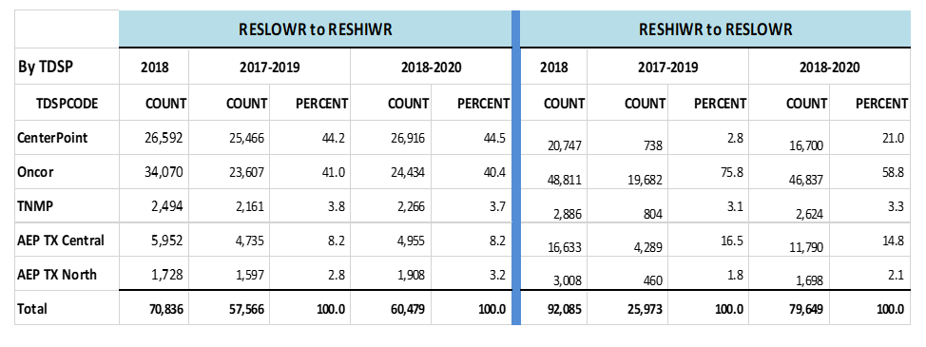

- Next Steps for LPGRR068, Add BUSLRG and BUSLRGDG Profile Types
  - Potential Smart Meter Texas (SMT) impacts
    - Decision on impacts still pending from JDOA
    - Early indication suggest more to the degree of minor changes within the scope of JDOA/SMT rather than the need to walk the path through the PUC for approval and changes to systems.
  - Timing for Implementation of LPGRR068
    - Reviewed the additional ERCOT comments and language as submitted by ERCOT on March 24, 2021:

“ERCOT submits these comments to recommend that Load Profiling Guide Revision Request (LPGRR) 068’s implementation occur no earlier than February 1, 2022”

    - LPGRR068 language review to be expected at April RMS meeting
      - Although the Impact Analysis will be reviewed at the May RMS, as a preview, PWG reviewed the report: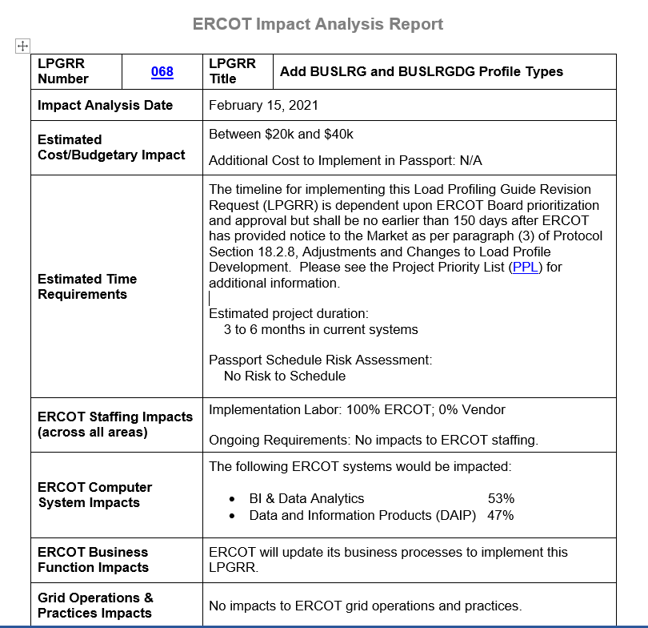

  - Transition Plan
    - TDSPs reviewed the additional questions 14 & 15 and respective TDSP responses to the AMS/IDR table (Matrix). See below:
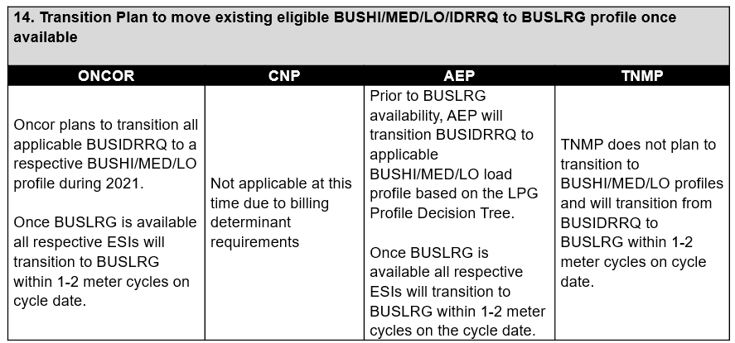
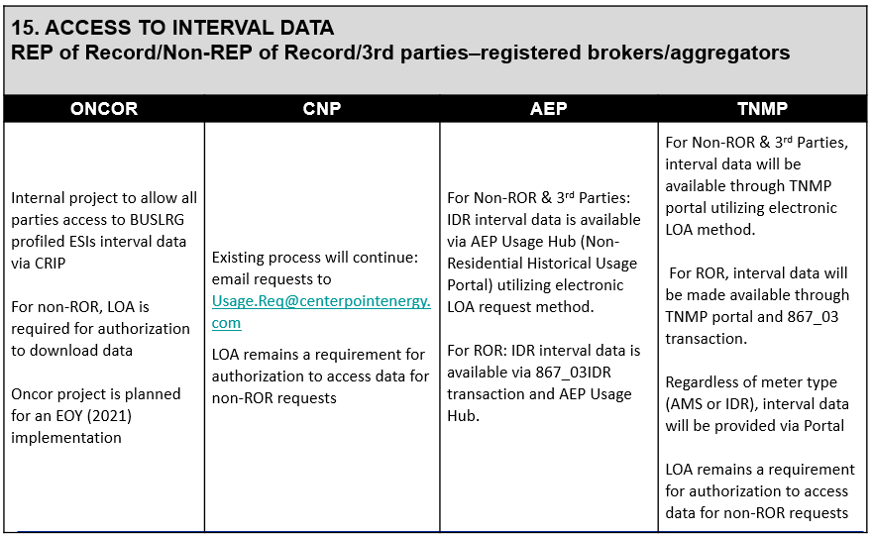

- Next Meeting: Agreed to cancel April 8th meeting. Next PWG meeting May 12th.

