|  |  |  |  |
| --- | --- | --- | --- |
| NPRR Number | [1081](http://www.ercot.com/mktrules/issues/NPRR1081) | NPRR Title | Revisions to Real-Time Reliability Deployment Price Adder to Consider Firm Load Shed |
|  | |  | |
| Date | | June 9, 2021 | |
|  | |  | |
| Submitter’s Information | | | |
| Name | | Steven M. Malkiewicz | |
| E-mail Address | | [steve.malkiewicz@ystas.com](mailto:steve.malkiewicz@ystas.com) | |
| Company | | Young Energy, LLC d/b/a Payless Power | |
| Phone Number | | 813.657.9340 | |
| Cell Number | | 813.220.5765 | |
| Market Segment | | Independent Retail Electric Provider (IREP) | |

|  |
| --- |
| Comments |

Payless Power objects to the addition of “ERCOT-directed firm Load shed during EEA Level 3” as an additional category to be considered in the determination of the Real-Time On-Line Reliability Deployment Price Adder. This issue should not be decided at ERCOT but instead should be fully vetted by the Public Utility Commission (PUC) first in a workshop setting first involving all stakeholders, including Consumer representatives, and then in a formal proceeding conducted under the Administrative Procedures Act (APA) where interested parties can comment or provide testimony.

This NPRR is tantamount to policy-making that should be vested with the PUC. The issue is too important to be buried in the rather obscure ERCOT Nodal Protocol revision process. Also, any change of this magnitude needs to be more deliberate and not treated as “urgent” to allow for a proper vetting. Instead, the matter should receive the full light of APA rulemaking and contested case processes with final decision to be made by the Commissioners.

It should be noted that Load shed was evaluated and dismissed as a reason to implement the discretionary adder. ERCOT considered—and expressly rejected—a proposal to include firm Load shed in proposed 2014 amendments to Protocol Section 6.5.7.3.1, Determination of Real-Time On-Line Reliability Deployment Price Adder.[1] On May 16, 2014, ERCOT published a Nodal Protocol Revision Request (NPRR) in which firm Load shed would be included among the factors that would be “considered in the determination of the Real-Time On-Line Reliability Deployment Price Adder.”

The 2014 NPRR proposed the following additions:

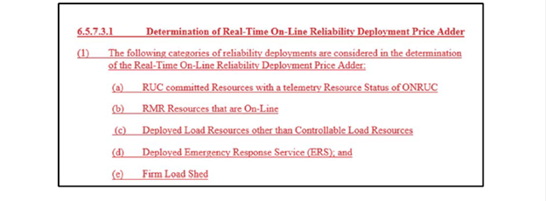

Another serious concern is the NPRR’s reliance on the PUC’s *Second Order Directing ERCOT to Take Action and Granting Exception to Commission Rules*, Project 51617 (Feb. 16, 2021) as authority for the proposed revision. The legality of this Second Order is currently being challenged at the Third Court of Appeals as well as at the Travis County District Court where the plaintiff argues:

34. The former Commissioners’ decision to trigger the Scarcity Pricing Mechanism by fiat during the recent winter storm signifies the arbitrariness that the APA, the Public Utility Regulatory Act, the Commission’s rules, and the ERCOT protocols were enacted to avoid. The Load Shed Rule was issued without notice, without publication, without public comment, and without reasoned justification. Had the Commissioners followed the legal requirements for modifying agency rules, Texas’s electricity market and those it serves could have been spared the drastic and unprecedented economic fallout.[2]

The same argument could be made here if Load shed is to trigger implementation of the price adder through a process other than at the PUC with full APA processes to ensure full public participation.

Lastly, the NPRR states that further discussions with stakeholders related to the Real-Time Reliability Deployment Price Adders for Ancillary Services will take place before these revisions can be proposed. Payless Power respectfully requests to be included in these discussions prior to implementation of the Real-Time Co-Optimization (RTC) project.

|  |
| --- |
| Revised Cover Page Language |

None

|  |
| --- |
| Revised Proposed Protocol Language |

None

1. *See 626NPRR-01 ORDC Price Reversal Mitigation Enhancements 051614* (May 16, 2014), available at

   <http://www.ercot.com/mktrules/issues/NPRR626#kevdocs>
2. Plaintiff’s Original Petition for Declaratory Judgment and Alternatively, Judicial Review, Cause No. v-1-gn-21-001772, *Exelon Generation Company, LLC and Constellation NewEnergy v. PUC*, in the District Court of Travis County Texas 53rd Judicial District, page 11.