ICE_M_VIEW_ECEII | Allows the user to view and retrieve postings for the ECEII group on the MIS | LSE QSE RE CRRAH CRRCP ERCOT PUCT TRE FERC IMM NERC DSP TSP IMRE QSEA DAOQSE Special
NMMS_M_IMM_ECEII | Allows the user to view and retrieve NMMS IMM ECEII postings on Citrix. | TSP, ERCOT

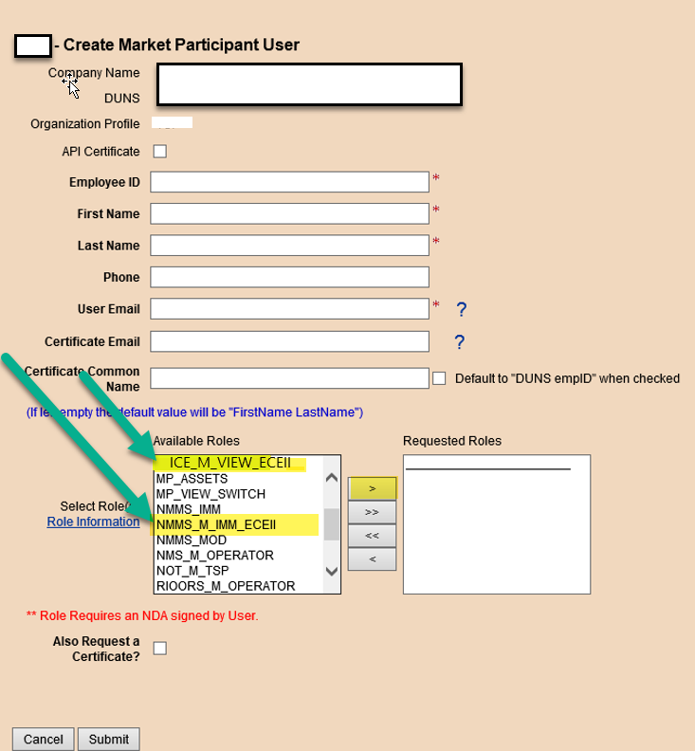

In MPIM you may add roles from the “Create” or “Modify” screen. “Available Roles” are on the left side: to add you must highlight the role(s) and then select the arrow to move to “Requested Roles” box and submit.

