April 2021 ERCOT Monthly Operations Report
Reliability and Operations Subcommittee Meeting
June 03, 2021

Table of Contents
1. Report Highlights 2
2. Frequency Control 3
2.1. Frequency Events 3
2.2. Responsive Reserve Events 4
2.3. Load Resource Events 4
3. Reliability Unit Commitment 4
4. Wind Generation as a Percent of Load 5
5. Largest Net-Load Ramp 7
6. COP Error Analysis 7
7. Congestion Analysis 9
7.1. Notable Constraints 9
7.2. Generic Transmission Constraint Congestion 15
7.3. Manual Overrides 16
7.4. Congestion Costs for Calendar Year 2021 16
8. System Events 17
8.1. ERCOT Peak Load 17
8.2. Load Shed Events 17
8.3. Stability Events 17
8.4. Notable PMU Events 17
8.5. DC Tie Curtailment 17
8.6. TRE/DOE Reportable Events 18
8.7. New/Updated Constraint Management Plans 18
8.8. New/Modified/Removed RAS 18
8.9. New Procedures/Forms/Operating Bulletins 18
9. Emergency Conditions 19
9.1. OCNs 19
9.2. Advisories 19
9.3. Watches 19
9.4. Emergency Notices 19
10. Application Performance 19
10.1. TSAT/VSAT Performance Issues 19
10.2. Communication Issues 19
10.3. Market System Issues 19
11. Model Updates 20
Appendix A: Real-Time Constraints 22

Report Highlights
- The unofficial ERCOT peak load was 52,800 MW.
- There were 3 frequency events.
- There were 4 instances where Responsive Reserves were deployed.
- There were 13 HRUC commitments.
- There were 11 days of congestion on the North to Houston GTC, 26 days on the Panhandle GTC, 5 days on the East Texas GTC, 15 days on the West Texas Export GTC, 27 days on the North Edinburg to Lobo GTC, and 18 days on the Nelson Sharpe to Rio Hondo GTC. There was no activity on the remaining GTCs during the month.
- There was 1 DC tie curtailment, due to an unplanned outage.

Frequency Control

Frequency Events
The ERCOT Interconnection experienced 3 frequency events, which resulted from unit’s trips. The average event duration was 00:04:56.

A summary of the frequency events is provided below. The reported frequency events meet one of the following criteria: Delta Frequency is 60 mHz or greater; the MW loss is 350 MW or greater; resource trip event triggered RRS deployment. Frequency events that have been identified as Frequency Measurable Events (FME) for purposes of BAL-001-TRE-1 analysis are highlighted in blue. When analyzing frequency events, ERCOT evaluates PMU data according to industry standards. Events with an oscillating frequency of less than 1 Hz are considered to be inter-area, while higher frequencies indicate local events. Industry standards specify that damping ratio for inter-area oscillations should be 3.0% or greater. For the frequency events listed below, the ERCOT system met these standards and transitioned well after each disturbance.

Date and Time | Delta Frequency | Max/Min Frequency | Duration of Event | PMU Data |  | MW Loss | Load | Wind | Inertia
 | (Hz) | (Hz) |  | Oscillation Mode (Hz) | Damping Ratio |  | (MW) | % | (GW-s)
4/8/2021 23:35 | 0.102 | 59.913 | 0:02:48 | 0.72 | 14% | 368 | 40,075 | 42% | 202,943
4/28/2021 21:03 | 0.108 | 59.909 | 0:05:30 | 0.86 | 11% | 529 | 49,635 | 35% | 240,798
4/30/2021 22:14 | 0.161 | 59.823 | 0:03:30 | 0.60 | 13% | 780.28 | 38,735 | 12% | 238,935

(Note: All data on this graph encompasses frequency event analysis based on BAL-001-TRE-1.)

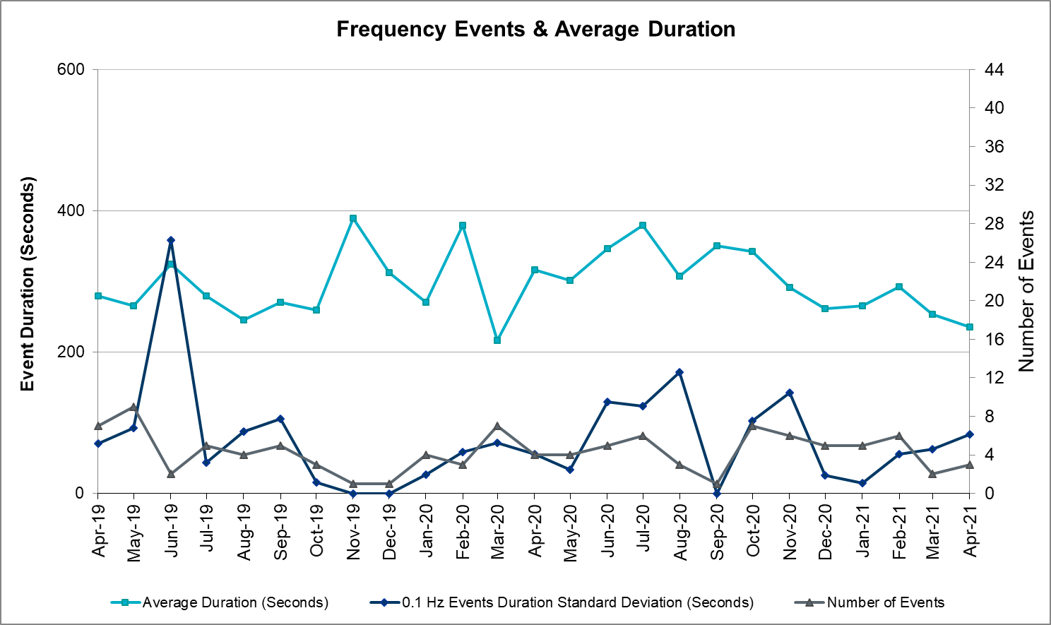

Note that the large standard deviation in June 2019 is due to coincidental extreme high and low durations for a small set of events (2).

Responsive Reserve Events
There were 4 events where Responsive Reserve MWs were released to SCED. The events highlighted in blue were related to frequency events reported in Section 2.1 above.

Date and Time Released to SCED | Date and Time Recalled | Duration of Event | Maximum MWs Released | Comments
4/11/2021 19:20 | 4/11/2021 19:35:48 | 00:14:51 | 1350
4/11/2021 19:56 | 4/11/2021 20:20:06 | 00:23:13 | 500
4/13/2021 15:58 | 4/13/2021 18:40:50 | 02:42:40 | 1000
4/30/2021 22:14 | 4/30/2021 22:18:10 | 00:03:20 | 1277

Load Resource Events
None

Reliability Unit Commitment
ERCOT reports on Reliability Unit Commitments (RUC) on a monthly basis. Commitments are reported grouped by operating day and weather zone. The total number of hours committed is the sum of the hours for all the units in the specified region. Additional information on RUC commitments can be found on the MIS secure site at Grid Generation Reliability Unit Commitment.

There were no DRUC commitments.

There were 13 HRUC commitment.

Resource Location | # of Resources | Operating Day | Total # of Hours Committed | Total MWhs | Reason for Commitment
NORTH CENTRAL & SOUTHERN | 2 | April 11, 2021 | 9 | 1,933 | System Capacity
NORTH CENTRAL & EAST | 5 | April 13, 2021 | 32 | 9,442 | System Capacity
NORTH CENTRAL & EAST | 4 | April 14, 2021 | 28 | 11,722 | System Capacity
EAST | 1 | April 26, 2021 | 8 | 1,336 | System Capacity
NORTH CENTRAL | 1 | April 28, 2021 | 8 | 944 | System Capacity

Wind Generation as a Percent of Load
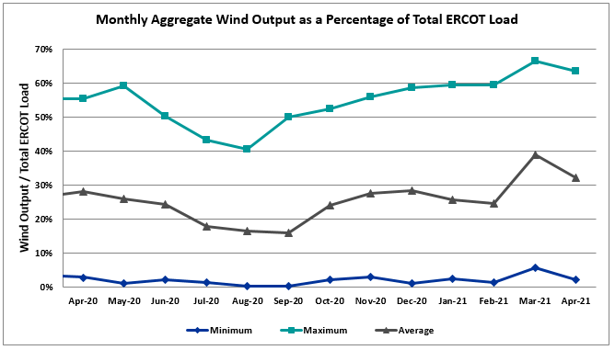

Wind Generation Record: 22,893 MW on 01/14/2021 at 07:27
Wind Penetration Record: 66.47% on 03/22/2021 at 00:46

Largest Net-Load Ramp
The net-load ramp is defined as the change in net-load (load minus wind and PVGR generation) during the defined time horizon. Such a variation in net-load needs to be accommodated in grid operations to ensure that the reliability of the grid is satisfactorily maintained. The largest net-load ramp during 5-min, 10-min, 15-min, 30-min and 60-min in Apr 2021 is 1414 MW, 1664 MW, 1967 MW, 2874 MW, and 4860 MW, respectively. The comparison with respect to the historical values is given in the table below.

Month and Year | 5 min | 10 min | 15 min | 30 min | 60 min
Apr 2021 | 1414 MW | 1664 MW | 1967 MW | 2874 MW | 4860 MW
Apr 2014 | 796 MW | 1358 MW | 1868 MW | 3445 MW | 6274 MW
Apr 2015 | 835 MW | 1482 MW | 1985 MW | 3216 MW | 5330 MW
Apr 2016 | 1183 MW | 1666 MW | 2394 MW | 3804 MW | 5101 MW
Apr 2017 | 914 MW | 1492 MW | 2315 MW | 3779 MW | 6385 MW
Apr 2018 | 947 MW | 1366 MW | 1710 MW | 3303 MW | 5030 MW
Apr 2019 | 1147 MW | 1778 MW | 1866 MW | 2866 MW | 4856 MW
Apr 2020 | 1189 MW | 1655 MW | 1578 MW | 2773 MW | 4948 MW
2014-2020 | 1494 MW | 1991 MW | 2780 MW | 4109 MW | 7786 MW

COP Error Analysis
COP Error is calculated as the capacity difference between the COP HSL and real-time HSL of the unit. Mean Absolute Error (MAE) stayed over 8,028 MW until Day-Ahead at 12:00, then dropped significantly to 1,028 MW by Day-Ahead at 15:00. In the following chart, Under-Scheduling Error indicates that COP had less generation capacity than real-time and Over-Scheduling Error indicates that COP had more generation capacity than real-time.

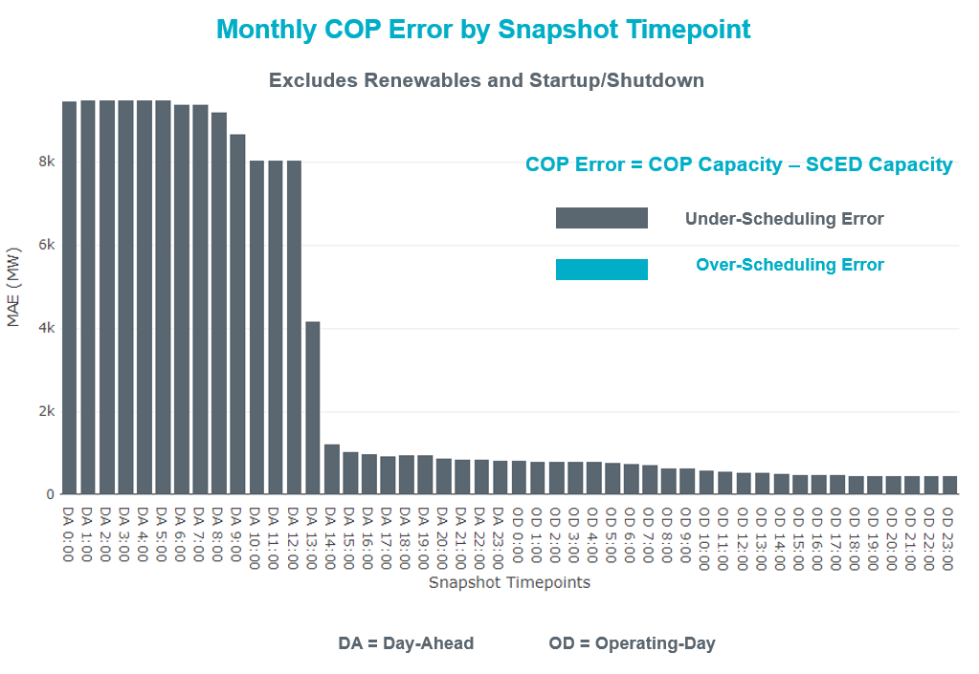

Monthly MAE for the Latest COP at the end of the Adjustment Period was 454 MW with median ranging from -641.9 MW for Hour-Ending (HE) 22 to 94.85 MW for HE 3. HE 23 on the 22nd had the largest Over-Scheduling Error (1,171 MW) and HE 24 on the 14^{h} had the largest Under-Scheduling Error (-2,850 MW).

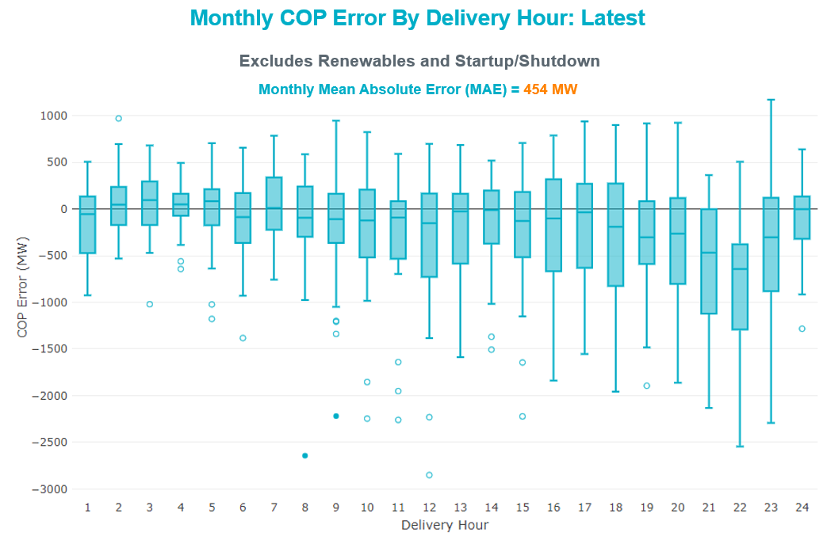

Monthly MAE for the Day-Ahead COP at 12:00 was 8,028 MW with median ranging from -10,738 MW for Hour-Ending (HE) 19 to -5,168 MW for HE 3. HE 19 on the 13th had the largest Under-Scheduling Error (-16,215 MW) and HE 2 on the 3rd had the largest Over-Scheduling Error (-732 MW).

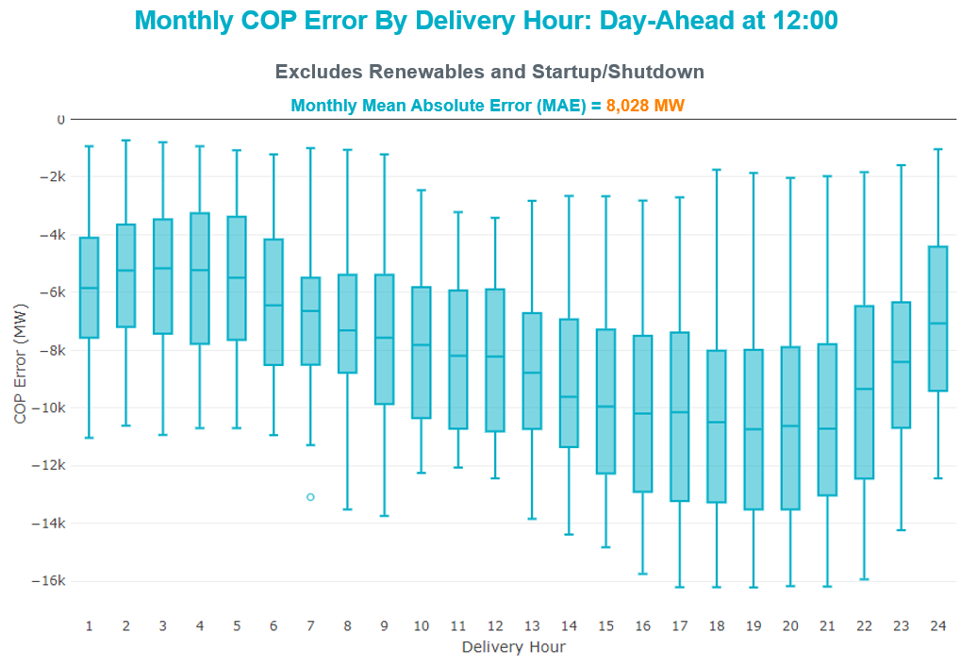

Congestion Analysis

Notable Constraints
Nodal protocol section 3.20 specifies that ERCOT shall identify transmission constraints that are active or binding three or more times within a calendar month. As part of this process, ERCOT reports congestion that meets this criterion to ROS. In addition ERCOT also highlights notable constraints that have an estimated congestion rent exceeding $1,000 for a calendar month. These constraints are detailed in the table below, including approved transmission upgrades from TPIT that may provide some congestion relief based on ERCOT’s engineering judgement. Rows highlighted in blue indicate the congestion was affected by one or more outages. For a list of all constraints activated in SCED, please see Appendix A at the end of this report.

Contingency Name | Overloaded Element | # of Days Constraint Active | Congestion Rent | Transmission Project
TWR(345) JCK-REF27 & JCK-STP18 | Oasis - Dow Chemical 345kV | 4 | $46,495,190.60 | Freeport - Master Plan (6668B)
Basecase | N_TO_H GTC | 11 | $39,166,560.86
TWR(345) JCK-REF27 & JCK-STP18 | South Texas Project - Wa Parish 345kV | 5 | $22,535,403.88 | Freeport - Master Plan (6668B)
Basecase | PNHNDL GTC | 26 | $20,827,697.28
TWR(345) JCK-STP18 & REF-STP27 | South Texas Project - Wa Parish 345kV | 5 | $16,085,611.84 | Freeport - Master Plan (6668B)
TWR(345) JCK-STP18 & REF-STP27 | Oasis - Dow Chemical 345kV | 4 | $14,508,107.35 | Freeport - Master Plan (6668B)
DEEN SWITCH to FOSSIL CREEK LIN _E | Wagley Robertson - Hicks Switch 138kV | 4 | $11,850,619.19
RILEY TO KRWSW 345 DBLCKT | Fisher Road Switch - Riley 345kV | 14 | $11,163,830.22
Basecase | EASTEX GTC | 5 | $9,089,886.18
Basecase | WESTEX GTC | 15 | $9,031,337.71
Basecase | NE_LOB GTC | 27 | $6,261,616.44
CRLNW TO LWSSW 345 DBLCKT | West Tnp - Highlands Tnp 138kV | 11 | $5,581,433.57
TRSES TO RCHBR 345 DBLCKT | Britton Road - Venus Switch 345kV | 1 | $4,728,491.77
CENTER to PH ROBINSON LIN A | Texas - Cedar Bayou 138kV | 1 | $3,639,863.25 | Baytown Area Upgrades (43284F)
ODLAW SWITCHYARD to ASPHALT MINES LIN 1 | Hamilton Road - Maverick 138kV | 22 | $3,398,458.72 | Brackettville to Escondido: Construct 138 kV line (5206)
BWNSW TO KLNSW 345 DBLCKT | Comanche Tap - Comanche Switch (Oncor) 138kV | 5 | $3,300,337.28
CDHSW TO VENSW 345 AND CDHSW TO EVRSW 345 DBLCKT | Park Row - Sherry Switch 138kV | 4 | $2,784,704.50
DMTSW-BCKSW&DMTSW-ECRSW 138 DBLCKT | Morgan Creek Ses - Sun Switch 138kV | 3 | $2,758,275.39
TWR(345) JCK-REF27 & JCK-STP18 | Bay City Sub - Sargent Sub 69kV | 9 | $2,547,361.55
Twinbu-Sarc&Amoscr 345kV | Schkad - San Angelo Power Station 138kV | 8 | $2,291,299.18
EVRSW TO CDHSW 345 AND EVRSW TO SHRSW 345 DBLCKT | Handley Ses - Lakewood (Oncor) 138kV | 2 | $2,121,802.64
PORTLAND to Gibbs LIN 1 | Hecker - Whitepoint 138kV | 7 | $1,993,524.23 | Whitepoint Area Improvements (50950)
Manual dbl ckt for NEDIN-BONILLA 345kV & RIOH-PRIM138kV | Burns Sub - Rio Hondo 138kV | 12 | $1,971,178.89 | Stewart Road: Construct 345 kV cut-in with two 450 MVA 345/138 autotransformers connected to Stewart Rd 138 station (5604, 6382)
Manual dbl ckt for NEDIN-BONILLA 345kV & RIOH-PRIM138kV | Haine Drive - La Palma 138kV | 10 | $1,818,889.32 | Luna 138 kV Station (44858)
GAS PAD to FLAT TOP TNP LIN 1 | Wickett Tnp - Pyote Tnp 138kV | 2 | $1,767,518.28
BAKERSFIELD SWITCHYARD to SCHNEEMAN DRAW LIN 1 | Schneeman Draw - Big Hill 345kV | 5 | $1,759,392.82
White Point to Angstrom & Lon Hill 345KV DOUBLE | Sea Drift Coke - North Carbide 138kV | 2 | $1,671,485.27
Twinbu-Sarc&Amoscr 345kV | San Angelo Power Station - San Angelo South Tap 138kV | 15 | $1,577,124.40
COMANCHE SWITCH (Oncor) to COMANCHE PEAK SES LIN _A | Comanche Tap - Comanche Switch (Oncor) 138kV | 12 | $1,509,020.18
Fowlerton to LOBO 345 LIN1 | North Laredo Switch - Piloncillo 138kV | 8 | $1,429,562.89
AJO to NELSON SHARPE LIN 1 | Falfurrias - Premont 69kV | 9 | $1,319,463.77
WOLF SWITCHING STATION to WICKETT TNP LIN 1 | Wickett Tnp - Yucca Drive Switch 69kV | 3 | $1,231,609.34
BRACKETTVILLE to HAMILTON ROAD LIN 1 | Hamilton Road - Maverick 138kV | 18 | $1,141,738.60 | Brackettville to Escondido: Construct 138 kV line (5206)
LOBO TRX A1 345/138 | Asherton - Catarina 138kV | 6 | $964,589.89
TWR(345) JCK-REF27 & JCK-STP18 | Blessing - Pavlov 138kV | 4 | $895,688.11 | Freeport - Master Plan (6668B)
Basecase | RV_RH GTC | 23 | $824,294.00
LAREDO VFT NORTH to LOBO LIN 1 | Molina - Sierra Vista 138kV | 3 | $770,874.32
Basecase | VALEXP GTC | 10 | $729,815.14
Grissom to COLETO CREEK LIN 1 | Aloe Sub - Warburton Road Switching Station 69kV | 6 | $729,678.53
Basecase | NELRIO GTC | 18 | $674,316.18
LON HILL to NELSON SHARPE LIN 1 | Celanese Bishop - Nelson Sharpe 138kV | 10 | $672,545.27
ENNIS SWITCH to ENNIS WEST SWITCH LIN _C | Ennis Switch - Ennis West Switch 138kV | 11 | $648,298.08
LON HILL to LON HILL LIN 1 | Lon Hill 138kV | 3 | $540,013.87
SALSW TO KLNSW 345 DBLCKT | Harker Heights South - Killeen Switch 138kV | 10 | $533,895.34
Marbfa-Lakewy &Wirtz-Palefa 138kV | Flat Rock Lcra - Wirtz 138kV | 19 | $461,588.92 | Wirtz to FlatRock to Paleface Transmission Line Upgrade (4465)
SWESW TO MULBERRY AND SWESW TO LNCRK 345 DBLCKT | Bluff Creek - Abilene Mulberry Creek 345kV | 3 | $459,382.58
TWR(345) JCK-STP18 & REF-STP27 | Bay City Sub - Sargent Sub 69kV | 6 | $447,900.98
LON HILL to NELSON SHARPE LIN 1 | Celanese Bishop - Kleberg Aep 138kV | 4 | $444,561.61
VICTORIA TRX 69A2 138/69 | Greenlake - Weaver Road 69kV | 5 | $346,231.68
Zorn-Marion & Cleasp 345kV | Clear Springs 138kV | 4 | $309,556.30 | LCRATSC_Clear Springs AT1 (50452)
FORT MASON to YELLOW JACKET LIN 1 | Yellow Jacket - Hext Lcra 69kV | 14 | $282,720.77
Rns-Rtw & Sng-Tb 345kV | Th Wharton 138kV | 3 | $256,709.14
POMELO to NORTH EDINBURG LIN 1 | Lobo - Freer 69kV | 4 | $218,695.31 | Stewart Road: Construct 345 kV cut-in with two 450 MVA 345/138 autotransformers connected to Stewart Rd 138 station (5604, 6382)
ASHERTON to Bevo Substation LIN 1 | Turtle Creek Switching Station - West Crystal City Sub 69kV | 4 | $201,598.16
SCOSW-LONG DRAW&FARADAY 345kV | Exxon Sharon Ridge - Willow Valley Switch 138kV | 7 | $195,959.59
COLETO CREEK to VICTORIA LIN 1 | Coleto Creek - Victoria 138kV | 10 | $187,974.48
Basecase | Santiago - Langford Wind Power Llc 138kV | 19 | $182,062.82
Goddard to PAWNEE SWITCHING STATION LIN 1 | Aloe Sub - Warburton Road Switching Station 69kV | 5 | $174,490.53
ODLAW SWITCHYARD to ASPHALT MINES LIN 1 | Maxwell - Whiting 138kV | 4 | $148,674.12
TWR(345) JCK-REF27 & JCK-STP18 | Oasis - Wa Parish 345kV | 5 | $148,617.22 | Freeport - Master Plan (6668B)
KING RANCH GAS PLANT to FALFURRIAS LIN 1 | Falfurrias - Premont 69kV | 9 | $144,376.56
LAREDO VFT NORTH to LOBO LIN 1 | Bruni Sub 138kV | 4 | $136,252.68
Manual Single ANGSTROM to STP 345 kV | Aloe Sub - Warburton Road Switching Station 69kV | 4 | $119,876.28
RINCON to RINCON LIN 1 | Whitepoint 138kV | 3 | $115,796.04 | Whitepoint: Add Second Auto (50954)
CI-THW21 & SA-THW24 138kV | Fairbanks - Deihl 138kV | 3 | $104,133.56
Goddard to LON HILL LIN 1 | Pettus - Normanna 69kV | 3 | $100,429.74
Sand Lake - Solstice line 1 and 2 | Pig Creek - Solstice 138kV | 5 | $79,977.46
FORT MASON to YELLOW JACKET LIN 1 | Mason Switching Station - Hext Lcra 69kV | 14 | $76,406.82
ELMOT TO WWEST 138 AND ELMOT TO WEAST 69 DBLCKT | Elm Mott - Mclennan County East 138kV | 15 | $76,193.74
Fowlerton to LOBO 345 LIN1 | Bruni Sub 138kV | 4 | $73,378.96
Comanche Peak 1 & 2 | Maxwell - Whiting 138kV | 3 | $70,152.92
SAN MIGUEL GEN to FOWLERTON LIN 1 | Dilley2 - Pearsall 69kV | 3 | $68,004.59
BRACKETTVILLE to ODLAW SWITCHYARD LIN 1 | Hamilton Road - Maverick 138kV | 18 | $63,442.69 | Brackettville to Escondido: Construct 138 kV line (5206)
RIO HONDO to EAST RIO HONDO SUB LIN 1 | South Carbide - Loma Alta Substation 138kV | 6 | $55,051.23
LOBO TRX AUTO 138/69 | Bruni Sub 138kV | 3 | $52,706.07
ODLAW SWITCHYARD to ASPHALT MINES LIN 1 | Escondido - Ganso 138kV | 5 | $42,722.25 | Escondido to Ganso: Rebuild 138 kV line (55624)
FORT MASON to YELLOW JACKET LIN 1 | Mason Switching Station - Hext Lcra 69kV | 14 | $42,570.10
COLEMAN LAKE IVIE TAP to EAST COLEMAN TAP LIN 1 | Ballinger - Ballinger Humble Tap 69kV | 4 | $40,466.20
GARDENDALE SWITCH to TELEPHONE ROAD - Sharyland Utilities LIN _A | Andrews North - Exxon Means Tap 138kV | 4 | $36,274.73
McCampbell to Gibbs LIN 1 | Hecker - Whitepoint 138kV | 3 | $34,584.42 | Whitepoint Area Improvements (50950)
HECKER to WHITEPOINT LIN 1 | Whitepoint - Rincon 138kV | 3 | $33,741.96 | Whitepoint Area Improvements (50950)
LOBO TRX AUTO 138/69 | Falfurrias - Premont 69kV | 6 | $33,544.69
Fergus-Granmo & Wirtz 138kV | San Angelo Power Station - Treadwell 138kV | 3 | $33,261.30
LCRANE TO KINGMO AND CASTIL 138 KV | Rio Pecos - Crane Lcra 138kV | 7 | $31,836.87
GRSES TO CFRSW AND GRSES TO LNCRK 345 DBLCKT | Murray - Paint Creek 138kV | 3 | $25,666.21
Bwnsw-Bowwoo&Amosct 345kV | San Angelo Concho - Veribest 69kV | 3 | $20,550.05
WESTSIDE AEP to HOLLY LIN 1 | Holly - Southside 138kV | 4 | $19,874.60 | Holly - Southside: 138 kV Line Rating Increase (45566)
COLETO CREEK to PAWNEE SWITCHING STATION LIN 1 | Loop 463 Sub - Victoria 138kV | 3 | $15,979.44
FORT MASON to YELLOW JACKET LIN 1 | Yellow Jacket - Hext Lcra 69kV | 14 | $8,069.32
FORT LANCASTER to ILLINOIS #4 LIN 1 | Hamilton Road - Maxwell 138kV | 11 | $7,544.62
LCRANE TO KINGMO AND CASTIL TO NORTMC 138 KV | Rio Pecos - Crane Lcra 138kV | 5 | $1,656.29
Basecase | Randado Aep - Zapata 138kV | 4 | $1,421.66

Generic Transmission Constraint Congestion
There were 11 days of congestion on the North to Houston GTC, 26 days on the Panhandle GTC, 5 days on the East Texas GTC, 15 days on the West Texas Export GTC, 27 days on the North Edinburg to Lobo GTC, and 18 days on the Nelson Sharpe to Rio Hondo GTC. There was no activity on the remaining GTCs during the month.

Note: This is how many times a constraint has been activated to avoid exceeding a GTC limit, it does not imply an exceedance of the GTC occurred or that the GTC was binding.

Manual Overrides
None

Congestion Costs for Calendar Year 2021
The following table represents the top twenty active constraints for the calendar year based on the estimated congestion rent attributed to the congestion. ERCOT updates this list on a monthly basis.

Contingency | Overloaded Element | # of 5-min SCED | Estimated | Transmission Project
Basecase | PNHNDL GTC | 16,481 | 78,702,832.68
Elmcreek-Sanmigl 345kV | Pawnee Switching Station - Calaveras 345kV | 2,079 | 76,199,104.65
LOST PINES AEN to FAYETTE PLANT 1 LIN 1 | Winchester - Fayette Plant 1 And 2 345kV | 415 | 51,438,867.64
JOHNSON SWITCH (ONCOR) to CONCORD LIN G1 | Decordova Dam - Carmichael Bend Switch 138kV | 726 | 46,614,977.07 | DeCordova 345/138kV_Sw. (7129)
TWR(345) JCK-REF27 & JCK-STP18 | Oasis - Dow Chemical 345kV | 524 | 46,495,190.60 | Freeport - Master Plan (6668B)
Basecase | N_TO_H GTC | 2,368 | 39,204,029.99
TWR(345) JCK-REF27 & JCK-STP18 | South Texas Project - Wa Parish 345kV | 1,866 | 35,934,198.14 | Freeport - Master Plan (6668B)
Hicross-Pilot & Garfield 138kV | Carson Creek - Pilot Knob 138kV | 803 | 30,600,531.85
Basecase | Colorado Bend Energy Center - Dyann 138kV | 242 | 26,093,025.30
Basecase | NE_LOB GTC | 11,625 | 23,241,461.67
TWR(345) JCK-REF27 & JCK-STP18 | Blessing - Pavlov 138kV | 4,312 | 21,362,696.58 | Freeport - Master Plan (6668B)
CONCORD TRX CRD1 345/138 | Concord 345kV | 840 | 21,139,669.60
Basecase | WESTEX GTC | 6,226 | 20,513,883.27
Lostpi-Austro&Dunlap 345kV | Sim Gideon - Winchester 138kV | 635 | 20,472,271.99
Lytton_S-Slaughte&Turner 138kV | Mccarty Lane - Zorn 138kV | 245 | 20,185,815.81
Manual dbl ckt for NEDIN-BONILLA 345kV & RIOH-PRIM138kV | Haine Drive - La Palma 138kV | 3,962 | 19,130,371.88 | Luna 138 kV Station (44858)
Basecase | Pawnee Switching Station - Calaveras 345kV | 27 | 17,214,426.04
ASHERTON to Bevo Substation LIN 1 | Hamilton Road - Maverick 138kV | 525 | 17,023,560.36 | Brackettville to Escondido: Construct 138 kV line (5206)
NORTH EDINBURG TRX 1382 345/138 | North Edinburg 345kV | 294 | 16,777,302.97 | Stewart Road: Construct 345 kV cut-in with two 450 MVA 345/138 autotransformers connected to Stewart Rd 138 station (5604, 6382)
KILLEEN SWITCH TRX KLNSW_3_2 345/138 | Killeen Switch 345kV | 234 | 16,301,132.28

System Events

ERCOT Peak Load
The unofficial ERCOT peak load for the month was 52,800 MW and occurred on the 9th, during hour ending 17:00.

Load Shed Events
None.

Stability Events
None.

Notable PMU Events
ERCOT analyzes PMU data for any significant system disturbances that do not fall into the Frequency Events category reported in section 2.1. The results are summarized in this section once the analysis has been completed.

There were no PMU events outside of those reported in section 2.1.

DC Tie Curtailment
Date | DC Tie | Curtailing Period | # of Tags Curtailed | Initiating Event | Curtailment Reason
04/15/2021 | DC-L | HE14 – HE15 | 2 | Unplanned outage | Planned or Unplanned Outage

TRE/DOE Reportable Events
- Garland TO submitted an OE-417 for 04/07/2021. Reportable Event Type: Loss of monitoring or control capability.
- Oncor TO submitted an OE-417 for 04/10/2021. Reportable Event Type: Damage or destruction of a facility.
- BPUB TO submitted an OE-417 for 04/13/2021. Reportable Event Type: Physical threat to its facility.
- ERCOT ISO submitted an OE-417 for 04/13/2021. Reportable Event Type: Media Appeal.
- City of Austin TO submitted an OE-417 for 04/21/2021. Reportable Event Type: Loss of monitoring or control capability.
- BPUB TO submitted an OE-417 for 04/24/2021. Reportable Event Type: Suspicious activity to its facility.

New/Updated Constraint Management Plans
None.

New/Modified/Removed RAS
None.

New Procedures/Forms/Operating Bulletins

Date | Subject | Bulletin No.
04/01/2021 | DC Tie Desk V1 Rev 65 | 971
04/01/2021 | Real Time Desk V1 Rev 71 | 972
04/01/2021 | Scripts V1 Rev 35 | 973
04/01/2021 | Shift Supervisor Desk V1 Rev 70 | 974
04/01/2021 | Transmission and Security Desk V1 Rev 83 | 975

Emergency Conditions

OCNs
Date and Time | Message
Apr 07 2021 01:39 CPT | ERCOT issued an OCN for modifying the WESTEX Generic Transmission Constraint due to the current transmission outage topology.
Apr 08 2021 08:30 CPT | ERCOT issued an OCN for a projected Reserve Capacity Shortage for 04/08/2021 HE15 – HE20.
Apr 11 2021 14:40 CPT | ERCOT issued an OCN for a projected Reserve Capacity Shortage for 04/11/2021 HE18 – HE21.
Apr 12 2021 07:45 CPT | ERCOT issued an OCN for a projected Reserve Capacity Shortage for 04/12/2021 HE14 – HE18.
Apr 12 2021 22:00 CPT | ERCOT issued an OCN for a projected Reserve Capacity Shortage for 04/13/2021 HE14 – HE21.
Apr 13 2021 22:00 CPT | ERCOT issued an OCN for a projected Reserve Capacity Shortage for 04/14/2021 HE13 – HE20.

Advisories
Date and Time | Message
Apr 11 2021 19:21 CPT | ERCOT issued an Advisory due to Physical Responsive Capability being below 3000 MW.
Apr 13 2021 16:22 CPT | ERCOT issued an Advisory due to Physical Responsive Capability being below 3000 MW.

Watches
Date and Time | Message
Apr 13 2021 17:17 CPT | ERCOT issued a Watch due to Physical Responsive Capability being below 2500 MW.

Emergency Notices
None.

Application Performance

TSAT/VSAT Performance Issues
None.

Communication Issues
None.

Market System Issues
None.

Model Updates
The Downstream Production Change (DPC) process allows ERCOT to make changes in the on-line Network Operations Model without loading a completely new model. The purpose of this process is to allow for reliable grid operations as system conditions change between designated Network Operations Model database loads. The DPC process is limited in scope to just those items listed below, with equipment ratings updates being the most common. ERCOT has seen a rise in the use of the DPC process to make on-line updates to the Network Operations Model in recent years, instead of through the standard Network Operations Model Change Request process.

- Static Line ratings (Interim Update)
- Dynamic Line ratings (non-Interim Update)
- Autotransformer ratings (non-Interim Update)
- Breaker and Switch Normal status (Interim Update)
- Contingency Definitions (Interim Update)
- RAP and RAS changes or additions (Interim Update)
- Net Dependable and Reactive Capability (NDCRC) values (Interim Update)
- Impedance Updates (non-Interim)

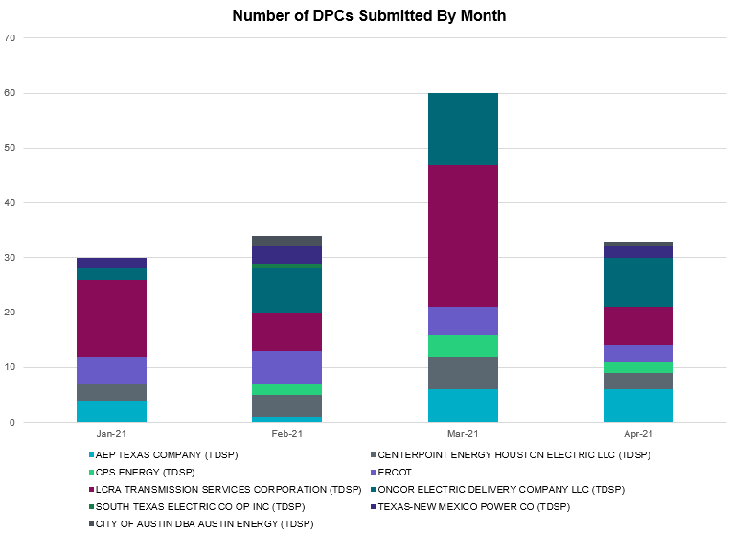

Transmission Operator | Number of DPCs
AEP TEXAS COMPANY (TDSP) | 6
BRAZOS ELECTRIC POWER CO OP INC (TDSP) | 0
BROWNSVILLE PUBLIC UTILITIES BOARD (TDSP) | 0
BRYAN TEXAS UTILITIES (TDSP) | 0
CENTERPOINT ENERGY HOUSTON ELECTRIC LLC (TDSP) | 3
CITY OF AUSTIN DBA AUSTIN ENERGY (TDSP) | 1
CITY OF COLLEGE STATION (TDSP) | 0
CITY OF GARLAND (TDSP) | 0
CPS ENERGY (TDSP) | 2
DENTON MUNICIPAL ELECTRIC (TDSP) | 0
ELECTRIC TRANSMISSION TEXAS LLC (TDSP) | 0
ERCOT | 3
LCRA TRANSMISSION SERVICES CORPORATION (TDSP) | 7
LONE STAR TRANSMISSION LLC (TSP) | 0
ONCOR ELECTRIC DELIVERY COMPANY LLC (TDSP) | 9
RAYBURN COUNTRY CO OP DBA RAYBURN ELECTRIC (TDSP) | 3
SHARYLAND UTILITIES LP (TDSP) | 0
SOUTH TEXAS ELECTRIC CO OP INC (TDSP) | 0
TEXAS MUNICIPAL POWER AGENCY (TDSP) | 0
TEXAS-NEW MEXICO POWER CO (TDSP) | 2

Appendix A: Real-Time Constraints
The following is a complete list of constraints activated in SCED. Full contingency descriptions can be found in the Standard Contingencies List located on the MIS secure site at Grid Generation Reliability Unit Commitment.

Contingency Name | Overloaded Element | From Station | To Station | Count of Days
BASE CASE | NE_LOB | n/a | n/a | 27
BASE CASE | PNHNDL | n/a | n/a | 26
BASE CASE | RV_RH | n/a | n/a | 23
SBRAUVA8 | HAMILT_MAVERI1_1 | HAMILTON | MAVERICK | 22
BASE CASE | LGD_SANTIA1_1 | LGD | SANTIAGO | 19
DMARPA_8 | 38T365_1 | WIRTZ | FLATRO | 19
SBRAHAM8 | HAMILT_MAVERI1_1 | HAMILTON | MAVERICK | 18
SODLBRA8 | HAMILT_MAVERI1_1 | HAMILTON | MAVERICK | 18
BASE CASE | NELRIO | n/a | n/a | 18
DELMWWE8 | 1020__A | ELMOT | MCTYE | 15
DBWNAMO5 | SAPOWE_SAST1_1 | SAPOWER | SAST | 15
BASE CASE | WESTEX | n/a | n/a | 15
SFORYEL8 | HEXT_MASONS1_1 | MASONSW | HEXT | 14
SFORYEL8 | HEXT_MASONS1_1 | HEXT | MASONSW | 14
SFORYEL8 | HEXT_YELWJC1_1 | YELWJCKT | HEXT | 14
DRILKRW5 | 6011__B | RILEY | FSHSW | 14
SFORYEL8 | HEXT_YELWJC1_1 | HEXT | YELWJCKT | 14
SENSENW8 | 943__A | ENWSW | ENSSW | 12
MHARNED5 | BURNS_RIOHONDO_1 | RIOHONDO | MV_BURNS | 12
SCMNCPS5 | 651__B | CMNSW | CMNTP | 12
SENSENW8 | 943__A | ENSSW | ENWSW | 12
BASE CASE | N_TO_H | n/a | n/a | 11
SILLFTL8 | HAMILT_MAXWEL1_1 | MAXWELL | HAMILTON | 11
DCRLLSW5 | 588_B_1 | LWSVH | LWSVW | 11
BASE CASE | VALEXP | n/a | n/a | 10
MHARNED5 | HAINE__LA_PAL1_1 | LA_PALMA | HAINE_DR | 10
SN_SLON5 | CELANE_N_SHAR1_1 | N_SHARPE | CELANEBI | 10
DSALKLN5 | 630__B | KLNSW | HHSTH | 10
SVICCO28 | COLETO_VICTOR2_1 | COLETO | VICTORIA | 10
SKINFAL8 | FALFUR_PREMON1_1 | FALFUR | PREMONT | 9
DSTPRED5 | BAY_SARG_1 | BAYCTYS | SARGNTS | 9
SN_SAJO5 | FALFUR_PREMON1_1 | FALFUR | PREMONT | 9
SLOBSA25 | NLARSW_PILONC1_1 | NLARSW | PILONCIL | 8
DBWNAMO5 | 134T429_1 | SCHKAD | SAPOWER | 8
SPORGIB8 | HECKER_WHITE_2_1 | WHITE_PT | HECKER | 7
DSCOFAR5 | 6216__B | WLVSW | SHRNE | 7
DLCRKIN8 | LCRANE_RIOPEC1_1 | RIOPECOS | LCRANE | 7
XLOB258 | ASHERT_CATARI1_1 | ASHERTON | CATARINA | 6
SGRICOL5 | ALO_WAR_1 | WARBURTN | ALOES | 6
DREFSTP5 | BAY_SARG_1 | BAYCTYS | SARGNTS | 6
XLOB89 | FALFUR_PREMON1_1 | FALFUR | PREMONT | 6
SSANFOW5 | GEO_SIG_1 | GEOWEST | SIGMOR | 6
SMV_RI28 | OCB_2175_1 | SCARBIDE | LOMA_ALT | 6
SBAKSCH5 | SCHNDR_BIGHIL_1 | SCHNDR | BIGHIL | 5
DSTPRED5 | STPWAP39_1 | STP | WAP | 5
BASE CASE | EASTEX | n/a | n/a | 5
SBRAUVA8 | ESCOND_GANSO1_1 | GANSO | ESCONDID | 5
DLCRCAS8 | LCRANE_RIOPEC1_1 | RIOPECOS | LCRANE | 5
XVIC89 | GREENL_WEAVER1_1 | GREENLK | WEAVERRD | 5
DSTPRED5 | OASWAP99_A | WAP | OAS | 5
SGODPAW5 | ALO_WAR_1 | WARBURTN | ALOES | 5
DREFSTP5 | STPWAP39_1 | STP | WAP | 5
DSLKSOL5 | PIGCRE_SOLSTI1_1 | SOLSTICE | PIGCREEK | 5
DBWNKLN5 | 651__B | CMNSW | CMNTP | 5
SGDNTEL5 | 6094__D | ANDNR | EXMTP | 4
DREFSTP5 | DOWOAS18_A | OAS | DOW | 4
SCOMHA38 | HAMILT_MAXWEL1_1 | MAXWELL | HAMILTON | 4
BASE CASE | RANDAD_ZAPATA1_1 | RANDADO | ZAPATA | 4
SBEVASH8 | TURTLECK_WCRYS_1 | TURTLCRK | WCRYSTS | 4
SDENFSC8 | 6270__D | HCKSW | WGROB | 4
SCOLBAL8 | BALLIN_HUMBLT1_1 | BALLINGE | HUMBLTAP | 4
DSTPRED5 | BLESSI_PAVLOV1_1 | BLESSING | PAVLOV | 4
SN_SLON5 | CELANE_KLEBER1_1 | CELANEBI | KLEBERG | 4
DSTPRED5 | DOWOAS18_A | OAS | DOW | 4
SPOMNED5 | FREER_LOBO1_1 | LOBO | FREER | 4
SHOLWES8 | HOLLY4_SOUTH_1_1 | HOLLY4 | SOUTH_SI | 4
DVICEDN8 | LOOP_VICTORIA_1 | VICTORIA | L_463S | 4
SCRTCDH5 | 6200__D | SHRSW | PRKRW | 4
SLARLOB8 | BRUNI_69_1 | BRUNI | BRUNI | 4
DCLEZOR5 | CLEASP_AT2L | CLEASP | CLEASP | 4
MANGSTP5 | ALO_WAR_1 | WARBURTN | ALOES | 4
SBRAUVA8 | MAXWEL_WHITIN1_1 | MAXWELL | WHITING | 4
SLOBSA25 | BRUNI_69_1 | BRUNI | BRUNI | 4
DCDHVEN5 | 6200__D | SHRSW | PRKRW | 4
SGODLON5 | NORMAN_PETTUS1_1 | NORMANNA | PETTUS | 3
SLARLOB8 | MOLINA_SIEVIS1_1 | MOLINA | SIEVISTA | 3
SWLFWIC8 | 6710__A | YUCSW | WICKETT | 3
DCI_SA_8 | DH_FR_81_A | FR | DH | 3
SPOMNED5 | NLARSW_PILONC1_1 | NLARSW | PILONCIL | 3
SGODLON5 | NORMAN_PETTUS1_1 | PETTUS | NORMANNA | 3
DRNS_TB5 | THW_AT1L | THW | THW | 3
SRINRIN8 | WHITE_PT_69A1 | WHITE_PT | WHITE_PT | 3
SLONLON8 | LON_HILL_382L | LON_HILL | LON_HILL | 3
DFER_WI8 | SAPOWE_TREADW1_1 | TREADWEL | SAPOWER | 3
SCOLPAW5 | LOOP_VICTORIA_1 | VICTORIA | L_463S | 3
DDMTBCK8 | 6474__A | MGSES | SUNSW | 3
DSWELNC5 | BLUF_C_MULBER1_1 | BLUF_CRK | MULBERRY | 3
SSANFOW5 | DILLY_PEARSA1_1 | DILLY | PEARSAL1 | 3
DGRSLNC5 | 6380__D | PAINTCRE | MURRAY | 3
DCPSES12 | MAXWEL_WHITIN1_1 | MAXWELL | WHITING | 3
XLOB89 | BRUNI_69_1 | BRUNI | BRUNI | 3
DBWN_AM5 | CONCHO_VRBS1_1 | CONCHO | VRBS | 3
SMV_RI28 | CP_MVCNT_1 | MV_CNTRA | COFFPORT | 3
SMCCGIB8 | HECKER_WHITE_2_1 | WHITE_PT | HECKER | 3
SHECWHI8 | RINCON_WHITE_2_1 | WHITE_PT | RINCON | 3
DDILCOT8 | DIL_COTU_1 | COTULAS | DILLEYSW | 2
SBRAUVA8 | GANSO_MAVERI1_1 | MAVERICK | GANSO | 2
STORLOB5 | NLARSW_PILONC1_1 | NLARSW | PILONCIL | 2
DCPSES12 | SAPOWE_TREADW1_1 | TREADWEL | SAPOWER | 2
DEVRCRT5 | 6415__C | HLSES | LKWOD | 2
DWHILON5 | NCARBI_SEADRF1_1 | NCARBIDE | SEADRFTC | 2
DHECWHI8 | RINCON_WHITE_2_1 | WHITE_PT | RINCON | 2
SILLFTL8 | CARVER_TINSLE1_1 | CARVER | TINSLEY | 2
SMOOPEA8 | FRI_PEAR_1 | PEARSALL | FRIOTOS | 2
DWHIGIB8 | HECKER_WHITE_2_1 | WHITE_PT | HECKER | 2
SPELWHI8 | KOCH_H_LON_HI1_1 | LON_HILL | KOCH_HF | 2
XLOB89 | MOLINA_SIEVIS1_1 | MOLINA | SIEVISTA | 2
SGRILON5 | NCARBI_SEADRF1_1 | NCARBIDE | SEADRFTC | 2
SMV_PAR8 | RIOHND_ERIOHND_1 | MV_RIOHO | RIOHONDO | 2
SLARLOB8 | ST_NIN_WORMSE1_1 | WORMSER | ST_NINO | 2
BASE CASE | TRDWEL | n/a | n/a | 2
SN_SLON5 | KINGSV_KLEBER1_1 | KLEBERG | KINGSVIL | 2
SSANFOW5 | NLARSW_PILONC1_1 | NLARSW | PILONCIL | 2
SKRWRI15 | OKLA_RILEY2_1 | RILEY | OKLA | 2
DFERSTA8 | SAPOWE_TREADW1_1 | TREADWEL | SAPOWER | 2
SHACPB38 | 138_WIC_PYT_1 | WICKETT | PYOTE | 2
DMTSCOS5 | 6437__F | SCRCV | KNAPP | 2
DCPSST58 | 651__B | CMNSW | CMNTP | 2
DCAGCO58 | 656T656_1 | KENDAL | BERGHE | 2
XLOB58 | ASHERT_CATARI1_1 | ASHERTON | CATARINA | 2
SBONNED5 | BURNS_RIOHONDO_1 | RIOHONDO | MV_BURNS | 2
XVIC89 | GREENL_NCARBI1_1 | NCARBIDE | GREENLK | 2
SFRIFTL8 | HAMILT_MAXWEL1_1 | HAMILTON | MAXWELL | 2
DWLDSCO5 | LUTHER_VEALMOR_1 | VEALMOOR | LUTHER | 2
DSNG_TB5 | THW_AT1L | THW | THW | 2
DMLSTYG5 | 1865__A | TYLNW | BLKSW | 2
DCAGCI58 | 656T656_1 | KENDAL | BERGHE | 2
SNCANCA8 | GREENL_WEAVER1_1 | WEAVERRD | GREENLK | 2
SGRILON5 | NORMAN_PETTUS1_1 | PETTUS | NORMANNA | 2
SLOBSA25 | ASHERT_CATARI1_1 | ASHERTON | CATARINA | 2
SILLFTL8 | CTHR_TINSLE1_1 | TINSLEY | CTHR | 2
SNCANCA8 | GREENL_WEAVER1_1 | GREENLK | WEAVERRD | 2
DELMSAN5 | MHONDOCR_1 | MOORE | HONDOCK | 2
DJACALV8 | MYRA_VAL_1 | MYRA | VALYVIEW | 2
SESPSPU9 | CROWEL_LIBR1_1 | CROWELL | LIBR | 2
SCOMHA38 | MAXWEL_WHITIN1_1 | MAXWELL | WHITING | 2
MANGSTP5 | WHITE_PT_69A1 | WHITE_PT | WHITE_PT | 2
XELM58 | 1030__B | BOSQUESW | RGH | 1
SKLNSAL5 | 271__A | KLNSW | SALSW | 1
DNLSCRL8 | 715__A | CRLNW | CRLJL | 1
SLOLFOR8 | BIGTRE_V_DUPS1_1 | V_DUPSW | BIGTRE | 1
DSTEXP12 | BLESSI_LOLITA1_1 | LOLITA | BLESSING | 1
SBAKCED5 | CONCHO_SAMATH1_1 | CONCHO | SAMATHIS | 1
SFRIFTL8 | CONCHO_SAMATH1_1 | CONCHO | SAMATHIS | 1
SFTLMES8 | CROSSO_NORTMC1_1 | NORTMC | CROSSOVE | 1
SLOLFOR8 | FORMOS_JOSLIN1_1 | JOSLIN | FORMOSA | 1
SLOBSA25 | LARDVN_LASCRU1_1 | LARDVNTH | LASCRUCE | 1
SRAYRI28 | LOYOLA_69_1 | LOYOLA | LOYOLA | 1
SSOLFTS8 | M_69_P2_1 | TNFSTP | FTSW | 1
SGRIGRI5 | NCARBI_SEADRF1_1 | NCARBIDE | SEADRFTC | 1
DENTSCS5 | NCDSE_MR1H | NCDSE | NCDSE | 1
SGRICOL5 | RAY_ALOE_1 | RAYBURN | ALOES | 1
SRINWHI8 | WHITE_PT_69A1 | WHITE_PT | WHITE_PT | 1
DTRSRCH5 | 530__C | VENSW | BRTRD | 1
DCAGTA58 | 656T656_1 | KENDAL | BERGHE | 1
STORLOB5 | ASHERT_CATARI1_1 | ASHERTON | CATARINA | 1
MBLYWAP5 | BELLSO_AT2 | BELLSO | BELLSO | 1
DVICEDN8 | BIGTRE_V_DUPS1_1 | V_DUPSW | BIGTRE | 1
DSTPRED5 | DOWOAS27_A | OAS | DOW | 1
SODLBRA8 | ESCOND_GANSO1_1 | GANSO | ESCONDID | 1
SBLSJAC8 | WISECNTY_JCKCN_1 | JACKCNTY | WISECNTY | 1
DSALHUT5 | 270__A | KNBSW | TMPSW | 1
DCDHVEN5 | 3180__A | FCRSW | CDHSW | 1
SBWNCTL5 | 651__B | CMNSW | CMNTP | 1
BASE CASE | BEARKT | n/a | n/a | 1
MANGWHI5 | BLESSI_LOLITA1_1 | LOLITA | BLESSING | 1
SMA2FOR8 | FRPHIL_GILLES1_1 | GILLES | FRPHILLT | 1
SWRDYN8 | LAN_CT_PAVLOV1_1 | LAN_CTY | PAVLOV | 1
SES2FRI8 | MIDW_OZONA1_1 | OZONA | MIDW | 1
DCOTDMT5 | OKLA_RILEY2_1 | RILEY | OKLA | 1
SGRIGRI5 | RAY_ALOE_1 | RAYBURN | ALOES | 1
DVICEDN8 | RAY_HIGH_1 | RAYBURN | HIGHLAS | 1
SSTAMDL8 | TALLCITY_TELPR_1 | TELPH_RD | TALLCITY | 1
DD1RAZ_8 | UVALDE_W_BATE1_1 | UVALDE | W_BATESV | 1
SRAZUVA8 | UVALDE_W_BATE1_1 | UVALDE | W_BATESV | 1
DFERHOR8 | 247T124_1 | PALEFA | PHILJC | 1
DGRSPKR5 | 6377__A | BRTSW | ORANS | 1
SDUKNE28 | ADERHO_ELSA1_1 | ADERHOLD | ELSA | 1
MSTPANS5 | ALO_WAR_1 | WARBURTN | ALOES | 1
SES2FRI8 | BISON_STRS1_1 | BISON | STRS | 1
DREFSTP5 | BLESSI_PAVLOV1_1 | BLESSING | PAVLOV | 1
SLAQLOB8 | BRUNI_69_1 | BRUNI | BRUNI | 1
SPHRCTR5 | CD_TX_87_A | CD | TX | 1
DSTPRED5 | CKT_3124_1 | STP | HLJ | 1
XCLE58 | CLEASP_AT2H | CLEASP | CLEASP | 1
BASE CASE | CORRAL_ILLN1_1 | ILLN | CORRAL | 1
SSANFOW5 | COTULL_REVEIL1_1 | REVEILLE | COTULLA | 1
DELMSAN5 | DILLY_PEARSA1_1 | DILLY | PEARSAL1 | 1
BASE CASE | HHGTOM_1 | HHGT | OMEGA | 1
BASE CASE | RAMBLER_GENTIE_1 | RAMBLER | TWINBU | 1
SCISPUT8 | SOUTHA_VINSON1_1 | SOUTHABI | VINSON | 1
SWIRFE28 | 51T376_1 | FERGUS | GRANMO | 1
DBWNKLN5 | 651__C | CMNTP | SHILO | 1
MSTPANS5 | BLESSI_LOLITA1_1 | LOLITA | BLESSING | 1
DCLEZOR5 | CLEASP_AT2H | CLEASP | CLEASP | 1
SCOLPAW5 | COLETO_ROSATA1_1 | COLETO | ROSATA | 1
UINGCTG1 | I_DUPP_I_DUPS2_1 | I_DUPSW | I_DUPP1 | 1
DDELGA58 | NLARSW_PILONC1_1 | NLARSW | PILONCIL | 1
SILLFTL8 | OZNR_OZONA1_1 | OZONA | OZNR | 1
SCARFRI8 | SANTIA_SAPOWE1_1 | SANTIAGO | SAPOWER | 1
SCRNLC38 | TALLCITY_TELPR_1 | TELPH_RD | TALLCITY | 1
SENTTR25 | 1350__E | NCSTP | LFKSW | 1
SPIGSOL8 | 138_WIC_PYT_1 | WICKETT | PYOTE | 1
SLWSCRL5 | 588_B_1 | LWSVH | LWSVW | 1
SZEPCMN8 | 670__C | CMPBW | BRNSO | 1
SGRILON5 | BIGTRE_V_DUPS1_1 | V_DUPSW | BIGTRE | 1
SMELRIN8 | BONIVI_RINCON1_1 | RINCON | BONIVIEW | 1
SGODPAW5 | CALLIC_LON_HI1_1 | LON_HILL | CALLICOA | 1
SLOBSA25 | FALFUR_PREMON1_1 | FALFUR | PREMONT | 1
SAIRNCA8 | GRETA_REFUGI1_1 | REFUGIO | GRETA | 1
SNCANCA8 | GRETA_REFUGI1_1 | REFUGIO | GRETA | 1
DBCVPSA8 | HL_PSA08_A | PSA | HL | 1
SBOSWHT8 | LKW_WHT_1 | LKWHITNY | WHTNY | 1
DCENFAL5 | NLARSW_PILONC1_1 | NLARSW | PILONCIL | 1
SGODPAW5 | NORMAN_PETTUS1_1 | NORMANNA | PETTUS | 1
SGRICOL5 | NORMAN_PETTUS1_1 | PETTUS | NORMANNA | 1
XB2I58 | ST_TAP25_1 | ST | ST | 1
MHARWES8 | WES_MV_W_1 | WESLACO | MV_WESL4 | 1
DWIRSTA8 | 51T376_1 | FERGUS | GRANMO | 1
DRNS_TB5 | AN_WO_21_A | WO | AN | 1
SLANLAN8 | BLESSI_PAVLOV1_1 | BLESSING | PAVLOV | 1
SBEVASH8 | CARRIZ_CRYSTA1_1 | CARRIZO | CRYSTAL | 1
DWISALV8 | JACKCNTY_BLSRA_1 | JACKCNTY | BLSRA | 1
SGRICOL5 | NCARBI_SEADRF1_1 | NCARBIDE | SEADRFTC | 1
DVICEDN8 | NUR_FORT_1 | NURSRYS | FORTRSW | 1
SAIRNCA8 | REFUG_VICTO_1C_1 | VICTORIA | OCONNOR | 1
XMDL58 | TALLCITY_TELPR_1 | TELPH_RD | TALLCITY | 1
DSTPRED5 | VNH_VANB_1 | VANBLTSS | VANHUMSW | 1
SCRTCDH5 | 3180__A | FCRSW | CDHSW | 1
DMLSTYG5 | 355__A | MLSES | SHBSW | 1
SBAKCED5 | 430T430_1 | GASCCR | MGSES | 1
DCREALN5 | 715__A | CRLNW | CRLJL | 1
MENWENS8 | 940__C | ENWSW | WXHCH | 1
DDILCOT8 | DILLEYSW_69A1 | DILLEYSW | DILLEYSW | 1
SCISPUT8 | ESTES_PECAN_1_1 | PECAN_BY | ESTES | 1
SBRAHAM8 | GANSO_MAVERI1_1 | MAVERICK | GANSO | 1
SKLELOY8 | LOYOLA_69_1 | LOYOLA | LOYOLA | 1
MWHILON5 | NCARBI_SEADRF1_1 | NCARBIDE | SEADRFTC | 1
SGODPAW5 | NORMAN_PETTUS1_1 | PETTUS | NORMANNA | 1

This is the hourly integrated peak demand as published in the ERCOT D&E report.
All DC Tie Curtailments are posted publically on the ERCOT Market Information System. See that posting for additional details for the event(s) in question.
See DC Tie Operating Procedure (http://www.ercot.com/mktrules/guides/procedures) for more details.

