System Planning
Monthly Status Report

Report Highlights

- ERCOT is currently reviewing proposed transmission improvements with a total estimated cost of $1,272.72 Million as of April 30, 2021.
- Transmission Projects endorsed in 2021 total $243.60 Million as of April 30, 2021.
- All projects (in engineering, routing, licensing and construction) total approximately $7.3 Billion as of February 1, 2021.
- Transmission Projects energized in 2021 total about $49.4 Million as of February 1, 2021.

Regional Planning Group Reviews
RPG Projects under Review:
- AEPSC has submitted the LRGV Import Project (RPG Project ID: 18RPG001). This is a Tier 1 project that is estimated to cost $73.4 million. AEPSC has also requested that ERCOT provide a conditional endorsement for an additional $357.2 million project. ERCOT’s independent review has been conducted in accordance with Protocol Section 3.11.4.9(3), and this project is currently placed on hold until the LNG loads are confirmed.
- STEC has submitted the Lower Rio Grande Valley Transmission Expansion Project (RPG Project ID: 19RPG009). This is a Tier 1 project that is estimated to cost $511 million. ERCOT’s independent review has been conducted in accordance with Protocol Section 3.11.4.9(3), and this project is currently placed on hold until the LNG loads are confirmed.
- Oncor has submitted the Nacogdoches Southeast Switch – Redland Switch – Lufkin Switch 345-kV Loop Project (RPG Project ID: 20RPG019). This is a Tier 2 project that is estimated to cost $71.26 million. This project is currently under ERCOT’s independent review.
- STEC and LCRA TSC have jointly submitted the Bakersfield to Big Hill 345‐kV Second Circuit Addition Project (RPG Project ID: 21RPG001). This is a Tier 2 project that is estimated to cost $83.2 million. This project is currently under ERCOT’s independent review.
- AEPSC has submitted the Port Lavaca Area Improvement Project (RPG Project ID: 21RPG002). This is a Tier 2 project that is estimated to cost $97.8 million. This project is currently under ERCOT’s independent review.
- CNP has submitted the Angleton to West Columbia 138-kV ckt 04 Rebuild Project (RPG Project ID: 21RPG005). This is a Tier 3 project that is estimated to cost $38.7 million. This project completed the RPG review on April 2. Pursuant to Protocol Section 3.11.4.3(1)(d), this project has been reclassified as a Tier 4 neutral project.
- CNP has submitted the Algoa Corner to La Marque 138 kV ckt 93 Rebuild Project (RPG Project ID: 21RPG006). This is a Tier 3 project that is estimated to cost $34.56 million. This project is currently in the RPG comment period.
- Oncor has submitted the Holliday - Seymour 69 kV Line Project (RPG Project ID: 21RPG007). This is a Tier 3 project that is estimated to cost $44.3 million. This project is currently in the RPG comment period.

RPG Project Reviews Completed in 2021:
RPG Project ID | RPG Project Name | Submitted Entity | Tier | Estimated Cost  ($ Millions) | Review Completion Month
20RPG022 | Hamilton Road to Maxwell 138-kV Line Rebuild Project | AEPSC | Tier 3 | 34.0 | January
20RPG023 | Royse - Commerce 69-kV Line Conversion to 138-kV | Oncor | Tier 3 | 72.1 | January
21RPG003 | Midland East Area Projects | Oncor | Tier 3 | 88.5 | March
21RPG004 | Venus Switch-Cedar Hill Switch 345-kV Line Project | Oncor | Tier 3 | 10.3 | March
21RPG005 | Angleton to West Columbia 138-kV ckt 04 Rebuild Project | CNP | Reclassified from Tier 3 to Tier 4 per Protocol | 38.7 | April

More information on current and past RPG projects can be found on the ERCOT MIS Secure (digital certificate required): https://mis.ercot.com/public/data-products/grid/regional-planning
Past email communication on RPG projects can be found on the ERCOT listserv by signing up for the REGPLANGROUP list: http://lists.ercot.com/scripts/wa-ERCOT.exe?A0=REGPLANGROUP

Planning Model Activities
The short-term calendar of major planning model events is as follows:
- By July 1, 2021 21SSWG Update cases and TPIT are posted
- By July 21, 2021 21SSWG Contingency definitions and Planning Data Dictionary are posted
The following table shows interconnection projects that met Planning Guide section 6.9(1) and 6.9(2) and were modeled in the SSWG cases as a full model or as a simple model in accordance with Planning Guide section 6.9. 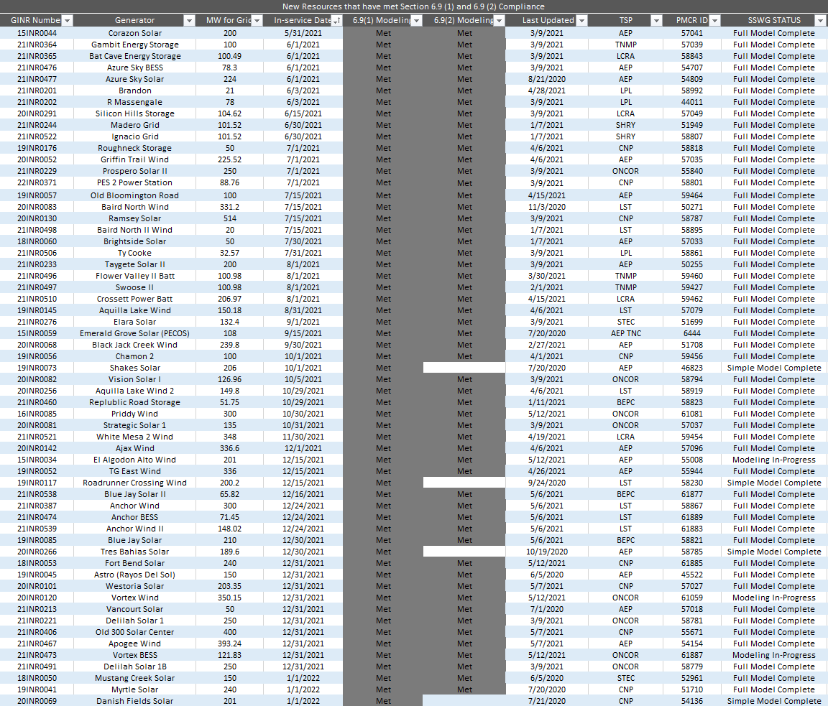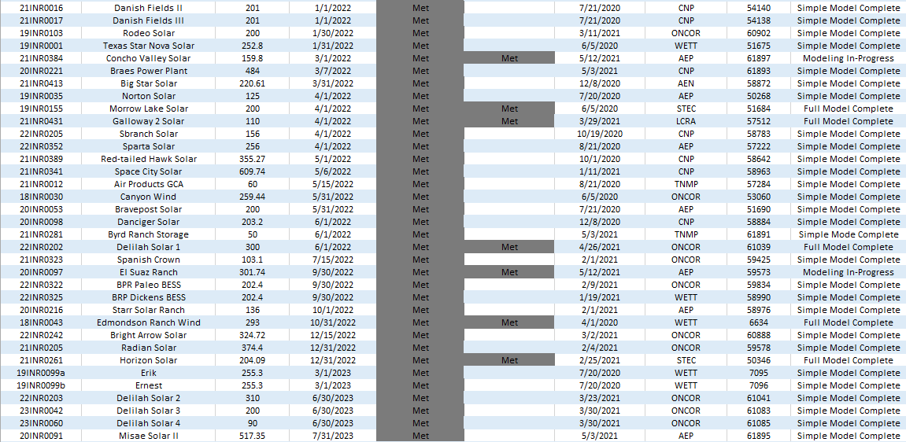

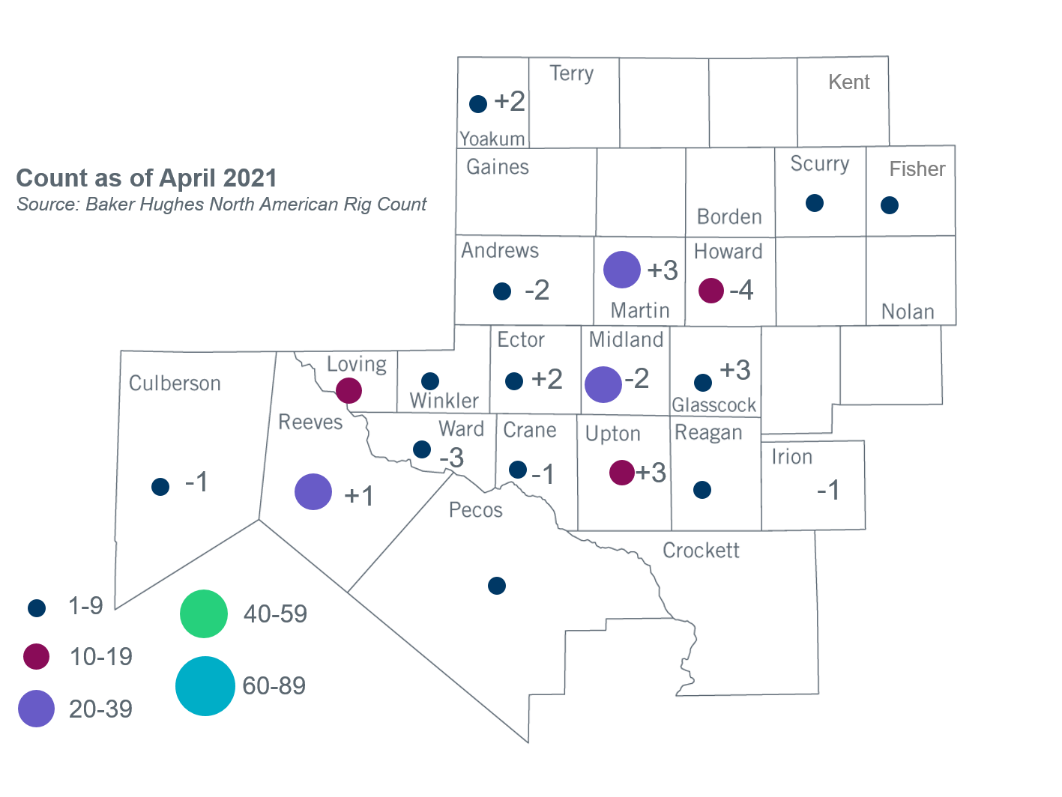
Permian Basin Oil Rig Count
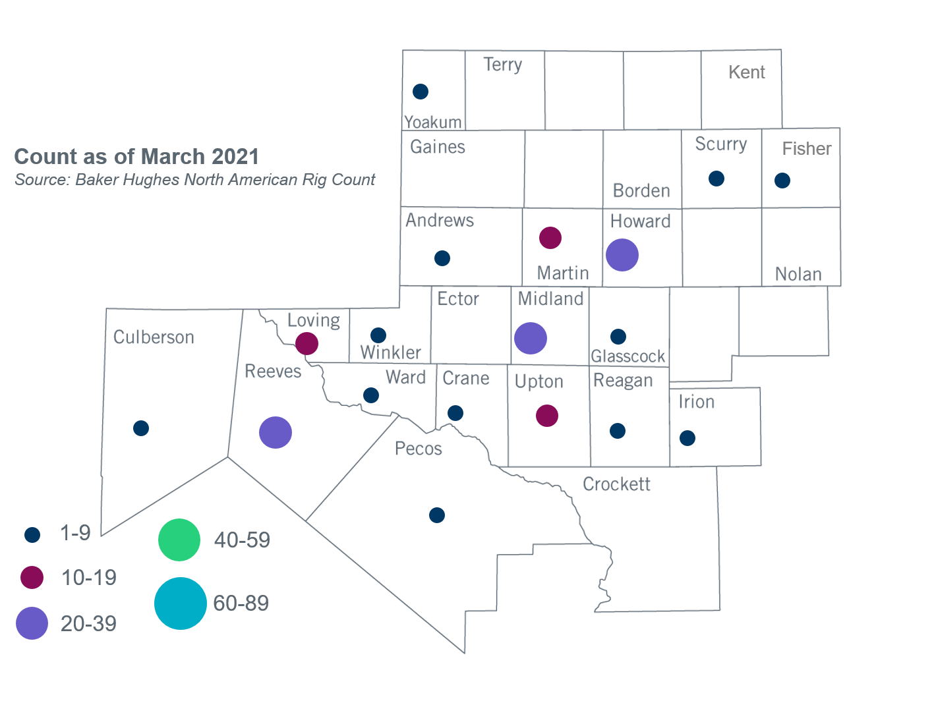

Other Notable Activities
- ERCOT presented an update on 2021 Regional Transmission Plan assumptions to the Regional Planning Group in April.
- ERCOT is conducting the West Texas Export Study and plans to complete the study in June, 2021.
- ERCOT is conducting the South Texas Stability Study and plans to complete the study in June, 2021.
- ERCOT is conducting the Permian Basin Load Integration Study and plans to complete the study in June, 2021.
- The SPWG is currently building 2021 FY base cases.

Based on the Total Project Estimated Cost for all future projects listed in the Transmission Project Information and Tracking (TPIT) report. TPIT is updated three times each year based on information TSPs provide in Model on Demand (MOD) as specified in the ERCOT Steady State Working Group Procedure Manual. The latest TPIT is available at http://www.ercot.com/gridinfo/planning.
Based on the Total Project Estimated Cost for all completed projects with Projected In-Service Dates in 2021 listed in the TPIT.
+/- symbol indicates the increase or decrease from the previous month in oil rigs present in each county. There are 152 rigs, including no increase or decrease oil rigs, in the Permian Basin from March 2021 to April 2021.

