2021 Benchmark and Supplemental GMD Vulnerability Assessment Scope and Process
Version 1.0

Document Revisions
Date | Version | Description | Author(s)
05/10/2021 | 1.0 | First draft | Minnie Han

Table of Contents

1. Introduction 3
2. Scope 3
3. Input Assumptions 3
3.1. Benchmark and Supplemental GMDVA Start Case 3
3.2. GMD Event 3
3.3. Geomagnetically Induced Reactive Power Losses 4
3.4. Ratings and Limits 4
4. Benchmark and Supplemental GMDVA Process and Method of Study 5
4.1. GMDVA Case Preparation 5
4.1.1. Transformer Thermal Impact Assessment Results 6
4.1.2. Benchmark and Supplemental GMD Event Caused Outages 6
4.2. Method of Study 7
4.2.1. Reactive Losses 7
4.2.2. Steady State Voltage Performance Analysis 7
4.2.3. Cascading Analysis 7
5. Corrective Action Plans 8
5.1. Identifying CAPs 8
6. Deliverables 9

Introduction
The Benchmark and Supplemental Geomagnetic Disturbance Vulnerability Assessments (GMDVA) are the result of a coordinated planning process, performed by ERCOT System Planning with review and input by NERC registered Transmission Planners (TPs), Transmission Owners (TOs), Generator Owners (GOs), and other stakeholders. This process produces a region-wide GMDVA of the transmission system in accordance with the requirements of NERC Reliability Standard TPL-007-4 and the ERCOT Planning Guide. The 2021 Benchmark and Supplemental GMDVA Scope and Process document captures the scope for planning studies conducted as part of both the 2021 ERCOT Benchmark and Supplemental GMDVAs. This document also briefly describes the process and various deliverables applicable to the 2021 ERCOT Benchmark and Supplemental GMDVAs.

Scope
The 2021 ERCOT Benchmark and Supplemental GMDVAs shall identify reliability needs and Corrective Action Plans (CAPs) to meet those needs per applicable performance criteria in the ERCOT Planning Guide and the NERC TPL-007-4 reliability standard.

The 2021 Benchmark and Supplemental GMDVAs will be based on the following cases of the final Geomagnetically-Induced Current (GIC) System models (both the GIC AC model and GIC DC model) that were posted to the MIS Secure area:

- 2022 Summer peak load case
- 2022 Minimum load case

To the extent practical, CAPs identified in both the 2021 Benchmark and Supplemental GMDVAs will be based on consensus between ERCOT and the TSPs and Resource Entities with input from other market participants.

Start cases and assessment results will be made available for review via the MIS Secure Area and the MIS Certified Area for TSPs.

Input Assumptions

Benchmark and Supplemental GMDVA Start Case
The 2022 Summer Peak and Minimum Load GIC System models developed by the ERCOT Planning Geomagnetic Disturbance Task Force (PGDTF) will be used as the starting cases for the Benchmark and Supplemental GMDVAs.

GMD Event
A reference peak geoelectric field amplitude of 8 V/km will be used in the GMD simulations for the 2021 ERCOT Benchmark GMDVA. A reference peak geoelectric field of 12 V/km will be used over the footprint of the ERCOT system in the GMD simulations for the 2021 ERCOT Supplemental GMDVA.

Geomagnetically Induced Reactive Power Losses
The reactive power losses produced by transformers modeled in the system are automatically generated by the GIC analysis software; however, the reactive power losses produced by DC Ties modeled without transformers are not automatically generated. The calculation of those losses will be incorporated using the following equation from the PSS/E Program Operation Manual:

$Three-Phase Mvar Losses=I_{eff}×K_{factor}×\frac{V_{H}}{500}$

$= I_{eff}×K_{factor(2)}$
Where:
- $I_{eff}$ = Effective GIC flow (amp/phase)
- $V_{H}$ = Transformer winding highest voltage (kV)
- $K_{factor}$ = Scaling factor defined at 500 kV of $V_{H}$ (Mvar/amp)
- $K_{factor(2)}$ = Scaling factor provided in GIC data file (Mvar/amp)

If the $K_{factor}$ is not provided by the equipment owner, a default value will be used. If the transformer core type is available, the default value will be based on the transformer core type. If the transformer core type is not available, the default value will then be determined by the highest winding base kV voltage level of the transformer. The default values that will be used can be found in the PSS/E Program Application Guide Volume 1.

Ratings and Limits
For voltage analysis, pre-contingency and post-contingency limits for all buses 100 kV and above will be monitored. The steady state voltage criteria used in the 2021 Benchmark and Supplemental GMDVAs is defined in Planning Guide Section 4.1.1.4

Automatic tripping will occur for elements that exceed the lower of their relay loadability limit or 125% of their emergency rating on Transmission Facilities that are 100 kV and above.

When applicable, Under-Voltage Load Shed (UVLS) information from TSPs, and generator over-voltage and under-voltage trip settings provided in the applicable Resource Registration Data, will be modeled. Default values for generator over-voltage and under-voltage trip settings will be used if those trip settings are not available.

The default values that will be used for generator over-voltage and under-voltage trip settings are:
- For renewable generators: 0.9 pu and 1.1 pu for under-voltage and over-voltage trip settings, respectively; and
- For all other generators: the post-contingency voltage limits.

Appropriate stability limits, as identified by the latest planning studies, will be modeled.

Benchmark and Supplemental GMDVA Process and Method of Study

Figure 1: 2021 GMDVA Methodology

GMDVA Case Preparation
Both the GIC AC model and the GIC DC model will be updated and conditioned in collaboration with PGDTF to address any GIC System model issues before beginning the GMDVA. Additionally, ERCOT will tune voltages and reactive support in the GIC AC model so that voltages are within, or as close to, acceptable limits and will communicate with corresponding TSPs on specific tuning measures.

The following subsections outline updates made to the GIC System model to prepare the cases for the benchmark and supplemental GMDVAs.

Transformer Thermal Impact Assessment Results
If applicable, transformer owners with transformers that meet R6 of TPL-007-4, based on provided GIC flow information, are required to perform thermal impact assessments for any transformer with maximum effective GIC flows exceeding the 75 A/phase threshold for the benchmark event so that suggested actions to mitigate the impact of GICs can be incorporated into the benchmark GMDVA start cases.

Transformer owners with transformers that meet R10 of TPL-007-4, based on provided GIC flow information, are required to perform thermal impact assessments for any transformer with maximum effective GIC flows exceeding the 85 A/phase threshold for the supplemental event so that suggested actions to mitigate the impact of GICs can be incorporated into the supplemental GMDVA start cases.

Benchmark and Supplemental GMD Event Caused Outages
GMD event induced quasi-DC GIC currents in transformer windings result in asymmetric or half-cycle saturation of transformer cores, which high-voltage transformers are more susceptible to. Saturation of transformers can lead to increased generation of harmonics resulting in the potential removal of equipment from service due to protection system operation or misoperation.

In preparation for the 2021 Benchmark and Supplemental GMDVAs, TSPs and Resource Entities are required to assess the impact of both the benchmark GMD event and supplemental GMD event to develop a list of potential equipment that may be removed from service as a result of generated harmonics for each.

To facilitate credible outage analysis based on the GMD events described in paragraphs (2)(a) and (2)(b) of Planning Guide Section 6.11, TSPs and Resource Entities will categorize event outages as outlined below for the benchmark GMD event, then the supplemental GMD event, before submitting these outages to ERCOT to be included in the Benchmark and Supplemental GMDVAs.

- Category A outage: equipment anticipated to have a high probability of tripping offline due to harmonics during the GMD event and may be studied simultaneously in the GMDVA.

- Category B outage: equipment anticipated to have a lower probability of tripping offline due to harmonics during the GMD event and may be studied one at a time in the GMDVA.

TSPs and Resource Entities will be requested to label each outage that could occur as a direct consequence of the GMD event only as either Category A or Category B.

Method of Study

Reactive Losses
The geoelectric field orientation that produces the most reactive power losses may not reveal all potential issues caused by the benchmark or supplemental GMD event, thus a degree scan will be performed across the GIC system model in 10-degree increments. The case used will have a baseline configuration with the Category A outages applied to determine the reactive power losses produced for different orientations.

For each orientation selected by the degree scan, a change file with reactive losses modeled as loads having only MVAR values will be produced. The reactive power losses produced by DC Ties modeled without transformers will be calculated as described in Section 3.3.

Steady State Voltage Performance Analysis
The reactive power loss change files, as described in Section 4.2.1, will be used to incorporate reactive power losses to the GIC AC model for each orientation selected by the degree scan. Category B outages will be applied one at a time as contingencies and powerflow analysis will be performed to determine if the system meets the steady-state voltage performance criteria. Unsolved powerflows, which may indicate potential voltage collapse issues, will also be investigated.

Manual system adjustments, such as transmission configuration changes, transformer tap changes, and generation re-dispatch, will be implemented first to resolve any reliability criteria violations. Reliability criteria violations that cannot be resolved with system adjustments will be discussed with TSPs and Resource Entities for feedback, which will then be used to develop CAPs as needed.

Cascading Analysis
Cascading analysis will be conducted to identify any potential cascading or uncontrolled separation events. Transmission Facilities (100 kV and above) that exceed the lower of their relay loadability limit or 125% of their emergency rating will be assumed to trip automatically and will be removed from service.

Load at buses with known UVLS protection schemes where the voltage falls below their under-voltage set point and generators with buses on the low side of the Generator Step Up (GSU) transformer that experience voltages lower than its under-voltage trip limits or higher than its over-voltage trip limits will also be assumed to trip automatically.

For system deficiencies that are a result of a potential cascading event, or uncontrolled islanding, CAPs will be developed in conjunction with TSPs and Resource Entities.
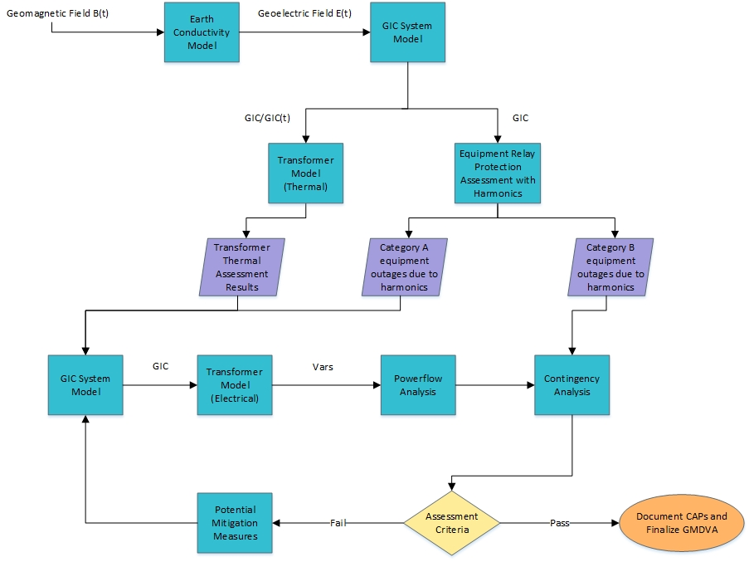
Figure 2: GMDVA Flowchart

Corrective Action Plans

Identifying CAPs
ERCOT, TSPs, and Resource Entities will develop and document CAPs to meet Benchmark and Supplemental GMD Reliability performance requirements outlined in Section 3.4. Each CAP will list system deficiencies and the associated actions required to meet the Benchmark and Supplemental GMD Reliability Criteria. Examples of such actions include:

- Installation, modification, retirement, or removal of Transmission and generation Facilities, and any associated equipment.
- Installation, modification, or removal of protection systems or Remedial Action Schemes.
- Use of Operating Procedures, specifying how long they will be needed as part of the CAP.
- Use of Demand-Side Management, new technologies, or other initiatives.

CAPs that propose upgrades or additions subject to Protocol Section 3.11.4 will be reviewed within the Regional Planning Group Review Process. All other CAPs will be reviewed by ERCOT to ensure that it addresses reliability criteria.

Deliverables
In the course of the analysis, the following information, at a minimum, will be shared with stakeholders via the MIS TSP Certified area:

- Initial GIC System model (GIC DC and AC models)¹
- TSP and RE identified Category A and B outages in PSSE file format
- GIC System model cases with Category A outages¹

The following information will be shared with stakeholders via the MIS Secure area:

- GMDVA study cases (AC model)¹
- Reactive power losses for all orientations
- Preliminary Benchmark and Supplemental GMDVA Assessment results with preliminary CAPs
- Final Benchmark and Supplemental GMDVA Report and CAPs

¹ Cases for both the 2022 Summer Peak load and 2022 Minimum load models will be provided.

