

March 2021 ERCOT Monthly Operations Report

Reliability and Operations Subcommittee Meeting

April 29, 2021

Table of Contents

1. Report Highlights 2

2. Frequency Control 3

2.1. Frequency Events 3

2.2. Responsive Reserve Events 4

2.3. Load Resource Events 4

3. Reliability Unit Commitment 4

4. Wind Generation as a Percent of Load 5

5. Largest Net-Load Ramp 6

6. COP Error Analysis 6

7. Congestion Analysis 8

7.1. Notable Constraints 8

7.2. Generic Transmission Constraint Congestion 13

7.3. Manual Overrides 13

7.4. Congestion Costs for Calendar Year 2021 14

8. System Events 15

8.1. ERCOT Peak Load 15

8.2. Load Shed Events 15

8.3. Stability Events 15

8.4. Notable PMU Events 15

8.5. DC Tie Curtailment 15

8.6. TRE/DOE Reportable Events 15

8.7. New/Updated Constraint Management Plans 15

8.8. New/Modified/Removed RAS 16

8.9. New Procedures/Forms/Operating Bulletins 16

9. Emergency Conditions 16

9.1. OCNs 16

9.2. Advisories 16

9.3. Watches 17

9.4. Emergency Notices 17

10. Application Performance 17

10.1. TSAT/VSAT Performance Issues 17

10.2. Communication Issues 17

10.3. Market System Issues 17

11. Model Updates 17

Appendix A: Real-Time Constraints 20

# Report Highlights

* The unofficial ERCOT peak load was 45,367 MW.
* There were 2 frequency events**.**
* There were 4 instances where Responsive Reserves were deployed.
* There were 7 HRUC commitments.
* There were 30 days of congestion on the Panhandle GTC, 20 days on the West Texas Export GTC, 29 days on the Raymondville to RioHondo GTC, 16 days on the Nelson Sharpe to Rio Hondo GTC, and 8 days on the North to Houston GTC. There was no activity on the remaining GTCs during the month.
* There were no DC Tie Curtailments

# Frequency Control

## Frequency Events

The ERCOT Interconnection experienced 2 frequency events, which resulted from unit’s trips. The average event duration was 00:04:14.

A summary of the frequency events is provided below. The reported frequency events meet one of the following criteria: Delta Frequency is 60 mHz or greater; the MW loss is 350 MW or greater; resource trip event triggered RRS deployment. Frequency events that have been identified as Frequency Measurable Events (FME) for purposes of BAL-001-TRE-1 analysis are highlighted in blue. When analyzing frequency events, ERCOT evaluates PMU data according to industry standards. Events with an oscillating frequency of less than 1 Hz are considered to be inter-area, while higher frequencies indicate local events. Industry standards specify that damping ratio for inter-area oscillations should be 3.0% or greater. For the frequency events listed below, the ERCOT system met these standards and transitioned well after each disturbance.

|  |  |  |  |  |  |  |  |  |  |
| --- | --- | --- | --- | --- | --- | --- | --- | --- | --- |
| **Date and Time** | **Delta Frequency** | **Max/Min Frequency** | **Duration of Event** | **PMU Data** | | **MW Loss** | **Load** | **Wind** | **Inertia** |
| **(Hz)** | **(Hz)** | **Oscillation Mode (Hz)** | **Damping Ratio** | **(MW)** | **%** | **(GW-s)** |
| 3/3/2021 9:56 | 0.106 | 59.909 | 0:04:58 | 0.710 | 9% | 429 | 39,927 | 26% | 202,664 |
| 3/30/2021 18:01 | 0.143 | 59.834 | 0:03:30 | 0.710 | 13% | 673.17 | 44,238 | 24% | 197,926 |

(Note: All data on this graph encompasses frequency event analysis based on BAL-001-TRE-1.)

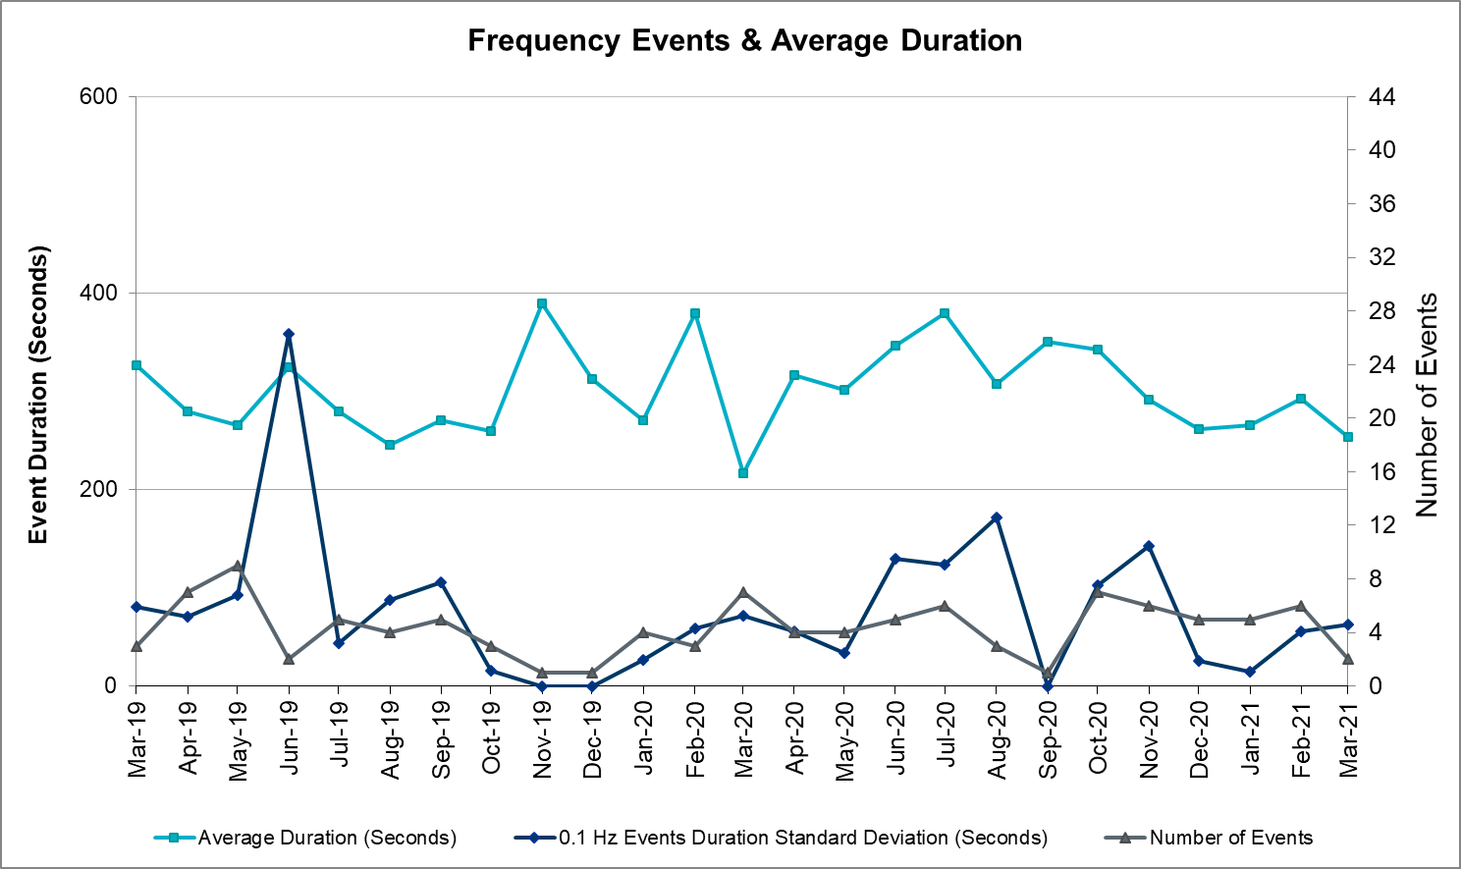

Note that the large standard deviation in June 2019 is due to coincidental extreme high and low durations for a small set of events (2).

## Responsive Reserve Events

There were 4 events where Responsive Reserve MWs were released to SCED. The events highlighted in blue were related to frequency events reported in Section 2.1 above.

|  |  |  |  |  |
| --- | --- | --- | --- | --- |
| Date and Time Released to SCED | Date and Time Recalled | Duration of Event | Maximum MWs Released | Comments |
| 3/9/2021 16:33 | 3/9/2021 16:52:11 | 00:18:50 | 716 |  |
| 3/25/2021 0:59 | 3/25/2021 1:06:04 | 00:06:29 | 644 |  |
| 3/26/2021 23:10 | 3/26/2021 23:15:16 | 00:04:44 | 662 |  |
| 3/30/2021 18:01 | 3/30/2021 18:04:36 | 00:03:24 | 821 |  |

## Load Resource Events

None

# Reliability Unit Commitment

ERCOT reports on Reliability Unit Commitments (RUC) on a monthly basis. Commitments are reported grouped by operating day and weather zone. The total number of hours committed is the sum of the hours for all the units in the specified region. Additional information on RUC commitments can be found on the MIS secure site at Grid 🡪 Generation 🡪 Reliability Unit Commitment.

There were no DRUC commitments.

There were 7 HRUC commitment.

|  |  |  |  |  |  |
| --- | --- | --- | --- | --- | --- |
| **Resource Location** | **# of Resources** | **Operating Day** | **Total # of Hours Committed** | **Total MWhs** | **Reason for Commitment** |
| SOUTHERN | 3 | March 10, 2021 | 13 | 1,742 | XNED258 |
| SOUTHERN | 2 | March 11, 2021 | 15 | 2,789 | XNED258 |
| NORTH_CENTRAL | 1 | March 15, 2021 | 1 | 382 | System Capacity |
| EAST | 1 | March 15, 2021 | 1 | 470 | System Capacity |

# Wind Generation as a Percent of Load



Wind Generation Record: 22,893 MW on 01/14/2021 at 07:27

Wind Penetration Record: 66.47% on 03/22/2021 at 00:46

# Largest Net-Load Ramp

The net-load ramp is defined as the change in net-load (load minus wind and PVGR generation) during the defined time horizon. Such a variation in net-load needs to be accommodated in grid operations to ensure that the reliability of the grid is satisfactorily maintained. The largest net-load ramp during 5-min, 10-min, 15-min, 30-min and 60-min in Mar 2020 is 926 MW, 1556 MW, 1945 MW, 3282 MW, and 6104 MW, respectively. The comparison with respect to the historical values is given in the table below.

|  |  |  |  |  |  |
| --- | --- | --- | --- | --- | --- |
| **Month and Year** | **5 min** | **10 min** | **15 min** | **30 min** | **60 min** |
| Mar 2021 | 926 MW | 1556 MW | 1945 MW | 3282 MW | 6104 MW |
| Mar 2014 | 822 MW | 1381 MW | 1895 MW | 3237 MW | 5257 MW |
| Mar 2015 | 956 MW | 1615 MW | 2146 MW | 3341 MW | 5661 MW |
| Mar 2016 | 979 MW | 1635 MW | 2149 MW | 2967 MW | 5070 MW |
| Mar 2017 | 888 MW | 1522 MW | 1838 MW | 3321 MW | 5395 MW |
| Mar 2018 | 1375 MW | 1688 MW | 2069 MW | 3576 MW | 5957 MW |
| Mar 2019 | 919 MW | 1511 MW | 1932 MW | 3194 MW | 5596 MW |
| Mar 2020 | 979 MW | 1406 MW | 1650 MW | 2642 MW | 4660 MW |
| 2014-2020 | 1494 MW | 1991 MW | 2780 MW | 4109 MW | 7786 MW |

# COP Error Analysis

COP Error is calculated as the capacity difference between the COP HSL and real-time HSL of the unit. Mean Absolute Error (MAE) stayed over 6,500 MW until Day-Ahead at 13:00, then dropped significantly to 1,143 MW by Day-Ahead at 15:00. In the following chart, Under-Scheduling Error indicates that COP had less generation capacity than real-time and Over-Scheduling Error indicates that COP had more generation capacity than real-time.

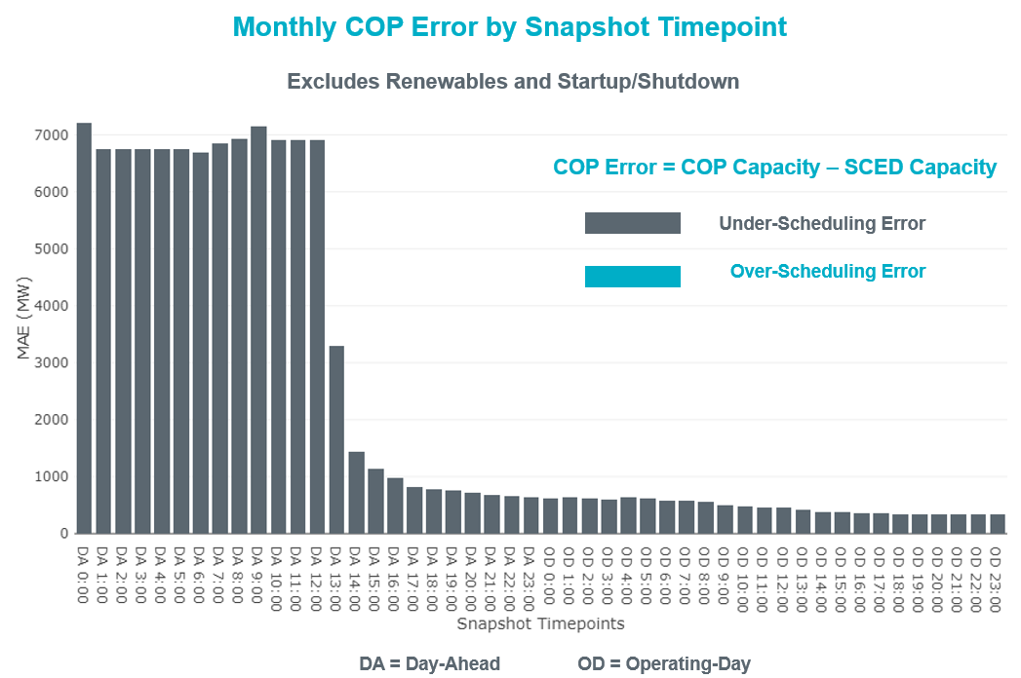

Monthly MAE for the Latest COP at the end of the Adjustment Period was 349 MW with median ranging from -249.5 MW for Hour-Ending (HE) 24 to 133.8 MW for HE 4. HE 10 on the 29th had the largest Over-Scheduling Error (2,070 MW) and HE 24 on the 19th had the largest Under-Scheduling Error (-2,610 MW).

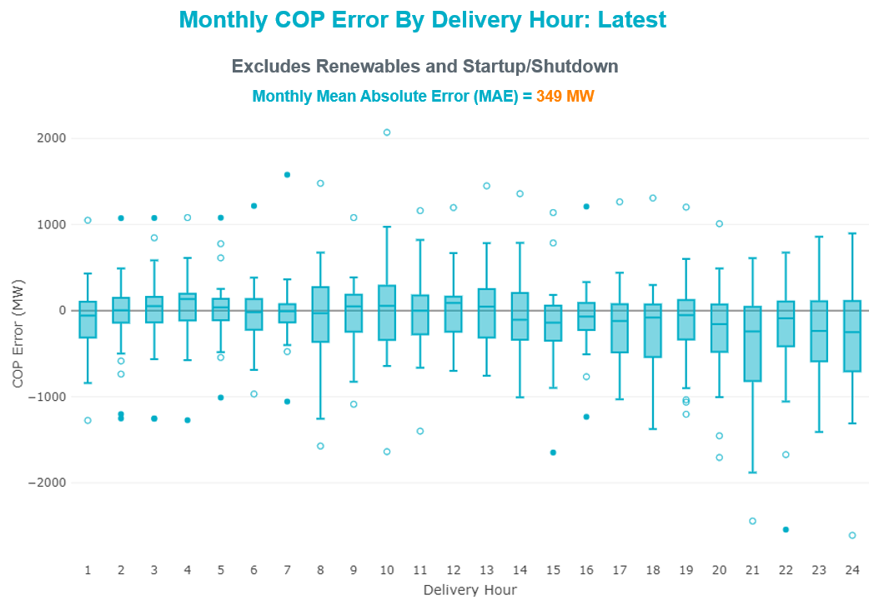

Monthly MAE for the Day-Ahead COP at 12:00 was 6,902 MW with median ranging from -8544 MW for Hour-Ending (HE) 18 to -3,674 MW for HE 3. HE 20 on the 15th had the largest Under-Scheduling Error (-18,042 MW) and HE 5 on the 22nd had the largest Over-Scheduling Error (263 MW).

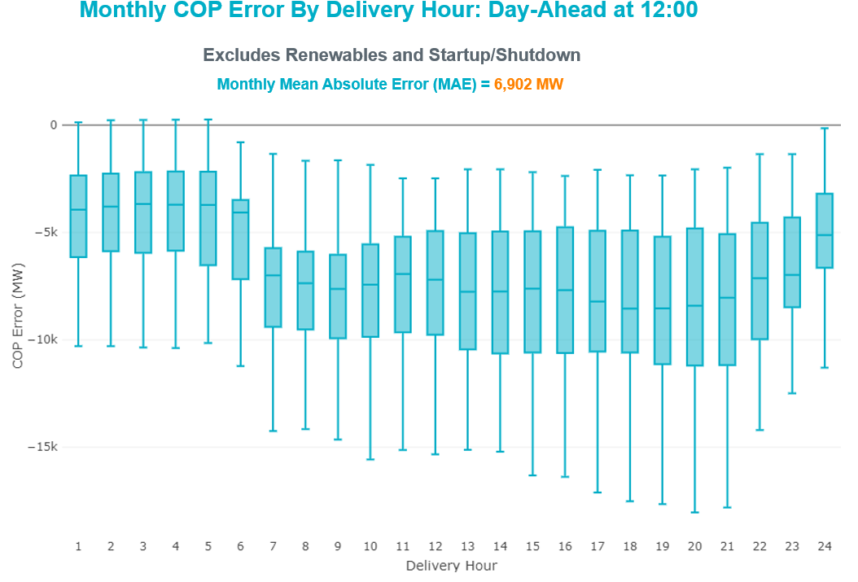

# Congestion Analysis

## Notable Constraints

Nodal protocol section 3.20 specifies that ERCOT shall identify transmission constraints that are active or binding three or more times within a calendar month. As part of this process, ERCOT reports congestion that meets this criterion to ROS. In addition ERCOT also highlights notable constraints that have an estimated congestion rent exceeding $1,000 for a calendar month. These constraints are detailed in the table below, including approved transmission upgrades from TPIT that may provide some congestion relief based on ERCOT’s engineering judgement. Rows highlighted in blue indicate the congestion was affected by one or more outages. For a list of all constraints activated in SCED, please see Appendix A at the end of this report.

|  |  |  |  |  |
| --- | --- | --- | --- | --- |
| **Contingency Name** | **Overloaded Element** | **# of Days Constraint Active** | **Congestion Rent** | **Transmission Project** |
|
| Basecase | PNHNDL GTC | 30 | $29,057,558.37 |  |
| TWR(345) JCK-REF27 & JCK-STP18 | Blessing - Pavlov 138kV | 13 | $18,088,390.33 | Freeport - Master Plan (6668A) |
| NORTH EDINBURG TRX 1382 345/138 | North Edinburg 345kV | 4 | $16,371,007.86 | Stewart Road: Construct 345 kV cut-in with two 450 MVA 345/138 autotransformers connected to Stewart Rd 138 station (5604, 6382) |
| TWR(345) JCK-REF27 & JCK-STP18 | South Texas Project - Wa Parish 345kV | 6 | $13,398,794.26 | Freeport - Master Plan (6668A) |
| Basecase | NE_LOB GTC | 29 | $9,889,208.98 |  |
| Basecase | WESTEX GTC | 20 | $7,901,532.12 |  |
| BAKERSFIELD SWITCHYARD to SCHNEEMAN DRAW LIN 1 | Schneeman Draw - Big Hill 345kV | 16 | $6,659,201.63 |  |
| Manual dbl ckt for NEDIN-BONILLA 345kV & RIOH-PRIM138kV | Haine Drive - La Palma 138kV | 17 | $6,641,937.36 | Luna 138 kV Station (44858) |
| DOW CHEMICAL to Jones Creek LIN A | Jones Creek - Velasco 138kV | 7 | $6,461,254.43 | Jones Creek Area Reconfigurations(52519A,B&C) |
| JEWET TO SNG 345 DBLCKT | Gibbons Creek - Twin Oak Switch 345kV | 9 | $5,809,441.90 |  |
| SALSW TO KLNSW 345 DBLCKT | Harker Heights South - Killeen Switch 138kV | 16 | $5,028,559.39 |  |
| DESOTO SWITCH TRX DESSW_3_1 345/138 | Lancaster - Watermill Switch 138kV | 2 | $4,708,780.80 |  |
| ODLAW SWITCHYARD to ASPHALT MINES LIN 1 | Hamilton Road - Maverick 138kV | 27 | $4,142,977.02 | Brackettville to Escondido: Construct 138 kV line (5206) |
| CRLNW TO LWSSW 345 DBLCKT | West Tnp - Highlands Tnp 138kV | 11 | $2,848,306.61 |  |
| Clear Crossing to Coulomb & Smoky Hill 345 kV | Fisher Road Switch - Riley 345kV | 4 | $2,331,944.16 |  |
| COMANCHE SWITCH (Oncor) to COMANCHE PEAK SES LIN _A | Comanche Tap - Comanche Switch (Oncor) 138kV | 19 | $1,850,880.28 |  |
| Melon Creek to RINCON LIN 1 | Bonnieview - Rincon 69kV | 17 | $1,064,671.63 |  |
| Manual dbl ckt for NEDIN-BONILLA 345kV & RIOH-PRIM138kV | Burns Sub - Rio Hondo 138kV | 10 | $944,967.99 | Stewart Road: Construct 345 kV cut-in with two 450 MVA 345/138 autotransformers connected to Stewart Rd 138 station (5604, 6382) |
| Basecase | RV_RH GTC | 29 | $879,005.59 |  |
| TWR(345) JCK-STP18 & REF-STP27 | Blessing - Pavlov 138kV | 11 | $869,527.56 | Freeport - Master Plan (6668A) |
| Fowlerton to LOBO 345 LIN1 | North Laredo Switch - Piloncillo 138kV | 10 | $784,462.70 |  |
| Cagnon-Kendal 345 & Cico-Comfor 138 | Bergheim - Kendall 345kV | 3 | $723,354.96 |  |
| RINCON to RINCON LIN 1 | Whitepoint 138kV | 7 | $668,970.14 |  |
| LAQUINTA to LOBO LIN 1 | Bruni Sub 138kV | 16 | $546,847.08 |  |
| VLYSW TO ANASW 345 AND VLYSW TO FMRVL 345 DBLCKT | Anna Switch - Valley Ses 345kV | 3 | $530,574.97 |  |
| GARCENO to ROMA LIN 1 | Garza 138kV | 12 | $516,918.17 | Uvalde - West Batesville: Rebuild 138 kV Line (57910) |
| Fowlerton to LOBO 345 LIN1 | Asherton - Catarina 138kV | 4 | $503,056.75 |  |
| BRACKETTVILLE to HAMILTON ROAD LIN 1 | Hamilton Road - Maverick 138kV | 18 | $365,277.29 | Brackettville to Escondido: Construct 138 kV line (5206) |
| Basecase | Santiago - Langford Wind Power Llc 138kV | 25 | $340,569.95 |  |
| Twinbu-Sarc&Amoscr 345kV | San Angelo Power Station - San Angelo South Tap 138kV | 10 | $247,927.51 |  |
| POMELO to NORTH EDINBURG LIN 1 | Lobo - Freer 69kV | 7 | $226,700.63 | Stewart Road: Construct 345 kV cut-in with two 450 MVA 345/138 autotransformers connected to Stewart Rd 138 station (5604, 6382) |
| FORT LANCASTER to ILLINOIS #4 LIN 1 | Hamilton Road - Maxwell 138kV | 19 | $220,537.97 |  |
| Fergus-Granmo & Wirtz 138kV | Ferguson - Horseshoe Bay 138kV | 6 | $173,698.74 |  |
| Basecase | NELRIO GTC | 16 | $164,514.20 |  |
| Bighil-Kendal 345kV | Yellow Jacket - Treadwell 138kV | 4 | $163,689.82 |  |
| Fowlerton to LOBO 345 LIN1 | Bruni Sub 138kV | 5 | $160,167.59 |  |
| COLEMAN LAKE IVIE TAP to EAST COLEMAN TAP LIN 1 | Ballinger - Ballinger Humble Tap 69kV | 8 | $155,345.22 |  |
| Loss of (White Point & Nueces Bay 138kV) and (White Point & Portland & Gibbs 138kV) | Whitepoint - Rincon 138kV | 8 | $152,008.61 | Whitepoint Area Improvements (50950) |
| Cagnon-Kendall 345kV&Txresch-Tally_Rd 138kV | Helotes - Ranchtwn 138kV | 3 | $146,816.66 |  |
| Marbfa-Lakewy &Wirtz-Palefa 138kV | Flat Rock Lcra - Wirtz 138kV | 7 | $140,153.91 |  |
| FORT MASON to YELLOW JACKET LIN 1 | Yellow Jacket - Hext Lcra 69kV | 5 | $136,050.87 |  |
| TWR(345) JCK-REF27 & JCK-STP18 | Lane City - Pavlov 138kV | 3 | $134,229.64 | Freeport - Master Plan (6668A) |
| FORT MASON to YELLOW JACKET LIN 1 | Mason Switching Station - Hext Lcra 69kV | 4 | $130,123.93 |  |
| GILLESPIE LCRA to FORT MASON LIN 1 | Mason Aep - Fredricksburg Phillips Tap 69kV | 13 | $112,088.65 |  |
| ENNIS WEST SWITCH to WAXAHACHIE PUMP 1 LIN _C | Ennis West Switch - Ennis South 138kV | 3 | $104,977.35 |  |
| Basecase | VALEXP GTC | 6 | $104,810.87 |  |
| LON HILL to NELSON SHARPE LIN 1 | Celanese Bishop - Kleberg Aep 138kV | 3 | $86,029.25 |  |
| GILLESPIE LCRA to FORT MASON LIN 1 | Fredricksburg Phillips Tap - Gillespie 69kV | 4 | $79,979.95 |  |
| SAN MIGUEL GEN to FOWLERTON LIN 1 | North Laredo Switch - Piloncillo 138kV | 4 | $78,618.96 |  |
| BENNETT ROAD SWITCH to WISE COUNTY LIN _B | Myra - Valley View Bepc 138kV | 3 | $74,396.65 |  |
| KLEBERG AEP to LOYOLA SUB LIN 1 | Loyola Sub 138kV | 4 | $73,311.53 |  |
| PARIS SWITCH to VALLEY SES Valley South | Rivercrest Ses - Deport Rea 138kV | 4 | $70,158.43 |  |
| Cenizo-Delsol ckt 2(345)&Rio_Brav-Zapata(138) | Roma - Roma Switch 138kV | 4 | $68,399.42 | Uvalde - West Batesville: Rebuild 138 kV Line (57910) |
| Twinbu-Sarc&Amoscr 345kV | Schkad - San Angelo Power Station 138kV | 7 | $68,077.77 |  |
| MCELMURRAY to ESKOTA SWITCH LIN 1 | Eskota Switch - Trent 69kV | 4 | $56,795.19 |  |
| Dilleysw-Sanmgsw&Cotulas 138kV | Dilley Switch Aep - Cotulla Sub 69kV | 3 | $51,252.47 | Dilley - Jourdanton 69 kV Line (44866) |
| Lynx to RIO PECOS LIN 1 | Fort Stockton Plant - Solstice 138kV | 4 | $45,591.59 |  |
| TWR(345) JCK-STP18 & REF-STP27 | Lane City - Pavlov 138kV | 3 | $44,886.27 | Freeport - Master Plan (6668A) |
| ELMOT TO WWEST 138 AND ELMOT TO WEAST 69 DBLCKT | Elm Mott - Mclennan County East 138kV | 8 | $43,745.86 |  |
| Manual dbl ckt for RIOHONDO-BONILLA 345kV & RRIOH-PRI 138kV | Haine Drive - La Palma 138kV | 3 | $42,977.42 | Luna 138 kV Station (44858) |
| Bighil-Kendal 345kV | Hamilton Road - Maxwell 138kV | 14 | $41,335.58 |  |
| GRSES TO CFRSW AND GRSES TO LNCRK 345 DBLCKT | Murray - Paint Creek 138kV | 5 | $37,664.98 |  |
| Basecase | N_TO_H GTC | 8 | $37,469.13 |  |
| SPUR to SALT CREEK SS LIN 1 | Aspermont Aep 138kV | 4 | $34,979.39 |  |
| Basecase | Randado Aep - Zapata 138kV | 16 | $33,991.96 |  |
| WICHITA FALLS SOUTH SWITCH to WINDTHORST SWITCH LIN _E | Cottonwood Road Switch - Olney Pod 69kV | 3 | $32,939.05 |  |
| CISCO to PUTNAM 138kv LIN 1 | Estes - Pecan Bayou 138kV | 4 | $30,450.23 |  |
| JACKCNTY TO BOW 138 AND WISECNTY TO ALVRD 138 DBLCKT | Myra - Valley View Bepc 138kV | 4 | $30,337.79 |  |
| FORT MASON to YELLOW JACKET LIN 1 | Fredricksburg Phillips Tap - Gillespie 69kV | 3 | $28,393.92 |  |
| Oran Sub to BARTON CHAPEL WIND FARM LIN _A | Graham Switch 138kV | 3 | $20,473.18 |  |
| SOUTH CARBIDE to TITAN SUBSTATION LIN 1 | South Carbide - Loma Alta Substation 138kV | 4 | $17,633.78 |  |
| Toksw-Gibcrk & Jk_Ck 345kV | Jewett - Singleton 345kV | 8 | $16,497.53 |  |
| PARIS SWITCH to VALLEY SES Valley South | Paris Switch - Deport Rea 138kV | 3 | $16,464.88 |  |
| PAREDES SWITCHING STATION to CENTRAL AVENUE SUB LIN 1 | Rio Hondo - East Rio Hondo Sub 138kV | 4 | $14,536.82 | Rebuild Rio Hondo to East Rio Hondo (6687) |
| BRACKETTVILLE to ODLAW SWITCHYARD LIN 1 | Hamilton Road - Maverick 138kV | 13 | $12,614.64 | Brackettville to Escondido: Construct 138 kV line (5206) |
| BLUFF CREEK to ABILENE SOUTH LIN 1 | Callahan Windfarm Fpl - Abilene Northwest 138kV | 3 | $11,876.24 |  |
| Basecase | Coffeeport - Central Avenue Sub 138kV | 4 | $11,409.66 |  |
| Delsol-Cabezntp-Cabezon(345)&Garza-Roma_Sw(138) | Garza 138kV | 6 | $11,032.45 | Uvalde - West Batesville: Rebuild 138 kV Line (57910) |
| ROMA SWITCH to GARZA LIN 1 | Garza 138kV | 3 | $9,735.49 | Uvalde - West Batesville: Rebuild 138 kV Line (57910) |
| WICHITA FALLS SOUTH SWITCH to WINDTHORST SWITCH LIN _E | Olney 138kV | 3 | $9,255.60 |  |
| Carver to FRIEND RANCH LIN 1 | Hamilton Road - Maxwell 138kV | 3 | $7,453.35 |  |
| ODLAW SWITCHYARD to ASPHALT MINES LIN 1 | Escondido - Ganso 138kV | 6 | $7,128.95 |  |
| TWINBU-DVIDE 345KV | Gasconades Creek - Morgan Creek Ses 345kV | 3 | $7,051.55 |  |
| SPUR to SALT CREEK SS LIN 1 | Aspermont Aep - Aspermont Continental 69kV | 2 | $5,078.28 |  |
| HAMILTON ROAD to CORRAL LIN 1 | Hamilton Road - Maxwell 138kV | 7 | $4,727.91 |  |
| FERGUSON to WIRTZ LIN 1 | Ferguson - Granite Mountain 138kV | 9 | $3,302.49 |  |
| Cenizo-Delsol(345)&Garza-Roma_Sw(138) | Garza 138kV | 6 | $2,986.26 | Uvalde - West Batesville: Rebuild 138 kV Line (57910) |
| MARCONI to LAURELES LIN 1 | Palo Alto Substation - Titan Substation 138kV | 3 | $2,615.43 | Stillman: Reterminate two AEP 138 kV lines (55270) |
| BLUFF CREEK TRX BLUF_CRK_3_1 345/138 | Bluff Creek 345kV | 6 | $1,953.31 |  |
| Manual SOAPTREE to RIOPECOS 138kV | Fort Stockton Plant - Solstice 138kV | 4 | $1,865.02 |  |
| FERGUSON to GRANITE MOUNTAIN LIN 1 | Starcke - Paleface 138kV | 4 | $1,231.70 |  |

## Generic Transmission Constraint Congestion

There were 30 days of congestion on the Panhandle GTC, 20 days on the West Texas Export GTC, 29 days on the Raymondville to RioHondo GTC, 16 days on the Nelson Sharpe to Rio Hondo GTC, and 8 days on the North to Houston GTC. There was no activity on the remaining GTCs during the month.

Note: This is how many times a constraint has been activated to avoid exceeding a GTC limit, it does not imply an exceedance of the GTC occurred or that the GTC was binding.

## Manual Overrides

None

## Congestion Costs for Calendar Year 2021

The following table represents the top twenty active constraints for the calendar year based on the estimated congestion rent attributed to the congestion. ERCOT updates this list on a monthly basis.

|  |  |  |  |  |
| --- | --- | --- | --- | --- |
| **Contingency** | **Overloaded Element** | **# of 5-min SCED** | **Estimated** | **Transmission Project** |
| Elmcreek-Sanmigl 345kV | Pawnee Switching Station - Calaveras 345kV | 2079 | $76,199,104.65 |  |
| LOST PINES AEN to FAYETTE PLANT 1 LIN 1 | Winchester - Fayette Plant 1 And 2 345kV | 415 | $51,438,867.64 |  |
| JOHNSON SWITCH (ONCOR) to CONCORD LIN G1 | Decordova Dam - Carmichael Bend Switch 138kV | 726 | $46,614,977.07 | DeCordova 345/138kV_Sw. (7129) |
| Basecase | PNHNDL GTC | 6460 | $30,917,045.40 |  |
| Hicross-Pilot & Garfield 138kV | Carson Creek - Pilot Knob 138kV | 803 | $30,600,531.85 |  |
| Basecase | Colorado Bend Energy Center - Dyann 138kV | 242 | $26,093,025.30 |  |
| CONCORD TRX CRD1 345/138 | Concord 345kV | 840 | $21,139,669.60 |  |
| Lostpi-Austro&Dunlap 345kV | Sim Gideon - Winchester 138kV | 635 | $20,472,271.99 |  |
| Lytton_S-Slaughte&Turner 138kV | Mccarty Lane - Zorn 138kV | 245 | $20,185,815.81 |  |
| Basecase | Pawnee Switching Station - Calaveras 345kV | 27 | $17,214,426.04 |  |
| ASHERTON to Bevo Substation LIN 1 | Hamilton Road - Maverick 138kV | 525 | $17,023,560.36 | Brackettville to Escondido: Construct 138 kV line (5206) |
| KILLEEN SWITCH TRX KLNSW_3_2 345/138 | Killeen Switch 345kV | 234 | $16,301,132.28 |  |
| GILA to HIWAY 9 LIN 1 | Gila - Hiway 9 138kV | 312 | $15,790,117.72 |  |
| MCCARTY LANE to ZORN LIN 1 | Crosswinds - Turnersville 138kV | 248 | $15,722,185.46 |  |
| Cagnon-Kendal 345kV & Mengcr-Ranchtwn 138kV | Txresrch - Tally_Rd 138kV | 247 | $13,023,749.96 |  |
| Manual dbl ckt for NEDIN-BONILLA 345kV & RIOH-PRIM138kV | Haine Drive - La Palma 138kV | 1012 | $10,669,545.19 | Luna 138 kV Station (44858) |
| Garfield-Stoney_R&Hicross138KV | Lytton Springs - Pilot Knob 138kV | 618 | $10,396,037.77 |  |
| SAN MIGUEL 345_138 KV SWITCHYARDS TRX SANMGL8_3_1 345/138 | Pawnee Switching Station - Calaveras 345kV | 223 | $10,178,642.77 |  |
| Lostpine-Fppyd1&Winches 345kV | Sim Gideon - Winchester 138kV | 160 | $9,872,618.58 |  |
| CBFSW TO BRNSW 345 AND CBFSW TO BLUF CRK 345 DBLCKT | Abilene Mulberry Creek - Abilene Northwest 138kV | 536 | $9,733,251.69 |  |

# System Events

## ERCOT Peak Load

The unofficial ERCOT peak load[1] for the month was 45,367 MW and occurred on the 27th, during hour ending 18:00.

## Load Shed Events

None.

## Stability Events

None.

## Notable PMU Events

ERCOT analyzes PMU data for any significant system disturbances that do not fall into the Frequency Events category reported in section 2.1. The results are summarized in this section once the analysis has been completed.

There were no PMU events outside of those reported in section 2.1.

## DC Tie Curtailment

None.

## TRE/DOE Reportable Events

* ONCOR TO submitted an OE-417 for 03/17/2021 Reportable Event Type: Loss of Electric Service.
* AEP TO submitted an OE-417 for 03/30/2021 Reportable Event Type: Transmission Loss.

## New/Updated Constraint Management Plans

On 03/31/2021, MP_2019_06 was removed.

## New/Modified/Removed RAS

On 03/31/2021, the Culberson Loop RAS was retired.

## New Procedures/Forms/Operating Bulletins

|  |  |  |
| --- | --- | --- |
| **Date** | **Subject** | **Bulletin No.** |
| 03/01/2021 | Transmission and Security Desk V1 Rev 82 | 970 |
| 04/01/2021 | DC Tie Desk V1 Rev 65 | 971 |
| 04/01/2021 | Real Time Desk V1 Rev 71 | 972 |
| 04/01/2021 | Scripts V1 Rev 35 | 973 |
| 04/01/2021 | Shift Supervisor Desk V1 Rev 70 | 974 |
| 04/01/2021 | Transmission and Security Desk V1 Rev 83 | 975 |

# Emergency Conditions

## OCNs

|  |  |
| --- | --- |
| **Date and Time** | **Message** |
| Mar 08 2021 09:37 CPT | ERCOT issued an OCN due to taking manual action on the PANHANDLE IROL due to transmission outages. |
| Mar 09 2021 03:25 CPT | ERCOT issued an OCN due to taking manual action on the WESTEX GTC for an unsolved contingency. |
| Mar 13 2021 15:26 CPT | ERCOT issued an OCN due to taking manual action to control an unsolved contingency in the West Texas area. |
| Mar 15 2021 03:00 CPT | ERCOT issued an OCN due to a Projected Reserve Capacity Shortage for HE19, HE20 and HE21. |

## Advisories

|  |  |
| --- | --- |
| **Date and Time** | **Message** |
| Mar 02 2021 13:30 CPT | ERCOT has postponed the deadline for the posting of the DAM Solution for Operating Day March 3, 2021 due to delay in clearing DAM. |
| Mar 05 2021 13:30 CPT | ERCOT has postponed the deadline for the posting of the DAM Solution for Operating Day March 6, 2021 due to delay in clearing DAM |
| Mar 25 2021 11:50 CPT | ERCOT issued an Advisory due to ERCOT’s Voltage Security Assessment Tool being unavailable. |

## Watches

|  |  |
| --- | --- |
| **Date and Time** | **Message** |
| Mar 10 2021 11:29 CPT | ERCOT issued a Watch due to the failure of the SCED process. |

## Emergency Notices

None.

# Application Performance

## TSAT/VSAT Performance Issues

None. Please review the Advisory above for ERCOT’s Voltage Security Assessment Tool being unavailable.

## Communication Issues

None.

## Market System Issues

None.

# Model Updates

The Downstream Production Change (DPC) process allows ERCOT to make changes in the on-line Network Operations Model without loading a completely new model. The purpose of this process is to allow for reliable grid operations as system conditions change between designated Network Operations Model database loads. The DPC process is limited in scope to just those items listed below, with equipment ratings updates being the most common. ERCOT has seen a rise in the use of the DPC process to make on-line updates to the Network Operations Model in recent years, instead of through the standard Network Operations Model Change Request process.

* Static Line ratings (Interim Update)
* Dynamic Line ratings (non-Interim Update)
* Autotransformer ratings (non-Interim Update)
* Breaker and Switch Normal status (Interim Update)
* Contingency Definitions (Interim Update)
* RAP and RAS changes or additions (Interim Update)
* Net Dependable and Reactive Capability (NDCRC) values (Interim Update)
* Impedance Updates (non-Interim)

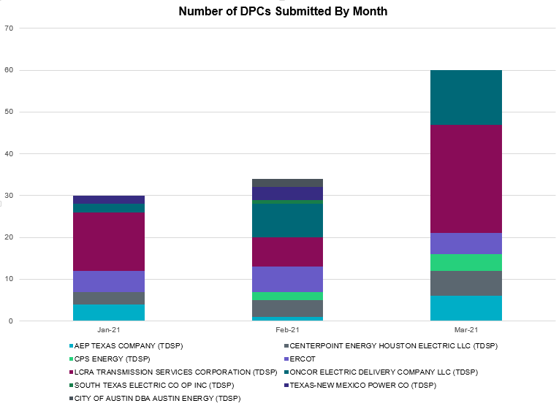

|  |  |
| --- | --- |
| **Transmission Operator** | **Number of DPCs** |
| AEP TEXAS COMPANY (TDSP) | 6 |
| BRAZOS ELECTRIC POWER CO OP INC (TDSP) | 0 |
| BROWNSVILLE PUBLIC UTILITIES BOARD (TDSP) | 0 |
| BRYAN TEXAS UTILITIES (TDSP) | 0 |
| CENTERPOINT ENERGY HOUSTON ELECTRIC LLC (TDSP) | 6 |
| CITY OF AUSTIN DBA AUSTIN ENERGY (TDSP) | 0 |
| CITY OF COLLEGE STATION (TDSP) | 0 |
| CITY OF GARLAND (TDSP) | 0 |
| CPS ENERGY (TDSP) | 4 |
| DENTON MUNICIPAL ELECTRIC (TDSP) | 0 |
| ELECTRIC TRANSMISSION TEXAS LLC (TDSP) | 0 |
| ERCOT | 5 |
| LCRA TRANSMISSION SERVICES CORPORATION (TDSP) | 26 |
| LONE STAR TRANSMISSION LLC (TSP) | 0 |
| ONCOR ELECTRIC DELIVERY COMPANY LLC (TDSP) | 13 |
| RAYBURN COUNTRY CO OP DBA RAYBURN ELECTRIC (TDSP) | 0 |
| SHARYLAND UTILITIES LP (TDSP) | 0 |
| SOUTH TEXAS ELECTRIC CO OP INC (TDSP) | 0 |
| TEXAS MUNICIPAL POWER AGENCY (TDSP) | 0 |
| TEXAS-NEW MEXICO POWER CO (TDSP) | 0 |

# Appendix A: Real-Time Constraints

The following is a complete list of constraints activated in SCED. Full contingency descriptions can be found in the Standard Contingencies List located on the MIS secure site at Grid 🡪 Generation 🡪 Reliability Unit Commitment.

|  |  |  |  |  |
| --- | --- | --- | --- | --- |
| Contingency Name | Overloaded Element | From Station | To Station | Count of Days |
| BASE CASE | PNHNDL | n/a | n/a | 30 |
| BASE CASE | NE_LOB | n/a | n/a | 29 |
| BASE CASE | RV_RH | n/a | n/a | 29 |
| SBRAUVA8 | HAMILT_MAVERI1_1 | HAMILTON | MAVERICK | 27 |
| BASE CASE | LGD_SANTIA1_1 | LGD | SANTIAGO | 25 |
| BASE CASE | WESTEX | n/a | n/a | 20 |
| SCMNCPS5 | 651__B | CMNSW | CMNTP | 19 |
| SILLFTL8 | HAMILT_MAXWEL1_1 | MAXWELL | HAMILTON | 19 |
| SBRAHAM8 | HAMILT_MAVERI1_1 | HAMILTON | MAVERICK | 18 |
| SMELRIN8 | BONIVI_RINCON1_1 | RINCON | BONIVIEW | 17 |
| MHARNED5 | HAINE__LA_PAL1_1 | LA_PALMA | HAINE_DR | 17 |
| DSALKLN5 | 630__B | KLNSW | HHSTH | 16 |
| SBAKSCH5 | SCHNDR_BIGHIL_1 | SCHNDR | BIGHIL | 16 |
| BASE CASE | NELRIO | n/a | n/a | 16 |
| SLAQLOB8 | BRUNI_69_1 | BRUNI | BRUNI | 16 |
| BASE CASE | RANDAD_ZAPATA1_1 | ZAPATA | RANDADO | 16 |
| BASE CASE | RANDAD_ZAPATA1_1 | RANDADO | ZAPATA | 16 |
| DBIGKEN5 | HAMILT_MAXWEL1_1 | MAXWELL | HAMILTON | 14 |
| SFORGIL8 | FRPHIL_MASN1_1 | MASN | FRPHILLT | 13 |
| DSTPRED5 | BLESSI_PAVLOV1_1 | BLESSING | PAVLOV | 13 |
| SODLBRA8 | HAMILT_MAVERI1_1 | HAMILTON | MAVERICK | 13 |
| SGA2ROM8 | GARZA_69A1 | GARZA | GARZA | 12 |
| DCRLLSW5 | 588_B_1 | LWSVH | LWSVW | 11 |
| DREFSTP5 | BLESSI_PAVLOV1_1 | BLESSING | PAVLOV | 11 |
| MHARNED5 | BURNS_RIOHONDO_1 | RIOHONDO | MV_BURNS | 10 |
| MHARNED5 | BURNS_RIOHONDO_1 | MV_BURNS | RIOHONDO | 10 |
| SLOBSA25 | NLARSW_PILONC1_1 | NLARSW | PILONCIL | 10 |
| DBWNAMO5 | SAPOWE_SAST1_1 | SAPOWER | SAST | 10 |
| DJEWSNG5 | 256_A_1 | TOKSW | GIBCRK | 9 |
| SWIRFE28 | 51T376_1 | FERGUS | GRANMO | 9 |
| DWHIGIB8 | RINCON_WHITE_2_1 | WHITE_PT | RINCON | 8 |
| BASE CASE | N_TO_H | n/a | n/a | 8 |
| DELMWWE8 | 1020__A | ELMOT | MCTYE | 8 |
| SCOLBAL8 | BALLIN_HUMBLT1_1 | BALLINGE | HUMBLTAP | 8 |
| DTOKJK_5 | 260_A_1 | JEWET | SNG | 8 |
| SPOMNED5 | FREER_LOBO1_1 | LOBO | FREER | 7 |
| SDOWJCK5 | JCKVL_02_A | JCK | VL | 7 |
| DMARPA_8 | 38T365_1 | WIRTZ | FLATRO | 7 |
| SCOMHA38 | HAMILT_MAXWEL1_1 | MAXWELL | HAMILTON | 7 |
| SRINRIN8 | WHITE_PT_69A1 | WHITE_PT | WHITE_PT | 7 |
| DBWNAMO5 | 134T429_1 | SCHKAD | SAPOWER | 7 |
| DSTPRED5 | STPWAP39_1 | STP | WAP | 6 |
| DFER_WI8 | 49T191_1 | FERGUS | HORSBA | 6 |
| BASE CASE | VALEXP | n/a | n/a | 6 |
| DREFSTP5 | STPWAP39_1 | STP | WAP | 6 |
| XBL2U58 | BLUF_CRK_T1_H | BLUF_CRK | BLUF_CRK | 6 |
| DCENRO58 | GARZA_69A1 | GARZA | GARZA | 6 |
| SBRAUVA8 | ESCOND_GANSO1_1 | GANSO | ESCONDID | 6 |
| DCABRO58 | GARZA_69A1 | GARZA | GARZA | 6 |
| DWIRSTA8 | 51T376_1 | FERGUS | GRANMO | 6 |
| BASE CASE | RAMBLER_GENTIE_1 | RAMBLER | TWINBU | 5 |
| SLOBSA25 | BRUNI_69_1 | BRUNI | BRUNI | 5 |
| DSNG_TB5 | THWZEN71_A | ZEN | THW | 5 |
| SFORYEL8 | HEXT_YELWJC1_1 | YELWJCKT | HEXT | 5 |
| DGRSLNC5 | 6380__D | PAINTCRE | MURRAY | 5 |
| DFERSTA8 | 49T191_1 | FERGUS | HORSBA | 4 |
| SLYNRIO8 | FTST_SOLSTI1_1 | FTST | SOLSTICE | 4 |
| DJACALV8 | MYRA_VAL_1 | MYRA | VALYVIEW | 4 |
| SSPUSLT8 | ASPM_69T1 | ASPM | ASPM | 4 |
| SMCEABS8 | HAMLIN_PLST1_1 | HAMLIN | PLST | 4 |
| SSANFOW5 | NLARSW_PILONC1_1 | NLARSW | PILONCIL | 4 |
| SMCEESK8 | ESKSW_TRNT1_1 | ESKSW | TRNT | 4 |
| SGRAFER8 | 83T196_1 | STARCK | PALEFA | 4 |
| BASE CASE | BEARKT | n/a | n/a | 4 |
| SFORYEL8 | HEXT_MASONS1_1 | HEXT | MASONSW | 4 |
| SMCEABS8 | HAMLIN_PLST1_1 | PLST | HAMLIN | 4 |
| XNED258 | NEDIN_138H | NEDIN | NEDIN | 4 |
| SMCEESK8 | ESKSW_TRNT1_1 | TRNT | ESKSW | 4 |
| SCISPUT8 | ESTES_PECAN_1_1 | PECAN_BY | ESTES | 4 |
| SMV_PAR8 | RIOHND_ERIOHND_1 | MV_RIOHO | RIOHONDO | 4 |
| DCLECOU5 | 6011__B | RILEY | FSHSW | 4 |
| MSOARIO8 | FTST_SOLSTI1_1 | FTST | SOLSTICE | 4 |
| STITSCA8 | OCB_2175_1 | SCARBIDE | LOMA_ALT | 4 |
| DCE_RIO5 | RGCIT_ROMAS_1C_1 | ROMA_SW | ROMA | 4 |
| DBIGKEN5 | TREADW_YELWJC1_1 | TREADWEL | YELWJCKT | 4 |
| DPRSVLS5 | 1561__A | DPREA | RCSES | 4 |
| SLOBSA25 | ASHERT_CATARI1_1 | ASHERTON | CATARINA | 4 |
| BASE CASE | CP_MVCNT_1 | MV_CNTRA | COFFPORT | 4 |
| SFORGIL8 | FRPHIL_GILLES1_1 | GILLES | FRPHILLT | 4 |
| SKLELOY8 | LOYOLA_69_1 | LOYOLA | LOYOLA | 4 |
| SSPUSLT8 | ASPM_CONA1_1 | ASPM | CONA | 3 |
| SSCLWF28 | OLN_FMR2 | OLN | OLN | 3 |
| SMARLAU8 | PALOAL_TITAN_1_1 | PALOALTO | TITAN_SU | 3 |
| SMGIENW8 | 941__C | ENSSO | ENWSW | 3 |
| SMGIENW8 | 941__C | ENWSW | ENSSO | 3 |
| SSPUSLT8 | ASPM_CONA1_1 | CONA | ASPM | 3 |
| DTWIDIV5 | 430T430_1 | GASCCR | MGSES | 3 |
| SCMNCPS5 | 651__C | CMNTP | SHILO | 3 |
| SSCLWF28 | 6830__B | CRDSW | OLNEY | 3 |
| SABSBLU8 | ABNTHW_CALLAH1_1 | CALLAHAN | ABNTHWST | 3 |
| DDILCOT8 | DIL_COTU_1 | COTULAS | DILLEYSW | 3 |
| SBRTORA8 | GRMSW_FMR1 | GRMSW | GRMSW | 3 |
| DSTPRED5 | LAN_CT_PAVLOV1_1 | PAVLOV | LAN_CTY | 3 |
| DREFSTP5 | LAN_CT_PAVLOV1_1 | PAVLOV | LAN_CTY | 3 |
| DLWSRNK5 | 587__A | ARGYL | LWSVH | 3 |
| DCAGCO58 | 656T656_1 | KENDAL | BERGHE | 3 |
| SMARLAU8 | PALOAL_TITAN_1_1 | TITAN_SU | PALOALTO | 3 |
| DVLYANA5 | 71__A | VLSES | ANASW | 3 |
| SFORYEL8 | FRPHIL_GILLES1_1 | GILLES | FRPHILLT | 3 |
| MHARRIO5 | HAINE__LA_PAL1_1 | LA_PALMA | HAINE_DR | 3 |
| SMCEESK8 | HAMLIN_PLST1_1 | PLST | HAMLIN | 3 |
| BASE CASE | HWY511_COFEPRT_1 | COFFPORT | MV_HW511 | 3 |
| SBTPBNT8 | MYRA_VAL_1 | MYRA | VALYVIEW | 3 |
| DPRSVLS5 | 1561__B | PRSSW | DPREA | 3 |
| SN_SLON5 | CELANE_KLEBER1_1 | CELANEBI | KLEBERG | 3 |
| SGARROM8 | GARZA_69A1 | GARZA | GARZA | 3 |
| SCARFRI8 | HAMILT_MAXWEL1_1 | MAXWELL | HAMILTON | 3 |
| BASE CASE | HWY511_SCARBID_1 | MV_HW511 | SCARBIDE | 3 |
| DCAGTA58 | H3_K0_1 | K0 | H3 | 3 |
| SSCLWF18 | 6840__B | NVKSW | ANARN | 2 |
| STITSCA8 | LAUREL_MARCON1_1 | LAURELES | MARCONI | 2 |
| SN_SLON5 | LOYOLA_69_1 | LOYOLA | LOYOLA | 2 |
| MGLDDMT8 | SNYDR_FMR1 | SNYDR | SNYDR | 2 |
| XDES258 | 760__D | WTRML | LNCST | 2 |
| SENSENS8 | 940__C | ENWSW | WXHCH | 2 |
| SMCEABS8 | ESKSW_TRNT1_1 | ESKSW | TRNT | 2 |
| DCBYJOR5 | HL_PSA08_A | PSA | HL | 2 |
| DRENRHO8 | MYRA_VAL_1 | MYRA | VALYVIEW | 2 |
| MHARNED5 | OCB_2175_1 | SCARBIDE | LOMA_ALT | 2 |
| SMARLAU8 | SCARBI_TITAN_1_1 | TITAN_SU | SCARBIDE | 2 |
| BASE CASE | SWEETWN3_XF31 | SWEETWN3 | SWEETWN3 | 2 |
| DMAR_PA8 | 83T196_1 | STARCK | PALEFA | 2 |
| SMGIENW8 | 943__A | ENWSW | ENSSW | 2 |
| DSWELNC5 | BLUF_C_MULBER1_1 | BLUF_CRK | MULBERRY | 2 |
| SDOWJCK5 | FP_SRF59_A | FP | SRF | 2 |
| SSCLWF28 | NVKSW_FMR1 | NVKSW | NVKSW | 2 |
| BASE CASE | REDTAP | n/a | n/a | 2 |
| XWH2T58 | WHTNY_HT1L | WHTNY | WHTNY | 2 |
| SLCDYN8 | EB_WA_65_A | EB | WA | 2 |
| SLOBSA25 | FREER_LOBO1_1 | LOBO | FREER | 2 |
| SLOBSA25 | LARDVN_LASCRU1_1 | LARDVNTH | LASCRUCE | 2 |
| BASE CASE | LVOK_SANTIA1_1 | SANTIAGO | LVOK | 2 |
| DCAGCI58 | 460T460_1 | MEDILA | W1 | 2 |
| DENWSTE8 | 943__A | ENWSW | ENSSW | 2 |
| XLOB58 | ASHERT_CATARI1_1 | ASHERTON | CATARINA | 2 |
| STITSCA8 | LAUREL_MARCON1_1 | MARCONI | LAURELES | 2 |
| SCARFRI8 | SANTIA_SAPOWE1_1 | SANTIAGO | SAPOWER | 2 |
| SMARLAU8 | SCARBI_TITAN_1_1 | SCARBIDE | TITAN_SU | 2 |
| SBOMJC25 | 6830__B | CRDSW | OLNEY | 2 |
| SBLSJAC8 | MYRA_VAL_1 | MYRA | VALYVIEW | 2 |
| DMTSCOS5 | 6474__A | SUNSW | MGSES | 2 |
| SBONNED5 | BURNS_RIOHONDO_1 | RIOHONDO | MV_BURNS | 2 |
| SJARDIL8 | DIL_COTU_1 | COTULAS | DILLEYSW | 2 |
| SN_SLON5 | KINGSV_KLEBER1_1 | KLEBERG | KINGSVIL | 2 |
| DCPSST58 | 651__B | CMNSW | CMNTP | 1 |
| DCPSST58 | 651__C | CMNTP | SHILO | 1 |
| DFERGRM8 | 654T654_1 | WIRTZ | STARCK | 1 |
| SBOMJC25 | 6560__A | RICSW | GRSES | 1 |
| DNLSCRL8 | 715__A | CRLNW | CRLJL | 1 |
| DPRSVLS5 | 871__A | COMRC | COMSW | 1 |
| BASE CASE | CORRAL_ILLN1_1 | ILLN | CORRAL | 1 |
| DTGFLC_8 | EL_CAM_LANCTY1_1 | LANCTYPM | EL_CAMPO | 1 |
| DELMSAN5 | MHONDOCR_1 | MOORE | HONDOCK | 1 |
| SSYCOLS9 | OLS_JNES_1 | OLSEN | JNESBORO | 1 |
| SLAULA_8 | PALOAL_TITAN_1_1 | PALOALTO | TITAN_SU | 1 |
| DFER_WI8 | SANDCR_AT1 | SANDCR | SANDCR | 1 |
| SMYRWOL8 | SJO_SJO2 | SJO | SJO | 1 |
| DRNS_TB5 | THWZEN98_A | ZEN | THW | 1 |
| DCAGCO58 | 583T583_1 | BANDER | MASOCR | 1 |
| DBWNKLN5 | 651__B | CMNSW | CMNTP | 1 |
| DPRSVLS5 | 870__A | COMSW | COMSO | 1 |
| DPRSVLS5 | 870__B | COMSO | CMBTP | 1 |
| SMCEABS8 | CAPELL_MERK1_1 | MERK | CAPELLA | 1 |
| SN_SLON5 | CELANE_N_SHAR1_1 | N_SHARPE | CELANEBI | 1 |
| DBIGKEN5 | CROSSO_NORTMC1_1 | NORTMC | CROSSOVE | 1 |
| DDILCOT8 | DILLEYSW_69A1 | DILLEYSW | DILLEYSW | 1 |
| SLCDYN8 | GEBWA_65_A | WA | GEB | 1 |
| DBIGKEN5 | HAMILT_MAVERI1_1 | HAMILTON | MAVERICK | 1 |
| SCABWES8 | HOLLY4_WESTSI1_1 | HOLLY4 | WESTSIDE | 1 |
| BASE CASE | LENSW_PUTN2_1 | LENSW | PUTN | 1 |
| STITSCA8 | P_ISAB_SCARBI1_1 | SCARBIDE | P_ISABEL | 1 |
| SPOMDEL5 | RGCIT_ROMAS_1C_1 | ROMA_SW | ROMA | 1 |
| SMYRSPR8 | SJO_SJO2 | SJO | SJO | 1 |
| DRNS_TB5 | THWZEN71_A | ZEN | THW | 1 |
| DEVRCRT5 | 6300__I | OAKT2 | TATTP | 1 |
| MHARNED5 | BURNS_HEIDLBRG_1 | MV_BURNS | MV_HBRG4 | 1 |
| DBWN_AM5 | CONCHO_VRBS1_1 | CONCHO | VRBS | 1 |
| SBRAUVA8 | FRIR_ROCKSP1_1 | FRIR | ROCKSPRS | 1 |
| SODLBRA8 | FRIR_ROCKSP1_1 | FRIR | ROCKSPRS | 1 |
| SMDOPHR5 | G138_10B_1 | SEMINOLE | MAGNO_TN | 1 |
| DMGSQAL5 | HARGRO_TWINBU1_1 | TWINBU | HARGROVE | 1 |
| SPALSCA8 | LAUREL_LA_PAL1_1 | LAURELES | LA_PALMA | 1 |
| SPOMNED5 | RGCIT_ROMAS_1C_1 | ROMA_SW | ROMA | 1 |
| DFERSTA8 | SANDCR_AT1 | SANDCR | SANDCR | 1 |
| SBRAUVA8 | SANTIA_SAPOWE1_1 | SANTIAGO | SAPOWER | 1 |
| DRILBOW5 | 6558__B | FSHSW | WFALS | 1 |
| DKENCA58 | 656T656_1 | KENDAL | BERGHE | 1 |
| SMGIENW8 | 941__B | ENNIS | ENSSW | 1 |
| BASE CASE | CFLATS_TLINE_1 | CFLATS | TREADWEL | 1 |
| SHOLWES8 | HOLLY4_SOUTH_1_1 | HOLLY4 | SOUTH_SI | 1 |
| SPALSCA8 | LAUREL_MARCON1_1 | MARCONI | LAURELES | 1 |
| SMCEABS8 | MKLT_TRNT1_1 | TRNT | MKLT | 1 |
| DFER_WI8 | SAPOWE_TREADW1_1 | TREADWEL | SAPOWER | 1 |
| DSNG_TB5 | THWZEN98_A | ZEN | THW | 1 |
| DD1RAZ_8 | UVALDE_W_BATE1_1 | UVALDE | W_BATESV | 1 |
| DGRSPKR5 | 6377__A | BRTSW | ORANS | 1 |
| SSASGOL8 | 670__C | CMPBW | BRNSO | 1 |
| SMGIENW8 | 920__D | ENPTP | TLC | 1 |
| DCC1DUKE | ASHERT_CATARI1_1 | ASHERTON | CATARINA | 1 |
| DWAPHLJ5 | BLESSI_PAVLOV1_1 | BLESSING | PAVLOV | 1 |
| XLAS95 | COCS_FTST1_1 | FTST | COCS | 1 |
| SSANFOW5 | COTULL_REVEIL1_1 | REVEILLE | COTULLA | 1 |
| STGFLC8 | EL_CAM_LANCTY1_1 | LANCTYPM | EL_CAMPO | 1 |
| DBIGKEN5 | FRIR_ROCKSP1_1 | FRIR | ROCKSPRS | 1 |
| SN_MNED8 | HALL_A_S_MCAL1_1 | HALL_ACR | S_MCALLN | 1 |
| SVCAMIL8 | LAUREL_LA_PAL1_1 | LA_PALMA | LAURELES | 1 |
| SCISPUT8 | LENSW_PUTN2_1 | PUTN | LENSW | 1 |
| SGOHJOS8 | LOLITA_VICTOR1_1 | LOLITA | VICTORIA | 1 |
| SCOMHA38 | MAXWEL_WHITIN1_1 | MAXWELL | WHITING | 1 |
| XN_S58 | OCB_2175_1 | SCARBIDE | LOMA_ALT | 1 |
| SBOSWHT8 | OLS_JNES_1 | OLSEN | JNESBORO | 1 |
| SLAULA_8 | PALOAL_TITAN_1_1 | TITAN_SU | PALOALTO | 1 |
| SSPRVAL8 | SJO_SJO2 | SJO | SJO | 1 |
| SESCGAN8 | UVALDE_W_BATE1_1 | UVALDE | W_BATESV | 1 |
| DSCOFAR5 | 6216__B | WLVSW | SHRNE | 1 |
| DCAGCI58 | 656T656_1 | KENDAL | BERGHE | 1 |
| SLAKMA28 | 83T196_1 | STARCK | PALEFA | 1 |
| DTWIBGL8 | CONCHO_SAMATH1_1 | CONCHO | SAMATHIS | 1 |
| DDELGA58 | FREER_LOBO1_1 | LOBO | FREER | 1 |
| SPOMDEL5 | FREER_LOBO1_1 | LOBO | FREER | 1 |
| SBRAHAM8 | GANSO_MAVERI1_1 | MAVERICK | GANSO | 1 |
| SMCEABS8 | MERK_MKLT1_1 | MKLT | MERK | 1 |
| SLAULA_8 | OLMITO_PALOAL1_1 | PALOALTO | OLMITO | 1 |
| DMARPA_8 | 49T191_1 | FERGUS | HORSBA | 1 |
| SGRAFER8 | 654T654_1 | WIRTZ | STARCK | 1 |
| XBLU58 | BLUF_CRK_T2_H | BLUF_CRK | BLUF_CRK | 1 |
| DCHBJOR5 | CBY_AT1 | CBY | CBY | 1 |
| SBRAHAM8 | ESCOND_GANSO1_1 | GANSO | ESCONDID | 1 |
| SBOSWHT8 | LKW_WHT_1 | LKWHITNY | WHTNY | 1 |
| SVCAMIL8 | MARCON_P_ISAB1_1 | MARCONI | P_ISABEL | 1 |
| SMARLAU8 | OCB_2175_1 | SCARBIDE | LOMA_ALT | 1 |
| SHACPB38 | PIGCRE_SOLSTI1_1 | SOLSTICE | PIGCREEK | 1 |
| SEAGHAM8 | UVALDE_W_BATE1_1 | UVALDE | W_BATESV | 1 |
| SRAZUVA8 | UVALDE_W_BATE1_1 | UVALDE | W_BATESV | 1 |
| SSANFOW5 | UVALDE_W_BATE1_1 | UVALDE | W_BATESV | 1 |
| DFERHOR8 | 654T654_1 | WIRTZ | STARCK | 1 |
| MANGWHI5 | BLESSI_LOLITA1_1 | LOLITA | BLESSING | 1 |
| DBIGKEN5 | BONDRO_SONR1_1 | SONR | BONDROAD | 1 |
| DSTPRED5 | CKT_3124_1 | STP | HLJ | 1 |
| SBAKSCH5 | MAXWEL_WHITIN1_1 | MAXWELL | WHITING | 1 |
| SBRAUVA8 | MAXWEL_WHITIN1_1 | MAXWELL | WHITING | 1 |
| DRNKLWS5 | MYRA_VAL_1 | MYRA | VALYVIEW | 1 |
| SCALPAI8 | ONYXRE_QUAINT1_1 | ONYXREA | QUAINT | 1 |
| XLOB58 | S_MCAL_TAYLOR1_1 | S_MCALLN | TAYLOR | 1 |
| BASE CASE | TRDWEL | n/a | n/a | 1 |
| SLULLOC8 | 124T157_1 | LOCKHA | MAGNME | 1 |
| DKENCA58 | 460T460_1 | MEDILA | W1 | 1 |
| SSTAWI28 | 51T376_1 | FERGUS | GRANMO | 1 |
| DEVRCRT5 | 6125__C | MSTLT | HMPHL | 1 |

1. This is the hourly integrated peak demand as published in the ERCOT D&E report.