**TDTMS**

**March 26th, 2021**

**WebEx only**

|  |  |  |  |  |  |
| --- | --- | --- | --- | --- | --- |
| Attendee | Company | Attendee | Company | Attendee | Company |
| Diana Rehfeldt | TNMP | Jim Lee | AEP | Norm Levine | Direct |
| Sam Pak | Oncor | Steven Pliler | TXU | Stephen Wilson | TXU |
| Kathy Scott | CenterPoint | Eric Blakey | Just Energy | Russell Kelley | TXU |
| Sheri Wiegand | TXU | Lauren Damen | NRG |  |  |
| Kyle Patrick | NRG | Marty Alchin |  |  |  |
| Mick Hanna | ERCOT | Dave Michelson | ERCOT |  |  |
| Jordan Troublefield | ERCOT | Shiv Madari | TXU |  |  |
|  | | | | | |

**Minutes, Antitrust**

* Antitrust Admonition was read by Sheri
* Minutes from 1/21/21 were approved

**ERCOT System Instances & MarkeTrak Monthly Performance Review**

* All Retail Market IT targets for February were met
* Only on 2/4 were 814_20s held during an upgrade
* MarkeTrak performance availability remains good. API Query Detail target was not met
* API update – found a site failover was running slower, a debug was turned ‘on’ which impacted Feb and likely March performance – ERCOT still finalizing
* Response times had slight uptick in February performance. See graph below

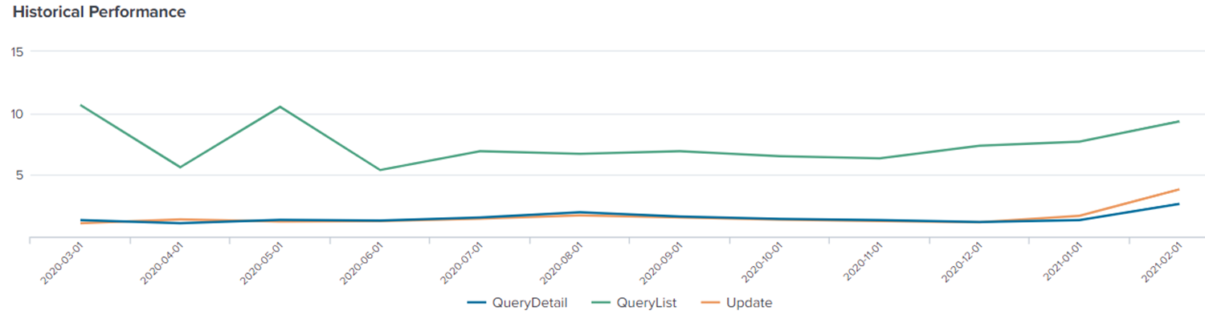

* May retail release extended outage 5/1 to 5/2
  + Longer than normal outage will be required due to migration into RMTE and moving a database activity
  + ERCOT will attempt to ‘tighten up’ needed window
  + Market call will be held on Monday, April 5th with final decision from ERCOT regarding needed window. MPs communicated 7PM Saturday through 7AM Monday is the optimal window which would not impact market operations and customer expectations, otherwise, work-arounds will need to be considered if ERCOT moves outage window to 2 PM Saturday through Sunday evening
* February 6th and 7th – normal retail release weekend scheduled and market notice with attachment typically refers to any NPRRs and O&M. Kathy noted the IDR Compliance report format was noted to change which directly impacts the 867_03 TDU reports. Kathy indicated the notice was not clear as to the impacts and could easily be missed by impacted stakeholders. Dave indicated he would take up the issue at ERCOT regarding the communication.
* TLS 1.0 will be deprecated in Q2 with ERCOT submitting a 10-day and 1-day market notice to alert impacted parties.

**Proposal for daily Switch Hold Daily files to post to ERCOT**

Dave Michelson reported initial attempts at resolution were made, however, attention has been focused on the impacts of Winter Storm Uri and an update is not available.

**FOLLOW UP**: Dave reported after the meeting the following SCR was developed and circulated, yet resources are scarce. We will address at next month’s TDTMS meeting.

**Biannual Review of overall MarkeTrak Subtype Volumes**

The data from the latter half of 2020 was reviewed with the following observations:

1. Higher volume of *Switch Holds* resulting from ERP conclusion and the offering of DPPs
2. Some seasonal activity (typical higher volumes in latter half YOY)
3. D2D activity opened up later in 2020 potentially contributing to higher volume of *IAGs/IALs*
4. Market participant stabilization period post system conversion continued into latter half of 2020 with higher volume of *Usage & Billing – Missing* and *Siebel Changes*
5. Drop in *AMS LSE Disputes* with improved data quality of LSE files
6. *Market Rule* still elevated as ERP program concluded in Q3 2020



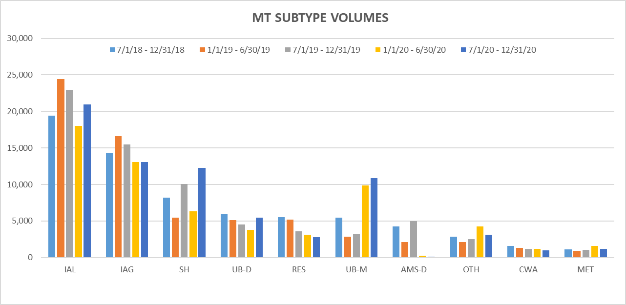

**ERCOT MIS API Functionality**

Kyle reported their teams were initially struggling with development and documentation of an MIS API but have since gained a better understanding. One issue is that the documentation provided from ERCOT is dated and limited.

Another issue with an MIS API is the ability to view the same information via API as is in the GUI. API functionality currently limits visibility of activity by DUNS. Previously Aubrey (ERCOT) had discussed the visual of MIS API to be that of the GUI and not just the information in the public area. The question is where does this get pushed? By market participants? If so, Vistra and NRG expressed interest in pursuing.

ACTION: Mick was to follow up with ERCOT on the EWS with any anti-trust limitations.

**Switch Hold Documentation**

* Kyle had reported NRG was receiving rejections for Switch Hold removals by some TDSPs due to the lease agreements were not dated within the last 60 days.
* The protocols were reviewed in the meeting on the required documentation and the only date specified is that of the electric/utility bill is required to be in the requesting parties name within the last 60 days.
* REPs indicated they preferred no time parameter on the lease allowing flexibility for investigation – in other words, if SH was applied post date on the lease, the removal of the SH could be rejected.
* Vistra introduced they would like to see a phone number as a required field on the New Occupancy Statement (NOS) where request for removal may be denied or unexecuted for invalid documentation.
* Vistra also noted additional clarity around warranty deeds as not being an acceptable form of documentation should be added to the guides.

ACTION: TDSPs will consult their teams if the interpretation on the lease agreements being dated within the last 60 days is considered in their decision on the removal of the switch hold.

ACTION: Vistra will propose an RMGRR seeking clarity on the above and review at the next TDTMS.

**Review of ERCOT’s IAG report from December 2020 stats** posted to the March RMS page

The working group reviewed the latest IAG report and noted the following:

* Volume of IALs are up and have been increasing over the last couple of years
* Offenders (higher percentage of IAGs to transactions) remain the same as some REPs have continuously maintained the higher percentages recording over 1% for an entire year
* Switch/Enrollment activity has increased toward the end of 2020, likely a result of COVID impacts

**Unexecutable IAG MTs** – July 2019 to July 2020

A full year of IAS data (July 2019 to July 2020) was reviewed to determine timing on the processing and the primary reasons for Unexecutable – IAGs, IALs, and Rescissions. Below are the findings as they compare to the IAG and IAL review.

First, a few overall notables:

* Of the ~44,000 MTs reviewed, only 1553 were unexecuted indicating only ~3.4% of the submitted MTs are Unexecuted for one of the following reasons:
  + *Broken due to a third party transaction* 
    - Of the **301 IAGs** unexecuted, 212 were broken, 70%
    - Of the **1236 IALs** unexecuted, 132 were broken, 11%
    - Of the **16 RESCs** unexecuted, 11 were broken, 69%
  + *Authorized Enrollment received*
    - Of the 1236 IALs unexecuted, 1018 were due to Authorized Enrollment, 82%

The following data compares timelines for IAGs, IALs, and the Unexecutable IAGs, IALs, and RESCs:

|  |  |  |  |  |  |  |
| --- | --- | --- | --- | --- | --- | --- |
| 2 → 1 | original transaction to submittal of MT | | | | | |
|  | IAGs | IALs | Unexecutables | | | Findings |
| IAGs | IALs | RESC |
| 0 - 1 day | 22% | 11% | 24% | 6% | 31% | 60% of unexecutables occur between 0-17 days for IALs |
| 0 - 7 days | 61% | 51% | 56% | 30% | 94% |
| over 30 days | 18% | 14% | 24% | 26% |  |
| 2 → 3 | how long to begin working | | | | | |
| same day | 51% | 45% | 11% | 13% | 12% |  |
| within 3 days | 87% | 82% | 81% | 81% | 75% |
| 0 - 7 days | 97% | 95% | 94% | 95% | 88% |
| 3 → 4 | how long to agree/unexecute once touched | | | | | |
| same day | 58% | 73% | 50% | 60% | 87% |  |
| within 3 days |  |  | 62% | 78% | 87% |
| 0 - 7 days | 95% | 94% | 76% | 89% | 93% |
| 4 → 8 | unexecute to close | | | | | |
|  | | | nearly 100% of Unexecutables are allowed to auto-close | | | |
|

**DRAFT SCR for Administrative MT Enhancements**

Sheri presented a DRAFT SCR for the administrative MT Enhancements primarily discussing the Description, Business Case, and structure of the matrix outlining the Issue and Proposed Resolution. Suggestion modifications were presented.

ACTION: Sheri will perform modifications of the proposed SCR and send to Dave Michelson and Tammy Stewart for their comments.

RMS would need to approve the final SCR then it would move to PRS to begin the voting process and assign rank and priority.

**AGENDA for 4/23/21 Meeting**

1. ERCOT Update
   1. System Instances and MarkeTrak Monthly Performance Review
   2. May Retail Release – extended outage
2. Follow up on ACTION item from MIS API functionality discussion
3. Review Proposed RMGRR Clarification of Switch Hold Documentation Requirements
4. Review DRAFT SCR on Switch Hold Repository
5. Review DRAFT SCR on Administrative MT Enhancements
6. Discuss cadence of IGL Monthly Report review