2705 West Lake Drive
Taylor, Texas 76574
(512) 248-6800
ercot.com

SELF-LIMITING FACILITIES
IN THE INTERCONNECTION PROCESS
Version 1.3

ERCOT
03/08/2021

Contents
Self-Limiting Facility Submission in RIOO-IS 3
Example IE submission in RIOO-IS 4
Entering the solar part 4
Entering storage part 5
Self-Limiting MW entry 5
Screening Studies 6
Reactive Study 7
FIS Studies 7
Steady-State Study 7
Short Circuit Study 7
Dynamic Stability Study 8
BESS Dynamic Modeling 8
Facility Study 9
Sub-Synchronous Resonance Study 9
Quarterly Stability Assessment (QSA) 9
Planning Model Representation 9
Steady-State Studies 9
Dynamic Studies 10
Appendix A: Resource Registration Glossary additions for Self-Limiting Facilities 12
REVISION HISTORY 16

Self-Limiting Facility Submission in RIOO-IS
Interconnecting Entities are warned that a project submitted in accordance with this proposal could be delayed until the BOD approved revision requests and system changes that were identified in the impact analysis are completed. This could also possibly result in FIS studies needing to be re-studied to reflect later CODs if the system changes are significantly delayed.
The system changes are not expected to be complete until the year 2023 at the earliest. Considering this, applications will not be accepted that have a Production Load Date (PLD) prior to the first model load date in 2023.
In the event that system changes are further delayed due to unforeseen circumstances, part of the Self-Limiting Facility may be allowed to proceed to PLD prior to 2023 if the configuration and MW output was specifically studied in the Full Interconnection Study (FIS).
Interconnecting Entities should also be aware that they must submit an attestation form to comply with the established MW Injection or MW Withdrawal limit with the RARF submitted for the Full Interconnection Study. Interconnecting Entities should also be aware that all registered generators or Energy Storage Systems proposed to be within a Self-Limiting Facility will be required to be represented by a single Resource Entity and a single Qualified Scheduling Entity when modeled in the Network Operations Model.
ERCOT will allow Interconnecting Entities (IE) to submit a proposed Self-Limiting Facility consisting of non-Energy Storage System (non-ESS) and/or ESS projects that would use the Self-Limiting Facility protocol changes found in NPRR1026 and planning guide PGRR081 such that an ESS project could be added to a new or existing facility.
To aid the Generation Interconnection Status Report, a standard naming convention will be used for the proposed Self-Limiting Facility. The “ITEST” part of the name is the [Common Name] that would be the same for both the solar and storage parts of the project or the Station name if adding to an operational facility. The terms “Solar” and “Storage” would be used to identify the technology of each part of the project. The “SLF” keyword would be used to identify that this project is part of a Self-Limiting Facility and “DCC” used to identify a SLF project that will be part of a DC-Coupled Resource when that type is allowed after Passport. Until that time, DCC projects will be considered SLF. Thus the naming convention would be:
[Common Name][space][“Solar”, “Wind”, “Storage” or “Other”][space][“SLF” or “DCC”]

Example IE submission in RIOO-IS

Entering the solar part
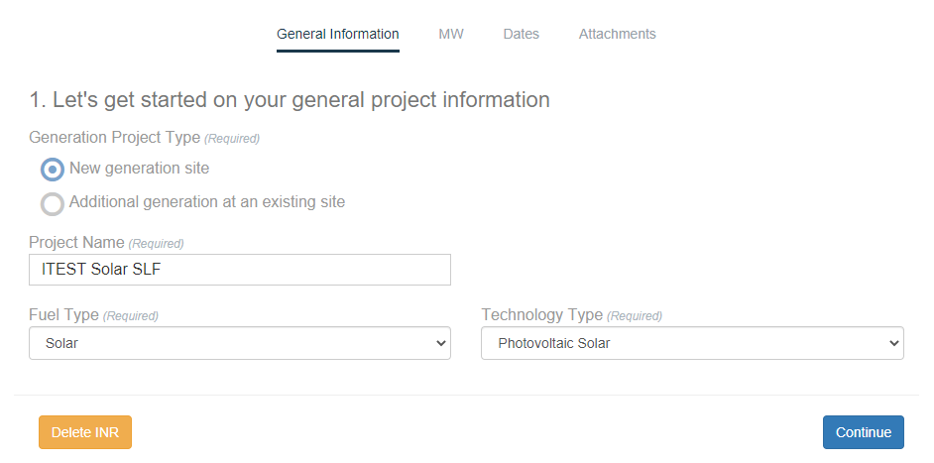
Figure 1: IE creates the solar project
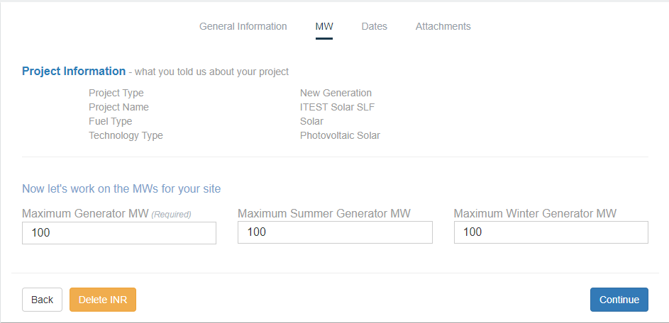
Figure 2: MW settings for solar part

Entering storage part
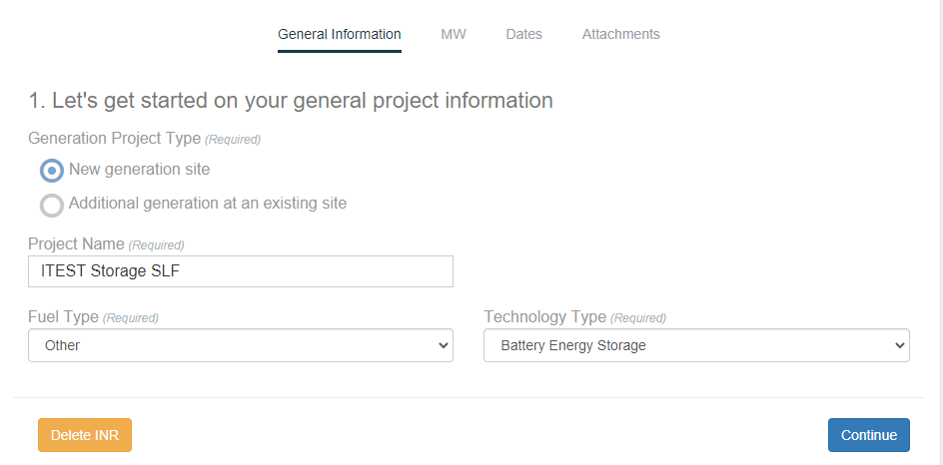
Figure 3: Adding storage portion.
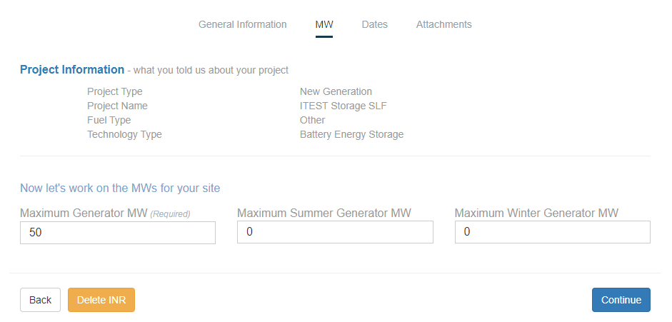
These are both zero to not show additional capability
Figure 4: MW settings for storage part, when not adding more MW above the installed capacity of the solar portion

Self-Limiting MW entry
ERCOT uses both Maximum Generator MW and Maximum Winter Generator MW in the logic that handles repowers and load changes in the Monthly Generator Interconnection Status Reports. Maximum Summer Generator MW is not used because IEs typically populate the winter and summer generator MW fields with the same number, at least during the early stages of the interconnection process.
For the ESS project, the Maximum Summer Generator and Maximum Winter Generator MW are both zero in Figure 4 to show that this project will not add additional MW to the SLF limit, which is generally the amount of the non-ESS project. If a SLF limit greater than the MW from the non-ESS project but less than the sum of non-ESS and ESS MW (in this example between 100 MW and 150 MW) is desired, both the Maximum Summer Generator and Maximum Winter Generator MW would be non-zero (SLF limit minus the MW of the non-ESS project) to reflect the MW needed to meet the SLF limit.
The ESS project would also act as a load when withdrawing from the grid in the amount entered in the Maximum Generator MW box. This will be the assumption unless the IE states otherwise. This amount would need to be studied as a load regardless of the value entered in the Maximum Summer Generator and Maximum Winter Generator MW.
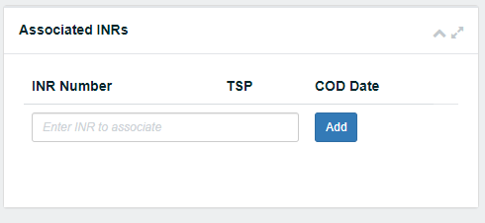
The two projects would also be associated to one another in RIOO-IS by ERCOT once they have been submitted and approved.
Figure 5: Associating INRs
Until full implementation of RRGRR023 in RIOO, when submitting the signed IA, the IE will also be required to submit Request for Information (RFI) form that will provide additional information about the ESS (such as duration, roundtrip efficiency at POI, etc.). This requirement is for all ESS and only applicable for a Self-Limiting Facility if it includes an ESS.

Screening Studies
Screening Studies will model a single generator with a PMAX equal to the total MW injection of the Self-Limiting Facility and a PMIN equal to the MW withdrawal of the self-limiting facility if an ESR is part of the SLF. The screening study will not be performed if ESS is being added to an existing Resource and MW injection is not increasing above the original SGIA. In addition, under this scenario, a screening study will not be done just to study the MW withdrawal.
Scenarios will include for both a summer peak and HWLL case:
- Transfer to PMAX + 20% (to allow for TARA DC/AC solution differences) for discharging mode
- Transfer to PMIN + 20% for charging mode

Reactive Study
Reactive studies will be performed using the total MW injection and total MW withdrawal of the Self-Limiting Facility if an ESR is part of the SLF. Each component of a SLF should have their own capability curve. Contractual limits on the Injection level should be documented but the reactive power capability should not be limited by any plant level controls.
The reactive capability curve of a SLF behind the same set of inverters will be modeled on the non-ESS part of the facility.
The Reactive study will not be performed if an ESS is being added to the DC side of the same set of inverters of an existing Inverter Based Resource (IBR) that will not withdraw from the grid.

FIS Studies
The lead TSP conducting the FIS studies can model the Self-Limiting Facility differently for each study element. If the ESS is being added to the DC side of the same set of inverters of an existing facility and will not withdraw from the grid, a new FIS study is not needed as long as an explanation for not needing the FIS is made available.

Steady-State Study
The steady state study will model a single generator with a PMAX equal to the total MW injection of the Self-Limiting Facility and a PMIN equal to the MW withdrawal of the self-limiting facility if an ESR is part of the SLF. When the ESS is being added to an existing Resource and an increase in the MW injection is not being requested, the steady-state study will only be done for the withdrawal capability of the ESS if it will be withdrawing from the grid. The following scenarios will be studied for an SLF that is not being added to an existing resource:
- Maximum generation at self-limiting value with no ESS withdrawal.
- Maximum ESS withdrawal down to self-limiting value with no generation.

Short Circuit Study
For the short circuit study, both the non-ESS and ESS should be modeled at the total installed MVA with the appropriate subtransient and transient reactances. The reactance of resources connected behind the same set of inverters would be based on ESS flow through those inverters while for a Self-Limiting Facility utilizing additional inverters, the short circuit current could come from two or more sets of inverters.
The short circuit study will be needed if the facility is a Self-Limiting Facility or consists of resources connected behindnew/modified inverters. The study is not needed if it is connected behind inverters that did not change.

Dynamic Stability Study
For the dynamic stability study the following should be considered:
Self-Limiting Facility: both the non-ESS and ESS should be modeled to their respective PMAX with the plant controller controlling active and reactive power limits.
Resources connected behind the same inverters: one set of inverters should be modeled and the facility response would be represented by the inverter model.
The scenarios listed below should be considered for study. Determination of the dispatch values of non-ESS and ESS could result in numerous permutations. Since it is most likely the non-ESS portion would be dispatched during peak load conditions, the non-ESS could be assumed to be providing most if not all the dispatch. Similarly, the ESS could be assumed to be providing dispatch if the non-ESS is solar during off-peak load conditions. Consideration of the “worst case” dispatch with respect to stability can also be used to determine appropriate scenarios.
- Summer Peak Case
  - Maximum generation at self-limiting value with no ESS charging.
  - No non-ESS generation with ESS charging at full withdrawal MW.
- Off-peak Case (e.g., HWLL Case)
  - No non-ESS generation with full ESS charging up to total withdrawal MW.
  - Maximum SLF output up to total MW Injection.

BESS Dynamic Modeling
User-Defined models can be used to model the dynamic response of the plant as a whole. If generic models are used, the following table can be used as guidance.
Generic Dynamic Models available to Represent BESSs in PSSE
Module | Siemens PTI Modules
Grid interface | REGC
Electrical controls | REECC1 or REECD1
Plant controller | REPC/PLNTBU1
Voltage/frequency protection | VRGTPA/FRQTPA

- REGC Module: Used to represent the converter (inverter) interface with the grid. It processes the real and reactive current command and outputs of real and reactive current injection into the grid model.
- REEC (REEC_C/REEC_D) Module: Used to represent the electrical controls of the inverters. It acts on the active and reactive power reference from the REPC module, with feedback of terminal voltage and generator power output, and gives real and reactive current commands to the REGC module.
REPC Module: Used to represent the plant controller. It processes voltage and reactive power output to emulate volt/var control at the plant level. It also processes frequency and active power output to emulate active power control. This module gives active reactive power commands to the REEC module.

Facility Study
If the IE asks the TSP to install a Wholesale Load (“WSL”) meter for the charging component of the ESS, then a limited Facility Study will be required to determine the cost and timeline for installing the meter(s). This applies only to an AC-coupled self-limiting facility.

Sub-Synchronous Resonance Study
The sub-synchronous (SSR) study will be done as determined by protocol 3.22 in all cases except the case where an ESS is being added to an existing IBR and is connected behind the same set of inverters and is not capable of withdrawing from the grid.

Quarterly Stability Assessment (QSA)
A SLF project will always be included in the QSA. A SLF project will not need to be included in the QSA when an ESS is being added to an existing IBR and is connected behind the same set of inverters and is not withdrawing from the grid. If the SLF project will withdraw from the grid, ERCOT will determine if it will need to be included in the QSA.

Planning Model Representation

Steady-State Studies
The Planning Model will use the Network Operations Model as its base case. Until appropriate specific models are implemented by the vendors of the various software used for analysis, the SSWG process will insert a zero-impedance branch (ZBR) between the RE generation model and the POI for that plant. The ZBR will model the total MW Injection limit to the grid on Rate A, B, and C. The ZBR will have its circuit ID set to “SL” to indicate it’s a self-limiting device.

Dynamic Studies
The dynamic model would be as described above in the FIS Dynamic Stability Study section. Reasonable scenarios need to be studied to capture the response from various dispatch levels with the ESS injection and withdrawal.

Appendix A: Resource Registration Glossary additions for Self-Limiting Facilities
These are additions to the Resource Registration Glossary that RRGRR023 is adding for Self-Limiting Facilities for reference. This is a subset of RRGRR023.
General and Site | X | X | X |  |  |  |  | Y/N | Is Resource a DC-Coupled Resource as defined in ERCOT Protocol Section 2.1, Definitions? | Refer to ERCOT Protocol Section 2.1, Definitions, for the definition of a DC-Coupled Resource.
General and Site | X | X | X | X | X |  |  | Y/N | Is Resource a part of a Self-Limiting Facility as defined in ERCOT Protocol Section 2.1, Definitions? | Refer to ERCOT Protocol Section 2.1, Definitions, for the definition of a Self-Limiting Facility.
Unit Information | X | X | X |  |  |  |  | Y/N | DC-Coupled Resource | Refer to ERCOT Protocol Section 2.1, Definitions, for the definition of a DC-Coupled Resource | R | R | R | R
Unit Information | X | X | X | X | X |  |  | Y/N | Part of Self-Limiting Resource Facility | Refer to ERCOT Protocol Section 2.1, Definitions, for the definition of a Self-Limiting Resource Facility | R | R | R | R
Unit Information | X | X | X | X | X |  |  | # | Self-Limiting Facility # | Self-Limiting Facility # 1, 2, 3….  Leave blank if not Self-Limiting Facility. Refer to definition of Self-Limiting Facility in Protocol Section 2.1, Definitions. | R | R | R | R
Unit Information | X | X | X | X |  |  | X | List | Resource Category | Nuclear  Hydro  Coal and Lignite  Combined Cycle ≤ 90 MW*  Combined Cycle > 90 MW*  Gas Steam - Supercritical Boiler  Gas Steam - Reheat Boiler  Gas Steam - Non-reheat or Boiler without air-preheater  Simple Cycle ≤ 90 MW  Simple Cycle > 90 MW  Diesel  Renewable  Reciprocating Engine  Solar  Battery Energy Storage  DC-Coupled Battery Energy Storage and Solar  DC-Coupled Battery Energy Storage and Wind  DC-Coupled Battery Energy Storage and Solar and Wind  Other |  |  | R | R
Unit Information | X | X | X | X | X |  | X | List | Physical Unit Type | BA – Battery Energy Storage  BA-PV – DC-Coupled Battery Energy Storage and Photovoltaic  BA-WT – DC-Coupled Battery Energy Storage and Wind Turbine  BA-PV-WT – DC-Coupled Battery Energy Storage, Photovoltaic and Wind Turbine  CA -- Combined cycle steam turbine part (includes steam part of integrated coal gasification combined cycle)  CC -- Combined cycle total unit (use only for plants/generators that are in planning stage, for which specific generator details cannot be provided)  CE -- Compressed air energy storage  CS -- Combined cycle single shaft (combustion turbine and steam turbine share a single generator)  CT -- Combined cycle combustion/gas turbine part (includes comb. turbine part of integrated coal gasification combined cycle)  FC -- Fuel Cell  GT -- Simple-cycle Combustion (gas) turbine (includes jet engine design)  HY -- Hydraulic turbine (includes turbines associated with delivery of water by pipeline  IC -- Internal combustion (diesel, piston) engine  NA -- Unknown at this time (planned units only)  OT -- Other  PS -- Hydraulic Turbine - Reversible (pumped storage)  PV -- Photovoltaic  ST -- Steam Turbine including nuclear, geothermal and solar. Does not include combined cycle.  WT -- Wind Turbine | R | R | R | R
Parameters | X | X | X | X | X |  |  | MW | High Reasonability Limit | A theoretical value of net generation above which, the generator is not expected to operate under most conceivable conditions. This value is used by ERCOT market systems to validate COP submissions of HSL, telemetered HSL, and certain offers which may have been entered in error by the QSE. The HRL is also used in settlements to deconstruct prices at a CCT logical resource node. Self-Limiting Resources should use this field to enter the limit for maximum MW injection |  |  |  | R
Parameters | X | X | X | X | X |  |  | MW | High Reasonability Limit, Self-Limiting Facility | Limit for maximum MW injection for Self-Limiting Facility above which the Self-Limiting Facility is not expected to operate.  This field should not be used by Resources that are not part of Self-Limiting Facility
Parameters | X | X | X | X | X |  |  | MW | Low Reasonability Limit | A theoretical limit of net generation below which, the generator is not expected to operate under most conceivable conditions. For Energy Storage Resource (ESR) Low Reasonability limit is a negative value showing theoretical limit of net withdrawal/charging below which ESR is not expected to withdraw/charge. This value is used by ERCOT market systems to validate COP submissions of LSL, telemetered LSL, and certain offers which may have been entered in error by the QSE. Self-Limiting Resources should use this field to enter the limit for maximum MW withdrawal |  |  |  | R
Parameters | X | X | X | X | X |  |  | MW | Low Reasonability Limit, Self-Limiting Facility | Limit for maximum MW withdrawal of Self-Limiting Facility above which the Self-Limiting Facility is not expected to operate  This field should not be used by Resources that are not part of Self-Limiting Facility

REVISION HISTORY
Revision | Comments | Date | Author
1.0 | Initial document after internal review by ERCOT sent for final internal review before external release. | 12/29/20 | Jay Teixeira with compiled comments
1.1 | Internal review by ERCOT and comments submitted by TSPs | 01/21/2021 | Jay Teixeira compiled comments
1.2 | External review with TSPs and ERCOT. Warning to IE’s reinstated, scenarios for Planning Model dynamic studies removed. | 1/22/2021 | ERCOT and TSPs
1.2a | Minor edits as result of RIWG meeting and internal meeting comments. | 2/12/2021 | ERCOT
1.3 | Added stronger warnings and removed reference to DC-Coupled since it is not pre-Passport. | 3/8/2021 | ERCOT

NERC IRPTF Reliability Guideline Performance, Modeling, and Simulations of BPS-Connected Battery Energy Storage Systems and Hybrid Power Plants, draft, dated November 2020, Page 17
NERC IRPTF Reliability Guideline Performance, Modeling, and Simulations of BPS-Connected Battery Energy Storage Systems and Hybrid Power Plants, draft, dated November 2020, page 30.
NERC IRPTF Reliability Guideline Performance, Modeling, and Simulations of BPS-Connected Battery Energy Storage Systems and Hybrid Power Plants, draft, dated November 2020, pages 35 and 36.
NERC IRPTF Reliability Guideline Performance, Modeling, and Simulations of BPS-Connected Battery Energy Storage Systems and Hybrid Power Plants, draft, dated November 2020, page 27.
REEC_D and REPC_B model descriptions: https://www.wecc.org/Administrative/Memo_RES_Modeling_Updates_083120_Rev17_Clean.pdf

