February 2021 ERCOT Monthly Operations Report
Reliability and Operations Subcommittee Meeting
April 1, 2021

Table of Contents
1. Report Highlights 2
2. Frequency Control 3
2.1. Frequency Events 3
2.2. Responsive Reserve Events 4
2.3. Load Resource Events 4
3. Reliability Unit Commitment 4
4. Wind Generation as a Percent of Load 5
5. Largest Net-Load Ramp 5
6. COP Error Analysis 6
7. Congestion Analysis 8
7.1. Notable Constraints 8
7.2. Generic Transmission Constraint Congestion 12
7.3. Manual Overrides 12
7.4. Congestion Costs for Calendar Year 2020 12
8. System Events 14
8.1. ERCOT Peak Load 14
8.2. Load Shed Events 14
8.3. Stability Events 14
8.4. Notable PMU Events 14
8.5. DC Tie Curtailment 14
8.6. TRE/DOE Reportable Events 14
8.7. New/Modified/Removed RAS 14
8.8. New Procedures/Forms/Operating Bulletins 14
9. Emergency Conditions 15
9.1. OCNs 15
9.2. Advisories 15
9.3. Watches 15
9.4. Emergency Notices 15
10. Application Performance 15
10.1. TSAT/VSAT Performance Issues 15
10.2. Communication Issues 15
10.3. Market System Issues 16
11. Model Updates 16
Appendix A: Real-Time Constraints 18

Report Highlights
- ERCOT is continuing to work with the market participants to investigate the February cold weather event.
- The unofficial ERCOT peak load was 69,692 MW.
- There were 6 frequency events.
- There were 12 instances where Responsive Reserves were deployed.
- There were 11 HRUC commitments.
- The level of reportable SCED congestion increased in February. This congestion was primarily due to high wind, planned outages and record winter load. There were 17 days of congestion on the Panhandle GTC, 22 days on the North Edinburg to Lobo GTC, 25 days on the Raymondville to RioHondo GTC, 9 days Nelson Sharpe to Rio Hondo GTC, 1 day on the McCamey GTC, 8 days on the West Texas Export GTC, 3 days on the Bearkat GTC, 10 days on the Pig Creek to Solstice GTC, 8 days on the Rio Grande Valley Import GTC and 3 days in the Redtap GTC. There was no activity on the remaining GTCs during the month.
- There were 4 DC Tie Curtailments

Frequency Control

Frequency Events

The ERCOT Interconnection experienced five frequency events, which resulted from unit’s trips. The average event duration was 00:04:52.

A summary of the frequency events is provided below. The reported frequency events meet one of the following criteria: Delta Frequency is 60 mHz or greater; the MW loss is 350 MW or greater; resource trip event triggered RRS deployment. Frequency events that have been identified as Frequency Measurable Events (FME) for purposes of BAL-001-TRE-1 analysis are highlighted in blue. When analyzing frequency events, ERCOT evaluates PMU data according to industry standards. Events with an oscillating frequency of less than 1 Hz are considered to be inter-area, while higher frequencies indicate local events. Industry standards specify that damping ratio for inter-area oscillations should be 3.0% or greater. For the frequency events listed below, the ERCOT system met these standards and transitioned well after each disturbance. Note that all the events related to the February cold weather event were not analyzed. ERCOT is continuing to work with market participants to investigate the cold weather event.

Date and Time | Delta Frequency | Max/Min Frequency | Duration of Event | PMU Data |  | MW Loss | Load | Wind | Inertia
 | (Hz) | (Hz) |  | Oscillation Mode (Hz) | Damping Ratio |  | (MW) | % | (GW-s)
2/13/2021 8:36 | 0.027 | 59.897 | 0:05:38 | 0.73 | 13% | 221.22 | 55,385 | 6% | 323,214
2/15/2021 5:26 | 0.246 | 59.775 | 0:03:58 | 0.75 | 14% | 1378.1 | 61,695 | 7% | 331,731
2/15/2021 4:54 | 0.085 | 59.833 | 0:05:16 | 0.63 | 9% | 421.44 | 54,087 | 9% | 278,052
2/15/2021 12:55 | 0.073 | 59.936 | 0:05:30 | 0.68 | 15% | 981.68 | 45,868 | 6% | 259,583
2/16/2021 12:46 | 0.086 | 59.931 | 0:05:26 | 0.66 | 3% | 628.3 | 43,716 | 9% | 264,302
2/22/2021 5:38 | 0.134 | 59.885 | 0:03:26 | 0.73 | 0.140 | 714 | 52,486 | 9% | 287,039

(Note: All data on this graph encompasses frequency event analysis based on BAL-001-TRE-1.)

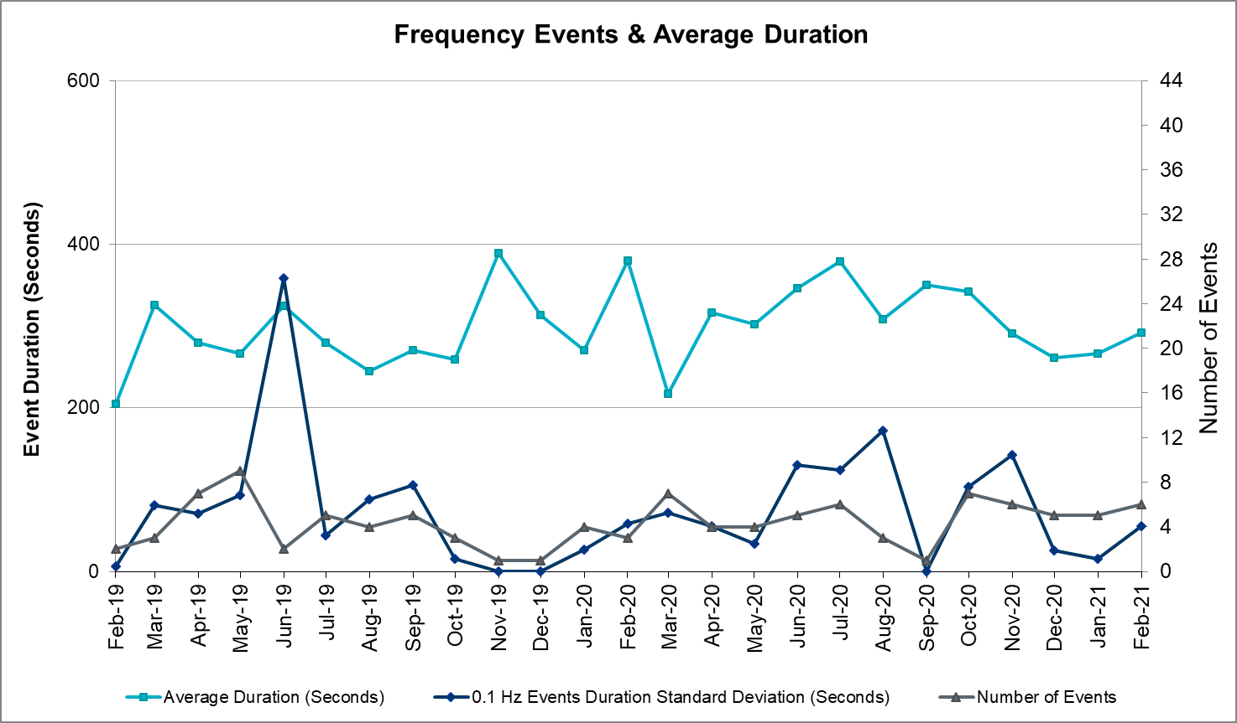
Note that the large standard deviation in June 2019 is due to coincidental extreme high and low durations for a small set of events (2).

Responsive Reserve Events

There were 12 events where Responsive Reserve MWs were released to SCED. The events highlighted in blue were related to frequency events reported in Section 2.1 above.

Date and Time Released to SCED | Date and Time Recalled | Duration of Event | Maximum MWs Requested | Comments
2/13/2021 8:36 | 2/13/2021 8:44 | 00:08:00 | 725
2/14/2021 23:19 | 2/15/2021 2:03 | 02:43:48 | 2000
2/15/2021 3:43 | 2/15/2021 11:56 | 08:13:08 | 1879
2/15/2021 17:08 | 2/15/2021 17:42 | 00:34:40 | 1000
2/15/2021 18:16 | 2/15/2021 19:28 | 01:12:20 | 1000
2/15/2021 21:42 | 2/15/2021 22:35 | 00:53:04 | 1000
2/16/2021 3:23 | 2/16/2021 9:31 | 06:08:04 | 1560
2/16/2021 12:49 | 2/16/2021 13:01 | 00:12:04 | 400
2/16/2021 14:27 | 2/16/2021 15:09 | 00:41:16 | 300
2/16/2021 17:29 | 2/16/2021 18:23 | 00:54:20 | 500
2/17/2021 6:05 | 2/17/2021 9:18 | 03:12:32 | 650
2/22/2021 5:39 | 2/22/2021 5:41 | 00:02:56 | 338

Load Resource Events
On 2/15/2021, ERCOT deployed group 1 and group 2 load resources.

Reliability Unit Commitment
ERCOT reports on Reliability Unit Commitments (RUC) on a monthly basis. Commitments are reported grouped by operating day and weather zone. The total number of hours committed is the sum of the hours for all the units in the specified region. Additional information on RUC commitments can be found on the MIS secure site at Grid Generation Reliability Unit Commitment.

There were no DRUC commitments.

There were 11 HRUC commitment.

Resource Location | # of Resources | Operating Day | Total # of Hours Committed | Total MWhs | Reason for Commitment
COAST | 2 | February 15, 2021 | 7 | 86 | System Capacity
NORTH_CENTRAL | 1 | February 16, 2021 | 1 | 136 | System Capacity
NORTH_CENTRAL | 1 | February 17, 2021 | 24 | 3,648 | EEA-3
EAST | 1 | February 17, 2021 | 23 | 8,893 | EEA-3
FAR_WEST | 5 | February 17, 2021 | 13 | 1,012 | EEA-3
EAST | 1 | February 18, 2021 | 24 | 12,463 | EEA-3
NORTH_CENTRAL | 1 | February 18, 2021 | 24 | 4,056 | EEA-3
COAST | 11 | February 18, 2021 | 70 | 4,348 | EEA-3
NORTH_CENTRAL | 1 | February 19, 2021 | 10 | 1,730 | EEA-3
EAST | 1 | February 19, 2021 | 10 | 5,288 | EEA-3
COAST | 10 | February 19, 2021 | 100 | 6,200 | EEA-3

Wind Generation as a Percent of Load
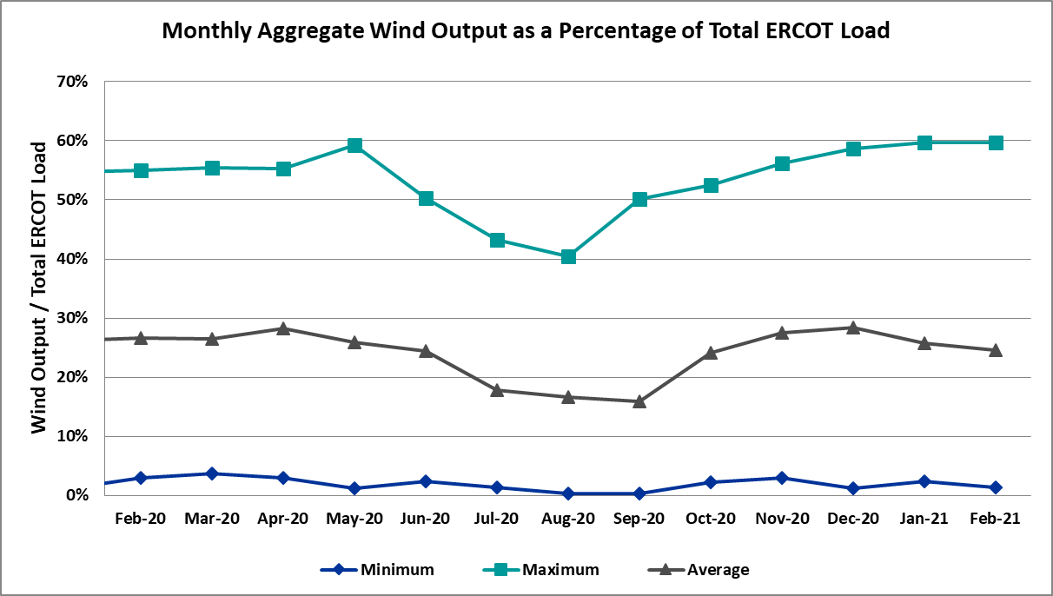

Wind Generation Record: 22,893 MW on 01/14/2021 at 07:27
Wind Penetration Record: 60.40% on 01/30/2021 at 07:54

Largest Net-Load Ramp
The net-load ramp is defined as the change in net-load (load minus wind and PVGR generation) during the defined time horizon. Such a variation in net-load needs to be accommodated in grid operations to ensure that the reliability of the grid is satisfactorily maintained. The largest net-load ramp during 5-min, 10-min, 15-min, 30-min and 60-min in Feb 2021 is 933 MW, 1661 MW, 2374 MW, 4479 MW, and 8079 MW, respectively. The comparison with respect to the historical values is given in the table below.

Month and Year | 5 min | 10 min | 15 min | 30 min | 60 min
Feb 2021 | 933 MW | 1661 MW | 2374 MW | 4479 MW | 8079 MW
Feb 2014 | 971 MW | 1610 MW | 2164 MW | 3516 MW | 5960 MW
Feb 2015 | 1131 MW | 1763 MW | 2469 MW | 4031 MW | 6910 MW
Feb 2016 | 999 MW | 1658 MW | 2144 MW | 3504 MW | 5923 MW
Feb 2017 | 1051 MW | 1744 MW | 2268 MW | 3228 MW | 5346 MW
Feb 2018 | 1494 MW | 1706 MW | 2003 MW | 3419 MW | 5628 MW
Feb 2019 | 1094 MW | 1793 MW | 2388 MW | 3718 MW | 6540 MW
Feb 2020 | 1173 MW | 1777 MW | 2198 MW | 4107 MW | 7430 MW
All Months in 2014-2020 | 1494 MW | 1991 MW | 2780 MW | 5882 MW | 10364 MW

COP Error Analysis
COP Error is calculated as the capacity difference between the COP HSL and real-time HSL of the unit. Mean Absolute Error (MAE) stayed over 8,000 MW until Day-Ahead at 13:00, then dropped significantly to 2,196 MW by Day-Ahead at 15:00. In the following chart, Under-Scheduling Error indicates that COP had less generation capacity than real-time and Over-Scheduling Error indicates that COP had more generation capacity than real-time.
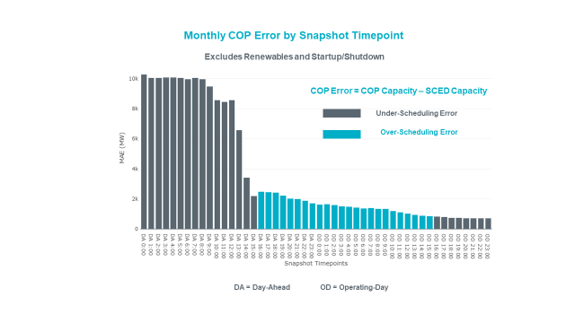

Monthly MAE for the Latest COP at the end of the Adjustment Period was 718 MW with median ranging from -341 MW for Hour-Ending (HE) 23 to 37.4 MW for HE 10. HE 4 on the 15th had the largest Over-Scheduling Error (7,657 MW) and HE 11 on the 13th had the largest Under-Scheduling Error (-3,600 MW).
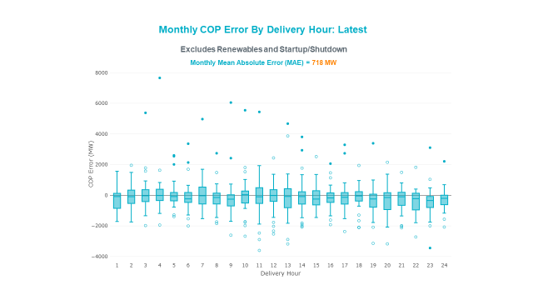

Monthly MAE for the Day-Ahead COP at 12:00 was 8,557 MW with median ranging from -8536 MW for Hour-Ending (HE) 7 to -5,817 MW for HE 24. HE 7 on the 12th had the largest Under-Scheduling Error (-21,787 MW) and HE 11 on the 15th had the largest Over-Scheduling Error (4,748 MW).
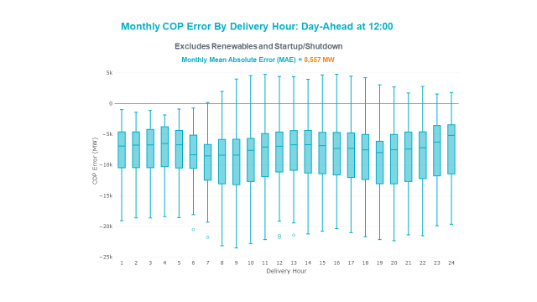

Congestion Analysis

Notable Constraints
Nodal protocol section 3.20 specifies that ERCOT shall identify transmission constraints that are active or binding three or more times within a calendar month. As part of this process, ERCOT reports congestion that meets this criterion to ROS. In addition ERCOT also highlights notable constraints that have an estimated congestion rent exceeding $1,000 for a calendar month. These constraints are detailed in the table below, including approved transmission upgrades from TPIT that may provide some congestion relief based on ERCOT’s engineering judgement. Rows highlighted in blue indicate the congestion was affected by one or more outages. For a list of all constraints activated in SCED, please see Appendix A at the end of this report.

Contingency Name | Overloaded Element | # of Days Constraint Active | Congestion Rent | Transmission Project
Elmcreek-Sanmigl 345kV | Pawnee Switching Station - Calaveras 345kV | 8 | $76,171,085.67
LOST PINES AEN to FAYETTE PLANT 1 LIN 1 | Winchester - Fayette Plant 1 And 2 345kV | 3 | $51,438,867.64
JOHNSON SWITCH (ONCOR) to CONCORD LIN G1 | Decordova Dam - Carmichael Bend Switch 138kV | 4 | $46,614,977.07 | DeCordova 345/138kV_Sw. (7129)
Hicross-Pilot & Garfield 138kV | Carson Creek - Pilot Knob 138kV | 6 | $30,600,531.85
Basecase | Pawnee Switching Station - Calaveras 345kV | 1 | $17,214,426.04
CONCORD TRX CRD1 345/138 | Concord 345kV | 4 | $21,132,830.95
Lostpi-Austro&Dunlap 345kV | Sim Gideon - Winchester 138kV | 2 | $20,351,174.08
Lytton_S-Slaughte&Turner 138kV | Mccarty Lane - Zorn 138kV | 2 | $20,185,815.81
ASHERTON to Bevo Substation LIN 1 | Hamilton Road - Maverick 138kV | 4 | $17,023,560.36 | Brackettville to Escondido: Construct 138 kV line (5206)
KILLEEN SWITCH TRX KLNSW_3_2 345/138 | Killeen Switch 345kV | 2 | $16,301,132.28
Manual dbl ckt for NEDIN-BONILLA 345kV & RIOH-PRIM138kV | Haine Drive - La Palma 138kV | 10 | $10,669,545.19
GILA to HIWAY 9 LIN 1 | Gila - Hiway 9 138kV | 2 | $15,790,117.72
MCCARTY LANE to ZORN LIN 1 | Crosswinds - Turnersville 138kV | 2 | $15,722,185.46
Basecase | RV_RH GTC | 25 | $7,823,886.99
Basecase | VALEXP GTC | 8 | $7,662,044.31
Tri Corner to SEAGOVILLE SWITCH LIN _B | Forney Switch - Tri Corner 345kV | 1 | $7,386,208.90
COLETO CREEK to Euler LIN 1 | Coleto Creek - Rosata Tap 138kV | 5 | $7,179,074.32
PAREDES SWITCHING STATION to CENTRAL AVENUE SUB LIN 1 | Rio Hondo - East Rio Hondo Sub 138kV | 19 | $6,253,141.67 | Rebuild Rio Hondo to East Rio Hondo (6687)
Lostpine-Fppyd1&Winches 345kV | Sim Gideon - Winchester 138kV | 2 | $9,872,618.58
Koch Upriver - Tortuga & Lon Hill - Nueces Bay 138KV | Champlin - Weil Tract 138kV | 3 | $4,527,732.93
ROUND ROCK to SPANISH OAK LIN 1 | Blockhouse - Whitestone 138kV | 3 | $9,653,040.09
COLETO CREEK to PAWNEE SWITCHING STATION LIN 1 | Coleto Creek - Rosata Tap 138kV | 3 | $3,846,551.75
DYANN to SOUTH LANE CITY LIN A | East Bernard - Wallis 138kV | 2 | $9,217,195.42
PH ROBINSON to GAF TNP LIN 1 | Freeway Park Tnp - Dickinson Tnp 138kV | 3 | $3,717,217.27
Fowlerton to LOBO 345 LIN1 | Laredo Vft North - Las Cruces 138kV | 9 | $3,636,223.06
Dilleysw-Sanmgsw&Cotulas 138kV | Dilley Switch Aep - Cotulla Sub 69kV | 6 | $2,276,622.34 | Dilley - Jourdanton 69 kV Line (44866)
Basecase | NE_LOB GTC | 22 | $2,202,190.12
Manual dbl ckt for NEDIN-BONILLA 345kV & RIOH-PRIM138kV | Burns Sub - Rio Hondo 138kV | 10 | $2,061,295.78 | Stewart Road: Construct 345 kV cut-in with two 450 MVA 345/138 autotransformers connected to Stewart Rd 138 station (5604, 6382)
ODLAW SWITCHYARD to ASPHALT MINES LIN 1 | Hamilton Road - Maverick 138kV | 11 | $1,953,635.10 | Brackettville to Escondido: Construct 138 kV line (5206)
BRACKETTVILLE to HAMILTON ROAD LIN 1 | Hamilton Road - Maverick 138kV | 10 | $1,383,669.07 | Brackettville to Escondido: Construct 138 kV line (5206)
CRLNW TO LWSSW 345 DBLCKT | West Tnp - Highlands Tnp 138kV | 4 | $1,220,530.73
CHB-KG & JOR-NB 345kV | Exxon - Lynch 138kV | 1 | $6,081,182.13
WEIMAR to SCHULENBURG LIN 1 | Magruder - Victoria 138kV | 1 | $1,173,963.68
LON HILL to LON HILL LIN 1 | #N/A | 1 | $4,927,422.99
Melon Creek to RINCON LIN 1 | Bonnieview - Rincon 69kV | 12 | $1,159,816.28 | Refugio - Rincon: Upgrade 69 kV Line (6427)
TWR (345) HLJ-WAP64 & BLY-WAP72 | Dow Chemical - Jones Creek 345kV | 2 | $1,117,957.60 | Freeport - Master Plan (6668A)
Kg-Rtw 345kV | Drilco - North Belt 138kV | 3 | $4,226,629.56
Garfie-Lytton_S & Austro-Zorn 345kV | Garfield Aen - Hicross Aen 138kV | 2 | $4,059,538.49
NORTH CARBIDE to SEADRIFT SUB LIN 1 | North Carbide - Port Lavaca Tap 69kV | 6 | $985,443.33
INGLESIDE COGEN SWITCH to OXYCHEM INGLESIDE LIN 1 | Dupont Pp1 - Ingleside - Dupont Switch - Ingleside 138kV | 10 | $799,895.41 | Air Liquide Pass Through 138 kV Station (59452)
SOUTH LANE CITY to NEW GULF LIN A | Blessing - Pavlov 138kV | 3 | $635,079.78
Fowlerton to LOBO 345 LIN1 | Bruni Sub 138kV | 5 | $539,952.86
Cenizo-Delsol ckt 1(345)&Revill-Zapata(138) | Orange Grove Switching Station - Lon Hill 138kV | 2 | $3,470,236.86
KLEBERG AEP to LOYOLA SUB LIN 1 | Loyola Sub 138kV | 10 | $349,455.52
Manual dbl ckt for RIOHONDO-BONILLA 345kV & RRIOH-PRI 138kV | Haine Drive - La Palma 138kV | 2 | $2,960,836.90
SAN MIGUEL 345_138 KV SWITCHYARDS to PAWNEE SWITCHING STATION LIN 1 | Pawnee Switching Station - Calaveras 345kV | 1 | $2,891,489.43
Basecase | Venado Wind - Revilla 138kV | 14 | $173,118.82
Cenizo-Delsol ckt 1(345)&Rio_Brav-Zapata(138) | Orange Grove Switching Station - Lon Hill 138kV | 2 | $2,346,051.87
FORT MASON to YELLOW JACKET LIN 1 | Fredricksburg Phillips Tap - Gillespie 69kV | 5 | $155,616.90
DYANN to SOUTH LANE CITY LIN A | Gebhrt - Wallis 138kV | 1 | $2,316,323.81
LAQUINTA to LOBO LIN 1 | Bruni Sub 138kV | 12 | $140,932.85
HAMILTON ROAD to CORRAL LIN 1 | Maxwell - Whiting 138kV | 5 | $120,040.04
TGF-WC04 & LC-TGF60 | Blessing - Pavlov 138kV | 3 | $100,573.02
COLEMAN LAKE IVIE TAP to EAST COLEMAN TAP LIN 1 | Ballinger - Ballinger Humble Tap 69kV | 5 | $79,749.01
Basecase | BEARKT GTC | 3 | $75,186.66
GILLESPIE LCRA to FORT MASON LIN 1 | Fredricksburg Phillips Tap - Gillespie 69kV | 4 | $64,434.00
CALAVERAS to PAWNEE SWITCHING STATION LIN 1 | Magruder - Victoria 138kV | 1 | $1,867,638.43
Zorn-Austro&Lytton_S 345kV | Crosswinds - Turnersville 138kV | 1 | $1,641,061.14
Cenizo-Delsol ckt 1(345)&Falcns-Revill(138) | Orange Grove Switching Station - Lon Hill 138kV | 1 | $1,585,815.29
Elmcreek-Sanmigl 345kV | Magruder - Victoria 138kV | 2 | $1,529,522.83
Gila - Highway 9 138KV | Lon Hill - Koch Hearns Ferry 138kV | 2 | $1,507,453.99
LISTON to BATES LIN 1 | Garza 138kV | 4 | $61,436.20
KYLE to SAN MARCOS LIN 1 | Trading Post - Marshall Ford 138kV | 2 | $1,449,783.81
Fowlerton to LOBO 345 LIN1 | North Laredo Switch - Piloncillo 138kV | 14 | $1,411,999.79
LON HILL to NELSON SHARPE LIN 1 | Loyola Sub 138kV | 5 | $52,819.96
Solstice to FORT STOCKTON PLANT LIN 1 | Alpine - Bronco 69kV | 3 | $43,813.80
BRACKETTVILLE to ODLAW SWITCHYARD LIN 1 | Hamilton Road - Maverick 138kV | 5 | $20,359.85 | Brackettville to Escondido: Construct 138 kV line (5206)
GILLESPIE LCRA to FORT MASON LIN 1 | Mason Aep - Fredricksburg Phillips Tap 69kV | 8 | $18,541.67
Basecase | REDTAP GTC | 3 | $17,666.56
BRACKETTVILLE to ODLAW SWITCHYARD LIN 1 | Hamilton Road - Maverick 138kV | 5 | $15,721.06 | Brackettville to Escondido: Construct 138 kV line (5206)
BWNSW TO KLNSW 345 DBLCKT | Fort Mason - Gillespie 138kV | 1 | $8,654.20
Fergus-Granmo&Wirtz-Starck 138kV | Johnson City - Wirtz 138kV | 3 | $1,021,829.89 | Wirtz to Johnson City to Mountain Top Rebuild to 138kV (6789)
Lostpi-Austro&Dunlap 345kV | Holman Aen - Lytton Springs 345kV | 2 | $1,009,061.84
ODLAW SWITCHYARD to ASPHALT MINES LIN 1 | Escondido - Ganso 138kV | 3 | $5,222.38
Basecase | Colorado Bend Energy Center - Dyann 138kV | 3 | $26,093,025.30
Cagnon-Kendal 345kV & Mengcr-Ranchtwn 138kV | Txresrch - Tally_Rd 138kV | 2 | $13,023,749.96
Basecase | PNHNDL GTC | 17 | $10,460,691.53
Garfield-Stoney_R&Hicross138KV | Lytton Springs - Pilot Knob 138kV | 4 | $10,396,037.77 | Bluff Spring 138kV substation (10TPIT0025)
SAN MIGUEL 345_138 KV SWITCHYARDS TRX SANMGL8_3_1 345/138 | Pawnee Switching Station - Calaveras 345kV | 2 | $10,178,642.77
CBFSW TO BRNSW 345 AND CBFSW TO BLUF CRK 345 DBLCKT | Abilene Mulberry Creek - Abilene Northwest 138kV | 2 | $9,733,251.69
McCampbell to Gibbs LIN 1 | Ingleside - Dupont Switch - Ingleside 138kV | 1 | $9,448,326.16 | Air Liquide Pass Through 138 kV Station (59452)
SWESW TO CBFSW 345 DBLCKT | Abilene Mulberry Creek - Abilene Northwest 138kV | 2 | $7,495,692.46
BIG LAKE TRX PS_1 138/138 | Bison - Strauss Rea 69kV | 3 | $272,304.95
Cagnon-Kendall 345kV&Txresch-Tally_Rd 138kV | Helotes - Ranchtwn 138kV | 2 | $6,958,359.14
SWESW TO MULBERRY AND SWESW TO LNCRK 345 DBLCKT | Abilene Mulberry Creek - Abilene Northwest 138kV | 1 | $6,861,189.90
LYTTON SPRINGS to TURNERSVILLE LIN 1 | Mccarty Lane - Redwood 138kV | 3 | $5,358,940.66
PYOTE TNP to WICKETT TNP LIN 1 | Wink Sub - Wink Tnp 138kV | 3 | $4,905,925.52
TRADINGHOUSE SES to LAKE CREEK SES LIN _A | Tradinghouse Ses - Sam Switch 345kV | 2 | $3,901,209.08
ATHNS TO TYWST 69 AND ELKTN TO FGRSW 138 DBLCKT | Hill Country - Marion 345kV | 1 | $3,382,324.00
DL-WAP02 & HOC-WAP05 | Wa Parish - Imperial 138kV | 1 | $2,867,636.72
Loss of (White Point & Nueces Bay 138kV) and (White Point & Portland & Gibbs 138kV) | Ingleside - Dupont Switch - Ingleside 138kV | 1 | $2,344,360.56 | Air Liquide Pass Through 138 kV Station (59452)
PYOTE TNP TRX PYT1 138/25 | Wink Sub - Wink Tnp 138kV | 2 | $2,194,420.25
PORTLAND to Gibbs LIN 1 | Ingleside - Dupont Switch - Ingleside 138kV | 1 | $1,957,398.26 | Air Liquide Pass Through 138 kV Station (59452)
SALSW TO KLNSW 345 DBLCKT | Temple Switch - Temple Southeast 138kV | 1 | $1,507,178.40
ABILENE NORTHWEST to ABILENE NORTHWEST LIN 1 | Anson - Radium 69kV | 2 | $1,264,312.23
BRNSW TO GOLDTH 138 AND BRNSW TO BRNWD 138 DBLCKT | Killeen Switch - Trimmier 138kV | 1 | $1,176,828.04
Fergus-Granmo & Wirtz 138kV | Ferguson - Horseshoe Bay 138kV | 18 | $885,412.89
COMANCHE SWITCH (Oncor) to COMANCHE PEAK SES LIN _A | Comanche Tap - Comanche Switch (Oncor) 138kV | 6 | $739,820.77
MOORE SWITCHING STATION to PEARSALL SWITCHING STATION LIN 1 | Frio Town Sub - Pearsall Switching Station 69kV | 5 | $674,439.27
Basecase | WESTEX GTC | 8 | $407,044.42
GARCENO to ROMA LIN 1 | Garza 138kV | 7 | $239,577.34
Basecase | PIGSOL GTC | 10 | $230,411.83
Delsol-Pomelo (345) & Garza-Liston (138) | Garza 138kV | 4 | $225,845.66
Basecase | NELRIO GTC | 9 | $202,787.63
SCOSW-LONG DRAW&FARADAY 345kV | Exxon Sharon Ridge - Willow Valley Switch 138kV | 3 | $185,932.62
Twinbu-Sarc&Amoscr 345kV | San Angelo Power Station - San Angelo South Tap 138kV | 3 | $151,473.23
SOUTH LANE CITY to NEW GULF LIN A | Lane City - Pavlov 138kV | 3 | $132,907.40
Goddard to PAWNEE SWITCHING STATION LIN 1 | Orange Grove Switching Station - Lon Hill 138kV | 3 | $120,632.70
Basecase | Santiago - Langford Wind Power Llc 138kV | 9 | $88,003.04
Twinbu-Sarc&Amoscr 345kV | Schkad - San Angelo Power Station 138kV | 3 | $32,191.89
Cenizo-Delsol(345)&Garza-Roma_Sw(138) | Garza 138kV | 3 | $8,132.78

Generic Transmission Constraint Congestion
There were 17 days of congestion on the Panhandle GTC, 22 days on the North Edinburg to Lobo GTC, 25 days on the Raymondville to RioHondo GTC, 9 days Nelson Sharpe to Rio Hondo GTC, 1 day on the McCamey GTC, 8 days on the West Texas Export GTC, 3 days on the Bearkat GTC, 10 days on the Pig Creek to Solstice GTC, 8 days on the Rio Grande Valley Import GTC and 3 days in the Redtap GTC. There was no activity on the remaining GTCs during the month.

Note: This is how many times a constraint has been activated to avoid exceeding a GTC limit, it does not imply an exceedance of the GTC occurred or that the GTC was binding.

Manual Overrides
On 2/14/2021 18:55, ERCOT issued manual HDL override for congestion management and the override was removed on 2/15/2021 00:40.

On 2/18/2021 8:08, ERCOT issued manual HDL override for congestion management and the override was removed on 2/19/2021 13:27.

Congestion Costs for Calendar Year 2020
The following table represents the top twenty active constraints for the calendar year based on the estimated congestion rent attributed to the congestion. ERCOT updates this list on a monthly basis.

Contingency | Overloaded Element | # of 5-min SCED | Estimated | Transmission Project
Elmcreek-Sanmigl 345kV | Pawnee Switching Station - Calaveras 345kV | 2079 | 76199104.65
LOST PINES AEN to FAYETTE PLANT 1 LIN 1 | Winchester - Fayette Plant 1 And 2 345kV | 415 | 51438867.64
JOHNSON SWITCH (ONCOR) to CONCORD LIN G1 | Decordova Dam - Carmichael Bend Switch 138kV | 726 | 46614977.07
Hicross-Pilot & Garfield 138kV | Carson Creek - Pilot Knob 138kV | 803 | 30600531.85
Basecase | PNHNDL GTC | 5620 | 28145894.7
Basecase | Colorado Bend Energy Center - Dyann 138kV | 242 | 26093025.3
CONCORD TRX CRD1 345/138 | Concord 345kV | 840 | 21139669.6
Lostpi-Austro&Dunlap 345kV | Sim Gideon - Winchester 138kV | 635 | 20472271.99
Lytton_S-Slaughte&Turner 138kV | Mccarty Lane - Zorn 138kV | 245 | 20185815.81
Basecase | Pawnee Switching Station - Calaveras 345kV | 27 | 17214426.04
ASHERTON to Bevo Substation LIN 1 | Hamilton Road - Maverick 138kV | 525 | 17023560.36 | Brackettville to Escondido: Construct 138 kV line (5206)
KILLEEN SWITCH TRX KLNSW_3_2 345/138 | Killeen Switch 345kV | 234 | 16301132.28
GILA to HIWAY 9 LIN 1 | Gila - Hiway 9 138kV | 312 | 15790117.72
MCCARTY LANE to ZORN LIN 1 | Crosswinds - Turnersville 138kV | 248 | 15722185.46
Cagnon-Kendal 345kV & Mengcr-Ranchtwn 138kV | Txresrch - Tally_Rd 138kV | 247 | 13023749.96
Manual dbl ckt for NEDIN-BONILLA 345kV & RIOH-PRIM138kV | Haine Drive - La Palma 138kV | 1012 | 10669545.19
Garfield-Stoney_R&Hicross138KV | Lytton Springs - Pilot Knob 138kV | 618 | 10396037.77 | Bluff Spring 138kV substation (10TPIT0025)
SAN MIGUEL 345_138 KV SWITCHYARDS TRX SANMGL8_3_1 345/138 | Pawnee Switching Station - Calaveras 345kV | 223 | 10178642.77
Lostpine-Fppyd1&Winches 345kV | Sim Gideon - Winchester 138kV | 160 | 9872618.583
CBFSW TO BRNSW 345 AND CBFSW TO BLUF CRK 345 DBLCKT | Abilene Mulberry Creek - Abilene Northwest 138kV | 536 | 9733251.694

System Events

ERCOT Peak Load
The unofficial ERCOT peak load for the month was 69,692 MW and occurred on the 14th, during hour ending 20:00.

Load Shed Events
ERCOT declared EEA level 3 with load shed on 2/15/2021 due to extreme cold weather event. 20,000 MW peak load was shed.

Stability Events
None.

Notable PMU Events
ERCOT analyzes PMU data for any significant system disturbances that do not fall into the Frequency Events category reported in section 2.1. The results are summarized in this section once the analysis has been completed.

There were no PMU events outside of those reported in section 2.1.

DC Tie Curtailment
Date | DC Tie | Curtailing Period | # of Tags Curtailed | Initiating Event | Curtailment Reason
02/15/2021 | DC-L | HE07 – HE17 | 7 | CENACE Emergency | Emergency in control area
02/15/2021 | DC-R | HE07 – HE17 | 8 | CENACE Emergency | Emergency in control area
02/15/2021 | DC-L | HE17 – HE24 | 6 | Unplanned outage | Planned or Unplanned Outage
02/15/2021 | DC-R | HE17 – HE24 | 9 | Unplanned outage | Planned or Unplanned Outage

TRE/DOE Reportable Events
- AEP TO submitted an OE-417 for 02/01/2021. Reportable Event Type: Transmission loss.
- BPUB TO submitted an OE-417 for 02/07/2021. Reportable Event Type: Physical threat to its facility.
- Oncor TO submitted an OE-417 for 02/10/2021. Reportable Event Type: Loss of electric service to more than 50,000 customers for 1 hour or more.
- ERCOT ISO submitted an OE-417 for 02/12/2021. Reportable Event Type: Fuel supply emergency.
- AEP TO submitted an OE-417 for 02/12/2021. Reportable Event Type: Media appeal.
- ERCOT ISO submitted an OE-417 for 02/14/2021. Reportable Event Type: Media appeal.
- Oncor TO submitted an OE-417 for 02/14/2021. Reportable Event Type: Media appeal.
- CenterPoint TO submitted an OE-417 for 02/15/2021. Reportable Event Type: Firm load shed.
- ERCOT ISO submitted an OE-417 for 02/15/2021. Reportable Event Type: Firm load shed.
- AEP TO submitted an OE-417 for 02/15/2021. Reportable Event Type: Firm load shed.
- TNMP TO submitted an OE-417 for 02/15/2021. Reportable Event Type: Firm load shed.
- CPS TO submitted an OE-417 for 02/15/2021. Reportable Event Type: Firm load shed.
- Austin Energy TO submitted an OE-417 for 02/15/2021. Reportable Event Type: Loss of electric service to more than 50,000 customers for 1 hour or more.
- Austin Energy TO submitted an OE-417 for 02/15/2021. Reportable Event Type: Firm load shed.
- Oncor TO submitted an OE-417 for 02/15/2021. Reportable Event Type: Firm load shed.
- AEP TO submitted an OE-417 for 02/28/2021. Reportable Event Type: Complete loss of monitoring or control capability.

New/Updated Constraint Management Plans
There were two new CMP’s, MP_2021_02 and MP_2021_03.

New/Modified/Removed RAS
None.

New Procedures/Forms/Operating Bulletins

Date | Subject | Bulletin No.
02/03/2021 | Transmission and Security Desk V1 Rev 80 | 969

Emergency Conditions

OCNs
Date and Time | Message
Feb 02 2021 10:06 CPT | An OCN issued due to ERCOT modifying the Bearkat GTC due to a transmission topology change.
Feb 08 2021 09:30 CPT | OCN issued for the predicted freezing precipitation event for the Panhandle and North areas of the ERCOT Region.
Feb 08 2021 17:15 CPT | ERCOT issued an OCN for an extreme cold weather system approaching Thursday, February 11, 2021 through Monday, February 15, 2021.

Advisories
Date and Time | Message
Feb 09 2021 13:30 CPT | ERCOT has postponed the deadline for the posting of the DAM Solution for Operating Day February 10, 2021 due to delay in clearing DAM.
Feb 10 2021 17:00 CPT | ERCOT issued an Advisory for the extreme cold weather system approaching Friday, February 12, 2021 through Tuesday, February 16, 2021.
Feb 13 2021 08:44 CPT | ERCOT issued an Advisory due to Physical Responsive Capability being below 3000 MW
Feb 14 2021 23:32 CPT | ERCOT issued an Advisory due to Physical Responsive Capability being below 3000 MW.
Feb 27 2021 13:30 CPT | ERCOT has postponed the deadline for the posting of the DAM Solution for Operating Day February 28, 2021 due to delay in clearing DAM.

Watches
Date and Time | Message
Feb 11 2021 11:15 CPT | ERCOT issued a Watch for the extreme cold weather system approaching Thursday, February 11, 2021 through Tuesday, February 16, 2021.
Feb 13 2021 04:30 CPT | ERCOT issued a Watch due to HRUC Failure for HE 06:00.
Feb 13 2021 05:50 CPT | ERCOT issued a Watch due to HRUC Failure for HE 07:00.
Feb 14 2021 10:40 CPT | ERCOT issued a Watch due to insufficient Ancillary Service offers in the Day Ahead Market.
Feb 14 2021 15:15 CPT | ERCOT issued a Watch for a projected reserve capacity shortage with no market solution available for HE 17:00 – 21:00, which causes a high risk for an EEA event.
Feb 14 2021 17:15 CPT | ERCOT issued a Watch for the freezing precipitation event which has caused multiple forced Transmission outages across the ERCOT Region.
Feb 15 2021 00:09 CPT | ERCOT issued a Watch for Physical Responsive Capability being below 2500 MW.
Feb 15 2021 02:45 CPT | ERCOT issued a Watch for a projected reserve capacity shortage with no market solution available for HE 04:00 – 24:00, which causes a high risk for an EEA event.
Feb 15 2021 05:05 CPT | ERCOT issued a watch due to HRUC timeline deviation.
Feb 15 2021 05:43 CPT | ERCOT issued a watch due to HRUC timeline deviation
Feb 15 2021 06:38 CPT | ERCOT issued a watch due to HRUC timeline deviation
Feb 15 2021 07:33 CPT | ERCOT issued a watch due to HRUC timeline deviation
Feb 15 2021 08:43 CPT | ERCOT issued a watch due to HRUC timeline deviation
Feb 15 2021 09:43 CPT | ERCOT issued a watch due to HRUC timeline deviation
Feb 15 2021 09:43 CPT | ERCOT issued a watch due to HRUC timeline deviation
Feb 15 2021 10:44 CPT | ERCOT issued a watch due to HRUC timeline deviation
Feb 15 2021 11:47 CPT | ERCOT issued a watch due to HRUC timeline deviation
Feb 15 2021 12:42 CPT | ERCOT issued a watch due to HRUC timeline deviation
Feb 16 2021 15:40 CPT | ERCOT issued a watch due to insufficient Ancillary Service offers in the Day Ahead Market.
Feb 27 2021 17:20 CPT | ERCOT issued a Watch for DRUC failure due to delay in clearing DAM.

Emergency Notices
Date and Time | Message
Feb 13 2021 08:47 CPT | ERCOT issued an Emergency Notice for the extreme cold weather event impacting the ERCOT Region.
Feb 15 2021 00:15 CPT | ERCOT declared EEA 1 - Reserves below 2,300 MW.
Feb 15 2021 01:07 CPT | ERCOT declared EEA 2 - Reserves below 1,750 MW.
Feb 15 2021 01:20 CPT | ERCOT declared EEA Level 3 With Firm Load Shed - Rotating outages are in progress to maintain frequency.
Feb 19 2021 09:00 CPT | ERCOT moved from EEA 3 to EEA 2.
Feb 19 2021 10:00 CPT | ERCOT moved from EEA 2 to EEA 1.
Feb 19 2021 10:35 CPT | ERCOT moved from EEA 1 to Normal.

Application Performance

TSAT/VSAT Performance Issues
None.

Communication Issues
None.

Market System Issues
None.

Model Updates
The Downstream Production Change (DPC) process allows ERCOT to make changes in the on-line Network Operations Model without loading a completely new model. The purpose of this process is to allow for reliable grid operations as system conditions change between designated Network Operations Model database loads. The DPC process is limited in scope to just those items listed below, with equipment ratings updates being the most common. ERCOT has seen a rise in the use of the DPC process to make on-line updates to the Network Operations Model in recent years, instead of through the standard Network Operations Model Change Request process.

- Static Line ratings (Interim Update)
- Dynamic Line ratings (non-Interim Update)
- Autotransformer ratings (non-Interim Update)
- Breaker and Switch Normal status (Interim Update)
- Contingency Definitions (Interim Update)
- RAP and RAS changes or additions (Interim Update)
- Net Dependable and Reactive Capability (NDCRC) values (Interim Update)
- Impedance Updates (non-Interim)

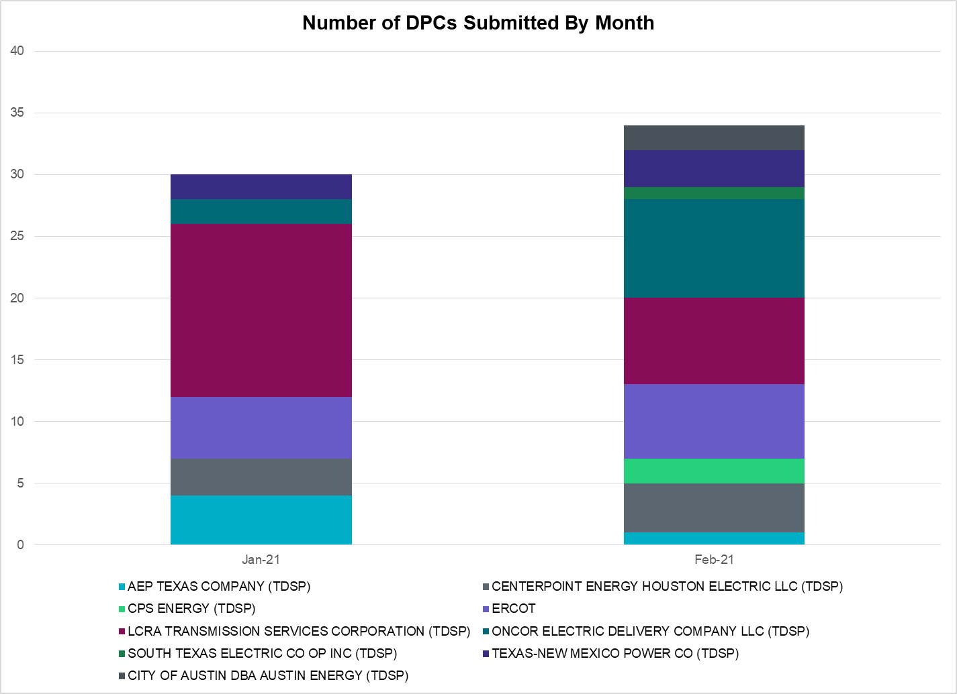

Transmission Operator | Number of DPCs
AEP TEXAS COMPANY (TDSP) | 1
BRAZOS ELECTRIC POWER CO OP INC (TDSP) | 0
BROWNSVILLE PUBLIC UTILITIES BOARD (TDSP) | 0
BRYAN TEXAS UTILITIES (TDSP)
CENTERPOINT ENERGY HOUSTON ELECTRIC LLC (TDSP) | 4
CITY OF AUSTIN DBA AUSTIN ENERGY (TDSP) | 2
CITY OF COLLEGE STATION (TDSP) | 0
CITY OF GARLAND (TDSP) | 0
CPS ENERGY (TDSP) | 2
DENTON MUNICIPAL ELECTRIC (TDSP) | 0
ELECTRIC TRANSMISSION TEXAS LLC (TDSP) | 0
ERCOT | 6
LCRA TRANSMISSION SERVICES CORPORATION (TDSP) | 7
LONE STAR TRANSMISSION LLC (TSP) | 0
ONCOR ELECTRIC DELIVERY COMPANY LLC (TDSP) | 8
RAYBURN COUNTRY CO OP DBA RAYBURN ELECTRIC (TDSP) | 0
SHARYLAND UTILITIES LP (TDSP) | 0
SOUTH TEXAS ELECTRIC CO OP INC (TDSP) | 1
TEXAS MUNICIPAL POWER AGENCY (TDSP) | 0
TEXAS-NEW MEXICO POWER CO (TDSP) | 3

Appendix A: Real-Time Constraints
The following is a complete list of constraints activated in SCED. Full contingency descriptions can be found in the Standard Contingencies List located on the MIS secure site at Grid Generation Reliability Unit Commitment.

Contingency Name | Overloaded Element | From Station | To Station | Count of Days
BASE CASE | RV_RH | n/a | n/a | 25
BASE CASE | NE_LOB | n/a | n/a | 22
SMV_PAR8 | RIOHND_ERIOHND_1 | MV_RIOHO | RIOHONDO | 19
DFER_WI8 | 49T191_1 | FERGUS | HORSBA | 18
BASE CASE | PNHNDL | n/a | n/a | 17
BASE CASE | VENADO_TLINE_1 | REVILLA | VENADO | 14
SLOBSA25 | NLARSW_PILONC1_1 | NLARSW | PILONCIL | 14
BASE CASE | VENADO_TLINE_1 | VENADO | REVILLA | 14
SLAQLOB8 | BRUNI_69_1 | BRUNI | BRUNI | 12
DFERSTA8 | 49T191_1 | FERGUS | HORSBA | 12
SBRAUVA8 | HAMILT_MAVERI1_1 | HAMILTON | MAVERICK | 12
SMELRIN8 | BONIVI_RINCON1_1 | RINCON | BONIVIEW | 12
SBRAUVA8 | HAMILT_MAVERI1_1 | MAVERICK | HAMILTON | 12
SBRAHAM8 | HAMILT_MAVERI1_1 | HAMILTON | MAVERICK | 11
SBRAHAM8 | HAMILT_MAVERI1_1 | MAVERICK | HAMILTON | 11
MHARNED5 | HAINE__LA_PAL1_1 | LA_PALMA | HAINE_DR | 10
SOXYIN28 | I_DUPP_I_DUPS2_1 | I_DUPP1 | I_DUPSW | 10
MHARNED5 | BURNS_RIOHONDO_1 | RIOHONDO | MV_BURNS | 10
BASE CASE | PIGSOL | n/a | n/a | 10
SOXYIN28 | I_DUPP_I_DUPS2_1 | I_DUPSW | I_DUPP1 | 10
SKLELOY8 | LOYOLA_69_1 | LOYOLA | LOYOLA | 10
BASE CASE | NELRIO | n/a | n/a | 9
BASE CASE | LGD_SANTIA1_1 | LGD | SANTIAGO | 9
SLOBSA25 | LARDVN_LASCRU1_1 | LARDVNTH | LASCRUCE | 9
SFORGIL8 | FRPHIL_MASN1_1 | MASN | FRPHILLT | 8
BASE CASE | WESTEX | n/a | n/a | 8
BASE CASE | VALEXP | n/a | n/a | 8
DELMSAN5 | PAWNEE_SPRUCE_1 | PAWNEE | CALAVERS | 8
BASE CASE | RANDAD_ZAPATA1_1 | RANDADO | ZAPATA | 7
SGA2ROM8 | GARZA_69A1 | GARZA | GARZA | 7
DHICPIL8 | CKT_944_1 | PILOT | CARSON | 6
SCMNCPS5 | 651__B | CMNSW | CMNTP | 6
SPORNCA9 | NCARBI_PV_TAP1_1 | NCARBIDE | PV_TAP | 6
DDILCOT8 | DIL_COTU_1 | COTULAS | DILLEYSW | 6
SFORYEL8 | FRPHIL_GILLES1_1 | GILLES | FRPHILLT | 5
SODLBRA8 | HAMILT_MAVERI1_1 | HAMILTON | MAVERICK | 5
SCO2EUL8 | COLETO_ROSATA1_1 | COLETO | ROSATA | 5
SN_SLON5 | LOYOLA_69_1 | LOYOLA | LOYOLA | 5
SODLBRA8 | HAMILT_MAVERI1_1 | MAVERICK | HAMILTON | 5
SFORYEL8 | FRPHIL_GILLES1_1 | FRPHILLT | GILLES | 5
SMOOPEA8 | FRI_PEAR_1 | PEARSALL | FRIOTOS | 5
SLOBSA25 | BRUNI_69_1 | BRUNI | BRUNI | 5
SCOLBAL8 | BALLIN_HUMBLT1_1 | BALLINGE | HUMBLTAP | 5
SCOMHA38 | MAXWEL_WHITIN1_1 | MAXWELL | WHITING | 5
SLISBAT8 | GARZA_69A1 | GARZA | GARZA | 4
SFORGIL8 | FRPHIL_GILLES1_1 | FRPHILLT | GILLES | 4
SBEVASH8 | HAMILT_MAVERI1_1 | HAMILTON | MAVERICK | 4
DGARHIC8 | CKT_943_1 | LYTTON_S | PILOT | 4
SFORGIL8 | FRPHIL_GILLES1_1 | GILLES | FRPHILLT | 4
DDELGA58 | GARZA_69A1 | GARZA | GARZA | 4
SCRDJON5 | 915__E | CMBSW | DCDAM | 4
XCRD58 | CRD_CRD2 | CRD | CRD | 4
SBRAUVA8 | ESCOND_GANSO1_1 | ESCONDID | GANSO | 4
SBRAUVA8 | ESCOND_GANSO1_1 | GANSO | ESCONDID | 4
DCRLLSW5 | 588_B_1 | LWSVH | LWSVW | 4
SSOLFTS8 | ALPINE_BRONCO1_1 | BRONCO | ALPINE | 3
DKG_RTW5 | DQ_NB_67_A | NB | DQ | 3
DCTZJCK8 | DOWJCK18_A | JCK | DOW | 3
DCENRO58 | GARZA_69A1 | GARZA | GARZA | 3
DTGFLC_8 | BLESSI_PAVLOV1_1 | BLESSING | PAVLOV | 3
STGFLC8 | BLESSI_PAVLOV1_1 | BLESSING | PAVLOV | 3
SCOLPAW5 | COLETO_ROSATA1_1 | COLETO | ROSATA | 3
BASE CASE | REDTAP | n/a | n/a | 3
DBWNAMO5 | SAPOWE_SAST1_1 | SAPOWER | SAST | 3
DKOCNUE8 | CHAMPL_WEIL_T1_1 | WEIL_TRC | CHAMPLIN | 3
SGODPAW5 | LON_HI_ORNGRO1_1 | LON_HILL | ORNGROV | 3
SPY2WIC8 | 9025_A_1 | WINKS | WINK | 3
DBWNAMO5 | 134T429_1 | SCHKAD | SAPOWER | 3
DBWNKLN5 | 924T214_1 | FORTMA | GILLES | 3
STURLYT8 | 103T262_1 | MCCALA | REDWOO | 3
DFERSTA8 | 318T313_1 | WIRTZ | JOHNCI | 3
DTGFLC_8 | BLESSI_PAVLOV1_1 | PAVLOV | BLESSING | 3
SFPPLO25 | CKT_3132_1 | FPPYD1 | WINCHES | 3
DSCOFAR5 | 6216__B | WLVSW | SHRNE | 3
SGRAFER8 | 83T196_1 | STARCK | PALEFA | 3
SGAFPHR8 | G138_14_1 | FRWYPARK | DICKNSON | 3
STGFLC8 | LAN_CT_PAVLOV1_1 | LAN_CTY | PAVLOV | 3
STGFLC8 | LAN_CT_PAVLOV1_1 | PAVLOV | LAN_CTY | 3
SRNDSPA8 | 469T469_1 | WHITES | BLOCKH | 3
DBWNKLN5 | 924T214_1 | GILLES | FORTMA | 3
BASE CASE | BEARKT | n/a | n/a | 3
XBGL88 | BISON_STRS1_1 | BISON | STRS | 3
XBGL88 | BISON_STRS1_1 | STRS | BISON | 3
BASE CASE | CBEDYN-1_A | CBEC | DYN | 3
STGFLC8 | BLESSI_PAVLOV1_1 | PAVLOV | BLESSING | 3
DAUSLOS5 | 190T152_1 | WINCHES | GIDEON | 2
DLYTTUN8 | 98T202_1 | ZORN | MCCALA | 2
SABSBLU8 | ABNTHW_CALLAH1_1 | CALLAHAN | ABNTHWST | 2
DAUSLOS5 | CKT_3121_1 | HOLMAN | LYTTON_S | 2
STULKEN8 | COLETO_ROSATA1_1 | COLETO | ROSATA | 2
DWAPHLJ5 | DOWJCK18_A | JCK | DOW | 2
SLCDYN8 | EB_WA_65_A | EB | WA | 2
SBRAHAM8 | ESCOND_GANSO1_1 | ESCONDID | GANSO | 2
SFTPFTP8 | OILMIT_SAWGRA1_1 | SAWGRASS | OILMITAP | 2
DMARPA_8 | 318T313_1 | WIRTZ | JOHNCI | 2
DFERSTA8 | 924T214_1 | GILLES | FORTMA | 2
SGILNU78 | GILA_HIWAY_1_1 | GILA | HIWAY_9 | 2
DCENREV5 | LON_HI_ORNGRO1_1 | LON_HILL | ORNGROV | 2
SKYLSAN8 | 229T315_1 | MARSFO | TRADPO | 2
XPYO85 | 9025_A_1 | WINKS | WINK | 2
DCBFBLU5 | ABNTHW_MULBER1_1 | MULBERRY | ABNTHWST | 2
SBEVASH8 | BAT_CRST_1 | BATESVL | CRSTLSW | 2
SSANFOW5 | COTULL_REVEIL1_1 | REVEILLE | COTULLA | 2
SVICCO28 | FANNIN_GOLIAD1_1 | FANNINS | GOLIAD | 2
SCOLPAW5 | GODDAR_PAWNEE1_1 | GODDARD | PAWNEE | 2
XARA89 | GREGOR_RINCON1_1 | RINCON | GREGORY | 2
DCAGTA58 | H3_K0_1 | H3 | K0 | 2
DKENCA58 | V3_W1_1 | V3 | W1 | 2
DLOSWIN5 | 190T152_1 | WINCHES | GIDEON | 2
DSTEXP12 | BLESSI_LOLITA1_1 | LOLITA | BLESSING | 2
SBRAHAM8 | ESCOND_GANSO1_1 | GANSO | ESCONDID | 2
MHARRIO5 | HAINE__LA_PAL1_1 | LA_PALMA | HAINE_DR | 2
DCENRI35 | LON_HI_ORNGRO1_1 | LON_HILL | ORNGROV | 2
SCOLPAW5 | LOOP_VICTORIA_1 | VICTORIA | L_463S | 2
SLOLFOR8 | NCARBI_PV_TAP1_1 | NCARBIDE | PV_TAP | 2
SMCCZO28 | 261T272_1 | TURNER | CROSSWI | 2
DFERHOR8 | 654T654_1 | WIRTZ | STARCK | 2
DSALHUT5 | 924T214_1 | GILLES | FORTMA | 2
SFREFAY8 | BELLSO_AT2 | BELLSO | BELLSO | 2
SGRICOL5 | GODDAR_PAWNEE1_1 | GODDARD | PAWNEE | 2
SGODPAW5 | LOOP_VICTORIA_1 | VICTORIA | L_463S | 2
SPAWSAN5 | LOOP_VICTORIA_1 | VICTORIA | L_463S | 2
SSOLFTS8 | M_69_P2_1 | TNFSTP | FTSW | 2
DCAGBRA5 | N5_P4_1_1 | CALAVERS | SKYLINE | 2
DMARPA_8 | 49T191_1 | FERGUS | HORSBA | 2
DHCKDEN8 | 6260__C | EMSES | RHTP1 | 2
DSWELNC5 | BLUF_C_MULBER1_1 | BLUF_CRK | MULBERRY | 2
SN_SLON5 | CELANE_KLEBER1_1 | CELANEBI | KLEBERG | 2
DGARLYT5 | CKT_963_1 | GARFIELD | HICROSS | 2
SN_SLON5 | KINGSV_KLEBER1_1 | KLEBERG | KINGSVIL | 2
XKLN358 | KLNSW_MR1H | KLNSW | KLNSW | 2
SPGWC8 | LAN_CT_PAVLOV1_1 | LAN_CTY | PAVLOV | 2
STURLYT8 | 106T200_1 | REDWOO | SANMAR | 2
DSALKLN5 | 924T214_1 | GILLES | FORTMA | 2
DSWECBF5 | ABNTHW_MULBER1_1 | MULBERRY | ABNTHWST | 2
XALM689 | ALMC_T2 | ALMC | ALMC | 2
DGILHIW8 | KOCH_H_LON_HI1_1 | LON_HILL | KOCH_HF | 2
SPGWC8 | LAN_CT_PAVLOV1_1 | PAVLOV | LAN_CTY | 2
DELMSAN5 | MAGRUD_VICTOR2_1 | VICTORIA | MAGRUDER | 2
XSA2N58 | PAWNEE_SPRUCE_1 | PAWNEE | CALAVERS | 2
SLCSTH25 | 505__A | THSES | SAMSW | 2
DCAGTA58 | 98T202_1 | ZORN | MCCALA | 2
DCBFBLU5 | ANSN_RADIUM1_1 | RADIUM | ANSN | 2
SABNABN8 | ANSN_RADIUM1_1 | RADIUM | ANSN | 2
SILLFTL8 | CARVER_TINSLE1_1 | CARVER | TINSLEY | 2
DBWNAMO5 | COKEST_REDCRE1_1 | REDCREEK | COKESTRE | 2
SILLFTL8 | HAMILT_MAXWEL1_1 | MAXWELL | HAMILTON | 2
DGILHIW8 | KOCH_H_LON_HI1_1 | KOCH_HF | LON_HILL | 2
SES2FRI8 | MIDW_OZONA1_1 | MIDW | OZONA | 2
SCENLOB5 | GODDAR_PAWNEE1_1 | GODDARD | PAWNEE | 1
SMCCGIB8 | INGLES_I_DUPS1_1 | I_DUPSW | INGLESID | 1
BASE CASE | LASPUL_RIOHON1_1 | LASPULGA | RIOHONDO | 1
BASE CASE | MCCAMY | n/a | n/a | 1
SMCEESK8 | MKLT_TRNT1_1 | TRNT | MKLT | 1
SSOLFTS8 | M_69_N1_1 | TNFS | TNPINION | 1
SPAWSAN5 | PAWNEE_XF1 | PAWNEE | PAWNEE | 1
SFTLMES8 | SAMATH_TANK1_1 | SAMATHIS | TANK | 1
BASE CASE | SWEETWN3_XF31 | SWEETWN3 | SWEETWN3 | 1
DBRNGOL8 | TRIMR_KLNSW_1 | KLNSW | TRIMMIER | 1
SLOLFOR8 | VICTOR_V_DUPS1_1 | V_DUPSW | VICTORIA | 1
SLAKMA28 | 83T196_1 | STARCK | PALEFA | 1
DSWELNC5 | ABNTHW_MULBER1_1 | MULBERRY | ABNTHWST | 1
SREVDIL8 | BRUNI_69_1 | BRUNI | BRUNI | 1
XBAL89 | CONCHO_VRBS1_1 | CONCHO | VRBS | 1
SBRAHAM8 | GANSO_MAVERI1_1 | GANSO | MAVERICK | 1
DGILHIW8 | GILA_MAYO1_1 | GILA | MAYO | 1
DCENRI35 | GODDAR_LON_HI1_1 | LON_HILL | GODDARD | 1
SCENLOB5 | GODDAR_LON_HI1_1 | LON_HILL | GODDARD | 1
SNCANCA8 | GREENL_NCARBI1_1 | NCARBIDE | GREENLK | 1
DWHIGIB8 | INGLES_I_DUPS1_1 | I_DUPSW | INGLESID | 1
SDELLAR8 | LARDVN_LASCRU1_1 | LARDVNTH | LASCRUCE | 1
DBERBO58 | MOUNTO_AT1 | MOUNTO | MOUNTO | 1
DODEMOS5 | ODEHV_MR2H | ODEHV | ODEHV | 1
DGRMGRS8 | OLN_FMR2 | OLN | OLN | 1
DBERBO58 | 254T331_1 | SATTLE | CRANMI | 1
DLYTZOR5 | 261T272_1 | TURNER | CROSSWI | 1
SWIRFE28 | 51T376_1 | FERGUS | GRANMO | 1
MDMTECR8 | 6235__A | CGRSW | SNYDR | 1
MDMTECR8 | 6235__A | SNYDR | CGRSW | 1
BASE CASE | ANSN_RADIUM1_1 | RADIUM | ANSN | 1
SES2FRI8 | BISON_STRS1_1 | BISON | STRS | 1
SWEILON8 | CHAMPL_WEIL_T1_1 | WEIL_TRC | CHAMPLIN | 1
SJARDIL8 | DIL_COTU_1 | COTULAS | DILLEYSW | 1
DBWNKLN5 | HAMILT_MAXWEL1_1 | MAXWELL | HAMILTON | 1
DDL_HOC8 | IM_WAP05_A | WAP | IM | 1
SLONLON8 | LON_HI_SERDEV3_1 | LON_HILL | LON_HILL | 1
SRAYRI28 | LOYOLA_69_1 | LOYOLA | LOYOLA | 1
DLOCRED8 | MAGRUD_VICTOR2_1 | VICTORIA | MAGRUDER | 1
SCITNUE8 | MORRIS_NUECES1_1 | NUECES_B | MORRIS | 1
SNADRIC8 | NAD_ELCM_1 | ELCMPOS | NADAS | 1
XDAN89 | TAB_DANS_1 | DANSBY | TABOR | 1
DLWSRNK5 | 587__A | ARGYL | LWSVH | 1
SGRAFER8 | 654T654_1 | WIRTZ | STARCK | 1
DDILCOT8 | BEVO_BRUNDAGE_1 | BRUNDGS | BEVO | 1
XBLE89 | BROOKH_P_LAVA1_1 | P_LAVACA | BROOKHOL | 1
DCPSES12 | MAXWEL_WHITIN1_1 | MAXWELL | WHITING | 1
SBI2STR9 | MIDW_OZONA1_1 | MIDW | OZONA | 1
SPOMNED5 | NLARSW_PILONC1_1 | NLARSW | PILONCIL | 1
XSSP58 | RYSSW_FMR2 | RYSSW | RYSSW | 1
XBLE58 | SAR_FRAN_1 | FRANKC | SARGNTS | 1
SBOSWHT5 | 1030__A | ELMOT | RGH | 1
DWTRTRC5 | 175__A | TRCNR | FORSW | 1
SSGVTRC5 | 175__A | TRCNR | FORSW | 1
DTWIDIV5 | 430T430_1 | GASCCR | MGSES | 1
DFERGRM8 | 654T654_1 | WIRTZ | STARCK | 1
DCPSES12 | 924T214_1 | GILLES | FORTMA | 1
DMGSBIT5 | ANSN_RADIUM1_1 | RADIUM | ANSN | 1
XBL2U58 | BLUF_CRK_T1_H | BLUF_CRK | BLUF_CRK | 1
SFTLMES8 | CONCHO_SAMATH1_1 | CONCHO | SAMATHIS | 1
SW_SW_L5 | CRTVLE_EINSTEN_1 | EINSTEIN | CRTRVLLE | 1
SILLFTL8 | DOLAN_WHITIN1_1 | WHITING | DOLAN | 1
SMELRIN8 | HEARDT_REFUGI1_1 | REFUGIO | HEARDTAP | 1
SCOLPAW5 | MAGRUD_VICTOR2_1 | VICTORIA | MAGRUDER | 1
DWEIHW89 | MCKENZ_WESTSI1_1 | WESTSIDE | MCKENZIE | 1
SMV_RI28 | OCB_2175_1 | SCARBIDE | LOMA_ALT | 1
SPAWSAN5 | PAWNEE_SPRUCE_1 | PAWNEE | CALAVERS | 1
BASE CASE | RAMBLER_GENTIE_1 | RAMBLER | TWINBU | 1
DGILHIW8 | REACTOR1_SEC_1 | WHITE_PT | WHITE_PT | 1
DBAKSOL5 | RIOPECOS_69-1 | RIOPECOS | RIOPECOS | 1
DWIRGRA8 | 49T191_1 | FERGUS | HORSBA | 1
DSALKLN5 | 610__B | TMPSW | TMPSE | 1
DSCOFAR5 | 6437__F | SCRCV | KNAPP | 1
SBEVASH8 | BEVO_BRUNDAGE_1 | BRUNDGS | BEVO | 1
DCHB_NB5 | EXNLH_03_A | EXN | LH | 1
DFERSTA8 | 38T365_1 | WIRTZ | FLATRO | 1
SMCCZO28 | 601T601_1 | LOCKHA | CLEAFO | 1
SEUSCDR8 | 975__H | EUSTSERC | EUSTC | 1
SMCCGIB8 | ARANSA_INGLES1_1 | INGLESID | ARANSASP | 1
SLGDSAP8 | BARNHR_BIGLAK1_1 | BIGLAKE | BARNHRT | 1
DFAYWEL8 | BELLSO_AT2 | BELLSO | BELLSO | 1
SPGWC8 | BLESSI_PAVLOV1_1 | PAVLOV | BLESSING | 1
DLONEQU8 | CHAMPL_WEIL_T1_1 | WEIL_TRC | CHAMPLIN | 1
DBURAMD8 | CKT_925_1 | PILOT | HICROSS | 1
SPAWCAL5 | COLETO_ROSATA1_1 | COLETO | ROSATA | 1
SDI2DIL9 | DILLEYSW_69A1 | DILLEYSW | DILLEYSW | 1
DFPPLOS5 | FAYETT_AT2L | FAYETT | FAYETT | 1
DVICEDN8 | FORMOS_JOSLIN1_1 | FORMOSA | JOSLIN | 1
SMDOPHR5 | G138_10B_1 | SEMINOLE | MAGNO_TN | 1
DCENRI35 | GODDAR_PAWNEE1_1 | GODDARD | PAWNEE | 1
DELMELM5 | HILL_MAR_2_1 | MARION | HILLCTRY | 1
SPORGIB8 | INGLES_I_DUPS1_1 | I_DUPSW | INGLESID | 1
SCENLOB5 | LON_HI_ORNGRO1_1 | LON_HILL | ORNGROV | 1
SWEIGLI8 | MAGRUD_VICTOR2_1 | VICTORIA | MAGRUDER | 1
DKOCNUE8 | MCKENZ_WESTSI1_1 | WESTSIDE | MCKENZIE | 1
BASE CASE | PAWNEE_SPRUCE_1 | PAWNEE | CALAVERS | 1
SMV_MV78 | RIOHND_ERIOHND_1 | MV_RIOHO | RIOHONDO | 1
SBEVASH8 | TURTLECK_WCRYS_1 | TURTLCRK | WCRYSTS | 1
DGRSLNC5 | 6380__D | PAINTCRE | MURRAY | 1
SDUKNE28 | ADERHO_ELSA1_1 | ADERHOLD | ELSA | 1
SPORGIB8 | ARANSA_INGLES1_1 | INGLESID | ARANSASP | 1
DSTPRED5 | BAY_SARG_1 | BAYCTYS | SARGNTS | 1
SPADTAR8 | CHLC_V_VERN1_1 | VERN | CHLC_VER | 1
SLGDSAP8 | CONCHO_SAMATH1_1 | CONCHO | SAMATHIS | 1
DBWN_AM5 | CONCHO_VRBS1_1 | CONCHO | VRBS | 1
SMOUMIL8 | DEVIHI_AT3 | DEVIHI | DEVIHI | 1
SFORJOS8 | FORMOS_LOLITA1_1 | FORMOSA | LOLITA | 1
SGOHJOS8 | FORMOS_LOLITA1_1 | FORMOSA | LOLITA | 1
SSOLFTS8 | FTST_69T1 | FTST | FTST | 1
DCABRO58 | GARZA_69A1 | GARZA | GARZA | 1
SN_SAJO5 | LASPUL_RAYMND1_1 | LASPULGA | RAYMND2 | 1
DCENFAL5 | LON_HI_ORNGRO1_1 | LON_HILL | ORNGROV | 1
SPAWSAN5 | MAGRUD_VICTOR2_1 | VICTORIA | MAGRUDER | 1
DRALDHI8 | M_69_F3_1 | WICKETT | WNKLRCO6 | 1
SCARFRI8 | SANTIA_SAPOWE1_1 | SANTIAGO | SAPOWER | 1
SGODLON5 | VICTO_WARBU_1A_1 | VICTORIA | WARBURTN | 1
DMTSCOS5 | 6437__F | SCRCV | KNAPP | 1
DENWSTE8 | 941__C | ENWSW | ENSSO | 1
DELMTEX5 | BLESSI_PALACI1_1 | BLESSING | PALACIOS | 1
BASE CASE | CMBTP_FMR1 | CMBTP | CMBTP | 1
SODLBRA8 | ESCOND_GANSO1_1 | ESCONDID | GANSO | 1
SPOMNED5 | FREER_LOBO1_1 | LOBO | FREER | 1
SODLBRA8 | GANSO_MAVERI1_1 | GANSO | MAVERICK | 1
SGARROM8 | GARZA_69A1 | GARZA | GARZA | 1
SLCDYN8 | GEBWA_65_A | WA | GEB | 1
SCOLPAW5 | GODDAR_LON_HI1_1 | LON_HILL | GODDARD | 1
DBIGKEN5 | HAMILT_MAXWEL1_1 | MAXWELL | HAMILTON | 1
DTGFLC_8 | LAN_CT_PAVLOV1_1 | LAN_CTY | PAVLOV | 1
DSTEXP12 | LN_92_1 | EXN | EXN | 1
SCOLKEN8 | MAGRUD_VICTOR2_1 | VICTORIA | MAGRUDER | 1
SPAWCAL5 | MAGRUD_VICTOR2_1 | VICTORIA | MAGRUDER | 1
DHWIND89 | MORRIS_NUECES1_1 | NUECES_B | MORRIS | 1
SREVDIL8 | NLARSW_PILONC1_1 | NLARSW | PILONCIL | 1
XTRL89 | RYSSW_FMR2 | RYSSW | RYSSW | 1
SCOLBAL8 | SANA_FMR1 | SANA | SANA | 1
SGODPAW5 | VICTO_WARBU_1A_1 | VICTORIA | WARBURTN | 1
DCAGTA58 | 243T278_1 | CICO | PIPECR | 1
DSCOFAR5 | 6216__A | SHRNE | BCKSW | 1
DHCKDEN8 | 6265__A | EMSES | MRSDO | 1

This is the hourly integrated peak demand as published in the ERCOT D&E report.
All DC Tie Curtailments are posted publically on the ERCOT Market Information System. See that posting for additional details for the event(s) in question.
See DC Tie Operating Procedure (http://www.ercot.com/mktrules/guides/procedures) for more details.

