TDTMS
January 21st, 2021
WebEx only
Attendee | Company | Attendee | Company | Attendee | Company
Diana Rehfeldt | TNMP | Jim Lee | AEP | Norm Levine | Direct
Sam Pak | Oncor | Steven Pliler | TXU | David Fimble | CNP
Kathy Scott | CenterPoint | Eric Blakey | Just Energy | Mark Ruane | ERCOT
Sheri Wiegand | TXU | Lauren Damen | NRG
Kyle Patrick | NRG | Angela Ghormley | Calpine
Mick Hanna | ERCOT | Dave Michelson | ERCOT
Jordan Troublefield | ERCOT | Andrea Couch | TNMP

Minutes, Antitrust, Leadership Elections
- Antitrust Admonition was read by Sheri
- Elections were conducted by Jordan Troublefield
  - Chair: Sheri Wiegand – TXU
  - Vice-Chair: Sam Pak - Oncor
- Minutes from 12/2/20 were approved

ERCOT System Instances & MarkeTrak Monthly Performance Review
- All targets for December were met
- Only one unplanned non-retail incident – 12/18
- MarkeTrak performance remains good. Response times have remained flat. See graph below
- IT Services report – “one stop shop” for all impacting market outages – initial and final notices
  - www.ercot.com/services/sla
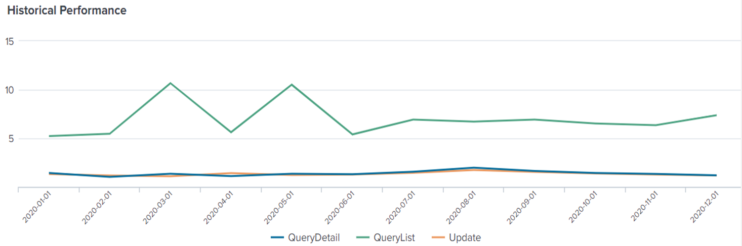

- May retail release extended outage 5/1 to 5/2
  - Longer than normal outage will be required due to migration into RMTE and moving a database activity
  - Expectation could be from noon on Saturday to Monday morning
  - Dave Michelson asked market participants if outage times needed to be extended or could be compressed, would that be preferred on the front or back end of the window. All market participants agreed the sliding the outage on Saturday is preferable if needed to be extended and not interfere with normal operations on Monday morning
  - WG agreed this needed to be discussed again future meetings for workaround plans – no later than mid-April
- February 6th and 7th – normal retail release weekend scheduled

Accomplishments 2020/Goals 2021
Goals and Accomplishments were finalized and will be presented at the February RMS meeting.
2021 Goals
- Support Texas data transport improvement initiatives and continue joint efforts with other retail market working groups
  - Collaborative with the Retail Market Training Task Force on operational issues in educating the market
  - Supporting a TXSET 5.0 IAG solution by providing needed data analysis results
  - Review of monthly ERCOT IAG report
- Develop a System Change Request (SCR) for proposed MarkeTrak operational/administrative enhancements to streamline efficiency and align with current market guides
- Collaborating with TXSET 5.0 improvements, draft a project proposal for MarkeTrak enhancements through Serena
- Perform biannual review of overall MarkeTrak subtype volumes for trends and the need for further analysis of various subtypes based on data points established
- Continued support in reviewing the market Switch Hold notification process
- Utilization of IAG data analysis framework to establish metrics for
  - Rescissions
  - Unexecuted IAGS
  - IAG results at least once per year
- Use MT data analysis results to review expected Service Level Agreements to improve performance and streamline the process
- Perform annual review of the Retail Market Services and Market Data Transparency Service Level Agreements (SLAs) and work with ERCOT to evaluate and implement any potential changes, as needed
- Review the quarterly ERCOT Retail Market Performance Measures if needed
- Support ERCOT resolution efforts in addressing each outage and/or degradation of service

2020 Accomplishments
- Supported Texas data transport improvement initiatives and continuous joint efforts with other retail market working groups
  - Collaborative effort with TXSET to review and develop an IAG solution for consideration of TXSET 5.0 enhancements
    - Established goals of the IAG solution proposal
    - Identified and fully vetted 4 initial options – pros and cons of each
    - Developed/updated proposed options matrix landing on the ‘push vs pull’ TXSET 5.0 solution matrix for IAG streamlining
- Established a matrix of data/reporting requirements for ERCOT to assist TDTMS in framing an on-going MarkeTrak sub-type analysis
- Reviewed biannual overall MarkeTrak subtype volumes, discussed trends, and applied results to support MarkeTrak enhancements
- Developed a list of proposed Marketrak enhancements
  - Sorted the list of enhancements by administrative vs validation revisions
    - administrative suggestions to be managed via a separate SCR and not required to follow the timeline for TXSET 5.0
    - validation suggestions requiring more coding/logic and thus will follow the TXSET 5.0 project timeline
  - Prioritized each recommendation by ‘level of effort’ and ‘priority – high/med/low’
- IAG/IAL Subtype Deep Dive Analysis – developed IAG MarkeTrak Performance Metrics framework and effectively evaluated over 44,000 completed IAG and IAL MarkeTraks to identify timelines for each step in the IAG/IAL Marketrak process:
Inadvertent Situation Flow
Time elapsed
2 → 1 | original transaction to submittal of MT
2 → 3 | how long touch
2 → 4 | agreement between CRs
3 → 4 | how long to agree once touched
4 → 6 | Losing CR to send BDMVI
5 → 6 | Ready to Receive to submittal of BDMVI
2 → 8 | total resolution time
  - Performance metrics presented to RMS as a tool for each CR to evaluate their own IAG/IAL performance and identify improvement opportunities
  - Developed Tips & Tricks/User’s Guide for IAS Market Reports and sent instructional email to RMS, TDTMS, and RMTTF listserves
- Support of ERCOT’s NAESB TLS 1.2 upgrade – preparation, establish workarounds to ensure market operations during cutover, communication, post implementation discussion
- Reviewed current switch hold notification market process (by TDU) and provided suggestion for new secure repository in ERCOT MIS – developed initial list of requirements
- Reviewed Switch Hold Removal process as outlined in the Retail Market Guide to ensure language provides clarity on declining such removal of the switch hold
- Full review of postings to MarkeTrak Information page on ercot.com with recommended actions to improve relevant information
- Reviewed and monitored monthly IT retail incident and service availability – new graph displaying historical MarkeTrak performance
- Approved the Retail Market Services Service Level Agreements for 2021 for endorsement to RMS
- Officially adopted ownership of the Market Data Transparency Service Level Agreements review for endorsement to RMS
- Supported relaunch of the Issue Tracking Page – an overall report of all outages posted to ercot.com

Proposal for daily Switch Hold Daily files to post to ERCOT
- WG reviewed the initial draft of the requirements to be sent to ERCOT proposing a repository for the daily switch hold files and revised as follows:
  - Allow TDUs to submit their master daily formatted switch hold files via NAESB to ERCOT no later than 0500 each day representing SH revisions of the day prior (NOTE: Sam will confirm Oncor can meet the 0500 deadline)
  - ERCOT to receive and post the five .csv formatted switch hold files (one from each TDU – Oncor, CNP, AEPN, AEPC, TNMP) in a designated location on ERCOT MIS (behind a Digital Certificate) by 0600 each day
  - Files will be formatted as indicated in the RMG Appendices J1 (see example attached)
  - Naming convention of files will remain the same - <TDSPDUNS><”SWITCHHOLD”><MMDDYYYY>.txt
  - Files may be delivered daily. ERCOT would post daily files if made available.
  - Current files will replace historical files, so only one file from each of the five TDUs will be in the repository at one time
- ACTION: Sheri will finalized email and forward to Dave Michelson to provide an update at the next TDTMS meeting.
- Andrea with TNMP provided an update on TNMP’s processing of 814_20s. At an earlier TDTMS, it was reported 814_20s are held and batched overnight which poses a delay to ERCOT’s TDSP extract file (which provides the Switch Hold indicator). By February 1st, TNMP will be sending 814_20s real time in lieu of the daily batch process. They will also be decommissioning depositing daily Switch Hold files to the STFP site and files will now be found on their CRIP portal.

AGENDA for 2/18/20 Meeting
- ERCOT Update
  - System Instances and MarkeTrak Monthly Performance Review
- Finalize Switch Hold Process Update from ERCOT
- Review of timing of Unexecutable IAG MTs
- MT Enhancements- DRAFT SCR

