System Planning
Monthly Status Report

Report Highlights

- ERCOT is currently reviewing proposed transmission improvements with a total estimated cost of $1,292.66 Million as of February 28, 2021.
- Transmission Projects endorsed in 2021 total $106.1 Million as of February 28, 2021.
- All projects (in engineering, routing, licensing and construction) total approximately $7.3 Billion as of February 1, 2021.
- Transmission Projects energized in 2021 total about $49.4 Million as of February 1, 2021.

Regional Planning Group Reviews
- AEPSC has submitted the LRGV Import Project. This is a Tier 1 project that is estimated to cost $73.4 million. AEPSC has also requested that ERCOT provide a conditional endorsement for an additional $357.2 million project. ERCOT’s independent review has been conducted in accordance with Protocol Section 3.11.4.9(3), and this project is currently placed on hold until the LNG loads are confirmed.
- STEC has submitted the Lower Rio Grande Valley Transmission Expansion Project. This is a Tier 1 project that is estimated to cost $511 million. ERCOT’s independent review has been conducted in accordance with Protocol Section 3.11.4.9(3), and this project is currently placed on hold until the LNG loads are confirmed.
- Oncor has submitted the Nacogdoches Southeast Switch – Redland Switch – Lufkin Switch 345-kV Loop Project. This is a Tier 2 project that is estimated to cost $71.26 million. This project is currently under ERCOT’s independent review.
- STEC and LCRA TSC have jointly submitted the Bakersfield to Big Hill 345‐kV Second Circuit Addition Project. This is a Tier 2 project that is estimated to cost $83.2 million. This project is currently in the RPG comment period.
- AEPSC has submitted the Port Lavaca Area Improvement Project. This is a Tier 2 project that is estimated to cost $97.8 million. This project is currently in the RPG comment period.
- Oncor has submitted the Midland East Area Project. This is a Tier 3 project that is estimated to cost $88.5 million. This project is currently in the RPG comment period.
- Oncor has submitted the Venus Switch - Cedar Hill Switch 345-kV Line Project. This is a Tier 3 project that is estimated to cost $10.3 million. This project is currently in the RPG comment period.

More information on current and past RPG projects can be found on the ERCOT MIS Secure (digital certificate required): https://mis.ercot.com/public/data-products/grid/regional-planning
Past email communication on RPG projects can be found on the ERCOT listserv by signing up for the REGPLANGROUP list: http://lists.ercot.com/scripts/wa-ERCOT.exe?A0=REGPLANGROUP

Planning Model Activities
The short-term calendar of major planning model events is as follows:
- By March 1, 2021 20SSWG Update 2 cases and TPIT are posted
- By March 31, 2021 20SSWGU2 Contingency definitions and Planning Data Dictionary are posted
The following table shows interconnection projects that met Planning Guide section 6.9(1) and 6.9(2) and were modeled in the SSWG cases as a full model or as a simple model in accordance with Planning Guide section 6.9.

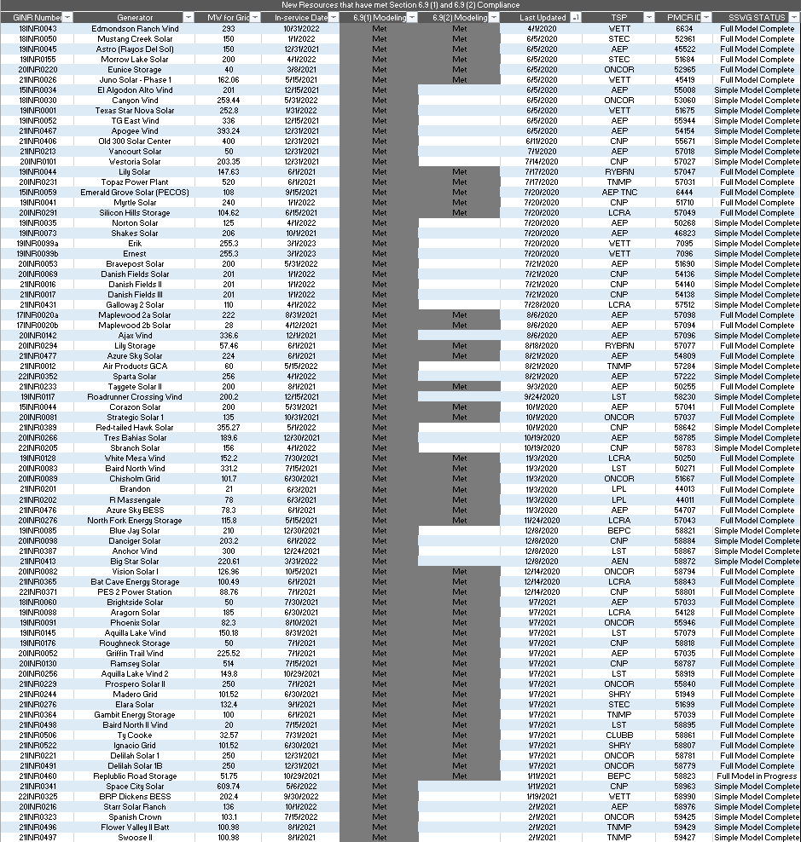

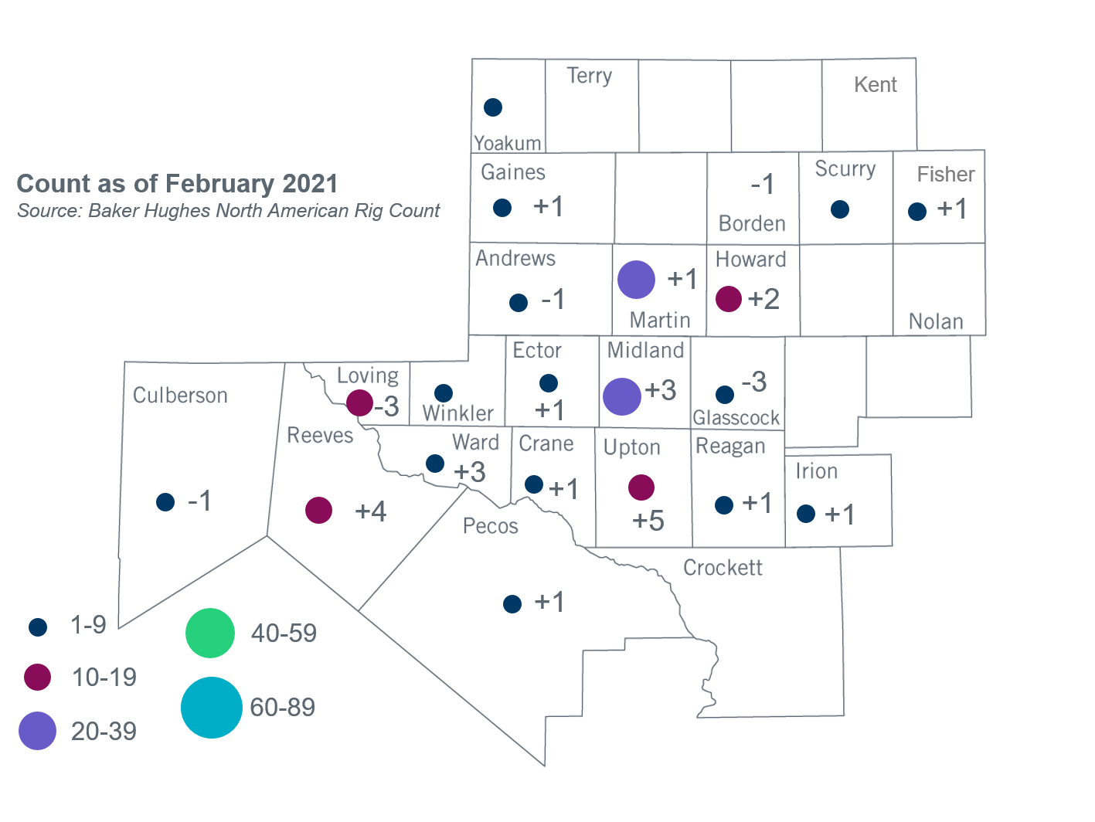
Permian Basin Oil Rig Count
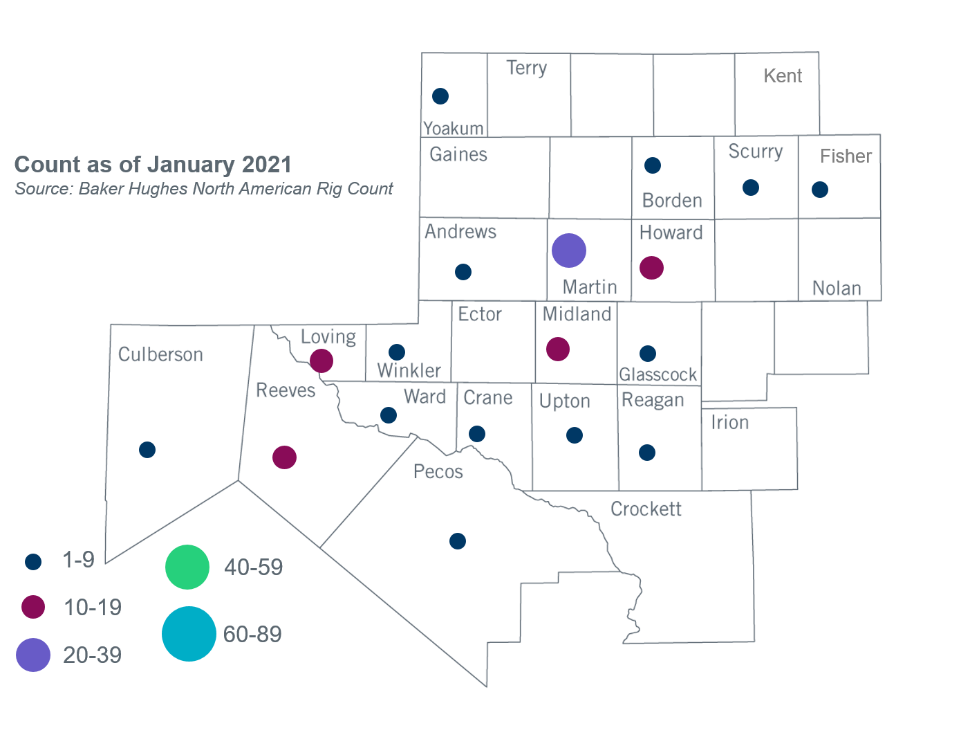

Other Notable Activities
- ERCOT is conducting the West Texas Export Study and plans to complete the study in June, 2021.
- ERCOT is conducting the South Texas Stability Study and plans to complete the study in June, 2021.
- The DWG completed and posted the 2021 flat start cases in February, 2021.
- The SPWG has begun building the 2021 CY base case.

+/- symbol indicates the increase or decrease from the previous month in oil rigs present in each county. There are 144 rigs, including a total increase of 16 oil rigs, in the Permian Basin from January 2021 to February 2021.

