PWG Meeting Notes – Feb 10, 2021
Via WebEx 9:30 AM
Attendees:
Sam Pak – Oncor | Bill Boswell - ERCOT | Jim Lee – AEP
Sheri Wiegand – TXU | Edward Lopez - BTU | Malcolm Ainspain
Kathy Scott – CNP | Randy Roberts - ERCOT | Angela Ghormley –Calpine Energy
Kim Rainwater - LCRA | Jordan Troublefield – ERCOT | Diana Rehfeldt - TNMP
Bill Barnes - NRG | Amar Khalifeh - ERCOT | Karen Malkey - CNP
Ester Kent - CNP | Clayton Stice - ERCOT | Kyle Patrick - NRG
Diana Mayo | Norm Levine - Direct | Rebecca DuPont – Evolve Energy
Lauren Damen - NRG

- Sam Pak reviewed Jan 13th meeting notes for approval

- Annual Weather Sensitivity Update
- ERCOT provided an updated report on completion status in early February.
- All Market Participants are deemed completed and on time.

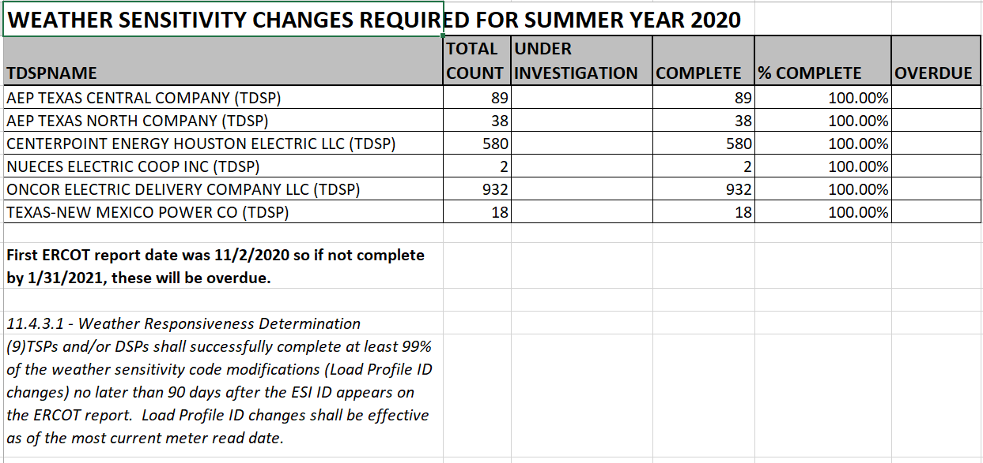

- Next Steps for LPGRR068, Add BUSLRG and BUSLRGDG Profile Types
  - Potential Smart Meter Texas (SMT) impacts
    - New load profiles could cause validations errors or rejects of LSE files
    - [Action Item] JDOA will provide feedback on potential issues
  - Timing for Implementation of LPGRR068
    - 150 days from ERCOT board approval per Protocols
    - OR earliest readiness of TDSP, REP, SMT, or ERCOT dates
    - Tentatively Q1 for 2022
  - Transition Plan
    - Reviewed a draft TDSP response table (Matrix) on Current Status, Transition Plan, and Access to Interval Data for IDR daily settlement
    - TDSPs suggested that the TDSP Matrix response table created from the 2020 IDR/AMS Workshops be used a reference guide where we can append additional questions as we move forward toward Transition Planning of LPGRR068.
    - [Action Item] Sheri will provide an enhancement to the above mentioned TDSP Matrix to the group

- Next Meeting: Next meeting will be Mar 10th at 9:30am via Webex.

