January 2021 ERCOT Monthly Operations Report
Reliability and Operations Subcommittee Meeting
March 4, 2021

Table of Contents
1. Report Highlights 2
2. Frequency Control 3
2.1. Frequency Events 3
2.2. Responsive Reserve Events 4
2.3. Load Resource Events 4
3. Reliability Unit Commitment 4
4. Wind Generation as a Percent of Load 5
5. Largest Net-Load Ramp 5
6. COP Error Analysis 6
7. Congestion Analysis 8
7.1. Notable Constraints 8
7.2. Generic Transmission Constraint Congestion 12
7.3. Manual Overrides 12
7.4. Congestion Costs for Calendar Year 2020 12
8. System Events 14
8.1. ERCOT Peak Load 14
8.2. Load Shed Events 14
8.3. Stability Events 14
8.4. Notable PMU Events 14
8.5. DC Tie Curtailment 14
8.6. TRE/DOE Reportable Events 14
8.7. New/Modified/Removed RAS 14
8.8. New Procedures/Forms/Operating Bulletins 14
9. Emergency Conditions 15
9.1. OCNs 15
9.2. Advisories 15
9.3. Watches 15
9.4. Emergency Notices 15
10. Application Performance 15
10.1. TSAT/VSAT Performance Issues 15
10.2. Communication Issues 15
10.3. Market System Issues 16
11. Model Updates 16
Appendix A: Real-Time Constraints 18

Report Highlights
- The unofficial ERCOT peak load was 55,598 MW.
- There were 5 frequency events.
- There were 5 instances where Responsive Reserves were deployed.
- There was 1 HRUC commitment.
- Congestion in the Panhandle can be attributed to wind generation in the area as well as multiple transmission outages. There were 23 days of congestion on the Panhandle GTC, 25 days on the North Edinburg to Lobo GTC, 21 days on the Raymondville to RioHondo GTC, 3 days Nelson Sharpe to Rio Hondo GTC, 9 days on the McCamey GTC, 11 days on the West Texas Export GTC, 2 days on the North to Houston Import GTC, 5 days on the Pig Creek to Solstice GTC and 7 days on the Rio Grande Valley Import GTC. There was no activity on the remaining GTCs during the month.
- There were no DC Tie Curtailments
- There was a new Wind Generation Record of 22,893 MW on 1/14/2021 at 07:27.

Frequency Control

Frequency Events

The ERCOT Interconnection experienced five frequency events, which resulted from unit’s trips. The average event duration was 00:04:26.

A summary of the frequency events is provided below. The reported frequency events meet one of the following criteria: Delta Frequency is 60 mHz or greater; the MW loss is 350 MW or greater; resource trip event triggered RRS deployment. Frequency events that have been identified as Frequency Measurable Events (FME) for purposes of BAL-001-TRE-1 analysis are highlighted in blue. When analyzing frequency events, ERCOT evaluates PMU data according to industry standards. Events with an oscillating frequency of less than 1 Hz are considered to be inter-area, while higher frequencies indicate local events. Industry standards specify that damping ratio for inter-area oscillations should be 3.0% or greater. For the frequency events listed below, the ERCOT system met these standards and transitioned well after each disturbance.

Date and Time | Delta Frequency | Max/Min Frequency | Duration of Event | PMU Data |  | MW Loss | Load | Wind | Inertia
 | (Hz) | (Hz) |  | Oscillation Mode (Hz) | Damping Ratio |  | (MW) | % | (GW-s)
1/3/2021 11:34 | 0.149 | 59.828 | 0:04:13 | 0.700 | 11% | 768.276 | 39,068 | 17% | 222,656
1/6/2021 18:20 | 0.164 | 59.848 | 0:04:50 | 0.840 | 16% | 774.066 | 43,289 | 42% | 192,810
1/11/2021 13:03 | 0.115 | 59.866 | 0:04:31 | 0.630 | 10% | 757.421 | 49,921 | 7% | 304,713
1/16/2021 21:35 | 0.111 | 59.898 | 0:04:17 | 2.020 | 7% | 453.471 | 41,291 | 17% | 211,857
1/28/2021 14:21 | 0.134 | 59.875 | 0:04:18 | 0.920 | 14% | 718.262 | 41,220 | 20% | 232,320

(Note: All data on this graph encompasses frequency event analysis based on BAL-001-TRE-1.)

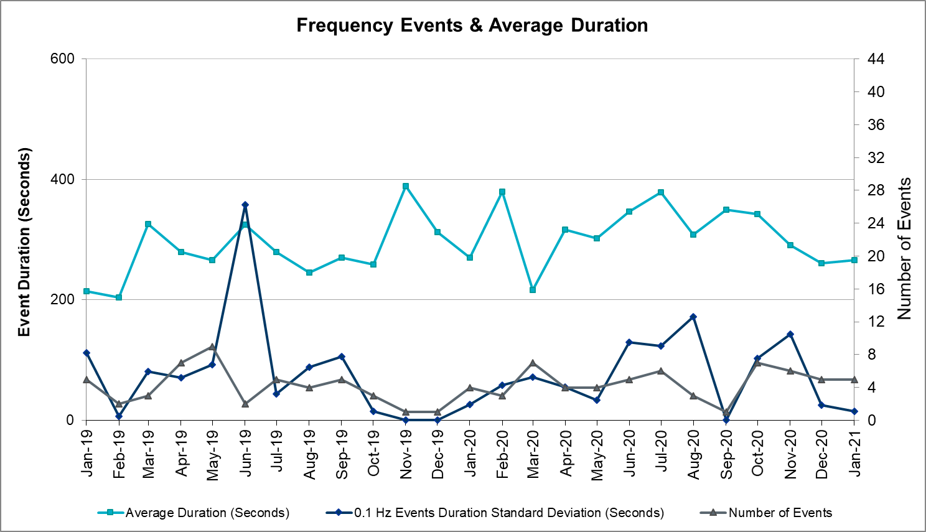
Note that the large standard deviation in June 2019 is due to coincidental extreme high and low durations for a small set of events (2).

Responsive Reserve Events

There were 5 events where Responsive Reserve MWs were released to SCED. The events highlighted in blue were related to frequency events reported in Section 2.1 above.

Date and Time Released to SCED | Date and Time Recalled | Duration of Event | Maximum MWs Released | Comments
1/3/2021 11:34 | 1/3/2021 11:38:44 | 00:04:13 | 999
1/6/2021 18:20 | 1/6/2021 18:25:12 | 00:04:50 | 796
1/11/2021 13:03 | 1/11/2021 13:08:12 | 00:04:31 | 756
1/16/2021 21:35 | 1/16/2021 21:39:28 | 00:04:17 | 568
1/28/2021 14:21 | 1/28/2021 14:25:20 | 00:04:18 | 656

Load Resource Events
None.

Reliability Unit Commitment
ERCOT reports on Reliability Unit Commitments (RUC) on a monthly basis. Commitments are reported grouped by operating day and weather zone. The total number of hours committed is the sum of the hours for all the units in the specified region. Additional information on RUC commitments can be found on the MIS secure site at Grid Generation Reliability Unit Commitment.

There were no DRUC commitments.

There was 1 HRUC commitment.

Resource Location | # of Resources | Operating Day | Total # of Hours Committed | Total MWhs | Reason for Commitment
Southern | 2 | 1/13/2021 | 5 | 2,276 | SPAWCAL5

Wind Generation as a Percent of Load

Wind Generation Record: 22,893 MW on 01/14/2021 at 07:27
Wind Penetration Record: 60.40% on 01/30/2021 at 07:54

Largest Net-Load Ramp
The net-load ramp is defined as the change in net-load (load minus wind and PVGR generation) during the defined time horizon. Such a variation in net-load needs to be accommodated in grid operations to ensure that the reliability of the grid is satisfactorily maintained. The largest net-load ramp during 5-min, 10-min, 15-min, 30-min and 60-min in January 2021 is 966 MW, 1744 MW, 2359 MW, 4458 MW, and 7842 MW, respectively. The comparison with respect to the historical values is given in the table below.

Month and Year | 5 min | 10 min | 15 min | 30 min | 60 min
Jan 2021 | 966 MW | 1744 MW | 2359 MW | 4458 MW | 7842 MW
Jan 2014 | 891 MW | 1603 MW | 2082 MW | 3607 MW | 6340 MW
Jan 2015 | 1025 MW | 1609 MW | 2150 MW | 3737 MW | 6496 MW
Jan 2016 | 950 MW | 1547 MW | 2076 MW | 3736 MW | 6213 MW
Jan 2017 | 959 MW | 1680 MW | 2160 MW | 3511 MW | 6181 MW
Jan 2018 | 1091 MW | 1824 MW | 2497 MW | 3901 MW | 6824 MW
Jan 2019 | 1087 MW | 1718 MW | 2308 MW | 4033 MW | 7786 MW
Jan 2020 | 1009 MW | 1610 MW | 2124 MW | 3700 MW | 6100 MW
All Months in 2014-2020 | 1494 MW | 1991 MW | 2780 MW | 5882 MW | 10364 MW

COP Error Analysis
COP Error is calculated as the capacity difference between the COP HSL and real-time HSL of the unit. Mean Absolute Error (MAE) stayed over 9,000 MW until Day-Ahead at 12:00, then dropped significantly to 1,212 MW by Day-Ahead at 15:00. In the following chart, Under-Scheduling Error indicates that COP had less generation capacity than real-time and Over-Scheduling Error indicates that COP had more generation capacity than real-time.

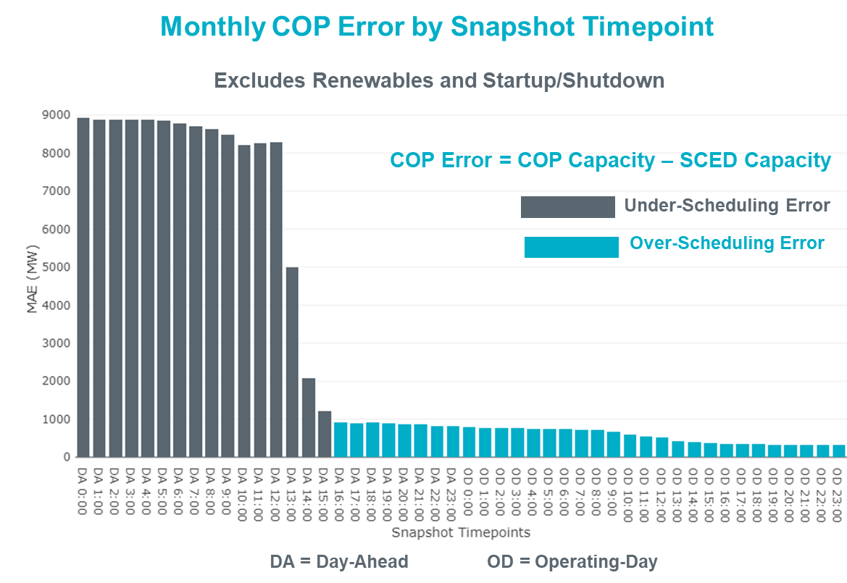

Monthly MAE for the Latest COP at the end of the Adjustment Period was 312 MW with median ranging from -119 MW for Hour-Ending (HE) 23 to 194 MW for HE 20. HE 20 on the 6th had the largest Over-Scheduling Error (1,499 MW) and HE 1 on the 27th had the largest Under-Scheduling Error (-2,345 MW).

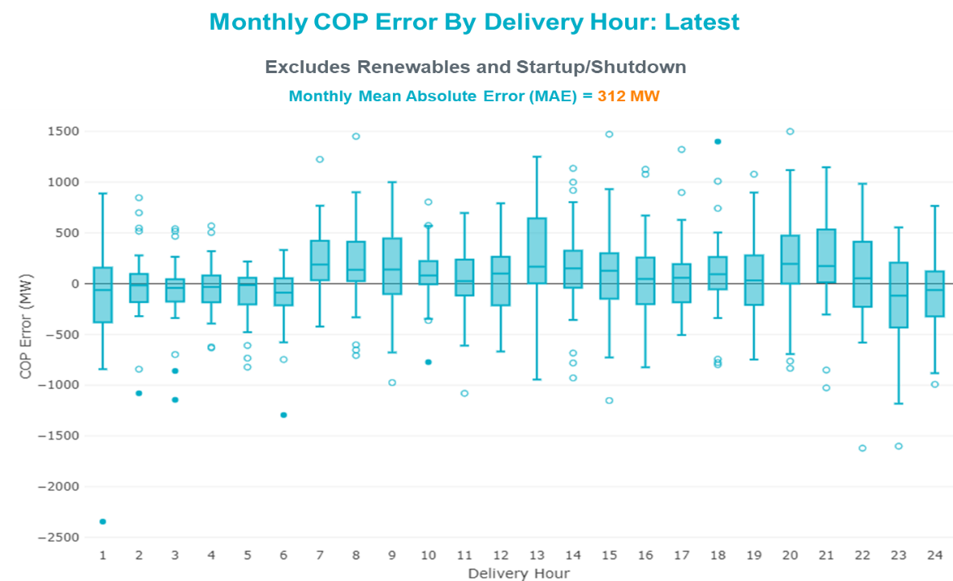

Monthly MAE for the Day-Ahead COP at 12:00 was 8,299 MW with median ranging from -9902 MW for Hour-Ending (HE) 20 to -6,792 MW for HE 24. HE 18 on the 11th had the largest Under-Scheduling Error (-19,676 MW) and HE 22 on the 13th had the largest Over-Scheduling Error (2,228 MW).

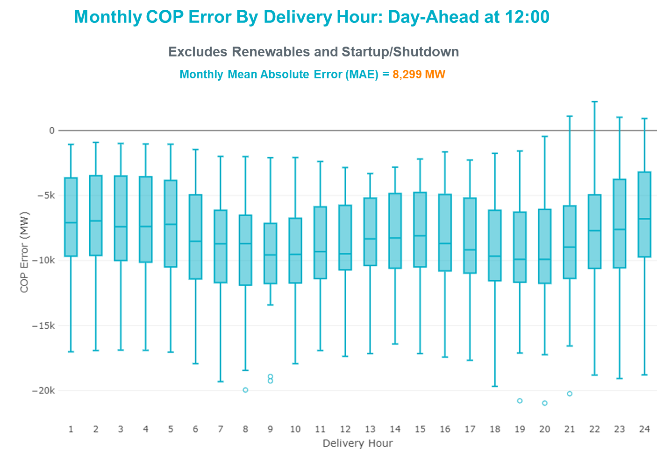

Congestion Analysis

Notable Constraints

Nodal protocol section 3.20 specifies that ERCOT shall identify transmission constraints that are active or binding three or more times within a calendar month. As part of this process, ERCOT reports congestion that meets this criterion to ROS. In addition ERCOT also highlights notable constraints that have an estimated congestion rent exceeding $1,000 for a calendar month. These constraints are detailed in the table below, including approved transmission upgrades from TPIT that may provide some congestion relief based on ERCOT’s engineering judgement. Rows highlighted in blue indicate the congestion was affected by one or more outages. For a list of all constraints activated in SCED, please see Appendix A at the end of this report.

Contingency Name | Overloaded Element | # of Days Constraint Active | Congestion Rent | Transmission Project
Basecase | PNHNDL GTC | 22 | $17,113,276.42
Hillctry-Marion 345kV | Cibolo - Schertz 138kV | 3 | $6,760,173.22
Basecase | NE_LOB GTC | 24 | $4,733,169.00
Basecase | WESTEX GTC | 10 | $3,173,969.02
TWR(345) JCK-REF27 & JCK-STP18 | Blessing - Pavlov 138kV | 6 | $2,378,618.14
EUSTACE SOUTHEAST to CEDAR SWITCHING STATION LIN 1 | Eustace Southeast - Eustace 138kV | 3 | $2,152,194.60
LON HILL to NELSON SHARPE LIN 1 | Celanese Bishop - Kleberg Aep 138kV | 8 | $1,937,739.52
NORTH EDINBURG TRX 1382 345/138 | North Edinburg 138kV | 3 | $1,920,595.58
Melon Creek to RINCON LIN 1 | Bonnieview - Rincon 69kV | 17 | $1,898,871.94 | Refugio - Rincon: Upgrade 69 kV Line (6427)
COMANCHE SWITCH (Oncor) to COMANCHE PEAK SES LIN _A | Comanche Tap - Comanche Switch (Oncor) 138kV | 12 | $1,465,956.32
HILL COUNTRY to MARION LIN 1 | Parkway - Schertz 138kV | 7 | $1,198,888.83
SKYLINE-CALAVERS 345KV | Cagnon - Calaveras 345kV | 10 | $1,181,328.75
Manual dbl ckt for NEDIN-BONILLA 345kV & RIOH-PRIM138kV | Burns Sub - Rio Hondo 138kV | 11 | $1,171,531.91 | Stewart Road: Construct 345 kV cut-in with two 450 MVA 345/138 autotransformers connected to Stewart Rd 138 station (5604, 6382)
ODLAW SWITCHYARD to ASPHALT MINES LIN 1 | Hamilton Road - Maverick 138kV | 18 | $1,005,375.34 | Brackettville to Escondido: Construct 138 kV line (5206)
FORT LANCASTER to ILLINOIS #4 LIN 1 | Carver - Tinsley Tap 138kV | 6 | $789,125.70
Fowlerton to LOBO 345 LIN1 | North Laredo Switch - Piloncillo 138kV | 12 | $774,262.73
LISTON to BATES LIN 1 | Garza 138kV | 16 | $602,874.85
Austro-Daffin&Dunlap-Decker 138kV | Mcneil Aen - Howard Lane Aen 138kV | 9 | $587,268.38 | Reconductor 138kV ckt 972 Howard Lane to McNeil to 3000A (48327)
Delsol-Pomelo (345) & Garza-Liston (138) | Garza 138kV | 16 | $486,165.47
BRACKETTVILLE to HAMILTON ROAD LIN 1 | Hamilton Road - Maverick 138kV | 9 | $479,496.95 | Brackettville to Escondido: Construct 138 kV line (5206)
Basecase | RV_RH GTC | 20 | $472,924.02
Fowlerton to LOBO 345 LIN1 | Asherton - Catarina 138kV | 5 | $426,475.69 | Brackettville to Escondido: Construct 138 kV line (5206)
Bighil-Kendal 345kV | Carver - Tinsley Tap 138kV | 7 | $411,116.11
Dilleysw-Sanmgsw&Cotulas 138kV | Dilley Switch Aep - Cotulla Sub 69kV | 6 | $388,894.44 | Dilley - Jourdanton 69 kV Line (44866)
Fppyd1-Lostpine 345kV | Fayetteville 345kV | 5 | $379,806.50
manual Sand Lake - Solstice line 1 and 2 | Pig Creek - Solstice 138kV | 5 | $377,811.51 | Barrilla Junction to Ft. Stockton SW: Rebuild 69 kV line (7027)
Basecase | MCCAMY GTC | 9 | $370,931.97
Elmcreek-STP 345kV | Pawnee Switching Station - Calaveras 345kV | 10 | $366,938.03
Fergus-Granmo&Wirtz-Starck 138kV | Flat Rock Lcra - Wirtz 138kV | 9 | $251,350.70
Fowlerton to LOBO 345 LIN1 | Bruni Sub 138kV | 3 | $243,967.35
FORT MASON to YELLOW JACKET LIN 1 | Fredricksburg Phillips Tap - Gillespie 69kV | 7 | $189,564.05
TWR(345) JCK-STP18 & REF-STP27 | Blessing - Pavlov 138kV | 3 | $189,055.02
ASHERTON to Bevo Substation LIN 1 | Turtle Creek Switching Station - West Crystal City Sub 69kV | 4 | $182,004.35
LAQUINTA to LOBO LIN 1 | Bruni Sub 138kV | 10 | $158,513.68
Fppyd1-Lostpine 345kV | Bellville South - Peters 138kV | 3 | $148,121.90
BARRILLA TRX FMR1 138/69 | Conoco Comp Station - FoStockton Plant 69kV | 4 | $143,621.80
Melon Creek to RINCON LIN 1 | Heard Tap - Refugio 69kV | 2 | $130,346.85
Lostpi-Austro&Dunlap 345kV | Sim Gideon - Winchester 138kV | 3 | $121,097.91
INGLESIDE COGEN SWITCH to OXYCHEM INGLESIDE LIN 1 | Dupont Pp1 - Ingleside - Dupont Switch - Ingleside 138kV | 3 | $98,406.95
GILLESPIE LCRA to FORT MASON LIN 1 | Mason Aep - Fredricksburg Phillips Tap 69kV | 12 | $74,955.83
Basecase | Venado Wind - Revilla 138kV | 11 | $74,469.15
FORT LANCASTER to ILLINOIS #4 LIN 1 | Hamilton Road - Maxwell 138kV | 10 | $71,795.81 | Hamilton Road - Maxwell 138 kV line rebuild project
KLEBERG AEP to LOYOLA SUB LIN 1 | Loyola Sub 138kV | 4 | $71,259.88
Basecase | VALEXP GTC | 7 | $65,588.94
Bighil-Kendal 345kV | Hamilton Road - Maxwell 138kV | 7 | $64,382.66 | Hamilton Road - Maxwell 138 kV line rebuild project
INGLESIDE COGEN SWITCH to OXYCHEM INGLESIDE LIN 1 | Dupont Pp1 - Ingleside - Dupont Switch - Ingleside 138kV | 5 | $63,873.73
FORT MASON to YELLOW JACKET LIN 1 | Yellow Jacket - Hext Lcra 69kV | 3 | $56,691.94 | Yellowjckt to Menard Phillips T 69 kV line: Rebld 69 kV line (6345)
Hillctry-Marion 345kV | Parkway - Schertz 138kV | 3 | $48,041.34
PAREDES SWITCHING STATION to CENTRAL AVENUE SUB LIN 1 | Rio Hondo - East Rio Hondo Sub 138kV | 15 | $45,090.07 | Rebuild Rio Hondo to East Rio Hondo (6687)
LON HILL to NELSON SHARPE LIN 1 | Kingsville - Kleberg Aep 138kV | 3 | $41,886.90
WISECNTY TO JACKCNTY AND ALVRD TO CHITP 138 DBLCKT | Jack County - Balsora 138kV | 7 | $38,638.43
GILLESPIE LCRA to FORT MASON LIN 1 | Fredricksburg Phillips Tap - Gillespie 69kV | 6 | $25,773.55
MILLER CREEK to PALEFACE LIN 1 | Johnson City - Wirtz 138kV | 4 | $24,635.93 | Wirtz to Johnson City to Mountain Top Rebuild to 138kV (6789)
Fergus-Gilles & Horsba 138kV | Johnson City - Wirtz 138kV | 9 | $23,311.16 | Wirtz to Johnson City to Mountain Top Rebuild to 138kV (6789)
Elmcreek-Sanmigl 345kV | Pawnee Switching Station - Calaveras 345kV | 10 | $16,853.74
Basecase | PIGSOL GTC | 4 | $7,010.28
BRACKETTVILLE to ODLAW SWITCHYARD LIN 1 | Hamilton Road - Maverick 138kV | 4 | $6,140.73 | Brackettville to Escondido: Construct 138 kV line (5206)
HAMILTON ROAD to CORRAL LIN 1 | Hamilton Road - Maxwell 138kV | 4 | $5,780.60 | Hamilton Road - Maxwell 138 kV line rebuild project
Ferguson-Sherwood Shores & Ferguson-Granite Mountain 138kV | Johnson City - Wirtz 138kV | 9 | $5,586.93 | Wirtz to Johnson City to Mountain Top Rebuild to 138kV (6789)
Basecase | Randado Aep - Zapata 138kV | 10 | $4,922.00
FORT MASON to YELLOW JACKET LIN 1 | Mason Switching Station - Hext Lcra 69kV | 4 | $3,816.71 | Mason to North Brady: Rebuild 69 kV line (50900)
COLETO CREEK to VICTORIA LIN 1 | Coleto Creek - Victoria 138kV | 4 | $2,468.44
Fergus-Granmo&Wirtz-Starck 138kV | Johnson City - Wirtz 138kV | 3 | $2,280.73 | Wirtz to Johnson City to Mountain Top Rebuild to 138kV (6789)
Marbfa-Lakewy &Wirtz-Palefa 138kV | Flat Rock Lcra - Wirtz 138kV | 8 | $1,635.40

Generic Transmission Constraint Congestion
There were 23 days of congestion on the Panhandle GTC, 25 days on the North Edinburg to Lobo GTC, 21 days on the Raymondville to RioHondo GTC, 3 days Nelson Sharpe to Rio Hondo GTC, 9 days on the McCamey GTC, 11 days on the West Texas Export GTC, 2 days on the North to Houston Import GTC, 5 days on the Pig Creek to Solstice GTC and 7 days on the Rio Grande Valley Import GTC. There was no activity on the remaining GTCs during the month.

Note: This is how many times a constraint has been activated to avoid exceeding a GTC limit, it does not imply an exceedance of the GTC occurred or that the GTC was binding.

Manual Overrides
None.

Congestion Costs for Calendar Year 2020
The following table represents the top twenty active constraints for the calendar year based on the estimated congestion rent attributed to the congestion. ERCOT updates this list on a monthly basis.

Contingency | Overloaded Element | # of 5-min SCED | Estimated | Transmission Project
Basecase | PNHNDL GTC | 3386 | 17113276.42
Hillctry-Marion 345kV | Cibolo - Schertz 138kV | 687 | 6760173.22
Basecase | NE_LOB GTC | 2356 | 4733169
Basecase | WESTEX GTC | 947 | 3173969.018
TWR(345) JCK-REF27 & JCK-STP18 | Blessing - Pavlov 138kV | 1108 | 2378618.14
EUSTACE SOUTHEAST to CEDAR SWITCHING STATION LIN 1 | Eustace Southeast - Eustace 138kV | 198 | 2152194.597
LON HILL to NELSON SHARPE LIN 1 | Celanese Bishop - Kleberg Aep 138kV | 1019 | 1937739.522
NORTH EDINBURG TRX 1382 345/138 | North Edinburg 138kV | 146 | 1920595.578
Melon Creek to RINCON LIN 1 | Bonnieview - Rincon 69kV | 1960 | 1898871.943 | Refugio - Rincon: Upgrade 69 kV Line (6427)
COMANCHE SWITCH (Oncor) to COMANCHE PEAK SES LIN _A | Comanche Tap - Comanche Switch (Oncor) 138kV | 1190 | 1465956.322
HILL COUNTRY to MARION LIN 1 | Parkway - Schertz 138kV | 1165 | 1198888.831
SKYLINE-CALAVERS 345KV | Cagnon - Calaveras 345kV | 1143 | 1181328.748
Manual dbl ckt for NEDIN-BONILLA 345kV & RIOH-PRIM138kV | Burns Sub - Rio Hondo 138kV | 829 | 1171531.914 | Stewart Road: Construct 345 kV cut-in with two 450 MVA 345/138 autotransformers connected to Stewart Rd 138 station (5604, 6382)
ODLAW SWITCHYARD to ASPHALT MINES LIN 1 | Hamilton Road - Maverick 138kV | 1605 | 1005375.337 | Brackettville to Escondido: Construct 138 kV line (5206)
TRCNR-SGVSW345kV&TRCNR-FORSW345KV_DBLCKT | Sargent Road - Oakland Tap 138kV | 98 | 915772.0501
FORT LANCASTER to ILLINOIS #4 LIN 1 | Carver - Tinsley Tap 138kV | 350 | 789125.7027
Fowlerton to LOBO 345 LIN1 | North Laredo Switch - Piloncillo 138kV | 607 | 774262.7268
TRCNR-SGVSW345kV&TRCNR-FORSW345KV_DBLCKT | Oakland Tap - Parkdale Switch 138kV | 58 | 695444.4583
LISTON to BATES LIN 1 | Garza 138kV | 1720 | 602874.8466
Austro-Daffin&Dunlap-Decker 138kV | Mcneil Aen - Howard Lane Aen 138kV | 1316 | 587268.3778 | Reconductor 138kV ckt 972 Howard Lane to McNeil to 3000A (48327)

System Events

ERCOT Peak Load
The unofficial ERCOT peak load for the month was 58,598 MW and occurred on the 12th, during hour ending 08:00.

Load Shed Events
None.

Stability Events
None.

Notable PMU Events
ERCOT analyzes PMU data for any significant system disturbances that do not fall into the Frequency Events category reported in section 2.1. The results are summarized in this section once the analysis has been completed.

There were no PMU events outside of those reported in section 2.1.

DC Tie Curtailment
None.

TRE/DOE Reportable Events
- Oncor submitted an OE-417 for 01/10/2021 Reportable Event Type: Loss of Electric Service
- Calpine submitted an EOP-004-4 for 01/14/2021 Reportable Event Type: Physical threat to a facility

New/Updated Constraint Management Plans
None.

New/Modified/Removed RAS
- The Mitchell BEND Remedial Action Scheme (RAS) was modified on January 6, 2021.
- The Stryker Creek Remedial Action Scheme (RAS) was modified on January 27, 2021.

New Procedures/Forms/Operating Bulletins
None.

Emergency Conditions

OCNs
Date and Time | Message
Jan 07 2021 15:30 CPT | ERCOT issued an OCN due to a predicted freezing precipitation event for the Panhandle, North and West areas of the ERCOT region.
Jan 14 2021 06:30 CPT | ERCOT issued an OCN for modifying the PNHNDL Generic Transmission Constraint due to the current transmission outage topology.

Advisories
Date and Time | Message
Jan 21 2021 13:30 CPT | ERCOT has postponed the posting of the DAM Solution for Operating Day January 22, 2021 due to delay in clearing DAM.

Watches
None.

Emergency Notices
None.

Application Performance

TSAT/VSAT Performance Issues
None.

Communication Issues
None.

Market System Issues
None.

Model Updates
The Downstream Production Change (DPC) process allows ERCOT to make changes in the on-line Network Operations Model without loading a completely new model. The purpose of this process is to allow for reliable grid operations as system conditions change between designated Network Operations Model database loads. The DPC process is limited in scope to just those items listed below, with equipment ratings updates being the most common. ERCOT has seen a rise in the use of the DPC process to make on-line updates to the Network Operations Model in recent years, instead of through the standard Network Operations Model Change Request process.

- Static Line ratings (Interim Update)
- Dynamic Line ratings (non-Interim Update)
- Autotransformer ratings (non-Interim Update)
- Breaker and Switch Normal status (Interim Update)
- Contingency Definitions (Interim Update)
- RAP and RAS changes or additions (Interim Update)
- Net Dependable and Reactive Capability (NDCRC) values (Interim Update)
- Impedance Updates (non-Interim)

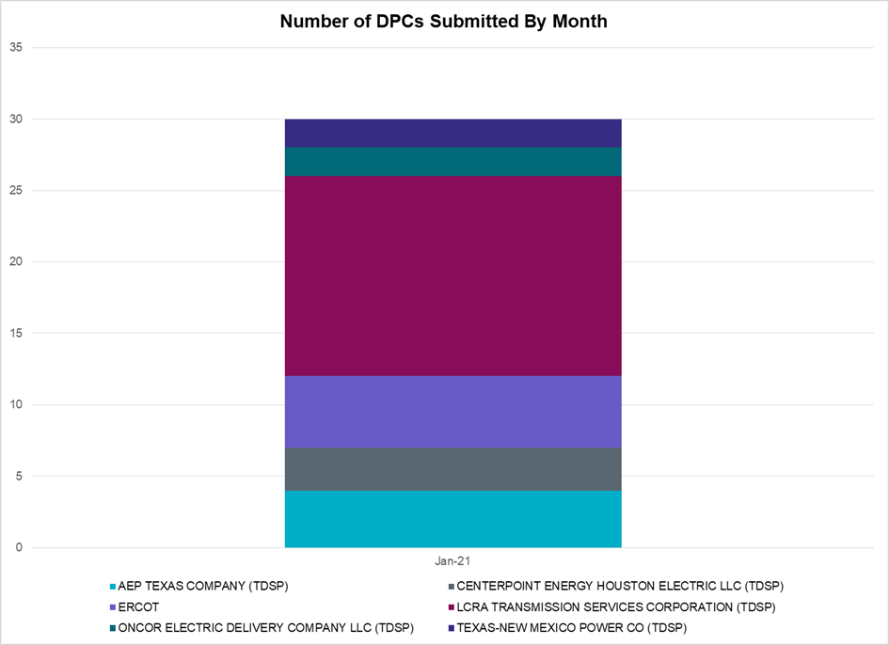

Transmission Operator | Number of DPCs
AEP TEXAS COMPANY (TDSP) | 4
BRAZOS ELECTRIC POWER CO OP INC (TDSP) | 0
BROWNSVILLE PUBLIC UTILITIES BOARD (TDSP) | 0
BRYAN TEXAS UTILITIES (TDSP) | 0
CENTERPOINT ENERGY HOUSTON ELECTRIC LLC (TDSP) | 3
CITY OF AUSTIN DBA AUSTIN ENERGY (TDSP) | 0
CITY OF COLLEGE STATION (TDSP) | 0
CITY OF GARLAND (TDSP)
CPS ENERGY (TDSP) | 0
DENTON MUNICIPAL ELECTRIC (TDSP) | 0
ELECTRIC TRANSMISSION TEXAS LLC (TDSP) | 0
ERCOT | 5
LCRA TRANSMISSION SERVICES CORPORATION (TDSP) | 14
LONE STAR TRANSMISSION LLC (TSP) | 0
ONCOR ELECTRIC DELIVERY COMPANY LLC (TDSP) | 2
RAYBURN COUNTRY CO OP DBA RAYBURN ELECTRIC (TDSP) | 0
SHARYLAND UTILITIES LP (TDSP) | 0
SOUTH TEXAS ELECTRIC CO OP INC (TDSP) | 0
TEXAS MUNICIPAL POWER AGENCY (TDSP) | 0
TEXAS-NEW MEXICO POWER CO (TDSP) | 2

Appendix A: Real-Time Constraints
The following is a complete list of constraints activated in SCED. Full contingency descriptions can be found in the Standard Contingencies List located on the MIS secure site at Grid Generation Reliability Unit Commitment.

Contingency Name | Overloaded Element | From Station | To Station | Count of Days
BASE CASE | NE_LOB | n/a | n/a | 24
BASE CASE | PNHNDL | n/a | n/a | 22
BASE CASE | RV_RH | n/a | n/a | 20
SBRAUVA8 | HAMILT_MAVERI1_1 | HAMILTON | MAVERICK | 18
SMELRIN8 | BONIVI_RINCON1_1 | RINCON | BONIVIEW | 17
SMELRIN8 | BONIVI_RINCON1_1 | BONIVIEW | RINCON | 17
DDELGA58 | GARZA_69A1 | GARZA | GARZA | 16
SLISBAT8 | GARZA_69A1 | GARZA | GARZA | 16
SMV_PAR8 | RIOHND_ERIOHND_1 | MV_RIOHO | RIOHONDO | 15
SFORGIL8 | FRPHIL_MASN1_1 | MASN | FRPHILLT | 12
SLOBSA25 | NLARSW_PILONC1_1 | NLARSW | PILONCIL | 12
SCMNCPS5 | 651__B | CMNSW | CMNTP | 12
BASE CASE | VENADO_TLINE_1 | REVILLA | VENADO | 11
BASE CASE | VENADO_TLINE_1 | VENADO | REVILLA | 11
MHARNED5 | BURNS_RIOHONDO_1 | RIOHONDO | MV_BURNS | 11
DSKYCAL5 | N5_R5_1 | CALAVERS | CAGNON | 10
SILLFTL8 | HAMILT_MAXWEL1_1 | MAXWELL | HAMILTON | 10
DELMTEX5 | PAWNEE_SPRUCE_1 | PAWNEE | CALAVERS | 10
DELMSAN5 | PAWNEE_SPRUCE_1 | PAWNEE | CALAVERS | 10
BASE CASE | WESTEX | n/a | n/a | 10
SLAQLOB8 | BRUNI_69_1 | BRUNI | BRUNI | 10
BASE CASE | RANDAD_ZAPATA1_1 | RANDADO | ZAPATA | 10
DFERSTA8 | 38T365_1 | WIRTZ | FLATRO | 9
BASE CASE | MCCAMY | n/a | n/a | 9
DAUSDUN8 | CKT_972_1 | HWRDLN | MCNEIL | 9
SBRAHAM8 | HAMILT_MAVERI1_1 | HAMILTON | MAVERICK | 9
DFERGRM8 | 318T313_1 | WIRTZ | JOHNCI | 9
DFERHOR8 | 318T313_1 | WIRTZ | JOHNCI | 9
SN_SLON5 | CELANE_KLEBER1_1 | CELANEBI | KLEBERG | 8
DMARPA_8 | 38T365_1 | WIRTZ | FLATRO | 8
BASE CASE | VALEXP | n/a | n/a | 7
DBIGKEN5 | CARVER_TINSLE1_1 | CARVER | TINSLEY | 7
DBIGKEN5 | HAMILT_MAXWEL1_1 | MAXWELL | HAMILTON | 7
SFORYEL8 | FRPHIL_GILLES1_1 | GILLES | FRPHILLT | 7
DWISALV8 | JACKCNTY_BLSRA_1 | JACKCNTY | BLSRA | 7
SMARHI25 | 361T361_1 | SCHERT | PARKWA | 7
DDILCOT8 | DIL_COTU_1 | COTULAS | DILLEYSW | 6
SFORGIL8 | FRPHIL_GILLES1_1 | GILLES | FRPHILLT | 6
SILLFTL8 | CARVER_TINSLE1_1 | CARVER | TINSLEY | 6
DSTPRED5 | BLESSI_PAVLOV1_1 | BLESSING | PAVLOV | 6
SFORYEL8 | HEXT_MASONS1_1 | HEXT | MASONSW | 5
MSLKSOL5 | PIGCRE_SOLSTI1_1 | SOLSTICE | PIGCREEK | 5
DFPPLOS5 | FAYETT_AT2H | FAYETT | FAYETT | 5
SFORYEL8 | HEXT_MASONS1_1 | MASONSW | HEXT | 5
SOXYIN28 | I_DUPP_I_DUPS2_1 | I_DUPP1 | I_DUPSW | 5
SLOBSA25 | ASHERT_CATARI1_1 | ASHERTON | CATARINA | 5
SPHIMIL8 | 318T313_1 | JOHNCI | WIRTZ | 4
SODLBRA8 | HAMILT_MAVERI1_1 | HAMILTON | MAVERICK | 4
BASE CASE | PIGSOL | n/a | n/a | 4
XBAR89 | COCS_FTST1_1 | FTST | COCS | 4
SVICCO28 | COLETO_VICTOR2_1 | COLETO | VICTORIA | 4
SFORYEL8 | HEXT_YELWJC1_1 | HEXT | YELWJCKT | 4
SBEVASH8 | TURTLECK_WCRYS_1 | TURTLCRK | WCRYSTS | 4
SCOMHA38 | HAMILT_MAXWEL1_1 | MAXWELL | HAMILTON | 4
SMELRIN8 | HEARDT_REFUGI1_1 | REFUGIO | HEARDTAP | 4
SPHIMIL8 | 318T313_1 | WIRTZ | JOHNCI | 4
SMELRIN8 | HEARDT_REFUGI1_1 | HEARDTAP | REFUGIO | 4
SFORYEL8 | HEXT_YELWJC1_1 | YELWJCKT | HEXT | 4
SKLELOY8 | LOYOLA_69_1 | LOYOLA | LOYOLA | 4
BASE CASE | LGD_SANTIA1_1 | LGD | SANTIAGO | 3
SEUSCDR8 | 975__H | EUSTSERC | EUSTC | 3
BASE CASE | NELRIO | n/a | n/a | 3
SLOBSA25 | BRUNI_69_1 | BRUNI | BRUNI | 3
DHILMAR5 | 292T303_1 | CIBOLO | SCHERT | 3
DFERSTA8 | 318T313_1 | WIRTZ | JOHNCI | 3
SSPUSLT8 | ROTN_WOLFGA1_1 | WOLFGANG | ROTN | 3
DAUSLOS5 | 190T152_1 | WINCHES | GIDEON | 3
DHILMAR5 | 361T361_1 | SCHERT | PARKWA | 3
DREFSTP5 | BLESSI_PAVLOV1_1 | BLESSING | PAVLOV | 3
SOXYIN28 | I_DUPP_I_DUPS1_1 | I_DUPP1 | I_DUPSW | 3
SN_SLON5 | KINGSV_KLEBER1_1 | KLEBERG | KINGSVIL | 3
DCPSST58 | 651__B | CMNSW | CMNTP | 3
DFPPLOS5 | 155T217_1 | BELLSO | PT | 3
XNED258 | NEDIN_138L | NEDIN | NEDIN | 3
DCPSJON5 | 6017__B | MBDSW | CMBSW | 2
DKOCNUE8 | CHAMPL_WEIL_T1_1 | WEIL_TRC | CHAMPLIN | 2
XNED258 | NEDIN_138H | NEDIN | NEDIN | 2
DELMMAR5 | PAWNEE_SPRUCE_1 | PAWNEE | CALAVERS | 2
DFPPLOS5 | 176T165_1 | FAYETT | WINCHES | 2
BASE CASE | N_TO_H | n/a | n/a | 2
DTRCFOR5 | 3590__C | OKLTP | PDSES | 2
DTRCFOR5 | 3590__D | SARRD | OKLTP | 2
SN_SLON5 | CELANE_N_SHAR1_1 | N_SHARPE | CELANEBI | 2
XCRD58 | CRD_CRD2 | CRD | CRD | 2
DLCRKIN8 | LCRANE_RIOPEC1_1 | RIOPECOS | LCRANE | 2
DSTPRED5 | STPWAP39_1 | STP | WAP | 2
DSTPRED5 | BAY_SARG_1 | BAYCTYS | SARGNTS | 2
SILLFTL8 | CTHR_TINSLE1_1 | TINSLEY | CTHR | 2
DCRLLSW5 | 588_A_1 | LWSVW | LWVTI | 2
DSCOFAR5 | 6216__B | WLVSW | SHRNE | 2
SREAUVA8 | DOWNIES_AX1H | DOWNIES | DOWNIES | 1
SBRAUVA8 | ESCOND_GANSO1_1 | GANSO | ESCONDID | 1
SSCLWF28 | NVKSW_FMR1 | NVKSW | NVKSW | 1
SGRICOL5 | VICTO_WARBU_1A_1 | VICTORIA | WARBURTN | 1
SGRILON5 | VICTO_WARBU_1A_1 | VICTORIA | WARBURTN | 1
DBUZLME8 | 6610__A | BUZSW | CHATP | 1
SPLDLME8 | 6610__A | BUZSW | CHATP | 1
DWAP_JN5 | BI_WAP50_A | WAP | BI | 1
DSWELNC5 | BLUF_C_MULBER1_1 | BLUF_CRK | MULBERRY | 1
BASE CASE | RAMBLER_GENTIE_1 | RAMBLER | TWINBU | 1
SSANFOW5 | ASHERT_CATARI1_1 | ASHERTON | CATARINA | 1
BASE CASE | HHGTOM_1 | HHGT | OMEGA | 1
SLOBSA25 | LARDVN_LASCRU1_1 | LARDVNTH | LASCRUCE | 1
SBLSJAC8 | WISECNTY_JCKCN_1 | JACKCNTY | WISECNTY | 1
DAUSLOS5 | 155T217_1 | BELLSO | PT | 1
MHCKDEN8 | 6265__A | EMSES | MRSDO | 1
DGRSPKR5 | 6377__A | BRTSW | ORANS | 1
SLARLO28 | ASHERT_CATARI1_1 | ASHERTON | CATARINA | 1
MASHDIL8 | DOWNIE_READIN1_1 | DOWNIES | READING | 1
SSWDMGS8 | ESKSW_TRNT1_1 | ESKSW | TRNT | 1
DSTEXP12 | FORMOS_JOSLIN1_1 | JOSLIN | FORMOSA | 1
DWIRGRA8 | 318T313_1 | WIRTZ | JOHNCI | 1
DSCOFAR5 | 6437__F | SCRCV | KNAPP | 1
SFTLMES8 | CROSSO_NORTMC1_1 | NORTMC | CROSSOVE | 1
DBIGKEN5 | TREADW_YELWJC1_1 | TREADWEL | YELWJCKT | 1
DTWIDIV5 | 430T430_1 | GASCCR | MGSES | 1
XSCO158 | 6437__F | SCRCV | KNAPP | 1
XBAR89 | ALPINE_BRONCO1_1 | BRONCO | ALPINE | 1
SSPUSLT8 | ASPM_CONA1_1 | ASPM | CONA | 1
DELMTEX5 | BLESSI_PALACI1_1 | BLESSING | PALACIOS | 1
SSANFOW5 | PAWNEE_XF1 | PAWNEE | PAWNEE | 1
SCISPUT8 | SOUTHA_VINSON1_1 | SOUTHABI | VINSON | 1
BASE CASE | THOMASTN_PS1 | THOMASTN | THOMASTN | 1
DLWSRNK5 | 587__A | ARGYL | LWSVH | 1
DMTSCOS5 | 6437__F | SCRCV | KNAPP | 1
SLANLAN8 | BLESSI_PAVLOV1_1 | BLESSING | PAVLOV | 1
DSKYCAL5 | CAGNON_MR4L | CAGNON | CAGNON | 1
BASE CASE | CORONA_AT4 | CORONA | CORONA | 1
SBRAHAM8 | GANSO_MAVERI1_1 | MAVERICK | GANSO | 1
SBLSJAC8 | MYRA_VAL_1 | MYRA | VALYVIEW | 1
SN_SLON5 | N_SHARPE_PS3 | N_SHARPE | N_SHARPE | 1
DRNS_TB5 | THWZEN71_A | ZEN | THW | 1
DSNG_TB5 | THWZEN71_A | ZEN | THW | 1
DCAGCO58 | 656T656_1 | KENDAL | BERGHE | 1
MHARNED5 | BURNS_HEIDLBRG_1 | MV_BURNS | MV_HBRG4 | 1
SPAWCAL5 | NORMAN_PETTUS1_1 | PETTUS | NORMANNA | 1

This is the hourly integrated peak demand as published in the ERCOT D&E report.

