ICE_M_VIEW_ECEII | Allows the user to view and retrieve postings for the ECEII group on the MIS | LSE QSE RE CRRAH CRRCP ERCOT PUCT TRE FERC IMM NERC DSP TSP IMRE QSEA DAOQSE Special

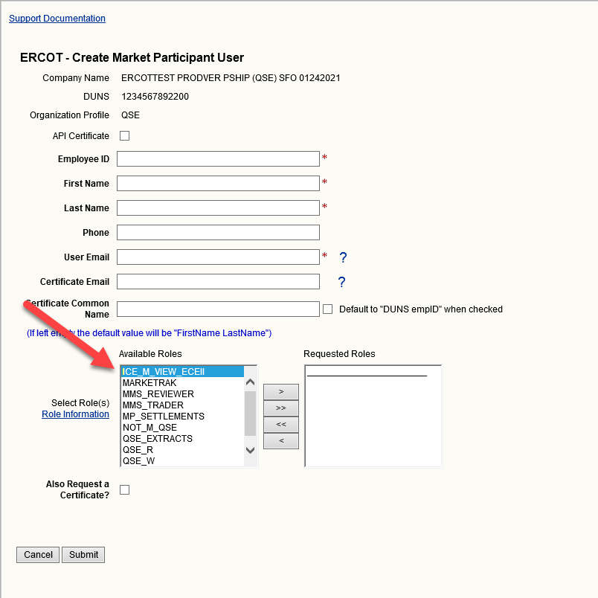

In MPIM you may add roles from the “Create” or “Modify” screen. “Available Roles” are on the left side: to add you must highlight the role(s) and then select the arrow to move to “Requested Roles” box and submit.

