PWG Meeting Notes – Jan 13, 2021
Via WebEx 9:30 AM
Attendees:
Sam Pak – Oncor | Bill Boswell - ERCOT | Jim Lee – AEP
Sheri Wiegand – TXU | Calvin Opheim - ERCOT | Eric Blakey – Just Energy
Kathy Scott – CNP | Randy Roberts - ERCOT | John Ritch - NextEra
Andrea Couch - TNMP | Jordan Troublefield – ERCOT | Angela Ghormley –Calpine Energy
Bill Barnes - NRG | Carl Raisch - ERCOT | Diana Rehfeldt - TNMP
Sarah Andrews - Oncor | Amar Khalifeh - ERCOT | Karen Malkey - CNP
Chris Rowley - Oncor | Clayton Stice - ERCOT | Kyle Patrick - NRG
Lauren Damen - NRG | Mark Ruane - ERCOT | Rebecca DuPont – Evolve Energy

- Jordan Troublefield read Antitrust Admonition and then proceeded with 2021 elections of PWG Chair and Vice Chair.
- By acclamation, Sam Pak (Oncor) and Sheri Wiegand (TXU) will continue as Chair and Vice Chair, respectively.
- Sam Pak reviewed Nov 6th meeting notes for approval

- Follow up on the Usage of O&G Flat Profiles:
  - Bill Barnes (NRG), who initially raised the topic for review, mentioned they would be providing enhanced training within their shops and their brokers in evaluating customers with the OGFLT load profiles and their usage. Other REPs also suggested they would do the same particularly as it comes to pricing an OGFLT customer whose usage may not necessarily conform to a “flat” load shape.
  - ERCOT however did agree to provide a “warning label” for all OGFLT profile requests if the historical load appears to be weather sensitive or not. ERCOT noted a majority of the request have little or no historical information and if so, that will be noted on the response. Carl explained the OGLFT profile was also intended as an indicator of a random profile as erratic usage could be expected.
- Annual Weather Sensitivity Update
- ERCOT provided an update to the WS changes with an updated status report as of 01/02/21 (see chart below). Due date is 1/31/21.
- ERCOT will provide an updated report on completion status in early February.

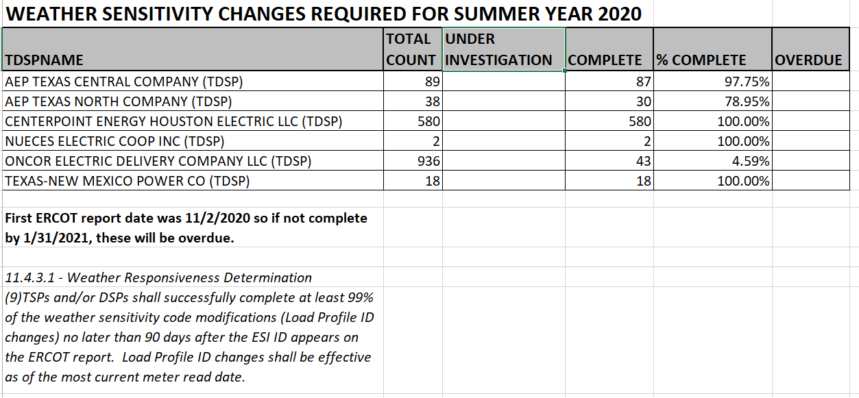
- Discussion on Pending Revision Requests:
  - Assuming happy path, the RMGRR & NPRR should be approved by the end of Q1:
    - Draft RMGRR Eliminate Section 7.13, IDR Meter Removal and Installation Process
    - Draft NPRR Modify IDR Meter Requirement and Eliminate IDR Meter Requirement Report
  - Draft LPGRR Creation of New BUSLRG and BUSLRGDG Profile Types will take longer as the IA involves groups and additional input within ERCOT but potentially Board approval in June.
    - Randy Roberts did mention there would be a necessary 150 day waiting period after Board approval before implementation so most likely a 2022 Q1, at the earliest, for adoption into the market.

- Oncor Transition of BUSIDRRQ Customers to AMS Daily Settlement
  - Oncor mentioned ramping of BUSIDRRQ customers transitioning in March/April to AMS daily settlement. REPs and ERCOT will be provided a 45 day MT notice and 814_20 updates as they default to the BUSLO load profile. Oncor will continue to scale in efforts to transition almost all these BUSIDRRQ customers by 2022. Oncor is also planning to provide access to interval data via their Historical Usage Portal possibly by late 2021.
  - Once the new BUSLRG and BUSLRGDG profiles are available, those will be transitioned accordingly.

- NPRR1059, Ability for MOUs and ECs to Send Non-BUSIDRRQ Interval Data
  - This Nodal Protocol Revision Request (NPRR) creates the ability to send interval readings for non-Interval Data Recorder (IDR) Meters, such as residential accounts with consumption under 700 kW, to be able to settle on actual usage/generation instead of the Load Profile.
  - While not necessarily in PWG’s purview, this was brought to PWG’s attention as a pending NPRR.
  - Randy did explain the creation of the new definition indicating ERCOT Legal had advised to keep the existing definition intact as it referenced PUC substantive rule that was applicable to other TDSPs in non-ERCOT territories.

- Proposed changes and modifications to the DG Template Spreadsheet for Unregistered DG
- Clayton Stice, ERCOT, provided an update that there have been ongoing constructive discussions and dialogue with the TDSPs on paving a path forward to provide ERCOT additional information and data related to unregistered DG. While the original proposal suggested leveraging and expanding for addl’ data elements (ie columns) within the DG Load Profile Template spreadsheet, discussions evolved around a more efficient means of delivery given the added complexity and granularity of the data.
- For now, ERCOT and TDSPs will continue discussions outside PWG meetings on a collaborative delivery mechanism for the requested data.
- ERCOT is targeting around 2023 or 2024 for this data from the TDSPs. The purpose of this data is for enhanced modeling and forecasting by ERCOT especially given growth projection of unregistered DG.
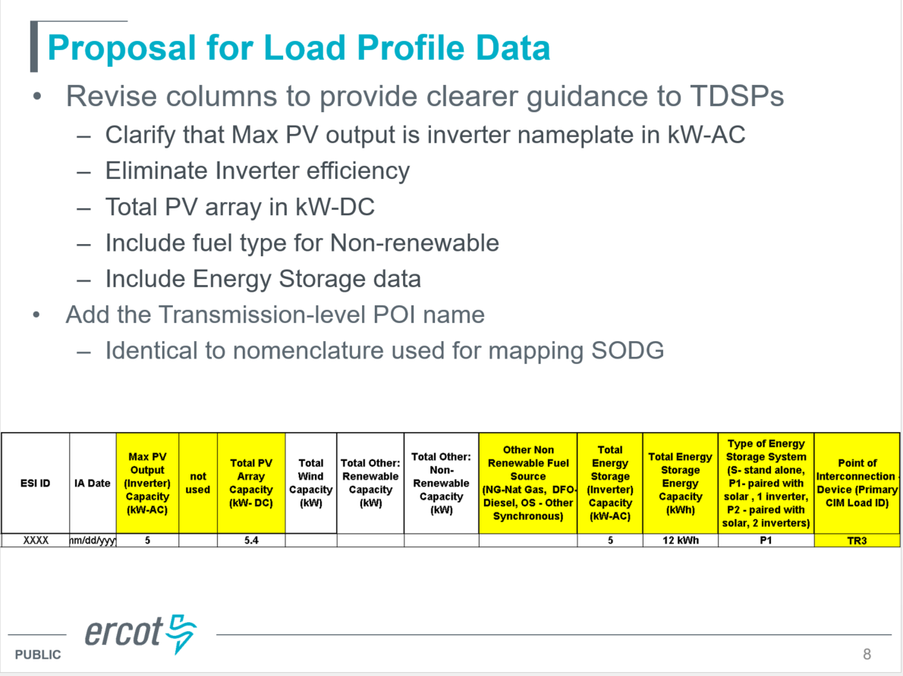

- 2021 Goals and 2020 Accomplishments:
- Reviewed 2020 goals below and agreed most of these were accomplished
- Most of these similar goals will be carrying over into 2021 in addition to the transition and planning related to LPGRRxxx, Add BUSLRG and BUSLRGDG Profile Types

- 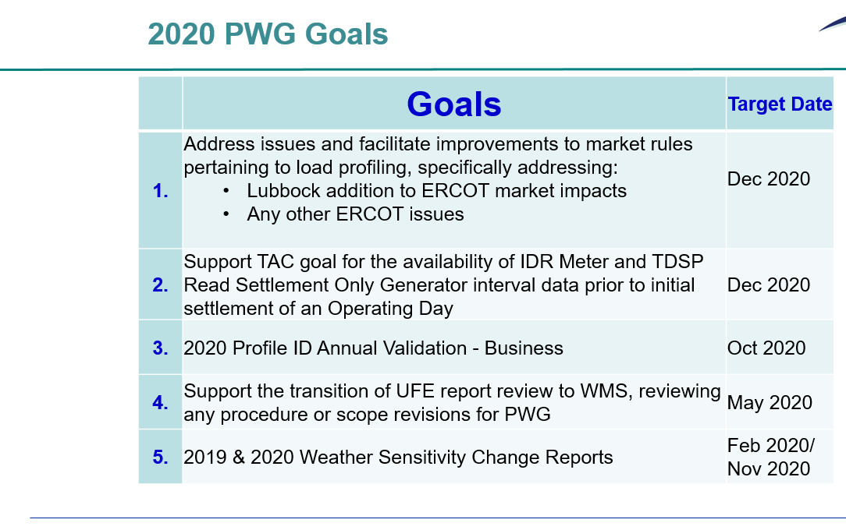
- Next Meeting: Next meeting will be Feb 10th at 9:30am via Webex.

