ERCOT AVR Test for a BESS DGR
Resource Integration Department, ERCOT
2/3/2021

BESS DGR - AVR Test Objective: The purpose of the AVR test is to test the BESS’s ability to go from full charge to full discharge while the AVR keeps the reactive power to 0 MVAr (unity power factor) at the Point of Common Coupling (PCC).

The AVR test is to be conducted during a continuous period of time at the charge/discharge rate shown in the table below with measurements recorded and reported on 4 second intervals or less.

During the AVR test, measurements must be taken and recorded at each the following charging and discharging levels (For example, MW levels for a maximum installed capability of 10 MW):
- 25% discharging – discharge rate is 2.5 MW for 5 minutes, go to 0 MW charge/discharge for at least 1 minute
- 50% discharging- discharging rate is 5 MW for 5 minutes, go to 0 MW charge/discharge for at least 1 minute
- 75% discharging- discharging rate is 7.5 MW for 5 minutes, go to 0 MW charge/discharge for at least 1 minute
- 100% discharging- discharging rate is 10 MW for 5 minutes, go to 0 MW charge/discharge for at least 1 minute
- 25% charging- charging rate is 2.5 MW for 5 minutes, go to 0 MW charge/discharge for at least 1 minute
- 50% charging- charging rate is 5 MW for 5 minutes, go to 0 MW charge/discharge for at least 1 minute
- 75% charging - charging rate is 7.5 MW for 5 minutes, go to 0 MW charge/discharge for at least 1 minute
- 100% charging - charging rate is 10 MW for 5 minutes, go to 0 MW charge/discharge for at least 1 minute
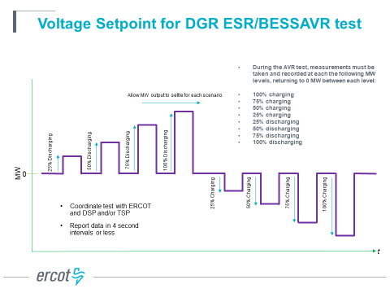
Additional test points between these MW levels may be included as well.

AVR test data will be entered on an Excel worksheet using the following template.

- Column A is for the time-stamp (CPT) using MM/DD/YYYY HH:MM:SS AM/PM
- Column B is for PCC voltage in kV
- Column C is for MW flow at the PCC (+ for flow from the BESS to the PCC)
- Column D is for MVAr flow at the PCC (+ for flow from the BESS to the PCC)

AVR Test PASS/FAIL Criteria:

- ERCOT will consult the DSP/TSP and exercise engineering judgement if there is a question of the AVR Test passing based on the following criteria.

- Each test point is evaluated using the following rules:
  - For when the absolute value of the BESS MW PCC flow is > 30% of maximum MW BESS capability
    - A test measurement will “pass” if the absolute value of the BESS MVAr PCC flow is <= 3.5% of absolute value of the BESS MW PCC flow

  - For when the absolute value of the BESS MW PCC flow is <= 30% of maximum installed BESS MW capability
    - A test measurement will “pass” if the absolute value of the BESS MVAr PCC flow is <= 1.3% of the maximum installed BESS MW capability

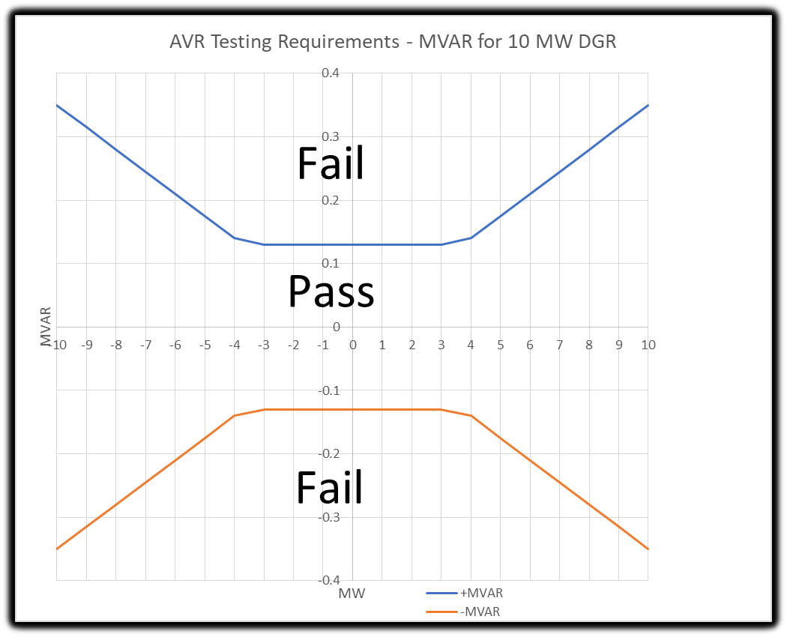

For the test points that “fail” the above 2 rules, the voltage dips (flicker) must be less than the following to minimize MVAr transients to the PCC. (Refer to IEEE Std 1453-2015 IEEE Recommended Practice for the Analysis of Fluctuating Installations on Power Systems – Figure 1 --- GE flicker curve.)
    - Voltage dips resulting in a <= 3% change in PCC voltage will “pass” if the frequency of voltage dips is <= 10 voltage dips per hour (for typical operations)
    - Voltage dips resulting in a <= 2% change in PCC voltage will “pass” if the frequency of voltage dips is <= 1 voltage dip per minute (for typical operations)
    - Voltage dips resulting in a <= 1% change in PCC voltage will “pass” if the frequency of voltage dips is <= 15 voltage dips per minute (for typical operations)
    - Voltage dips resulting in a <= 0.5% change in PCC voltage will “pass” regardless of frequency of voltage dips (for typical operations)

The AVR test data spreadsheet is to be submitted as an attachment in the NDCRC application on MIS in the section for AVR Tests.

References:

- Initial discussions with Oncor, TNMP and PEC.
- IEEE Std 1453-2015 IEEE Recommended Practice for the Analysis of Fluctuating Installations on Power Systems

