December 2020 ERCOT Monthly Operations Report
Reliability and Operations Subcommittee Meeting
February 4, 2021

Table of Contents
1. Report Highlights 2
2. Frequency Control 3
2.1. Frequency Events 3
2.2. Responsive Reserve Events 4
2.3. Load Resource Events 4
3. Reliability Unit Commitment 4
4. Wind Generation as a Percent of Load 5
5. Largest Net-Load Ramp 5
6. COP Error Analysis 6
7. Congestion Analysis 8
7.1. Notable Constraints 8
7.2. Generic Transmission Constraint Congestion 12
7.3. Manual Overrides 12
7.4. Congestion Costs for Calendar Year 2020 12
8. System Events 14
8.1. ERCOT Peak Load 14
8.2. Load Shed Events 14
8.3. Stability Events 14
8.4. Notable PMU Events 14
8.5. DC Tie Curtailment 14
8.6. TRE/DOE Reportable Events 14
8.7. New/Modified/Removed RAS 14
8.8. New Procedures/Forms/Operating Bulletins 14
9. Emergency Conditions 15
9.1. OCNs 15
9.2. Advisories 15
9.3. Watches 15
9.4. Emergency Notices 15
10. Application Performance 15
10.1. TSAT/VSAT Performance Issues 15
10.2. Communication Issues 15
10.3. Market System Issues 16
11. Model Updates 16
Appendix A: Real-Time Constraints 18

Report Highlights
- The unofficial ERCOT peak load was 55,904 MW.
- There were 5 frequency events.
- There were 4 instances where Responsive Reserves were deployed.
- There were no RUC commitments.
- Congestion in the Panhandle can be attributed to wind generation in the area as well as multiple transmission outages. There were 24 days of congestion on the Panhandle GTC, 27 days on the North Edinburg to Lobo GTC, 15 days on the Raymondville to RioHondo GTC, 15 days Nelson Sharpe to Rio Hondo GTC, 11 days on the McCamey GTC, 8 days on the West Texas Export GTC, 5 days on the North to Houston Import GTC, and 5 days on the Rio Grande Valley Import GTC. There was no activity on the remaining GTCs during the month.
- There were no DC Tie Curtailments
- There was a new Wind Generation Record of 22,222 MW on 12/30/2020 at 11:22.

Frequency Control

Frequency Events

The ERCOT Interconnection experienced five frequency events, which resulted from unit’s trips. The average event duration was 00:04:21.

A summary of the frequency events is provided below. The reported frequency events meet one of the following criteria: Delta Frequency is 60 mHz or greater; the MW loss is 350 MW or greater; resource trip event triggered RRS deployment. Frequency events that have been identified as Frequency Measurable Events (FME) for purposes of BAL-001-TRE-1 analysis are highlighted in blue. When analyzing frequency events, ERCOT evaluates PMU data according to industry standards. Events with an oscillating frequency of less than 1 Hz are considered to be inter-area, while higher frequencies indicate local events. Industry standards specify that damping ratio for inter-area oscillations should be 3.0% or greater. For the frequency events listed below, the ERCOT system met these standards and transitioned well after each disturbance.

Date and Time | Delta Frequency | Max/Min Frequency | Duration of Event | PMU Data |  | MW Loss | Load | Wind | Inertia
 | (Hz) | (Hz) |  | Oscillation Mode (Hz) | Damping Ratio |  | (MW) | % | (GW-s)
12/4/2020 7:44 | 0.111 | 59.869 | 0:05:28 | 0.74 | 13% | 595 | 50,168 | 13% | 276,381
12/7/2020 12:38 | 0.053 | 59.928 | 0:05:03 | 0.68 | 16% | 360.11 | 39,824 | 4% | 263,002
12/10/2020 14:34 | 0.119 | 59.890 | 0:04:37 | 0.84 | 15% | 571 | 39,455 | 41% | 181,176
12/22/2020 15:45 | 0.079 | 59.893 | 0:05:10 | 1.26 | 12% | 370 | 38,696 | 52% | 157,245
12/26/2020 20:49 | 0.060 | 59.906 | 0:01:28 | 0.74 | 9% | 286 | 38,848 | 54% | 157,639

(Note: All data on this graph encompasses frequency event analysis based on BAL-001-TRE-1.)

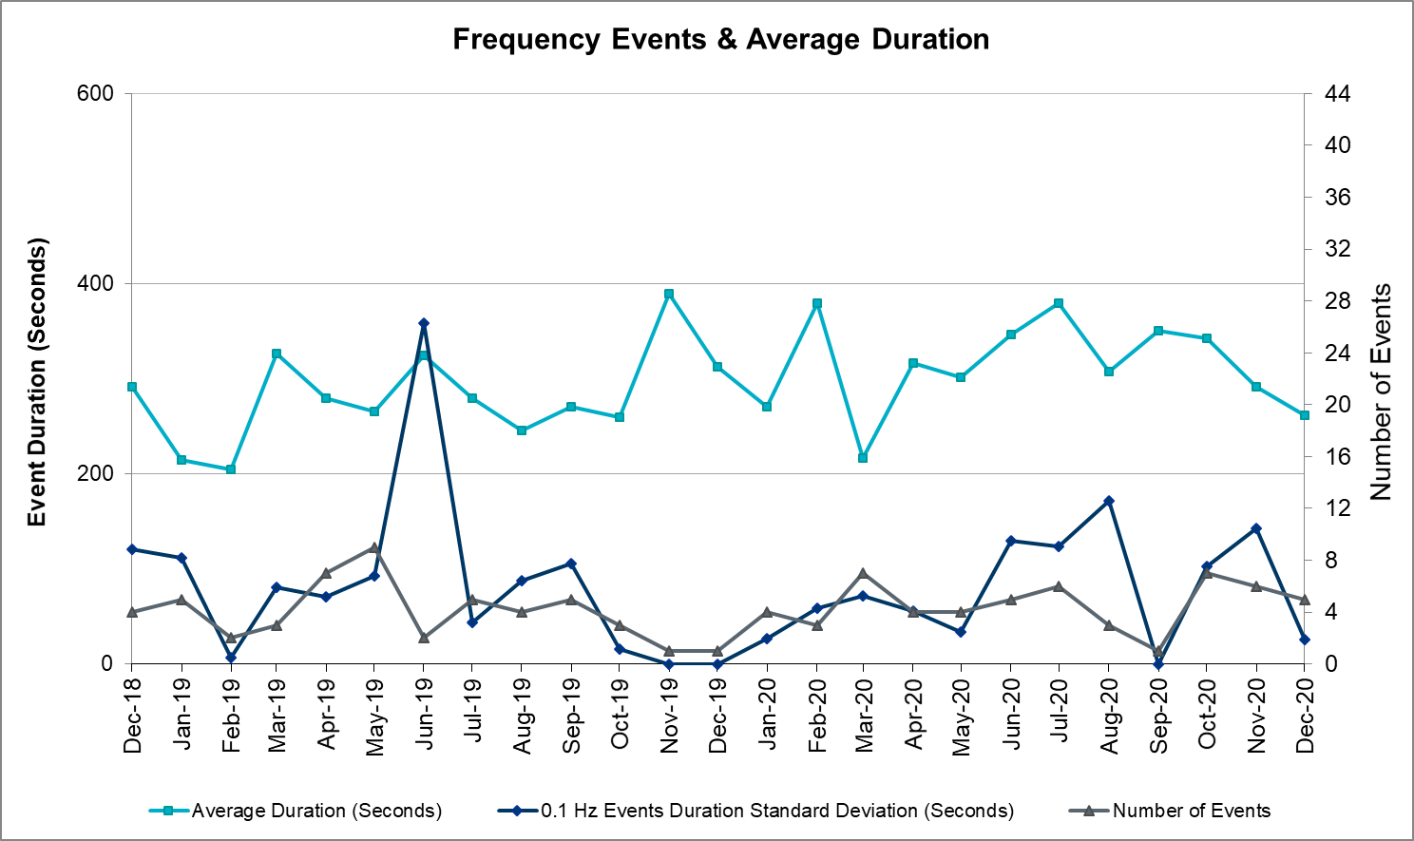
Note that the large standard deviation in June 2019 is due to coincidental extreme high and low durations for a small set of events (2).

Responsive Reserve Events

There were 4 events where Responsive Reserve MWs were released to SCED. The events highlighted in blue were related to frequency events reported in Section 2.1 above.

Date and Time Released to SCED | Date and Time Recalled | Duration of Event | Maximum MWs Released | Comments
12/4/2020 7:44:54 | 12/4/2020 7:50:18 | 00:05:24 | 753
12/10/2020 14:34:42 | 12/10/2020 14:39:10 | 00:04:28 | 582
12/22/2020 15:46:00 | 12/22/2020 15:51:08 | 00:05:08 | 564
12/26/2020 20:49:52 | 11/22/2020 1:26:24 | 00:01:28 | 662

Load Resource Events
None.

Reliability Unit Commitment
ERCOT reports on Reliability Unit Commitments (RUC) on a monthly basis. Commitments are reported grouped by operating day and weather zone. The total number of hours committed is the sum of the hours for all the units in the specified region. Additional information on RUC commitments can be found on the MIS secure site at Grid Generation Reliability Unit Commitment.

There were no DRUC commitments.

There were no HRUC commitments.

Wind Generation as a Percent of Load

Wind Generation Record: 22,222 MW on 12/30/2020 at 11:22
Wind Penetration Record: 59.30% on 05/02/2020 at 02:10

Largest Net-Load Ramp
The net-load ramp is defined as the change in net-load (load minus wind and PVGR generation) during the defined time horizon. Such a variation in net-load needs to be accommodated in grid operations to ensure that the reliability of the grid is satisfactorily maintained. The largest net-load ramp during 5-min, 10-min, 15-min, 30-min and 60-min in December 2020 are 1083 MW, 1780 MW, 2479 MW, 5882 MW, and 10364 MW, respectively. The comparison with respect to the historical values is given in the table below.

Month and Year | 5 min | 10 min | 15 min | 30 min | 60 min
December 2020 | 1083 MW | 1780 MW | 2479 MW | 5882 MW | 10364 MW
December 2014 | 1014 MW | 1689 MW | 2112 MW | 3034 MW | 5296 MW
December 2015 | 962 MW | 1637 MW | 1995 MW | 3241 MW | 5516 MW
December 2016 | 857 MW | 1404 MW | 1827 MW | 3166 MW | 5866 MW
December 2017 | 964 MW | 1581 MW | 2078 MW | 3393 MW | 5708 MW
December 2018 | 923 MW | 1553 MW | 2148 MW | 4109 MW | 7218 MW
December 2019 | 1014 MW | 1689 MW | 2112 MW | 3034 MW | 5296 MW
All Months in 2014-2019 | 1494 MW | 1991 MW | 2780 MW | 4109 MW | 7786 MW

COP Error Analysis
COP Error is calculated as the capacity difference between the COP HSL and real-time HSL of the unit. Mean Absolute Error (MAE) stayed over 6,000 MW until Day-Ahead at 12:00, then dropped significantly to 1,204 MW by Day-Ahead at 14:00. In the following chart, Under-Scheduling Error indicates that COP had less generation capacity than real-time and Over-Scheduling Error indicates that COP had more generation capacity than real-time.
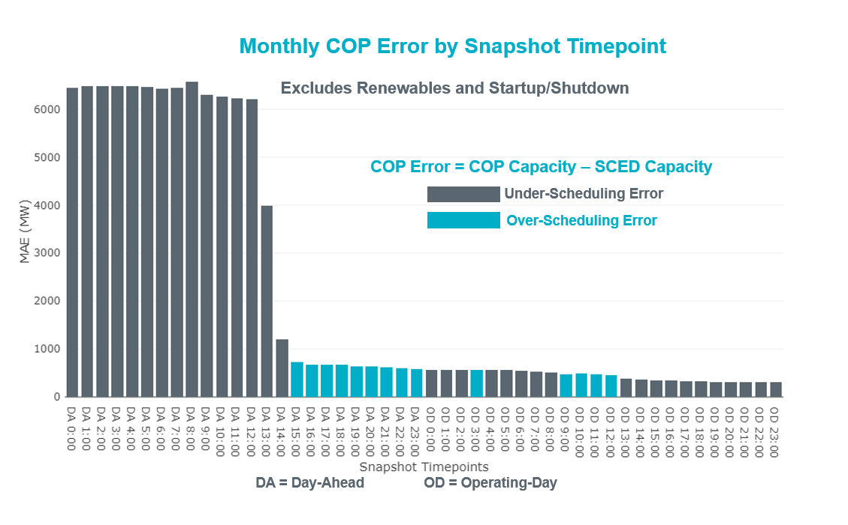
Monthly MAE for the Latest COP at the end of the Adjustment Period was 310 MW with median ranging from -236 MW for Hour-Ending (HE) 19 to 140 MW for HE 8. HE 16 on the 30th had the largest Over-Scheduling Error (1,278 MW) and HE 5 on the 21st had the largest Under-Scheduling Error (-1,795 MW).
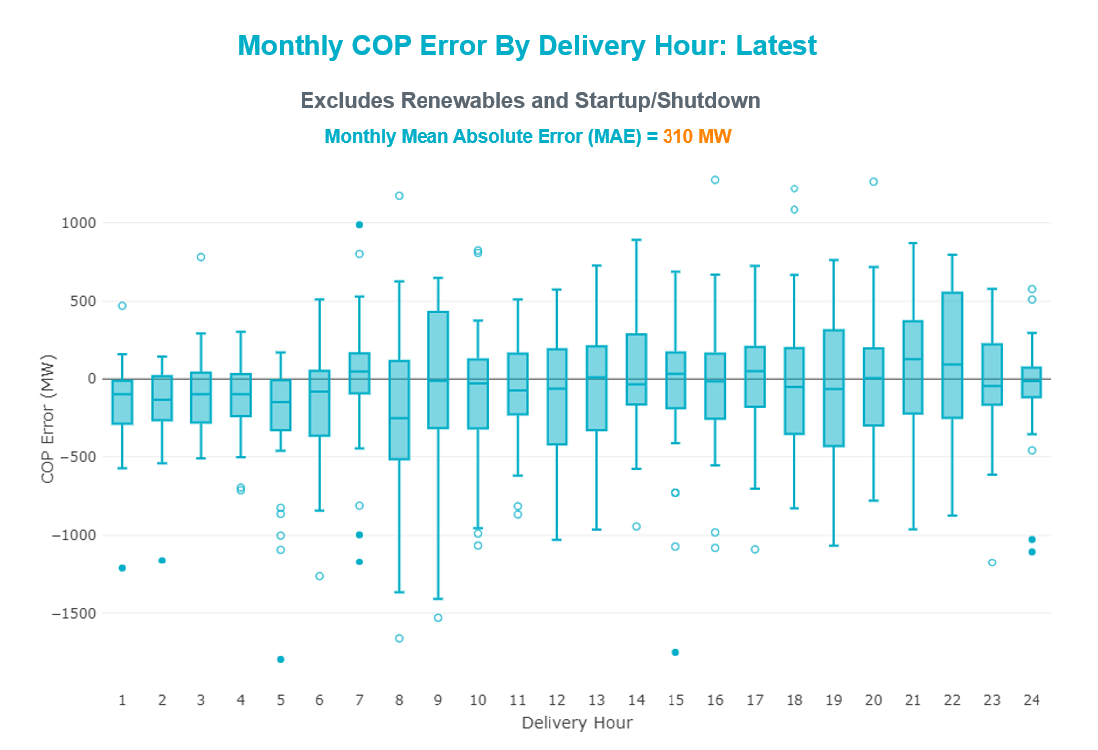

Monthly MAE for the Day-Ahead COP at 12:00 was 6,203 MW with median ranging from -7,367 MW for Hour-Ending (HE) 9 to -3,244 MW for HE 24. HE 8 on the 17th had the largest Under-Scheduling Error (-19,322 MW) and HE 24 on the 21st had the largest Over-Scheduling Error (1,651 MW).

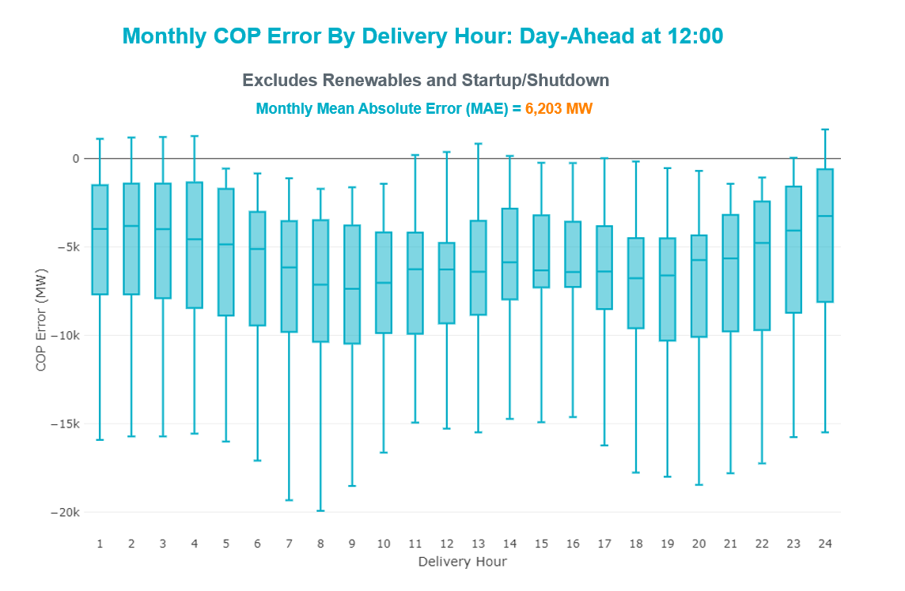

Congestion Analysis

Notable Constraints

Nodal protocol section 3.20 specifies that ERCOT shall identify transmission constraints that are active or binding three or more times within a calendar month. As part of this process, ERCOT reports congestion that meets this criterion to ROS. In addition ERCOT also highlights notable constraints that have an estimated congestion rent exceeding $1,000 for a calendar month. These constraints are detailed in the table below. Rows highlighted in blue indicate the congestion was affected by one or more outages. For a list of all constraints activated in SCED, please see Appendix A at the end of this report.

Contingency Name | Overloaded Element | # of Days Constraint Active | Congestion Rent | Transmission Project
GAS PAD to FLAT TOP TNP LIN 1 | Lynx - Tombstone 138kV | 8 | $21,276,095.10 | Lynx: Expand 138 kV station (45503)
Basecase | PNHNDL GTC | 24 | $17,005,156.73 | Panhandle GTC Exit Plan - "PANHANDLE RENEWABLE ENERGY ZONE (PREZ)  STUDY REPORT" on MIS, CONSTRUCT OGALLALA TO BLACKWATER DRAW 345 KV LINE (52245), CONSTRUCT BLACKWATER DRAW TO FOLSOM POINT345 KV LINE (52258), CONSTRUCT BLACKWATER DRAW TO DOUBLE MOUNTAIN (52299), CONSTRUCT DOUBLE MOUNTAIN TO FIDDLEWOOD TO FARMLAND 345 KV L (522307)
CRLNW TO LWSSW 345 DBLCKT | Ti Tnp - West Tnp 138kV | 12 | $9,536,453.45
Basecase | NE_LOB GTC | 27 | $8,644,202.62 | GTC Exit plan in the North Edinburg - Lobo Stability Study Report posted in the ERCOT MIS website
COMANCHE SWITCH (Oncor) to COMANCHE PEAK SES LIN _A | Comanche Tap - Comanche Switch (Oncor) 138kV | 15 | $4,698,657.00
Austro-Daffin&Dunlap-Decker 138kV | Mcneil Aen - Howard Lane Aen 138kV | 23 | $3,727,058.06 | Reconductor 138kV ckt 972 Howard Lane to McNeil to 3000A (48327)
CARROLLTON NORTHWEST to LAKEPOINTE TNP LIN _A | South Tnp - Carrollton Northwest 138kV | 3 | $3,076,934.48
ODEHV-MOSSW 345&ODEHV-WLFSW 345_DBLCKT | Pig Creek - Solstice 138kV | 6 | $3,075,143.86 | Barrilla Junction to Ft. Stockton SW: Rebuild 69 kV line (7027)
NORTH EDINBURG TRX 1382 345/138 | North Edinburg 345kV | 1 | $1,887,550.73 | Stewart Road: Construct 345 kV cut-in with two 450 MVA 345/138 autotransformers connected to Stewart Rd 138 station (5604, 6382)
BAKERSFIELD SWITCHYARD to Big HiLL LIN 1 | Pig Creek - Solstice 138kV | 5 | $1,620,973.33 | Barrilla Junction to Ft. Stockton SW: Rebuild 69 kV line (7027)
Basecase | Venado Wind - Revilla 138kV | 6 | $1,550,422.57
Lockha-Luling & Redroc 138kV | Deer Creek 138kV | 3 | $1,477,081.29
Melon Creek to RINCON LIN 1 | Bonnieview - Rincon 69kV | 19 | $1,451,685.74 | Refugio - Rincon: Upgrade 69 kV Line (6427)
Cagnon-Kendal 345 & Cico-Comfor 138 | Mason Creek - Bandera 138kV | 4 | $1,352,012.48
ODLAW SWITCHYARD to ASPHALT MINES LIN 1 | Hamilton Road - Maverick 138kV | 19 | $1,337,673.58 | Brackettville to Escondido: Construct 138 kV line (5206)
CONCORD TRX CRD1 345/138 | Concord 345kV | 4 | $1,233,023.47
KLEBERG AEP to LOYOLA SUB LIN 1 | Loyola Sub 138kV | 14 | $894,375.45 | Lon Hill: Replace 345/138 kV autotransformers (6101)
Fowlerton to LOBO 345 LIN1 | North Laredo Switch - Piloncillo 138kV | 11 | $872,080.69 | GTC Exit plan in the North Edinburg - Lobo Stability Study Report posted in the ERCOT MIS website
Fowlerton to LOBO 345 LIN1 | Bruni Sub 138kV | 8 | $769,349.94
Dilleysw-Sanmgsw&Cotulas 138kV | Dilley Switch Aep - Cotulla Sub 69kV | 5 | 759396.6895 | Dilley - Jourdanton 69 kV Line (44866)
Basecase | Omega - Horse Hollow Generation Tie 345kV | 6 | $609,184.04
Basecase | MCCAMY GTC | 11 | $599,303.01 | McCamey GTC Exit Plan posted on the ERCOT MIS website (Far West Transmission Project 2)
Manual dbl ckt for NEDIN-BONILLA 345kV & RIOH-PRIM138kV | Burns Sub - Rio Hondo 138kV | 7 | $551,729.55 | Stewart Road: Construct 345 kV cut-in with two 450 MVA 345/138 autotransformers connected to Stewart Rd 138 station (5604, 6382)
MCELMURRAY to ESKOTA SWITCH LIN 1 | Eskota Switch - Trent 69kV | 17 | $535,058.89
Basecase | RV_RH GTC | 23 | $533,796.36 | GTC Exit plan in the Raymondville-RioHondo GTC Study Report posted in the ERCOT MIS website
POMELO to NORTH EDINBURG LIN 1 | Lobo - Freer 69kV | 3 | $389,894.42 | GTC Exit plan in the North Edinburg - Lobo Stability Study Report posted on the ERCOT MIS website
Basecase | WESTEX GTC | 8 | $350,968.38 | GTC Exit Plan Identified in the West Texas Export Stability Study Report Posted on ERCOT MIS Website
Elmcreek-Sanmigl 345kV | Pawnee Switching Station - Calaveras 345kV | 10 | $319,668.30
Carver to FRIEND RANCH LIN 1 | Hamilton Road - Maxwell 138kV | 12 | $311,433.14 | Hamilton Road - Maxwell (recently approved RPG project)
FORT MASON to YELLOW JACKET LIN 1 | Yellow Jacket - Hext Lcra 69kV | 17 | $269,351.93 | Yellowjckt to Menard Phillips T 69 kV line: Rebld 69 kV line (6345)
Cagnon-Kendal 345 & Cico-Comfor 138 | Bergheim - Kendall 345kV | 3 | $237,605.70
KING MOUNTAIN SWITCHYARD to ODESSA EHV SWITCH LIN 1 | Pig Creek - Solstice 138kV | 5 | $204,518.39 | Barrilla Junction to Ft. Stockton SW: Rebuild 69 kV line (7027)
NORTH McCAMEY TRX NORTMC_AT2 345/138 | Pig Creek - Solstice 138kV | 3 | $200,501.74 | Barrilla Junction to Ft. Stockton SW: Rebuild 69 kV line (7027)
NORTH McCAMEY to NEVILL ROAD SWITCH LIN 1 | Pig Creek - Solstice 138kV | 5 | $162,905.68 | Barrilla Junction to Ft. Stockton SW: Rebuild 69 kV line (7027)
Sng-Tb&Rns 345kV | Th Wharton - Zenith 345kV | 6 | $152,621.16
WLFSW-MOSSW 345&WLFSW-ODEHV 345____TRPLCKT-1of3 | Pig Creek - Solstice 138kV | 5 | $146,053.57 | Barrilla Junction to Ft. Stockton SW: Rebuild 69 kV line (7027)
Elmcreek-Sanmigl 345kV | Coleto Creek - Victoria 138kV | 3 | $139,572.02 | Coleto Creek - Rosata: Line Rebuild (50870)
NORTH EDINBURG TRX 1382 345/138 | Weslaco Switch - Weslaco Sub 138kV | 5 | $132,465.06 | Stewart Road: Construct 345 kV cut-in with two 450 MVA 345/138 autotransformers connected to Stewart Rd 138 station (5604, 6382)
FORT LANCASTER to ILLINOIS #4 LIN 1 | Carver - Tinsley Tap 138kV | 5 | $128,695.10 | Carver - Maxwell: Line Rebuild (52070)
Fowlerton to LOBO 345 LIN1 | Asherton - Catarina 138kV | 6 | $127,373.50 | Brackettville to Escondido: Construct 138 kV line (5206)
LAQUINTA to LOBO LIN 1 | Bruni Sub 138kV | 7 | $126,566.94
Loss of (White Point & Nueces Bay 138kV) and (White Point & Portland & Gibbs 138kV) | Whitepoint - Rincon 138kV | 8 | $125,476.76 | Whitepoint Area Improvements (50950)
Bighil-Kendal 345kV | Hamilton Road - Maxwell 138kV | 6 | $111,744.31 | Hamilton Road - Maxwell (recently approved RPG project)
LON HILL to NELSON SHARPE LIN 1 | Celanese Bishop - Kleberg Aep 138kV | 8 | $99,756.58 | GTC Exit plan in the Rio Grand Valley Stability Study Report posted in the ERCOT MIS webpage
CPSES TO WOFHO 345 AND CPSES TO MBDSW 345 DBLCKT | Everman Switch - Rocky Creek 345kV | 4 | $93,573.75
BRACKETTVILLE to HAMILTON ROAD LIN 1 | Hamilton Road - Maverick 138kV | 6 | $92,008.37 | Brackettville to Escondido: Construct 138 kV line (5206)
PAREDES SWITCHING STATION to CENTRAL AVENUE SUB LIN 1 | Rio Hondo - East Rio Hondo Sub 138kV | 16 | $78,228.34 | Rebuild Rio Hondo to East Rio Hondo (6687)
CPSES TO JONSW 345 AND CPSES TO EVRSW 345 DBLCKT | Everman Switch - Rocky Creek 345kV | 4 | $67,855.09
South Texas # 1 & # 2 | Coleto Creek - Victoria 138kV | 6 | $64,886.43 | Coleto Creek - Rosata: Line Rebuild (50870)
NORTH EDINBURG TRX 1382 345/138 | Weslaco Switch - Weslaco Sub 138kV | 5 | $59,067.81 | Stewart Road: Construct 345 kV cut-in with two 450 MVA 345/138 autotransformers connected to Stewart Rd 138 station (5604, 6382)
FORT MASON to YELLOW JACKET LIN 1 | Mason Switching Station - Hext Lcra 69kV | 11 | $58,757.66 | Mason to North Brady: Rebuild 69 kV line (50900)
Ferguson-Sherwood Shores & Ferguson-Granite Mountain 138kV | Johnson City - Wirtz 138kV | 24 | $55,361.74 | Wirtz to Johnson City to Mountain Top Rebuild to 138kV (6789)
TWINBU-DVIDE 345KV | Gasconades Creek - Morgan Creek Ses 345kV | 5 | $39,958.09
Bighil-Kendal 345kV | Carver - Tinsley Tap 138kV | 3 | $35,488.38 | Carver - Maxwell: Line Rebuild (52070)
COLETO CREEK to PAWNEE SWITCHING STATION LIN 1 | Coleto Creek - Victoria 138kV | 4 | $33,895.11 | Coleto Creek - Rosata: Line Rebuild (50870)
Rns-Rtw & Sng-Tb 345kV | Th Wharton - Zenith 345kV | 6 | $31,056.79
Basecase | NELRIO GTC | 15 | $24,902.47 | GTC Exit Plan in the Nelson Sharpe - Rio Hondo Stability Study Report Posted in the ERCOT MIS Website
manual Sand Lake - Solstice line 1 and 2 | Pig Creek - Solstice 138kV | 4 | $21,960.18 | Barrilla Junction to Ft. Stockton SW: Rebuild 69 kV line (7027)
GUNSIGHT SWITCH to GETTY VEALMOOR TAP LIN _A | Chevron Ackerly Tap - Buzzard Draw Switch 69kV | 6 | $20,205.89 | Big Spring - Buzzard Draw 69 kV Line Conversion (46259)
Manual dbl ckt for NEDIN-BONILLA 345kV & RIOH-PRIM138kV | Weslaco Switch - Weslaco Sub 138kV | 3 | $19,203.48 | Stewart Road: Construct 345 kV cut-in with two 450 MVA 345/138 autotransformers connected to Stewart Rd 138 station (5604, 6382)
FORT LANCASTER to ILLINOIS #4 LIN 1 | Hamilton Road - Maxwell 138kV | 10 | $15,988.88 | Hamilton Road - Maxwell (recently approved RPG project)
SAN MIGUEL GEN to FOWLERTON LIN 1 | San Miguel Gen 345kV | 3 | $14,619.33 | San Miguel 345/138 kV autotransformer replacements (5218A, 5218B)
Basecase | VALEXP GTC | 5 | $12,767.53 | Need for GTC Exit plan is identified in the Valley Export Stability Report posted in the ERCOT MIS website
FORT MASON to YELLOW JACKET LIN 1 | Yellow Jacket - Hext Lcra 69kV | 17 | $9,302.42 | Yellowjckt to Menard Phillips T 69 kV line: Rebld 69 kV line (6345)
Basecase | Randado Aep - Zapata 138kV | 6 | $9,131.11
ODLAW SWITCHYARD to ASPHALT MINES LIN 1 | Escondido - Ganso 138kV | 3 | $8,000.49 | Brackettville to Escondido: Construct 138 kV line (5206)
SUN SWITCH to SCURRY SWITCH LIN 1 | Aspermont Aep - Aspermont Continental 69kV | 3 | $7,999.85
Fergus-Granmo&Wirtz-Starck 138kV | Johnson City - Wirtz 138kV | 9 | $7,664.76 | Wirtz to Johnson City to Mountain Top Rebuild to 138kV (6789)
Bighil-Kendal 345kV | San Angelo Power Station - Treadwell 138kV | 3 | $6,753.89 | GTC Exit Plant in the San Angelo Area Stability Study Report Posted in the ERCOT MIS Website
FORT MASON to YELLOW JACKET LIN 1 | Mason Switching Station - Hext Lcra 69kV | 11 | $5,755.48 | Mason to North Brady: Rebuild 69 kV line (50900)
GREENS BAYOU - KING 345KV | Bigvue - Lyondell 138kV | 3 | $4,702.38
Arrowhead Tap to Lotebush LIN 1 | Fort Stockton Plant - Tombstone 138kV | 3 | $4,271.79 | Barrilla Junction to Ft. Stockton SW: Rebuild 69 kV line (7027)  Solstice: Install 138 kV PST and capacitor bank (44359)
Basecase | N_TO_H GTC | 5 | $3,781.38 | North - Houston Import Stability Report posted on the ERCOT MIS website
SUN SWITCH to SCURRY SWITCH LIN 1 | Wolfgang - Rotan 69kV | 5 | $3,652.98
SOUTH TEXAS PROJECT to BLESSING LIN 1 | Coleto Creek - Victoria 138kV | 5 | $3,621.82 | Coleto Creek - Rosata: Line Rebuild (50870)
PADUCAH REA TAP to PADUCAH CLARE STREET LIN 1 | Spur 138kV | 5 | $2,434.35

Generic Transmission Constraint Congestion
There were 24 days of congestion on the Panhandle GTC, 27 days on the North Edinburg to Lobo GTC, 15 days on the Raymondville to RioHondo GTC, 15 days Nelson Sharpe to Rio Hondo GTC, 11 days on the McCamey GTC, 8 days on the West Texas Export GTC, 5 days on the North to Houston Import GTC, and 5 days on the Rio Grande Valley Import GTC. There was no activity on the remaining GTCs during the month.

Note: This is how many times a constraint has been activated to avoid exceeding a GTC limit, it does not imply an exceedance of the GTC occurred or that the GTC was binding.

Manual Overrides
None.

Congestion Costs for Calendar Year 2020
The following table represents the top twenty active constraints for the calendar year based on the estimated congestion rent attributed to the congestion. ERCOT updates this list on a monthly basis.

Contingency | Overloaded Element | # of 5-min SCED | Estimated | Transmission Project
MOSS SWITCH to ECTOR COUNTY NORTH SWITCHING STATION LIN _A | #N/A | 12277 | 115237549.4
Basecase | PNHNDL GTC | 34987 | 112594997.1 | Panhandle GTC Exit Plan - "PANHANDLE RENEWABLE ENERGY ZONE (PREZ)  STUDY REPORT" on MIS, CONSTRUCT OGALLALA TO BLACKWATER DRAW 345 KV LINE (52245), CONSTRUCT BLACKWATER DRAW TO FOLSOM POINT345 KV LINE (52258), CONSTRUCT BLACKWATER DRAW TO DOUBLE MOUNTAIN (52299), CONSTRUCT DOUBLE MOUNTAIN TO FIDDLEWOOD TO FARMLAND 345 KV L (522307)
CRLNW TO LWSSW 345 DBLCKT | Ti Tnp - West Tnp 138kV | 15543 | 77718127.05 | Lewisville - Lewisville Jones - Lakepointe 138 kV Line (45537)
WINK to DUNE SWITCH and YUKON | #N/A | 10924 | 76533287.97
GAS PAD to FLAT TOP TNP LIN 1 | Lynx - Tombstone 138kV | 7190 | 74457575.56 | Lynx: Expand 138 kV station (45503)  Rebuild Rio Pecos-Lynx Ckt 2 (1926 ACSS) (54255)
MANUAL Nedin-Mv_Wedn4 Dbl Ckt 138kV | Hidalgo Energy Center - Azteca Sub 138kV | 1656 | 62254257.21 | Stewart Road: Construct 345 kV cut-in with two 450 MVA 345/138 autotransformers connected to Stewart Rd 138 station (5604, 6382)
Manual MDSSW_TRX1_345/138 | Trigas Odessa Tap - Odessa Ehv Switch 138kV | 1787 | 38328997.67 | Riverton-Odessa EHV/Moss 345 kV Line (5445)
WEST EDNBURG SUB to ALTON SUB LIN 1 | Weslaco Switch - North Alamo 138kV | 681 | 33768437.92 | Stewart Road: Construct 345 kV cut-in with two 450 MVA 345/138 autotransformers connected to Stewart Rd 138 station (5604, 6382)
NORTH EDINBURG TRX 1382 345/138 | North Edinburg 345kV | 1869 | 33082897.46 | Stewart Road: Construct 345 kV cut-in with two 450 MVA 345/138 autotransformers connected to Stewart Rd 138 station (5604, 6382)
Basecase | NE_LOB GTC | 21002 | 28163649.97 | GTC Exit plan in the North Edinburg - Lobo Stability Study Report posted in the ERCOT MIS website
NORTH PHARR to WESLACO SWITCH LIN 1 | Key Switch - North Mcallen 138kV | 526 | 27451240.28 | Stewart Road: Construct 345 kV cut-in with two 450 MVA 345/138 autotransformers connected to Stewart Rd 138 station (5604, 6382)
WINK to DUNE SWITCH and YUKON | #N/A | 2002 | 23188211.21
WEST EDNBURG SUB to NORTH EDINBURG LIN 1 | North Edinburg - West Ednburg Sub 138kV | 529 | 22020286.78 | Stewart Road: Construct 345 kV cut-in with two 450 MVA 345/138 autotransformers connected to Stewart Rd 138 station (5604, 6382)
HCKSW TO SAGNA 138 DBLCKT | Eagle Mountain Ses - Morris Dido 138kV | 4392 | 21889329.29 | Upgrade the Saginaw - Eagle Mountain 138 kV Double Circuit Line (6273)
MOSS SWITCH to ECTOR COUNTY NORTH SWITCHING STATION LIN _A | #N/A | 1316 | 21247827.71
ODLAW SWITCHYARD to ASPHALT MINES LIN 1 | Hamilton Road - Maverick 138kV | 25897 | 20693558.34 | Brackettville to Escondido: Construct 138 kV line (5206)
JEWET TO SNG 345 DBLCKT | Jack_Creek - Twin Oak Switch 345kV | 1193 | 17477432.7
CPSES TO JONSW 345 AND CPSES TO EVRSW 345 DBLCKT | Rocky Creek - Mitchell Bend Switch 345kV | 1226 | 16439085.77 | Mitchell Bend - Rocky Creek 345 kV line (5312)
TWR (345) HLJ-WAP64 & BLY-WAP72 | South Texas Project - Wa Parish 345kV | 4967 | 16202680.55 | Freeport - Master Plan (6668B)
GAS PAD to FLAT TOP TNP LIN 1 | Lynx - Rio Pecos 138kV | 2166 | 11923489.36 | Rebuild Rio Pecos-Lynx Ckt 2 (1926 ACSS) (54255)

System Events

ERCOT Peak Load
The unofficial ERCOT peak load for the month was 55,904 MW and occurred on the 17th, during hour ending 08:00.

Load Shed Events
None.

Stability Events
None.

Notable PMU Events
ERCOT analyzes PMU data for any significant system disturbances that do not fall into the Frequency Events category reported in section 2.1. The results are summarized in this section once the analysis has been completed.

There were no PMU events outside of those reported in section 2.1.

DC Tie Curtailment
None.

TRE/DOE Reportable Events
- CenterPoint TO submitted an OE-417 for 12/11/2020. Reportable Event Type: Complete loss of monitoring or control capability.

New/Updated Constraint Management Plans
No changes were made this month.

New/Modified/Removed RAS
- The Morgan Creek Remedial Action Scheme (RAS) was retired on December 2, 2020.
- The Barney Davis Remedial Action Scheme (RAS) was retired on December 2, 2020.

New Procedures/Forms/Operating Bulletins
ERCOT Operations Procedure Manual Revisions
- Transmission and Security Desk Operating Procedure
- Shift Supervisor Desk Operating Procedure
- Scripts
- Resource Desk Operating Procedure
- Reliability Unit Commitment Desk Operating Procedure
- Reliability Risk Desk Operating Procedure
- Real Time Desk Operating Procedure
- DC Tie Desk Operating Procedure

Emergency Conditions

OCNs

Date and Time | Message
December 29 2020 09:00 CPT | ERCOT issued an OCN due to a predicted freezing precipitation event for the Panhandle, North and West areas of the ERCOT region.

Advisories
None.

Watches
None.

Emergency Notices
None.

Application Performance

TSAT/VSAT Performance Issues
None.

Communication Issues
None.

Market System Issues
None.

Model Updates
The Downstream Production Change (DPC) process allows ERCOT to make changes in the on-line Network Operations Model without loading a completely new model. The purpose of this process is to allow for reliable grid operations as system conditions change between designated Network Operations Model database loads. The DPC process is limited in scope to just those items listed below, with equipment ratings updates being the most common. ERCOT has seen a rise in the use of the DPC process to make on-line updates to the Network Operations Model in recent years, instead of through the standard Network Operations Model Change Request process.

- Static Line ratings (Interim Update)
- Dynamic Line ratings (non-Interim Update)
- Autotransformer ratings (non-Interim Update)
- Breaker and Switch Normal status (Interim Update)
- Contingency Definitions (Interim Update)
- RAP and RAS changes or additions (Interim Update)
- Net Dependable and Reactive Capability (NDCRC) values (Interim Update)
- Impedance Updates (non-Interim)

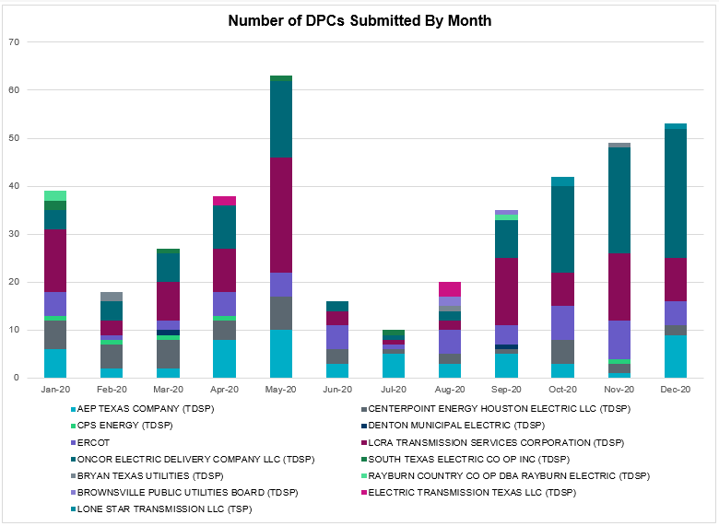

Transmission Operator | Number of DPCs
AEP TEXAS COMPANY (TDSP) | 9
BRAZOS ELECTRIC POWER CO OP INC (TDSP) | 0
BROWNSVILLE PUBLIC UTILITIES BOARD (TDSP) | 0
BRYAN TEXAS UTILITIES (TDSP) | 0
CENTERPOINT ENERGY HOUSTON ELECTRIC LLC (TDSP) | 2
CITY OF AUSTIN DBA AUSTIN ENERGY (TDSP) | 0
CITY OF COLLEGE STATION (TDSP) | 0
CITY OF GARLAND (TDSP) | 0
CPS ENERGY (TDSP) | 0
DENTON MUNICIPAL ELECTRIC (TDSP) | 0
ELECTRIC TRANSMISSION TEXAS LLC (TDSP) | 0
ERCOT | 5
LCRA TRANSMISSION SERVICES CORPORATION (TDSP) | 9
LONE STAR TRANSMISSION LLC (TSP) | 1
ONCOR ELECTRIC DELIVERY COMPANY LLC (TDSP) | 27
RAYBURN COUNTRY CO OP DBA RAYBURN ELECTRIC (TDSP) | 0
SHARYLAND UTILITIES LP (TDSP) | 0
SOUTH TEXAS ELECTRIC CO OP INC (TDSP) | 0
TEXAS MUNICIPAL POWER AGENCY (TDSP) | 0
TEXAS-NEW MEXICO POWER CO (TDSP) | 5

Appendix A: Real-Time Constraints
The following is a complete list of constraints activated in SCED. Full contingency descriptions can be found in the Standard Contingencies List located on the MIS secure site at Grid Generation Reliability Unit Commitment.

Contingency Name | Overloaded Element | From Station | To Station | Count of Days
BASE CASE | NE_LOB | n/a | n/a | 27
DFERGRM8 | 318T313_1 | JOHNCI | WIRTZ | 24
DFERGRM8 | 318T313_1 | WIRTZ | JOHNCI | 24
BASE CASE | PNHNDL | n/a | n/a | 24
BASE CASE | RV_RH | n/a | n/a | 23
DAUSDUN8 | CKT_972_1 | HWRDLN | MCNEIL | 23
SMELRIN8 | BONIVI_RINCON1_1 | RINCON | BONIVIEW | 19
SBRAUVA8 | HAMILT_MAVERI1_1 | HAMILTON | MAVERICK | 19
SMCEESK8 | ESKSW_TRNT1_1 | TRNT | ESKSW | 17
SFORYEL8 | HEXT_YELWJC1_1 | HEXT | YELWJCKT | 17
SMCEESK8 | ESKSW_TRNT1_1 | ESKSW | TRNT | 17
SFORYEL8 | HEXT_YELWJC1_1 | YELWJCKT | HEXT | 17
SMV_PAR8 | RIOHND_ERIOHND_1 | MV_RIOHO | RIOHONDO | 16
BASE CASE | NELRIO | n/a | n/a | 15
SCMNCPS5 | 651__B | CMNSW | CMNTP | 15
SKLELOY8 | LOYOLA_69_1 | LOYOLA | LOYOLA | 14
DCRLLSW5 | 588_A_1 | LWSVW | LWVTI | 12
SCARFRI8 | HAMILT_MAXWEL1_1 | MAXWELL | HAMILTON | 12
BASE CASE | MCCAMY | n/a | n/a | 11
SLOBSA25 | NLARSW_PILONC1_1 | NLARSW | PILONCIL | 11
SFORYEL8 | HEXT_MASONS1_1 | HEXT | MASONSW | 11
SFORYEL8 | HEXT_MASONS1_1 | MASONSW | HEXT | 11
SILLFTL8 | HAMILT_MAXWEL1_1 | MAXWELL | HAMILTON | 10
DELMSAN5 | PAWNEE_SPRUCE_1 | PAWNEE | CALAVERS | 10
DFERSTA8 | 318T313_1 | WIRTZ | JOHNCI | 9
SHACPB38 | LYNX_TOMBST1_1 | LYNX | TOMBSTNE | 8
SN_SLON5 | CELANE_KLEBER1_1 | CELANEBI | KLEBERG | 8
DWHIGIB8 | RINCON_WHITE_2_1 | WHITE_PT | RINCON | 8
SLOBSA25 | BRUNI_69_1 | BRUNI | BRUNI | 8
BASE CASE | WESTEX | n/a | n/a | 8
MHARNED5 | BURNS_RIOHONDO_1 | RIOHONDO | MV_BURNS | 7
SLAQLOB8 | BRUNI_69_1 | BRUNI | BRUNI | 7
SAVMBSP8 | 6610__A | BUZSW | CHATP | 6
SLOBSA25 | ASHERT_CATARI1_1 | ASHERTON | CATARINA | 6
DSTEXP12 | COLETO_VICTOR1_1 | COLETO | VICTORIA | 6
SBRAHAM8 | HAMILT_MAVERI1_1 | HAMILTON | MAVERICK | 6
BASE CASE | RANDAD_ZAPATA1_1 | ZAPATA | RANDADO | 6
DRNS_TB5 | THWZEN71_A | ZEN | THW | 6
DODEMOS5 | PIGCRE_SOLSTI1_1 | SOLSTICE | PIGCREEK | 6
DBIGKEN5 | HAMILT_MAXWEL1_1 | MAXWELL | HAMILTON | 6
DSNG_TB5 | THWZEN71_A | ZEN | THW | 6
BASE CASE | RANDAD_ZAPATA1_1 | RANDADO | ZAPATA | 6
BASE CASE | VENADO_TLINE_1 | VENADO | REVILLA | 6
BASE CASE | HHGTOM_1 | HHGT | OMEGA | 6
SBAKBIG5 | PIGCRE_SOLSTI1_1 | SOLSTICE | PIGCREEK | 5
BASE CASE | VALEXP | n/a | n/a | 5
SSCUSU28 | ROTN_WOLFGA1_1 | WOLFGANG | ROTN | 5
XNED258 | WES_MV_W_1 | MV_WESL4 | WESLACO | 5
DCPSST58 | 651__B | CMNSW | CMNTP | 5
DWLFMOS5 | PIGCRE_SOLSTI1_1 | SOLSTICE | PIGCREEK | 5
SPADPAD9 | SPUR_69_1 | SPUR | SPUR | 5
SKINODE5 | PIGCRE_SOLSTI1_1 | SOLSTICE | PIGCREEK | 5
XNED258 | WES_MV_W_1 | WESLACO | MV_WESL4 | 5
SBLESTP5 | COLETO_VICTOR1_1 | COLETO | VICTORIA | 5
DTWIDIV5 | 430T430_1 | GASCCR | MGSES | 5
SILLFTL8 | CARVER_TINSLE1_1 | CARVER | TINSLEY | 5
DDILCOT8 | DIL_COTU_1 | COTULAS | DILLEYSW | 5
SMELRIN8 | HEARDT_REFUGI1_1 | HEARDTAP | REFUGIO | 5
BASE CASE | N_TO_H | n/a | n/a | 5
SNORNEV5 | PIGCRE_SOLSTI1_1 | SOLSTICE | PIGCREEK | 5
SGODPAW5 | BONIVI_RINCON1_1 | RINCON | BONIVIEW | 4
XCRD58 | CRD_CRD2 | CRD | CRD | 4
MSLKSOL5 | PIGCRE_SOLSTI1_1 | SOLSTICE | PIGCREEK | 4
SODLBRA8 | HAMILT_MAVERI1_1 | HAMILTON | MAVERICK | 4
SCOLPAW5 | COLETO_VICTOR1_1 | COLETO | VICTORIA | 4
DCPSMBD5 | 155__A | RKCRK | EVRSW | 4
DCAGCO58 | 583T583_1 | BANDER | MASOCR | 4
DCPSJON5 | 155__A | RKCRK | EVRSW | 4
DGBY_KG5 | BCVLY_03_A | BCV | LY | 3
DBIGKEN5 | CARVER_TINSLE1_1 | CARVER | TINSLEY | 3
SSCUSU28 | ASPM_CONA1_1 | ASPM | CONA | 3
XNOR358 | PIGCRE_SOLSTI1_1 | SOLSTICE | PIGCREEK | 3
SLKPCRL8 | 589_C_1 | LWSVS | CRLNW | 3
DBCVPSA8 | CHSKG_94_A | CHAMON | KG | 3
DLOCRED8 | DEERCR_AT1 | DEERCR | DEERCR | 3
DELMSAN5 | COLETO_VICTOR1_1 | COLETO | VICTORIA | 3
SBRAUVA8 | ESCOND_GANSO1_1 | GANSO | ESCONDID | 3
SLOBSA25 | LARDVN_LASCRU1_1 | LARDVNTH | LASCRUCE | 3
DMCEBUT8 | MKLT_TRNT1_1 | TRNT | MKLT | 3
MHARNED5 | WES_MV_W_1 | MV_WESL4 | WESLACO | 3
DCAGCO58 | 656T656_1 | KENDAL | BERGHE | 3
SPOMNED5 | FREER_LOBO1_1 | LOBO | FREER | 3
SARRLOT8 | FTST_TOMBST1_1 | FTST | TOMBSTNE | 3
DBIGKEN5 | SAPOWE_TREADW1_1 | SAPOWER | TREADWEL | 3
SSANFOW5 | SANMIGL_ATAH | SANMIGL | SANMIGL | 3
XNED258 | BURNS_RIOHONDO_1 | RIOHONDO | MV_BURNS | 2
SSNGRNS5 | THWZEN71_A | ZEN | THW | 2
SOBTHW5 | THWZEN71_A | ZEN | THW | 2
DMARPA_8 | 318T313_1 | WIRTZ | JOHNCI | 2
DCRLLSW5 | 589_C_1 | LWSVS | CRLNW | 2
XCMN58 | COLETA_COLE_I1_1 | COLE_IVI | COLETAP | 2
SMCEESK8 | MERK_MKLT1_1 | MKLT | MERK | 2
SBONNED5 | WES_MV_W_1 | MV_WESL4 | WESLACO | 2
DCPSMBD5 | 152__A | MBDSW | RKCRK | 2
DGRSPKR5 | 6377__A | BRTSW | ORANS | 2
SCMNCPS5 | 651__F | SHILO | HAS | 2
DLONOR58 | FALFUR_PREMON1_1 | FALFUR | PREMONT | 2
DBIGKEN5 | TREADW_YELWJC1_1 | TREADWEL | YELWJCKT | 2
DTRCFOR5 | 3590__C | OKLTP | PDSES | 2
SSACSUN8 | 6474__A | SUNSW | MGSES | 2
DBCVPSA8 | CHSMTS94_A | MTS | CHAMON | 2
DWLFMOS5 | FTST_SOLSTI1_1 | FTST | SOLSTICE | 2
SHACPB38 | FTST_SOLSTI1_1 | FTST | SOLSTICE | 2
DCAGTA58 | H3_K0_1 | K0 | H3 | 2
SKDLRN25 | THWZEN71_A | ZEN | THW | 2
DCAGCI58 | 255T279_1 | PIPECR | MEDILA | 2
SSUNMGS8 | 6240__C | SACRC | DPCRK | 2
SKINFAL8 | FALFUR_PREMON1_1 | FALFUR | PREMONT | 2
SKINODE5 | FTST_SOLSTI1_1 | FTST | SOLSTICE | 2
DSKYCAL5 | R5_T5_1 | CAGNON | HILLCTRY | 2
DELMSAN5 | SANMIGL_ATAH | SANMIGL | SANMIGL | 2
SGODLON5 | VICTO_WARBU_1A_1 | VICTORIA | WARBURTN | 2
SLWVLWS8 | 587__A | ARGYL | LWSVH | 2
DDELGA58 | FREER_LOBO1_1 | LOBO | FREER | 2
DTRCFOR5 | 3590__D | SARRD | OKLTP | 2
DMCEBUT8 | CAPELL_MERK1_1 | MERK | CAPELLA | 2
XBLE58 | COLETO_VICTOR1_1 | COLETO | VICTORIA | 2
XCR2D58 | CRD_CRD1 | CRD | CRD | 2
SN_SLON5 | HOLLY4_SOUTH_1_1 | HOLLY4 | SOUTH_SI | 2
SPAWSAN5 | PAWNEE_XF1 | PAWNEE | PAWNEE | 2
SPORGIB8 | RINCON_WHITE_2_1 | WHITE_PT | RINCON | 2
SBOSELM5 | 1030__B | BOSQUESW | RGH | 1
SCMNCPS5 | 651__C | CMNTP | SHILO | 1
SSCLWF18 | 6840__B | NVKSW | ANARN | 1
DCC1_VIC | COLETO_VICTOR1_1 | COLETO | VICTORIA | 1
SVICCOL8 | COLETO_VICTOR1_1 | COLETO | VICTORIA | 1
DBIGKEN5 | HAMILT_MAVERI1_1 | HAMILTON | MAVERICK | 1
XKEN458 | KENDAL_AT3H | KENDAL | KENDAL | 1
SKINODE5 | LYNX_TOMBST1_1 | LYNX | TOMBSTNE | 1
XNED258 | NEDIN_138H | NEDIN | NEDIN | 1
DODEMOS5 | ODEHV_MR2H | ODEHV | ODEHV | 1
DCAGCO58 | R0_FAIR_1 | FAIROA | R0 | 1
SMDOPHR5 | 138_ALV_MNL_1 | ALVIN | MAINLAND | 1
MFTSLYN8 | 138_SXT_SPT_1 | 16TH_ST | SOAPTREE | 1
DBBSRCH5 | 2050__C | CRSCN | RICES | 1
DSCOFAR5 | 6216__B | WLVSW | SHRNE | 1
DBUZLME8 | 6610__A | BUZSW | CHATP | 1
DSWELNC5 | ANSN_RADIUM1_1 | RADIUM | ANSN | 1
XLOB258 | ASHERT_CATARI1_1 | ASHERTON | CATARINA | 1
DELMSAN5 | COLETO_ROSATA1_1 | COLETO | ROSATA | 1
SOAKNIC8 | CONCHO_VRBS1_1 | CONCHO | VRBS | 1
SILLFTL8 | CTHR_TINSLE1_1 | TINSLEY | CTHR | 1
SLOBSA25 | FALFUR_PREMON1_1 | FALFUR | PREMONT | 1
SNORODE5 | FTST_SOLSTI1_1 | FTST | SOLSTICE | 1
DODEMOS5 | LYNX_TOMBST1_1 | LYNX | TOMBSTNE | 1
DODEWL58 | 6485__B | RLKSW | PWPOD | 1
DKENCA58 | 656T656_1 | KENDAL | BERGHE | 1
DBUZLME8 | 6610__D | BSPSW | BSCTP | 1
SLOCMEN8 | DEERCR_AT1 | DEERCR | DEERCR | 1
SPIGSOL8 | FTST_TOMBST1_1 | FTST | TOMBSTNE | 1
SBAKNOR5 | PIGCRE_SOLSTI1_1 | SOLSTICE | PIGCREEK | 1
XSLK58 | PIGCRE_SOLSTI1_1 | SOLSTICE | PIGCREEK | 1
SMCCGIB8 | RINCON_WHITE_2_1 | WHITE_PT | RINCON | 1
SCISPUT8 | SOUTHA_VINSON1_1 | SOUTHABI | VINSON | 1
DVLYANA5 | 1590__B | VLSES | CHMND | 1
DCAGCI58 | 243T278_1 | CICO | PIPECR | 1
DCAGCO58 | 415T415_1 | MILLER | HENLY | 1
DCPSJON5 | 6042__A | PKRSW | BNBSW | 1
DELMSAN5 | BLESSI_LOLITA1_1 | LOLITA | BLESSING | 1
SBONNED5 | BURNS_HEIDLBRG_1 | MV_BURNS | MV_HBRG4 | 1
DGBY_KG5 | GBY_AT1 | GBY | GBY | 1
XKEN458 | H3_K0_1 | K0 | H3 | 1
SBEVASH8 | TURTLECK_WCRYS_1 | TURTLCRK | WCRYSTS | 1
SPHIMIL8 | 318T313_1 | WIRTZ | JOHNCI | 1
SKEYWLV8 | 6610__A | BUZSW | CHATP | 1
SASPPAI8 | ASPM_69T1 | ASPM | ASPM | 1
SCOLBAL8 | BALLIN_HUMBLT1_1 | BALLINGE | HUMBLTAP | 1
SBEVASH8 | BAT_CRST_1 | BATESVL | CRSTLSW | 1
SCREBRU8 | BRUNI_69_1 | BRUNI | BRUNI | 1
DSKYCAL5 | CAGNON_MR4H | CAGNON | CAGNON | 1
SN_SLON5 | CELANE_N_SHAR1_1 | N_SHARPE | CELANEBI | 1
SN_SLON5 | KINGSV_KLEBER1_1 | KLEBERG | KINGSVIL | 1
BASE CASE | MAXWEL_WHITIN1_1 | MAXWELL | WHITING | 1
XSAN58 | PAWNEE_XF1 | PAWNEE | PAWNEE | 1
DCAGCO58 | R0_FAIR_1 | R0 | FAIROA | 1
SSNGRNS5 | THWZEN98_A | ZEN | THW | 1
DCAGCO58 | 122T122_1 | COMFOR | RAYBAR | 1
DCAGCI58 | 584T584_1 | KENDAL | WELFAR | 1
DZORHAY5 | BERGHE_AT1L | BERGHE | BERGHE | 1
SVICCO28 | COLETO_VICTOR2_1 | COLETO | VICTORIA | 1
SFTLMES8 | CROSSO_NORTMC1_1 | NORTMC | CROSSOVE | 1
XHHG58 | HHGT_T2H | HHGT | HHGT | 1
XKE2N58 | KENDAL_AT3H | KENDAL | KENDAL | 1
DSNG_TB5 | THWZEN98_A | ZEN | THW | 1
DCAGCI58 | V3_W1_1 | W1 | V3 | 1
DFERWIR8 | 318T313_1 | WIRTZ | JOHNCI | 1
DCAGCI58 | 415T415_1 | MILLER | HENLY | 1
DCAGCI58 | 656T656_1 | KENDAL | BERGHE | 1
SSOLFTS8 | ALPINE_BRONCO1_1 | BRONCO | ALPINE | 1
SSPUSLT8 | ASPM_CONA1_1 | ASPM | CONA | 1
DELMSAN5 | BEEVIL_NORMAN1_1 | BEEVILLE | NORMANNA | 1
DSTEXP12 | BLESSI_LOLITA1_1 | LOLITA | BLESSING | 1
DSWELNC5 | BLUF_C_MULBER1_1 | BLUF_CRK | MULBERRY | 1
DCAGBRA5 | N5_P4_2_1 | CALAVERS | SKYLINE | 1
SNADRIC8 | NAD_ELCM_1 | ELCMPOS | NADAS | 1
SNORODE5 | PIGCRE_SOLSTI1_1 | SOLSTICE | PIGCREEK | 1
DRNS_TB5 | THWZEN98_A | ZEN | THW | 1
DFERHOR8 | 318T313_1 | WIRTZ | JOHNCI | 1
SRICGRS8 | 6840__B | NVKSW | ANARN | 1
DMCEBUT8 | ESKSW_FMR2 | ESKSW | ESKSW | 1
DODEMOS5 | FTST_SOLSTI1_1 | FTST | SOLSTICE | 1
XKE2N58 | KENDAL_AT3L | KENDAL | KENDAL | 1
DELMSAN5 | KENEDS_ROSATA1_1 | ROSATA | KENEDSW | 1
DLCRKIN8 | LCRANE_RIOPEC1_1 | RIOPECOS | LCRANE | 1
DBCVPSA8 | LHMLY_08_A | LHM | LY | 1
SBRAUVA8 | MAXWEL_WHITIN1_1 | MAXWELL | WHITING | 1
DVLYANA5 | VLSES_MR1H | VLSES | VLSES | 1

This is the hourly integrated peak demand as published in the ERCOT D&E report.

