PWG Meeting Notes – Nov 6, 2020
ERCOT Met Center
9:30 AM

Attendees:
Sam Pak – Oncor | Bill Boswell - ERCOT | Jim Lee – AEP
Sheri Wiegand – TXU | Calvin Opheim - ERCOT | Eric Blakey – Just Energy
Kathy Scott – CNP | Randy Roberts - ERCOT | Kim Rainwater - LCRA
Andrea Couch - TNMP | Jordan Troublefield – ERCOT | Angela Ghormley –Calpine Energy
Bill Barnes - NRG | Read Comstock - ERCOT | Diana Rehfeldt - TNMP
Norm Levine - Direct | Megan Miller - ERCOT | Alex Miller – EDF Renewables
Anoush Farhangi- Demand Control 2 | Brittney Albracht - ERCOT | Jim Painter - Oncor
Lauren Damen - NRG | Clayton Stice - ERCOT | Rebecca DuPont
KB ?

- Sam Pak read Antitrust Admonition and reviewed the agenda
- PWG meeting notes from October meeting were approved

- Annual Weather Sensitivity kickoff
- ERCOT reported Annual WS changes were provide to TDSPs via MarkeTrak on Nov 2nd and due 90 days after on Jan 31, 2021.

- 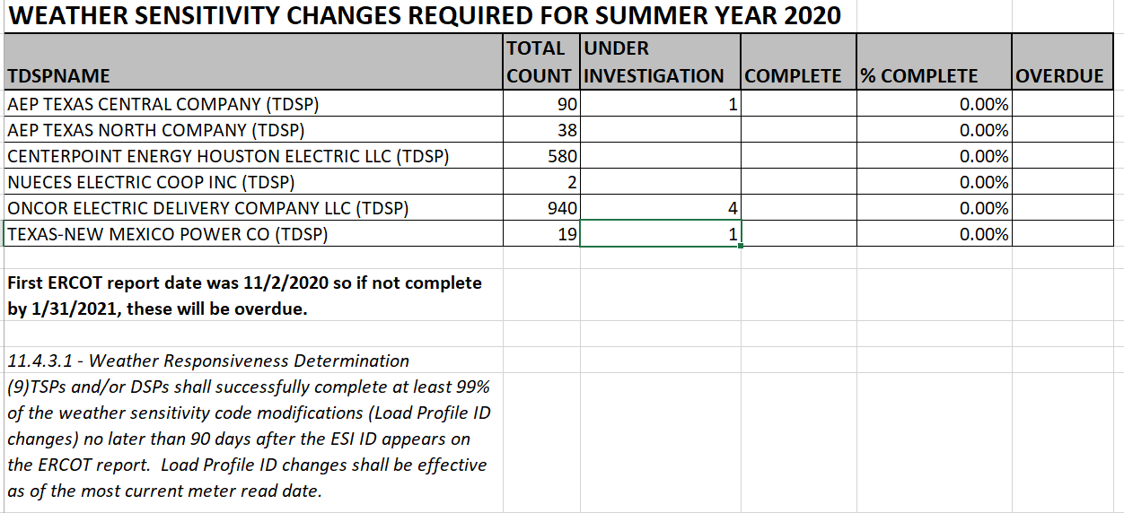

- Draft Revision Requests have been vetted with final edits and endorsed at PWG. These will be presented at December’s RMS meeting for discussion. The plan is to hopefully work through the stakeholder process for voting and approvals by end of 1st quarter of 2021.
  - Draft RMGRR Eliminate Section 7.13, IDR Meter Removal and Installation Process
  - Draft NPRR Modify IDR Meter Requirement and Eliminate IDR Meter Requirement Report
  - Draft LPGRR Creation of New BUSLRG and BUSLRGDG Profile Types

- Review analysis of Oil & Gas Flat Profiles
  - There was a concern that O&G Flat profiles might not be true indicators of “flat” usage. This would be somewhat concerning for REPs who may be pricing such customers with more usage volatility than what their O&G Flat profile might indicate. At the request of a market participant last month, ERCOT provided some insights and analysis of these O&G Flat customers across the 3 different Avg Load Factor Ranges below. The expectation as most would be in the BUSHI (AVGLF>0.6) grouping as shown, but there was also some expressed concern that approx 13% were in the BUSLO grouping. The REP community found this insightful and may possibly provide feedback/thoughts at next PWG meeting.

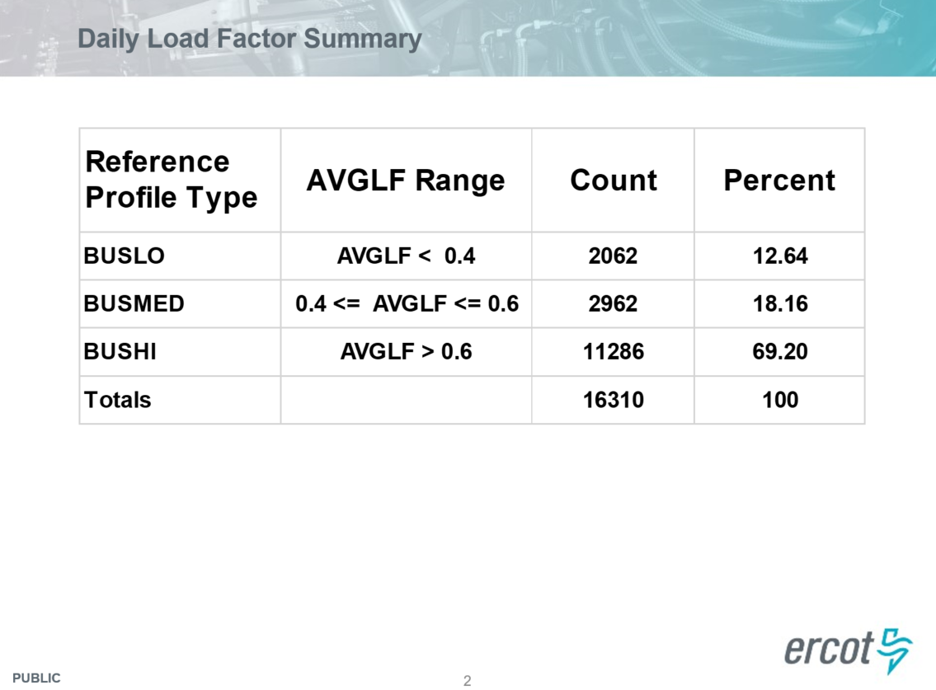

- Discussion on Proposal for TDSPs to provide additional information on the DG Load Profile Template
- Clayton Stice, ERCOT, presented a proposal for additional information related to unregistered DG on the DG Load Profile Template spreadsheet for future modelling and forecasting purposes:
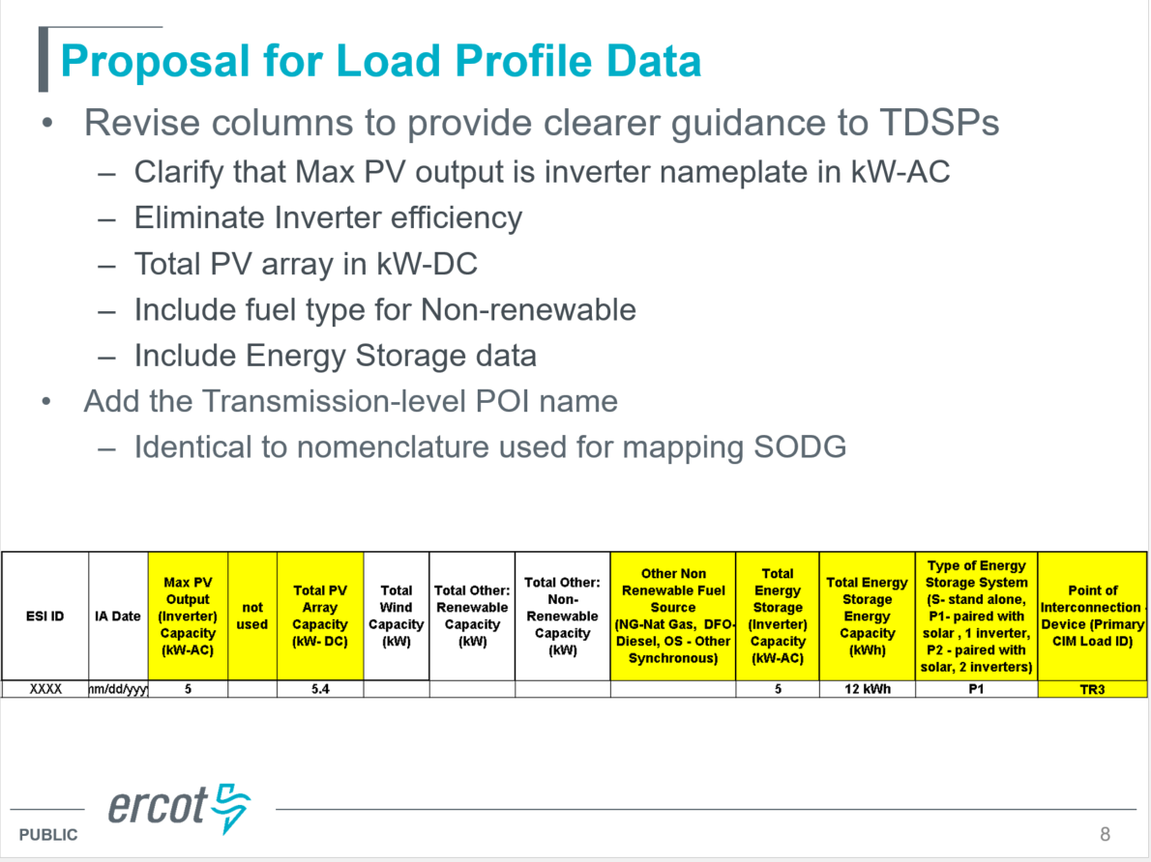
- While TDSPs were generally supportive of ERCOT’s needs, there were some raised concerns on the manual effort and task of submitting this additional information on a regular basis to ERCOT given the growth of DG (eg rooftop solar).
- TDSPs plan to take back this proposal to their respective shops as well as discuss amongst the TDSPs on a collective path to move forward.

- Next Meeting: The group felt there was no urgent need for an unscheduled December meeting. Therefore, the next PWG meeting will be January 13, 2021 @ 9:30am.

