NOGRR Number | 215 | NOGRR Title | Limit Use of Remedial Action Schemes

Date | January 8, 2021

Submitter’s Information
Name | Shannon Caraway, Bob Helton, Ian Haley, Jeremy Carpenter, John Dumas
E-mail Address | shannon@solar-prime.com, robert.helton@engie.com, ian.haley@vistracorp.com, jcarpenter@tnsk.com, john.dumas@lcra.org
Company | Solar Prime LLC, ENGIE North America, Luminant Generation, Tenaska Power Services, Lower Colorado River Authority
Phone Number | 214-478-6009, 713-636-1347, 512-673-9655, 817-303-1869, 512-913-9399
Cell Number
Market Segment | Independent Generator, Independent Power Marketer, Cooperative

Comments
EXECUTIVE SUMMARY
Managing an open access grid is challenging, because generation and Load can come and go with relatively short lead-times. Transmission planning, design, permitting, and construction by its very nature usually has longer lead times than generation and Load additions. This timing mismatch has been a “front and center” issue from the very outset of wholesale deregulation in ERCOT, as the prior model of vertically integrated generation and transmission planning gave way to market driven generation expansion. Remedial Action Schemes (RASs) have been reliably used for over two decades as a key tool to manage this timing mismatch, while the transmission planning process develops, evaluates, and implements necessary grid upgrades. Most RASs have been temporary in nature until exit strategies such as new transmission upgrades are identified, approved, and constructed. However, in a few cases, such as the East Direct Current Tie (DC Tie) integration, they have been in service long-term, because the cost / benefit metrics of identified exit strategies could not meet the economic criteria hurdles. Unfortunately, NOGRR215 seeks to eliminate the continued use of RASs to manage this inherent timing mismatch, based on the stated Business Case concerns that:
- The continued use of RASs is incenting new Generation Resources to locate “in areas where the Resource would need to be curtailed on a near constant basis to maintain the reliability of the transmission grid in the immediate area”, and
- “It is expected that the number of such RAS proposals will continue to significantly increase, based on the locations and unit sizes being considered in the interconnection process”.
The analysis presented within clearly demonstrates how these stated concerns are not materially different from the Generation Resource integration challenges that ERCOT has faced from the outset of deregulation, by specifically including a broader view of this two-decade period, rather than just the past few years. This review illustrates:
- ERCOT has a history of reliable RAS operation
  - ERCOT has only reported two RAS misoperations in the past 10 years.
  - PRC-015, PRC-016, and PRC-017 became effective in April 2017 and increase the likelihood of reliable RAS operation by requiring RAS documentation, misoperation reporting, maintenance, and testing.
- RASs have saved consumers a significant amount of money over the years
  - 2004 and 2005 IMM State of the Market Report excerpts are provided that illustrate how RASs in the Northeastern part of ERCOT completely eliminated the congestion that they were designed to mitigate, resulting in annualized congestion savings of ~$45M/year, based on a one time cost of <$1M, and were successfully implemented ~6 months after approved by ERCOT.
  - The RAS implemented on the Permian Basin combustion turbines in 2013, were successful in mitigating constraints on Permian exit lines caused by nearby Load growth on the Culberson loop, once again allowing this generation to counterflow the Odessa area congestion associated with the extreme Delaware basin Load growth that has occurred over the past 7 years. Note: the Permian Basin combustion turbines were often the only dispatchable generation capable of counterflowing these Odessa area constraints.
- RAS demand (i.e. simultaneous RAS count on the system) is largely correlated to “rapid changes to the system” (e.g. generation interconnections or Load changes), until transmission upgrades can catch up
  - The most common form of rapid change to the system is new generation additions. Although occasionally, rapid Load changes occur, such as the Delaware Basin Load growth and the Alcoa smelter retirement (~510 MW shift all at once).
  - During periods of significant generation expansion, a growth in RAS count can be expected. As shown within, the current generation expansion pace is higher than at any time in the past two decades, even more pronounced than the early 2000s. Thus, the recent increase in RAS request is not unexpected.
- The Competetive Renewable Energy Zone (CREZ) system build-out has provided an anomalous ~8-year period where RAS requests were artificially low, due to an unprecedented amount of transmission capacity that was available for new generation to connect into, with only minimal additional grid upgrades needed
  - Now that the CREZ system is fully subscribed, the opportunity to site large amounts of new generation without needing a RAS while local area grid upgrades are made, is beginning to return to pre-CREZ historical norms.
- ERCOT has historically managed substantially more RASs / Automatic Mitigation Plans (AMPs) than are currently in place or have recently been requested
  - Currently, there are only 7 RAS / AMPs in operation, of which 6 are of the nature that would be eliminated on a go forward basis, by the adoption of NOGRR215.
  - As shown within, these 7 RASs represent a low point for the number of active RASs / AMPs. A number this low, has only been achieved one other time, during the Q3 2018 to Q3 2019 time period.
  - Based on ERCOT’s admittedly incomplete list of 37 RASs / AMPs in use since 2004, which appears to be missing 30% to 40% of these that have been used since deregulation began, the average number of active RASs / AMPs has been 15 and the maximum has been 25. Adjusting for known missing RASs / AMPs from ERCOT’s list, it appears that the maximum number of active RASs / AMPs was in the 27 to 30 range during the Q2 to Q3 2010 time frame (i.e. pre CREZ).
  - Thus, even if ERCOT were to approve all 6 recently requested RASs, it would only increase the total number of RASs / AMPs, back up to a level less than the average level of 15 historically active RASs / AMPs at any one time. Given that it appears that ERCOT’s list of historical RASs / AMPs is likely missing 30% to 40% of the historical RASs / AMPs, then these 13 (7 active + 6 requested) RASs / AMPs would likely still be below actual average historical levels.
- ERCOT has historically managed significant concentrations of electrically and geographically close RASs without any unintended RAS / RAS interaction.
  - A stated concern used to justify the need for NOGRR215 is that the overall concentration RASs in a limited geographical / electrical area has reached unmanageable levels.
  - As shown within, ERCOT has historically managed as many as 10 RASs / AMPs simultaneously within the same geographic / electrical area of the system (e.g. the Northeast portion of ERCOT). During this period there were four at Valley switchyard and four at Monticello switchyard at one time!
  - Thus, even if ERCOT were to approve all 6 recently requested RASs and they were all located in the West, which is dramatically bigger than Northeast ERCOT, the total amount of geographic / electrical concentration would still be within historical levels.
  - The ability to successfully manage this type of local area RAS concentration, is a largely a measure of careful design by the Transmission Service Provider (TSP) and review by ERCOT during the development and approval phase.
- ERCOT has historically managed congestion on stability constraints, even those that were Interconnection Reliability Operating Limits (IROLs)
  - A stated concern used to justify the need for NOGRR215 is that approval of some of the recently requested RASs, will result in increased intervals of congestion on downstream Generic Transmission Constraints (GTCs) associated with voltage and dynamic stability limits and due to the uncertainty of calculating accurate Generic Transmission Limits (GTLs) associated with these GTCs, this is undesirable.
  - As shown within, ERCOT has historically managed similar stability-based flow constraints associated with the voltage stability limits associated with Houston imports, without ever seeking to limit RAS approval as a mitigating factor.
  - There is widespread stakeholder agreement for the need for ERCOT to apply an appropriate level of safety margin to the GTLs associated with GTCs; however, once that safety margin has been applied, ERCOT must be comfortable operating up against those GTLs.
- Limiting the use of RASs as envisioned by NOGRR215 will subject the market to years and years of unnecessary congestion while transmission upgrades are developed, considered for approval per criteria, and implemented where justified
  - As shown within, the average number of years that a RAS / AMP has remained in place, is 6.5 years.
  - The P25 number of years that a RAS / AMP has remained in place is 4.5 years
  - The P75 number of years that a RAS / AMP has remained in place is 8.0 years
  - The max and minimum number of years that a RAS / AMP has remained in place is 14.25 years and 2.25 years, respectively.
  - Thus, even proposals to limit the maximum duration of an individual RAS on the system to 4 to 5 years, would dramatically curtail the among of congestion relief that these have historically provided.
- RAS usage is a critical “tool in the tool kit” for ERCOT to help ensure resource adequacy which is a key Reliability Indicator identified by the North American Electric Reliability Corporation (NERC). NERC’s 2020 State of Reliability Report published in July 2020 discusses ERCOT’s 2019 performance in this area as follows:
  - “In 2019, the reserve margin assessment reported for Texas RE-ERCOT assessment area was determined by the ERO’s reliability assessment process to be “inadequate” for the 2019 summer peak in comparison to the ERCOT Reference Margin Level of 13.75%”
  - It reported the “Amount Needed to Meet Reference Margin Level: 3,802 MW”
  - Removing or diminishing the ability to use RAS technology to benefit resource adequacy does not help improve the likelihood of meeting and continuing to meet this measure going forward.
For all the reasons outlined above and discussed in detail within the Supporting Detailed Discussion section below, we believe that NOGRR215 is not narrowly tailored to address demonstrably new reliability issues and does not preserve historic levels of reliable open access. As such, we believe that no changes are currently warranted to ERCOT’s binding documents (e.g. Protocols, Planning Guides, Operating Guides, etc.), so that historic levels of reliability and open access are preserved.

SUPPORTING DETAILED DISCUSSION SECTION
RAS Overview
At a high level, a RAS is a protection scheme that can automatically take corrective actions, such as adjusting generation, Load, or reconfiguring the transmission system, usually in response to a narrowly defined and relatively rare set of trigger events. Because these are automatic actions, when deployed post contingency, they can expand the secure operating envelope beyond normal Security Constrained Economic Dispatch (SCED) N-1 limits. To illustrate, imagine a 1,500 MW generator connecting into a 1,000 MVA transmission line (i.e. Point of Interconnection, with two 1,000 MVA exit paths):
- Without a RAS, the new generator would be N-1 SCED limited to <=1,000 MW and economically limited even further due to the nodal market design.
- With a simple RAS that locally monitors both exit paths and has a run back / trip scheme, the generator can likely operate N-1 unconstrained in SCED.
In this example, it is easy to see how the RAS allows the 1,500 MW generator to operate unconstrained in SCED, until such time as the RAS exit strategy is achieved, i.e. two 1,000 MVA transmission paths from its Point of Interconnection to the nearby switching stations are upgraded to a 1,500 MVA or higher post contingency rating. It is important to note that the Protocols have long prohibited the use of RASs on IROLs, due to the potentially extreme consequences associated with a RAS misoperation.

Long History Of RAS Utilization in ERCOT
The ERCOT market has a long history of RAS use, where utility use of RASs predates ERCOT deregulation, such as with the East DC Tie integration. Many of the early post-deregulation CCGT new generation build, such as Midlothian, Hays, Ennis, Lamar, Kiamichi, Gateway, as well as, more recent CCGT builds, such as Mitchell Bend have temporarily relied on them, until transmission upgrades were developed. Similarly, many new renewable generators in West Texas, such as Trent, South Trent, Forest Creek, Rattlesnake, etc. have used them, until transmission upgrades were implemented. Additionally, numerous existing generators, such as Monticello, Martin Lake, Sandow, Stryker, Valley, Morgan Creek, Permian Basin, Ferguson, Wirtz, etc. have participated in them, while transmission upgrades were made to address rapidly changing system conditions. Of specific note, is that the Permian Basin RAS was implemented due to the extreme Delaware Basin area Load growth on the Culberson loop, so that this critical dispatchable resource could remain available for counterflowing Odessa area constraints caused by this same Load growth.

History Of Reliable RAS Operation
First and foremost, it is extremely important to acknowledge that ERCOT and the TSPs and Resource Entities associated with RASs, have historically done an excellent job of designing, installing, and operating them in a reliable fashion and continuing to do so in the future is of utmost importance. The following RAS Misoperations information from slide 9 of ERCOT’s NOGRR215 Overview presentation at the November 2, 2020 Congestion Management Working Group (CMWG) / Operations Working Group (OWG) meeting illustrates this fact, by showing that there have only been 2 RAS misoperations in the past 9 years.
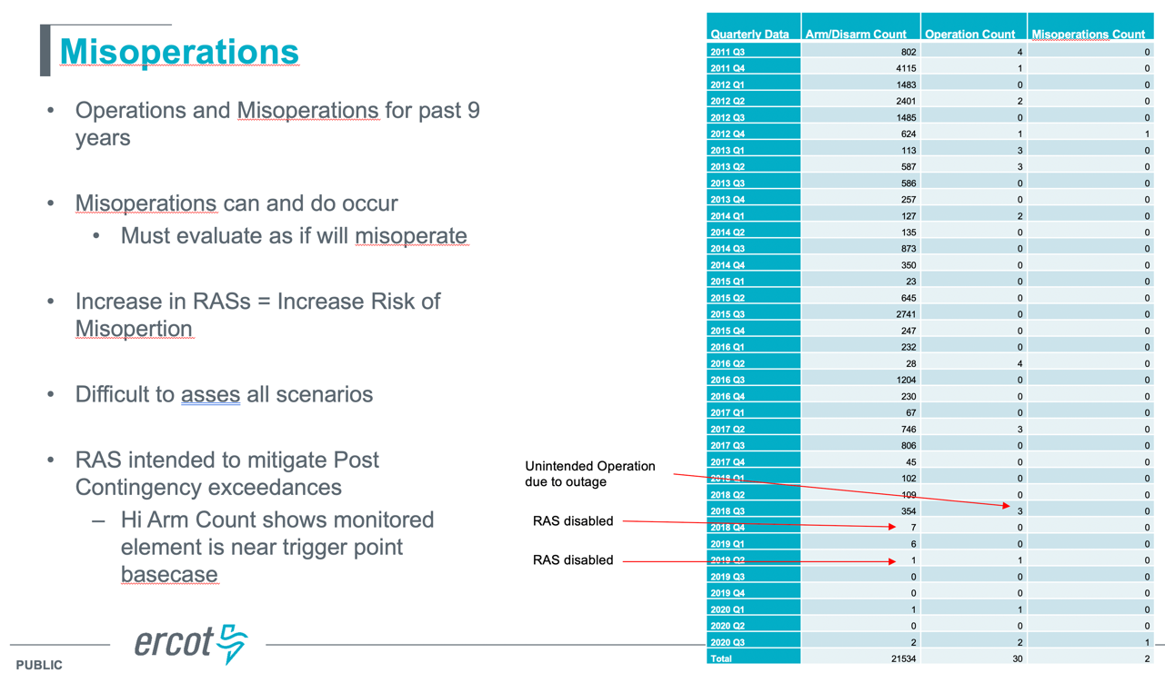
The aforementioned NERC PRC standards which came into effect in 2017 further help ensure RAS reliability.

Correlation Of Recent RAS Count Vs. New Generation Interconnection Count
On slide 7 of ERCOT’s NOGRR215 Overview presentation at the November 2, 2020, CMWG / OWG meeting, the following graph was shown to illustrate RASs vs New Generation:
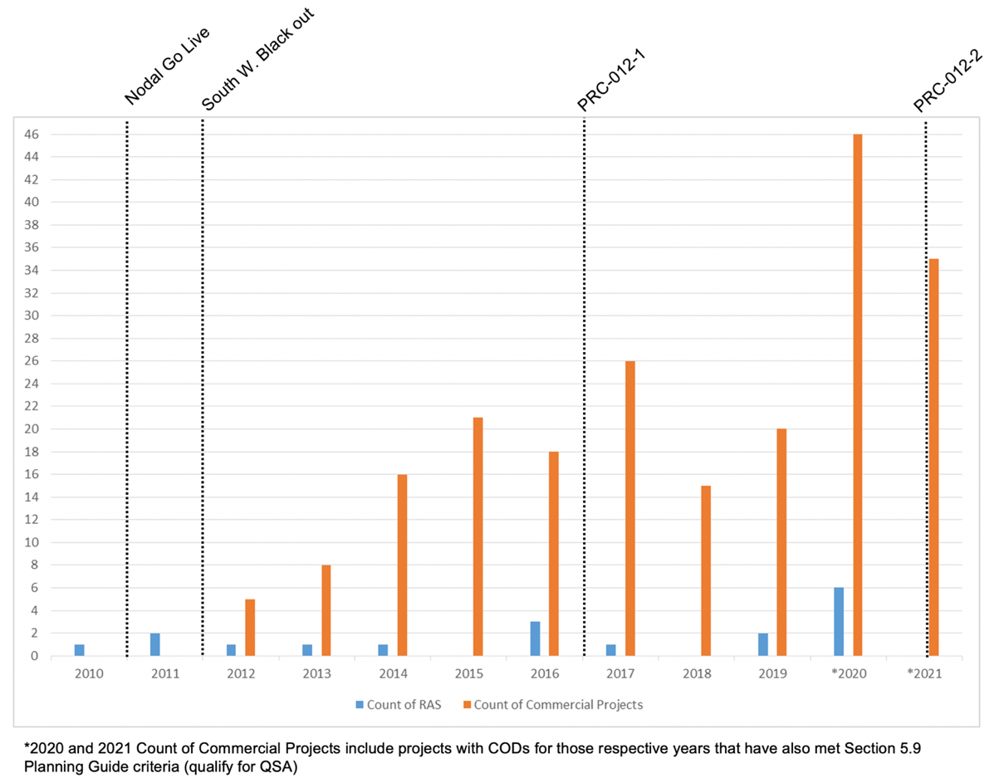
Figure 1: RASs vs New Generation in Recent Years
Figure 1 illustrates a sharp increase in the number of new Resource integrations in recent years. A stated concern was that historic RASs impacted the system differently than new RASs, specifically that historic RASs managed thermal constraints and new RASs are being focused on stability constraints. In addition to the 7 RASs currently in place at the end of 2020, slide 8 of this same presentation indicated that there are 6 additional RASs that have been requested and ERCOT has under review.
Since NOGRR215 seeks to eliminate the continued use of RASs that “allow Generation Resources… that would otherwise be subject to restrictions to operate at their full Rating” and the above information illustrates a correlation of increased RAS request associated with increased new Resource integrations, it is helpful to review:
- Other periods in ERCOT’s deregulated history when the volume of new Resource integration was also high and whether the corresponding use of RASs during those periods included their use for managing stability constraints,
- Other periods in ERCOT’s deregulated history when generation related RASs have been used to manage unexpected Load growth,
- How the historic geographic / electrical concentration and potential RAS / RAS interaction was managed, and
- How the current volume of requested RAS use compares to historic levels
As shown in Figure 2 below, in the past 21 years (1999 through YTD 2020), ERCOT has successfully integrated over 76,000 MW of new Generation Resources into the grid and is currently on track to reach the 95,000 MW level in the next few years.
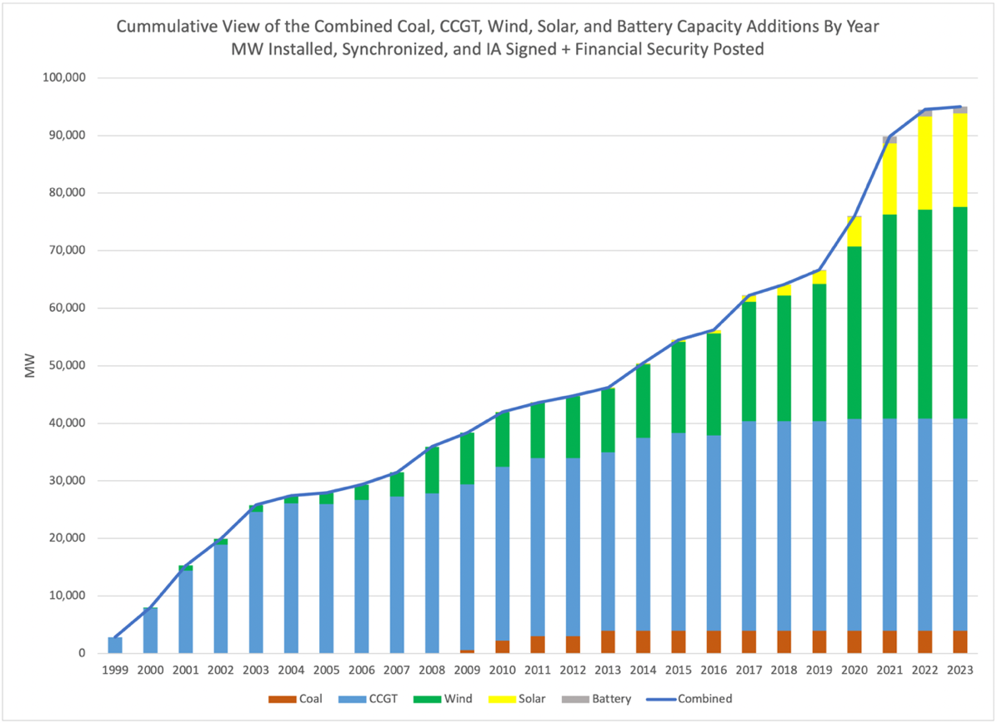
Figure 2: Cumulative View of New Coal, CCGT, Wind, Solar, and Battery Storage
One thing that is immediately obvious from the cumulative chart in Figure 2, is that the annual MW level of new Generation Resource additions that is currently being experienced (i.e. 2019 through 2021), shares much more in common with the first five years (i.e. 1999 through 2003) than it does with any of the years in between. The graph in Figure 3 below provides a year over year view of this same data, in order to provide greater visibility of the amount of annual new Generation Resource additions.
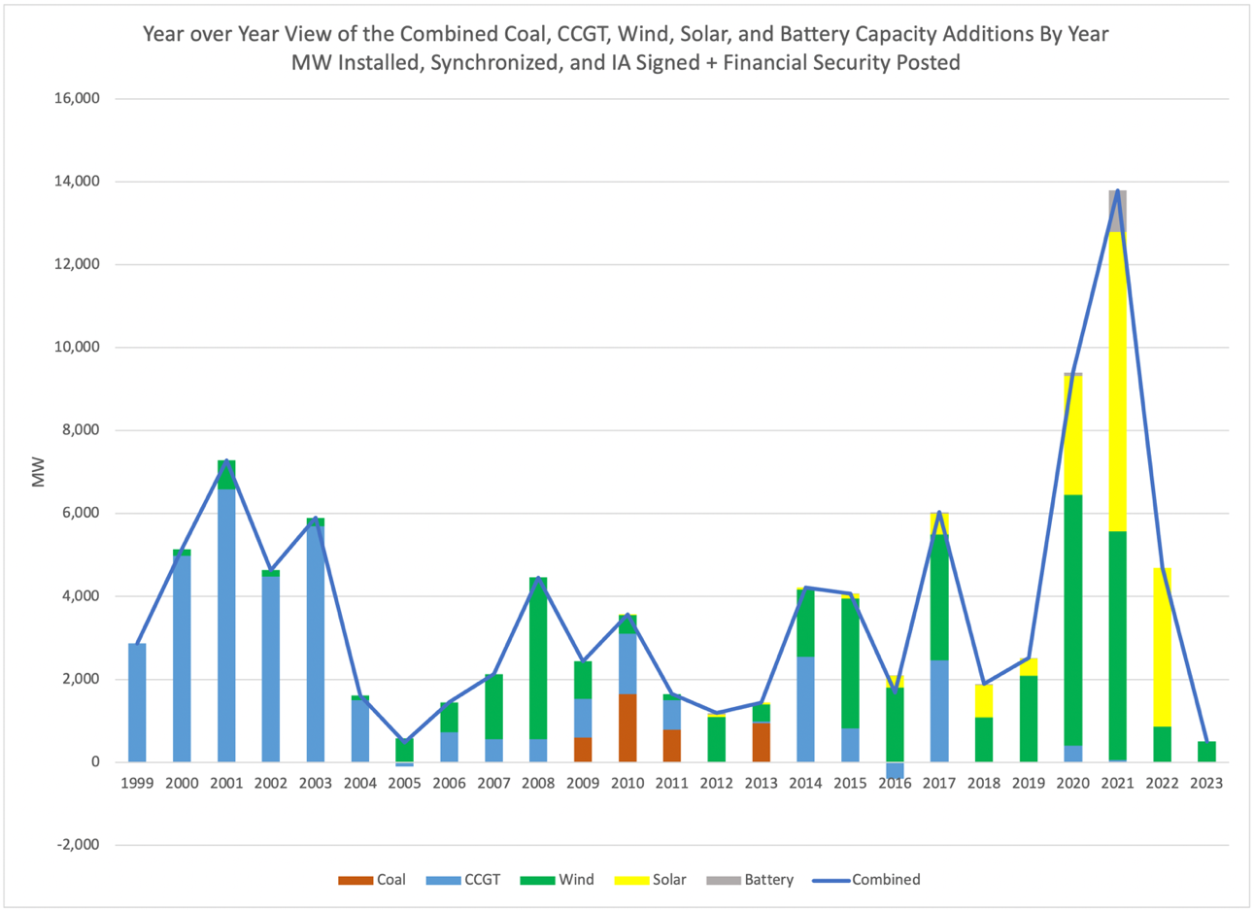
12,598 MW
25,712 MW
33,633 MW
25,829 MW
Figure 3: Year over Year View of New Coal, CCGT, Wind, Solar, and Battery Storage
This year over year view, clearly illustrates that the current three year period (i.e. 2019 through 2021) involves the integration of more MWs of new Generation Resources than at any other time. In fact, the only other historical period where there was anywhere near this same volume of new Generation Resource additions (i.e. 1999 through 2003), was spread over 5 years rather than only 3 years! Alternatively, if an apples to apples, current 5 year period (i.e. 2017 through 2021) of 33,633 MW is compared to the proceeding 5 year period (i.e. 2012 through 2016) of 12,598 MW, it is immediately obvious that perhaps the primary driver of increased RAS requests that ERCOT is beginning to experience has more to do with the MW volume of new Generation Resource integration than anything else. Additionally, new Generation Resources that interconnected during the 2012 through 2016 five year period, enjoyed the relatively unprecedented benefit of the recently completed $7B CREZ transmission infrastructure, which is not expected to reoccur again in the foreseeable future. For all these reasons, it is clearly more informative to compare recent levels of RAS requests associated with new Generation Resource additions with the 1999 through 2003 time period than it is the 2012 through 2016 time period, as was the focus in Figure 1.

Example of RAS Utilization For Generation Resource Integration During Early Years
As ERCOT staff has recently noted, they no longer have complete records of all the RASs that existed on the system further back in time; however, as shown below there is still plenty of information available to make key observations from the 1999 through 2003 time period. Between 1995 and 2003, the 600 MW East DC Tie, the 1,004 MW Lamar Generation Resource, and the 1,222 MW Kiamichi Generation Resource were interconnected into the Northeast ERCOT transmission system. The interconnection process associated with each of these new resources, involved the use of one or more RASs. The East DC Tie integration required a stability related RAS at Monticello Sw. Sta. The Lamar Generation Resource integration required both a stability RAS and a thermal RAS installation at Paris Sw. Sta. However, although Oncor was actively developing and implementing transmission system upgrades which would allow the exit these RASs, by the time that the Kiamichi Generation Resource integration occurred in 2003, the Northeastern ERCOT transmission system was starting to experience substantial congestion. The CMWG requested that Oncor perform a study “to investigate and determine if viable and acceptable options existed that could be implemented to reduce Northeast ERCOT congestion in 2004”. Oncor completed and presented their report at the 9/23/2003 WMS Congestion Management Workshop and again at the 10/2/2003 WMS Special Session. The Oncor report recommended:
- Modifying existing and developing new RASs:
  - Modify the existing Valley RAS to incorporate remote monitoring
  - Install a new RAS at Valley with local monitoring
  - Install a breaker tripping RAS at Valley to protect the Valley 345/138 auto
  - Install a breaker tripping RAS at Collin to protect the Bridges line
  - Install a breaker tripping RAS at E. Mesquite to protect the W. Mesquite line
  - Modify the existing Monticello thermal RAS to incorporate remote monitoring
- 3 system configuration changes (i.e. operating lower rated lines in normally open position):
  - Operate E. Richardson breaker #3400 normally open
  - Operate Cooper switch #906 normally open
  - Operate NW Sherman switch #380 normally open
- 2 Contingency Response Plans:
  - Switching action to insert Centerville series reactors to manage Royse – Ben Davis overloads
  - Switching action to move Load at Wills Point to Edgewood to manage Terrel N. Tap – Terrel North overloads
- 3 modifications to system upgrades that were already underway prior to the study:
  - Increase the size of the series reactor planned for the Allen 345/138 kV auto from two ohms to three ohms
  - Rebuild and install a 326 MVA circuit from Custer to Rolater to Lebanon
  - Release the Northhaven – Alpha Road line for elevated temperature operation.
The Oncor report carefully explained the redundant communication paths that would be implemented to minimize the impacts on transmission reliability associated with the remote monitoring RASs, as well as, extensive discussion was provided of the steps being taken to mitigate potential RAS / RAS interaction and minimizing the amount of generation tripping. This proposal addressed both thermal and stability (currently managed as a GTC) issues, in order to eliminate congestion associated with the 5,060 MW of generation and 600 MW of DC tie import located in the Northeastern portion of ERCOT, while longer term transmission upgrades were developed and implemented. Oncor estimated that the RASs could be implemented within 6 months for less than $1,000,000 and that the modifications to system upgrades would result in negligible cost increases over what was already underway. Approximately 7 months later, ERCOT Operations Support presented an update on the Northeast Congestion Management plan at the 5/12/2004 Operations & Planning Review Group Meeting, where slide 13 (shown in Table 1 below) shows Oncor RASs outlined above, as well as, others that were in place at that time.
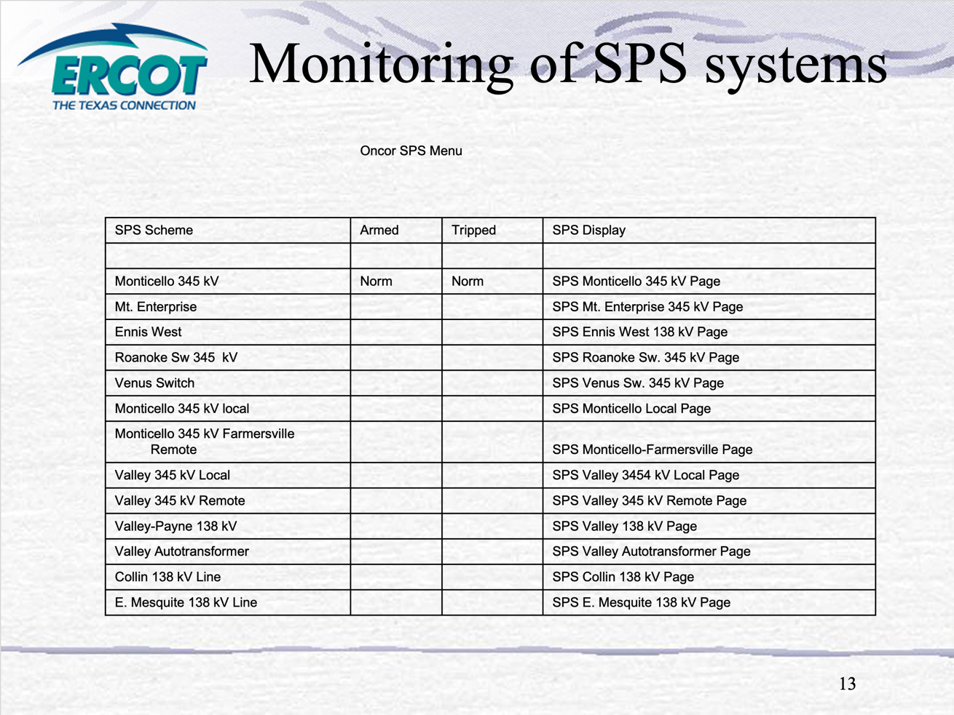
Figure 4: Oncor RASs in place in May 2004
By June 1, 2004, Oncor and ERCOT had completed the installations of all the RASs contained in the Northeast ERCOT Congestion Study. Their associated market benefits were reflected by the Potomac Economics 2004 and 2005 State of the Market Reports.
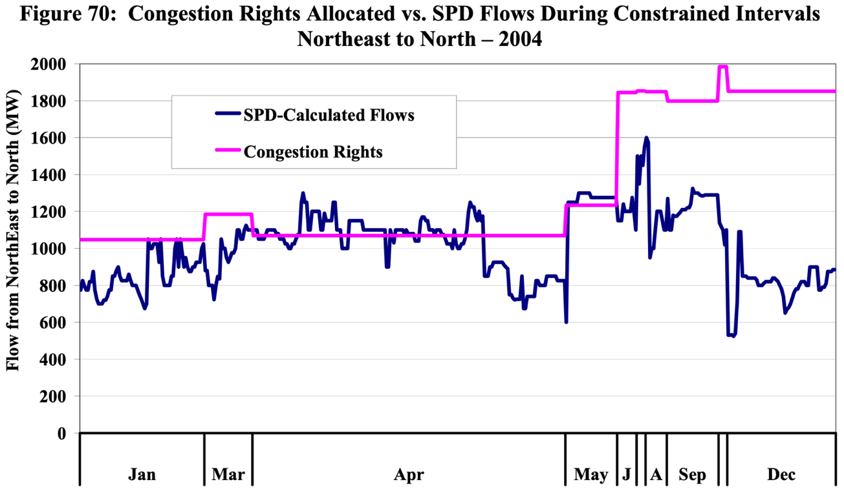
Figure 5: Northeast to North CSC Flows vs. Congestion Rights in 2004
The Potomac Economics 2004 State of the Market Report noted:
Figure 70 shows that the quantity of congestion rights for the Northeast to North interface ranged below 1,300 MW from January through May, and then increased above 1,800 MW for the remainder of the year. Constraints were significantly more common during the early period, which is consistent with there being less transmission capability. However, after the upgrade in transmission capability, SPD-calculated flows were lower than the quantity of congestion rights by an average of 828 MW during constrained intervals. The increase in transmission capability resulted from a Special Protection Scheme (“SPS”) that ERCOT implemented June 1, 2004. Ordinarily, interface limits are set so that in the event of a sudden contingency, the grid would still be reliable. The SPS sets in place procedures and/or equipment that allow the interface to carry more flow under normal conditions by limiting the impact that a large contingency would have on reliability. When these can be implemented reliably, they greatly enhance the capability of the transmission system to carry power from low- cost areas to higher-cost areas.
By the 2005 State of the Market Report, Potomac Economics noted:
It is notable that the Northeast to North CSC was never constrained during 2005.

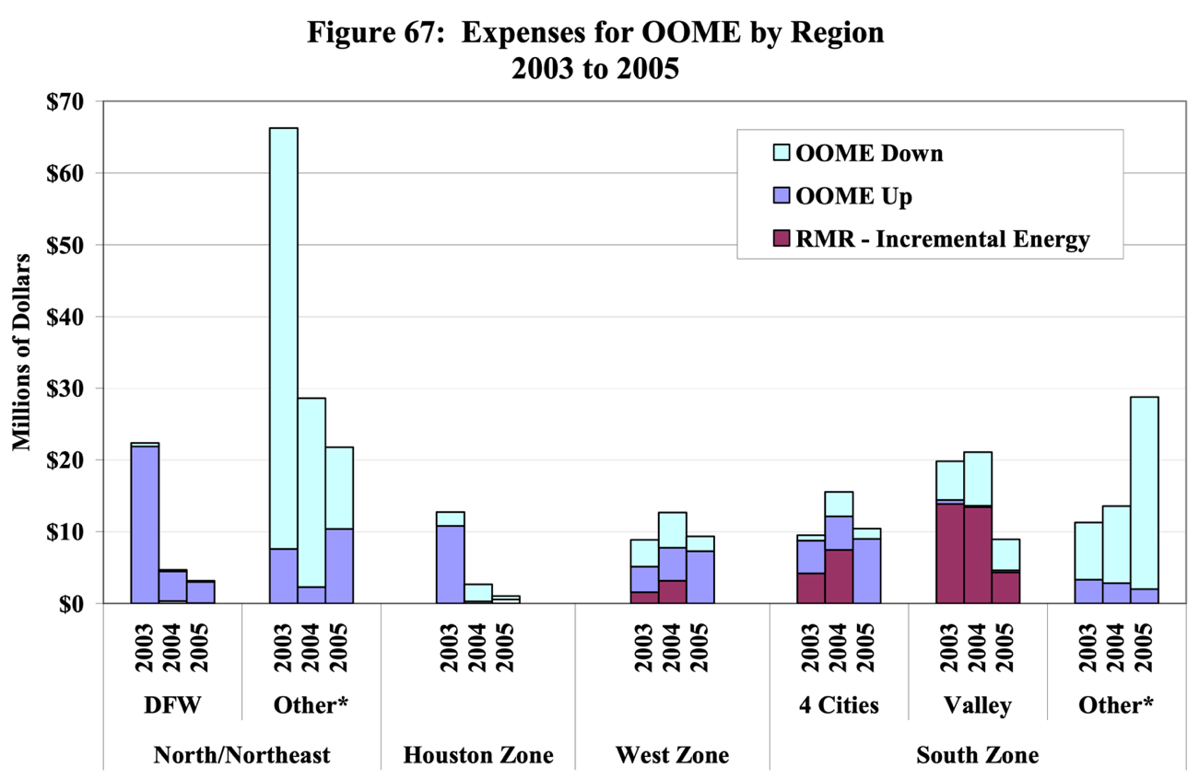
Figure 6: Congestion Reduction Benefits from NE Congestion Management Plan
Combining the information from Figure 6 above and the prior statement that the Northeast to North CSC did not congest at all in 2005, it can be seen that the Oncor Northeast ERCOT Congestion Management Plan resulted in an annualized congestion reduction of ~$45M from full year 2003 to full year 2005. What is all the more amazing, is that Oncor implemented these RASs within 6 months at an estimated cost of less than $1,000,000! If NOGRR215 is adopted, the very transmission tools and associated ERCOT processes and systems that made all this possible, would be eliminated, requiring the market to unnecessarily experience years and years of needless congestion and the associated higher market clearing prices, while longer term transmission upgrades are made.
With the benefit of 16 years of hindsight, we now know that Oncor’s response to the CMWG request, did not incent other new Generation Resources to locate in this same area and result in the need for near constant curtailment in order to maintain the reliability of the transmission system, which is one of the stated Business Case justifications given for NOGRR215. In fact, another 16 years would pass before another new Generation Resource would be developed in this Northeast area of ERCOT and only after the 1,850 MW Monticello coal plant retired in early 2018.
In Table 1 above, entries can also be seen for the Venus RAS, which was a thermal RAS used to quickly integrate the 1,400 MW Midlothian Generation Resource and the Mt. Enterprise RAS, which was a stability RAS used to quickly integrate the 850 MW Gateway Generation Resource, while longer term transmission upgrades were being made in both cases. Keep in mind, Table 1 only represents Oncor’s RASs at that time. Similar RASs were used by other TSPs in many similar such new Generation Resource integrations (e.g. LCRA with their integration of the Hays, Guadalupe, and Rio Nogales Generation Resources).

Example of RAS Utilization For Generation To Manage Unexpected Load Growth
While the prior section focused on examples of RAS use to facilitate the integration of new Generation Resources in an area that had become a “generation pocket” in the Northeastern part of ERCOT, Generation Resource related RASs have also been integral for managing Load growth in a “Load pocket” as well. Beginning in 2012, congestion began to become extreme in Far West Texas as Load growth became pronounced in the Delaware Basin. In 2012, this congestion was most pronounced on the Odessa North 138 / 69 kV autotransformer, which was the single most congested element in that year at $135M and the Odessa – Odessa North 138 kV line at $20M. The Permian Basin combustion turbines were some of the only dispatchable Generation Resources that could unload these constraints and during 2012 they received an extensive number of mitigated deployments for this reason. However, by 2013 as the Load continued to grow in the Delaware Basin, congestion began to occur on the Permian Basin – Wink 138 kV line and the Permian Basin – Ward Gulf Tap – Wink 138 kV line, when the Permian Basin combustion turbines were dispatched. Essentially, the Permian Basin combustion turbines which were critical for mitigating the Odessa area congestion, were at the same time causing congestion between Permian Basin and the Culberson loop where the Delaware Basin Load growth was the most extreme. Oncor and Luminant worked together to develop and implement the Permian Basin RAS in July 2013 that protected the Permian Basin – Wink 138 kV line and the Permian Basin – Ward Gulf Tap – Wink 138 kV line, so that the Permian Basin combustion turbines could once again dispatch to full output whether needed for managing congestion in the Odessa area or meeting system energy needs. In 2013, the Odessa area congestion was still around $105M, even though the Permian Basin RAS was implemented in July of that year. Although Oncor and other TSPs in the area have been extremely busy implementing transmission upgrades in the Delaware Basin area for the past 8 years, the Load has continued to grow so quickly, that the Permian Basin RAS has not yet been able to be retired. While it is impossible to know how much congestion has been mitigated by the Permian Basin combustion turbines, solely due to the Permian Basin RAS, one thing is for certain, if would have been dramatically higher because one of the only dispatchable generation resources that could counterflow these area constraints, would have been severely limited in its ability to do so for the past 7 years.

Ability To Successfully Manage Potential RAS / RAS Interaction
Since potential RAS / RAS interaction of geographically and/or electrically close RASs is a stated reason that ERCOT is sponsoring NOGRR215, it is instructive to read Oncor’s full report that was referenced in footnote 2 above, to see how Oncor clearly and demonstrably addressed this potential issue in their Northeast ERCOT Congestion Management Plan. Consider the geographic and electrically close concentration of RASs as shown below:
- 4 RASs at Monticello
  - Monticello 345 kV Local
  - Monticello 345 kV Remote
  - Monticello B
  - Monticello Mining
- 4 RASs at Valley
  - Valley 345 kV Local
  - Valley – Anna 345 kV Remote
  - Valley – Payne 138 kV
  - Valley Auto
- Automatic Breaker Tripping (analogous to today’s AMP)
  - Collin – Bridges 138 kV Line
  - East Mesquite – West Mesquite 138 kV Line
With this historical local area concentration of RASs background in mind, it would not be surprising that even if all 6 additional RASs that have recently been requested by ERCOT market participants, were to all be located in West Texas, (note: ERCOT has not stated their location) and they were added to the 5 existing West Texas RASs that are currently in operation, that it could done without leading to undesirable RAS / RAS interaction. If this were not the case, then modifications could likely be made to avoid this potential problem. Further, this overall number of RASs in a single area, (e.g. West Texas) would still be within historical geographical / electrical concentration norms for a well-designed set of RASs, especially considering that West Texas represents a much larger geographic and electrical area than the Northeastern portion of ERCOT.

Analyzing Historical RAS Implementation Durations And Volume Of Use
On slide 8 of ERCOT’s NOGRR215 Overview presentation at the joint CMWG / OWG meeting on November 2, 2020, ERCOT presented a RAS History slide, which shows that at least 37 RASs have been used in ERCOT since 2004. In sharing this information, ERCOT was attempting to be responsive to an earlier stakeholder requests that they show all of the RASs and AMPs that have been implemented since the implementation of deregulation. ERCOT verbally caveated when it presented this RAS History information, that their record keeping that far back was limited and that this list may not be complete. Since Oncor has historically numbered their RASs and AMPs (historically referred to as SPSs), starting with #1 back around the time that deregulation began and reached as high as #52 with the Mitchell Bend RAS that was implemented 2016, as well as the fact that several other TSPs such as AEP, LCRA TSC, etc. have developed and implemented RASs, some of which were captured on ERCOT’s RAS History list and others were not, the above referenced list is definitely incomplete. Based on this information, it appears that there have most likely been 60+ RASs and AMPs developed and implemented in ERCOT system over the past 20 years. However, even though ERCOT’s RAS History list appears to be a subset of the all the RASs that have been implemented over the past two decades, there is still value in analyzing this admittedly incomplete list.
After filling in the missing “Retired” date for the first 9 entries in the ERCOT RAS History table, based on the retirement of the associated generation and/or other information, analysis can be performed to understand how long these RASs have typically been in place, as well as, the number of simultaneous RASs in operation across time. The resulting statistics for RAS duration are:
- Average number of years that a RAS has remained in place ~6.50 years
- P25 number of years that a RAS has remained in place ~4.50 years
- P75 number of years that a RAS has remained in place ~8.00 years
- Maximum number of years that a RAS has remained in place ~14.25 years
- Minimum number of years that a RAS has remained in place ~2.25 years
These statistics were calculated only using the RASs and AMPs that have already been retired, so that they are not skewed by those that have only recently been implemented. Figure 7, illustrates the number of simultaneous RASs and AMPs in operation across time based on the data from Slide 8 of ERCOT’s NOGRR215 Overview presentation at the joint CMWG / OWG meeting on November 2, 2020. While Figure 7 below indicates that there were 9 active RASs and AMPs as of the date that ERCOT prepared the data for this slide, the 1/5/2021 In-Service Remedial Action Scheme report from the ERCOT MIS identifies 7 active RASs, which implies some recent RAS retirements.

Figure 7: Illustration of the Number of Simultaneous RASs and AMPs in Operation
Based on this limited and admittedly partial dataset, there were over 25 separate RASs in operation in Q2 and Q3 2010 and an average of approximately 15 RASs in operation across this entire period. Keep in mind that this is based on an incomplete RAS History that omits both the Sandow Local RAS (Oncor SPS #40) and Sandow Remote RAS (Oncor SPS #43) that were known to be in operation during Q2 2010, as well as, other RASs that were not included in ERCOT’s RAS History list. So, we know that a complete list of historic RASs and AMPs would yield even higher numbers. However, even in spite of these limitations, this graph clearly illustrates that ERCOT is currently operating with the lowest level of simultaneous RAS utilization at any point in history. In fact, even if ERCOT were to approve all six of the additional RASs that have recently been requested, the total simultaneous count of 13 (7 in-service + 6 requested) would still be below the average (i.e. 15) and maximum (i.e. 25) count of historic simultaneous RASs, from this admittedly incomplete list of RASs and AMPs. This observation is all the more remarkable, when considering that ERCOT is currently experiencing by far the highest annual levels of new Generation Resource integration compared to any previous historic period (refer to Figure 3 on page 9) and the fact that the CREZ buildout has now been fully utilized, making it harder to find new generation interconnection locations that do not require any grid upgrades.

Potential For Increased Frequency Of Congestion On Downstream GTCs
ERCOT has stated that one of the reasons that they would like to eliminate generation run back related RASs, is because they in some cases contribute to increased downstream flows on system GTCs, such as the West Texas export GTC. Specifically, ERCOT has indicated that they want to avoid having to constrain on a GTL for a stability related GTC when they could instead deny a RAS elsewhere in West Texas and effectively constrain more generation upstream with SCED based on thermal constraints. While this may make for a more comfortable operations environment, it is an inefficient and economically undesirable way to operate the transmission system. Using this same logic, would ERCOT seek to deny further transmission upgrades in West Texas that could facilitate better new generation integration (and output) and/or reliable integration of Load growth, but downstream would result in more intervals of constraining on the GTL associated with the West Texas export GTC?
To illustrate how this is a departure from historical ERCOT operating practices, consider that back in 2005, ERCOT found themselves in a similar situation with voltage stability often being the limiting factor for imports into Houston. The 2005 ERCOT Report on Existing and Potential Electric System Constraints and Needs does an excellent job of describing the situation:
Houston is one of ERCOT’s two largest Load centers. It has also been a prime area for independent generation and cogeneration development in recent years. In early 2005 decommissioning of 3,807 MW of generation from T.H. Wharton unit 2, Cedar Bayou unit 3, Deepwater unit 7, H.O. Clarke units 1, 2, 3, 4, 5, and 6, Webster units 21 and 3, and P.H. Robinson units 1, 2, 3, and 4 was announced… Timely transmission construction has resulted in minimal internal congestion costs, but voltage stability concerns resulted in P.H. Robinson unit 2 being retained for RMR in 2005.
Various low-cost, short-lead-time upgrades have been completed to help mitigate the constraints in the Houston area. These include upgrades of the South Texas Project to W. A. Parish (STP–WAP) and Gibbons Creek to Obrien 345-kV circuits, autotransformer upgrades, the new Oasis substation, and 642-MVAR transmission capacitor banks. In addition, 750 MVAR of transmission capacitor banks will be installed by the summer peak of 2006. An undervoltage Load-shedding scheme has also been installed for the Houston area. It will serve as a safety net in the event of contingencies exceeding the normal planning and operating criteria.
While the transmission upgrades have helped reduce congestion and improve reliability, imports into Houston are still constrained due to thermal and voltage stability limitations. Relatively low- cost, short-lead-time upgrades have largely been exhausted, and import limitations continue to pose significant economic and reliability concerns.
The 2005 State of the Market Report illustrates that zonal congestion associated with Houston imports, represented the most dominant CSC congestion at the time.
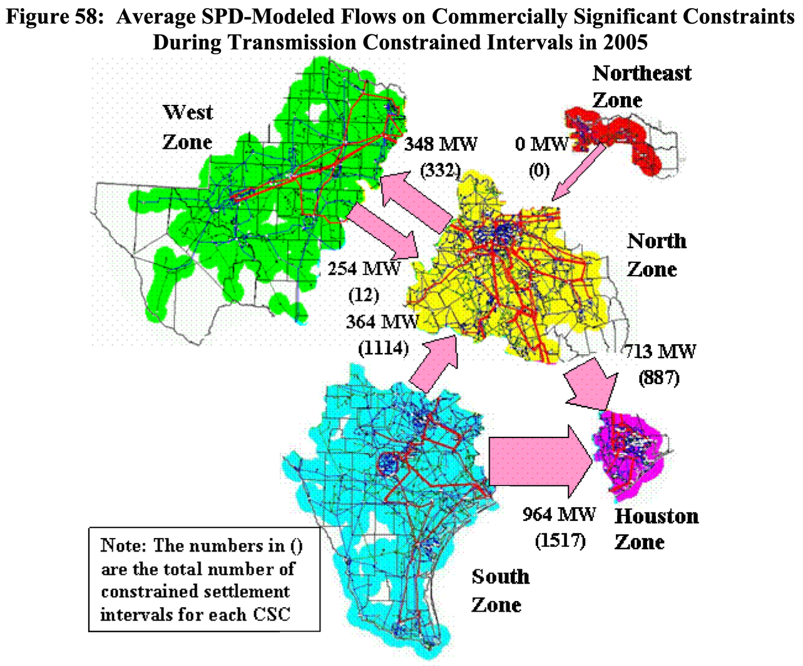
Figure 8: Illustration Commercially Significant Constraint Congestion in 2005
Taken together, these two contemporaneous reports from 2005, illustrate that ERCOT has historically managed congestion in Real Time that was associated with voltage stability limits on an IROL, without ever seeking to deny the implementation of additional RASs outside of Houston that might result in additional low cost generation trying to flow into Houston over the South to Houston CSC or North to Houston CSCs that were both IROLs and were often voltage stability limited. It is widely understood and supported by Market Participants that ERCOT needs to apply an appropriate amount of safety margin between their calculated interface transfer limits and the GTLs used in Operations, where stabily is the limiting factor, due to the imprecision of the inputs into these studies, as well as the potentially significant system consequences when the GTC is also an IROL. However, once this appropriate level of safety margin has been applied and limits set in the form of GTLs for a given GTC, it is economically inefficient, and inconsistent without historical practice, for ERCOT to seek to take additional steps in the form of denying upstream RASs that would economically allow more generation to attempt to flow on this GTC, even when it is an IROL.

Closing
For all the reasons outlined within, we believe that NOGRR215 is not narrowly tailored to address demonstrably new reliability issues and does not not preserve historic levels of reliable open access. As such, we believe that no changes are currently warranted to ERCOT’s binding documents (e.g. Protocols, Planning Guides, Operating Guides, etc.), so that historic levels of reliability and open access are preserved.

Revised Cover Page Language
None
Revised Proposed Guide Language
None

Current RAS count based of 7 based on the 1/5/2021 In-Service Remedial Action Scheme report from the ERCOT MIS.
Based on the RAS History slide (slide 8) from ERCOT’s NOGRR215 Overview presentation at the joint CMWG / OWG meeting on November 2, 2020.
The four RASs at Valley and four RASs at Monticello is based on ERCOT’s RAS History slide (slide 8) from their NOGRR215 Overview presentation at the joint CMWG / OWG meeting on November 2, 2020.
https://www.nerc.com/pa/RAPA/PA/Performance%20Analysis%20DL/NERC_SOR_2020.pdf
Current RAS count based of 6 based on the 1/5/2021 Approved Remedial Action Scheme report from the ERCOT MIS.
Source Data: ERCOT’s October 2020 Capacity Changes by Fuel Type report + Coal Plant data from the May 2020 CDR.
Refer to the Northeast ERCOT Congestion Study, which is a posted Key Document for the 10/2/2003 WMS Special Session at: http://www.ercot.com/calendar/2003/10/2/40684-WMS.
Refer to slide 13 of the Northeast CM SPS presentation, which is a posted Key Document for the 5/14/2004 Operations & Planning Review Group Meeting at: http://www.ercot.com/calendar/2004/5/12/40320-RPG.
https://www.puc.texas.gov/industry/electric/reports/ERCOT_annual_reports/2004annualreport.pdf, page 137 (emphasis added)
https://www.puc.texas.gov/industry/electric/reports/ERCOT_annual_reports/2005annualreport.pdf, page 116
https://www.puc.texas.gov/industry/electric/reports/ERCOT_annual_reports/2005annualreport.pdf, page 136
https://www.puc.texas.gov/industry/electric/reports/ERCOT_annual_reports/2012annualreport.pdf, page xi
https://www.puc.texas.gov/industry/electric/reports/ERCOT_annual_reports/2013annualreport.pdf, page xi
The list below is from slide 8 of ERCOT’s 11/2 NOGRR215 Overview presentation at the joint CMWG / OW, which listed the count of RASs by their component pieces at Monticello and Valley. This count is slightly different than the number of specific Oncor RASs for Monticello and Valley, since some of the RASs that Oncor submitted covered multiple elements; however, the number of protected elements represented is correct.
http://www.ercot.com/news/presentations/2005/ERCOT2005ReportOnConstraintsAndNeeds11012005.pdf, page 59 (emphasis added)
http://www.ercot.com/news/presentations/2005/ERCOT2005ReportOnConstraintsAndNeeds11012005.pdf, page 61 (emphasis added)
http://www.ercot.com/news/presentations/2005/ERCOT2005ReportOnConstraintsAndNeeds11012005.pdf, page 63 (emphasis added)

