 2705 West Lake Drive
Taylor, Texas 76574
(512) 248-6800
ercot.com

RESOURCE INTERCONNECTION HANDBOOK
Version 1.95

ERCOT
10/28/2025

This handbook is intended to provide a general description of ERCOT’s generator interconnection process for current and potential ERCOT Market Participants. This handbook is not a replacement for the ERCOT Protocols, Operating Guides, Planning Guide, or Other Binding Documents. In the event of any conflict, the ERCOT Protocols, Market Guides, and/or Other Binding Documents (OBDs) shall control.

Contents
Acronyms and Abbreviations 6
Resource Interconnection Handbook Purpose 7
Generation Interconnection Overview 7
Generation Interconnection Process Overview 9
STAGE 1 – Generation Interconnection Request Application to QSA 11
Generation Interconnection or Change Request Application and Fees 12
GIM (GINR) Applications for Multiple Technology Types 17
GIM (GINR) Applications for Multiple Project Phases or Long Commissioning 17
Lone Star Infrastructure Protection Act RFI 18
Security Screening Study 18
Full Interconnection Study (FIS) 18
FIS Scope Meeting 21
FIS Study Process 21
Subsynchronous Resonance Study (SSR) 21
Standard Generation Interconnection Agreement (SGIA) 22
Planning Guide section 6.9 22
Reactive Study Requirements 22
Compliance with Operational Standards Review 23
Quarterly Stability Assessment (QSA) 23
Small Generation Process: 25
STAGE 2 - Registration and Modeling 27
Registering as a Resource Entity 27
RIOO Resource Data Entry (Substation Data) 27
Network Modeling Requirements 29
ERCOT Polled-Settlement Meter and ESI ID Requirements 31
Telemetry and ICCP Requirements 31
STAGE 3: Energization, Synchronization and Commissioning 33
Final Compliance with Operational Standards 33
Background 33
ERCOT New Generator Commissioning Checklist 34
RIOO-IS Commissioning Planned Dates 34
Commissioning Plan Template 34
ERCOT 90-day expectation for the Commissioning Process of a Resource 35
Outage Scheduler 35
Commissioning Process 35
Checklist submittals and approval: 36
Additional Details on Commissioning Checklist Submissions 36
Base Point, Reactive Power Capability, VSS, AVR, PFR and PSS Testing 38
Base Point following during Curtailment – IRRs and IRR Groups 38
IRR Unit Curtailment Testing (Note: Use the following process for an individual IRR that is not in an IRR Group) 38
IRR Group Curtailment Testing (Note: The IRR Group is being curtailed at each step below; these are not individual unit curtailments) 39
Reactive Power Capability 40
Voltage Support Service (VSS) 40
Automatic Voltage Regulator (AVR) 41
Primary Frequency Response (PFR) 43
Power System Stabilizer (PSS) 43
Generator Status during the Commissioning Process - ONTEST, ON and OUT Status 43
Operation Requirement of Data Center Loads and/or PUN loads with IRR Generation 44
APPENDIX A: Helpful Resources and Links 45
APPENDIX B: LIST OF ERCOT FORMS FOR INTERCONNECTION PROCESS 46
APPENDIX C: NAMING CONVENTIONS 47
APPENDIX D: LARGE GEN TIMELINE 1 48
APPENDIX E: LARGE GEN TIMELINE 2 49
APPENDIX F: SMALL GEN TIMELINE 1 50
APPENDIX G: SMALL GEN TIMELINE 2 51
APPENDIX H: SMALL GEN PROCESS FLOWCHART (Zoom In for more details) 52
APPENDIX I: GIM (GINR) TABULAR TIMELINE: 53
APPENDIX J: FIS Review Checklist – dated 8/3/2020 54
APPENDIX K: Small Gen Review Checklist – Dated 1/22/2022: 60
APPENDIX L: Template for RE’s Wanting to Submit Model Information 66
APPENDIX M: REVISIONS 68
APPENDIX N: Resource Status Codes (ICCP Handbook 2020) 70

Acronyms and Abbreviations

Acronym | Definition
AVR | Automatic Voltage Regulator
CAMR | Collaborative Action Modeling Request
DESR | Distribution Energy Storage Resource
DGR | Distribution Generation Resource
ESI ID | Electric Service Identifier
FIS | Full Interconnection Study
GINR | Generation Interconnection or Change Request
GIM | Generation Interconnection or Modification
GIM Coordinator | ERCOT Resource Integration Analyst that creates the interconnection record.
IE | Interconnecting Entity
ME | Meter Engineering
NOIE | Non-Opt-In Entity
NOMCR | Network Operations Model Change Request
PFR | Primary Frequency Response
PLD | Production Load Date
PMCR | Planning Model Change Request
POI | Point of Interconnection
POIB | Point of Interconnection Bus
PSS | Power System Stabilizer
PUCT | Public Utility Commission of Texas
QSA | Quarterly Stability Assessment
QSE | Qualified Scheduling Entity
RARF | Resource Asset Registration Form
RE | Resource Entity
RI | ERCOT Resource Integration Department
RIOO-IS | Resource Interconnection and On-going Operations - Interconnection Services
RIOO-RS | Resource Interconnection and On-going Operations - Resource Services
SCADA | Supervisory Control and Data Acquisition
SCED | Security-Constrained Economic Dispatch
SGIA | Standard Generation Interconnection Agreement (commonly referred to as “IA”)
SSS | Security Screening Study
SSR | Subsynchronous Resonance
TSP/TDSP | Transmission and/or Distribution Service Provider

Resource Interconnection Handbook Purpose
The goal of the Resource Interconnection Handbook is to provide an overview of the process an Interconnecting Entity must follow when it is required to enter the Generation Interconnection or Modification (GIM) Process either to commission new generation to the ERCOT System or to modify existing generation connected to the ERCOT System as described in Planning Guide section 5.2.1. When revisions to this document are made by ERCOT, a market notice will be posted on the Market Information System and the updated document will be posted to the ERCOT website.
Link to the Resource Integration Page: https://www.ercot.com/services/rq/integration.

Generation Interconnection Overview
All entities that own generation connected to the ERCOT System at or above 1 MW must be registered as a Resource Entity (RE). The RE must register each generator through the ERCOT registration process by submitting the required data using the applicable resource registration process. The resource registration process incorporates electronic and manual processes to submit, validate, and approve the resource data that is used in planning, market and operations systems as defined in the ERCOT Protocols and Market Guides.
Connecting new or modified generation to the grid requires that QSEs, REs, IEs and TSPs provide ERCOT with accurate engineering models and telemetry of the new or modified generator and all associated transmission facilities as required for the Network Operations Model. Adding information to the ERCOT Network Operations Model is controlled by protocol 3.10. The registration and modeling process ensures that data submitted by equipment owners is accurately modeled and that communications between ERCOT systems and the new generator’s systems through the QSE are in place before the new or modified generation is commissioned.
During the interconnection process, the ERCOT Resource Integration department is the primary contact for an Interconnecting Entity (IE). ERCOT Resource Integration is responsible for tracking each generator through the stages of the interconnection process and facilitating interactions between ERCOT, TSPs and REs as well as resolution of any issues that may arise. Each RE is assigned an Account Manager upon registration as a Market Participant who serves as its primary contact for operational interactions with ERCOT after commissioning. Account Managers will guide each RE through its preparations for market operations while the IE completes the interconnection process as the generator is energized, synchronized, and approved as ready to be commissioned for participation in the ERCOT market.
ERCOT will work with the IE to establish the Production Load Date (PLD) which is based on the Initial Energization date of the Point of Interconnection (POI) and the Initial Synchronization date of the generator. The energization date of the POI needs to be coordinated with the TSP’s PLD for their side of the POI to allow time to resolve issues with telemetry or other operational issues before synchronization. The POI must be a new or existing station with breakers (no hard taps) capable of interrupting fault current to sectionalize the transmission lines connecting the station to the rest of the ERCOT System. The POI must also be connected to the ERCOT System where there are breakers and not, for example, connected to an existing line that is tapped off another transmission line.
ERCOT recommends that the potential RE register as a Market Participant at least 140 days prior to the date that the new or modified generator is to be added to the Network Operations Model (PLD). The Resource Entity should also complete the fields required for full registration in RIOO-IS Substation Details for the Network Operations Model at least 120 days prior to the desired Production Load Date (PLD) and inform ERCOT that it had been submitted to allow time for revisions to help ensure being able to meet the submittal date for the PLD shown in Protocol 3.10.1.

Generation Interconnection Process Overview
The generation interconnection process described in this handbook has been divided into the following three stages for the purpose of defining the interactions between the developer/owner of the generation resource, ERCOT and TSPs:

Stage 1: Interconnection Request Application to Quarterly Stability Assessment
Stage 2: Registration and Modeling
Stage 3: Energization, Synchronization and Commissioning
Figure 1: Generation Resource Interconnection Process Flow
3. Energization, Synchronization & Commissioning

GINR Application and Fees
Security Screening Study
Full Interconnection Studies
Subsynchronous Resonance Screening
Standard Gen. Interconnection Agreement
Resource Integration and On-Going Operations data submittal
Compliance with Operational Standards
Reactive Study
Quarterly Stability Assessments

RE Registration
Resource Integration and On-Going Operations data submittal
ERCOT Polled-Settlement Meters and ESI ID Requirements
Telemetry and ICCP Requirements

TSP: 1: Request to Energize POI
Commissioning Plan Template
New Generator Commissioning Checklist
1: Request to Energize
2: Request for Initial Synchronization
3: Request to Commission a Resource
Reactive Capability & Performance
Resource Status during Testing
Final Compliance with Operational Standards review

1. Interconnection Request Application to QSA

2. Registration and Modeling

In Stage 1, the IE submits a GIM application to ERCOT for any generation that meets the applicability requirements in section 5.2.1 of the ERCOT Planning Guides using RIOO-IS. ERCOT will review the RIOO submittal and accept or return the application within 10 business days after which the status of the GIM will change to “In Progress” or ”Planned” (See Table 1, the IE will see the status of “In Progress” while ERCOT will see the status of “Planned”). ERCOT will conduct a Security Screening Study (SSS) to evaluate the proposed generator’s effect on the ERCOT transmission system. ERCOT will post the SSS to the RIOO system upon completion. Prior to or no later than 180 days after completion of the SSS, the IE will submit a RIOO change request to attach the Proof of Site Control and enter the Energization, Sychronization, and Commercial Operations Date along with the required data in Substation Details to initiate the Full Interconnection Study process that is performed by the TSP owning the POI facilities. The IE shall inform ERCOT by email when the data required for the FIS has been submitted. If the IE does not request the FIS within 180 days of the date ERCOT notifies the IE of the Security Screening Study results, the GIM (GINR) application will be considered withdrawn by the IE and cancelled by ERCOT.
Once all FIS studies are completed, a Standard Generation Interconnection Agreement must be executed with the TSP within 180 days for the GIM to continue. Failure to meet this requirement will result in cancellation of the GIM by ERCOT. Upon completion of the SGIA, generation data required by the Resource Registration Glossary – Planning Model column shall be supplied by the IE to ERCOT using RIOO-IS. The IE shall provide to the TSP the Notice to Proceed with construction and the full financial security required to fund the interconnection and the TSP will provide these dates in RIOO-IS. The IE must also provide the Department of Defense Notification attestation in RIOO-IS. ERCOT then models the new generation in planning base cases built by the Steady State Working Group (SSWG) once it meets Planning Guide section 6.9.
Once the Interconnecting Entity meets Planning Guide section 6.9, ERCOT performs a Compliance with Operational Standards review in accordance with Protocol 16.5 (3) to determine if the generator can fully comply with ERCOT Operating Standards based on the submitted FIS, SGIA and resource data. The Quarterly Stability Assessment is used to assess the stability impact of the proposed resource alongside other resources that are synchronizing in the same quarter and determine if mitigation plans are needed before the generator is allowed to synchronize to the ERCOT system.
In Stage 2, the Resource Entity registers as a Market Participant with ERCOT. Once registered, the Resource Entity is responsible for registering the generator by submitting the resource data required by the Resource Registration Glossary – Full Registration column in RIOO-IS. ERCOT models the new generator in the Network Operations Model from the resource data supplied to reflect the addition of the new generation and related facilities. The RE will need to coordinate with the TSP to make sure the TSP facilities are also modeled for the same PLD.
ERCOT will also review the proposed telemetry points list required to establish real-time communication and control between ERCOT and the QSE. ERCOT works directly with the TSPs and REs to establish the necessary ERCOT Polled Settlement (EPS) meter communication points which allows gathering of 15-minute data for settlements.
In Stage 3, ERCOT reviews the generator’s Commissioning Plan Template, and approves the following 3 checklist parts described in the New Generator Commissioning Checklist:
- Part 1: Request to Energize
- Part 2: Request for Initial Synchronization (or Parts 2a and 2b for WGR’s meeting applicability of Planning Guide section 5.2.1(1)(c)(ii).
- Part 3: Request to Commission a Resource
For the generator to be commissioned and approved for participation in ERCOT market operations, it must demonstrate that it can satisfy ERCOT’s requirements for Reactive Power (both leading and lagging), Automatic Voltage Regulator (AVR), Primary Frequency Response (PFR), Power System Stabilizer (PSS), and follow SCED instructions as applicable to the generation type and registration.
See the Normal and Fast timelines in appendices D and E.
IE sign up guide: https://www.ercot.com/files/docs/2022/01/14/IE-SignUp-Guide-for-RIOO-Services.pdf
RE sign up guide: https://www.ercot.com/files/docs/2022/01/14/RE-SignUp-Guide-for-RIOO-Services.pdf
TDSP sign up guide: https://www.ercot.com/files/docs/2022/01/14/TSP-Sign-Up-for-RIOO-Services.pdf
Managing your RIOO account: https://www.ercot.com/files/docs/2022/01/14/Managing-Your-RIOO-Services-User-Account.pdf

STAGE 1 – Generation Interconnection Request Application to QSA
Examples of Applicability (Planning Guide Section 5): 1 - 9.99 MW is Small Gen, 10+ MW is Large Gen.
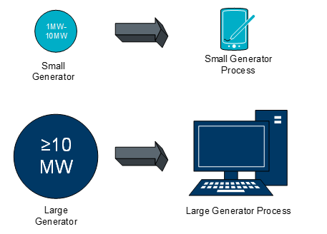
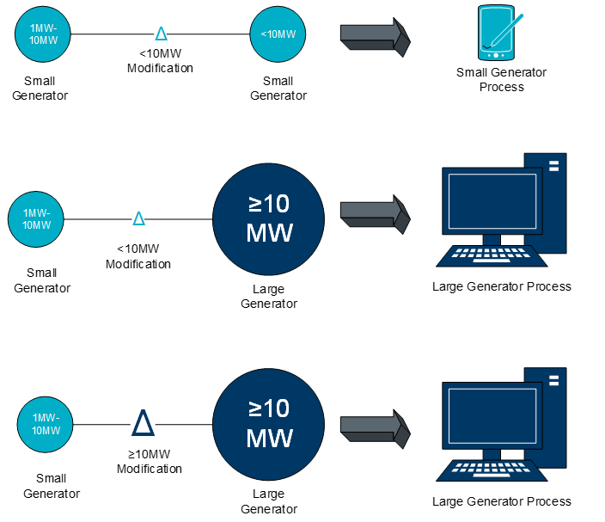
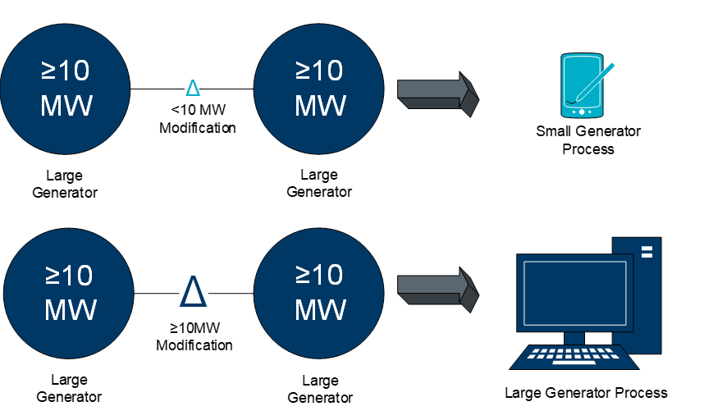

Generation Interconnection or Change Request Application and Fees
All IEs seeking to interconnect new generation or modify existing generation connected to the ERCOT system 1 MW or greater in accordance with Planning Guide section 5.2.1 are required to follow the Generation Interconnection or Modification (GIM) process.
To begin the GIM process and initiate the Security Screening Study or a simultaneous Security Screening Study and Full Interconnect Study, IEs must initiate an application using the RIOO-IS system. Information on RIOO-IS access and use can be found on-line as shown with the numbered icons below.
- Figure 1 shows how to launch the RIOO-IS application. Best browser to use is Chrome.
- Figure 2 shows Related content to help IEs and TSPs sign-up to create an account and to use the application with user guides specific to IEs and TSPs. Note that TSPs must follow the RIOO-IS TSP Sign-Up Reference very carefully to create a TSP account which will allow them to see all GIM (GINR)s.
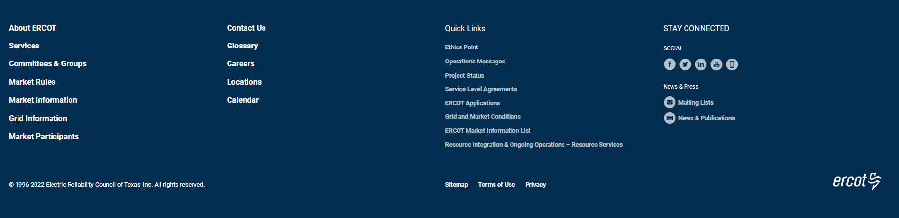
1
Figure 1 ERCOT.com bottom of page link to launch RIOO-IS
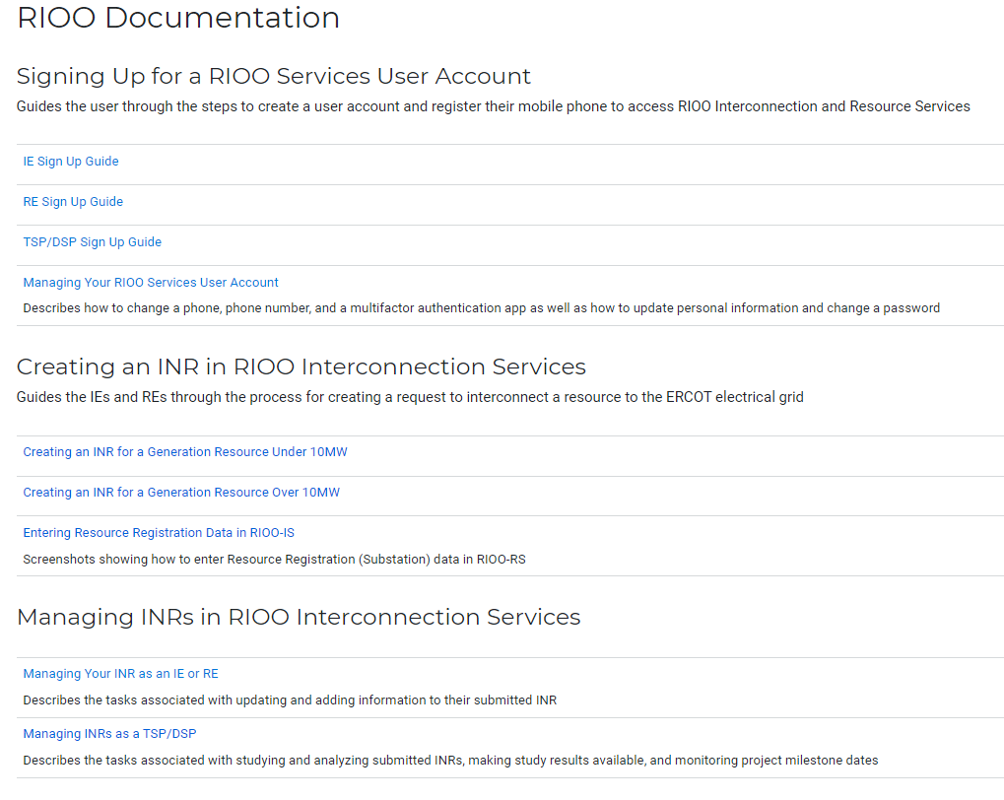
2
Figure 2: Resource Integration page for related content to help IE’s and TSP’s
IEs should see a page like that below if they have signed up correctly. Note the “Start New INR Request” button in the top right. TSPs should not see this button and if they do, they should submit an ERCOT Helpdesk ticket to remove their Auth0 account. The “Start New INR Request” button is a drop down with a choice to start as either an IE or a RE. Load Resources need to start as a RE, as should Small Generation projects because they will need to submit a full registration RARF right away.

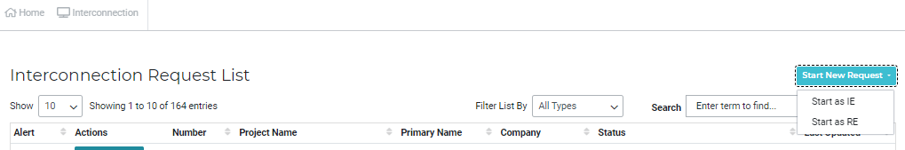

Figure 3: IE RIOO page after signing in
After clicking the “Start New INR Request” button, IEs should see the following screen showing the action items to choose the size and whether the connection will be transmission or distribution.
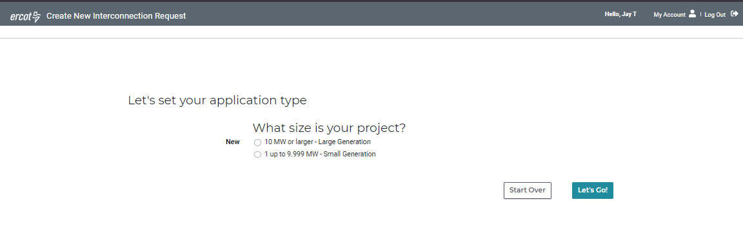
Figure 4: The IE screen to start an INR. Choose the size of your project
RE’s will see a similar screen, but first will have to select the company that they want to use to create the INR if more than one company is listed. For a company to be listed, a RE will need to have the role RIOORS_M_OPERATOR listed in their MPIM for the companies DUNS number. Contact your USA to have that role added.
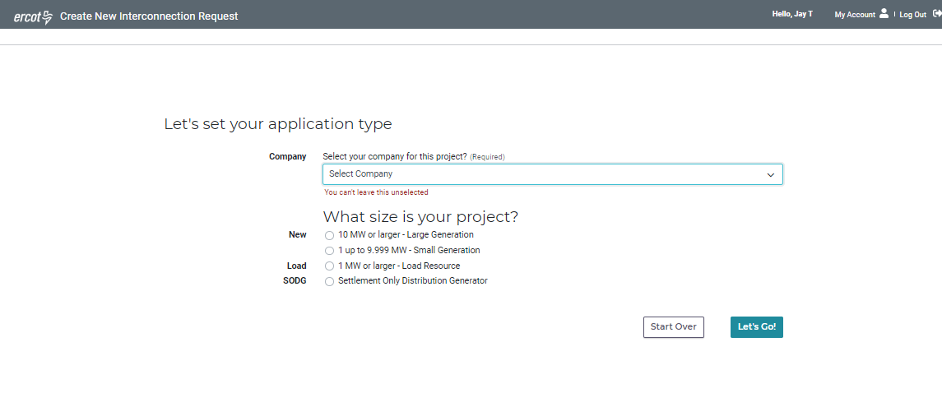
Figure 5 The RE screen to start an INR, select the company from the drop down and choose the size of your project
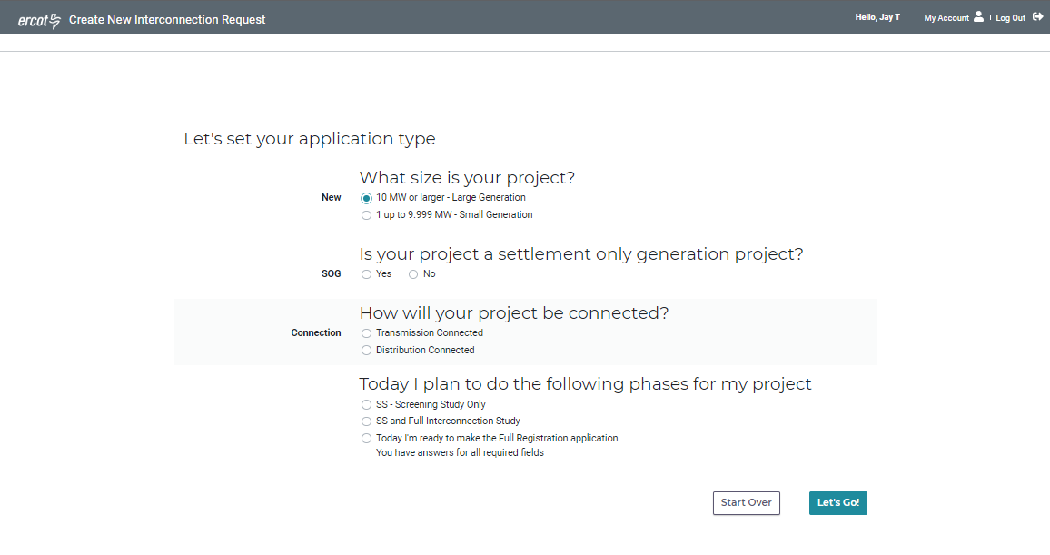

Figure 6 Once the size is chosen, new options appear
From the initial GIM (GINR) application submittal until the IE is assigned a Resource Integration (RI) Engineer, IEs should direct questions about the generator interconnection or change process itself or primary contact changes to ResourceIntegrationDepartment@ercot.com. RIOO-IS access issues should be submitted to the ERCOT Helpdesk or RIOO-HELP@ercot.com.
When an ERCOT RI Engineer is assigned to the GIM (GINR) application, the RI Engineer will notify the IE with their contact information and inform them that they will oversee their interconnection application and be available to answer questions.
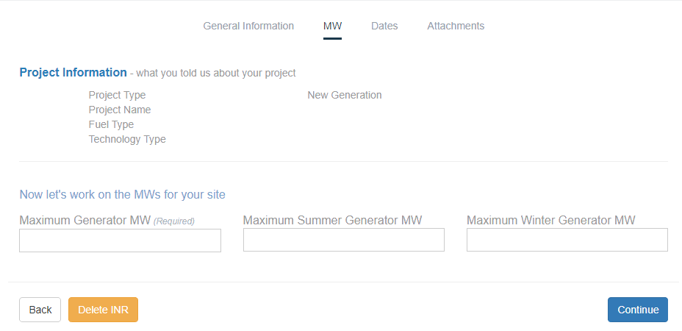
Figure 7 MW Size Entry
The MW values entered into the Maximum Generator MW, Maximum Summer Generator MW, and Maximum Winter Generator MW in the RIOO-IS screen above should be the MW value at the generator terminals as modeled in the ERCOT Network Operations Model (typically 34.5 kV bus for IRRs and IBRs), not the Point of Interconnection Bus. For projects meeting PG 5.2.1(1)(c)(ii), the Maximum and Maximum Summer Generator MW are the same (except for thermal units) and the Maximum Winter Generator MW is set to the delta MW value caused by the changes being done in the project.
ERCOT will notify the IE within 10 Business days if any part of the application requirements are not complete or the appropriate fee was not submitted. ERCOT will immediately contact the IE if more information is needed, and the IE will have 10 Business Days to respond without impacting the timeline. If the IE does not respond within 10 Business Days, ERCOT shall notify the IE that the request has been deemed incomplete and rejected.
When the application is deemed complete, ERCOT will change the status of the completed GIM (GINR) application within 10 Business Days to “In progress”/”Planned”. The IE will see the status of “In Progress”, while ERCOT will see the status of “Planned”. Other statuses are shown in the table below:
(Changed from new) - is in the status of new until ERCOT coordinator moves it to incomplete.
- – with a credit card and we have automatic confirmed payment
- – is manually reconciled by the coordinator. The coordinator will have access to the banking system and can move the INR to incomplete when the check clears.
– this is an ERCOT internal status when in this status we display to the IE the following labels instead:
- on Your INR Request – when ERCOT requested a change from the IE using the toggle button in the ERCOT information section of the INR review
- Submitted to ERCOT– otherwise it says submitted during ERCOT review of paperwork
– stays in planned until it is commissioned, canceled, or suspended during a sale. We display labels to the IE user of:
- - when no CR is in progress has the label of in progress.
- – when there is a CR in progress will go back to planned when the CR is resolved by either an IE cancel or ERCOT or IE merge.
- – waiting for check to clear for ERCOT Stability Modeling Fee. – the IE as requested an FIS and paid by check
- – when ercot has responded to the IE that not all of their changes were excepted, the IE user can either acknowledge or cancel the feedback from ercot.
– the IE has sent in a CR for change of owner, the system has automatically updated the status to suspend. The label that is displayed to the IE is
- – displayed until the IE send in a CR with a new RARF, ercot will manually move the status from suspended to planned.
– is displayed when an INR is canceled
– is displayed when ercot changes the status to operational.

GIM (GINR) Status | Saved – is set to Saved until the IE submits it to ERCOT  Submitted (changed from new) - is in the status of new until ERCOT coordinator moves it to incomplete. The IE will see the status of:  - INR Submitted to ERCOT – with a credit card and we have automatic confirmed payment  - INR Submitted to ERCOT - waiting for check to clear – is manually reconciled by the coordinator. The coordinator will have access to the banking system and can move the INR to incomplete when the check clears.  Incomplete – this is an ERCOT internal status when in this status we display to the IE the following labels instead:  - Updates Needed on Your INR Request – when ERCOT requested a change from the IE using the toggle button in the ERCOT information section of the INR review  - INR Submitted to ERCOT– otherwise it says submitted during ERCOT review of paperwork  Planned – stays in planned until it is commissioned, canceled, or suspended during a sale. The IE will see:  - In Progress - when no CR is in progress has the label of in progress.  - Change Request Submitted to ERCOT – when there is a CR in progress will go back to planned when the CR is resolved by either an IE cancel or ERCOT or IE merge.  - Change Request Submitted to ERCOT – waiting for check to clear for ERCOT Stability Modeling Fee. – the IE as requested an FIS and paid by check  - Review ERCOT Feedback – when ERCOT has responded to the IE that not all their changes were accepted, the IE user can either acknowledge or cancel the feedback from ERCOT.  Suspended (also used for “Inactive”) – the IE has sent in a CR for change of owner or have requested the project be put in Inactive status, the system has automatically updated the status to suspended. The label that is displayed to the IE is  - Suspended for Ownership Determination – displayed until the IE send in a CR with a new RARF, ERCOT will manually move the status from suspended to planned.  - (Temporary) Used to denote “INACTIVE” status but IE will still see “Suspended for Ownership Determination”. The project is Inactive.  Canceled – is displayed when an INR is canceled  Operational – is displayed when ERCOT changes the status to operational.
Table 1: ERCOT/IE Status Mapping

GIM (GINR) Applications for Multiple Technology Types
Separate GIM applications should be submitted for each technology type in the interconnection request. For example, if an interconnection request includes solar and battery facilities, two GIM applications should be submitted. ERCOT and the interconnecting TSP will hold a single FIS kickoff meeting for both INR numbers and the IE and the TSP may sign a single SGIA referring to both INR numbers. Both GIMs will be included in the SSS and FIS.

GIM (GINR) Applications for Multiple Project Phases or Long Commissioning
A separate GIM application should be submitted for Projects being built in phases or over a long period of time. ERCOT desires the time between Initial Synchronization and Resource Commissioning Date to be 120 days or less. Projects requiring more time should be split into separate GIM’s as soon as it is first known.
For projects requiring multiple INR numbers, the IE must ensure that each of the modeled generator’s capacity at a given point in time is completely contained in a single INR number. It is expected that all modeled generators whose capacity is included in the same INR number must all be approved for Resource Commissioning (Part 3) on the same day.

Lone Star Infrastructure Protection Act RFI
During the initial application stage for both Small and Large generation, the following screen will appear. The blue text concerning the Lone Star Infrastructure Protection Act can be ignored as an attestation will have to be e-signed later in the process before payment.
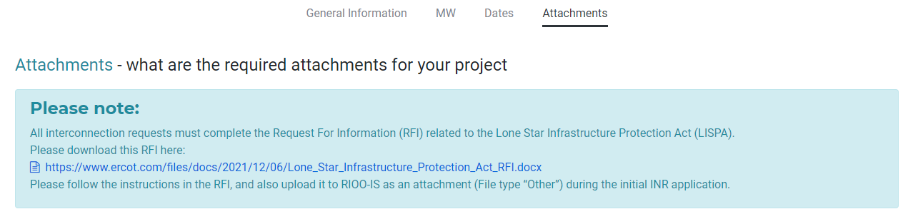
Figure 8: The text in the blue box can be ignored concerning the Lone Star Infrastructure Protection Act Screen

Security Screening Study
For each GIM request submitted, ERCOT will conduct a high-level, steady-state Security Screening Study (SSS), including power-flow and transfer studies, based on the proposed Commercial Operation Date (COD) and a single Point of Interconnection (POI). The main purpose of the study is to provide an indication of the level at which the proposed generation can expect to operate simultaneously with other known generation in the area before significant transmission additions or enhancements may be required.
ERCOT is allowed 90 days to perform the Screening Study. During this time, ERCOT will contact the IE if additional information is needed, and the IE will have 10 Business Days to respond without impacting the study timeline.
During the Security Screening Study, ERCOT may consult with affected TSPs to identify the most efficient means of providing transmission service. The TSP may suggest an alternate POI which will be allowed and not force the IE to submit another GIM.
Upon completion of the Security Screening Study, ERCOT will share the report with the IE using the RIOO-IS system. The report shall indicate study assumptions, transfer analysis results, and whether a SSR study is required. See below for more information on SSR.
When a GIM is “Cancelled” by ERCOT or “Withdrawn” by the IE, if the IE desires to proceed with the project at a later date, they must submit a new GIM application. The IE may use INACTIVE status to gain time once the FIS has been completed.

Full Interconnection Study (FIS)
Within 180 days of the date ERCOT notifies the IE of the SSS results, the IE must begin the FIS Request process to indicate its desire to pursue a Full Interconnection Study, or the GIM will be cancelled. This is done by:
- Submitting a change request on the RIOO-IS system to add the
  - Energization date
  - Synchronization date
  - Attach the proof of site control
  - If a MW size change is desired, change the MW size of your project and wait for this CR to be approved before proceeding to step 2.
- Entering the required resource data required for the FIS Proof of Site Control and resource data with data required by the Resource Registration Glossary – Full Interconnect Study (FIS)
After accepting the change request containing the proof of site control attachment and reviewing the resource data submitted by the IE, ERCOT will check the submissions and approve the FIS Application. When the FIS Application is approved, RIOO-IS will generate an email to the Lead TSP to begin initiation and coordination of the FIS Kick-off meeting.
IMPORTANT: If you plan to reduce or increase the MW size of your project, it must be done before entry of Resource data for the FIS. Change the MW size with the CR to change the dates and add proof of site control. Payment will not reflect the new size if this CR is not submitted and approved by ERCOT.
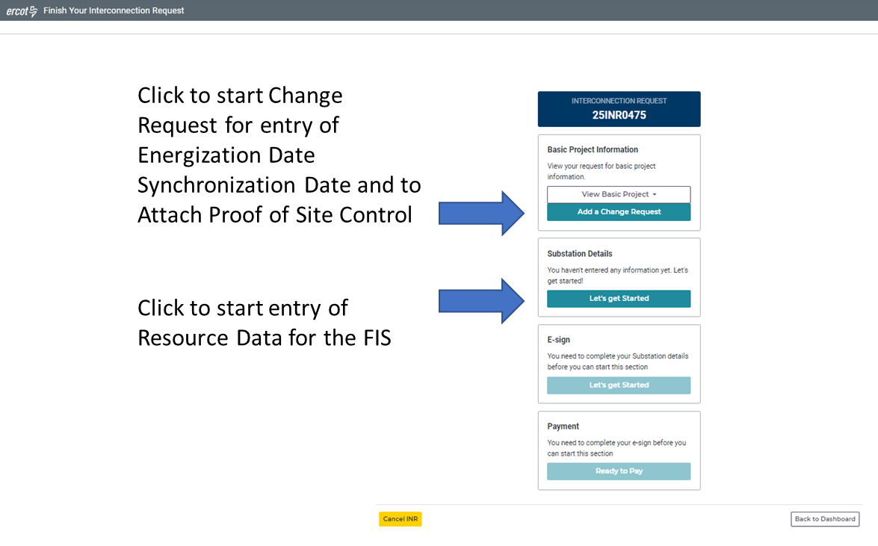
Figure 9: To request a FIS study, click “Add a Change Request” in the Basic Project Information block to enter the Energization and Synchronization dates and attach the proof of site control. The resource data also needs to be added by clicking the “Let’s get Started” button in the Substation Details block.
The IE can begin the FIS Request by entering data for only the Steady State study, Short Circuit study, or the Stability and Dynamics study or any combination of the three studies. RIOO will then indicate each data field that is required for the chosen Level of Commitment (LOC).
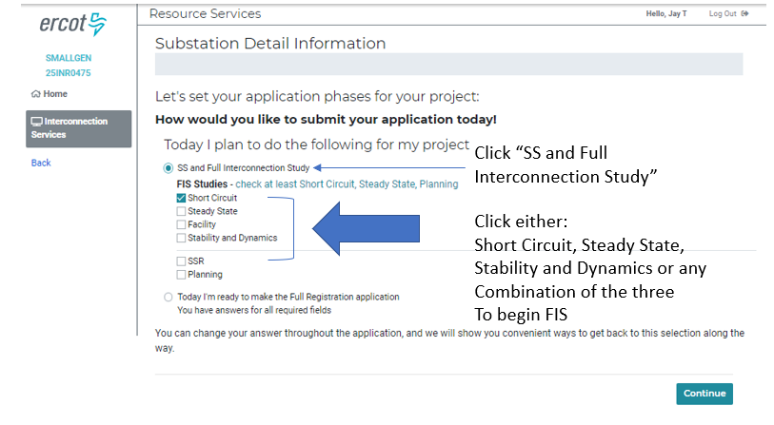
Figure 10 RIOO screen to select Level of Comittment
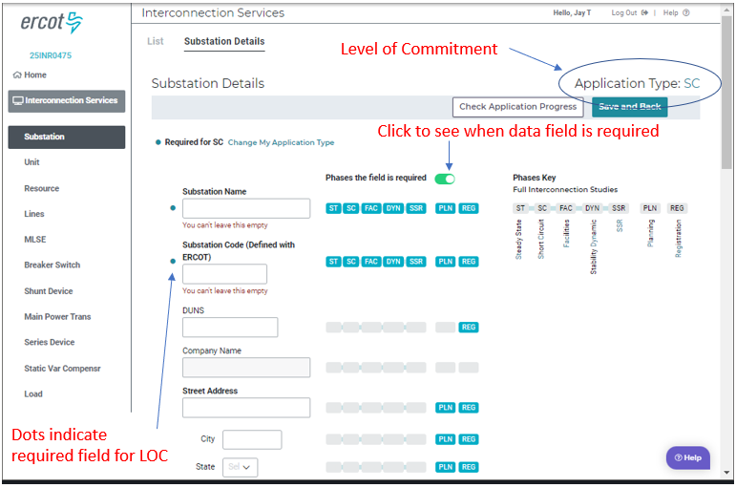
Figure 11 RIOO Screen showing the data fields required for the chosen level of comittment
The IE will pay FIS fees to both ERCOT using RIOO-IS, as specified in the ERCOT Fee Schedule, and to the TSP performing the studies in accordance with an agreement with the TSP. Fees paid to the TSP should be agreed on and specified in the FIS Scope Agreement. ERCOT is not a party to the FIS Scope Agreement.
As discussed in Section 5 of the Planning Guide, the FIS process consists of a set of steady-state, dynamic, short-circuit, and facility studies. The FIS studies are not intended to ensure the deliverability of power from the proposed generation to the market or to ensure that the proposed generation does not experience any congestion-related curtailments in real-time.
Because the FIS is generally the critical path item in the GIM process with no defined length to complete, ERCOT recommends that a timetable for the FIS be developed and included in the FIS study scope agreement.
See Planning Guide section 5.3.2, Full Interconnection Study Request, for more information regarding the FIS.

FIS Scope Meeting
Within 10 Business Days of receiving the RIOO-IS data required to proceed with the FIS from the IE, ERCOT will designate the lead TSP for the FIS. The selection of the lead TSP will be based upon a preliminary analysis of the most likely Point of Interconnection (POI). The lead TSP will then arrange a FIS kick-off meeting with ERCOT, the IE and other TSPs desiring to participate in the study. During the meeting, the IE will discuss the GIM application and the TSP will discuss the overall scope, timetable of activities, studies being performed, anticipated facilities needed, etc. ERCOT will discuss the Security Screening Study results.
The date of the FIS kick-off meeting starts the 60-calendar day clock within which the IE and TSP should reach an agreement on the FIS scope. ERCOT will attempt to mediate if an agreement cannot be reached within that period. After the 60-day period, if no agreement is reached, the GIM may be terminated.

FIS Study Process
Based on the overall scope established during the FIS kick-off meeting, the lead TSP shall use the data provided by ERCOT and the IE to develop and study the existing and future ERCOT system to determine the generator’s reliability impact at the proposed POI. The TSP(s) will examine normal transmission operating conditions as well as potentially adverse, or contingency, conditions.
In comparing interconnection alternatives, the TSP(s) will consider such information as interconnection cost and construction schedule, impact to short and long-range reliability, operational flexibility, and compatibility with future transmission plans. The TSP(s) may also consider interconnection alternatives not suggested by the IE or ERCOT. ERCOT will perform an independent Economic Study for informational purposes if the TSP determines in the facility study that the estimated transmission interconnection costs could exceed $25 million dollars.
Following the completion and review of the FIS studies by the TSPs and approval by ERCOT, the report will be deemed complete, and the IE and TSP may execute a SGIA.

Subsynchronous Resonance Study (SSR)
The ERCOT Protocols section 3.22 contains detailed definitions and information pertaining to the Subsynchronous Resonance, countermeasure, protection, mitigation, etc. terminology used in this section.
If ERCOT determines during the Security Screening Study topology-check that the generator may be vulnerable to SSR, the lead TSP shall be notified that a SSR study is required. The SSR study scope will be shared between ERCOT, TSPs and the IE and discussed during the FIS kick-off meeting, but the study itself is not part of the FIS.
ERCOT will review the SSR study for approval. If the study results determine that the Resource is vulnerable to SSR, the IE shall be responsible for either installing the appropriate SSR countermeasures or developing a SSR Mitigation Plan. The ERCOT-approved SSR Protection scheme or Mitigation Plan must be installed and operational prior to Initial Synchronization.

Standard Generation Interconnection Agreement (SGIA)
Should the IE decide to proceed with the construction and completion of the proposed generation project, they shall execute a SGIA with the respective TSP. ERCOT is not a party to the agreement.
The SGIA must be signed by all parties within 180 days following the completion of the FIS or, following notification by ERCOT, the GIM will be cancelled unless the IE requests and is granted an exception before expiration of the 180 days. The exception will require that work has begun on the IA by both the IE and TSP and is confirmed by email by the TSP.
In certain situations, the IE and the TSP may agree to allow the TSP to begin design or construction of facilities prior to the execution of the SGIA, or to allow the IE to delay issuing a Notice to Proceed until sometime after the SGIA is signed.

Planning Guide section 6.9
Meeting the requirements of Planning Guide section 6.9 is an important milestone in the GIM process. It is required to qualify for entry in the Quarterly Stability Assessment (QSA) and for submittal into the Network Operations Model. It is also required to begin the Protocol section 16.5 Compliance with Operational Standards Review which will be reviewed prior to Initial Synchronization of the generator. Generator’s designated as a small generator need to meet P.G. 6.9(3).

Reactive Study Requirements
The Interconnecting Entity is required to submit to ERCOT a reactive study that provides an engineering analysis of the reactive capability of the proposed interconnected generation facilities. This study shall include the list of equipment and systems that are to be installed to meet ERCOT reactive support requirements. It is recommended that the Interconnecting Entity incorporate in their project plan at least one month for ERCOT to review and approve the study with consideration for lead-time necessary for procurement of associated equipment. New generation facilities adding reactive equipment, in addition to the generation’s reactive capability specified in the ERCOT approved reactive study, shall have the reactive equipment installed in the field and ready to be placed in service at the time of Initial Synchronization. Protocol Section 3.15 Voltage Support provides more information about reactive requirements.
The Reactive Study is a requirement for the Quarterly Stability Assessment (QSA).

Compliance with Operational Standards Review
After the SGIA is signed and Planning Guide section 6.9 is met, ERCOT will begin the Protocol section 16.5 (3) review and assess whether the proposed generator would violate any operational standards as established in the Protocols, Operating Guides, Market Guides or Other Binding Documents.
ERCOT has 90-days from the date that PG 6.9 was met to complete its review and provide the IE a written determination of whether the proposed system design complies with the operational standards.
If, based on the information contained in the FIS, IA, RARF and other submitted data, ERCOT determines that the Resource does not meet, or cannot determine whether the Resource will meet, the operational standards, ERCOT will provide a written document to the IE explaining the determination. Additional data may have to be provided to ERCOT by updating the RARF or other required studies or documents. Final determination of compliance with operational standards will occur during the Stage 3 process and is needed prior to synchronization.

Quarterly Stability Assessment (QSA)
ERCOT conducts a stability assessment every three months to assess the impact of planned new or modified generation proposing to synchronize to the ERCOT System five to seven months in the future as shown in PG 5.3.5, ERCOT Quarterly Stability Assessment, and repeated in the table below. The QSA assesses the impact of proposed generation and determines if mitigation plans are required before the generator can synchronize to the ERCOT grid.
Generation not included in the quarter shown in the Initial Synchronization Quarter column in the table below will not be eligible for Initial Synchronization during that three-month period:
Generation Resource Initial Synchronization Quarter | Last Day for an IE to meet prerequisites as listed below | Completion of Quarterly Stability Assessment
Upcoming January, February, March | Prior August 1 | End of October
Upcoming April, May, June | Prior November 1 | End of January
Upcoming July, August, September | Prior February 1 | End of April
Upcoming October, November, December | Prior May 1 | End of July
The IE must have met the following requirements before being allowed to synchronize new or modified generation:
- Completed the requirements of Planning Guide Section 6.9, Addition of Proposed Generation to the Planning Models.
- Completed the following:
- FIS studies;
- Reactive Power Study;
- SSR study if required;
- System improvements or mitigation plans that were identified in studies
- Initial Compliance with Operational Standards review.
The summary results of the Quarterly Assessment will be posted to the MIS within ten days of completion. Please refer to Planning Guide section 5.3.5 for detailed information pertaining to the QSA process.

Small Generation Process:
The Small Generation process is governed by Planning Guide Section 5.4.
A flow chart with more details of the Small Generation process flow is in Appendix H. An example of the Small Gen Checklist is in Appendix K.
RIOO-IS Small Generation Initial Application Checks:
- One-line diagram (Need the Load Transformer name on the One-Line)
- Valid Load/Load Transformer information in RIOO-IS
- Site Photos, .kmz files, and/or Maps
- Proof of Site Control
- Signed Declaration of Department of Defense (DOD) Notification
- Payment for Small Gen application
Small Generator Review Meetings.
These meetings are optional but are HIGHLY RECOMMENDED for new IEs or for an IE submitting a Small Generation application for the first time. The IE must request these meetings for any Small Generator interconnection request if they desire a meeting. (These are optional as per Planning Guide Section 5.4.1)
Small Gen Application Information (Planning Guide 5.4):
In addition to the above items, the following items / studies are required to submit the full Registration Level RARF in accordance with PG 5.4.3, Review and Approval to Submit Model Information. Please coordinate with your TDSP:
- Initial RARF – Uploaded to RIOO by IE/RE (See the RARF Glossary for all required fields and data for Registration purposes)
- Include the TDSP Station Name and Code for the Resource Site Name/Code in the General Site ESIID Form. (Resource Site/Station Code must be 8 digits)
- Inverter and Technology data sheets and specs embedded to Gen Form – Dynamic Data tab
- All Operation Limitations should be reflected in Gen Form – Operation Limitation tab
- Only the Station tab information is required in the Transmission Form. One-Line and Transformer Test Report tabs are still used.
- Include Load Resource Form
- System Impact Study – Conducted by TDSP (Operating Guide Section 2.9 [VRT], Operating Guide Section 2.6 and 2.9 [FRT and VRT] and Planning Guide Section 5.4.2)
- Voltage Ride through (VRT)
- Frequency Ride through (FRT)
- Over/Under Frequency relaying
- Primary Frequency Response
- DGR/DESR limitations (Min/Max MW charge/discharge and ramp rates limits)
- Confirmation that TDSP’s system will not preclude compliance with ERCOT’s requirements
- Operation Limitations to the DGR/DESR (If any) – Provided by TDSP via a Change Request in RIOO-IS (Planning Guide Section 5.4.2)
- Confirmation that this DGR/DESR will not be a part of a Load Shedding scheme. Line cannot be subject to a manual or automatic disconnection by the DSP, TSP, or TO as part of any under-frequency, under-voltage, or manual load shed scheme – Provided by TDSP via a Change Request in RIOO-IS (Protocol Section 3.8.6)
- Confirmation the IE / RE has provided financial security sufficient to fund the Required Distribution System Upgrades identified by the TDSP (if any) – provided by TDSP via a Change Request in RIOO-IS (Planning Guide Section 5.4.2)
- Fully Executed and Funded IA – Singed by TDSP and IE/RE, and submitted via a Change Request in RIOO-IS by the TDSP (Planning Guide Section 5)
- Financial security to fund system upgrades (if any)
- Notice to proceed
In order for ERCOT to approve the Registration level resource data in RIOO, all of these conditions described above must be met before ERCOT gives Approval to Submit Model Information. (Planning Guide Section 5.4.3).
Other Information and Links:
For more information regarding this process. Please see the attached presentations. Small Gen uses a System Impact Study. Here is some additional information that may help you with this process. Here are some links you should find useful for the specific rules associated with a DGR or DESR (Distribution Generation Resource or Distribution Energy Storage Resource).

Distributed Generation information: https://www.ercot.com/services/rq/re/dgresource/
To start an interconnection application please follow this link: https://sa.ercot.com/rioo-rs/
DGR and Impedance Calculations from a RIWG meeting: https://www.ercot.com/files/docs/2022/02/18/Resource_Integration_Working_Group_DGR_Topics_02222022.pptx
Resource Registration Glossary: https://www.ercot.com/mktrules/guides/resourcereg/library
DGR workshop 12: https://www.ercot.com/files/docs/2021/10/13/DGR_Workshop_12_.pptx
TDSP contacts: https://www.ercot.com/files/docs/2021/11/23/Market_Participant_List.xls

STAGE 2 - Registration and Modeling
Stage 2 of the Generation Interconnection Process involves the following steps:
- Registering as a Resource Entity
- Completing the Resource data entry in RIOO
- Network Modeling Requirements
- ERCOT Polled-Settlement Meters and ESI ID Requirements
- Telemetry and ICCP Requirements

Registering as a Resource Entity
With the completion of a signed SGIA, a Resource Entity (RE) that will own or control a generator in the ERCOT market must be registered. Power Generation Companies operating within Texas are also required to register with the Public Utility Commission of Texas in accordance with PUCT Substantive rules which may be found at http://www.puc.texas.gov/.
The ERCOT account manager assigned to each RE will assist the applicant with registering as a Resource Entity. Applicants are strongly encouraged to submit their applications at least 60 days in advance to allow sufficient time for review and processing. Processing times can vary depending on volume and application-specific factors. The process is comprised of the following key submissions which may be found at ercot.com on the Registration & Qualification webpages:
- Standard Form Market Participant Agreement
- Resource Entity (RE) Application for Registration
- Managed Capacity Declaration Form
- Attestation Regarding Market Participant Citizenship, Ownership, or Headquarters
- Reporting and Attestation Regarding Purchase of Critical Electric Grid Equipment (CEGE) and Critical Electric Grid Services (CEGS) from a Lone Star Infrastructure Protection Act (LSIPA) Designated Company or LSIPA Designated Country

RIOO Resource Data Entry (Substation Data)
RIOO now contains screens for the IE/RE to enter resource data for the generator and associated substation equipment information needed for ERCOT systems. The content of RIOO’s resource data screens are governed by the Resource Registration Glossary. RIOO shows the data fields that are required for the selected level of commitment as shown in Figure 11 above. RIOO allows the following levels of commitment:
- Full Interconnection Study (FIS) – either Steady State, Short Circuit, or Stability and Dynamic studies separately or any combination
- Planning Model
- Full Registration
The Resource Entity must complete the fields required for full registration in RIOO-IS Substation Details for the Network Operations Model 120 days prior to the desired Production Load Date (PLD) and inform ERCOT that it had been submitted to allow time for revisions to help ensure being able to meet the submittal date for the PLD shown in Protocol 3.10.1. For Full Registration, the desired Production Load Date deadlines can be found in Production Load Schedule.
Once a GIM has reached the PLD, data will move from RIOO-IS to RIOO-RS. From this point forward, the RE shall use RIOO-RS to submit changes to registration data.
Resource data for a Small Generator must use the simplified modeling approach. This means that the Unit is modeled at the TDSP Station as shown below.
Current DGR Modeling Topology Examples:

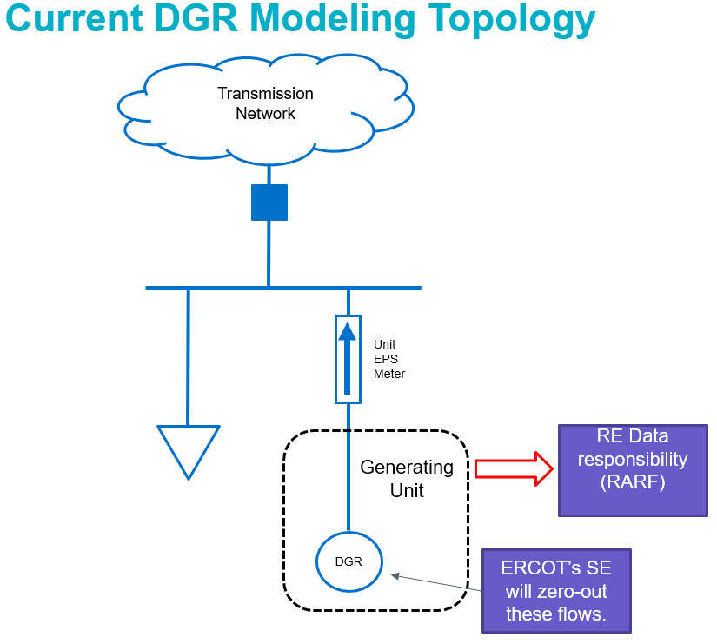
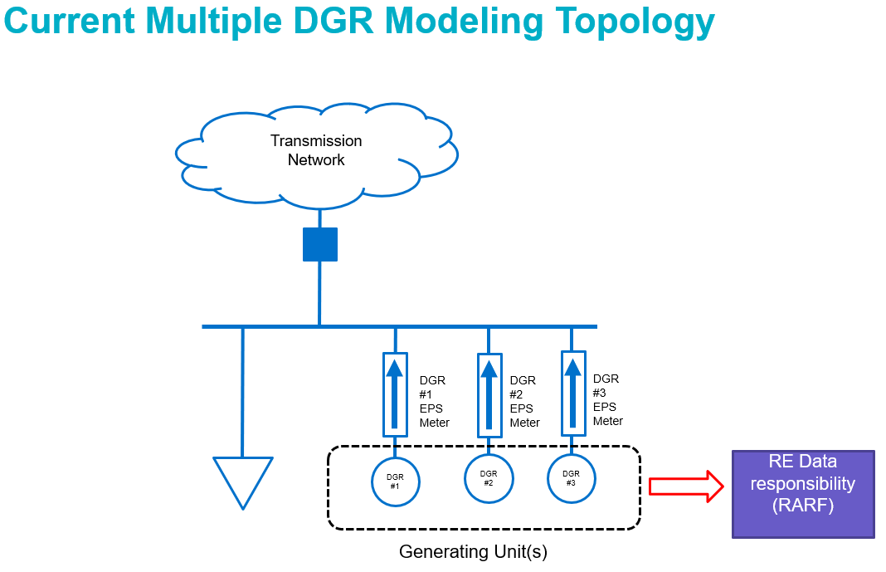

Network Modeling Requirements
The ERCOT Network Operations Model is defined as: A representation of the ERCOT System providing the complete physical network definition, characteristics, ratings, and operational limits of all elements of the ERCOT Transmission Grid and other information from TSPs, Resource Entities, and QSEs. ERCOT uses the physical characteristics, ratings, and operational limits provided by TSPs and REs to specify limits within which the ERCOT Transmission Grid will be operated. The Network Operations Model is the basis for the model used to send accurate Base Points and pricing signals to Market Participants. During the Modeling phase, data required for dispatching, metering, and communicating with the new or modified Resource will be established and verified. The model is updated on a scheduled basis as shown in the Network Operations Model Change Schedule in Protocol 3.10.1. Each BESS or ESR Unit needs to be an equivalent impedance for that Unit. See here for more information: https://www.ercot.com/files/docs/2022/02/18/Resource_Integration_Working_Group_DGR_Topics_02222022.pptx
ERCOT will work with the IE to establish the all-important Production Load Date (PLD) on which ERCOT’s systems will link together the following key components:
- Metering and Meter Data Acquisition System (MDAS)
- ERCOT market settlement information and pricing location
- Supervisory Control and Data Acquisition (SCADA) and Inter-Control Center Communication Protocol (ICCP) communication points
- QSE and Resource Entity relationship and contact information
- The Network Operations Model of the resource data for the new generator site
Establishing these links requires coordination between all involved Market Participants and internal ERCOT departments. Appendix A of this document also provides a list of forms and links to the ERCOT website where Resource Entities can find the forms and additional information on how to submit modeling data to ERCOT. The PLD for loading the new generator and associated equipment into the Network Operations Model should precede the desired Planned Energization Date of the Point of Interconnection (Checklist Part 1) by at least 15- 30 days. 30 days is typical from PLD to energization.
The responsibility for model data submissions is shared between the TSP, QSE and RE.
TSPs must submit:
- Network Operations Model Change Request (NOMCR) for TSP facilities at the Point of Interconnection and any line owned by the TSP to connect the RE site
- Outage requests for equipment being added or removed from the Network Operations Model
- Telemetry points for line flow MW and MVAr of the line connecting the generator station to the TSP POI station.
- Telemetry for KVM and KVT for voltage control
QSEs must submit:
- ICCP communication points for all required telemetry
- Outage requests for all Transmission Facilities/equipment and all generators being added or removed from the Network Operations Model.
  - For a new generation station that has multiple generator owners – a single QSE (the QSE for the Resource Entity submitting the resource data for the new station) is assigned the responsibility to enter all Transmission Facility outages in the Outage Scheduler regardless of which RE owns the Transmission Facilities at the station or any RE-owned line.
  - Generator outages must be entered by the RE-owner’s QSE. For Split Generation Resources, the Master QSE must enter the Resource’s outage.
REs must submit:
- Modeling data for the new/modified generation including RE-owned and operated Transmission Facilities data through the ERCOT-prescribed process applicable to Resource Entities
- Generation Node and Meter Mapping package (GENMAP) verification
The Generation Node and Meter Mapping (GENMAP) package is compiled by ERCOT and provided to the Resource Entity. The GENMAP package provides documentation on the modeled location of the Resource Node and EPS metering in the Network Operations Model as of the PLD. The Resource Entity will review and provide confirmation to ERCOT that the Generation Node and Meter Mapping is accurate by submitting the Resource Node & EPS Meter Mapping Verification document included in the Generation Node and Meter Mapping package.
All resource data submissions and verifications are designed to take effect on the PLD. On this day, with submission of the EPS Cutover form by the TSP, all telemetry and metering with ERCOT will be fully functional and the generator and associated equipment will appear in the ERCOT Network Operations Model. At this point, the generator site is modeled such that it later can be approved for energization, synchronization, and commissioning so that it can proceed to be dispatched, scheduled, and settled in ERCOT market systems.

ERCOT Polled-Settlement Meter and ESI ID Requirements
ERCOT maintains a Meter Data Acquisition System (MDAS) to collect all generation and load data for Settlement purposes as outlined in the Protocols and the Settlement Metering Operating Guide. MDAS receives its data from ERCOT-Polled Settlement Meters (EPS) which are installed and maintained by TSPs. Prior to installing EPS meters at generation facilities, TSPs must work with the RE to prepare an EPS Meter Design Proposal with one-line drawings, facility details and contact information.
NOTE: The EPS Meter Design Proposal needs to be submitted by the TSP before the Resource data is submitted by the RE so the meter proposal can be approved before the Resource data submittal deadline shown in Protocol 3.10.1(4).
To meet the ERCOT Polled Settlement Meter requirements, TSPs will submit the following to ERCOT:
- Metering Plan
- Design Proposal with one-lines
- Meter Data Acquisition Form
- Meter Cutover Form
TSPs may commence installation of the meters as soon as ERCOT approves the design.
Each Resource Entity must request an ESI ID(s) from the DSP(s) that will be serving the Load at the Resource site as specified in Protocols 10.3.2(2). The ESI ID(s) must be established in the ERCOT settlement system in a state that allows for the Load to be properly settled to the appropriate QSE before ERCOT approves Initial Energization as shown in Planning Guide 5.5(2).

Telemetry and ICCP Requirements
ERCOT interfaces with each QSE and TSP over a fully redundant, highly available Wide Area Network (WAN). The WAN is designed for the normal and emergency exchange of Real-Time data and voice communications used for wholesale operations, frequency control, transmission security and emergency operations.
Data exchange between ERCOT, QSEs and TSPs is accomplished by using Inter-control Center Communications Protocol (ICCP) as defined in Chapter 5 of the ICCP Handbook. The data is used to support functions such as generation control, Current Operating Plans, Outage Scheduling, Dispatch Instructions, posting of information and other applications. QSEs must work with interconnected TSPs and ERCOT to establish an ICCP points list based on the Resource data and NOMCRs approved for use in the Network Operations Model.
Wind Generation Resources (WGRs) and Photovoltaic Generation Resources (PVGRs) must also provide ICCP points for the site-specific meteorological data required for the Renewable Production Potential forecasts as specified in Protocols 4.2.2 Wind-Powered Generation and & 4.2.3 Photovoltaic Generation Resource Production Potential.
In addition to SCED telemetry for the generator(s) and CLR(s), ICCP points for breaker/switch statuses, transformer low and high side kV, line flows MW/MVAr for both ends of the interconnecting line (QSE provides for the RE generation site end of the line and TSP provides for the TSP end of the line), transformer high-side MW/MVAr flows, capacitor/reactor and other reactive device MVAr, load MW/MVAr and generator gross and net MW/MVAr outputs, AVR status and PSS status must be supplied.
To assure that the new Resource station and generators will be added to the Network Operations Model on the PLD, the QSE needs to submit the ICCP Point List to ERCOT at least 30 days prior to the PLD. It is expected that the ICCP Points List includes parameters for the new generation and associated equipment, including the interconnecting transmission substation equipment at the Point of Interconnection.
NOTE: If insufficient telemetry data is provided during the modeling process, there is a high risk of delay in the energization, synchronization, and commissioning of the new generator.
Accurate and working telemetry and communication systems from the generation site to the QSE to ERCOT must be tested and proven reliable prior to submittal of the Part 1 checklist for energization and Part 2 checklist for synchronization of all new or modified RE and TSP facilities.
Gross Real-Time Power Potential
The Gross Real-Time Power Potential (GRPP) telemetry point must be added for:
- Data Center Loads and/or PUN Loads with IRR Generation

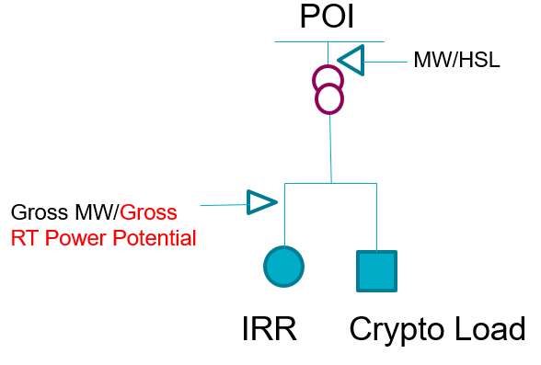
For co-located data center loads and/or PUN loads netted with IRR generation, the GRPP must be added to IRR(s) at the site to reflect the real-time power potential of the IRR(s).

- Self-Limiting Facilities with IRR Generation

For Self-Limiting Facilities with IRR generation, the GRPP must be added to IRR(s) at the site to reflect the real-time power potential of the IRR(s).

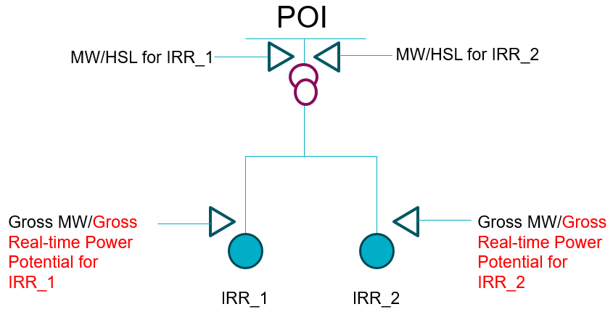

STAGE 3: Energization, Synchronization and Commissioning
Stage 3 involves the following steps:
- Final Compliance with Operational Standards Review
- New Generator Commissioning Part 1, 2, and 3 Checklists
- Commissioning Plan Template
- Commissioning Process
- Reactive Capability, AVR, PSS and Performance Testing
- Resource Status during Testing

Final Compliance with Operational Standards
As stated in Protocol 16.5 Registration of a Resource Entity, an IE shall not proceed to Initial Synchronization of a generation resource in the event of any of the following conditions:
- ERCOT has reasonably determined that the generation resource may violate operational standards established in the Protocols, Planning Guide, Nodal Operating Guides, or Other Binding Documents
- The Resource Entity has not yet demonstrated to ERCOT’s satisfaction that the generation resource can comply with the Operational Standards.
- The requirements of Planning Guide 5.3.5, Quarterly Stability Assessment, have not been completed
- Any required sub-synchronous resonance studies have not been completed and approved by ERCOT as specified in the ERCOT Protocols and any required mitigation or monitoring has not been completed.
Based on ERCOT’s review of the Operational Standards requirements, the RE will be notified by email if the generator to be synchronized has passed or failed to meet the Protocol requirements. A copy of the compliance report will be available in RIOO-IS. Initial synchronization will not be allowed until all Operational Standards requirements have been satisfied.
Planning Guide Applicability
- New units that meet PG 5.2.1 and go through the INR process will be required to do Part 1, 2 and 3 checklists
- New units that do not meet PG 5.2.1, and do not go through the INR process, will be required to submit new resource data and do Part 1, 2 and 3 checklists
- Existing units that meet PG 5.2.1and go through the INR process will be required to do Part 2 and 3 checklists but do not have to do Part 1
- Existing units that do not meet PG 5.2.1- will be required to submit new resource data but will not be required to do Part 1, 2, and 3 checklists

Background
Stage 3 is primarily governed by the ERCOT New Generator Commissioning Checklist and the Commissioning Plan Template, which are available on the ERCOT website. The Generator Commissioning checklist and Commissioning Plan Template process is initiated by the Resource Entity/QSE, and all approvals are made by ERCOT Resource Integration.

ERCOT New Generator Commissioning Checklist
The three-part ERCOT New Generator Commissioning Checklist is designed to coordinate the energization, synchronization, and commissioning of a new or modified generator once all qualification measures have been met to the satisfaction of ERCOT.
The three parts of the Generator Commissioning Checklist for interconnection requests representing new generation are:
- Part 1: Request for Energization of Resource Entity Equipment
- Part 2: Request for Initial Synchronization
- Part 3: Request to Commission a Resource
Checklist Submissions for Existing Generation meeting PG 5.2.1(1)(c)(ii) Seeking to Increase Output:
For interconnection requests representing modified Wind Generation Resources meeting PG 5.2.1(1)(c)(ii), Applicability, the Checklist Part 2 above is replaced by the following two Checklist parts, submitted before and after modification:
Part 2a: Request for Wind Units meeting PG 5.2.1(1)(c)(ii) Pre-Synchronization [QSE submits checklist to request approval to begin re-power work at the site]
Part 2b: Request for Wind Units meeting PG 5.2.1(1)(c)(ii) Initial Synchronization [QSE submits checklist prior to desired Initial Synchronization of first re-powered turbine]
For modified Wind Generation Resources meeting PG 5.2.1(1)(c)(ii), Applicability, Checklist Part 1 is not necessary and Checklist Part 3 is unchanged.
Upon reaching Stage 3 of the interconnection process, these REs and/or QSEs are required to submit the Checklist Part 2 and 3. Checklist Part 1 is not necessary, but the telemetry points listed in Part 1 are still required. Parts 2 and 3 are necessary to ensure the resource is modeled correctly and able to pass all required testing up to the increased capability. This check also helps ensure that any generation previously exempt from PSS requirements as indicated in Section 2.2.6 of the ERCOT Nodal Operating Guides that have done work on their excitation systems have installed a PSS and are operating with it in service.

RIOO-IS Commissioning Planned Dates
It is very important to update RIOO-IS planned commissioning dates for Energization, Synchronization and Commercial Operation. RIOO-IS dates are used by ERCOT teams for timing of GTC updates and other key steps during commissioning. NOTE: If these RIOO-IS planned dates are not kept updated, the project could experience delays in approvals for energization, synchronization, and the commissioning of the generators.

Commissioning Plan Template
The Commissioning Plan Template provides in-depth details on how the facility will be operated during all three stages of the Checklist, including testing of generation and control systems while supporting grid security in accordance with ERCOT Operational Standards. Within 15 days of receipt, ERCOT shall review the commissioning plan and provide feedback with regards to compliance with operational standards and identify possible operational limitations during the commissioning process. The commissioning plan must include the planned dates for all ERCOT required testing.
The 8 sections of the Commissioning Plan Template are:
- Section 1: General Resource Description
- Section 2: Resource Controls
- Section 3: Resource Shut-Down Sequences
- Section 4: Resource Telemetry Verification
- Section 5: Resource Commissioning Milestones
- Section 6: Resource Detailed Commissioning Schedule
- Section 7: Resource Design Capabilities
- Section 8: Process Notes and Descriptions
All 8 sections of the commissioning plan must be completed before submitting it to ERCOT in RIOO-IS.
The ERCOT New Generator Commissioning Checklist and Commissioning Plan Template verify critical communication points and generation security measures before allowing the Resource Entity to energize the point of interconnection, synchronize generation, and prepare for commissioning of the Resource.

ERCOT Good Cause Exception Request
Within 300 days of receiving ERCOT’s approval for Initial Synchronization above 20MVA of a new or repowered Generation Resource or ESR, a Resource Entity shall ensure the Resource meets the conditions established by ERCOT for commercial operations. As specified in Planning Guide 5.5(3), in the event a Generation Resource or ESR will be unable to complete all necessary construction and required testing to commence commercial operations and connect reliably to the ERCOT System within the 300 days, the Generation Resource or ESR may request a Good Cause Exception Request with sufficient detail, and shall notify ERCOT prior to the planned commercial operation date and provide ERCOT with an updated commercial operation date that the Generation Resource or ESR can reasonably expect to commence operations in a reliable manner
Outage Scheduler
The generator has the responsibility to provide accurate and timely updates to the Outage Scheduler to reflect their expected future equipment unavailability if they are expecting not to be capable of generating at their modeled maximum output level due to equipment derates or generation equipment commissioning progression. Prior to approval of each stage of commissioning and on an on-going basis, the Outage Scheduler must be updated to accurately reflect the generator’s future derate amount, start time and end time. Outage submission requirements are outlined in ERCOT Nodal Protocols Section 3.1.
[Note: ERCOT’s renewable forecasts make predictions 168 hours (7 days) into the future. Because of this, ERCOT needs accurately updated outage scheduler information 7 days into the future. If the derate has an end-date that is tentative during the commissioning at the site, then the RE/QSE need to review derates daily, to ensure it is accurate for at least 7 days into the future. Also, be aware that Information regarding planned daily capacity that is provided in the Commissioning Plan is for coordination purposes only during commissioning and is not a substitute for the entries of deratings in the Outage Scheduler].

Commissioning Process
At least 30 days before the RE plans to submit Checklist Part 1, the RE is required to submit a completed Commissioning Plan Template.

Checklist submittals and approval:
- Separate Generator Commissioning Checklists must be submitted for each new generator associated with the same Point of Interconnection. RE/QSE will submit all Checklists to ERCOT using the RIOO-IS application.
- Prior to submitting Part 1 (Energization) of the Checklist, the QSE, Resource Entity, and interconnecting Transmission Service Provider shall ensure that the transmission switchyard facilities have been adequately constructed and modeled in ERCOT’s Network Operations Model and are ready for energization and operation as part of the ERCOT system.
- ERCOT recommends that Part 1 of the Checklist be submitted at least 7 Business Days in advance of the planned date of the initial energization of the Point of Interconnection.
- ERCOT will provide a response to a submitted Checklist part within 7 Business Days of receipt.
- ERCOT recommends that Checklist Part 2 be submitted after approval of Checklist Part 1 by ERCOT and successful energization of the RE site and be at least 7 Business Days from the date ERCOT approves the previous Checklist part.
- Checklist Part 3 can only be submitted after satisfactory completion of required testing and approval by ERCOT.
- Any Checklist Part submitted prior to receiving approval of the previous Checklist Part will be considered as being submitted on the next business day after the approval of the previous Checklist part by ERCOT

Additional Details on Commissioning Checklist Submissions
ERCOT reviews and approves Checklist submissions for execution on Business Days only, during the hours of 8 AM to 5 PM Central Prevailing Time (CPT). On Friday’s and the day before ERCOT holidays, Checklists will be either approved before 2 PM CPT or the review will resume on the next Business Day. Checklist submissions received by ERCOT after 2 PM CPT will be considered as received by ERCOT on the following Business Day.
ERCOT Checklist approval will be communicated by Resource Integration to the IE Contacts listed on RIOO-IS. RE and QSE contacts will be notified by their ERCOT Account Manager of the checklist approval.
Upon receipt of Part 1 of the Checklist, ERCOT shall review it for accuracy and completeness. ERCOT shall then perform a verification of the network model and SCADA telemetry before providing energization approval. Telemetry must be good quality and reasonable for at least 48 hours prior to ERCOT approval. ERCOT shall provide a response within 7 Business Days of receipt. If any problems are encountered with the network model or SCADA telemetry that cannot be readily resolved, ERCOT shall reject Part 1 of the Checklist, and request the QSE, Resource Entity or Transmission Service Provider, where appropriate, to review and correct any outstanding issues as required, and have the RE resubmit Checklist Part 1. Part 1 of the Checklist shall not be approved until all identified problems have been resolved to the satisfaction of ERCOT.
The above process applies with Checklist Part 2. ERCOT shall review the model and telemetry and will reject Part 2 of the Checklist if any problems are encountered that cannot be readily resolved. Telemetry must be good quality and reasonable for at least 48 hours prior to ERCOT approval.
ERCOT’s approval of Part 1 and Part 2 checklists, energization of the generator’s Point of Interconnection and synchronization of the generator to the grid, is given for a specific target day requested by the Resource Entity (Part 1) or QSE (Part 2) and is subject to real-time grid operating conditions. Accordingly, the Resource Entity’s QSE must contact the ERCOT control room on the day of energization as per ERCOT’s Operating Procedures and receive permission to proceed prior to station energization or synchronization of the generation.
If system conditions are such that energizing the generator station facilities or allowing the generation to synchronize to the grid will place unnecessary risk to the ERCOT Transmission Grid, ERCOT System Operators have the authority to cancel or otherwise prohibit these actions.
Checklist Part 3 approval requires verification of several generator capabilities such as reactive capability, primary frequency response, base point compliance during curtailment and voltage control. Obtaining approval of Checklist Part 3 is dependent on the time necessary for the RE and QSE to commission the equipment and conduct all required performance testing. Once all testing has been performed, ERCOT shall review all test results within 30 days of test submittal and approve Checklist Part 3 within 7 business days of submittal as appropriate. The reactive test and AVR test need to both be submitted before review will begin. The review will then have 30 days after the submittal of the latest of the two tests. It’s best to submit all testing to ERCOT as soon as possible to allow sufficient time to review. If any issues are identified with regards to performance testing that cannot be readily resolved, ERCOT shall reject the Part 3 submittal, and request the QSE, Resource Entity or Transmission Service Provider, where appropriate, review and correct any outstanding issues as required, and then resubmit Checklist Part 3. Part 3 of the Checklist shall not be approved until all identified problems have been resolved to the satisfaction of ERCOT.
Checklist Part 3 requires submittal of 5 minutes of sample PMU data during a period that the generators are on-line with outputs greater than zero. The PMU data needs to comply with Operating Guide Section 6.1.3 Phasor Measurement Recording Equipment Including Dynamic Disturbance Recording Equipment. The PMU sample data file is in the form of worksheet or comma separated data file. Column A is the Date/Timestamp followed by columns for voltage phasor magnitude and angle for each phase, current phasor magnitude and angle for each phase, frequency and df/dt. There should be at least 30 data rows per second. Sample PMU data files need to be uploaded to RIOO-IS for each generator or if PMU data for IRRs is collected on the high side of the MPT, then at least one file for each MPT. File name needs to identify the INR#, project name, station code and generator or MPT codes. File names can only include alpha-numeric characters, underscores, and dashes. It is suggested that the sample PMU files be provided during Part 3 testing.
Checklist Part 3 for Generation Resources and Energy Storage Resources requesting to commission a Resource during the winter months (December through February), the Declaration of Preparedness – Generation Entity Winter Weatherization required by Public Utility Commission of Texas (PUCT) Substantive Rule 25.55(c)(3)(A), require statement of the date that it was submitted. Likewise for summer months (June through September), the Declaration of Preparedness – Generation Entity Summer Weatherization required by PUCT Substantive Rule 25.55(c)(3)(B) and Attachment K: Declaration of Natural Gas Pipeline Coordination was submitted require a statement of the date that it was submitted.
Checklist Part 3 requires acknowledgement that a Plant Verification Report is required to be submitted to ERCOT within 30 days following Part 3 approval in accordance with PG 5.5.
The Checklist Part 3 approval by ERCOT represents the Resource Commissioning Date and approval for participation in ERCOT market operations. This represents that final review by ERCOT and initial qualification testing by the RE has been completed and the generator has progressed out of the interconnection process. [Note: Ancillary Service testing and qualifications are separate from Part 3 testing.]

Base Point, Reactive Power Capability, VSS, AVR, PFR and PSS Testing
For the generator to be commissioned and approved for participation in ERCOT market operations, it must demonstrate that it can satisfy ERCOT’s requirements for following its base points (during curtailments for IRRs and IRR Groups), Reactive Power (both leading and lagging), Automatic Voltage Regulator (AVR), Primary Frequency Response (PFR), and Power System Stabilizer (PSS), as applicable to the generation type.
These performance tests are some of the final steps before the commissioning of a generator. ERCOT may direct the generator to isolate from the grid until the required testing has been completed or mitigation plans have been established to address operational risks until the testing can be completed.

Base Point following during Curtailment – IRRs and IRR Groups
Due to increased numbers of Generic Transmission Constraints and IROLs, ERCOT is requiring IRRs and IRR Groups to perform Curtailment testing before allowing IRRs and IRR Groups to connect more than 20 MVA of generation capacity to the Point of Interconnection during commissioning. Per protocol requirement 6.5.7.4 and 6.6.5.4, IRR units should follow SCED Base Points when curtailed. A curtailed IRR that is not in an IRR Group will receive telemetered SBBH (SCED Base Point Below HDL) telemetry flag that is set to “ON” and should follow it’s telemetered Base Point. IRR Groups are curtailed if any IRR in the IRR Group receives a telemetered SBBH flag of “ON” and the IRR Group total output should be curtailed to the sum of the Base Points for the IRRs in the IRR Group.
There are two forms of curtailment test depending on if the IRR under test a single unit or part of an IRR Group is (which is comprised of multiple IRR units). Below is an example of the Curtailment test procedure for a single IRR and the expected response from the unit followed by an example of Curtailment of an IRR Group.

IRR Unit Curtailment Testing (Note: Use the following process for an individual IRR that is not in an IRR Group)

Step #0: Following approval to conduct the Curtailment Self-Test, set RST to “ONTEST” (RST=8) for the unit.

Step #1: Set Curtailment Flag to True (SBBH=True) and BP = 0 MW for the unit
- This sends a curtailment to 0 MW to the unit
- The unit should respond to the curtailment and the output is expected to be equal to zero MW.
- Maintain the curtailment for 15 minutes
- Note that ERCOT will evaluate how the unit’s output (MW), HSL, ramping rate and turbines/inverters availability are telemetered during a 15-minute observation period.

Step #2: Following the completion of the above 15 minutes, set Curtailment Flag to False (SBBH=False) for the unit.
- This releases the unit from curtailment.
- The unit should ramp up its power output until the unit’s output (MW) matches its HSL.

Step #3: Following the completion of the above test, set RST to “ON” (RST=3) for the unit so it can follow SCED curtailment instructions.
- Note that ERCOT will observe the 10 minutes period after the completion of the test to analyze how the unit’s output (MW), HSL, ramping rate and turbines/inverters availability are telemetered.

Step#4: Provide ERCOT with the date and beginning/ending times of the Curtailment Self-Test.

IRR Group Curtailment Testing (Note: The IRR Group is being curtailed at each step below; these are not individual unit curtailments)

Step #0: Following approval to conduct the IRR Group Curtailment Self-Test, to begin the test, set RST telemetered to ERCOT to “ONTEST” (RST=8) for all the units in the IRR Group.

Step #1: QSE sends telemetry to Resources setting Curtailment Flag to True (SBBH=True) and BP = 0 MW for the first unit of the IRR Group. This should be recognized as an IRR Group curtailment. If any unit in the IRR Group receives a SBBH = True, then the IRR Group is being curtailed. During IRR Group curtailment, the HSL for all units in the IRR Group should be telemetered to ERCOT as the unit’s output capability considering wind-speed/irradiance and the number of turbines/inverters available to generate.
- The IRR Group should respond to the curtailment and the group’s output is expected to be equal to group’s output prior to Step #1 minus the first unit’s output prior to Step #1 (“X1” MW). In this step the IRR Group is curtailed by a total of X1 MW.
- Maintain the IRR Group curtailment for 15 minutes
- Note that ERCOT will observe the 15 minutes period to analyze how the IRR Group output (sum of the group’s unit MW output), IRR Group unit’s HSL, ramping rate and turbines/inverters availability are telemetered.
- Repeat Step #1 for the remaining units within IRR Group. Each time, curtailment test increases the IRR Group curtailment amount by the pre-curtailment output of the next unit within the same IRR Group in successive steps. Following the initial curtailment, the IRR Group is then curtailed by the second unit’s pre-curtailment MW output (“X2” MW), and then in the next step by the third unit’s pre-curtailment output (“X3” MW), and so on.
- When the IRR group is curtailed by the pre-curtailment output of the last unit in the IRR Group, the group output is expected to be equal to zero MW.

Step #2: Following the completion of the above IRR Group curtailment periods, set Curtailment Flag to False (SBBH=False) for all the IRR Group units.
- This releases the IRR Group from curtailment.
- The IRR Group should ramp up output until the IRR Group output (sum of its units’ MW outputs) matches the sum of the IRR Group units’ HSL.

Step #3: Following the completion of the above test, set RST telemetered to ERCOT to “ON” (RST=3) for the IRR Group units so it the IRR Group can follow SCED curtailment instructions.
- Note that ERCOT will observe the 10 minutes period after the completion of the test to analyze how the IRR Group unit’s output (MW), HSL, ramping rate and turbines/inverters availability are telemetered.

Step#4: Provide ERCOT with the date and beginning/ending times of the IRR Group Curtailment Self-Test.

The curtailment test will confirm the ability of a single IRR unit or an IRR Group to follow the SCED Base Point and to respond in a proper way when released from curtailment as well as the accuracy of the telemetry. When an IRR unit is not curtailed, HSL is expected to be equal to unit’s output. However, when the IRR unit is curtailed, its HSL should reflect the available capacity in power production which is a function of the available turbine/inverters and meteorological conditions (wind speed and solar irradiance). In other words, HSL should correlate with the wind speed/ solar irradiance if the number of turbine/inverters is not changed when curtailed. When an IRR unit is curtailed, the wind turbine/ inverters in operations should be telemetered as NTON (available). The HSL should have a smooth transition prior and post curtailment, and HSL is not expected to drop to the unit’s output when the curtailment is lifted. In addition, the units up/down ramp rate telemetry should be accurate, and the units must follow this ramp rate when being curtailed to ensure the reliability of ERCOT’s grid.

Reactive Power Capability
Typically, coordinated Reactive Power Capability tests are performed in coordination with ERCOT and the TSP as described in Operating Guide section 3.3.2.2 Reactive Testing Requirements. Although the ERCOT Operating Guides recommend maximum leading reactive tests be performed in low load months, and maximum lagging reactive tests be performed in high load months, this is often not possible for initial operation. Coordinated Reactive testing is generally required for Part 3 approval.
If issues arise in completing a non‐coordinated reactive test, then a coordinated reactive test will be required. No extensions to complete reactive testing for Part 3 approval are provided. If either leading or lagging reactive test cannot be completed due to RE plant limitations, the issues must be resolved, and a new reactive test conducted.
All Resources need to submit a Reactive Test through NDCRC. DGRs or DESRs that are in a fixed power factor (unity power factor) control mode need to submit a reactive test with 0’s or 0.1 for all MVAr values.

Voltage Support Service (VSS)
All Generation Resources connecting over 20 MVA of gross capacity or those units connected at the same Point of Interconnection aggregating to greater than 20 MVA of gross capacity shall provide VSS according to Protocol Section 3.15 (2) Voltage Support. This means that Generation Resources, such as wind or solar plants that plan on energizing their facility as new equipment is installed, shall meet the requirement to provide VSS as required in the Protocols once the gross connected capacity of the generation resource exceeds 20 MVA.
If unable to provide VSS until the generation resource is fully constructed, the Resource Entity may continue commissioning the new equipment so long as the Resource Entity has only 20 MVA of equipment energized at a time.
For IRRs, once a generation unit has enough generation capacity available for AVR, PFR and VSS control and has passed a curtailment self-test and has submitted an email attestation to ERCOT Resource Integration of being able to provide this control, the Resource Entity can request approval from ERCOT to connect more than 20 MVA and up to the capability at which the generation unit(s) can provide VSS and voltage control.
The way a generation resource can operate above 20 MVA shall be documented in the Commissioning Plan. For Intermittent Renewable Resources planning on providing VSS in part using capacitor and reactive banks, it is encouraged that those reactive devices be installed by the beginning of Stage 3 (prior to Checklist Part 1 approval) to maximize output from the generator during the Commissioning process. Note that capacitor and reactor banks can only be used to make up for losses from the generator terminal to the POIB.

Automatic Voltage Regulator (AVR)
Operating Guide Section 2 governs AVR tests and testing. All generators are required to have an AVR and have it on-line when generating. AVR testing is done in accordance Operating Guide section 2.2.5, Automatic Voltage Regulators and varies slightly by technology type. A Resource Entity required to provide VSS shall maintain the generator voltage or Reactive Power schedule to maintain voltage at the POIB to be within a tolerance band of the Voltage Set Point while operating at less than or equal to the maximum reactive capability of the Generation Resource. A Generation Resource’s POIB voltage may be out of the tolerance band ONLY if it has exhausted all of its reactive capability. The tolerance bands are as follows:
Voltage tolerance band in Op Guide 2.7.3.5(4):
Nominal Voltage | Tolerance  Band KV
345 | +/- 4kV
230 | +/- 3kV
138 | +/- 2kV
115 | +/- 2kV
69 | +/- 1kV

The required VSS response times for Generation Resources when voltage measurements at the POIB are outside of the Voltage Set Point tolerance band identified in paragraph (4) of Section 2.7.3.5, Resource Entity Responsibilities and Generation Resource Requirements, then the unit mvar capability and all switchable shunts (If applicable) must be fully deployed in no more than five minutes. The following document are posted at https://www.ercot.com/services/rq/integration:

- Combined AVR Template is used to complete the AVR test for IRRs, ESRs and conventional generators.
- AVR Testing Expectations for IRR explains what is expected for the IRR AVR test.
- AVR and PSS Test Guidelines for Conventional Generation explains what is expected for the conventional generation AVR test.
- AVR Test Guidelines for DESRs (DGRs) explains what is expected for distribution connected Resources (DGRs, DESRs).
Here is how the AVR test should work:
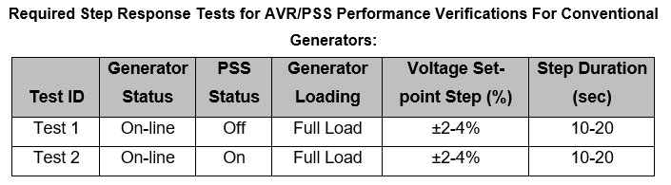
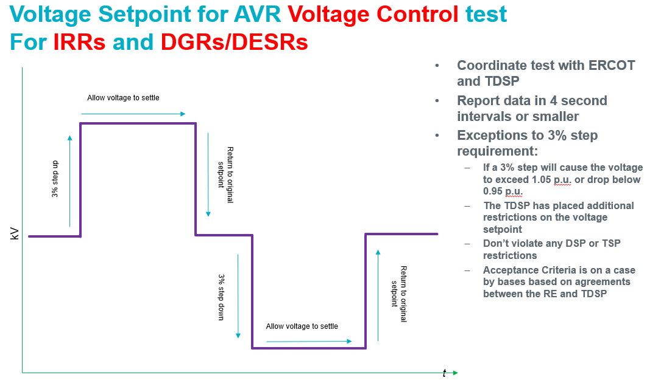
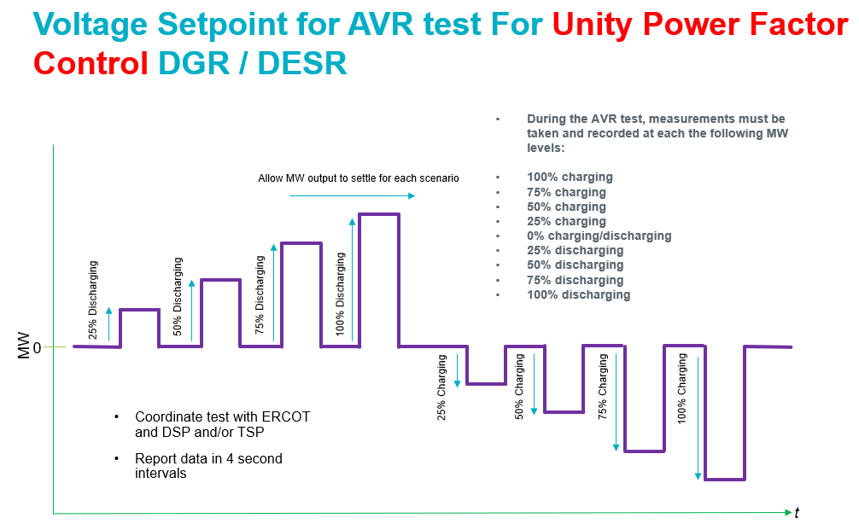

Primary Frequency Response (PFR)
PFR testing is performed in accordance with Nodal Operating Guide Section 8, Attachment C. Test data is submitted to ERCOT via NDCRC.

Power System Stabilizer (PSS)
Synchronous generators must have a PSS installed per Nodal Operating Guide Section 2.2.6. PSS testing requirements are included in Nodal Operating Guide Section 2.2.6(7).

Generator Status during the Commissioning Process - ONTEST, ON and OUT Status
During the commissioning process for new unit(s), the QSE will submit a generator status in the COP and telemetry in accordance with Protocol section 3.9.1 Current Operating Plan (COP) Criteria.
- Before approval of Part 2 up to 20 MVA, the Resource status of “OUT” is expected with associated Outage Scheduler entry with HSL = 0.
- After approval of Part 2 up to 20 MVA of connected capacity (IRRs and BESS) when the unit is on-line:
  - Resource status of “ONTEST” is expected if the AVR, PFR, VSS and curtailment controls are not yet functioning – this indicates to SCED that the unit(s) can’t curtail output under full automatic control.
  - Outage Scheduler entry for HSL is entered based on connected capacity and operating conditions
  - Battery Energy Storage Systems (BESS) units need to demonstrate the correct telemetry for both charging load and discharging generation as a portion of the telemetry check-out before approval to lift the 20 MVA limit.
- After approval of Part 2 over 20 MVA connected capacity -
  - IRRs having their control system in automatic control mode and having passed the Curtailment Test), when the unit(s) are on-line, it is expected that the generator status will be “ON” except during PFR, AVR and Leading and Lagging Reactive testing and for a limited number of hours for specific tests that would require a certain level of MW output in order to tune controls for Part 3 testing or other specific exceptional cases. Requests for unit testing are submitted by the QSE to ERCOT Operations.
  - When the unit(s) are unavailable a generator Status is expected to be “OUT”. When a unit is sending real-time telemetry status of “OUT”, it also should reflect this in its COP to let ERCOT know how long it will be unavailable. In this sense, COP status and real-time Resource status (RST) should match if the status is “OUT”.
  - The use of “OFF” status is not expected during the commissioning process because it would indicate that the unit(s) are “off-line but available” for RUC and DAM dispatch which would not be the typical case.
  - Solar units - at night, would not use “OUT” status unless the unit is on outage or the breaker is open. As long as the unit is on-line at night but not injecting power, it should continue to send “ONTEST” before Part 2 over 20 MVA approval. Following Part 2 over 20 MVA approval it should send the “ON” status. A telemetered AVR status of “ON” indicates the unit’s AVR system’s ability to change unit MVAr output within the registered reactive capabilities at the current unit MW output level to control voltage.
  - Non-IRR units can request unit testing and if approved can use the “ONTEST” status during commissioning. Use of the “ON” status requires following of SCED Base Points. Requests for unit testing are submitted by the QSE to ERCOT Operations.
Note: Generators using an “ON” status are subject to Base Point Deviation charges and GREDP monitoring.

Operation Requirement of Data Center Loads and/or PUN loads with IRR Generation
- QSEs need to estimate load consumption for PUN load or Data Center load for the next 168 hours
- QSEs will deduct the estimated load consumption from the vendor-provided IRR forecast to update the COP HSL, which would need to be reduced further if there is any equipment outage or derate that is not reported in the Outage Scheduler.
Forecasting vendors will produce the forecast for the gross capability for the next 168 hours to estimate the power potential for the IRR

Frequency Ride-Through and Voltage Ride-Through Requirements For IBRS, Type 1 and Type 2 WGRs
The Resource Entity must submit the Frequency Ride-Through (FRT) and Voltage Ride-Through (VRT) capabilities for each Resource via RIOO-RS in accordance with Nodal Operating Guide (NOG) Sections 2.6.2.1, 2.9.1, 2.9.1.1, and 2.9.1.2. The applicable FRT/VRT requirements differ depending on the Standard Generation Interconnection Agreement (SGIA) date:

- The FRT requirements in NOG Sec. 2.6.2.1 apply to a Resource with a SGIA dated before 8/1/24 that has implemented modifications to satisfy NOG Sec. 2.6.2.1(1) – (5)
- The FRT requirements in NOG Sec. 2.6.2.1.1 apply to a Resource with a SGIA dated before 8/1/24 that has not implemented modifications to satisfy NOG Sec. 2.6.2.1(1) – (5)
- The VRT requirements in NOG Sec. 2.9.1(2) – (9) apply to a Resource: (i) with a SGIA dated after 8/1/24 or (ii) that has a SGIA dated before 8/1/24 but has gone through the GIM process after 8/1/24
- The VRT requirements in NOG Sec. 2.9.1.2 apply to a Resource with a SGIA dated before 8/1/24 that has not gone through the GIM process.

- If FRT capability differs from the capability previously submitted to ERCOT, the Resource Entity must update the FRT capability in the RARF/RIOO-RS to obtain Checklist Part 2 approval.

- If VRT capability (per NOG Sections 2.9.1.1, 2.9.1.2 and IEEE 2800-2022) differs from the capability previously submitted to ERCOT, the Resource Entity must update the VRT capability in the RARF/RIOO-RS to obtain Checklist Part 3 approval.

APPENDIX A: Helpful Resources and Links
Public Utility Commission of Texas (PUCT) Substantive Rules 25.198 governs the initiation of transmission service in Texas, and Substantive Rule §25.109 outlines the certification, licensing, and registration of generators. ERCOT Protocol Section 16.5 identifies additional requirements related to the registration of the Resource Entity as a Market Participant and the generation that it will represent in the ERCOT market.
Refer to the following links for additional information.
PUCT rules: http://www.puc.texas.gov/agency/rulesnlaws/subrules/electric/Electric.aspx.
ERCOT Protocols: http://www.ercot.com/mktrules/nprotocols/current
ERCOT Planning Guides: http://www.ercot.com/mktrules/guides/planning/current
GIM (GINR) application forms and registration information is available on the ERCOT website at:
http://www.ercot.com/services/rq/integration
Interconnecting Distributed Generation (less than 10 MW and at voltages below 60-kV) is described in PUCT substantive Rule 25.211, and is not discussed in this document.
Planning Guide Section 5: https://www.ercot.com/files/docs/2021/12/29/05-PG-010122.docx
Here is the Resource Integration Page: https://www.ercot.com/services/rq/integration
Distributed Generation information: https://www.ercot.com/services/rq/re/dgresource/
To start an interconnection application please follow this link: https://sa.ercot.com/rioo-rs/
IE sign up guide: https://www.ercot.com/files/docs/2022/01/14/IE-SignUp-Guide-for-RIOO-Services.pdf
RE sign up guide: https://www.ercot.com/files/docs/2022/01/14/RE-SignUp-Guide-for-RIOO-Services.pdf
TDSP sign up guide: https://www.ercot.com/files/docs/2022/01/14/TSP-Sign-Up-for-RIOO-Services.pdf
Managing your RIOO account: https://www.ercot.com/files/docs/2022/01/14/Managing-Your-RIOO-Services-User-Account.pdf
Here is the ICCP Handbook on the RE page: https://www.ercot.com/files/docs/2022/02/10/ERCOT_Nodal_ICCP_Communications_Handbook.docx
Here is a presentation that you may find particularly interesting: https://www.ercot.com/files/docs/2022/02/18/Resource_Integration_Working_Group_DGR_Topics_02222022.pptx
Here is the Resource Entity page on ercot.com: https://www.ercot.com/services/rq/re
Here is the RARF Glossary Site: https://www.ercot.com/mktrules/guides/resourcereg/library
EPS Meter Design Proposal site: https://www.ercot.com/mktinfo/metering/eps/index.html
DGR workshop 12: https://www.ercot.com/calendar/10142021-DGR-Workshop-XII-by
TDSP contacts: https://www.ercot.com/files/docs/2021/11/23/Market_Participant_List.xls

APPENDIX B: LIST OF ERCOT FORMS FOR INTERCONNECTION PROCESS
http://www.ercot.com/content/wcm/lists/168310/SGIA.doc
Process/Form | Entity | Access Location | Submission Location
Generation Interconnection or Change Request (GIM (GINR)) | IE | RIOO-IS
Screening Study Data submission | IE | RIOO-IS
SGIA | IE | SGIA | RIOO-IS
Resource Entity Registration | RE | RE Registration | Resource Entity Application
Standard Market Participant Agreement | RE | SFMA
Managed Capacity Declaration Form | RE | Managed Capacity Form | MIS or ercotregistration@ercot.comand MPRegistration@ercot.com
Resource Asset Registration Form (RARF) | RE | RARF Forms | MIS or mpappl@ercot.com and resourcereg@ercot.com
Resource Registration Glossary | IE/RE | Res Reg Glossary
EPS Design Proposal | TSP/RE | EPS Metering Design Proposal | epsmetering@ercot.com
MDAS Form | TSP/RE | MDAS Form | mreads@ercot.com
EPS Cutover Form | TSP/RE | EPS Cutover Form | epsmetering@ercot.com, 1ERCOTEAADataAggregation@ercot.com
Outage Schedule | QSE | MIS System | Through MIS outage scheduler
QSE ICCP Points List | QSE | MIS System | Through MIS service request
New Generation Checklist | RE | New Gen Checklist | RIOO-IS
Request for Unit Testing | QSE | Operating Procedures | Sent to the ERCOT Shift Supervisor: shiftsupv@ercot.com.
Commissioning Plan Template | QSE | Comm Plan Template | RIOO-IS
Net Dependable Capability and Reactive Capability (NDCRC) | QSE | MIS System | Through MIS dashboard

APPENDIX C: NAMING CONVENTIONS
LLC names – not used by ERCOT Operations, not used by ERCOT Planning, and they are therefore unrestricted.
Sitecode names – used by Operations in switching orders and used by Planning in modeling. Therefore, it is critical that they are clear and distinct and not easily confused with anything else. There is an 8-character limit in the Sitecode name. A certain amount of human judgment goes into accepting new names. For example, “Heart Solar” and “Hart Solar” sound alike and either one could be okay, but not both. Sometimes similar names can be tolerated if they are geographically far apart.
Project names – used by Planning and all other departments in all other communications. Ideally the project name would be the same as the Sitecode, and it is convenient for the project name to include “wind” or “solar” or “gas” instead of “ranch” or “farm” or “project.” For example, if the project name is Ibis Wind, then the Sitecode can be IBIS_W and everyone can easily recognize it.
Commission Plan file names - Include the GIM (GINR) number at the end of the filename before the extension and include the GIM (GINR) number in the subject line of all emails regarding the commissioning plan.
Commissioning Checklist file name - [Gen site name] & [unit name] & “Part” & [1,2, or 3] & “Checklist” & [Date Submitted] & “.pdf”.

APPENDIX D: LARGE GEN TIMELINE 1

APPENDIX E: LARGE GEN TIMELINE 2

APPENDIX F: SMALL GEN TIMELINE 1

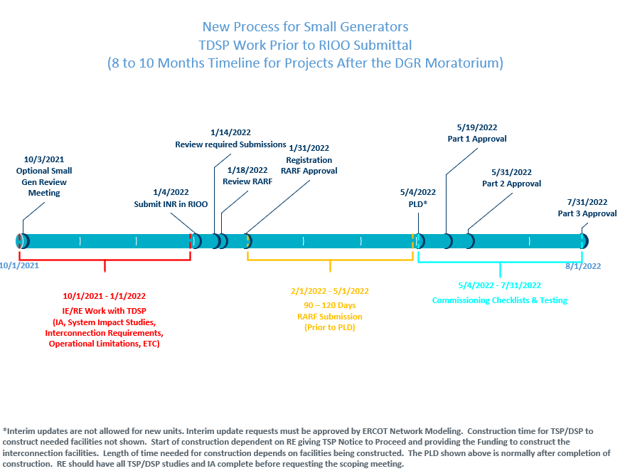

APPENDIX G: SMALL GEN TIMELINE 2
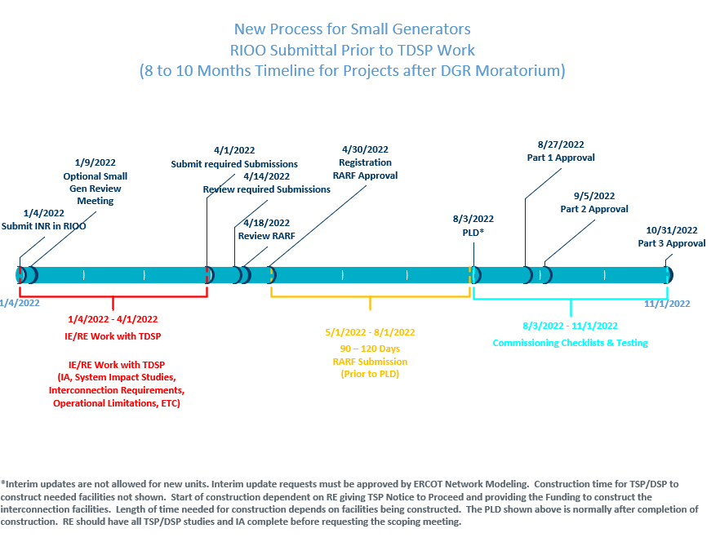

APPENDIX H: SMALL GEN PROCESS FLOWCHART (Zoom In for more details)

APPENDIX I: GIM (GINR) TABULAR TIMELINE:
Task | Responsible Entity | Time Required to Complete
Acknowledgement of GIM (GINR) Application | ERCOT | 1 to 10 Business Days
Notification of Additional Information Needed to Complete Application | ERCOT | 1 to 10 Business Days
Perform Security Screening Study (after application is deemed complete) | ERCOT | 10 to 90 days
Decision to Pursue FIS (following issuance of Security Screening Study by ERCOT) | IE | Up to 180 days
Develop Scope Agreement for FIS (following IE’s Notification to ERCOT of desire for FIS and remittance of appropriate fees) | IE, ERCOT, and TSP(s) | Up to 60 days
Perform FIS (following agreement on scope) |  | 40 to 300 days
Steady-State and Transfer Analysis | TSP(s) | 10 to 90 days
System Protection Analysis (following Steady-State Analysis) | TSP(s) | 10 to 30 days
Dynamic and Transient Stability Analysis (following System Protection Study) | TSP(s) | 10 to 90 days
Facility Study | TSP(s) | 10 to 90 days
SSR | TSP(s) | 60 to 180 days
Study Report Review and Acceptance (following issuance of FIS) | ERCOT, and TSP(s) | 10 to 15 Business Days
FIS Posted to Market Information System (MIS) | ERCOT | Within 10 days of being deemed complete
Report stability resolution findings to ERCOT | TSP | Within 90 days
Negotiate and Execute Standard Generation Interconnection Agreement  (SGIA) (following acceptance of FIS) | IE and TSP | 180 days

APPENDIX J: FIS Review Checklist – dated 8/3/2020
INR # and Name
Reviewing Engineer
Studies Reviewed | Steady State Short Circuit Facilities  Draft / Final
Date Received
10-day Review period ends
Is this a restudy?

Steady State Study
Criteria | Notes | Evaluation
INR # and project name included in the report? | These should match RIOO | Y/N
COD matches RIOO-IS and RARF? | Verify the COD and request update from IE/TSP | Y/N
POI matches RIOO-IS? | Some TSPs will study a second POI. | Y/N
Correct size of proposed project? | The MW values in RIOO-IS, RARF and Steady State report should match. | Y/N
Charging case studied? | Applicable if there is a storage facility. | Y/N
Correct cases considered? | The Steady State study uses the SSWG cases.  SUM case should correspond to the summer season after COD (i.e. same year if prior to June 1 and following year if on or after June 1).  HWLL case should be studied for projects in areas with high wind penetration. The screening study is a good source for which cases to use. | Y/N  If no, explain.
Generators meeting PG 6.9(1) |  | Y/N
List of generators added to / excluded from the cases, and explanation for those additions / exclusions is included? |  | Y/N
Nearby units dispatched at high output? |  | Y/N
Future transmission upgrades in the area of the project included in cases? | In some cases it may be reasonable to do the studies both with and without a transmission upgrade due to timing uncertainty. | Y/N
P1 – P7 contingencies run in the vicinity? | Contingencies for neighboring TSPs may need to be considered.  P2, P4, and P5 contingencies can be duplicates in steady state. If the TSP does not run all contingencies in these types they should explain why in the report. | Y/N  If no, explain.

Short Circuit Study
Criteria | Notes | Evaluation
INR # and project name included in the report? | These should match RIOO | Y/N
COD matches RIOO- IS and RARF? | Verify the COD and request update from IE or TSP | Y/N
POI matches RIOO-IS? | Some TSPs will study a second POI. | Y/N
Model listed? | Manufacturer, model and rating of the WTG/Inverter/ conventional generator. This should match the model in the RARF. | Y/N
Correct cases considered? | The Short Circuit Study uses the SPWG cases.  Case should correspond to the summer season after COD (i.e. same year if prior to June 1 and following year if after June 1). | Y/N  If no, explain.
Circuit Breaker Rating included in the report? | The breaker interrupting capacity/rating should be higher than the short circuit current. | Y/N
Faults and impedances look reasonable? |  | Y/N  If no, explain.
Study indicates whether existing transmission equipment is adequate? |  | Y/N

Facilities Study
Criteria | Notes | Evaluation
INR # and project name included in the report? | These should match RIOO | Y/N
COD matches RIOO- IS and RARF? | Verify the COD and request update from IE or TSP | Y/N
POI matches RIOO-IS? | Some TSPs will study a second POI. | Y/N
Simple oneline or map showing project’s POI? |  | Y/N
Cost over $25,000,000? | If so, an economic study is required. Notify RPG@ercot.com | Y/N
Economic Study Required field in RIOO | Indicate in the Project Details section of INR under Other Studies> Economic Study Required> Yes/No | Y/N

Stability Study
RI Engineer high-level review
RI Engineer |  |  |  | Comments
Project size. These should match. | Stability Study
Project size. These should match. | RARF
Project size. These should match. | RIOO-IS
COD | Stability Study
COD | RARF
COD | RIOO-IS
Study case | SUM
Study case | HWLL
Inverter / WT Model | RARF
Inverter / WT Model | Stability Study
POIB | RIOO
POIB | Stability Study
Check generation additions and statements about dispatch changes. |  |  | ☐
Check if P1-P7 contingencies were run. If not, check for statements explaining why some were omitted. |  |  | ☐
Check if Protected Information (e.g. events or contingencies causing instabilities, dynamic data) is redacted from the redacted version of the stability report. |  |  | ☐
Check if dynamic data sets included for any cases studied.  - Power flow case: .raw or .sav  - Dynamic case/data: .snp and .dyr |  |  | ☐

Dynamics Review
Dynamics Engineer
If Report submitted as Draft, Key Checking List  (DRAFT Results/Report CANNOT be shared with IE) | Clearly identify NERC P1 thru P7 contingencies?
 | Contingency List sufficient for study area? No important contingencies missing or rationale provided for any contingency types not studied?
 | Study Criteria?
 | Study Assumptions?
Nearby generation dispatched at full output and listed in report or rationale provided for generation dispatch scenario that was studied?
-Is there a separate table for new generation that meets PG 6.9 in the study report based on the cutoff date?
 | Report lists .dyr parameters of unit?
Is the POI near/in any established GTC?
-If yes, are the critical contingencies studied in the FIS study?
 | Model type used in FIS aligns with model submitted in RARF?
 | Model Quality Test report provided in RARF and shows acceptable performance per DWG Procedure Manual section 3.1.5? Model quality test required if RIOO “FIS Requested” date after: 5/1/2020
 | Dynamic load models used if interconnect at a large load center?
 | Stability Issue Identified? Is a curtailment level or other mitigation identified?
Is this an update on the Final report posted in the MIS per PG 5.3.2.4.3 (6)?
- What is the recommended mitigation to address instability issue?
  - Any solution related to change in Generation Resource (e.g. Tuning, Parameter update, other model)?
  - Any Transmission solution?
  - Did the report say solution is feasible and can be implement before In-Sync?
IRR Generators | HVRT and LVRT*: Check 0.95 pf lead/lag  *0.95 pf lead/lag initial condition required for LVRT if RIOO “FIS Requested” date after: 7/30/2020
IRR Generators | HVRT performed as one simulation (instead of piece-wise)
IRR Generators | HVRT and LVRT: Real and reactive power plotted at POIB? Performance per DWG Procedure Manual section 3.1.5?

Post Review Checklist
Item | Complete?
Place a copy of the study in the appropriate project folder. | Y/N
If the study is approved and considered final, post the study to MIS Secure | Y/N
Once the final report is posted to MIS, update the approval date in RIOO-IS | Y/N
Send emails to IE and TSP saying the reports are posted to MIS | Y/N

APPENDIX K: Small Gen Review Checklist – Dated 1/22/2022:
INR # and Name
Reviewing Engineer
Date Received
10-day Review period ends
Small Generation Interconnection Request Application and Approval to Submit Model Information Checklist

Small Gen (Interconnection Application Only):
Criteria | Notes | Evaluation
Make sure Name is not taken (Check RIOO-IS and the Planning Data Dictionary). |  | Y/N
Make sure MWs, Dates, and Voltages Levels look reasonable (Cross-check). |  | Y/N
Verify Load/Load Transformer for connections (Analogous to POI/POIB). |  | Y/N
Lone Star Infrastructure Protection Act (LSIPA) Attestation (It is required for the initial submission, send IE the link so they download it). |  | Y/N
Verify One-Line has necessary information, and that the Load/Load Transformer is shown in the One-Line. |  | Y/N
Verify Payment, and put the payment information in RIOO-IS.  - ACH - Authorize.net  - WIRE – Treasury to verify: treasury@ercot.com | Note: RIOO-IS is the payment method of Small Gen Applications. | Y/N
Verify DOD/Entity sheet is included in INR application |  | Y/N
Assign a TDSP based on Planning Data Dictionary |  | Y/N
Check LSIPA check box, fee amount and fee paid along with putting the appropriate date fields |  | Y/N
Assign a supervisor for both Planning and RI Engineers |  | Y/N

Small Gen Approval To Submit Model Information Checklist (Planning Guide Section 5.4.3):
INR # and Name
Reviewing Engineer
Date Received
10-day Review period ends

Provided by IE/RE or TDSP (Depending on Item):
Criteria | Notes | Evaluation
Approved Interconnection Application |  | Y/N
Notification that all required studies (System Impact Study) are completed and approved by ERCOT.  DSP conducted studies to confirm that DSP’s system will not preclude compliance with ERCOT requirements  DSP conducted studies to identify DGR limitations |  | Y/N
Fully executed Interconnection Agreement: |  | Y/N
Whether any operational limitations exist and description of limitations (if applicable) that will affect generator’s operation | Operational limitations include (but are not limited to) ramping limitations, maximum output limitation, or maximum charging limitation | Y/N
Confirmation that IE has provided Notice to Proceed and Financial Security to fund distribution system upgrades | Security should be sufficient to fund distribution system upgrades identified by the TDSP | Y/N
Timeline for system upgrades required to interconnect the project | (If applicable) | Y/N
Operational limitations of the project and the details of those operational limitations prior to interconnection | (If applicable) | Y/N

System Impact Studies (Operating Guide Section 2.9 [VRT], Operating Guide Section 2.6 [FRT] Planning Guide Section 5.4.2(1)(b))
 | Criteria | Notes | Evaluation
Small Gen | DSP conducted studies to confirm that DSP’s system will not preclude compliance with ERCOT requirements | Requirements include  - Voltage ride-through (VRT)  - Under-frequency and over-frequency relaying, and  - Primary frequency response (PFR) | Y/N
Small Gen | DSP conducted studies to identify DGR limitations | Limitations include  - Min / max MW discharge  - Min / max MW charge (if applicable), and  - Ramp rates limits | Y/N

- DGRs utilizing synchronous generation must have over-/under-voltage relays set to ride through the following operating conditions:
Voltage (p.u. of nominal) | Minimum Ride-Through Time  (seconds)
0.88 < V < 1.10 | continuous
0.70 < V < 0.88 | Linear slope of 4 s/1 p.u. voltage starting at 0.7 s @ 0.7 p.u.
- DGRs and DESRs utilizing inverter-based generation must be designed and relays must be set to ride through the following operating conditions:
Voltage (p.u. of nominal) | Ride-Through Mode | Minimum Ride-Through Time  (seconds)
1.10 < V < 1.20 | Momentary Cessation | 12
0.88 < V < 1.10 | Continuous Operation | continuous
0.70 < V < 0.88 | Mandatory Operation | 20
0.50 < V < 0.70 | Mandatory Operation | 10
V < 0.50 | Momentary Cessation | 1
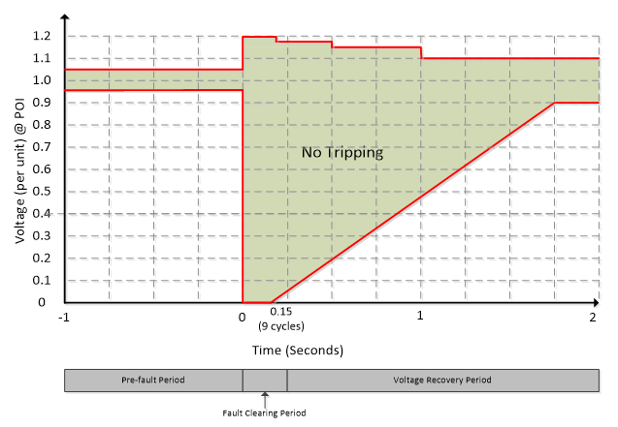
Modeling (Protocol Section 3.10.7.2(3))
Criteria | Notes | Evaluation
Valid Load Transformer information from the TDSP? | This is the Load Transformer that the TDSP will model in NMMS. | Y/N

Operational Limitations and Telemetry (P.G. 5.4)
Criteria | Notes | Evaluation
Confirmation from DSP that all known distribution system operational limitations have been disclosed to RE | Limitations may include DSP-imposed limits on the rate or magnitude of injection or withdrawal | Y/N
All operational limitations are reflected in RARF |  | Y/N
Confirmation from RE that all limits are reflected in ERCOT model and/or telemetry |  | Y/N

Frequency Relaying (Operating Guide Section 2.6.2.1)
Criteria | Notes | Evaluation
Written agreement between RE and DSP confirming ERCOT frequency relaying requirements will operate and take precedence |  | Y/N
  Frequency (Hz) | Ride-Through Mode | Minimum Ride-through Time  (seconds)
  f > 61.8 | No ride-through requirements
  61.2 < f ≤ 61.8 | Mandatory Operation | 299
  58.8 ≤ f ≤ 61.2 | Continuous Operation | continuous
  57.0 ≤ f < 58.8 | Mandatory Operation | 299
  f < 57.0 | No ride-through requirements

Load Shed (Protocol Section 3.8.6)
Criteria | Notes | Evaluation
DSP confirmation that DGR is not connected to load-shed circuit | Line cannot be subject to…  - manual or automatic disconnection…  - by DSP, TSP, or TO…  - as part of any under-frequency, under-voltage, or manual load shed scheme | Y/N

Outage Scheduling (Protocol Section 3.1.6.13)
Criteria | Notes | Evaluation
DSP confirmation that DSP will notify RE or QSE of outages | Relevant outages include any planned or forced outage of any distribution facility controlled by DSP that impacts, or that foreseeably could impact, the operation of the DGR. This could be spelled out in the IA. | Y/N

APPENDIX L: Template for RE’s Wanting to Submit Model Information
Template to Submit Model Information: |  |  | For Informational Purposes Only
What Needs to be Ready for a Submission? | Owner | Comment | In RIOO (Y/N)? | IA Exhibit # | IA Page? | System Impact Study | Study Page?
Small Gen Process per Planning Guide
ERCOT RIOO Fee Paid
Load/Load Transformer and Station name with TDSP
RIOO Gen/DOD forms
LSIPA Form
Clear One-line with load/transformer information and station name
Affidavit for Conditions of Acceptance [P.G. 5.4.2 (1)] - or Approval to Submit Model Information (RARF) [P.G. 5.4.3]
RIOO Application complete and in Planned Status
Confirmation of TDSP System Impact Studies and approvals
Full technology data sheet and specs
Resource Registration data (Initial RARF)
Fully Executed and Funded IA
Any operational limitations from TDSP (Unity Power Factor Requirement, rates, ETC)
VRT Performance
FRT Performance
TDSP modeling, if required
TDSP confirmation that IE has funded distribution system upgrades and a timeline for those upgrades
Confirmation of non-load shed UF circuit
Confirmation of Outage Scheduler
Full RARF Package with All Attachments per Glossary
EPS Metering design proposal in and approved

APPENDIX M: REVISIONS
Revision | Comments | Date | Author
0.1 | Original Document Draft | 10/12/2012 | Al Garcia
0.2 | Editing and reduction of scope | 10/24/2012 | John Adams
0.3 | Editing and Addition of Description of Changes/Table of Contents | 10/29/2012 | W. Rickerson
0.4 | Replacing details of each process with checklist in appendix and other edits | 11/1/2012 | John Adams
0.5 | Editing, make Figure 2 and 3 consistent with Planning Guide, changes to Appendices G and H, updated TOC | 11/6/2012 | Paul Tan
0.6 | Editing for simplicity & clarity | 11/13/2012 | Eric Adams/John Adams
0.7 | Incorporate comments Art Deller, Bill Blevins, | 11/26/2012 | Art Deller, Bill Blevins, John Adams
0.8 | Incorporate comments Patrick Coon, Ed Geer, Art Deller | 11/30/2012 | Ed Geer, Art Deller, Patrick Coon
0.9 | Editing and cleanup – initial draft | 11/30/2012 | Woody Rickerson
1.0 | Add planning model requirements, commercial operation requirements, corrections & Initial Issue | 12/20/2012 | John Adams
1.1 | Clarify SCADA Point plan, Generation checkout, and fate of projects if FIS scope not agreed to within 60 days. | 12/28/2012 | John Adams
1.2 | Incorporate recommendations of QMWG to clarify | 3/29/2013 | John Adams
1.3 | Update language to Incorporate ERCOT and Market Participant comments pertaining to the Resource Interconnection, Modeling, and Operations processes. | 12/12/2014 | Isabel Flores, Art Deller, Bill Blevins, Chad Thompson, Ed Geer, Ted Hailu, Patrick Coon
1.4 | Updated language to change references to “Commercial Operations Date” to “Resource Commissioning Date” as per NPRR 705 (Provides Consistency for references to the End Date of the Generation Interconnection Process) | 02/01/2016 | Ted Hailu, Chad Thompson
1.5 | Updated to include information about the Quarterly Stability Assessment | 01/15/2018 | Jay Teixeira
1.6 | Handbook revised and updated | 07/16/2018 | Dennis Caufield
1.7 | Post Dennis Caufield revisions – formatting mostly | 09/15/2018 | Jay Teixeira
1.8 | Post formatting – footer, cover page, begin content change for RIOO-IS | 10/15/2018 | Jay Teixeira
1.91 | Updated to include GIM (GINR) Timelines, Curtailment test, FIS Review Checklist and various small edits. | 01/8/2021 | Jay Teixeira
1.92 | Updated Planning Guide references, revised Curtailment test process, added Outage Scheduler submission requirements, added descriptions of the Small Gen process, links and other clarifications and edits. | 02/15/2022 | Jay Teixeira, Ed Geer, Zach Reich, Leo Villanueva
1.94 | Update from ERCOT Operations and updates to replace the term “RARF” with “resource data” and changes to RIOO screens and other various small updates. | 03/01/2023 | Jay Teixeira, Mary Vu
1.95 | Updated to include Gross Real-Time Power Potential for Self-Limiting Facilities with IRR Generation. Revised RE Registration timeline under Registering as a Resource Entity. Additional updates include Voltage Ride-Through and Frequency Ride-Through data collection during the commissioning Process, ESI ID(s) requirements and 300-day good cause exception. | 10/28/2025 | Jenifer Fernandes

APPENDIX N: Resource Status Codes (ICCP Handbook 2020)

Resource Category | Status Code | Status Acronym | Status Description
Generation Resource | 000 | n/a | Resource status has not been defined.
Generation Resource | 001 | ONRUC | On-Line and the hour is a RUC-Committed Interval
Generation Resource | 002 | ONREG | On-Line Resource with Energy Offer Curve providing Regulation Service
Generation Resource | 003 | ON | On-Line Resource with Energy Offer Curve
Generation Resource | 004 | ONDSR | On-Line Dynamically Scheduled Resource
Generation Resource | 005 | ONOS | On-Line Resource with Output Schedule
Generation Resource | 006 | ONOSREG | On-Line Resource with Output Schedule providing Regulation Service
Generation Resource | 007 | ONDSRREG | On-Line Dynamically Scheduled Resource providing Regulation Service
Generation Resource | 008 | ONTEST | On-Line Test with Output Schedule
Generation Resource | 009 | ONEMR | On-Line EMR (available for commitment or dispatch only for ERCOT-declared Emergency Conditions; the QSE may appropriately set LSL and HSL to reflect operating limits
Generation Resource | 010 | ONRR | On-Line as a synchronous condenser (hydro) providing Responsive Reserve but unavailable for dispatch by SCED and available for commitment by RUC
Generation Resource | 011 | OUT | Off-Line and unavailable
Generation Resource | 012 | OFFNS | Off -Line but reserved for Non-Spin
Generation Resource | 013 | OFF | Off-Line but available for commitment by DAM and RUC
Generation Resource | 014 | EMR | Available for commitment only for ERCOT-declared Emergency Condition events; the QSE may appropriately set LSL and HSL to reflect operating limits
Generation Resource | 015 | SHUTDOWN | The Resource is On-Line and in a shutdown sequence, and has no Ancillary Service Obligations. This Resource status is only to be used for Real-Time telemetry purposes
Generation Resource | 016 | STARTUP | The Resource is On-Line and in a startup sequence and has no Ancillary Service Obligations. This Resource status is only to be used for Real-Time telemetry purposes
Generation Resource | 017 | FRRSUP | On-Line Resource with FRRS-UP obligation
Generation Resource | 018 | ONOPTOUT | On-Line hour is a RUC Buy-Back hour
Generation Resource | 019 | OFFQS | Offline – QSGR available for SCED development
Generation Resource | 020 | EMRSWGR | Offline – Switchable Generation Resource (SWGR) operating in a non-ERCOT Control Area, available for ERCOT control under Emergency conditions
Generation Resource | 021 | ONFFRRRS | On-Line Available for FFR
Load Resource | 256 | n/a | Resource status has not been defined
Load Resource | 257 | ONRGL | Available for dispatch of Regulation Service by LFC and for any remaining dispatchable capacity by SCED with an RTM Energy Bid
Load Resource | 258 | ONCLR | Available for dispatch of a Controllable Load Resource by SCED with an RTM Energy Bid
Load Resource | 259 | ONRL | Available for dispatch of Responsive Reserve Service, excluding Controllable Load Resources
Load Resource | 260 | OUTL | Not available
Load Resource | 261 | FRRSDN | On-Line Controllable Load Resource with FRRS-Down obligation
Load Resource | 262 | FRRSUP | On-Line Controllable Load Resource with FRRS-Up obligation
Load Resource | 263 | ONFFRRRSL | Available for FFR Excluding Controllable Load Resources

