TDTMS
December 2, 2020
WebEx only
Attendee | Company | Attendee | Company | Attendee | Company
Diana Rehfeldt | TNMP | Jim Lee | AEP | Charles McLemore | Vistra
Sam Pak | Oncor | Steven Pliler | TXU
Kathy Scott | CenterPoint | Eric Blakey | Just Energy
Sheri Wiegand | TXU | Lauren Damen | NRG
Kyle Patrick | NRG | Abhinav Chada | eP Solutions
Mick Hanna | ERCOT | Dave Michelson | ERCOT

Minutes & Antitrust
- Antitrust Admonition was read by Sheri
- Minutes from 11/16/20 were approved

ERCOT System Instances And MarkeTrak Monthly Performance Review
- November SLAs were all met – MT performance remains solid – no spikes – with upgrade, performance should improve
- 2021 MT SLAs were approved at December RMS. Release dates are firm.
  - Issue Tracking Page – ‘IT Application Service Report’ will commence Jan 1- combining all outages
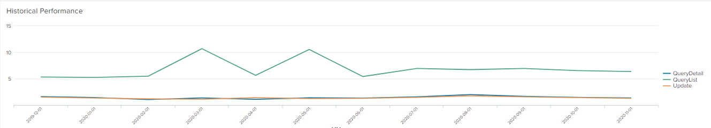

Accomplishments 2020/Goals 2021
- Briefly reviewed Goals of 2020 to assess if accomplished. Added a few additional accomplishments
- Reviewed Goals for 2020 to modify as Goals for 2021.
- ACTION: Sheri will draft a summary of 2020 Accomplishments and 2021 Goals as discussed for final review at January TDTMS

Tips & Tricks /User’s Guide to IAS Market Reports
- Further discussion on how to broadly communicate the IAG Timeline Data Analysis to REPs that was presented at the December 1st RMS meeting
- ACTION: Sheri to send out IAG Timeline report communication to RMS list serves with instructions/considerations in reviewing the REP-specific data – including current relevant information and excluding the TXSET 5.0 IAG solution

- Collaborate with RMTTF to integrate into IAG/MarkeTrak Training
- With framework already established, it was suggested the IAS data be requested through December 2020 (in March 2021) for analysis and present to RMS in June 2021
  - Perhaps a new visual format with trend analysis
- IAG and IAL Analysis spreadsheets will be posted on the main meeting page for TDTMS
- ACTION: communicate with RMS leadership that the current IAG report (prepared by ERCOT) be presented quarterly at RMS for visibility

Switch Hold Process – current process & opportunities
- the current switch hold notification process involves each TDU post files by 9 AM each weekday to an SFTP for each REP to be able to access and utilize
- the discussion has been prompted with the transition of the TNMP switch hold files to no longer be deposited on the SFTP site, but made available via their CRIP portal effective early 2021
- this change will result in some REPs revising their internal processing of SH files, seeking alternative automated processing
- a couple of the options discussed included
  - utilizing the TDSP daily extract file of which SH is an indicator
  - posting SH files via MarkeTrak
  - providing a new repository via secured MIS for TDUs to send files via NAESB and REPs pick up the files in a secured location behind MIS
- Level setting was established on the timeline for the ‘pulls’ and posting of the current files
  - TDSP Daily Extract file includes all 814_20s received through midnight for the specified day
  - TNMP:
    - removal/adding of SH is real time, however, 814_20s are batched overnight (after midnight) and sent to ERCOT
    - Daily SH report is loaded on CRIP ~1:30 AM
  - AEP:
    - Removal/adding of SH is real time, 814_20s are sent real time to ERCOT
    - Daily SH report is generated at 3 AM and posted to REP Desk
  - CNP:
    - Removal/adding of SH is real time, 814_20s are sent real time to ERCOT
    - Daily SH files are posted to SFTP @ 2 AM
  - Oncor:
    - Removal/adding of SH is real time, 814_20s are sent real time to ERCOT
    - Daily SH files are posted by 7 AM to CRIP
- After much discussion, the preferred option seemed to be an ERCOT file/repository. Dave Michelson needed to confirm, but did not feel this was a heavy lift for ERCOT and technically feasible.
- The initial requirements of the ‘ask’ were outlined as follows and will be provided in further detail to Dave via email:
  - Information will not need to go through registration system (Siebel)
  - Must be secure (behind DC/MIS)
  - Timing of information must be up through day prior and posted possibly sooner than the current 9 AM guideline (possibly 7 AM)
  - Posting maybe as received or once per day, specified cadence, with ‘old files’ rolling off
  - Automated – creating a path for TDUs to post specified file format (.csv) via certain path (NAESB) utilizing existing naming convention (as outlined in Appendix J1 of RMG)
- Based on initial requirements, Dave thought it might be posted in EMIL and there may be paperwork involved in establishing. In terms of timing, Dave was not certain if this would have to follow a project path (rank and priority) or would be handled differently. Hopes are additional clarity could be provided by the end of Q1
- ACTION: Sheri will draft the email for the above requirements of the SH process change

AGENDA for 12/16/20 Meeting
- Leadership Elections
- ERCOT Update
  - System Instances and MarkeTrak Monthly Performance Review
- Accomplishments of 2020/ Goals for 2021
- Review of Switch Hold Process Proposal to ERCOT
- Review of timing of Unexecutable IAG MTs
- MT Enhancements- follow up on SCR items
  - Rolodex entries
  - Archiving of unused subtypes
  - Unexecutable reasons
- Begin development of SCR – assignments – timeline for submission

