System Planning
Monthly Status Report

Report Highlights

- ERCOT is currently reviewing proposed transmission improvements with a total estimated cost of $1,040.86 Million as of November 30, 2020.
- Transmission Projects endorsed in 2020 total $1,043.29 Million as of November 30, 2020.
- All projects (in engineering, routing, licensing and construction) total approximately $7.6 Billion as of October 1, 2020.
- Transmission Projects energized in 2020 total about $1.20 Billion as of October 1, 2020.

Regional Planning Group Reviews
- AEPSC has submitted the LRGV Import Project. This is a Tier 1 project that is estimated to cost $73.4 million. AEPSC has also requested that ERCOT provide a conditional endorsement for an additional $357.2 million project. ERCOT’s independent review has been conducted in accordance with Protocol Section 3.11.4.9(3), and this project is currently placed on hold until the LNG loads are confirmed.
- STEC has submitted the Lower Rio Grande Valley Transmission Expansion Project. This is a Tier 1 project that is estimated to cost $511 million. ERCOT’s independent review has been conducted in accordance with Protocol Section 3.11.4.9(3), and this project is currently placed on hold until the LNG loads are confirmed.
- Oncor has submitted the Nacogdoches Southeast Switch – Redland Switch – Lufkin Switch 345-kV Loop Project. This is a Tier 2 project that is estimated to cost $71.26 million. This project is currently under ERCOT’s independent review.
- AEPSC has submitted the Lake Pauline Area Improvement Project. This is a Tier 3 project that is estimated to cost $47.5 million. The RPG Project Review of this project was completed on November 9. Pursuant to the Protocol Section 3.11.4.3.1 (d), this project has been reclassified as a Tier 4, neutral project.
- CNP has submitted the Wallis to Peters Ckt 65 138-kV Line Rebuild Project. This is a Tier 3 project that is estimated to cost $64.78 million. The RPG Project review of this project was completed on November 18, and ERCOT has issued an acceptance letter.
- AEPSC has submitted the Burma to Sterling City 69-kV Line Rebuild Project. This is a Tier 3 project that is estimated to cost $28 million. The RPG Project Review of this project was completed on November 23. Pursuant to the Protocol Section 3.11.4.3.1 (d), this project has been reclassified as a Tier 4, neutral project.
- AEPSC has submitted the Hamilton Road to Maxwell 138-kV Line Rebuild Project. This is a Tier 3 project that is estimated to cost $28 million. This project is currently in the RPG study mode.

More information on current and past RPG projects can be found on the ERCOT MIS Secure (digital certificate required): https://mis.ercot.com/public/data-products/grid/regional-planning
Past email communication on RPG projects can be found on the ERCOT listserve by signing up for the REGPLANGROUP list: http://lists.ercot.com/scripts/wa-ERCOT.exe?A0=REGPLANGROUP

Planning Model Activities
The short-term calendar of major planning model events is as follows:
- By March 1, 2021 20SSWG Update 2 cases and TPIT are posted
- By March 31, 2021 20SSWGU2 Contingency definitions and Planning Data Dictionary are posted
The following table shows interconnection projects that met Planning Guide section 6.9(1) and 6.9(2) and were modeled in the SSWG cases as a full model or as a simple model in accordance with Planning Guide section 6.9. 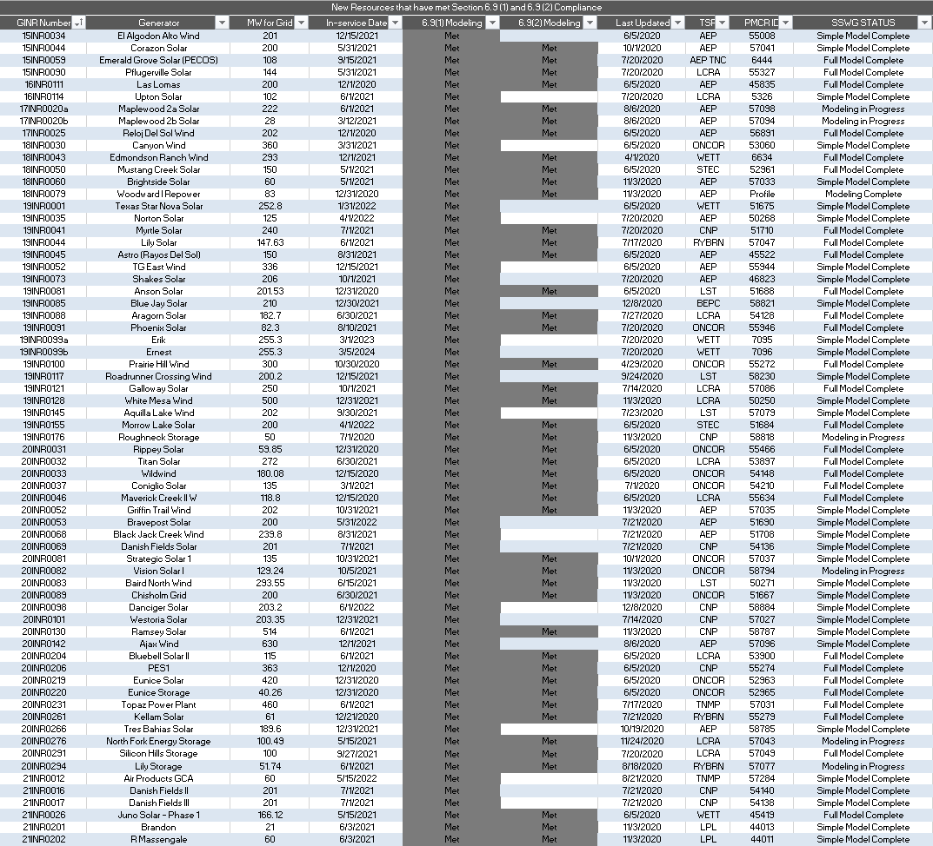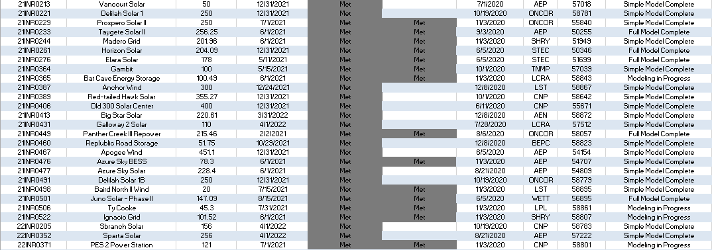

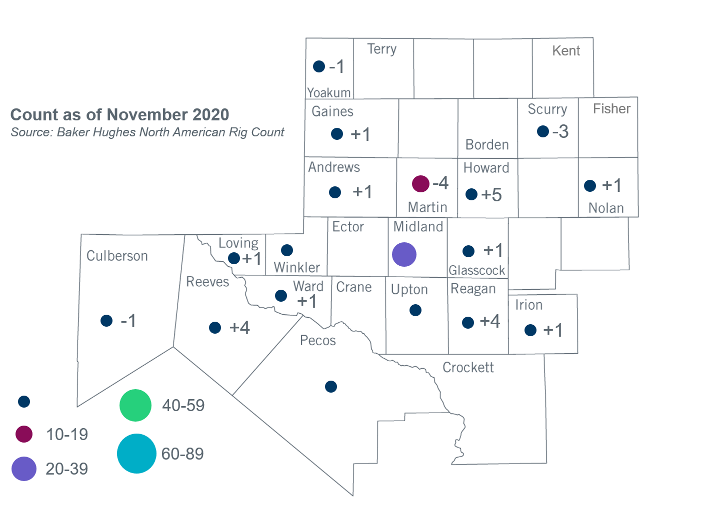
Permian Basin Oil Rig Count
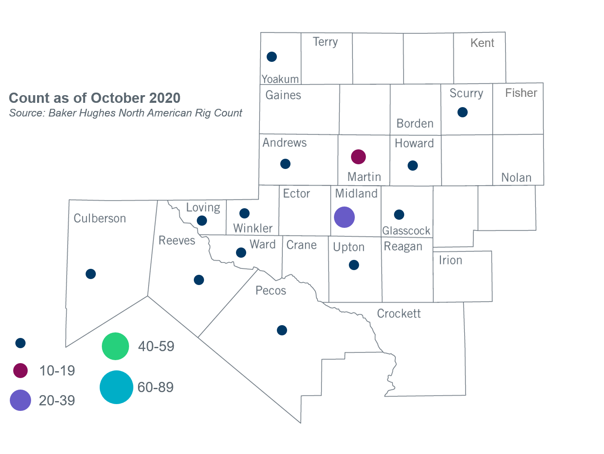

Other Notable Activities
- ERCOT posted short-circuit analysis results for the 2020 Regional Transmission Plan (RTP) to the MIS Secure Area in November.
- ERCOT posted preliminary secure reliability cases for the 2020 RTP in PowerWorld format, including generator cost curve data used for security-constrained optimal power flow (SCOPF), to the MIS Certified Area for TSPs in November.
- ERCOT plans to post the public version of the 2020 RTP report, the 2020 Long-Term System Assessment report and the 2020 Report on Existing and Potential Electric System Constraints and Needs in the following location by December 31: http://www.ercot.com/gridinfo/planning.
- ERCOT continued discussion of the near-term proposal for including distributed energy resources (DER) in planning models with SSWG and DWG in November.
- ERCOT will conduct a special study to develop a potential roadmap of transmission solutions for West Texas export constraints. ERCOT will provide regular updates at future RPG meetings.

+/- symbol indicates the increase or decrease from the previous month in oil rigs present in each county. There are 104 rigs, including a total increase of 11 oil rigs, in the Permian Basin from October to November 2020.

