November 2020 ERCOT Monthly Operations Report
Reliability and Operations Subcommittee Meeting
January 7, 2021

Table of Contents
1. Report Highlights 2
2. Frequency Control 3
2.1. Frequency Events 3
2.2. Responsive Reserve Events 4
2.3. Load Resource Events 4
3. Reliability Unit Commitment 4
4. Wind Generation as a Percent of Load 5
5. Largest Net-Load Ramp 5
6. COP Error Analysis 6
7. Congestion Analysis 8
7.1. Notable Constraints 8
7.2. Generic Transmission Constraint Congestion 12
7.3. Manual Overrides 12
7.4. Congestion Costs for Calendar Year 2020 12
8. System Events 14
8.1. ERCOT Peak Load 14
8.2. Load Shed Events 14
8.3. Stability Events 14
8.4. Notable PMU Events 14
8.5. DC Tie Curtailment 14
8.6. TRE/DOE Reportable Events 14
8.7. New/Modified/Removed RAS 14
8.8. New Procedures/Forms/Operating Bulletins 14
9. Emergency Conditions 15
9.1. OCNs 15
9.2. Advisories 15
9.3. Watches 15
9.4. Emergency Notices 15
10. Application Performance 15
10.1. TSAT/VSAT Performance Issues 15
10.2. Communication Issues 15
10.3. Market System Issues 16
11. Model Updates 16
Appendix A: Real-Time Constraints 18

Report Highlights
- The unofficial ERCOT peak load was 49,027 MW.
- There were 6 frequency events.
- There were 5 instances where Responsive Reserves were deployed.
- There was 1 RUC commitment.
- Congestion in the Panhandle can be attributed to wind generation in the area as well as multiple transmission outages. There were 26 days of congestion on the Panhandle GTC, 23 days on the North Edinburg to Lobo GTC, 20 days on the McCamey GTC 13 days on the Raymondville to RioHondo GTC, 12 days on the West to Central Texas GTC, and 8 days on the North to Houston Import GTC. There was no activity on the remaining GTCs during the month.
- Load Event
  - On November 15th at approximately 10:47:40 frequency spiked up to 60.112 Hz. CenterPoint TO reported the loss of approximately 579 MW industrial load at Cortez (CTZ) 138 kV substation. No transmission breaker operations occurred on the system due to this event and the CTZ load transformers remained energized during and after the event.

Frequency Control

Frequency Events

The ERCOT Interconnection experienced six frequency events, which resulted from unit’s trips. The average event duration was 00:04:51.

A summary of the frequency events is provided below. The reported frequency events meet one of the following criteria: Delta Frequency is 60 mHz or greater; the MW loss is 350 MW or greater; resource trip event triggered RRS deployment. Frequency events that have been identified as Frequency Measurable Events (FME) for purposes of BAL-001-TRE-1 analysis are highlighted in blue. When analyzing frequency events, ERCOT evaluates PMU data according to industry standards. Events with an oscillating frequency of less than 1 Hz are considered to be inter-area, while higher frequencies indicate local events. Industry standards specify that damping ratio for inter-area oscillations should be 3.0% or greater. For the frequency events listed below, the ERCOT system met these standards and transitioned well after each disturbance.

Date and Time | Delta Frequency | Max/Min Frequency | Duration of Event | PMU Data |  | MW Loss | Load | Wind | Inertia
 | (Hz) | (Hz) |  | Oscillation Mode (Hz) | Damping Ratio |  | (MW) | % | (GW-s)
11/7/2020 18:05 | 0.098 | 59.891 | 0:03:40 | 0.560 | 13% | 474.2 | 42,152 | 35% | 181,125
11/15/2020 10:47 | -0.096 | 60.112 | 0:03:58 | 0.680 | 8% | 579.02 | 36,150 | 16% | 204,029
11/16/2020 9:51 | 0.209 | 59.797 | 0:07:56 | 0.660 | 9% | 1020.3 | 39,374 | 21% | 209,662
11/21/2020 0:20 | 0.166 | 59.829 | 0:05:29 | 0.670 | 10% | 734.18 | 33,709 | 30% | 205,995
11/22/2020 12:35 | 0.075 | 59.902 | 0:04:15 | No PMU Data Available |  | 367.36 | 39,964 | 24% | 219,654
11/27/2020 9:19 | 0.090 | 59.910 | 0:03:49 | No PMU Data Available |  | 338.51 | 37,165 | 42% | 167,172

(Note: All data on this graph encompasses frequency event analysis based on BAL-001-TRE-1.)

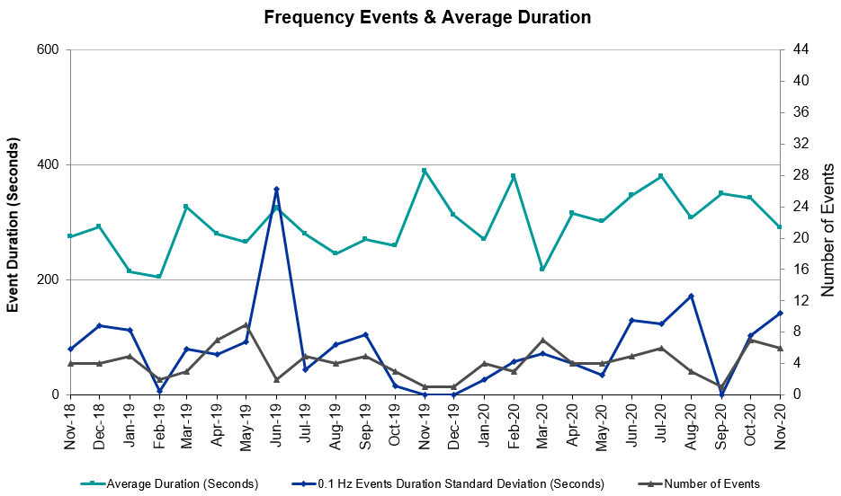

Note that the large standard deviation in June 2019 is due to coincidental extreme high and low durations for a small set of events (2).

Responsive Reserve Events
There were 5 events where Responsive Reserve MWs were released to SCED. The events highlighted in blue were related to frequency events reported in Section 2.1 above.

Date and Time Released to SCED | Date and Time Recalled | Duration of Event | Maximum MWs Released | Comments
11/7/2020 18:05:22 | 11/7/2020 18:08:46 | 00:03:24 | 596
11/16/2020 9:51:44 | 11/16/2020 9:57:12 | 00:05:28 | 1163
11/21/2020 0:20:18 | 11/21/2020 0:25:30 | 00:05:12 | 1235
11/22/2020 1:22:20 | 11/22/2020 1:26:24 | 00:04:04 | 626
11/22/2020 12:35:22 | 11/22/2020 12:39:34 | 00:04:12 | 506

Load Resource Events
None.

Reliability Unit Commitment
ERCOT reports on Reliability Unit Commitments (RUC) on a monthly basis. Commitments are reported grouped by operating day and weather zone. The total number of hours committed is the sum of the hours for all the units in the specified region. Additional information on RUC commitments can be found on the MIS secure site at Grid Generation Reliability Unit Commitment.

There were no DRUC commitments.

There was 1 HRUC commitment.

Resource Location | # of Resources | Operating Day | Total # of Hours Committed | Total MWhs | Reason for Commitment
Southern | 2 | 11/17/2020 | 3 | 1,211 | XNED258

Wind Generation as a Percent of Load
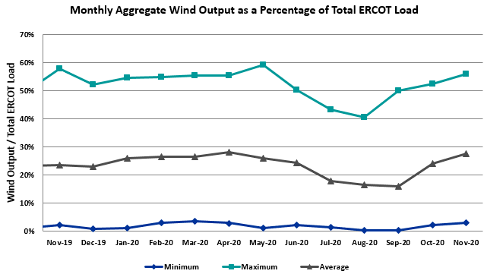

Wind Generation Record: 21,375 MW on 6/28/2020 at 23:22
Wind Penetration Record: 59.30% on 05/02/2020 at 02:10

Largest Net-Load Ramp
The net-load ramp is defined as the change in net-load (load minus wind and PVGR generation) during the defined time horizon. Such a variation in net-load needs to be accommodated in grid operations to ensure that the reliability of the grid is satisfactorily maintained. The largest net-load ramp during 5-min, 10-min, 15-min, 30-min and 60-min in November 2020 are 971 MW, 1264 MW, 1655 MW, 3061 MW, and 5751 MW, respectively. The comparison with respect to the historical values is given in the table below.

Month and Year | 5 min | 10 min | 15 min | 30 min | 60 min
November 2020 | 971 MW | 1264 MW | 1655 MW | 3061 MW | 5751 MW
November 2014 | 991 MW | 1689 MW | 2112 MW | 3289 MW | 5392 MW
November 2015 | 915 MW | 1637 MW | 1995 MW | 3241 MW | 5516 MW
November 2016 | 821 MW | 1404 MW | 1827 MW | 3166 MW | 5866 MW
November 2017 | 877 MW | 1581 MW | 2078 MW | 3393 MW | 5708 MW
November 2018 | 814 MW | 1553 MW | 2148 MW | 4109 MW | 7218 MW
November 2019 | 940 MW | 1606 MW | 2269 MW | 3934 MW | 6317 MW
All Months in 2014-2019 | 1494 MW | 1991 MW | 2780 MW | 4109 MW | 7786 MW

COP Error Analysis
COP Error is calculated as the capacity difference between the COP HSL and real-time HSL of the unit. Mean Absolute Error (MAE) stayed over 7,000 MW until Day-Ahead at 12:00, then dropped significantly to 1,671 MW by Day-Ahead at 14:00. In the following chart, Under-Scheduling Error indicates that COP had less generation capacity than real-time and Over-Scheduling Error indicates that COP had more generation capacity than real-time.
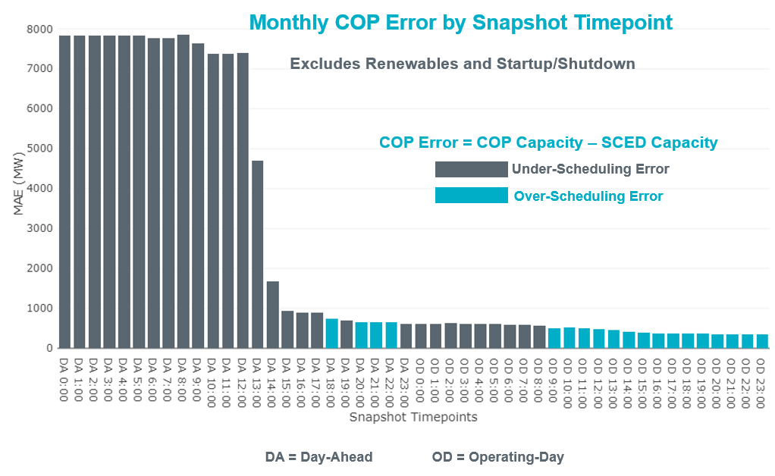
Monthly MAE for the Latest COP at the end of the Adjustment Period was 355 MW with median ranging from -236 MW for Hour-Ending (HE) 19 to 140 MW for HE 8. HE 24 on the 18th had the largest Over-Scheduling Error (3,026 MW) and HE 22 on the 5th had the largest Under-Scheduling Error (-3,076 MW).

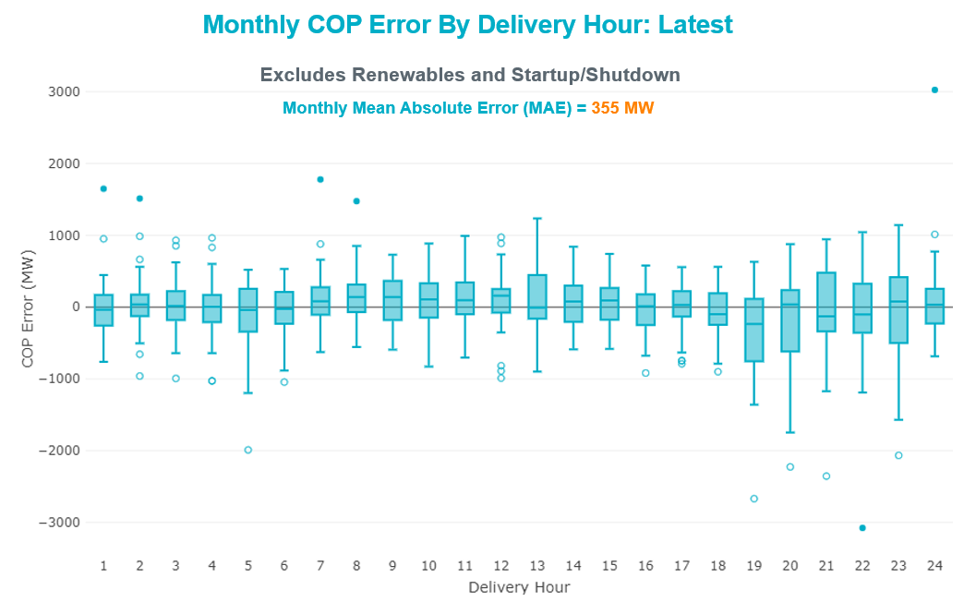

Monthly MAE for the Day-Ahead COP at 12:00 was 7,402 MW with median ranging from -10,632 MW for Hour-Ending (HE) 17 to -3,789 MW for HE 2. HE 17on the 10th had the largest Under-Scheduling Error (-17,705 MW) and HE 24 on the 23rd had the largest Over-Scheduling Error (1247 MW).

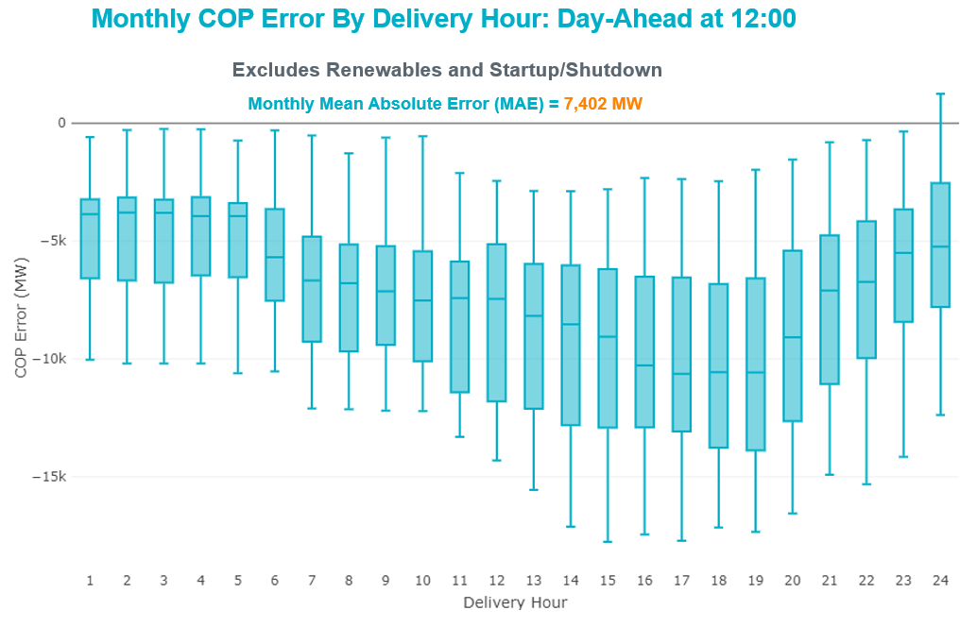

Congestion Analysis

Notable Constraints
Nodal protocol section 3.20 specifies that ERCOT shall identify transmission constraints that are active or binding three or more times within a calendar month. As part of this process, ERCOT reports congestion that meets this criterion to ROS. In addition ERCOT also highlights notable constraints that have an estimated congestion rent exceeding $1,000 for a calendar month. These constraints are detailed in the table below. Rows highlighted in blue indicate the congestion was affected by one or more outages. For a list of all constraints activated in SCED, please see Appendix A at the end of this report.

Contingency Name | Overloaded Element | # of Days Constraint Active | Congestion Rent | Transmission Project
GAS PAD to FLAT TOP TNP LIN 1 | Lynx - Tombstone 138kV | 16 | $45,457,738.33 | Lynx: Expand 138 kV station (45503)
CRLNW TO LWSSW 345 DBLCKT | Ti Tnp - West Tnp 138kV | 16 | $22,814,730.48 | Lewisville - Lewisville Jones - Lakepointe 138 kV Line (45537)
Basecase | PNHNDL GTC | 26 | $16,863,252.84 | Panhandle GTC Exit Plan - "PANHANDLE RENEWABLE ENERGY ZONE (PREZ)  STUDY REPORT" on MIS, CONSTRUCT OGALLALA TO BLACKWATER DRAW 345 KV LINE (52245), CONSTRUCT BLACKWATER DRAW TO FOLSOM POINT345 KV LINE (52258), CONSTRUCT BLACKWATER DRAW TO DOUBLE MOUNTAIN (52299), CONSTRUCT DOUBLE MOUNTAIN TO FIDDLEWOOD TO FARMLAND 345 KV L (522307)
CPSES TO JONSW 345 AND CPSES TO EVRSW 345 DBLCKT | Rocky Creek - Mitchell Bend Switch 345kV | 10 | $15,180,127.44 | Mitchell Bend - Rocky Creek 345 kV line (5312)
GAS PAD to FLAT TOP TNP LIN 1 | Lynx - Rio Pecos 138kV | 7 | $9,003,429.29 | Rebuild Rio Pecos-Lynx Ckt 2 (1926 ACSS) (54255)
GibbonsCreek-Limestone 345kV | Jewett - Singleton 345kV | 11 | $7,858,974.33
ODLAW SWITCHYARD to ASPHALT MINES LIN 1 | Hamilton Road - Maverick 138kV | 21 | $2,634,396.14 | Brackettville to Escondido: Construct 138 kV line (5206)
Basecase | NE_LOB GTC | 23 | $1,965,598.15 | GTC Exit plan in the North Edinburg - Lobo Stability Study Report posted in the ERCOT MIS website
Basecase | MCCAMY GTC | 20 | $1,683,350.77 | McCamey GTC Exit Plan posted on the ERCOT MIS website (Far West Transmission Project 2)
Dmtsw-Kirchhof-Figaro 345kV | Knapp - Scurry Chevron 138kV | 4 | $1,634,222.44 | Ennis Creek - Cogdell 69 kV Line (4554) & Ennis Creek 138 kV Switching Station (6269)
NORTH EDINBURG TRX 1382 345/138 | Burns Sub - Rio Hondo 138kV | 8 | $1,203,137.88 | Stewart Road: Construct 345 kV cut-in with two 450 MVA 345/138 autotransformers connected to Stewart Rd 138 station (5604, 6382)
Cagnon-Kendal 345 & Cico-Comfor 138 | Mason Creek - Bandera 138kV | 4 | $962,812.21
NORTH EDINBURG TRX 1382 345/138 | Weslaco Switch - Weslaco Sub 138kV | 3 | $945,261.19 | Stewart Road: Construct 345 kV cut-in with two 450 MVA 345/138 autotransformers connected to Stewart Rd 138 station (5604, 6382)
BRACKETTVILLE to HAMILTON ROAD LIN 1 | Hamilton Road - Maverick 138kV | 12 | $771,458.67 | Brackettville to Escondido: Construct 138 kV line (5206)
Cagnon-Kendall 345kV&Txresch-Tally_Rd 138kV | Helotes - Ranchtwn 138kV | 3 | $742,802.15 | CPSE_New_Scenic_Loop_138kV_Load_Serving_Station (44946)
Melon Creek to RINCON LIN 1 | Bonnieview - Rincon 69kV | 9 | $608,196.08 | Refugio - Rincon: Upgrade 69 kV Line (6427)
Basecase | WESTEX GTC | 12 | $598,209.89
ENTPR TO TRSES 345 AND MLSES TO SCSES 345 DBLCKT | Lufkin Switch - Nacogdoches South Tap 138kV | 4 | $582,352.87 | Nacogdoches Southeast Switch – Redland Switch – Lufkin Switch 345 kV Loop Project (Currently under RPG IR)
Pig Creek to Solstice LIN 1 | Fort Stockton Plant - Tombstone 138kV | 22 | $374,914.25 | Barrilla Junction to Ft. Stockton SW: Rebuild 69 kV line (7027)  Solstice: Install 138 kV PST and capacitor bank (44359)
MCELMURRAY to ESKOTA SWITCH LIN 1 | Eskota Switch - Trent 69kV | 12 | $371,670.35
LON HILL to NELSON SHARPE LIN 1 | Celanese Bishop - Kleberg Aep 138kV | 6 | $331,733.59
SAN MIGUEL GEN to FOWLERTON LIN 1 | San Miguel Gen 345kV | 8 | $321,885.85 | San Miguel 345/138 kV autotransformer replacements (5218A, 5218B)
FORNEY SWITCH to LAKE HUBBARD SES and Centerville Rd 345 and 138 | Seagoville - Kleberg Tap 138kV | 3 | $263,561.81
FORT MASON to YELLOW JACKET LIN 1 | Yellow Jacket - Hext Lcra 69kV | 14 | $239,710.68 | Yellowjckt to Menard Phillips T 69 kV line: Rebld 69 kV line (6345)
DUPONT SWITCH - INGLESIDE to INGLESIDE COGEN SWITCH LIN 1 | Dupont Pp1 - Ingleside - Dupont Switch - Ingleside 138kV | 7 | $233,078.44
Basecase | RV_RH GTC | 13 | $209,169.67 | GTC Exit plan in the Raymondville-RioHondo GTC Study Report posted in the ERCOT MIS website
COMANCHE SWITCH (Oncor) to COMANCHE PEAK SES LIN _A | Comanche Tap - Comanche Switch (Oncor) 138kV | 6 | $187,074.08
RIO HONDO to LAS PULGAS LIN 1 | Raymondville 2 138kV | 7 | $147,202.77 | Harlingen SS - Raymondville #2: Convert to 138 kV (6167)
Bighil-Kendal 345kV | Yellow Jacket - Treadwell 138kV | 3 | $133,817.59 | Treadwell GTC Exit Plan posted on the ERCOT MIS website
POMELO to NORTH EDINBURG LIN 1 | Lobo - Freer 69kV | 6 | $129,188.20 | GTC Exit plan in the North Edinburg - Lobo Stability Study Report posted on the ERCOT MIS website
WLFSW-MOSSW 345&WLFSW-ODEHV 345____TRPLCKT-1of3 | Lynx - Tombstone 138kV | 4 | $125,522.93 | Lynx: Expand 138 kV station (45503)
FORT MASON to YELLOW JACKET LIN 1 | Mason Switching Station - Hext Lcra 69kV | 7 | $115,680.81 | Mason to North Brady: Rebuild 69 kV line (50900)
PAREDES SWITCHING STATION to CENTRAL AVENUE SUB LIN 1 | Rio Hondo - East Rio Hondo Sub 138kV | 10 | $110,748.73 | Rebuild Rio Hondo to East Rio Hondo (6687)
Fowlerton to LOBO 345 LIN1 | North Laredo Switch - Piloncillo 138kV | 6 | $107,877.24 | GTC Exit plan in the North Edinburg - Lobo Stability Study Report posted in the ERCOT MIS website
Pig Creek to Solstice LIN 1 | Lynx - Rio Pecos 138kV | 14 | $84,890.40 | Rebuild Rio Pecos-Lynx Ckt 2 (1926 ACSS) (54255)
Solstice to ALAMITO CREEK LIN 1 | Fort Stockton Plant - Tombstone 138kV | 3 | $80,094.70 | Barrilla Junction to Ft. Stockton SW: Rebuild 69 kV line (7027)  Solstice: Install 138 kV PST and capacitor bank (44359)
SOUTH TEXAS PROJECT to BLESSING LIN 1 | Coleto Creek - Victoria 138kV | 5 | $70,834.73 | Coleto Creek - Rosata: Line Rebuild (50870)
Ferguson-Sherwood Shores & Ferguson-Granite Mountain 138kV | Johnson City - Wirtz 138kV | 17 | $61,022.27 | Wirtz to Johnson City to Mountain Top Rebuild to 138kV (6789)
KING MOUNTAIN SWITCHYARD to ODESSA EHV SWITCH LIN 1 | Fort Stockton Plant - Solstice 138kV | 10 | $59,249.21 | Solstice: Build 345 kV station (5530)
KLEBERG AEP to LOYOLA SUB LIN 1 | Loyola Sub 138kV | 3 | $58,540.95 | Lon Hill: Replace 345/138 kV autotransformers (6101)
SCURRY SWITCH to SALT CREEK BEPC LIN 1 | Aspermont Continental - Hamlin Shell 69kV | 6 | $54,344.07
SPUR to SALT CREEK SS LIN 1 | Aspermont Aep - Aspermont Continental 69kV | 11 | $47,274.37
MESA VIEW SWITCH to FORT LANCASTER LIN 1 | North Mccamey - Crossover 138kV | 4 | $40,263.41 | McCamey GTC Exit Plan posted on the ERCOT MIS website
CENTERVILLE ROAD SWITCH to FORNEY SWITCH LIN _A | Forney Switch 138kV | 3 | $38,656.49 | Forney Sw. Sta. Second 600 MVA, 345/138 kV Autotransformer (12TPIT0080)
FORT LANCASTER to ILLINOIS #4 LIN 1 | Hamilton Road - Maxwell 138kV | 6 | $31,630.42 | Hamilton Road - Maxwell (recently approved RPG project)
WLFSW-MOSSW 345&WLFSW-ODEHV 345____TRPLCKT-1of3 | Odessa Ehv Switch - Yarbrough Sub 138kV | 6 | $30,282.97 | Riverton-Odessa EHV/Moss 345 kV Line (5445)
Carver to FRIEND RANCH LIN 1 | Hamilton Road - Maxwell 138kV | 10 | $29,286.80 | Hamilton Road - Maxwell (recently approved RPG project)
Bighil-Kendal 345kV | Hamilton Road - Maxwell 138kV | 5 | $10,502.86 | Hamilton Road - Maxwell (recently approved RPG project)
KING MOUNTAIN SWITCHYARD to ODESSA EHV SWITCH LIN 1 | Lynx - Tombstone 138kV | 7 | $10,500.07 | Lynx: Expand 138 kV station (45503)
Fergus-Granmo&Wirtz-Starck 138kV | Johnson City - Wirtz 138kV | 14 | $10,209.13 | Wirtz to Johnson City to Mountain Top Rebuild to 138kV (6789)
Basecase | N_TO_H GTC | 8 | $7,049.05 | North - Houston Import Stability Report posted on the ERCOT MIS website
Marbfa-Lakewy &Wirtz-Palefa 138kV | Johnson City - Wirtz 138kV | 8 | $5,209.04 | Wirtz to Johnson City to Mountain Top Rebuild to 138kV (6789)
SUN SWITCH to SCURRY SWITCH LIN 1 | Aspermont Aep - Aspermont Continental 69kV | 7 | $2,677.77
Arrowhead Tap to Lotebush LIN 1 | Lynx - Rio Pecos 138kV | 12 | $1,876.00 | Rebuild Rio Pecos-Lynx Ckt 2 (1926 ACSS) (54255)
Arrowhead Tap to Lotebush LIN 1 | Fort Stockton Plant - Tombstone 138kV | 22 | $1,552.23 | Barrilla Junction to Ft. Stockton SW: Rebuild 69 kV line (7027)  Solstice: Install 138 kV PST and capacitor bank (44359)

Generic Transmission Constraint Congestion
There were 26 days of congestion on the Panhandle GTC, 23 days on the North Edinburg to Lobo GTC, 20 days on the McCamey GTC 13 days on the Raymondville to RioHondo GTC, 12 days on the West to Central Texas GTC, and 8 days on the North to Houston Import GTC. There was no activity on the remaining GTCs during the month.

Note: This is how many times a constraint has been activated to avoid exceeding a GTC limit, it does not imply an exceedance of the GTC occurred or that the GTC was binding.

Manual Overrides
None.

Congestion Costs for Calendar Year 2020
The following table represents the top twenty active constraints for the calendar year based on the estimated congestion rent attributed to the congestion. ERCOT updates this list on a monthly basis.

Contingency | Overloaded Element | # of 5-min SCED | Estimated | Transmission Project
Basecase | PNHNDL GTC | 37200 | 119500538.9 | Panhandle GTC Exit Plan - "PANHANDLE RENEWABLE ENERGY ZONE (PREZ)  STUDY REPORT" on MIS, CONSTRUCT OGALLALA TO BLACKWATER DRAW 345 KV LINE (52245), CONSTRUCT BLACKWATER DRAW TO FOLSOM POINT345 KV LINE (52258), CONSTRUCT BLACKWATER DRAW TO DOUBLE MOUNTAIN (52299), CONSTRUCT DOUBLE MOUNTAIN TO FIDDLEWOOD TO FARMLAND 345 KV L (522307)
MOSS SWITCH to ECTOR COUNTY NORTH SWITCHING STATION LIN _A | Dollarhide - No Trees Switch 138kV | 12277 | 115237549.4 | Wink to Andrews County South 138 kV Second Circuit (Project-51236, completed in May 2020)
WINK to DUNE SWITCH and YUKON | Dollarhide - No Trees Switch 138kV | 10924 | 76533287.97 | Wink to Andrews County South 138 kV Second Circuit (Project-51236, completed in May 2020)
CRLNW TO LWSSW 345 DBLCKT | Ti Tnp - West Tnp 138kV | 14618 | 68907852.74 | Lewisville - Lewisville Jones - Lakepointe 138 kV Line (45537)
MANUAL Nedin-Mv_Wedn4 Dbl Ckt 138kV | Hidalgo Energy Center - Azteca Sub 138kV | 1656 | 62254257.21 | Stewart Road: Construct 345 kV cut-in with two 450 MVA 345/138 autotransformers connected to Stewart Rd 138 station (5604, 6382)
GAS PAD to FLAT TOP TNP LIN 1 | Lynx - Tombstone 138kV | 5375 | 50656859.86 | Lynx: Expand 138 kV station (45503)  Rebuild Rio Pecos-Lynx Ckt 2 (1926 ACSS) (54255)
Manual MDSSW_TRX1_345/138 | Trigas Odessa Tap - Odessa Ehv Switch 138kV | 1787 | 38328997.67 | Riverton-Odessa EHV/Moss 345 kV Line (5445)
WEST EDNBURG SUB to ALTON SUB LIN 1 | Weslaco Switch - North Alamo 138kV | 681 | 33768437.92 | Stewart Road: Construct 345 kV cut-in with two 450 MVA 345/138 autotransformers connected to Stewart Rd 138 station (5604, 6382)
NORTH EDINBURG TRX 1382 345/138 | North Edinburg 345kV | 1787 | 31195346.73 | Stewart Road: Construct 345 kV cut-in with two 450 MVA 345/138 autotransformers connected to Stewart Rd 138 station (5604, 6382)
NORTH PHARR to WESLACO SWITCH LIN 1 | Key Switch - North Mcallen 138kV | 526 | 27451240.28 | Stewart Road: Construct 345 kV cut-in with two 450 MVA 345/138 autotransformers connected to Stewart Rd 138 station (5604, 6382)
HCKSW TO SAGNA 138 DBLCKT | Eagle Mountain Ses - Morris Dido 138kV | 5716 | 26725680.9 | Upgrade the Saginaw - Eagle Mountain 138 kV Double Circuit Line (6273)
WINK to DUNE SWITCH and YUKON | Andrews County South - Amono Three Bar Tap 138kV | 2002 | 23188211.21 | Wink to Andrews County South 138 kV Second Circuit (Project-51236, completed in May 2020)
WEST EDNBURG SUB to NORTH EDINBURG LIN 1 | North Edinburg - West Ednburg Sub 138kV | 529 | 22020286.78 | Stewart Road: Construct 345 kV cut-in with two 450 MVA 345/138 autotransformers connected to Stewart Rd 138 station (5604, 6382)
MOSS SWITCH to ECTOR COUNTY NORTH SWITCHING STATION LIN _A | Andrews County South - Amono Three Bar Tap 138kV | 1316 | 21247827.71 | Wink to Andrews County South 138 kV Second Circuit (Project-51236, completed in May 2020)
Basecase | NE_LOB GTC | 18734 | 20764143.62 | GTC Exit plan in the North Edinburg - Lobo Stability Study Report posted in the ERCOT MIS website
ODLAW SWITCHYARD to ASPHALT MINES LIN 1 | Hamilton Road - Maverick 138kV | 25663 | 20154183.32 | Brackettville to Escondido: Construct 138 kV line (5206)
JEWET TO SNG 345 DBLCKT | Jack_Creek - Twin Oak Switch 345kV | 1193 | 17477432.7
CPSES TO JONSW 345 AND CPSES TO EVRSW 345 DBLCKT | Rocky Creek - Mitchell Bend Switch 345kV | 1226 | 16439085.77 | Mitchell Bend - Rocky Creek 345 kV line (5312)
TWR (345) HLJ-WAP64 & BLY-WAP72 | South Texas Project - Wa Parish 345kV | 4967 | 16202680.55 | Freeport - Master Plan (6668B)
GAS PAD to FLAT TOP TNP LIN 1 | Lynx - Rio Pecos 138kV | 2166 | 11923489.36 | Rebuild Rio Pecos-Lynx Ckt 2 (1926 ACSS) (54255)

System Events

ERCOT Peak Load
The unofficial ERCOT peak load for the month was 49,012 MW and occurred on the 9th, during hour ending 16:00.

Load Shed Events
None.

Stability Events
None.

Notable PMU Events
ERCOT analyzes PMU data for any significant system disturbances that do not fall into the Frequency Events category reported in section 2.1. The results are summarized in this section once the analysis has been completed.

There were no PMU events outside of those reported in section 2.1.

DC Tie Curtailment
Date | DC Tie | Curtailing Period | # of Tags Curtailed | Initiating Event | Curtailment Reason
11/13/2020 | DC-L | HE17 – HE24 | 5 | RTU Issues | Unplanned outage
11/14/2020 | DC-L | HE01 – HE23 | 4 | RTU Issues | Unplanned outage

TRE/DOE Reportable Events
- Gridforce QSE submitted an OE-417 for 11/20/2020. Reportable Event Type: Cyber Event.

New/Updated Constraint Management Plans
No changes were made this month.

New/Modified/Removed RAS
No changes were made this month.

New Procedures/Forms/Operating Bulletins
No changes were made this month.

Emergency Conditions

OCNs

Date and Time | Message
November 2 2020 22:40 CPT | ERCOT issued an OCN for modifying PNHNDL Generic Transmission Constraint due to the current transmission outage topology.

Advisories

Date and Time | Message
November 17 2020 13:30 CPT | ERCOT has postponed the posting of the DAM Solution for Operating Day November 18, 2020 due to delay in clearing DAM.
November 23 2020 13:30 CPT | ERCOT has postponed the posting of the DAM Solution for Operating Day November 24, 2020 due to delay in clearing DAM.

Watches
Date and Time | Message
November 17 2020 17:20 CPT | ERCOT issued a watch due to DRUC not completing by 18:00 due to delay in clearing DAM and posting DAM solution.

Emergency Notices
None.

Application Performance

TSAT/VSAT Performance Issues
None.

Communication Issues
None.

Market System Issues
None.

Model Updates
The Downstream Production Change (DPC) process allows ERCOT to make changes in the on-line Network Operations Model without loading a completely new model. The purpose of this process is to allow for reliable grid operations as system conditions change between designated Network Operations Model database loads. The DPC process is limited in scope to just those items listed below, with equipment ratings updates being the most common. ERCOT has seen a rise in the use of the DPC process to make on-line updates to the Network Operations Model in recent years, instead of through the standard Network Operations Model Change Request process.

- Static Line ratings (Interim Update)
- Dynamic Line ratings (non-Interim Update)
- Autotransformer ratings (non-Interim Update)
- Breaker and Switch Normal status (Interim Update)
- Contingency Definitions (Interim Update)
- RAP and RAS changes or additions (Interim Update)
- Net Dependable and Reactive Capability (NDCRC) values (Interim Update)
- Impedance Updates (non-Interim)

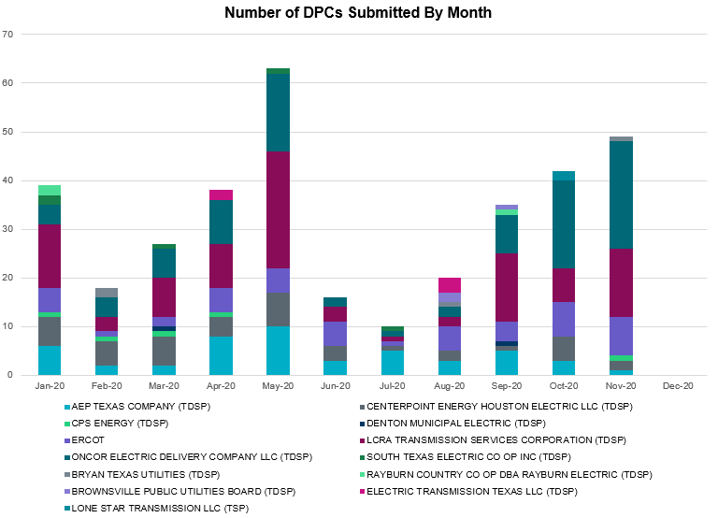

Transmission Operator | Number of DPCs
AEP TEXAS COMPANY (TDSP) | 1
BRAZOS ELECTRIC POWER CO OP INC (TDSP) | 0
BROWNSVILLE PUBLIC UTILITIES BOARD (TDSP) | 0
BRYAN TEXAS UTILITIES (TDSP) | 1
CENTERPOINT ENERGY HOUSTON ELECTRIC LLC (TDSP) | 2
CITY OF AUSTIN DBA AUSTIN ENERGY (TDSP) | 0
CITY OF COLLEGE STATION (TDSP) | 0
CITY OF GARLAND (TDSP) | 0
CPS ENERGY (TDSP) | 1
DENTON MUNICIPAL ELECTRIC (TDSP) | 0
ELECTRIC TRANSMISSION TEXAS LLC (TDSP) | 0
ERCOT | 8
LCRA TRANSMISSION SERVICES CORPORATION (TDSP) | 14
LONE STAR TRANSMISSION LLC (TSP) | 0
ONCOR ELECTRIC DELIVERY COMPANY LLC (TDSP) | 22
RAYBURN COUNTRY CO OP DBA RAYBURN ELECTRIC (TDSP) | 0
SHARYLAND UTILITIES LP (TDSP) | 0
SOUTH TEXAS ELECTRIC CO OP INC (TDSP) | 0
TEXAS MUNICIPAL POWER AGENCY (TDSP) | 0
TEXAS-NEW MEXICO POWER CO (TDSP) | 2

Appendix A: Real-Time Constraints
The following is a complete list of constraints activated in SCED. Full contingency descriptions can be found in the Standard Contingencies List located on the MIS secure site at Grid Generation Reliability Unit Commitment.

Contingency Name | Overloaded Element | From Station | To Station | Count of Days
BASE CASE | PNHNDL | n/a | n/a | 26
SARRLOT8 | FTST_TOMBST1_1 | FTST | TOMBSTNE | 23
BASE CASE | NE_LOB | n/a | n/a | 23
SARRLOT8 | FTST_TOMBST1_1 | TOMBSTNE | FTST | 23
SPIGSOL8 | FTST_TOMBST1_1 | FTST | TOMBSTNE | 22
SPIGSOL8 | FTST_TOMBST1_1 | TOMBSTNE | FTST | 22
SBRAUVA8 | HAMILT_MAVERI1_1 | HAMILTON | MAVERICK | 21
BASE CASE | MCCAMY | n/a | n/a | 20
DFERGRM8 | 318T313_1 | WIRTZ | JOHNCI | 17
SHACPB38 | LYNX_TOMBST1_1 | LYNX | TOMBSTNE | 16
DCRLLSW5 | 588_A_1 | LWSVW | LWVTI | 16
SPIGSOL8 | LYNX_RIOPEC1_1 | LYNX | RIOPECOS | 14
SFORYEL8 | HEXT_YELWJC1_1 | YELWJCKT | HEXT | 14
DFERSTA8 | 318T313_1 | WIRTZ | JOHNCI | 14
SPIGSOL8 | LYNX_RIOPEC1_1 | RIOPECOS | LYNX | 14
BASE CASE | RV_RH | n/a | n/a | 13
SMCEESK8 | ESKSW_TRNT1_1 | TRNT | ESKSW | 12
SSPUSLT8 | ASPM_CONA1_1 | CONA | ASPM | 12
BASE CASE | WESTEX | n/a | n/a | 12
SARRLOT8 | LYNX_RIOPEC1_1 | RIOPECOS | LYNX | 12
SMCEESK8 | ESKSW_TRNT1_1 | ESKSW | TRNT | 12
SBRAHAM8 | HAMILT_MAVERI1_1 | HAMILTON | MAVERICK | 12
SARRLOT8 | LYNX_RIOPEC1_1 | LYNX | RIOPECOS | 12
SSPUSLT8 | ASPM_CONA1_1 | ASPM | CONA | 12
DGIBLIM5 | 260_A_1 | JEWET | SNG | 11
SMV_PAR8 | RIOHND_ERIOHND_1 | MV_RIOHO | RIOHONDO | 10
SKINODE5 | FTST_SOLSTI1_1 | FTST | SOLSTICE | 10
SCARFRI8 | HAMILT_MAXWEL1_1 | MAXWELL | HAMILTON | 10
DCPSJON5 | 152__A | MBDSW | RKCRK | 10
SMELRIN8 | BONIVI_RINCON1_1 | RINCON | BONIVIEW | 9
DMARPA_8 | 318T313_1 | WIRTZ | JOHNCI | 8
SFORYEL8 | HEXT_MASONS1_1 | MASONSW | HEXT | 8
SSANFOW5 | SANMIGL_ATAH | SANMIGL | SANMIGL | 8
SFORYEL8 | HEXT_MASONS1_1 | HEXT | MASONSW | 8
BASE CASE | N_TO_H | n/a | n/a | 8
XNED258 | BURNS_RIOHONDO_1 | RIOHONDO | MV_BURNS | 8
SHACPB38 | LYNX_RIOPEC1_1 | RIOPECOS | LYNX | 7
SI_DI_48 | I_DUPP_I_DUPS2_1 | I_DUPP1 | I_DUPSW | 7
SKINODE5 | LYNX_TOMBST1_1 | LYNX | TOMBSTNE | 7
SRAYRI28 | RAYMND2_69A1 | RAYMND2 | RAYMND2 | 7
SSCUSU28 | ASPM_CONA1_1 | ASPM | CONA | 7
SSCUSU28 | ASPM_CONA1_1 | CONA | ASPM | 7
SLOBSA25 | NLARSW_PILONC1_1 | PILONCIL | NLARSW | 6
SPOMNED5 | FREER_LOBO1_1 | LOBO | FREER | 6
SN_SLON5 | CELANE_KLEBER1_1 | CELANEBI | KLEBERG | 6
SSPUMW18 | CONA_SHHA1_1 | CONA | SHHA | 6
SILLFTL8 | HAMILT_MAXWEL1_1 | MAXWELL | HAMILTON | 6
SCMNCPS5 | 651__B | CMNSW | CMNTP | 6
DWLFMOS5 | 6520__E | ODEHV | YARBR | 6
SSPUMW18 | CONA_SHHA1_1 | SHHA | CONA | 6
SLOBSA25 | NLARSW_PILONC1_1 | NLARSW | PILONCIL | 6
SODLBRA8 | HAMILT_MAVERI1_1 | HAMILTON | MAVERICK | 5
DBIGKEN5 | HAMILT_MAXWEL1_1 | MAXWELL | HAMILTON | 5
DMCEBUT8 | MKLT_TRNT1_1 | TRNT | MKLT | 5
DMCEBUT8 | MKLT_TRNT1_1 | MKLT | TRNT | 5
SBLESTP5 | COLETO_VICTOR1_1 | COLETO | VICTORIA | 5
DWLFMOS5 | LYNX_TOMBST1_1 | LYNX | TOMBSTNE | 4
DCAGCO58 | 583T583_1 | BANDER | MASOCR | 4
DENTSCS5 | 1350__E | NCSTP | LFKSW | 4
XNED258 | WES_MV_W_1 | MV_WESL4 | WESLACO | 4
DDMTFIG5 | 6437__F | SCRCV | KNAPP | 4
SFTLMES8 | CROSSO_NORTMC1_1 | NORTMC | CROSSOVE | 4
XNED258 | WES_MV_W_1 | WESLACO | MV_WESL4 | 4
DBIGKEN5 | TREADW_YELWJC1_1 | TREADWEL | YELWJCKT | 3
SGRICOL5 | COLETO_VICTOR1_1 | COLETO | VICTORIA | 3
SCNRFOR5 | FORSW_MR3L | FORSW | FORSW | 3
SSOLALM8 | FTST_TOMBST1_1 | TOMBSTNE | FTST | 3
SBRAUVA8 | GANSO_MAVERI1_1 | MAVERICK | GANSO | 3
SCOMHA38 | HAMILT_MAXWEL1_1 | MAXWELL | HAMILTON | 3
DFORCN85 | 1750__B | SGOVL | KLBTP | 3
SKLELOY8 | LOYOLA_69_1 | LOYOLA | LOYOLA | 3
DCAGTA58 | H3_K0_1 | K0 | H3 | 3
SSOLALM8 | FTST_TOMBST1_1 | FTST | TOMBSTNE | 3
SGRIGRI5 | COLETO_VICTOR1_1 | COLETO | VICTORIA | 2
DCHB_NB5 | JFSSC_06_A | JFS | SC | 2
SPORWH38 | RINCON_WHITE_2_1 | RINCON | WHITE_PT | 2
DCAGCO58 | BERGHE_AT1H | BERGHE | BERGHE | 2
SCOLBAL8 | DRSY_SANA_T1_1 | SANA_TAP | DRSY | 2
DWLFMOS5 | LYNX_RIOPEC1_1 | RIOPECOS | LYNX | 2
DMCEBUT8 | MERK_MKLT1_1 | MKLT | MERK | 2
DCAGCI58 | 460T460_1 | MEDILA | W1 | 2
DODEWL58 | 6475__F | ODESA | ODNTH | 2
DPAIGR58 | ASPM_CONA1_1 | ASPM | CONA | 2
DAUSDUN8 | CKT_972_1 | HWRDLN | MCNEIL | 2
SGRILON5 | COLETO_VICTOR1_1 | COLETO | VICTORIA | 2
DMCEBUT8 | ESKSW_TRNT1_1 | TRNT | ESKSW | 2
DGIBZEN5 | SNGZEN99_A | SNG | ZEN | 2
DCAGCI58 | 493T493_1 | BERGHE | ANTLER | 2
SN_SLON5 | CELANE_N_SHAR1_1 | N_SHARPE | CELANEBI | 2
DHUTHUT5 | HUTTO_MR2H | HUTTO | HUTTO | 2
SSOLALM8 | LYNX_RIOPEC1_1 | RIOPECOS | LYNX | 2
DBIGKEN5 | SAPOWE_TREADW1_1 | SAPOWER | TREADWEL | 2
SKINODE5 | FTST_TOMBST1_1 | TOMBSTNE | FTST | 2
DFORCN85 | 1750__C | KLBTP | SFTPE | 2
DCAGCO58 | 656T656_1 | KENDAL | BERGHE | 2
DCAGCI58 | BERGHE_AT1H | BERGHE | BERGHE | 2
SCOLPAW5 | COLETO_VICTOR1_1 | COLETO | VICTORIA | 2
DMCEBUT8 | ESKSW_TRNT1_1 | ESKSW | TRNT | 2
BASE CASE | HHGTOM_1 | HHGT | OMEGA | 2
DCPSJON5 | HOOD_DECRDVA_1 | DCDAM | HOD | 2
SSOLALM8 | LYNX_RIOPEC1_1 | LYNX | RIOPECOS | 2
DWHIGIB8 | RINCON_WHITE_2_1 | WHITE_PT | RINCON | 2
SWLFWIC8 | 6710__A | YUCSW | WICKETT | 2
SLOBSA25 | ASHERT_CATARI1_1 | ASHERTON | CATARINA | 2
SPIGTAY8 | FTST_TOMBST1_1 | FTST | TOMBSTNE | 2
BASE CASE | RANDAD_ZAPATA1_1 | RANDADO | ZAPATA | 2
SSOLFTS8 | ALPINE_BRONCO1_1 | BRONCO | ALPINE | 2
SKINODE5 | CROSSO_NORTMC1_1 | NORTMC | CROSSOVE | 2
BASE CASE | NELRIO | n/a | n/a | 2
DTULTES5 | WHIT_RV_W_CW1_1 | WHIT_RVR | W_CW_345 | 2
DCAGCI58 | 255T279_1 | PIPECR | MEDILA | 1
DGIBZEN5 | SNGTB_74_A | SNG | TB | 1
DCAGCO58 | 493T493_1 | BERGHE | ANTLER | 1
DEVRCRT5 | 6125__C | MSTLT | HMPHL | 1
DDMTFIG5 | 6429__D | ENCRT | BRAND | 1
SNEDLON5 | BESSEL_LON_HI1_1 | LON_HILL | BESSEL | 1
SBEVASH8 | BEVO_BRUNDAGE_1 | BRUNDGS | BEVO | 1
DWISALV8 | JACKCNTY_BLSRA_1 | JACKCNTY | BLSRA | 1
DAUSLOS5 | 155T217_1 | BELLSO | PT | 1
SPHIMIL8 | 318T313_1 | WIRTZ | JOHNCI | 1
SKINODE5 | CASSAV_MERR1_1 | CASSAVA | MERR | 1
DWISALV8 | COTN_BLSRA_1 | BLSRA | COTNDALE | 1
DBCVPSA8 | HL_PSA08_A | PSA | HL | 1
SARRLOT8 | LYNX_TOMBST1_1 | TOMBSTNE | LYNX | 1
SBLSJAC8 | WISECNTY_JCKCN_1 | JACKCNTY | WISECNTY | 1
DCAGCO58 | 256T330_1 | DEVIHI | CRANMI | 1
DKENCA58 | 256T330_1 | DEVIHI | CRANMI | 1
SHIGSAL8 | 367T347_1 | MAXZUE | GAYHIL | 1
DKENCA58 | 460T460_1 | MEDILA | W1 | 1
SSCLWF18 | 6840__B | NVKSW | ANARN | 1
DPAIMUR8 | CONA_SHHA1_1 | CONA | SHHA | 1
SILLFTL8 | CTHR_TINSLE1_1 | TINSLEY | CTHR | 1
SHACPB38 | FTST_TOMBST1_1 | TOMBSTNE | FTST | 1
SMDOPHR5 | G138_10B_1 | SEMINOLE | MAGNO_TN | 1
SGILNU78 | GILA_HIWAY_1_1 | GILA | HIWAY_9 | 1
SI_DI_38 | I_DUPP_I_DUPS1_1 | I_DUPP1 | I_DUPSW | 1
DREFSTP5 | LAN_CT_PAVLOV1_1 | PAVLOV | LAN_CTY | 1
DGRSPA58 | LIBR_PAUL1_1 | PAUL | LIBR | 1
SPIGTAY8 | LYNX_TOMBST1_1 | TOMBSTNE | LYNX | 1
SGRILON5 | NORMAN_PETTUS1_1 | PETTUS | NORMANNA | 1
DJEWSNG5 | 155T217_1 | BELLSO | PT | 1
SPAIMUR8 | ASPM_CONA1_1 | ASPM | CONA | 1
SLAQLOB8 | BRUNI_69_1 | BRUNI | BRUNI | 1
DSTEXP12 | COLETO_VICTOR1_1 | COLETO | VICTORIA | 1
DCAGCI58 | MOUNTO_AT1 | MOUNTO | MOUNTO | 1
SGRILON5 | VICTO_WARBU_1A_1 | VICTORIA | WARBURTN | 1
DKENCA58 | 255T279_1 | PIPECR | MEDILA | 1
DSALKLN5 | 630__B | KLNSW | HHSTH | 1
DGRSPA58 | CONA_SHHA1_1 | CONA | SHHA | 1
SPIGTAY8 | LYNX_RIOPEC1_1 | LYNX | RIOPECOS | 1
SFRIFTL8 | MAXWEL_WHITIN1_1 | MAXWELL | WHITING | 1
BASE CASE | SWEETWN3_XF31 | SWEETWN3 | SWEETWN3 | 1
SLULLOC8 | 124T157_1 | LOCKHA | MAGNME | 1
SPRAWAL8 | 155T217_1 | BELLSO | PT | 1
DKENCA58 | 493T493_1 | BERGHE | ANTLER | 1
DAUSLOS5 | 608T608_1 | GIDEON | BASTCI | 1
MFIGKI25 | 6437__F | SCRCV | KNAPP | 1
DSTPRED5 | BLESSI_PAVLOV1_1 | BLESSING | PAVLOV | 1
SDOWMOO8 | DOWNIES_AX1H | DOWNIES | DOWNIES | 1
XOD2E58 | ODEHV_MR2H | ODEHV | ODEHV | 1
DELMSAN5 | PAWNEE_SPRUCE_1 | PAWNEE | CALAVERS | 1
SGRICOL5 | VICTO_WARBU_1A_1 | VICTORIA | WARBURTN | 1
SGRIGRI5 | VICTO_WARBU_1A_1 | VICTORIA | WARBURTN | 1
SBOMGRS8 | 6635__G | ESTLD | MRVLY | 1
SILLFTL8 | CARVER_TINSLE1_1 | CARVER | TINSLEY | 1
XHHG58 | HHGT_T2H | HHGT | HHGT | 1
SKINODE5 | 421T441_1 | LCRANE | CRANEA | 1
DKENCA58 | BERGHE_AT1H | BERGHE | BERGHE | 1
DLONOR58 | BESSEL_LON_HI1_1 | LON_HILL | BESSEL | 1
BASE CASE | CBYCTR97_A | CTR | CBY | 1
DCC1_VIC | COLETO_VICTOR1_1 | COLETO | VICTORIA | 1
SCITNUE8 | MORRIS_NUECES1_1 | NUECES_B | MORRIS | 1
SKINODE5 | 442T442_1 | LCRANE | ARCO__ | 1

This is the hourly integrated peak demand as published in the ERCOT D&E report.
All DC Tie Curtailments are posted publically on the ERCOT Market Information System. See that posting for additional details for the event(s) in question.
See DC Tie Operating Procedure (http://www.ercot.com/mktrules/guides/procedures) for more details.

