1. Comparison of the EORM charts for the 2018 and 2020 studies (copied below): What strikes me first is that in the old chart, the costs at 4% and 17% are about the same.  In the new chart, the cost at 17% is way below the cost at 4%.  So the two charts have a very different overall shape. The next thing that strikes me is that the new chart is mostly missing the "Production Costs (Above Base line)" which was a major component of the costs in the earlier chart. I actually think the newer chart makes more intuitive sense to me in terms of item one (costs at higher reserve margins are lower than costs at very low reserve margins), but I would like to get more info on both of these items.

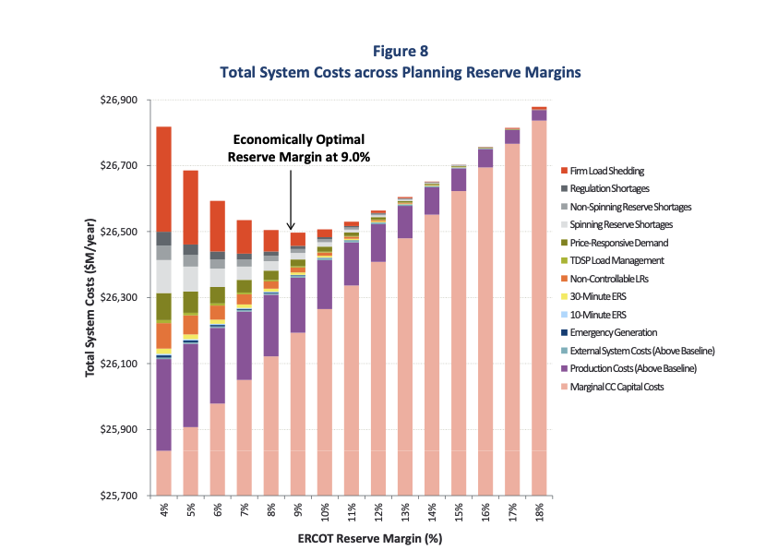

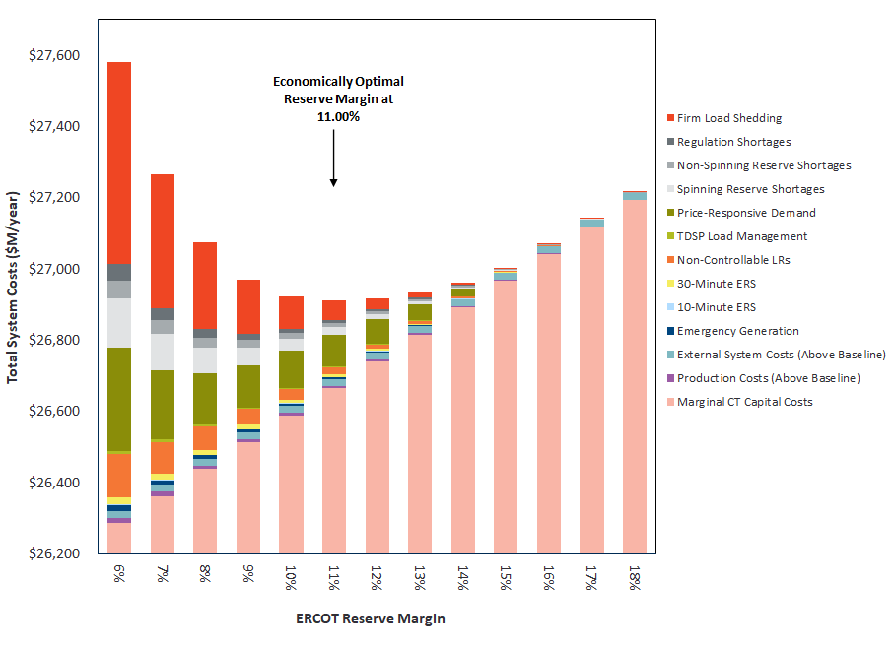

**Astrapé Response:** *I replaced the second chart with one that has a more comparable y-axis range and starts at 6% on the x-axis since the comparison needs to reflect the 2% shift (1% due to EFOR and 1% due to resource accounting). Comparing the total system cost at EORM to EORM + 6% (that is from 9% to 15% in the 2018 study and from 11% to 17% in the 2020 study) is very similar between the two studies. ~$200M in additional system cost in both studies. The difference is primarily in the emergency costs in the 2020 study at the low reserve margins. EUE at EORM minus 5% is 68GWh in 2020 vs 35 GWh in 2018. There are a few drivers of this change. One is more careful calibration of planned and maintenance outages. At reserve margins below EORM in this study, we begin to surface some non peak loss of load due to maintenance outages (we have 700 MW of MO in the summer on average; it’s not present in the monthly peak, but on some shoulder peak days it can influence EUE in low reserve margin scenarios). The second is the inclusion of more energy limited capacity (1,100 MW of batteries) which gets exhausted more rapidly at low reserve margins.*

*The difference in ‘production costs above the baseline’ is primarily due to the previous study having CC capacity in the marginal resource additions. The CTs don’t provide as much production cost savings. See response to the next question.*

1. There's a statement in the report (pp. 35-36) about since the marginal unit is now a CT, there are not much incremental production cost savings from additional new capacity.  But I'm not sure I agree.  A brand spanking new CT is a lot more efficient than the old gas units we have in ERCOT.  Also, they don't have to run for 4 - 8 hours minimum.

**Astrapé Response:** *There’s a little bit of mis-attribution in our figures. The system production cost category has all production costs for conventional units, so as we increase reserve margin, conventional units serve some of the energy that was previously served by the emergency products, and this looks like an increase in cost for the conventional category even though it is a savings on the emergency side. A more nuanced analysis of the production cost savings that should be allocated to conventional units shows about $2.5M per 1% RM near MERM instead of ~$1.3M per 1% RM. This still wouldn’t show up visually in the EORM chart since that’s quite a bit smaller still than the production cost savings of the CCs we saw in the last study. For more info, here is a chart of the reduction in run hours for the gas fleet by dispatch cost of each unit. There is ~15GW of conventional capacity with dispatch cost > $26/MWh (the dispatch cost of marginal CTs). Multiply that by average savings of 20 hours per year times average $/MWh savings of ~$8/MWh yields ~$2.5M. Note: the run hour reduction per unit is small since we’re analyzing the impact of 700 MW of CTs on a 15GW fleet. Marginal CTs have a capacity factor of ~9%.*

1. What price did Astrape assign to price responsive demand, as shown in the EORM chart?

**Astrapé Response:** *PRD cost was determined by the hourly market price in the hours it responded. It is the only emergency category that has price = cost.*

1. As an energy only market, the reserve margin report is quite useful to gauge whether the administrative scarcity pricing (ORDC) is doing the right thing.

The conclusion of the report is that the market equilibrium reserve margin is 12.25%; whereas the optimal reserve margin is 11.00%.

**Astrapé Response:** *Correct.*

1. The report correctly points out that the additional cost of the higher reserve margin is modest. Both reserve margins achieve about the same level of reliability.

**Astrapé Response:** *I don’t believe the report says this. Reliability at EORM reliability is worse than at MERM.*

1. It may make sense to point out that, while the addition cost of a slightly too-high reserve margin is modest, the additional cost of a too-low reserve margin is not modest. The additional cost as a function of a deviation from the optimal is not symmetric. Thus, in a world of uncertainty, it makes sense to have a market reserve margin that is above the “optimal reserve margin”.

**Astrapé Response:** *We agree with the statement to this point.*

Thus, the optimal reserve margin is optimal only in a world where reserve margin is precisely controlled, rather than the actual world where reserve margin varies randomly based on uncoordinated entry and exit as well as other factors. Correct?

**Astrapé Response:** *The optimal reserve margin is still optimal even though the realized reserve margin will vary due to uncoordinated entries and exits. I don’t think the uncoordinated nature of entries and exits naturally supports a higher than optimal reserve margin. This is conjecture, but I think it is a combination of optimism from merchant developers, reliability focused procurement from LSEs within ERCOT, amid other factors. Given that the asymmetry you mention above accrues to consumers and not to developers, I don’t think they have incentive to fall on the high side of MERM. It seems more logical for them to plan to the median MERM which would be lower than the reported MERM which is based on weighted average.*

1. I don’t understand the sentence on page 11, “the steepness of the net load shape results in significant four-hour battery capacity being able to supply capacity value.” All battery durations provide capacity value (the ability to provide energy or reserves during shortage). The amount of capacity value depends on the typical duration of shortages. Historically, ERCOT shortages tend to be short, so even one-hour duration batteries can provide substantial capacity value.

**Astrapé Response:** *I agree that some quantity of batteries can supply substantial capacity value. In the context of measuring the potential of a large portfolio, we have to recognize that only a portion can serve A/S. Further additions of battery would need to serve energy, and with each addition, the duration would need to be longer. So the capacity value is not simply a function of the duration of shortages when the penetration increases. Some resources need to serve energy hours in advance of the net load peak and hours after the net load peak. High penetrations of short-duration batteries would result in exhaustion of the storage capability prior to the peak, exacerbating reliability issues.*

1. Many useful details of the modeling approach are presented in the appendix. Nonetheless, it remains unclear to me how the SERVM works. Is there a description of the model somewhere? I think a detailed description would be valuable in helping the reader better understanding what the model does and does not do. Apologies if I somehow missed the description in my quick read of the report.

**Astrapé Response:** *SERVM is an hourly chronological full commitment and dispatch production cost model designed for analyzing resource adequacy and system cost risk assessments. For more information, footnote 13 has a reference to the following link on the Astrapé website:* [*https://www.astrape.com/servm/*](https://www.astrape.com/servm/)*.*

1. In the report, the higher the penetration of renewables the lower energy prices, due to renewables having zero marginal cost. This lowers revenues for CT units and the equilibrium reserve margin. A higher renewable penetration may generally lower prices, but also increases net-load volatility, possibly increasing the frequency and magnitude of scarcity pricing. Combustion turbines, and to a lesser extent combined cycle, should benefit from the latter effect. Is this reflected in the simulation? For example, the frequency of the simulation appears to be hourly and scarcity pricing is likely to occur at higher frequencies. More generally, are there assumptions in the simulations that could bias results for the relationship between the level of renewable penetration and energy revenues for CT and CC units?

**Astrapé Response:** *This is partially reflected in the simulations. We utilize unitized day-ahead historical wind, solar, and load forecast error to extrapolate to the forecast error at higher penetrations. We don’t capture intra-hour volatility except in that our market price calibrations we use historical price duration curves which incorporate intra-hour price fluctuations. Our expectation is that operating reserve practices (carrying more reserves as a function of renewable penetration) will largely absorb incremental volatility, but I’m not dogmatic on this point. This may be an area to be explored in future studies.*

1. I’m struggling to understand how the higher Forced Outage Rate contributes to the higher MERM.  It seems counter-intuitive.

**Astrapé Response:** *If we remove all forced outage rates on the conventional fleet, the frequency of reliability events and high priced periods would drop substantially at a given reserve margin. A system at a 7% RM where all generators have 0% EFOR will have similar-enough market characteristics to a system at an 11% RM with generators having a 4% EFOR such that MERM changes will mimic EFOR changes.*

1. What does the increased MERM imply for loss of load events compared to the prior MERM and why? 1 in 2 is based on 12.25 MERM so how many additional LOLEs should the market expect with additional intermittent resources?

**Astrapé Response:** *Increased MERM does not correspond to improvement in reliability. The 2% increase in MERM is due to higher EFOR (1%) and due to a difference in renewable accounting (1%), neither of which correspond with reliability improvement. The 2018 and 2020 studies both indicate .5 LOLE at MERM. The high renewable scenario shows that with the addition of another 20GW of renewable capacity, LOLE is expected to rise to 1.3 days per year at MERM.*

1. Is it appropriate to assume 4 hour batteries for the report when there is a higher amount of 1 hour batteries in the interconnection queue? 15 minute? Modeling different duration batteries to ensure proper representation of what’s being built, the impact on reliability, and potential LOLE?

**Astrapé Response:** *We modeled the 1,100 MW of projected batteries at their respective durations (.3 – 2 hours with most near 1 hour). Going forward the ability of batteries to serve A/S will begin to be exhausted so we needed to model batteries that could serve the energy need. The load shape analysis suggests that 4 hour duration is necessary to serve that need when the battery portfolio is > 5 GW.*

1. How does the battery duration used in the study comport with what is in the interconnection queue and how does that impact the MERM?

**Astrapé Response:** *See response to #12.*

1. How do co-located resources get reflected in the MERM? What assumptions were made to model this as part of the report?

**Astrapé Response:** *We modeled hybrid projects as distinct projects for this report. We did not model constraints such as interconnection limit on hybrid facilities, but we may model that in the future.*

1. How are AS costs developed? How is AS revenue affecting the MERM?

**Astrapé Response:** *A/S costs are based on the larger of opportunity cost and ORDC adder and are calibrated to historical A/S costs. Less than 1% of the CT marginal unit’s revenues are from A/S.*

1. How much does the current model compare to changes that will come via Passport?

**Astrapé Response:** *SERVM co-optimizes energy & A/S, however, it includes day ahead uncertainty (load, wind, and solar) in its commitment process (resulting in suboptimal commitment relative to perfect foresight) and we calibrated to historical market price duration curves (so theoretically the suboptimal commitment in the model is likely consistent with historical suboptimal commitment). The IMM in its report on RTC says “As a result [of incorporating RTC], in a year with relatively few occurrences of scarcity pricing, scarcity pricing levels were eliminated and energy prices were reduced. The amount of price reduction, as measured by the average price paid by load (system lambda) multiplied by the total generation for each interval, was $1.6B, or approximately $4/MWh.” If RTC does have that level of impact on market prices, the MERM would likely shift downward.*

1. Table A2.7 reflects a much different average contribution capacity from wind compared to the ELCC. Given that, how do we compare the reserve margin in the CDR to the one in the MERM, from a reliability perspective?

**Astrapé Response:** *The reserve margin in CDR matches the reserve margins in the MERM report, except for the high renewable scenario. The ELCCs in Appendix 2 are for information only.*

1. Table A1-7 reflects the High SWOC is always applied to the ORDC. However, the PUC changed the ORDC cap to match the Low SWOC after PNM which would be $2000 not $9000. Why is the study assuming applicability of the ORDC to $9,000? Does Low SWOC ever apply to the calculation and if so, is it applied accordingly?

**Astrapé Response:** *This was an oversight. The report was adjusted to reflect the updated ORDC methodology.*

1. The study assumes the marginal system cost of load resource, ERS and load shed based on non-shifted ORDC. Should it be a higher number given the $50M capacity payment for procuring the capacity?

**Astrapé Response:** *The capacity payment for those resources does not change across reserve margins analyzed and would not affect the EORM.*