Estimation of the Market Equilibrium and Economically Optimal Reserve Margins for the ERCOT Region for 2024
DRAFT

12/1/2020

PREPARED FOR
Electric Reliability Council of Texas (“ERCOT”)

PREPARED BY
Kevin Carden
Alex Krasny Dombrowsky

Astrapé Consulting
Disclaimer: This report was prepared by the authors for the Electric Reliability Council of Texas (ERCOT). It is provided as is, and Astrapé Consulting and ERCOT disclaim any and all express or implied representations or warranties of any kind relating to the accuracy, reliability, completeness, or currency of the data, conclusions, forecasts or any other information in this report. Readers of this report should independently verify the accuracy, reliability, completeness, currency, and suitability for any particular purpose of any information in this report.
Furthermore, this report is not intended nor should it be read as either comprehensive or fully applicable to any specific opportunity in the ERCOT market, as all opportunities have idiosyncratic features that will be impacted by actual market conditions. Readers of this report should seek independent expert advice regarding any information in this report and any conclusions that could be drawn from this report. The report itself in no way offers to serve as a substitute for such independent expert advice.
To the fullest extent permitted by law, Astrapé Consulting and ERCOT, along with their respective directors, officers, and employees, shall not be liable for any errors, omissions, defects, or misrepresentations in the information contained in this report, whether intentional or unintentional, or for any loss or damage suffered by persons who use or rely on such information or any conclusions that could be drawn from the report that turn out to be inaccurate (including by reason of negligence, negligent misstatement, or otherwise).
By reviewing this report, the reader agrees to accept the terms of this disclaimer.
Acknowledgement: We acknowledge the valuable contributions of many individuals to this report and to the underlying analysis, including peer review and input offered by ERCOT staff and members of the ERCOT stakeholder groups. In particular, we would like to acknowledge the analytical, technical, and conceptual contributions of Julie Jin, Kevin Hanson and Peter Warnken. We are deeply indebted to the Brattle Group for developing the framework for addressing many off the topics covered in the report and would like to acknowledge the input and review for this report from Kathleen Spees, Sam Newell and Michael Hagerty.

TABLE OF CONTENTS

EXECUTIVE SUMMARY 5

I. Background and Context 16

II. Study Assumptions and Approach 18

A. Modeling Framework 18

B. Primary Inputs 19

A. Renewable Accounting 22

B. Scarcity Pricing and Demand Response Modeling 24

C. Study Sensitivities and Scenarios 25

D. Model Validation 27

III. Results 30

A. Market Equilibrium Reserve Margin 30

1. Average Equilibrium Reserve Margin 30

2. Volatility in Realized Prices and Generator Revenues 31

3. Year-to-Year Reserve Margin Variability 32

4. Comparison to 2018 Study Results 33

B. Economically Optimal Reserve Margin 34

1. System Cost-Minimizing Reserve Margin 34

2. Exposure to Extreme Scarcity Events 37

C. System Reliability 38

1. Physical Reliability Metrics 38

2. Emergency Event Frequency 41

D. Sensitivity of Market Equilibrium Reserve Margin to Study Assumptions 42

1. Renewables Penetration Scenarios 43

2. Storage Potential at the High Renewables Penetration 44

3. Cost of New Entry Sensitivity 48

4. Probability Weighting of Weather Sensitivity 48

5. Forward Period and Load Forecast Uncertainty Sensitivity 49

6. Summary of Sensitivities 49

IV. Discussion of Results 51

List of Acronyms 53

Bibliography 55

APPENDIX 1: Modeling Assumptions 0

A. Demand Modeling 0

1. Peak Demand and Regional Diversity 0

2. Demand Shapes and Weather Uncertainty Modeling 1

3. Non-Weather Demand Forecast Uncertainty and Forward Period 2

4. External Region Demand 3

B. Generation Resources 5

1. Marginal Resource Technology 5

2. Conventional Generation Outages 6

3. Private Use Networks 7

4. Intermittent Wind and Solar 8

5. Hydroelectric 10

6. Fuel Prices 10

C. Demand-Side Resources 12

1. Emergency Response Service 12

2. Load Resources Providing Ancillary Services 13

3. Price Responsive Demand and 4 Coincident Peak 13

D. Transmission System Modeling and External Resource Overview 16

1. Transmission Topology 16

2. External Systems’ Resource Overview 17

3. Availability of External Resources for ERCOT 18

E. Scarcity Conditions 19

1. Administrative Market Parameters 20

2. Emergency Procedures and Marginal Costs 20

3. Emergency Generation 22

4. Operating Reserves Demand Curve 23

5. Power Balance Penalty Curve 25

APPENDIX 2: EFFECTIVE LOAD CARRYING CAPABILITY 27

Average ELCC versus Incremental ELCC 28

ELCC Results 29

EXECUTIVE SUMMARY
We have been asked by the Electric Reliability Council of Texas (ERCOT) to estimate the market equilibrium reserve margin (MERM) and the economically optimal reserve margin (EORM) for ERCOT’s wholesale electric market. For this analysis, Astrapé Consulting simulated the ERCOT market using its Strategic Energy & Risk Valuation Model (SERVM). The model captures ERCOT’s wholesale market design and projected system conditions for 2024; it probabilistically simulates the economic and reliability implications of a range of possible reserve margins under a range of weather and other conditions. The MERM concept is relevant in ERCOT because, unlike all other electricity systems in North America, ERCOT does not have a resource adequacy reliability standard or reserve margin requirement. In ERCOT, the reserve margin is ultimately determined by suppliers’ costs and willingness to invest based on market prices, where prices are determined by market fundamentals and by the administratively-determined Operating Reserve Demand Curve (ORDC) during tight market conditions. This approach creates a supply response to changes in energy market prices towards a “market equilibrium”; low reserve margins cause high energy and ancillary service (A/S) prices and attract investment in new resources, and investment will continue until high reserve margins result in prices too low to support further investment.
We estimate a market equilibrium reserve margin of 12.25% under projected 2024 market conditions, as shown in Figure ES-1. This is higher than our MERM projection of 10.25% in our 2018 study, however, the projections of system reliability are nearly identical at 0.5 Loss of Load Expectation (LOLE).

Figure ES-1. Market Equilibrium Reserve Margin
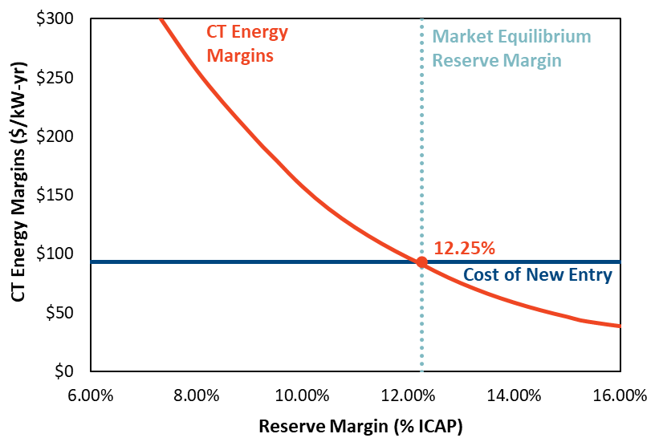
Input and reserve margin accounting changes with both upward and downward effects have been introduced since 2018. An increase in renewable penetration put downward pressure on MERM, while the changes in resource accounting increased the MERM. The PUCT administered changes to the ORDC which put upward pressure on MERM, and higher forced outage rates also put upward pressure on MERM. The change in marginal resource composition put slight downward pressure on MERM. The waterfall chart in Figure ES-2 quantifies the magnitude of the impact of each of these factors.

Figure ES-2. Base MERM Changes from 2018 to 2020 Study
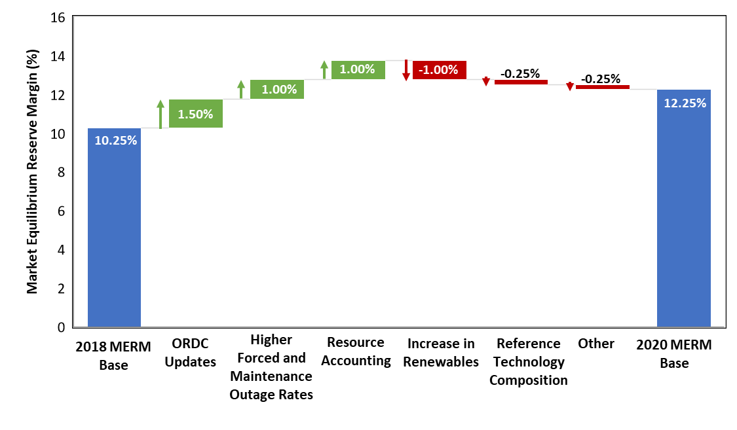
In terms of reliability, our probabilistic simulations indicate that under base case assumptions with a market equilibrium reserve margin of 12.25%, the system is expected to experience 0.5 days per year Loss of Load Expection (LOLE). As shown in Figure ES-3, this is significantly higher than the 0.1 events per year LOLE standard used by most electric systems in North America for planning purposes. It is also important to note that this LOLE is the same value reported in the 2018 study at the MERM of 10.25%. Intuitively, the higher MERM in this study would supply higher reliability. However, the higher Equivalent Forced Outage Rate (EFOR) assumptions, combined with a discrepancy between the renewable credit (or reliability contribution) estimated for CDR reserve margin reporting and the actual reliability value provided by these resources, increase the MERM without an improvement to reliability.

Figure ES-3. Loss-of-Load Expectation at Varying Reserve Margins
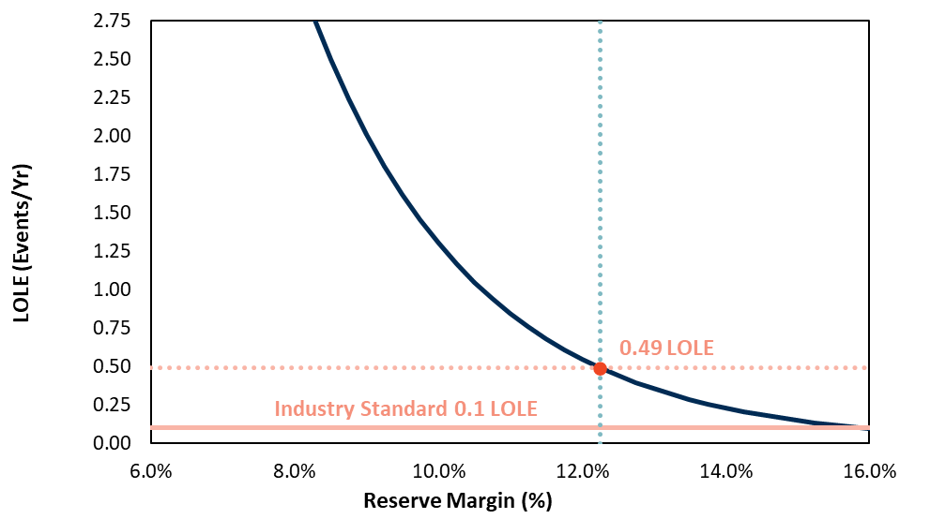
Determination of the economic potential of marginal resources in an energy-only market is complex. The potential energy margins of any generating resource are a function of the load profile, the technological composition of the entire generation fleet, the reserve margin of the fleet, the fuel prices to operate those generators, and other factors. The MERM for marginal peaking capacity then is in part determined by the characteristics of the other resources on the system. While this study is designed to analyze only marginal peaking capacity decisions, the ramifications of that equilibrium penetration can inform the calculus for other resource classes making investment or retirement decisions as well.
One interaction among resources that is analyzed in detail for this study is the impact of renewable penetration on MERM for marginal peaking capacity. Since the introduction of renewable generation, with its de minimis variable operating costs, will tend to depress market prices, we find that the MERM will be reduced by increases in renewable penetration. This downward pressure on the MERM from increasing renewables is initially small. For the 2018 study, Astrapé and Brattle quantified that an increase of 20 GW of renewable capacity would shift MERM down by only 0.75 percentage points, or approximately 500 MW. The magnitude of the impact however grows as the penetration of renewable grows, and is particularly sensitive to solar capacity. The size of the impact is primarily dependent on how the renewable fleet affects the frequency of hours with high electricity market prices. In an extremely high solar penetration scenario, the net load shape is very steep, so there are very few hours with very high loads, and commensurately high market price hours are infrequent. Up to projected penetrations in 2024 however, the net load shape is quite flat. There are eight or more hours every day within a few thousand megawatts (MW) of the daily peak load. Figure ES-4 compares the net load shape in the base case and in a high renewable scenario. Both scenarios require the same reserve margin to maintain the same reliability, but the high renewable scenario will have many fewer hours with high market prices.
Figure ES-4. Average August Daily Net Load Comparison
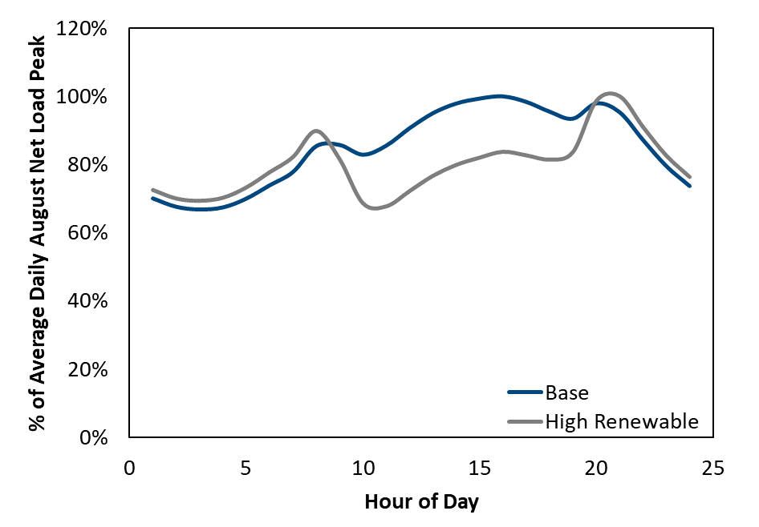
2-3 Hours Near Peak in 2024 High Renewable Case
6-8 Hours Near Peak in 2024 Base Case
The moderation of net load peak frequency can be seen clearly in the annual net load duration curve shown in Figure ES-5. Scarcity conditions and associated high prices are most likely when net load is near its annual peak. The addition of another 15 GW of solar capacity dramatically steepens the net load duration curve near the annual peak. This steepening translates to lower frequency of scarcity conditions and high prices depressing MERM.

Figure ES-5. Net Load Duration Curve Comparison
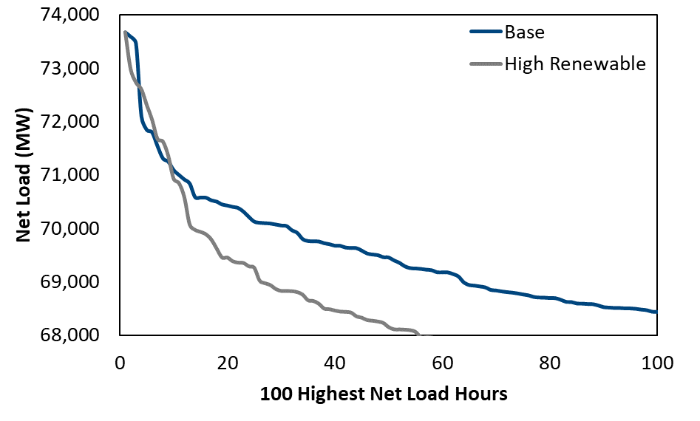
From the waterfall chart (Figure ES-2), the impact of the 20 GW of renewable additions from the 2018 study to the 2020 study was to reduce the MERM by 1.00 percentage points. Because of the more pronounced effect on load shape of additional solar from the projected 2024 penetration, the next 20 GW of renewable additions analyzed in the high renewable scenario are expected to reduce MERM by 2.00 percentage points to 10.25%, as shown in Figure ES-6. At this level, the reliability implications of a different MERM are significant with firm load shed occurring 0.5 days per year at MERM in the base case, but more than 1.3 days every year in the high renewable case.
Figure ES-6. Marginal Unit Net Energy Revenues
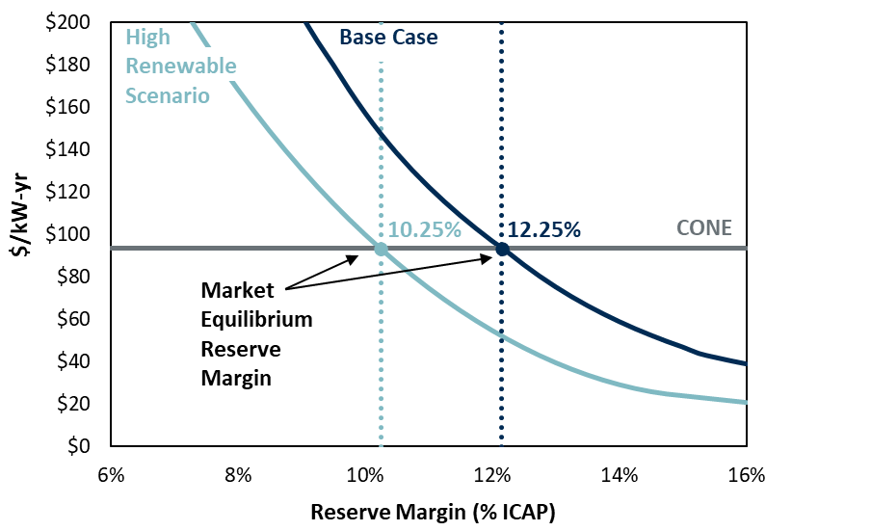
While the change in net load shape reduces the frequency of scarcity pricing, it creates opportunities for other classes of resources, namely battery storage, as shown in Figure ES-7. Prior to the introduction of any solar, the load peak in ERCOT spans several hours; the net load is within a few thousand MW of the daily peak for six to eight hours. Even after the addition of over 16 GW of solar projected to be online by 2024, the net load shape is still quite flat near the peak, and consequently batteries would need to supply long duration storage. Subsequent additions begin to produce steeper net loads near the daily peak, and at the penetrations in the high renewable scenario, the steepness of the net load shape results in significant four-hour battery capacity being able to supply capacity value.
Figure ES-7. Net Load Shape Impact of Solar
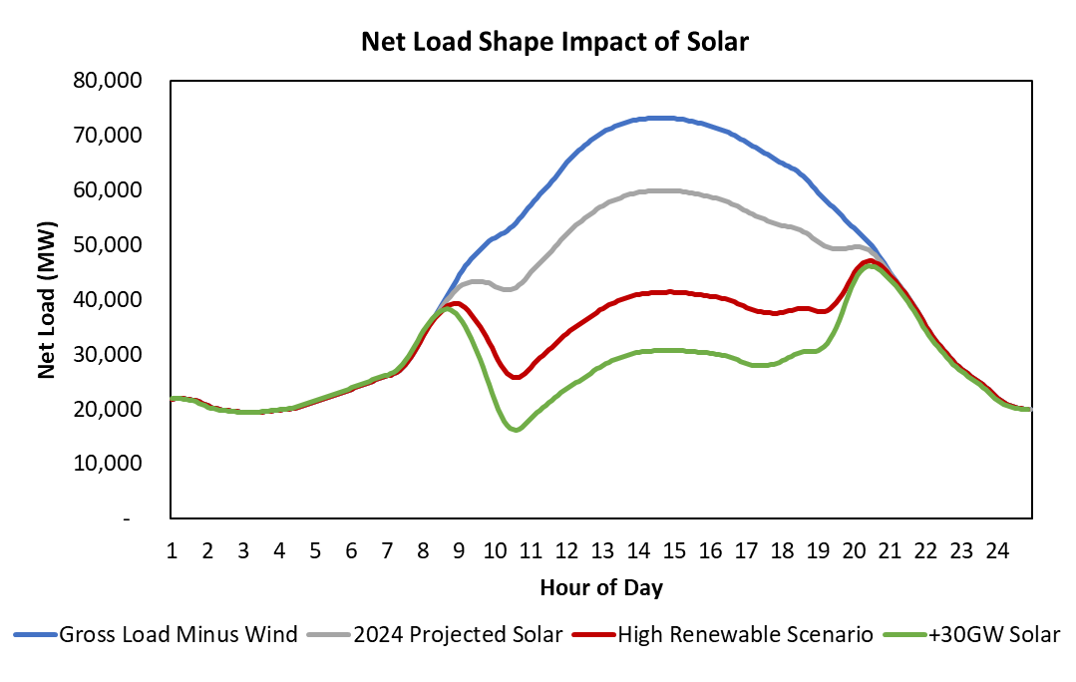
While the capital cost of batteries is higher than that of conventional combustion turbine (CT) capacity, the economic benefits of batteries are substantial in the high renewable scenario. At the high renewable MERM of 10.25%, incremental batteries can expect to earn a return in excess of their fixed and variable costs from the energy and ancillary service market. Swapping out new CTs for new four-hour batteries yields the energy margins shown in Figure ES-8 for incremental battery capacity, and demonstrates a breakeven incremental penetration of 1,100 MW. The energy margin decline is modest and if technology improvements lead to a battery capital cost decline to $115/kw-yr, up to 6.5 GW of incremental four-hour battery capacity could be economic in ERCOT in a high renewable scenario with the reserve margin at 10.25%. These results are contingent on a number of assumptions including the bidding behavior of renewable resources and the qualification for providing ancillary services, and they do not include other potential value streams for storage including locational benefits, but they provide indications of the economic potential for storage in ERCOT in the future.
Figure ES-8. Storage Energy Margins
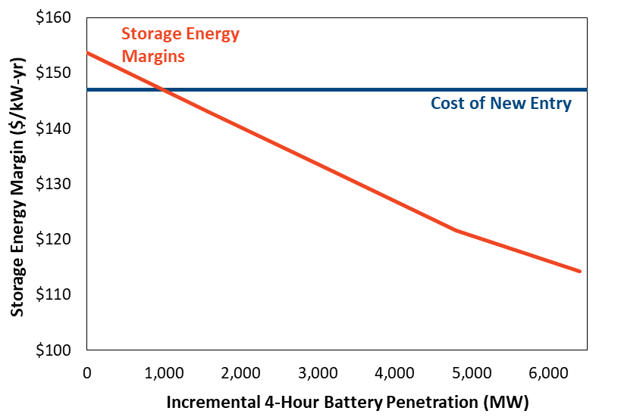
Another key difference from the 2018 study is an increase to ORDC pricing. A comparison of the 2018 and 2020 ORDC adders is illustrated in Figure ES-9. At the same level of reserves, market participants will realize higher energy and ancillary service prices which will increase MERM.

Figure ES-9. ORDC Curve Comparison
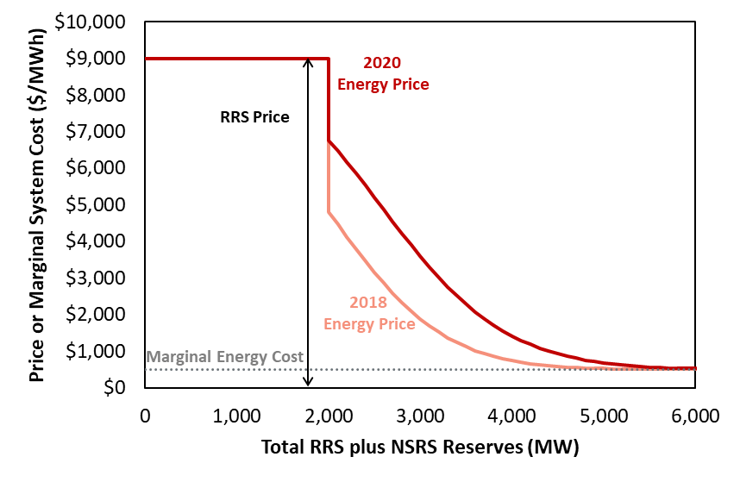
As shown in the waterfall chart (Figure ES-2), the ORDC curve change increased the MERM by 1.5 percentage points. In isolation this administrative change would improve reliability. However, the increase of renewable penetration in the base case almost completely offsets this effect.
Other key differences from the 2018 study include higher forced outages rates in the more recent outage data used for this study and the effect of the change in the reference technology.
While the MERM tests market outcomes, ERCOT stakeholders may be interested in the associated economic optimality outcomes. The economic optimum occurs at the reserve margin that minimizes societal costs net of all supply costs and the lost value from any disruptions in electric service. We calculate the economically optimal reserve margin (EORM) by finding the balance between the marginal costs and marginal benefits of adding capacity. The marginal costs are simply the levelized capital costs and fixed costs of a new generator. Marginal benefits include lower production costs and reduced load shedding (at an assumed cost of $9,000/MWh), reserve shortages, demand-response calls, and other costly emergency events. Our simulations quantify how scarcity event frequencies decrease (at a diminishing rate) as reserve margins increase. We estimate 11.00% as the EORM, based on the risk-neutral, probability-weighted-average cost of 80,000 simulations. However, the estimated societal costs are relatively flat with respect to reserve margin near the minimum, with only modest variation between reserve margins of 10.00% and 12.00%.
Our analysis shows that the market equilibrium of 12.25% is greater than the economically optimal level of capacity by 1.25 percentage points. The market equilibrium is higher than the economic optimum because the ORDC as currently designed sets prices higher than the marginal value of energy during scarcity conditions. The size of the gap is lower than suggested by current ORDC values and the gaps identified in previous studies because of the presence of more energy-limited resources. In certain reliability-constrained hours in the simulation, additional capacity can provide more value than its nameplate. This is because in addition to being available during the peak hour, the incremental resource can preserve the energy from the energy limited resources such as battery and demand response for availability during peak conditions. This means that the production cost savings in some extreme hours will be larger than the market price benefit the marginal CT realizes.
Table ES-1 shows the MERM and EORM for the base case as well as for sensitivity and scenario analyses conducted for this study. Some of the key assumptions we test are the estimated capital cost of new generation, load forecasting error, coal and natural gas prices, the value of lost load (VOLL), intermittent renewable penetration, and weather distributions. Regarding weather, our base case assumption is that all 40 years of historical weather are assigned an equal probability of occurring for the 2024 simulation year, and this reliance on long term history is consistent with the EORM Manual. More recent weather has been hotter (especially 2011) and may be more representative of future weather. Assuming accordingly that each of the last 15 weather years has a 1/15th chance of reoccurring (with 0% weight on each of the prior 25 years) leads to higher simulated prices and reliability events at a given reserve margin; but the higher prices would attract more investment, resulting in a 1% higher market equilibrium reserve margin and similar reliability to the base case.
Table ES-1. Market Equilibrium and Economically Optimal Reserve Margins and Reliability
Scenario/Sensitivity | MERM | EORM
 | (%) | (%)
Base Case | 12.25 | 11.00
Vary Cost of New Entry (CONE) | 11.25 – 13.25 | 10.00 – 12.00
Vary VOLL | 12.25 | 10.25 – 13.25
Vary Probability of Weather Years | 13.25 | 12.00
Vary Forward Period and Load Forecast Uncertainty | 11.25 – 12.00 | 10.00 – 10.75
High Renewables Scenario | 10.25 | 9.00
Lower EFOR | 11.25 | 10.00
Notes:
Table reflects all scenarios and sensitivities analyzed, as described in Section II.D; Current practice has VOLL set to the max of the ORDC but the sensitivity which varies to VOLL does not change the ORDC curve and therefore does not affect the MERM.

These estimates must not be interpreted as deterministic, since actual market conditions will fluctuate from year-to-year. In reality, the reserve margin will vary as plants enter and exit. Moreover, even at a given reserve margin, realized reliability and price outcomes can deviate far from the expected value, primarily due to weather and variations in wind generation. For example, with a projected market equilibrium reserve margin of 12.25%, we estimate that in the 90th percentile outcome—representing relatively hot weather and low generation availability—energy prices would more than double, marginal units could have net energy revenues reaching $246/kW-year, with 1.2 load-shed events per year (compared to a mean of 0.5 across all conditions modeled).

Background and Context
We have been asked to estimate the market equilibrium reserve margin (MERM) and the economically optimal reserve margin (EORM) for ERCOT’s wholesale electric market.
The MERM describes the reserve margin that the market can be expected to support in equilibrium, as investment in new supply resources responds to expected market conditions. This concept is relevant in ERCOT because, unlike all other electricity systems in North America, ERCOT does not have a reserve margin requirement. In ERCOT, the reserve margin is ultimately determined by suppliers’ costs and willingness to invest based on market prices, where prices are determined by market fundamentals and by the administratively-determined Operating Reserve Demand Curve (ORDC) during tight market conditions. This approach creates a supply response to changes in energy market prices toward a “market equilibrium”; low reserve margins cause high energy and ancillary service (A/S) prices and attract investment in new resources, and investment will continue until high reserve margins result in prices too low to support further investment. The PUCT also wants to know whether the market outcome will be acceptable with respect to economic optimality. The EORM is the benchmark for establishing the sufficiency of the expected MERM, where the marginal benefits of new supply are just equal to the marginal costs of new supply.
As the left panel of Figure 1 shows, higher reserve margins are associated with higher generation capital and fixed costs of building more capacity (dark blue line). The higher costs are offset by a reduction in the frequency and magnitude of costly reliability events, such as load-shed events, other emergency events, and demand-response curtailments, and the reduced production costs (light blue line). The tradeoff between increasing capital costs and decreasing reliability-related operating costs results in a U-shaped societal cost curve (red line), with costs minimized at what we refer to as the “economically optimal” reserve margin. The right chart of Figure 1 shows how we derive the “market equilibrium” reserve margin. The marginal cost of capacity is known as the “Cost of New Entry” (CONE), which depends on technology costs and economic conditions such as tax structures and remains stable across reserve margins (dark blue line). A marginal unit’s net revenues from energy markets and ancillary services (light blue line) quickly decrease with less scarcity pricing at higher reserve margins. The intersection point of a marginal unit’s net revenue and CONE represent the “market equilibrium” reserve margin where the marginal unit breaks even.

Figure 1. Economically Optimal Reserve Margin and Market Equilibrium Reserve Margin Concepts
(Illustrative Schematics, Not Simulation Results)
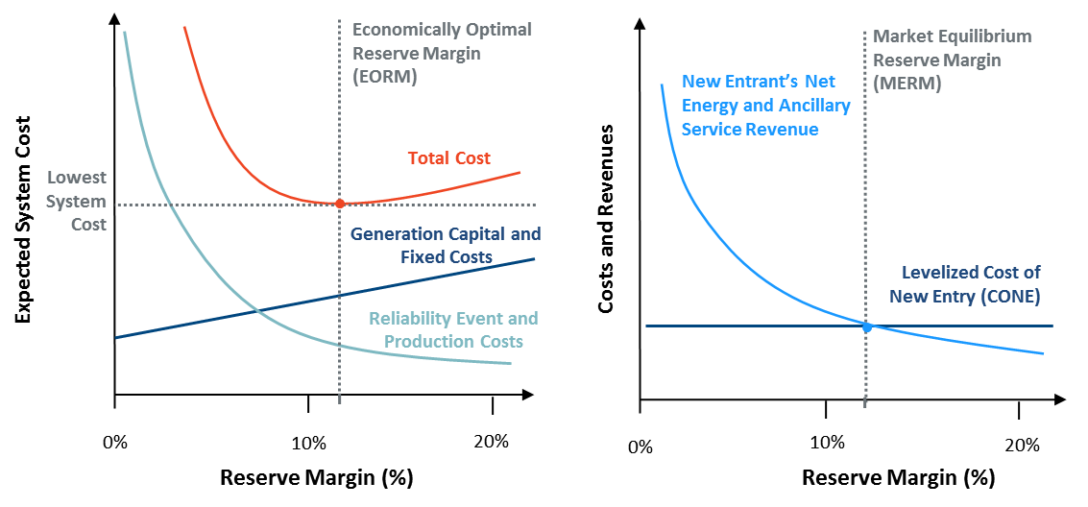
This study estimates the MERM and the EORM for the ERCOT market given the currently formulated scarcity pricing mechanism and expected market conditions. It estimates the reliability at each of those levels of reserves, but strictly for informational purposes since there is no reliability requirement. Our study methodology follows the ERCOT manual for estimating the EORM and MERM. The primary analytical tool in this study is energy market simulations using the SERVM model. SERVM simulates hourly energy demand (under a range of weather conditions), energy production, and energy prices given the marginal cost of available supply and the Operating Reserve Demand Curve (ORDC). By analyzing the results of simulations conducted at many possible levels of investment, we can identify which of the reserve margins represents the MERM and which level represents the EORM.
This study was previously performed in 2014 and 2018. The present study incorporates updated market conditions regarding the projected resource mix, the CONE for a reference generation resource, ORDC, maintenance outages, and gas prices; different assumptions regarding weather; higher forced outage rates based on recent data; and current conventions for describing peak load and accounting for intermittent resources in expressing the reserve margin.

Study Assumptions and Approach
Our simulations rely on a detailed representation of the ERCOT system, including: load and weather patterns and their probabilistic variations; the cost and performance characteristics of ERCOT’s generation and demand-response resources; the mechanics of the ERCOT energy and ancillary services markets, including a unit commitment and economic dispatch of all generation resources, demand-response resources, and the transmission interties with neighboring markets. Assumptions on the generation fleet, demand-response penetration, fuel prices, and energy market design reflect expected conditions in 2024.

Modeling Framework
We use the Strategic Energy & Risk Valuation Model (SERVM) to estimate the economically optimal reserve margin, the market equilibrium reserve margin, and associated reliability in the ERCOT system. Like other reliability models, SERVM probabilistically evaluates the reliability implications of any given reserve margin. It does so by simulating generation availability, load profiles, load uncertainty, inter-regional transmission availability, and other factors. SERVM ultimately generates standard reliability metrics such as loss-of-load events (LOLE), loss-of-load hours (LOLH), and expected unserved energy (EUE). Unlike other reliability modeling packages, however, SERVM simulates economic outcomes, including hourly generation dispatch, ancillary services, and price formation under both normal conditions and emergency operating procedures. SERVM estimates hourly and annual production costs, customer costs, market prices, net import costs, load shed costs, and generator net energy revenues as a function of the planning reserve margin. These results allow us to compare these variable costs against the incremental capital costs required to achieve higher planning reserve margins, such that the optimal reserve margin can be identified. The MERM can be identified by comparing potential new generators’ net revenues to their levelized fixed costs.
The multi-area economic and reliability simulations in SERVM include an hourly chronological economic dispatch that is subject to inter-regional transmission constraints. Each generation unit is modeled individually, characterized by its economic and physical characteristics. Planned outages are scheduled in off-peak seasons, consistent with standard practices, while unplanned outages and derates occur probabilistically using historical distributions of time between failures and time to repair, as explained in Appendix 1. Load, hydro, wind, and solar conditions are modeled based on profiles consistent with individual historical weather years. Dispatch limitations and limitations on annual energy output are imposed on certain types of resources such as demand response, hydro generation, and seasonally mothballed units.
The model implements a week-ahead and then multi-hour-ahead unit commitment algorithm considering the outlook for weather and planned generation outages. In the operating day, the model runs an hourly economic dispatch of baseload, intermediate, and peaking resources, including an optimization of transmission-constrained inter-regional power flows to minimize total costs. During most hours, hourly prices reflect marginal production costs, with higher prices being realized when import constraints are binding. During emergency and other peaking conditions, SERVM simulates scarcity prices that exceed generators’ marginal production costs as explained further in Appendix 1.E
To examine a full range of potential economic and reliability outcomes, we implement a Monte Carlo analysis over a large number of scenarios with varying demand and supply conditions. Because reliability events occur only when system conditions reflect unusually high loads or limited supply, these simulations must capture wide distributions of possible weather, load growth, and generation performance scenarios. This study incorporates 40 weather years, 5 levels of economic load forecast error, and 50 draws of generating unit performance for a total of 10,000 iterations for each simulated reserve margin case. Each individual iteration simulates 8,760 hours for the year 2024. The large number of simulations is necessary to accurately assess the reliability and economic implications of varying reserve margins. A probabilistic approach is needed to characterize the distribution of possible outcomes, particularly because the majority of reliability-related costs are associated with infrequent and sometimes extreme scarcity events. Such reliability events are typically triggered by rare circumstances that reflect a combination of extreme weather-related loads, high load-growth forecast error, and unusual combinations of generation outages.
To properly capture the magnitude and impact of reliability conditions during extreme events, a critical aspect of this modeling effort is the correct economic and operational characterization of emergency procedures. For this reason, SERVM simulates a range of emergency procedures, accounting for energy and call-hour limitations, dispatch prices, operating reserve depletion, dispatch of economic and emergency demand-response resources, and administrative scarcity pricing.

Primary Inputs
The projected resource mixes in ERCOT have shifted and load has grown since completion of the 2018 study report. This section focuses on those changes and discusses their implications for the MERM and EORM.
Load and resource accounting for the base case is based on ERCOT’s conventions in the May 2020 CDR, as summarized in column C of Table 1. Peak load is reduced for non-controllable load resources (LRs), 10-minute and 30-minute emergency response service (ERS), and Transmission/Distribution Service Providers (TDSP) energy efficiency and load management. On the supply side, most resources are counted toward the reserve margin at their summer ratings, except for coastal wind, panhandle wind, other wind, solar, and storage counting at 63%, 29%, 16%, 76%, and 0% of nameplate respectively, and the High Voltage Direct Current (HVDC) ties counting at approximately 31% of the path ratings, consistent with the CDR. The capacity credit estimation process for renewable resources is discussed further in section II.A.
Table 1. Components of Supply and Demand in Current 2020 Study vs. 2018 Study
 | Values from  2018 Study | Re-expressed  Values from  2018 Study  (Using 2020  Accounting) | Values from  2020 Study | Difference  Attributable to  Accounting  Changes | Difference  Attributable  to Fundamentals  Changes
 | (MW) | (MW) | (MW) | (MW) | (MW)
 | [A] | [B] | [C] | [B-A] | [C-B]
Modelled Year | 2022 |  | 2024
Accounting Methodology Year | 2018 |  | 2020
Peak Load | 79,027 | 79,027 | 82,982 | 0 | 3,955
Load Reduction | 2,173 | 2,173 | 2,202 | 0 | 29
LRs serving RRS | 1,119 | 1,119 | 1,172 | 0 | 53
10-Minute ERS | 140 | 140 | 76 | 0 | -64
30-Minute ERS | 632 | 632 | 692 | 0 | 60
TDSP Curtailment Programs | 282 | 282 | 262 | 0 | -20
Supply | 85,919 | 86,813 | 93,979 | 894 | 7,166
Conventional Generation | 72,441 | 72,441 | 68,395 | 0 | -4,046
Hydro | 467 | 467 | 474 | 0 | 7
Wind | 6,331 | 7,052 | 9,137 | 721 | 2,085
Solar | 2,708 | 2,744 | 12,161 | 36 | 9,417
Storage | 324* | 0 | 0** | -324 | 0
PUNs | 3,259 | 3,259 | 2,962 | 0 | -297
Capacity of DC Ties | 389 | 850 | 850 | 461 | 0
Reserve Margin | 11.80% | 12.96% | 16.34% | 1.16% | 3.38%
Notes: *The 324 MW of storage capacity represents a CAES unit. Batteries were also given 0% capacity credit in the 2018 study.
**1,103 MW of nameplate capacity of storage is included in the 2020 study but given a 0% capacity credit in the reserve margin calculation.
The base 2024 supply fleet, as summarized in column C of Table 1 is consistent with the 2020 North American Electric Reliability Corporation (NERC) Long-Term Reliability Assessment (LTRA) report. The fleet summary developed by ERCOT staff for the NERC LTRA was the most recent data available when this study was developed. When compared to the 2020 CDR values for 2024, the supply fleet fluctuates by a relatively modest 129 MW of thermal capacity, 115 MW of wind, and 620 MW less of solar installed capacity (reflecting reported delays in planned solar projects by developers). The composition of installed capacity in the 2020 LTRA is summarized in Figure 2.
Figure 2. Installed Capacity by Resource Type
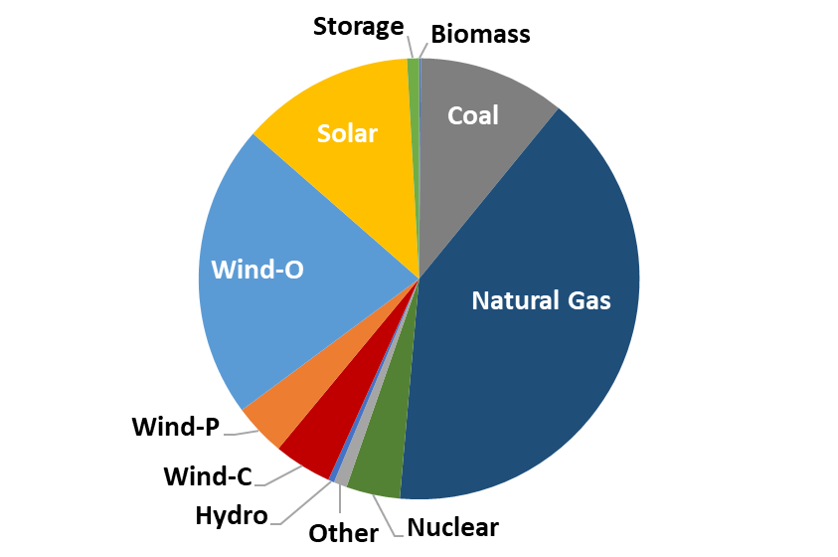
Sources and Notes: Most recent LTRA data supplied by ERCOT staff and ERCOT, 2020a.The LTRA data was comparable to the capacities provided in the May 2020 CDR.
We conducted simulations over a wide range of reserve margins by adding or removing capacity from this supply fleet. To analyze higher reserve margins, we add gas CT capacity, assuming the characteristics shown in Table 2 below that were derived from a recent study Brattle conducted. To analyze lower reserve margins, we selectively retired coal units and excluded planned thermal units. We assume the CONE for the new CT units are $93,500/MW-year.

Table 2. Reference Technology Cost and Summer Performance Characteristics
Characteristic | Unit | Simple Cycle
Plant Configuration
Turbine |  | GE 7HA.02
Configuration |  | 1 x 0
Heat Rate (HHV)
Base Load
Non-Summer | (Btu/kWh) | 9,138
Summer | (Btu/kWh) | 9,274
Installed Capacity
Base Load
Non-Summer | (MW) | 371
Summer | (MW) | 352
CONE | ($/kW-yr) | 93.5
Sources and Notes: Based on ambient conditions of 92°F Max. Summer (55.5% Humidity).
On the demand side, this study starts with ERCOT’s peak load forecast for 2024, and then uses hourly shapes under many possible weather patterns. We simulate each of 40 weather years, from 1980 through 2019 (with corresponding wind and solar conditions from the same years). When calculating expected values, we assume an equal probability for each year’s weather. Applying equal probabilities is reasonable given that so many years can be taken to be fairly representative of the underlying distribution, assuming there is not a trend in the average weather or in the variability of weather. (Other possibilities are considered in the Section III.D.5. below.)

Renewable Accounting
The CDR methodology used for determining the renewable capacity contribution is calculated by the following process:
- Wind Capacity Contribution Values: Values are calculated for three zones--Coastal, Panhandle, and Other—based on average telemetered dispatch limits (HSLs) during the highest 20 seasonal peak load hours for each season for each of the last ten years (2010-2019). They are re-calculated after each season with the new seasonal historical data. In addition to including a new Panhandle zone for calculating contribution values, another change introduced in 2019 was to use weighted averaging of the historical seasonal nameplate capacities. This approach reduces the influence of older wind turbine technologies installed in the earlier years of the estimation period, and thereby increased the contribution values relative to the ones based on the original methodology.
- Solar Capacity Contribution Values: Values are based on average telemetered HSLs during the highest 20 seasonal peak load hours for each season for each of the last three years (2017-2019). They are re-calculated after each season with new seasonal historical data. Weighted-averaging of the seasonal nameplate capacities is also applied to the solar contribution values.
However, the value from this calculation will not match the calculated reliability contribution from SERVM simulations for the same resources. Table 3 illustrates the apparent disconnect between the reported capacity value and the true reliability contribution of renewable resources.
Table 3. Potential ELCC Methods: Average Output Versus Peak Net Load Reduction
 | Wind |  |  | Solar
 | Avg Output During Top 20 Load Hours (ERCOT Accounting Method) | Peak Net Load Reduction (Modeled Reliability Contribution) |  | Avg Output During Top 20 Load Hours (ERCOT Accounting Method) | Peak Net Load Reduction (Modeled Reliability Contribution)
2010 | 12% | 8% |  | 78% | 75%
2011 | 24% | 12% |  | 83% | 72%
2012 | 13% | 6% |  | 80% | 72%
2013 | 24% | 13% |  | 82% | 80%
2014 | 24% | 16% |  | 80% | 68%
2015 | 18% | 13% |  | 81% | 76%
2016 | 30% | 21% |  | 76% | 71%
2017 | 24% | 18% |  | 75% | 68%
2018 | 20% | 16% |  | 76% | 70%
2019 | 27% | 16% |  | 79% | 65%
Average | 22% | 14% |  | 79% | 72%
This disconnect means that the reserve margin needed to maintain the same reliability will shift. Since the reliability contribution is less than the average output during high gross load hours, the reserve margin will increase. This disconnect is not new. The 2018 study also used CDR accounting practices, and likewise the renewable capacity credit did not match its reliability contribution either. In order to isolate the impact of the renewable accounting on changes in MERM from the 2018 study to this study, only the incremental disconnect is quantified.
The magnitude of the incremental disconnect is about 1,800 MW or a 2% increase in reserve margin. Other reserve margin accounting related changes from the 2018 study include the addition of 1,103 MW of battery storage capacity. These resources are not given any capacity credit in CDR accounting, but they provide reliability benefits in the SERVM simulations, offsetting the increase in reserve margin due to renewable penetration. The net impact of the resource accounting treatment from the 2018 study to this study is an increase in reserve margin of one percentage point. For the higher renewable penetration analyzed in this study, the reserve margin accounting was normalized such that the capacity credit of incremental renewable resources matched its simulated reliability contribution. Given the complexity of reserve margin accounting and reliability contributions, ERCOT commissioned the calculation of Effective Load Carrying Capability (ELCC) for each renewable resource category to rigorously quantify the dynamic of declining capacity contributions as a function of increasing renewable penetration. This analysis is documented in Appendix 2.

Scarcity Pricing and Demand Response Modeling
A number of different types of demand-side resources contribute to resource adequacy and price formation in ERCOT. Table 4 summarizes these resources, explaining how we model their characteristics, their assumed marginal costs when utilized, and how they are accounted for in the reserve margin. We developed these assumptions in close coordination with the ERCOT staff, who provided assumptions regarding the appropriate quantities for modeling.
The marginal costs of these demand-side resources are highly uncertain, although the marginal costs we report in the table are in the general range that we would anticipate given the sparse data availability. Most of these resources including TDSP load management, emergency response service (ERS), and load resources (LRs) are dispatched for energy based on an emergency event trigger rather than a price-based trigger consistent with marginal cost. We use ERCOT’s administrative scarcity pricing mechanism, the ORDC, to reflect the willingness to pay for spinning and non-spinning reserves in the real-time market. We make the simplifying assumption that these resources are triggered in order of ascending marginal cost, and at the time when market prices are equal to their marginal curtailment cost, as explained further in Appendix 1.E.4 below.
Energy efficiency (EE) is not explicitly modeled because the load shapes already reflect their projected impact as a function of historical energy reduction trends. These resources are appropriately accounted for using the conventions of ERCOT’s CDR report as explained further in Appendix 1.A.1 below.
Two programs with overlapping response were modeled explicitly in both load and resources: four coincident peak (4CP) and price-responsive demand (PRD). Both programs had strong response in 2019 when the reserve margin was lower than typically experienced. A single model for the aggregate response was constructed to gross up the synthetic load shapes. For simulating the respective response, separate functions were developed since PRD response varies with price while 4CP is primarily expected to vary as a function of load only. At low reserve margins then, PRD response is expected to be higher with the corresponding higher prices while 4CP response is the same at all reserve margin levels.
Table 4. Summary of Demand Resource Characteristics and Modeling Approach
Resource Type | Quantity (MW) | Modeling Approach | Marginal Curtailment Cost | Adjustments to ERCOT Load Shape | Reserve Margin Accounting
TDSP Programs
Energy Efficiency | 2,884 | Not explicitly modeled. | n/a | None | Load reduction
Load Management | 262 | Emergency trigger at EEA Level 1 | $2,469 | None | Load reduction
Emergency Response Service (ERS)
30-Minute ERS | 691 | Emergency trigger at EEA Level 1 | $1,372 | None | Load reduction
10-Minute ERS | 76 | Emergency trigger at EEA Level 2 | $2,469 | None | Load reduction
Load Resources (LRs)
Non-Controllable LRs | 1,172 | Economically dispatch for Responsive Reserve Service (most hours) or energy (few peak hours). Emergency deployment at EEA Level 2 | $2,469 | None | Load reduction
Controllable LRs | 0 | Currently no controllable LRs modeled in ERCOT | n/a | n/a | n/a
Voluntary Self-Curtailments
4 CP Reductions | 1,700 | Load shapes grossed up for projected response and corresponding response modeled on the resource side | n/a | None | None; excluded from reported peak load
Price Responsive Demand | Variable | Load shapes explicitly grossed up for expected response. Economic self-curtailment modeled on resource side | $5,000 - $9,000/MWh | None | None; excluded from reported peak load
Sources and Notes:
Developed based on analyses of recent DR participation in each program and input and data from ERCOT staff. See corresponding sections in the Appendix for more detail.

Study Sensitivities and Scenarios
In addition to the base case analysis described above, we simulated three alternative scenarios and several “sensitivity” analyses to inform how the MERM and EORM could vary under different plausible conditions. The three scenarios are “High Renewables Penetration,” “Storage Potential at the High Renewables Penetration,” and “Lower Equivalent Forced Outage Rate (EFOR)”. The high renewable penetration scenario adds much more wind and solar generation to explore the implications of understating renewable penetration in 2024 (or beyond). The storage scenario evaluates the economic potential for batteries using the renewable penetrations in the high renewable scenario. The Lower EFOR study uses the class average forced outage rate assumptions from the 2018 study to isolate the impact of more recent outage data. The assumptions for each scenario are summarized in Table 5 below.

Table 5. Description of Modeled Scenarios
Scenario Name | Base Case Assumption | Alternate Scenario Assumption | Expected EORM Impact
High Renewables Penetration | Only include CDR-eligible wind and solar from CDR | Include some of the wind and solar from the interconnection queue that has not met all requirements for CDR (15 GW of new solar, 5 GW of new wind) | Downward pressure on prices and therefore lower EORM
Storage Potential at the High Renewables Penetration | 1,100 MW of battery storage | Test various battery penetrations at MERM from the High Renewables Scenario
Lower EFOR | Last 3 years used to populate outage rates for all units | Use class average EFORs from 2018 study | 2018 modeled EFOR was lower, so the reversion will decrease EORM
The other sensitivity analyses that we conducted, defined in Table 6, examine the impacts of: (a) varying the assumed cost of building new plants; (b) adjusting the value of lost load (VOLL); (c) adjusting the likelihood of recent weather years compared to historic values; and (d) varying the associated load forecast uncertainty not attributable to weather conditions.
Table 6. Definition of Non-Modeled Sensitivities
Sensitivity | Base Case Assumption | Sensitivity Range
CONE | $93.5/kW-year | -25% / +25%
VOLL | $9,000/MWh | $5,000 to $30,000/MWh
Weighting of Historical Weather Years | Equal probability assigned to all 40 weather years | Equal probability assigned to the last 15 weather years
Forward Period and Load Forecast Uncertainty | 4 years | 0 years to 3 years

Model Validation
In addition to carefully constructing realistic inputs to the model, we validated that the model’s outputs are reasonable by comparing them to real-world market observations. In the 2018 study, Astrapé and Brattle introduced calibration efforts to ensure modeled economic and reliability results corresponded to historical conditions. The approach primarily looked at Peaker Net Margin (PNM); careful tuning of the annual market price duration curve was not performed. Since the economics of the marginal resource were primarily influenced by hours where the market cleared above the dispatch cost of CTs, this was adequate. In the 2020 EORM study, hybrid battery and solar resources are a potential marginal resource, making the market prices throughout the year critical to the conclusions of this analysis. Also, the higher penetrations of renewable resources are expected to make low price conditions more impactful. For this calibration, a number of benchmarks were considered:
- Market price duration curve
- Monthly peak and off-peak pricing
- Scarcity pricing timing, magnitude, and frequency
The typical drivers of the market prices throughout the year are fuel prices, the underlying reserve margin, the resource mix and economic parameters of generators, and generator forced outage rates. Through the calibration process, a number of other drivers were identified including planned and maintenance outages, day ahead load and wind forecast error, and generator bidding strategies.
An example of the outcome of the SERVM calibration for 2019 is shown below in Figure 3. The chart reflects the cumulative energy margin for CTs with a 10,000 btu/kwh heat rate. The historical load, renewable profiles, and generators were input into the model. The simulations were run for five iterations of random generator outages, market support, and day ahead forecast error. Planned and maintenance outages were modeled with historical averages rather than forcing exact 2019 conditions. The modest slope in most months of the years reflect limited energy margins for CTs when scarcity is not present in the market. The steep ramp during the summer reflects the historical and modeled scarcity conditions where market prices approached $9,000/MWh. Another period of increasing energy margins starting around hour 5,800 reflects September conditions when loads remained high, but maintenance and planned outages began to take place.

Figure 3. SERVM Energy Margin Calibration for 2019
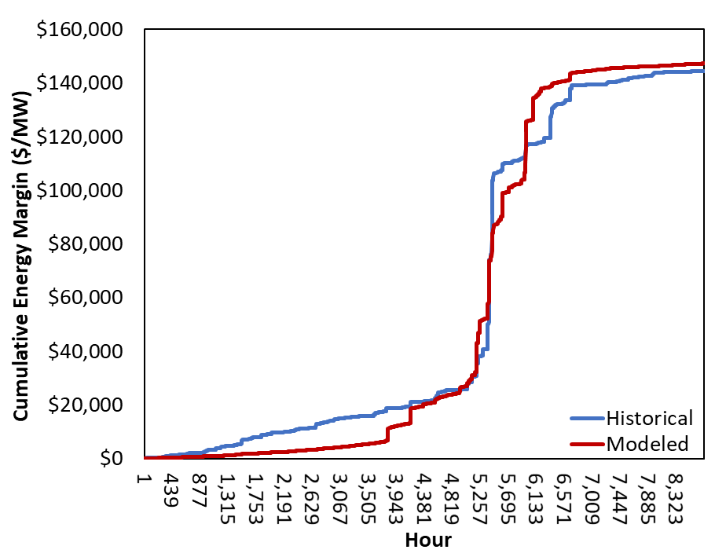
Not all years calibrated this well, but the intent of the process was not to force the model to replicate history but to understand how random drivers may influence market prices. In 2018 for instance, reserve margins were relatively low, but energy margins did not reflect significant scarcity. This was primarily driven by better than expected performance of conventional generation as shown in Table 7.
Table 7. Average Megawatts Forced Offline for Modeled Versus Historical in Top 3 Load Days of 2018
Date | Modeled Forced Outages (MW) | Historical from NERC Generating Availability Data System  (MW)
7/23/2018 | 3,231 | 2,272
7/19/2018 | 3,383 | 1,891
7/20/2018 | 3,041 | 2,141
More distant history also did not calibrate as well. In 2011-2014, the modeled energy margins were mostly lower than those experienced in history. This may be due to the retirement of old generating capacity with high heat rates that may have set market prices for some hours in those years. Figure 4 below compares the simulated and historical CT net energy revenues for 2011 to 2019.
Figure 4. Modeled vs. Actual Combustion Turbine Net Energy Revenues
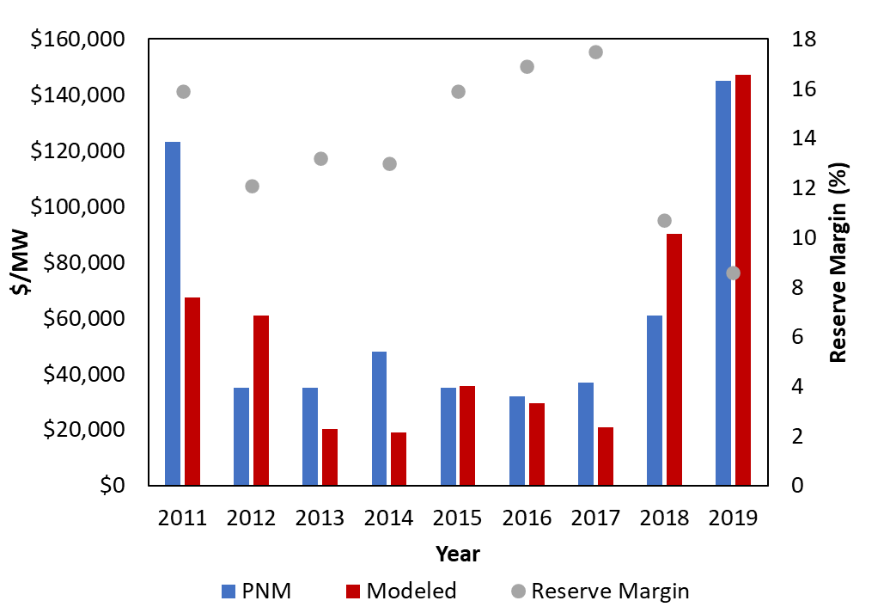

Results
This section first presents the results of our study under base case assumptions, including the estimated 2024 MERM and EORM and the associated reliability statistics, and then describes how the results could differ under alternative market conditions captured in the scenarios and sensitivities described above. This section explains why the MERM and EORM results differ with respect to the result from the 2018 study.

Market Equilibrium Reserve Margin
We describe here the anticipated equilibrium conditions under ERCOT’s current market design by: (1) estimating the market equilibrium for our base case assumptions and several sensitivity cases; (2) summarizing the volatility in realized prices and net revenues across reserve margins; and (3) describing the likely year-to-year variation in realized reserve margins.

Average Equilibrium Reserve Margin
As described above, the MERM occurs at the level of capacity where the net revenues of new capacity from our simulations just equal the marginal costs of capacity, which is equal to CONE. As shown in Figure 5 below, CT net energy revenues tend to decrease with higher reserve margins due to lower energy prices and few scarcity hours that occur when there is additional supply available on the system. We find that the MERM, where marginal costs of new capacity intersect with the marginal revenues for that capacity, is 12.25%.
Figure 5. ERCOT Projected 2024 Market Equilibrium Reserve Margin
However, the single average MERM of 12.25% does not provide a complete story of the expected reliability of the ERCOT system or the expected revenues for new entrants. In the remainder of this section we discuss the volatility in realized prices in our simulations and the year-to-year variability in the reserve margin. In Section III.B we compare this market equilibrium to an economically optimal reserve margin, and in Section III.C we examine the sensitivity of our analysis to uncertainties in future market conditions.

Volatility in Realized Prices and Generator Revenues
Our estimate of the average MERM is strongly influenced by the assumed peak load and generator outage probability distributions, especially the most extreme scarcity events at the tails of those distributions. As the reserve margin declines, these tails become more likely to produce scarcity resulting in high prices, high system-wide costs, and high generator margins.
Figure 6 shows the range of annual energy prices (left) and marginal unit net energy revenues (right) for the base case across the reserve margins analyzed. The upper percentile curves show that prices and supplier margins in the tails of the distribution can be much higher in any given year than their median or overall weighted average values.
Figure 6. Distribution of Spot Energy Prices (Left) and Net Energy Revenues for a Marginal Unit (Right)
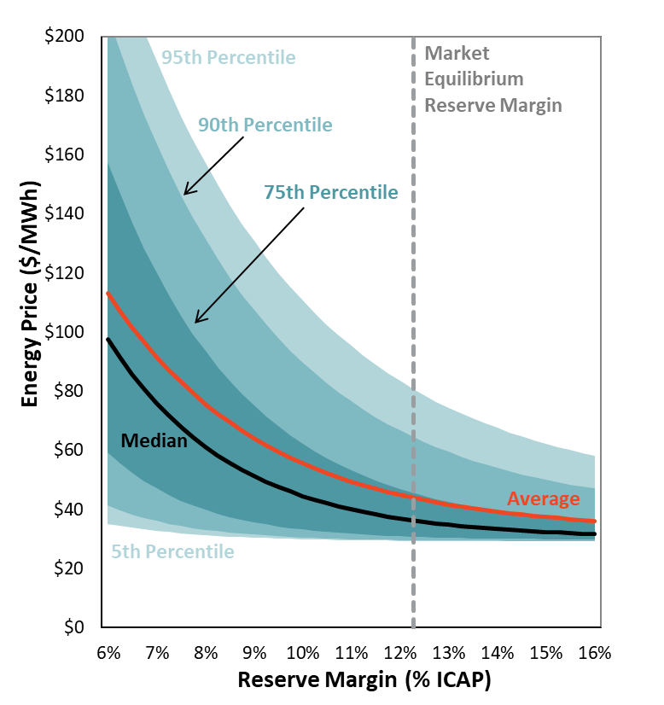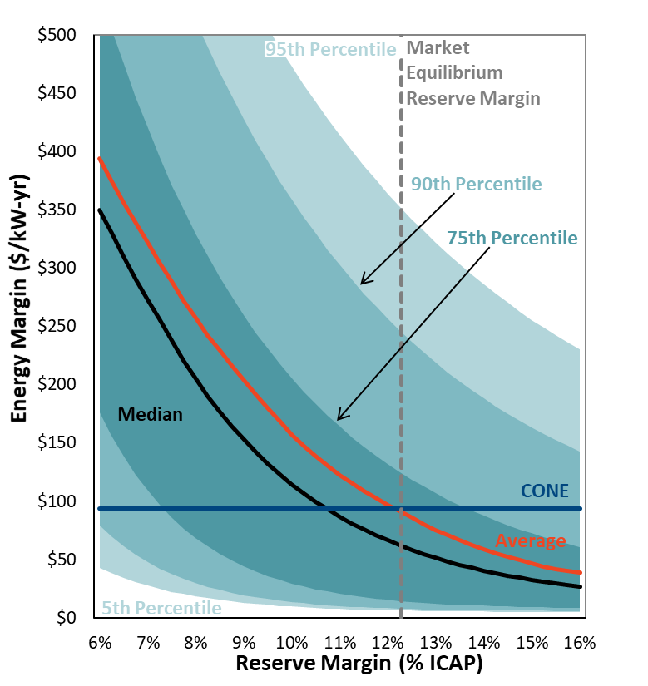
Note: Marginal Unit Net Energy Revenues represent net revenues from added CTs.
The years reflected in the tails of the distribution have a substantial effect on the MERM. For example, at the base case MERM value of 12.25%, we estimate that once per decade (90th percentile) energy prices would exceed $65/MWh (78% higher than the median price at this reserve margin). Once every two decades (95th percentile), prices would exceed $81/MWh (123% above the median price). Similarly, new gas plant net revenues in the median year are only $62/kW-year, which is just 66.5% of CONE, but occasional high-priced years would elevate the average to CONE. Assuming full exposure to spot market prices (i.e., no hedging) net revenues of marginal units would exceed $246/kW-year (about 2.6 times CONE) once in a decade (90th percentile) and $353/kW-year (about 3.8 times CONE) once every two decades (95th percentile). All simulation results reflect scarcity pricing rules that reduce the systemwide offer cap from $9,000/MWh to $2,000/MWh when net operating profit exceeds three times the cost of new entry (assumed at $93.5/kw-yr).

Year-to-Year Reserve Margin Variability
The uncertainty in future load growth can have significant impacts on reserve margins and reliability. Our base case simulations assume that the market invests based on the expected load growth and resulting prices on a four-year forward basis. However, realized load growth will generally differ from four-year expectations, resulting in a range of reserve margins that differ from the equilibrium reserve margins shown above.
We simulate this effect by assuming alternative load growth projections based on the distribution of non-weather forecast error in projecting future load, as described in Appendix 1.A.1 below. Even if the four-year-ahead planning reserve margin is exactly at the market equilibrium of 12.25%, realized shorter-term planning reserve margins can be higher or lower as load growth uncertainty resolves itself over the next four years. The planning reserve margins projected going into each summer would thus vary around the equilibrium from 10.7% to 13.8% in 50% of all years and drop below 9.25% approximately once per decade (i.e., below the 10th percentile). Once weather-related load fluctuations are considered as well, after-the-fact realized reserve margins will vary even more substantially and will drop below 9.4% approximately once per decade (i.e., below the 10th percentile). However, realized reserve margins, particularly the lows that largely reflect realized weather extremes, should not be compared to more familiar planning reserve margin benchmarks.
Variability in reserve margins may be moderated by short lead-time resources (including switchable units, mothballs, uprates, and demand response) that can exit or enter the market as expectations change between four years forward and delivery. By not simulating the effects of market exit and entry by short-term resources, our results would tend to overstate the range of realized reserve margins. However, our simulations do not account for the countervailing effects of additional supply-side uncertainties, such as unanticipated retirements, construction delays, and lumpiness in uncoordinated new entry, which would tend to increase the variability of reserve margins. Furthermore, uncertainties about anticipated fuel prices, the capacity contribution of renewables, and other modeling assumptions would further widen the distribution of realized reserve margins. Overall, we estimate that with a four-year forward period, load forecast uncertainty would result in equilibrium reserve margins ranging from 9.25% to 15.25% (10th to 90th percentiles).

Comparison to 2018 Study Results
The 2018 study estimated a market equilibrium reserve margin for 2022 of 10.25%, which is 2.00 percentage points lower than current base case results of 12.25%. There are several offsetting factors that result in a 2.00% net change in the MERM, shown in Figure 7 below. While changes in the ORDC and forced outage rate assumptions increase the MERM, these changes are somewhat offset by an increase in renewables, and a change to the reference technology from a blended CT and combined-cycle to just a CT.
The largest drivers that had upward effects on the MERM are the higher ORDC, the higher forced outage rates for conventional generators, and renewable accounting procedures. The economic effects of higher renewable penetration and the composition of the reference technology reduced the MERM. While sensitivity simulations were not performed to assess the implications for a change in reference technology to an alternative gas-fired technology, the small difference in capital costs between combined cycles and combustion turbines is likely slightly more than offset by the production cost savings of the more efficient technology. This likely contributes to a small reduction in the MERM.
Since the base case uses the renewable accounting methodology applied in ERCOT’s CDR development process, any discrepancy between the renewable capacity in the CDR and the reliability contribution in the simulations will also affect the MERM. The largest discrepancy between the capacity credit for incremental resources was for wind resources. The net change in capacity credit for wind in the CDR between the two studies was 2,806 MW, while the reliability contribution of wind only changed by 1,142 MW in the SERVM simulations. Offsetting this effect was the fact that storage resources were not given any capacity credit in the CDR, but in the simulations they did provide reliability value. The net effect of these accounting practices is a 1.00% increase in MERM.

Figure 7. Drivers of the Market Equilibrium Reserve Margin Change from 2018 to 2020 Study
Given the MERM in this study is 2.00 percentage points higher than the MERM found in the 2018 study, intuition suggests that ERCOT would be more reliable at MERM now. However, since the one percentage point increase in forced outage rates and one percentage point renewable accounting impact do not correspond to reliability improvements. The reliability actually stayed the same between the 2018 study MERM and the 2020 study MERM. Absent the administrative boost to ORDC prices, reliability would have degraded at MERM. Since the effects reducing MERM are projected to escalate with additional renewable, it will be important to carefully monitor projected reliability going forward.

Economically Optimal Reserve Margin

System Cost-Minimizing Reserve Margin
The EORM is the level of capacity that minimizes total system capital and production costs. As shown in Figure 8 below, we estimated the annual average of reliability-related costs over a range of planning reserve margins and found the EORM under base case assumptions to be 11.00%.
At the lowest reserve margins analyzed, the average annual reliability costs are high, driven by the cost of firm load shedding (red bar), regulation and reserve scarcity (grey bars), and production costs of emergency and conventional resources. As reserve margins increase, total reliability costs drop due to the decrease in scarcity events and production costs. These costs decrease more quickly than the increases in capital costs associated with adding additional CTs resulting in a decrease in total system costs. This continues at higher reserve margins until the “economically optimal” quantity of capacity has been added at a reserve margin of 11.00%. After crossing this minimum cost point, the capital costs of adding more CTs exceed the benefits from reducing reliability-related costs, so total costs increase.
Figure 8. Total System Costs across Planning Reserve Margins
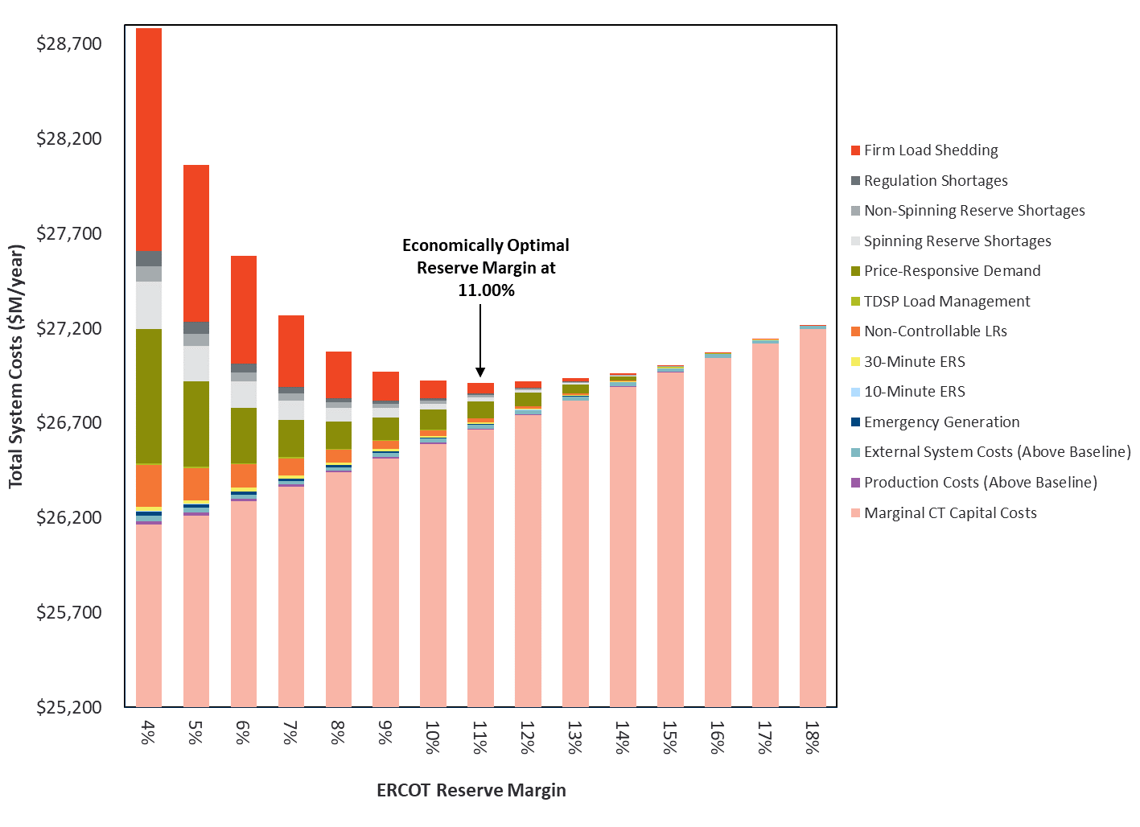
Notes:
Total system costs include a large baseline of total system costs that do not change across reserve margins, including $13.4B/year in transmission and distribution (assumption not updated from 2018 study), $7.5B/year in external system costs, and $5.2B/year in production costs.
The total cost curve shown above has a shape similar to those we have observed in value-of-service studies for many other electric systems. The curve is relatively flat near the minimum average cost point, indicating that expected total costs do not vary substantially between reserve margins of 10%–12%. However, the lower end of that range (10%) is associated with much more uncertainty in realized annual reliability costs, which we discuss in the next section, and a much larger number of severe, high-cost reliability events. At the 12% reserve margin, a greater proportion of total annual costs is associated with the costs of adding new units (which has less uncertainty), and a smaller proportion of the average annual costs are from uncertain, low-probability, but high-cost reliability events. One notable difference from the components of the EORM curve is the smaller magnitude of production cost savings. Since CTs are near the top of the dispatch stack, increasing penetration does not provide much incremental production cost savings.
At each reserve margin level in Figure 8, we show the weighted-average costs across all 10,000 annual simulations for several components of system costs that change with reserve margins. We estimated each of the components of system costs based on the following assumptions:
- Marginal CT Capital Costs are the annualized fixed costs associated with building CT plants at a cost of $93.5/kW-year in the Base Case.
- Production Costs (Above $5.2 billion per year Baseline) are total system production costs of all resources above an arbitrary baseline cost of $5.2 billion. We show only a portion of total system costs as an individual slice on the chart in order to avoid having production costs dwarf the magnitude of other cost components and subtract the same $5.2 billion at all reserve margins shown. Production costs decrease at higher reserve margins because adding efficient new gas CTs reduces the need to dispatch higher-cost peakers.
- External System Costs (Above Baseline) include production and scarcity costs in neighboring regions above an arbitrary baseline, which drop by a small amount with increasing reserve margins because ERCOT will rely less on imports from high-cost external peakers during internal scarcity events, and may be able to export more supply during external scarcity events.
- Emergency Generation is the price-driven dispatch of units outputting at high levels above their summer peak ratings at an assumed cost of $1,372/MWh, see Appendix 1.E.3.
- 10-Minute and 30-Minute ERS is the cost of dispatching these resources during emergency events at assumed costs of $2,469 and $1,372/MWh for 10-minute and 30-minute ERS respectively, see Appendix 1.C.1.
- Non-Controllable LR costs reflect the cost of administratively re-dispatching LRs from supplying Responsive Reserve Service (RRS) to supplying energy at a cost of $2,469/MWh during emergencies, see Appendix 1.C.2.
- TDSP Load Management costs are incurred when ERCOT administratively orders these demand-side resources to curtail during emergencies at an assumed cost of $2,469/MWh, see Appendix 1.E.2.
- Spinning and Non-Spinning Reserve Scarcity costs are calculated as the area under the ORDC curve, calculated assuming load would be shed at X = 1,000 MW, see Appendix 1.E.4.
- Regulation Scarcity costs are calculated according to the Power Balance Penalty Curve (PBPC) assuming that this curve accurately reflects the marginal cost of running short on regulating reserves, see Appendix 1.E.5.
- Firm Load Shedding costs are the customer costs imposed during load-shed events at a cost at the assumed VOLL of $9,000/MWh.

Exposure to Extreme Scarcity Events
The economic results shown above assume risk neutrality with respect to the uncertainty and volatility of reliability-related costs. Figure 8 compares total costs at different reserve margins as the probability-weighted average of annual reliability costs for all 10,000 simulation draws. However, there is substantial volatility around the average level of possible reliability cost outcomes. Most simulated years will have very modest reliability costs, while a small number of years have very high costs. These high-cost outcomes account for the majority of the weighted-average annual costs shown as the individual bars in Figure 8 above.
Figure 9 below summarizes this risk exposure by comparing the weighted-average costs for different reserve margins (red line, which is equal to the height of the individual bars in Figure 8) to annual costs under the most costly possible outcomes, represented by the 75th, 90th, and 95th percentiles of annual reliability costs across all 10,000 simulated scenarios.
Considering the higher-cost uncertainty exposure at lower reserve margins, some policymakers prefer reserve margins to exceed the risk-neutral economic optimum. As the simulation results show, a several percentage point increase in the reserve margin would only slightly increase the average annual costs, but more significantly reduce the likelihood of experiencing very high-cost events. Total average costs change by a relatively modest amount over a range of planning reserve margins (e.g., average system costs increase by just $5 million with an increase in reserve margin from 10% to 15%). However, lower planning reserve margins have a significantly larger uncertainty in reliability costs and the likelihood of high-cost outcomes than can be encountered in any particular year. For example, at a 7% reserve margin, costs are expected to be $2.2 billion higher than average once every ten years, while at 11% they would increase with a similar frequency by $1.2 billion.
Figure 9. Year-to-Year Possible Realizations of Total Annual System Costs 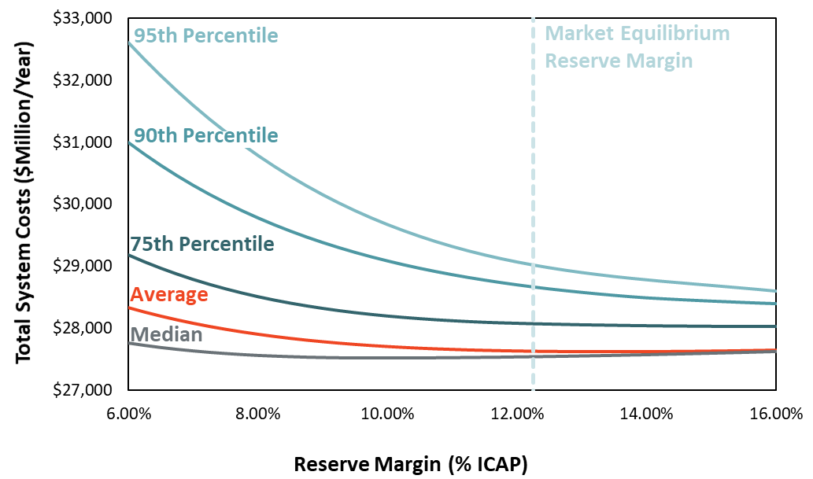
Notes:
Total system costs include scarcity-related and production costs (that decrease with reserve margin), generation capital costs (that increase with reserve margin), and T&D costs (which remain constant across reserve margins. Additional detail on the individual components of total system costs is available in Section III.B.1.

System Reliability
In this section, we compare the expected reliability of the market equilibrium reserve margin to traditional reliability metrics.

Physical Reliability Metrics
At a market equilibrium reserve margin of 12.25% ERCOT can expect a probability-weighted average of 0.5 loss-of-load events (LOLE) per year. Our simulations find that there is likely to be a loss-of-load event about every two years in the range of 1,541 MW of load being shed for 2.9 hours on average, for a total expected unserved energy of 4,507 MWh. Such events would be more frequent, longer, and deeper at lower reserve margins and less so at higher reserve margins. Figure 10 depicts how three physical reliability metrics vary with reserve margin: (1) LOLE on the left; (2) loss of load hours (LOLH) in the middle; (3) Normalized Expected Unserved Energy (EUE) on the right.
Figure 10. Reliability Metrics that Vary with Reserve Margins
(a) LOLE (b) LOLH (c) EUE
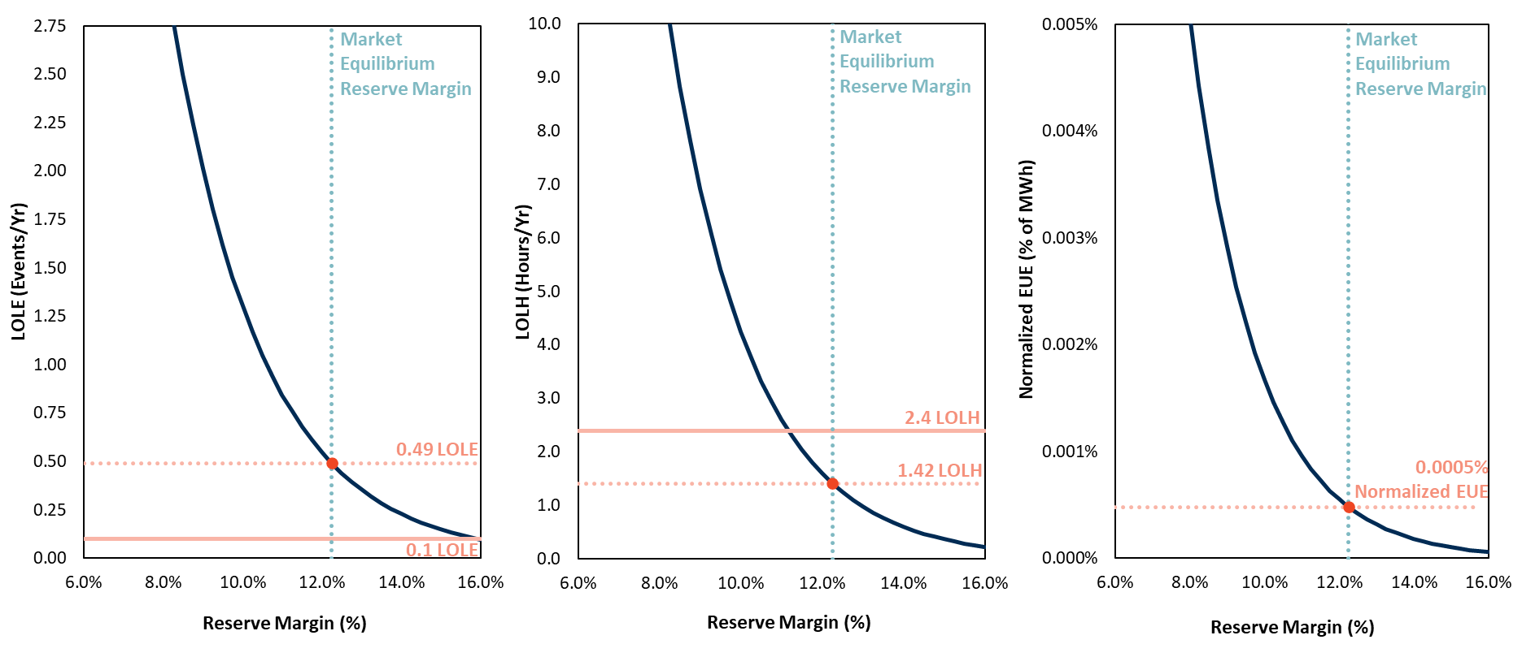
Notes: Reflects Base Case assumptions, including 4-Year Forward LFE, and equal weather weights of all 40 weather years.
Table 8 shows the same information in tabular form, along with additional information describing the magnitude of outage events when they occur.
Table 8. Detailed Reliability Metrics across Planning Reserve Margins in Base Case
Reserve Margin | Total Annual Loss of Load |  |  | Average Outage Event
 | LOLE | LOLH | EUE | Duration | Energy Lost | Depth
(%) | (events/yr) | (hours/yr) | (MWh) | (hours) | (MWh) | (MW)
4% | 17.61 | 79.45 | 209,338 | 4.51 | 11,890 | 2,635
5% | 11.41 | 48.76 | 120,154 | 4.27 | 10,532 | 2,464
6% | 7.39 | 29.93 | 68,964 | 4.05 | 9,329 | 2,304
7% | 4.79 | 18.37 | 39,583 | 3.83 | 8,264 | 2,155
8% | 3.10 | 11.27 | 22,720 | 3.63 | 7,320 | 2,015
9% | 2.01 | 6.92 | 13,040 | 3.44 | 6,484 | 1,885
10% | 1.30 | 4.25 | 7,485 | 3.26 | 5,744 | 1,762
11% | 0.84 | 2.61 | 4,296 | 3.09 | 5,088 | 1,648
12% | 0.55 | 1.60 | 2,466 | 2.92 | 4,507 | 1,541
13% | 0.35 | 0.98 | 1,415 | 2.77 | 3,992 | 1,441
14% | 0.23 | 0.60 | 812 | 2.62 | 3,536 | 1,348
15% | 0.15 | 0.37 | 466 | 2.49 | 3,132 | 1,260
16% | 0.09 | 0.23 | 268 | 2.35 | 2,775 | 1,179
17% | 0.06 | 0.14 | 154 | 2.23 | 2,458 | 1,102
18% | 0.04 | 0.09 | 88 | 2.11 | 2,177 | 1,031
Most US areas set reliability metrics on the “1-in-10” standard, i.e., a probability-weighted average of 0.1 loss-of-load events (LOLE) per year. Under base case conditions a 15.75% reserve margin would be required to achieve 0.1 LOLE, which is 3.5 percentage points higher than MERM.
All of the reliability metrics shown above reflect the average over many possible outcomes at a given reserve margin. Average statistics provide a convenient summary of a large amount of data, but they can obscure the wide distribution of possible outcomes around the average, as shown in the sections above. Realized reliability in any given year will depend strongly on the weather and on generation availability.
To illustrate the distribution of possible outcomes, Figure 11 below shows how reliability varies with weather, as measured by the annual expected unserved energy. The teal bars show the total MWh of load shed during each of the 40 weather years for the Base Case simulations at a 12.25% reserve margin corresponding to the market equilibrium reserve margin. The reoccurrence of 2011 weather conditions could lead to almost 17,080 MWh of expected involuntary curtailment of firm load, far above the equal-probability-weighted average of 2,171 MWh over all 40 years depicted by the blue horizontal line. By contrast, 25 out of the 40 years have much milder weather, with substantially less load shed than the average. Thus, the actual reliability will vary. In addition, the expected value of reliability would differ if different probability weights were assigned to the various weather patterns, as discussed in the next section.
Figure 11. Expected Unserved Energy by Weather Year at 12.25% Reserve Margin
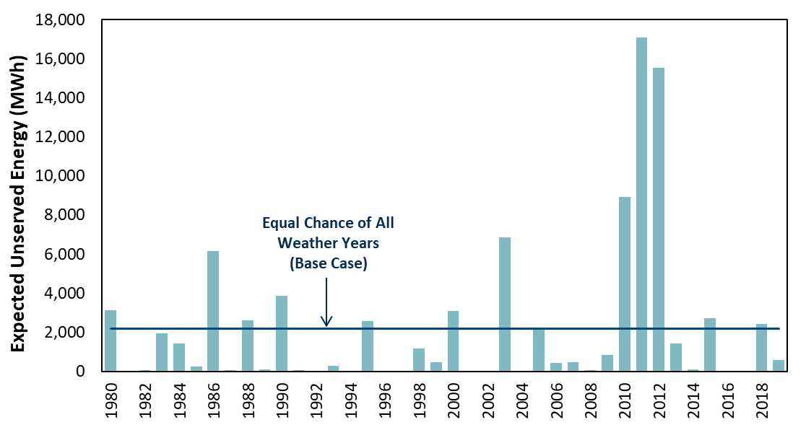
Notes: Figure reflects Base Case 4-Year forward LFE assumption and the Base Case equal weather weight for all 40 years.

Emergency Event Frequency
Figure 12 summarizes the frequency of six types of emergency events for the base case simulations as a function of the reserve margin. The emergency events, in increasing order of severity, are: (1) the economic dispatch of emergency generation (red line); (2) calling 30-minute ERS (dark gray line); (3) calling TDSP load curtailments (dark blue line); (4) re-dispatching LRs from RRS to energy (light gray line); (5) calling 10-minute ERS (light blue line); and, finally, (6) shedding firm load (light red line). As shown, at a 15.75% reserve margin corresponding to 1-event-in-10-years (0.1 LOLE), emergency generation would be dispatched approximately one time a year on a weighted-average basis across all simulated years. At a reserve margin of 8.5%, the system faces two load shed events per year on average, most years without load shed events and some years with several. At the same 8.5% reserve margin, the various types of demand resources would have to be called from two to four times on average each year (depending on the resource type), and emergency generation would be dispatched approximately nine times on average each year. At the market equilibrium reserve margin of 12.25%, emergency generation would be dispatched about three times on average per year, and other demand resources would average about one time per year.
All types of emergency events become more frequent at lower reserve margins, but the frequency of load shed and emergency generation decline faster than several of the other categories of emergency events. Some of the emergency products in ERCOT are summer-only so any reliability events that occur in non-summer months will only entail emergency generation and load shed.

Figure 12. Average Annual Frequency of Emergency Events
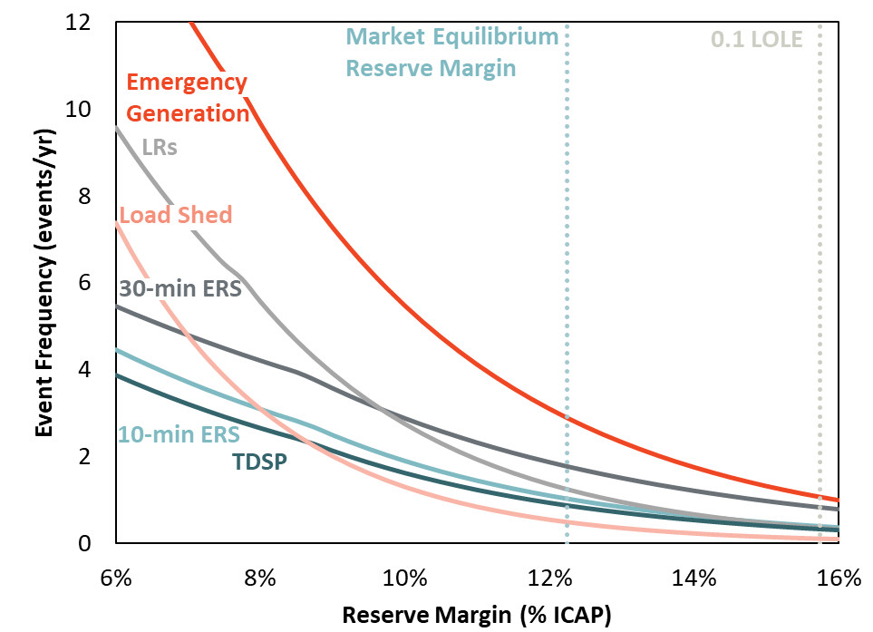
Notes: Results from Base Case (4-Year Forward LFE, equal weighting of weather years).
Inflections in the series data reflect the fact that some emergency procedures are not available in all seasons or they have other call constraints.

Sensitivity of Market Equilibrium Reserve Margin to Study Assumptions
If investors have different beliefs about load and other factors affecting revenues, or if they face different costs, the MERM could differ from our estimates. Here we examine several important uncertainty factors affecting the MERM, including: (1) the amount of intermittent renewable generation installed; (2) the reference technology moving to four-hour battery storage; (2) the forced outage rate of conventional generators; (3) the assumed cost of building new natural gas-fired plants; (3) the value of lost load; (4) the assumed probabilities of the historical weather years used to model hourly loads and renewable generation; (5) and load forecast uncertainty.
Changing the values for these variables over a plausible range results in market equilibrium reserve margins ranging from 10.25% to 13.25%. The actual uncertainty could be even wider, however, when considering other possibilities such as extreme weather events, broader distributions of intermittent renewable generation coinciding with the highest load years (rather than always taking the 2011 wind patterns with 2011 loads, for example), or different beliefs about future market and regulatory conditions. This range of equilibrium reserve margins would produce a range of reliability outcomes, which we estimate to be 0.32 to 1.17 LOLE.

Renewables Penetration Scenarios
The base case analysis assumes 37.4 GW of wind and 16 GW of solar online by 2024, based on the existing fleet and planned resources that have met the criteria to be included in the CDR. Our alternative “High Renewables” scenario adds wind and solar capacity that has not yet met all the requirements to be included in the May 2020 CDR, resulting in an additional five GW of wind and 15 GW of solar.
All else equal, adding renewable generation would decrease prices; but lower prices should force out conventional generation, until the market re-equilibrates at approximately the same reserve margin. However, we do estimate that equilibrium reserve margins would decrease slightly with higher renewable penetration because the net load duration curve becomes steeper. A steeper net load duration curve causes prices to fall faster from the peak hour. That would reduce generators’ net revenues, so reserve margins have to tighten slightly to re-equilibrate, with a slight increase in high-priced ORDC hours. As discussed in the Executive Summary, the load shape impact of increasing renewables is becoming significant given projected 2024 penetrations. Solar capacity additions to date have not materially steepened the net load shape since solar afternoon output has not reduced the net load below the load after sunset. Once the net load in late afternoon hours is below the post-sunset net load, subsequent additions of solar will make the net load much steeper late in the day. This steep net load shape means that few hours will be close to the daily peak load, and correspondingly few hours will be close to the annual peak load. In the 2018 study, the High Renewables scenario reduced the MERM by 1 percentage point. In this study, a commensurate 20 GW increase in renewable capacity reduces the MERM by 2.00 percentage points, as illustrated in Figure 13.
Figure 13. Market Equilibrium Reserve Margin Sensitivity to Renewable Penetration

Storage Potential at the High Renewables Penetration
The net load shape effect of increasing renewable resources provides an opportunity for short duration resources to provide capacity value. The area under the net load curve during peak days that could be served by four-hour duration resources increases over the addition of the next 15 GW of solar capacity. Quantification of this shift is shown in Figure 14.
Figure 14. Net Load Shape Impact of Solar
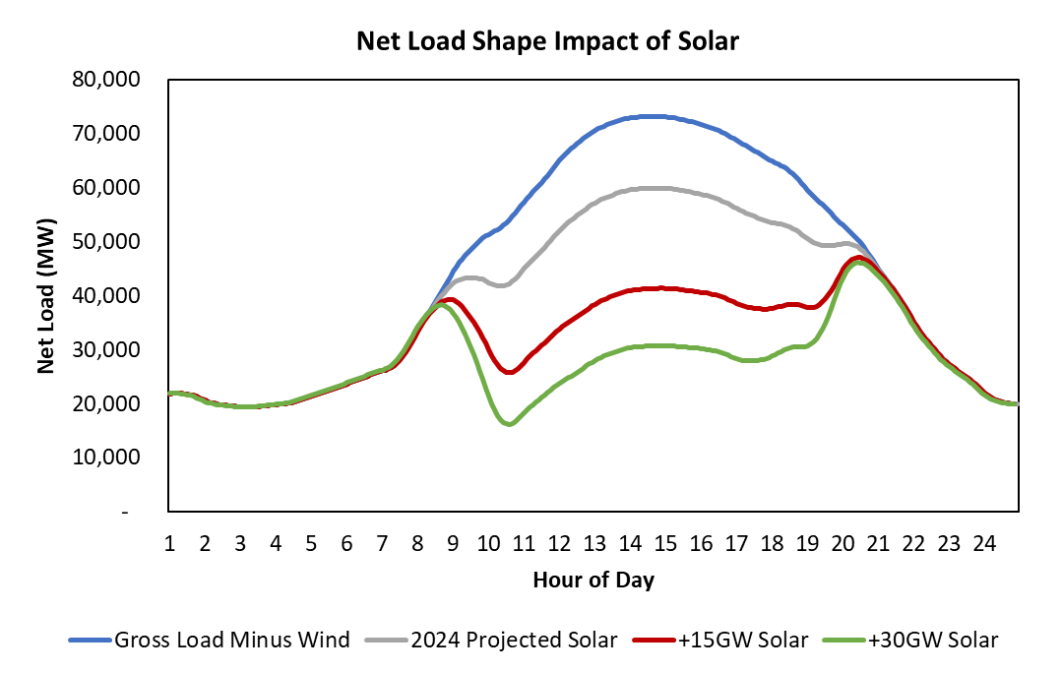
To quantify the capacity of storage that can contribute to reliability, the area under each net load curve is analyzed. The area under the series labeled ‘Gross Load Minus Wind’ within one GW of the daily net load peak is approximately 1.6 GWh. This means that one GW of load can be served reliably with 1.6 hours of energy from a battery resource. Within two GW of the daily net load peak a longer duration is required and that area represents 2.1 hours of energy. Figure 15 contains a visual illustration of this example. The area under the curve for the ‘Gross Load Minus Wind’ series at four-hours of duration corresponds to 8,000 MW of capacity and is shown as the far left point on Figure 16.

Figure 15. Net Load Shape Impact of Solar
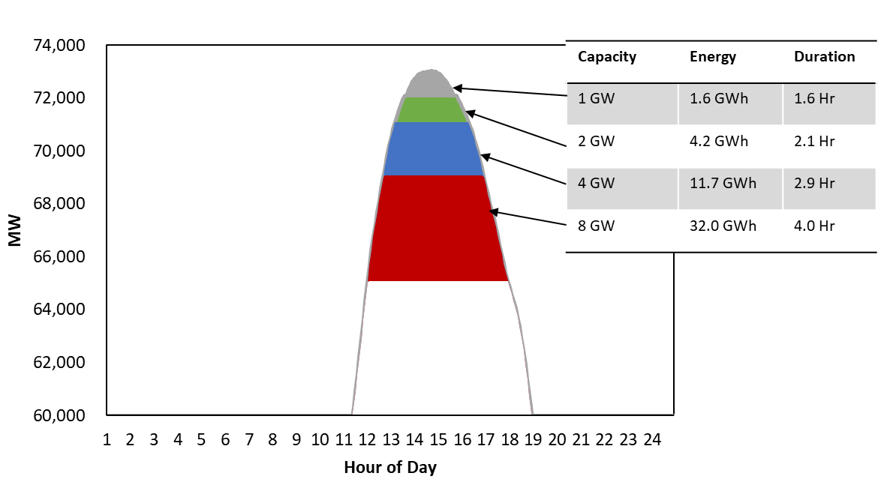
Performing this calculation for a wide range of solar penetrations yields the remaining points on this series. Initial incremental solar flattens the net load shape, reducing the potential for storage to supply reliability to ERCOT. At approximately 30 GW of total solar penetration, the net load shape begins to steepen and storage potential begins to increase. In the high renewable scenario analyzed, approximately 10 GW of four-hour battery storage has the potential to supply reliability value to ERCOT.
Figure 16. Storage Potential to Contribute to Reliability
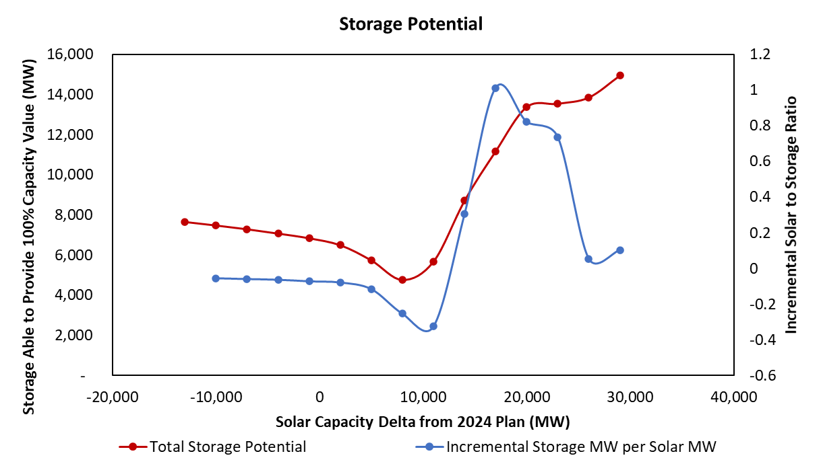
Example charging and discharging schedules, in Figure 17, illustrate the flatness or steepness of the respective daily load shapes under different solar penetrations.
Figure 17. Storage Charging Potential 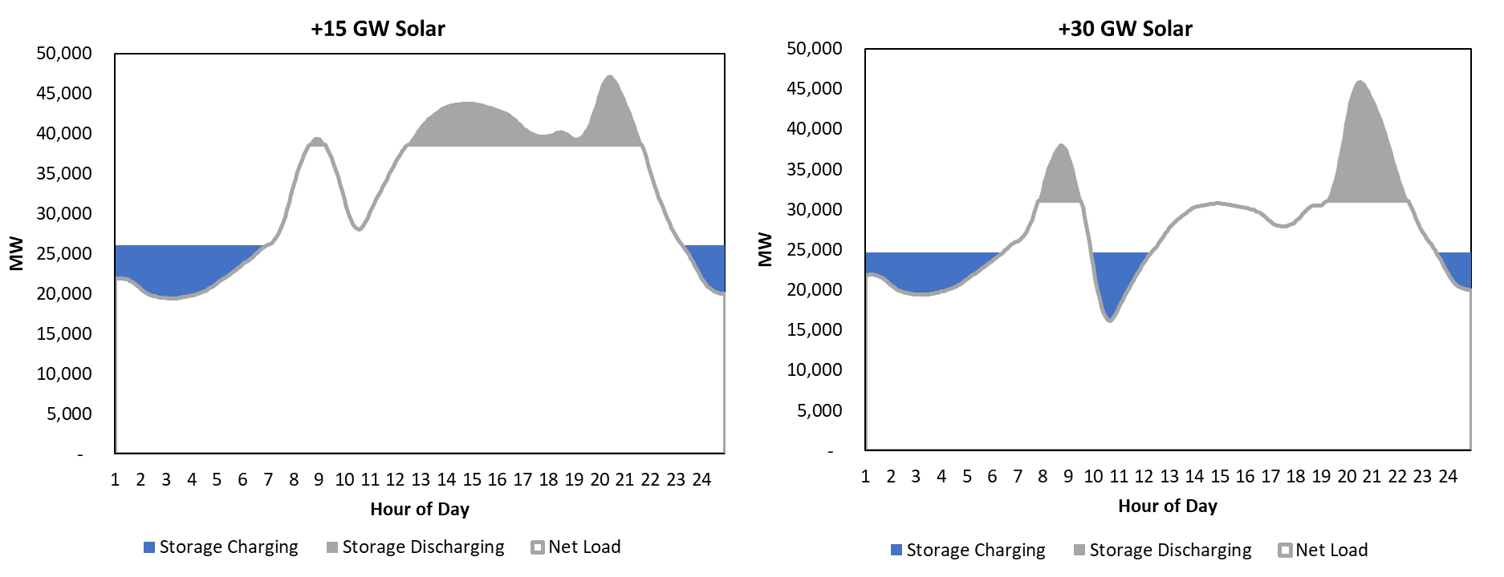
The economic opportunity for battery storage is limited by the daily arbitrage opportunity throughout the year. The significant penetrations of renewable resources in ERCOT create frequent low market price hours where most conventional generation is either turned off or dispatched near minimum. During these periods, renewable generation can even be curtailed. The bidding strategies of renewable generator owners may entail bidding at negative prices since they have a financial incentive in terms of tax credits to continue to produce. Batteries are able to charge during these periods and capture significant arbitrage opportunities. To assess the potential for batteries to earn an economic return in future high renewable scenarios, the bidding behavior of these resources must be modeled. The historical relationship between curtailment and the average minimum zonal price is reflected in Figure 18.
Figure 18. Historical Relationship Between Curtailment and the Average Minimum Zonal Price
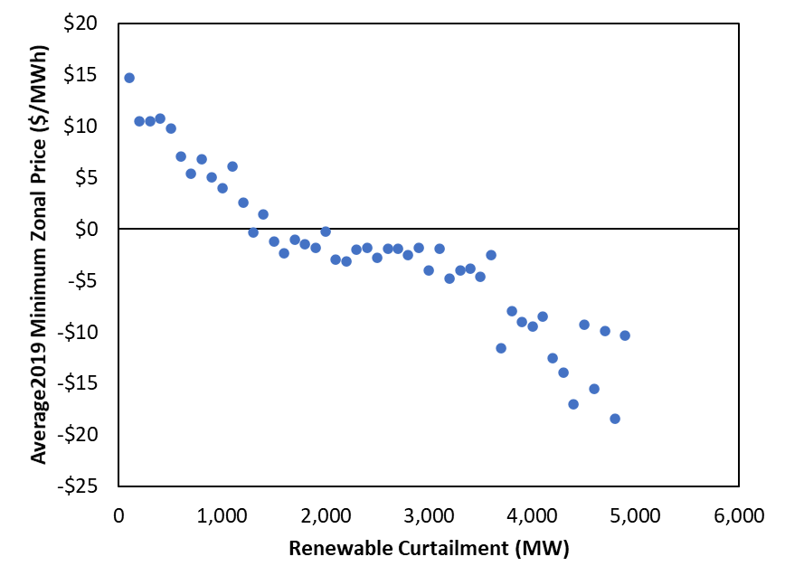
Unfortunately the behavior is likely influenced by penetration and composition of renewable resources that will be on the system in the future and extrapolating from historical relationships is challenging. Assuming that market prices in these low net load periods will continue to be correlated to system renewable curtailment, the historical relationship was modeled in SERVM. A sensitivity reflecting moderation of negative pricing bidding strategies demonstrated that energy margins for battery resources could decline by 10%.
Even with frequent negative pricing, the economic arbitrage opportunity is still limited and declines as the penetration of storage increases. On days in which combined-cycle generators are on the margin in low load hours and CTs are on the margin in high load hours, the arbitrage opportunity is less than $10/MWh with gas prices below $3/MMBtu. Simulations of mild weather years with a reserve margin near MERM suggest energy arbitrage opportunities over the course of the year approaching $30/kw-yr. After inclusion of ancillary service market opportunity and scarcity pricing periods, the economic margins of the first tranches of energy storage exceed those of marginal CTs, but decline as the penetration increases. As shown in Figure 19, with capital carrying costs of $147/kw-yr, the economic potential for batteries is only 2,100 MW, and approximately 1,100 MW of batteries is already expected to be in the system in 2024. This opportunity also presumes that other conventional resources would economically retire to maintain the system reserve margin near MERM. Otherwise, if reserve margins increased with increasing penetration of storage, returns would drop much faster. If battery capital costs decline to $115/kw-yr, up to 6.5 GW of incremental 4-hour battery capacity could be economic.
Figure 19. Storage Charging Potential

Cost of New Entry Sensitivity
The base case simulations assume that a combination of natural gas-fired CTs are the marginal resource with industry standard assumptions for capital costs. However, industry experience suggests that there is a range of uncertainty around technology cost estimates. Figure 20 shows the impact of varying CONE from −25% to +25% relative to our base assumptions. The base case CONE estimate was adapted from a Brattle Group study from 2018. A more recent report from Lazard gives a range of estimates for installed capital costs with a lower end of $700/kW. This is approximately 22% lower than the comparable installed cost in the Brattle report. Accordingly, we selected a range of -25% to +25% relative to our base assumptions. Overall, the MERMn could vary over a range of 11.25% to 13.25% depending on the range of CONE uncertainty.
Figure 20. Market Equilibrium Reserve Margin Sensitivity to Cost of New Entry
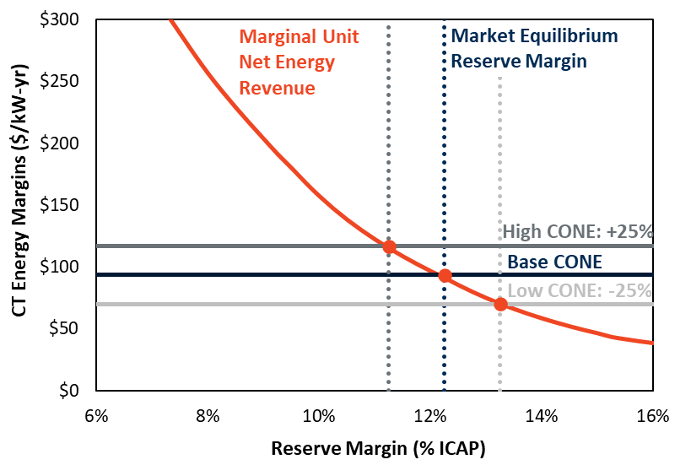

Probability Weighting of Weather Sensitivity
The high impact of weather on net energy revenue means that different weather expectations will influence the market equilibrium reserve margin. The base case assumes equal probability for all 40 weather years because 40 years should be a sufficient sample of the underlying distribution, assuming that distribution is representative of future weather patterns. This reliance on long history is consistent with the EORM Manual. However, more recent weather has, on average, been hotter (especially in 2011) and may be assumed to be more representative of future weather, as discussed in Section II.E above. Assuming accordingly that each of the last 15 weather years has a 6.66% chance of reoccurring (with 0% weight on each of the prior 25 years) leads to higher simulated prices and reliability events at a given reserve margin; but the higher prices would attract more investment, resulting in a 1% higher market equilibrium reserve margin of 13.25%. With that higher MERM protecting against the effects of hotter weather, the simulated reliability is approximately the same as in the base case.

Forward Period and Load Forecast Uncertainty Sensitivity
In our base case analysis, we assume that all future supply decisions must be locked in four years in advance, approximately consistent with the lead time needed to construct new natural gas-fired generation resources. However, unlike weather-related load uncertainty, non-weather load forecasting error (LFE) increases with the forward period. The forward period may increase if investors require a longer planning period and decrease if there are significant short-term resources (such as demand response, switchable units, mothballed units, and even renewable resources) to respond more quickly to market conditions than traditional new builds. Depending on the expected forward periods the market equilibrium will vary from 11.25% to 12.25%.

Summary of Sensitivities
Our estimate of the MERM is sensitive to a number of study assumptions as we have explained in previous sections, and summarized in Figure 21 and Table 9. As shown in the table, the MERM is between 10.25% and 13.25% for all sensitivities.
The change in the VOLL is not considered to shift the operating reserves demand curve (ORDC) and will not affect the MERM. Moving from a four-year LFE forward period to no forward period reduces the MERM by one percentage point. Each one-year increase in the forward period increases the MERM by 0.25%. Weighting more recent weather years more heavily increases MERM since recent data exhibits higher loads on average. And the effects of CONE pricing are symmetrical, but even a reasonably large shift of 25% only moves MERM by one percentage point.

Figure 21. Sensitivity of the Market Equilibrium Reserve Margin to Study Assumptions
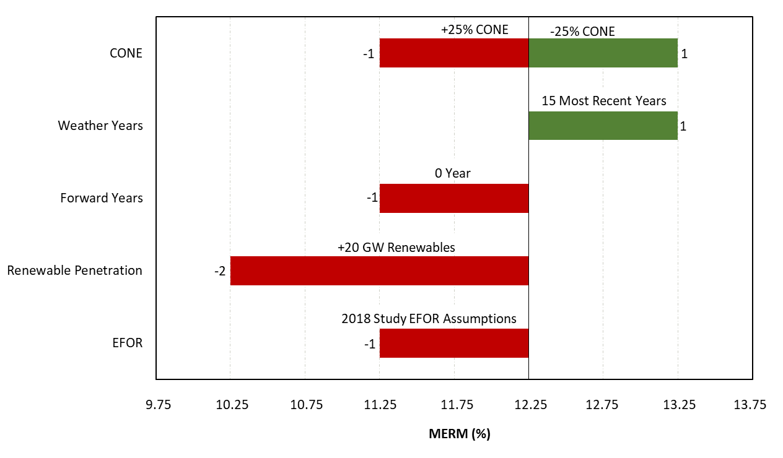
Notes: Varying the VOLL is not shown because it does not affect the MERM.
Table 9. Sensitivity of the Market Equilibrium Reserve Margin to Study Assumptions
Scenario/Sensitivity | Market Equilibrium Reserve Margin  (%) | Base Assumptions | Low/High Sensitivity
Base Case | 12.25
Vary CONE | 11.25 – 13.25 | $93.5/kW-yr | $70.1 - $116.9/kW-yr
Vary VOLL | 12.25 | $9,000/MWh | $5,000-$30,000/MWh
Vary Probability of Weather Years | 13.25 | Equal probability to all 40 weather years | Equal probability to last 15 weather years
Vary Forward Period and Load Forecast Uncertainty | 11.25 – 12.00 | 4 years | 0 years to 3 years
High Renewables Scenario | 10.25 | May 2020 CDR values for 2024 study year | 15 GW of new solar and 5 GW of new wind
Lower EFOR | 11.25 | Last 3 years to populate outage rates for all units | 2018 study class average EFORs
Notes: Varying the VOLL does not affect the MERM.

Discussion of Results
As shown in Table 10, the reported MERM from the 2018 study increased from 10.25% to 12.25%, but the increase is associated with forced outage rate changes and reserve margin reporting artifacts which do not translate to improvements in reliability. The base case in this study, as in the 2018 study, projects 0.5 LOLE days per year, a level 5 times higher than the industry standard of 0.1 LOLE. If renewable deployments continue to increase to the level in the high renewable scenario analyzed, firm load shed frequency will rise 160% to 1.3 days per year. This high renewable scenario demonstrates a MERM of 10.25%. Since further renewable penetration increases have a more dramatic impact on the shape of the net load curve, the impact on MERM will escalate, further reducing reserve margins and increasing the frequency of reliability events.
Table 10. MERM and Reliability Comparison Between Scenarios
Scenario | MERM | Reliability at MERM  (LOLE in Days per Year)
2018 Study | 10.25% | 0.5
2020 Study | 12.25% | 0.5
2020 Study, High Renewable | 10.25% | 1.3
However, other factors, which have in recent history mostly resulted in realized reserve margins in ERCOT above MERM, may continue to exert an influence on reserve margin levels. Renewable resource investments motivated by alternate economic or other decision criteria have continued to be added at a pace that maintains a reserve margin above the market equilibrium even after economic retirements are accounted for. Storage deployment costs have dropped dramatically in recent years and after consideration of current and potential governmental incentives for storage devices, may support significant investment and result in the continuation of reserve margins that support high levels of reliability. However, the design of an energy-only market does not inherently protect system reliability. Future reserve margin studies will continue to analyze the implications of not only marginal conventional technology, but also the interactions of all resource classes and other market conditions that may result in realized reliability higher than projected by MERM.
In addition to highlighting the potential market and reliability outcomes of the ERCOT system, this report has provided information on the impact of accounting treatment of renewable resources. While the reserve margin is primarily only a reporting indicator, it can communicate the wrong message with respect to reliability if the disconnect between capacity credit and reliability contribution continues to grow. In fact, if current CDR accounting was applied to the high renewable scenario, the reported MERM would rise to 19.25%, even though the projected reliability for this scenario is 160% worse than that of the base case. In order to provide market participants with the most meaningful information, it is important that the reliability contribution calculations and capacity accounting be synchronized.
The results presented throughout this report consider a range of possibilities for a number of uncertain variables.To the extent history provides guidance for the distribution of uncertainty, rigorous analysis was performed to quantify it. Load shapes, renewable output profiles, and generator outages all have histories that give reasonable representations for how the future may materialize.

List of Acronyms

4CP Four Coincident Peak
ATWACC After-Tax Weighted Average Cost of Capital
AEO Annual Energy Outlook
CC Combined Cycle
CDR Capacity, Demand, and Reserves (report)
CONE Cost of New Entry (Gross)
CT Combustion Turbine
EFOR Equivalent Forced Outage Rate
EE Energy Efficiency
EORM Economically Optimal Reserve Margin
ERCOT Electric Reliability Council of Texas
ERS Emergency Response Service
EUE Expected Unserved Energy
GADS Generation Availability Data System
HCAP High System-Wide Offer Cap
HVDC High Voltage Direct Current
LCAP Low System-Wide Offer Cap
LFE Load Forecast Error
LTRA Long-Term Reliability Assessment
LOL Loss-of-Load
LOLE Loss-of-Load Event
LOLH Loss-of-Load Hour
LOLP Loss of Load Probability
LRs Load Resources
MERM Market Equilibrium Reserve Margin
NERC North American Electric Reliability Corporation
ORDC Operating Reserve Demand Curve
PBPC Power Balance Penalty Curve
PNM Peaker Net Margin
PRD Price Responsive Demand
PUCT Public Utility Commission of Texas
PUN Private Use Network
RRS Responsive Reserve Service
SCED Security Constrained Economic Dispatch
SERVM Strategic Energy Risk Valuation Model
SWOC System-Wide Offer Cap
TDSP Transmission/Distribution Service Providers
VOLL Value of Lost Load
VOM Variable Operations and Maintenance

Bibliography
Astrapé Consulting (2020). SERVM Software: Strategic Energy & Risk Valuation Model (SERVM). (Astrapé, 2020) Available at http://www.Astrape.com/servm/
Carden, Pfeifenberger, and Wintermantel (2011). The Value of Resource Adequacy Why reserve margins aren’t just about keeping the lights on. March 2011. (Carden, Pfeifenberger, and Wintermantel, 2011) Available at http://www.astrape.com/?ddownload=271
Electric Reliability Council of Texas (ERCOT) (2020a). Report on the Capacity, Demand and Reserves (CDR) in the ERCOT Region, 2021-2030, May 2020. (ERCOT, 2020a) Available at http://www.ercot.com/content/wcm/lists/197379/CapacityDemandandReserveReport_May2020.xlsx
Electric Reliability Council of Texas (ERCOT) (2020b). ERS Procurement Results. (ERCOT, 2020b) Available at http://mis.ercot.com/misapp/GetReports.do?reportTypeId=11465&reportTitle=ERS%20Procurement%20Results&showHTMLView=&mimicKey/
Electric Reliability Council of Texas (ERCOT) (2020c). Emergency Response Service Technical Requirements & Scope of Work, June 1, 2020 through September 30, 2020. April 6, 2020. (ERCOT, 2020c) Available at http://www.ercot.com/content/wcm/lists/89551/Technical_Requirements_draft_FINAL.docx
Electric Reliability Council of Texas (ERCOT) (2020d). ERCOT Nodal Protocols. September 2020. (ERCOT, 2020d) Available at http://www.ercot.com/content/wcm/libraries/212201/September_1__2020_Nodal_Protocols.pdf
Electric Reliability Council of Texas (ERCOT) (2020e). ERCOT DC-Tie Operations, Version 3.0 Rev 13. July 31, 2020. (ERCOT, 2020e) Available at http://www.ercot.com/content/wcm/key_documents_lists/90055/ERCOT_DC_Tie_Operations_Document.docx
Electric Reliability Council of Texas (ERCOT) (2020f). ERCOT Nodal Operating Guide. July 2020. (ERCOT, 2020f) Available at http://www.ercot.com/mktrules/guides/noperating/current
Electric Reliability Council of Texas (ERCOT) (2019a). 2020 ERCOT System Planning Long-Term Hourly Peak Demand and Energy Forecast. December 31, 2019. (ERCOT, 2019a) Available at http://www.ercot.com/content/wcm/lists/196030/2020_LTLF_Report.pdf
Electric Reliability Council of Texas (ERCOT) (2019b). Methodology for Setting Maximum Shadow Prices for Network and Power Balance Constraints. June 2019. (ERCOT, 2019b) Available at http://www.ercot.com/content/wcm/key_documents_lists/89286/Methodology_for_Setting_Maximum_Shadow_Prices_for_Network_and_Power_Balance_Constraints.zip
Electric Reliability Council of Texas (ERCOT) (2018a). Emergency Response Service Procurement Methodology. July 1, 2018. (ERCOT, 2018a) Available at http://www.ercot.com/content/wcm/key_documents_lists/91842/Emergency_Response_Service_Procurement_Methodology.zip
Electric Reliability Council of Texas (ERCOT) (2018b). Retail Demand Response Survey Participant Headcounts 2013 - 2017. February 23, 2018. (ERCOT, 2018b) Available at http://www.ercot.com/content/wcm/key_documents_lists/27290/Demand_Response_Presentations.zip
Electric Reliability Council of Texas (ERCOT) (2017a). Analysis of Load Reductions Associated with 4-CP Transmission Charges and Price Responsive Load/Retail DR. April 5, 2017. (ERCOT, 2017a) Available at http://www.ercot.com/content/wcm/key_documents_lists/108818/17.__WMS_2017_4CP__Retail_DR_Analysis_Raish.v2.pptx
Electric Reliability Council of Texas (ERCOT) (2017b). Study Process and Methodology Manual: Estimating Economically Optimum and Market Equilibrium Reserve Margins (EORM and MERM). December 12, 2017. (ERCOT, 2017b) Available at http://www.ercot.com/content/wcm/lists/114801/ERCOT_Study_Process_and_Methodology_Manual_for_EORM-MERM_11-3-2017_InitialDraft.docx
Electric Reliability Council of Texas (ERCOT) and William Hogan (2013). Back Cast of Interim Solution B+ to Improve Real-Time Scarcity Pricing, White Paper, March 21, 2013. (ERCOT and Hogan, 2013) Available at http://lmpmarketdesign.com/papers/Back_Cast_of_Interim_Solution_B_Improve_Real_Time_Scarcity_Pricing_Whitepaper.pdf
Federal Energy Regulatory Commission (FERC). Form No. 714 – Annual Electric Balancing Authority Area and Planning Area Report. 2020. (FERC, 2020) Available at https://www.ferc.gov/industries-data/electric/general-information/electric-industry-forms/form-no-714-annual-electric/data
Lazard (2020). Lazard’s Levelized Cost of Energy Analysis – Version 14.0. October 2020. (Lazard, 2020). Available at https://www.lazard.com/media/451419/lazards-levelized-cost-of-energy-version-140.pdf
Midcontinent Independent System Operator (2019). Planning Year 2020-2021 Loss of Load Expectation Study Report. November 2019. (MISO, 2019) Available at https://cdn.misoenergy.org/2020%20LOLE%20Study%20Report397064.pdf
Munasinghe, M. and A. Sanghvi (1988). “Reliability of Supply, Outage Costs and value of Service: An Overview,” The Energy Journal. Volume 9, Special Issue on Electricity Reliability. (Munasinghe and Sanghvi, 1988)
National Centers for Environmental Information: National Centers for Environmental Information (2019). Dataset Search. (NOAA, 2020) Available at https://www.ncei.noaa.gov/access/search/index
Newell, Hagerty, Pfeifenberger, Zhou, Shorin, Fitz (2018). PJM Cost of New Entry. April 19, 2018. (Newell, et al., 2018a) Available at https://www.pjm.com/~/media/committees-groups/committees/mic/20180425-special/20180425-pjm-2018-cost-of-new-entry-study.ashx
Newell, Carroll, Kaluzhny, Spees, Carden, Wintermantel, Krasny (2018). Estimation of the Market Equilibrium and Economically Optimal Reserve Margins for the ERCOT Region, 2018 Update. December 20, 2018. (Newell, et al., 2018b) Available at http://www.ercot.com/content/wcm/lists/167026/2018_12_20_ERCOT_MERM_Report_Final.pdf
North American Electric Reliability Corporation (NERC) (2019). 2019 Long-Term Reliability Assessment, December 2019. (NERC, 2019) Available at https://www.nerc.com/pa/RAPA/ra/Reliability%20Assessments%20DL/NERC_LTRA_2019.pdf
Poland, William B. (1988). “The Importance of Including Uncertainties in Economic Generation Reliability Planning,” The Energy Journal. Volume 9, Special Issue on Electricity Reliability. (Poland, 1988)
Public Utility Commission of Texas (PUCT) (2019). Chapter 25. Substantive Rules Applicable to Electric Service Providers. Subchapter S. Wholesale Markets, Effective Date May 30, 2019. (PUCT, 2019a) Available at http://www.puc.texas.gov/agency/rulesnlaws/subrules/electric/25.505/25.505.pdf
Public Utility Commission of Texas (PUCT) (2019). Control Number: 48539 Item Number: 33 Public Utility Commission of Texas Memorandum, January 16, 2019. (PUCT, 2019b) Available athttps://interchange.puc.texas.gov/Documents/48539_33_1004833.PDF
Southwest Power Pool (2018).2017 SPP Loss of Load Expectation Study Report. June 2018. (SPP, 2018) Available at https://www.spp.org/documents/58198/2017%20spp%20lole%20study%20report.pdf
Spees, Kathleen, Samuel A. Newell, Robert Carlton, Bin Zhou, and Johannes P. Pfeifenberger. 2011 Cost of New Entry Estimates for Combustion Turbine and Combined-Cycle Plants in PJM. August 24, 2011. (Spees, et al., 2011) Available at http://files.brattle.com/files/7932_cost_of_new_entry_estimates_for_combustion-turbine_and_combined-cycle_plants_in_pjm_spees_et_al_aug_24_11.pdf
U.S. Energy Information Administration (EIA). Form EIA-923. (EIA, 2020) Available at https://www.eia.gov/electricity/data/eia923/

APPENDIX 1: Modeling Assumptions
This Appendix describes in more detail the representation of the ERCOT system, including: load and weather patterns and their probabilistic variations; the cost and performance characteristics of ERCOT’s generation and demand-response resources; the mechanics of the ERCOT energy and ancillary services markets, including a unit commitment and economic dispatch of all generation resources, demand-response resources, and the transmission interties with neighboring markets. We also explain assumptions developed to reflect expected conditions of 2024 on the generation fleet, demand-response penetration, fuel prices, and energy market design.

Demand Modeling
This section describes the data and modelling of the demand in the model, specifically peak load, weather uncertainty, non-weather forecast uncertainty, and demand shapes.

Peak Demand and Regional Diversity
The peak load forecast normalizes for weather by identifying a 50th percentile peak load (“50/50”) forecast for each weather zone. The 50/50 peak load for each weather zone represents the average peak load from 40 synthetic load profiles, each representing the expected load in a future year given the weather patterns from each of the last 40 years of history. To develop a system 50/50 peak load forecast, the load in each weather zone must be identified at the time of the system peak. To do so, an average load duration curve is constructed for each weather zone by averaging each hour of the load duration curves from 40 years of historical data. Then, the zonal load duration curves are mapped to a single historical year. The single historical year ERCOT uses for the 2020 CDR is 2008 because it was a generally “normal” weather year. The mapping is completed by identifying the peak load hour in 2008 and setting its load to the peak load from the average zonal load duration curve. Then the second highest load hour in 2008 is assigned the second highest load in the average zonal load duration curve. This continues until all of the hours in 2008 are assigned a load level based on their rank and the equivalent load at that rank in the average load duration curve. The resulting hourly load profile constructed for each zone is then used to aggregate the individual zonal loads into the system peak load.
However, 2008 experienced less peak diversity between weather zones than ERCOT normally experiences. Expressing the “50/50” peak from the many years of historical data using 2008 as a base shape therefore understates typical load diversity and may overstate the 50/50 system peak load. It results in a 82,982 MW system peak load rather than 81,793 MW 50/50 peak when using the median system peak across the study years (1980–2019). For the purposes of this study, this is only a reporting issue and does not affect the underlying hourly weather patterns and loads used in our simulations. It does cause the EORM and MERM to appear lower than they would if expressed against a 50/50 peak load using typical diversity, by about 1.4% (since the reserve margin is expressed relative to a 83 GW reported peak load when the actual 50/50 corresponding to the same underlying data may be closer to 82 GW).

Demand Shapes and Weather Uncertainty Modeling
We represent weather uncertainty in the projected ERCOT 2024 peak load by modeling 40 load forecasts based on 40 historical weather years from 1980–2019, as summarized in Figure A1-1. ERCOT staff used these 40 weather years as inputs into its 2020 load forecasting model, which produced the range of hourly load forecasts for 2024 we used in the SERVM model for this study.
The left chart shows projected 2024 peak load for each weather year relative to the weather-normal peak load. The chart illustrates asymmetry in the distribution of peak loads, with the highest projected peak load (based on 2011 weather) at 3.9% above the weather-normal peak loads, compared to a peak load in the mildest weather year that is only 5.9% below weather-normal peak load.
The right chart in Figure A1-1 shows the 2024 load duration curves for the 250 highest-load hours in each of the 40 weather years. The light blue load duration curve is based on the extreme and extended hot summer weather in 2011. As shown, the entire load duration curve from 2011 weather is far above all other weather years in the top 250 hours. This extreme heat resulted in a number of emergency events and price spikes during the summer of 2011, which is described by some as a 1-in-100 weather year. Despite this, our base case assigns equal probability to all 40 weather years because the sample set is large enough to be reasonably representative of weather patterns. We also report the MERM and EORM under an alternative weather weight of equal probability of the last 15 years.

Figure A1-1. ERCOT Peak Load (Left) and Peak Load Duration Curve (Right) by Weather Year
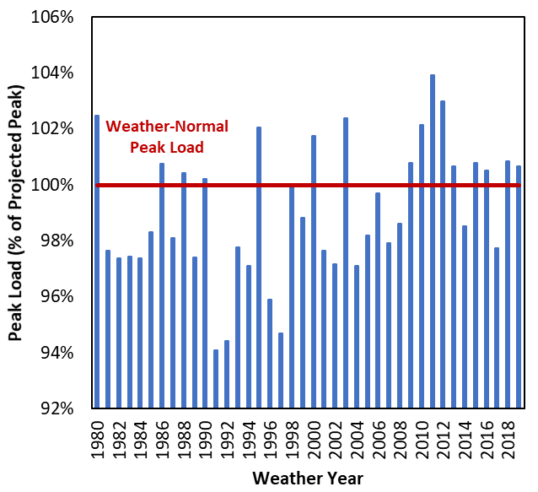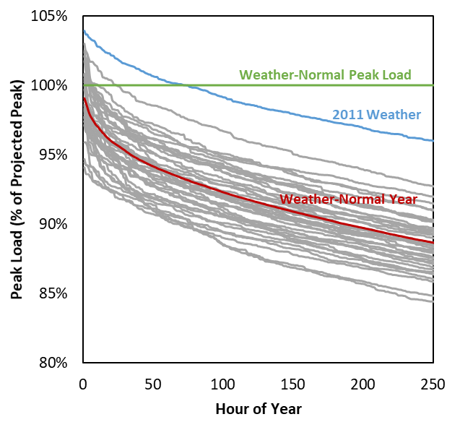
Sources and Notes: ERCOT load shapes provided by ERCOT staff.

Non-Weather Demand Forecast Uncertainty and Forward Period
Forward-looking “planning” or “target” reserve margins differ from actually-realized reserve margins because both realized peak load and actual available resources can differ from projections. One cause of forecast error is simply the weather. Another is due to uncertainties in population growth, economic growth, efficiency rates, and other factors. These non-weather drivers of load forecast errors (LFEs) differ from weather-related LFEs because they increase with the forward planning period, while weather uncertainties will generally remain constant and be independent with the forward period.
As shown in the left chart of Figure A1-2, we assume that non-weather LFE is normally distributed with a standard deviation of 0.43% on a 1-year forward basis, increasing by 0.66% with each additional forward year. The distribution includes no bias or asymmetry in non-weather LFEs, unlike the weather-driven LFE in ERCOT, which has more upside than downside uncertainty.
For our purposes, the relevant forward period for characterizing non-weather LFEs is the period at which investment decisions must be finalized. We assume investment decisions must be finalized four years prior to delivery, consistent with the approximate construction lead time for new generation resources. This means that available supply and the expected planning reserve margin are “locked in” at four years forward, and the realized reserve margin may differ substantially as both weather and non-weather uncertainties are resolved as the delivery year approaches. The right-hand chart of Figure A1-2 shows the five discrete levels of LFE we model, equal to 0%, +/−2%, and +/−4% above and below the forecast. The largest errors are the least likely, consistent with a normal distribution. We also conduct a sensitivity analysis, examining the implications on economically optimal and reliability-based reserve margins if the forward period is varied between zero and four years forward.
Figure A1-2. Non-Weather Load Forecast Error
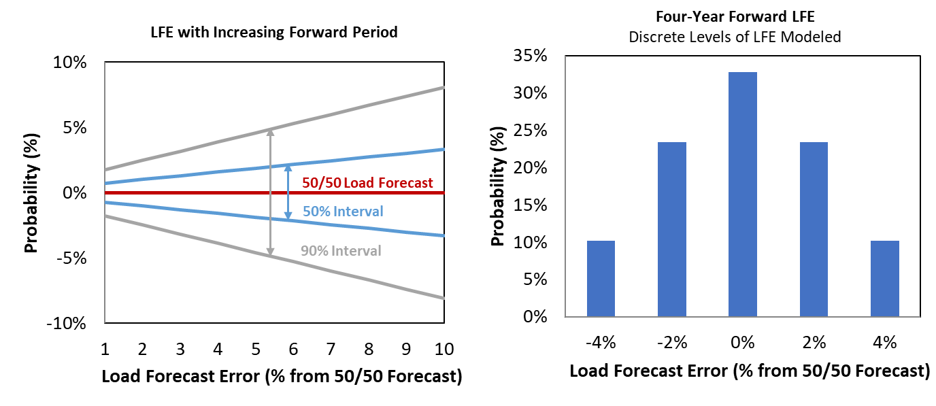

External Region Demand
We independently developed external regions’ peak load and load shapes based on publicly-available peak load projections, historical hourly weather profiles, and historical hourly load data. Table A1-1 summarizes the peak load for the ERCOT system and the load diversity relative to the interconnected neighboring regions. Consistent with the peak load reporting conventions used in ERCOT’s CDR report, these peak loads are reported: (a) net of anticipated load reductions from price-responsive demand (PRD) and load resources (LRs); and (b) prior to any potential reductions from transmission and distribution service provider (TDSP) load management or energy efficiency (EE) programs.

Table A1-1. Peak Loads and Diversity Used in Reserve Margin Accounting
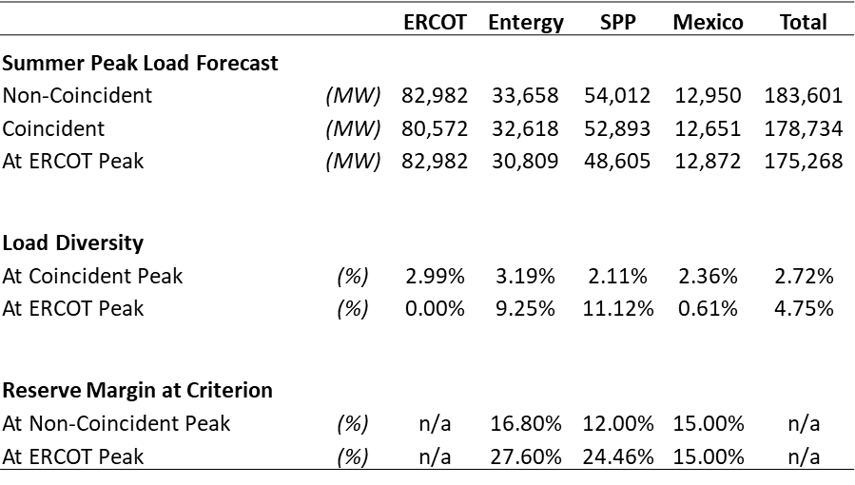
Sources and Notes:
Non-Coincident Peak represents each individual region’s peak load.
Coincident Peak represents the load in each region at the maximum total model area peak.
At ERCOT Peak represents the load in each region at the time of the ERCOT system peak.
SPP 50/50 peak load forecast is from the NERC 2019 Long-Term Reliability Assessment.
Entergy’s 50/50 peak load forecast is from the MISO Planning Year 2020-2021 Loss of Load Expectation Study Report.
Load shapes in SPP and Entergy are based on our independently-developed statistical relationship between hourly weather and load estimated over five years of load data and 40 years of weather data.
Mexico’s peak load and load shape were unavailable. The peak is assumed at a 15% reserve margin above the currently-installed generation fleet). Load shapes in Mexico are assumed identical to those in ERCOT.
As shown in the table above, there is a substantial amount of load diversity between ERCOT and the neighboring systems, indicating that ERCOT may have access to substantial import quantities during shortages to the extent that sufficient intertie capability exists. For example, at the time of ERCOT’s peak load, SPP load is likely to be at only 90% of its own non-coincident peak load. This load diversity results in having more than 11,500 MW of excess generation available for export in hours where ERCOT is shedding firm load. However, most of these excess supplies will not be imported because ERCOT is relatively isolated from neighboring systems with only 820 MW of intertie capability with SPP and 400 MW with Mexico.

Generation Resources
We model the economic, availability, ancillary service capability, and dispatch characteristics of all generation units in the ERCOT fleet, using unit ratings and online status consistent with ERCOT’s May 2020 CDR report. In this section we describe our approach for modeling conventional generation, private use networks (PUNs), and intermittent wind and solar. We also describe the assumed cost and technical specifications of the CT reference technology.

Marginal Resource Technology
The quantity of installed generating capacity must vary to simulate ERCOT’s system costs, market prices, and reliability across different reserve margins. We add gas CT plants in our base case, roughly reflecting the types of capacity resources that have been added or proposed for the ERCOT market. Our technology choices for the gas CT plants is consistent with assumptions from the 2018 study.
The costs and performance characteristics of the reference CT are summarized in Table A1-2 and Table A1-3 respectively. These characteristics are based on GE 7HA technology for the CT plants, which is the same as the CT reference technology from EORM 2018. We use updated cost of new entry (CONE) assumptions consistent with this technology, as well as an updated after-tax weighted-average cost of capital (ATWACC) for a merchant developer based on current financial market conditions. These updates result in an estimated CONE of $93,500/MW-year for the gas CT, which is 5.65% higher than in EORM 2018, as shown in Table A1-2.
Table A1-2. Cost of New Entry
 | ATWACC | CONE
 |  | Simple Cycle | Combined Cycle
 | (%/yr) | ($/MW-yr) | ($/MW-yr)
From 2018 Study (2022 Online Date)
Low: Base Minus 10% | n/a | $79,700 | $85,100
Base: Merchant ATWACC | 7.80% | $88,500 | $94,500
High: Base Plus 25% | n/a | $110,600 | $118,100
Updated Estimate (2024 Online Date)
Low: Base Minus 25% | n/a | $70,100
Base: Merchant ATWACC | 7.80% | $93,500
High: Base Plus 25% | n/a | $116,90

Sources and Notes:
2018 study numbers and current numbers are adapted from CONE studies for PJM, with adjustments applied as relevant for ERCOT; see Spees, et al. (2011) and Newell, et al. (2018a), respectively. CONE values determined with adjustments to technology characteristics within an area that most closely resemble ERCOT, as outlined in Table A1-3. The updated CONE estimate was developed based on the values in the 2018 PJM CONE report before adjustments were made to the assumed discount rate and exemption from paying sales taxes. .

Table A1-3. Performance Characteristics
Characteristic | Unit | Simple Cycle
Plant Configuration
Turbine |  | GE 7HA.02
Configuration |  | 1 x 0
Heat Rate (HHV)
Base Load
Non-Summer | (Btu/kWh) | 9,138
Summer | (Btu/kWh) | 9,274
Installed Capacity
Base Load
Non-Summer | (MW) | 371
Summer | (MW) | 352
CONE | ($/kW-yr) | 93.5
Sources and Notes:
Technical and performance parameters use region EMAAC as most closely resembling ERCOT in altitude and ambient conditions from Newell, et al. (2018a).
Based on ambient conditions of 92°F Max. Summer (55.5% Humidity) and 59°F Non-Summer.

Conventional Generation Outages
A major component of reliability analyses is modeling the availability of supply resources after considering maintenance and forced outages. We model forced and maintenance outages of conventional generation units stochastically. Partial and full forced outages occur probabilistically based on distributions accounting for time-to-fail, time-to-repair, startup failure rates, and partial outage derate percentages. Maintenance outages also occur stochastically, but SERVM accommodates maintenance outages with some flexibility to schedule maintenance during off-peak hours. Planned outages are differentiated from maintenance outages and are scheduled in advance of each hourly simulation. Consistent with market operations, the planned outages occur during low demand periods in the spring and fall, such that the highest coincident planned outages occur in the lowest load days. This outage modeling approach allows SERVM to recognize some system-wide scheduling flexibility while also capturing the potential for severe scarcity caused by a number of coincident unplanned outages.
We develop distributions of outage parameters for time-to-fail, time-to-repair, partial outage derate percentages, startup probabilities, and startup time-to-repair from historical Generation Availability Data System (GADS) data for individual units in ERCOT’s fleet, supplemented by asset class average outage rates provided by ERCOT where unit-specific data were unavailable. Table A1-4 summarizes fleet-wide and asset-class outage rates, including both partial and forced outages.
Table A1-4. Forced Outage Rates by Asset Class and Fleet Average
Unit Type | Equivalent Forced Outage Rate | Mean Time  to Fail | Mean Time  to Repair
 | (%) | (hours) | (hours)
Gas Combined Cycle | 3.7 | 1,312 | 32
Gas Combustion Turbine | 8.3 | 967 | 74
Gas Steam | 14.0 | 687 | 58
Coal | 5.9 | 833 | 39
Nuclear | 0.2 | 16,467 | 330
Fleet Weighted Average | 5.9
Sources and Notes: Parameter distributions based on two years (2018-2019) of unit-specific GADS data and asset class average outage rates from ERCOT.

Private Use Networks
We represent generation from Private Use Networks (PUNs) in ERCOT on a net generation basis, where the net output increases with the system portion of peak load consistent with historical data and as summarized in Figure A1-3. At any given load, the realized net PUN generation has a probabilistic quantity, with 10 different possible quantities of net generation within each of 10 different bands of system load. Each of the 10 possible quantities has an equal 10% chance of materializing, although Figure A1-3 reports only the lowest, median, and highest possible quantity. We developed this probabilistic net PUN supply curve based on aggregate hourly historical net output data within each range of peak load percentage. During scarcity conditions with load at or above 93% of normal peak load, PUN output produces at least 2,776 MW of net generation with an average of 3,691 MW.
We observe a pattern of availability and responsiveness consistent with: (a) gross generation, much of which is fully integrated into ERCOT’s economic dispatch and security constrained economic dispatch (SCED), resulting in substantial increases in the expected quantities over moderate price levels, minus (b) gross load, which introduces some probabilistic uncertainty around net generation, minus (c) some apparent load price-responsiveness, which likely contributes to some small additional increase in net PUN generation at very high prices.

Figure A1-3. PUN Net Generation
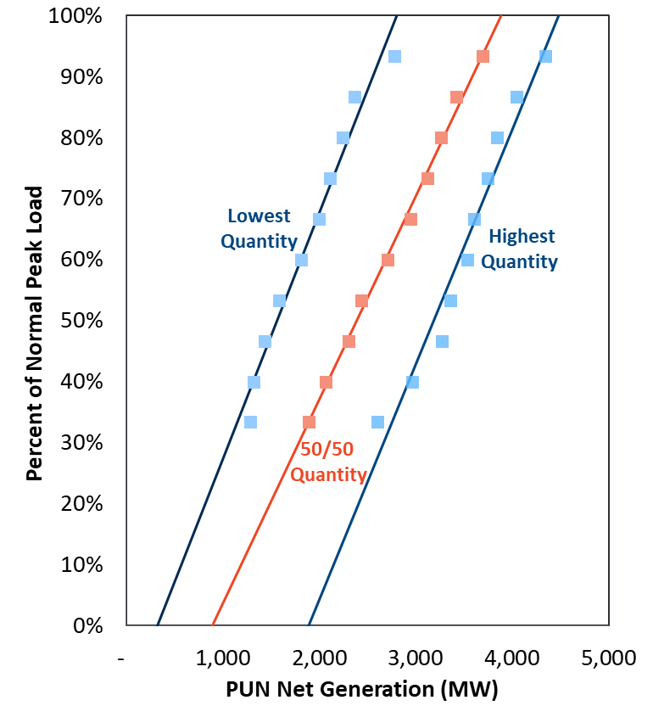
Sources and Notes:
Hourly net PUN output data gathered from ERCOT, hourly load data from Velocity Suite, ABB Inc.
Individual data points represent summary of data in a series of data binned by system load level, within each load bin, the points on the chart represent the lowest 10%, middle 10%, and top 10% of realized quantities in 2012 to 2020.

Intermittent Wind and Solar
We model a total quantity of intermittent wind and solar photovoltaic resources that reflects what ERCOT reported to NERC for its 2020 LTRA report, including the installed capacity of all existing and planned resources as of 2024. This includes 37,396 MW nameplate capacity of wind and 16,001 MW nameplate of solar, with intermittent output based on hourly generation profiles that are specific to each weather year.
We developed our system-wide hourly wind profiles by aggregating 40 years of synthesized hourly wind shapes for each location of individual units across the system wind shapes over 1980 to 2019, as provided by ERCOT staff. Figure A1-4 plots the average wind output by season and time of day, showing the highest output overnight and in spring months with the lowest output in mid-day and in summer months. The overall capacity factor for wind resources is 36.4%; although we calculate reserve margins assuming an ELCC of 63% for coastal wind, 29% for panhandle wind, and 16% for other wind, consistent with the ERCOT May 2020 CDR convention. In EORM 2018, wind units were given an ELCC of 14% for non-coastal wind and 59% for coastal wind, consistent with the ERCOT May 2018 CDR convention.
Figure A1-4. Average Wind Output by Month and Time of Day
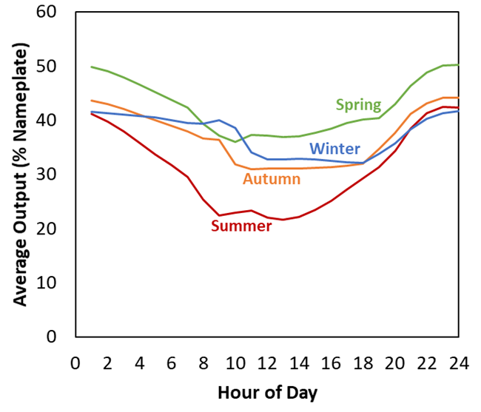
Sources and Notes:
Average of 40 years’ hourly wind profiles provided by ERCOT, originally from UL (formerly AWS Truepower).
We similarly model hourly solar photovoltaic output based on hourly output profiles that are specific to each weather year, as aggregated from county-specific synthesized output profiles over years 1980 to 2019. In aggregate, solar resources have a capacity factor of 27.3% across all years, and we assign a 76% of nameplate contribution toward the reserve margin consistent with ERCOT’s CDR accounting convention.

Hydroelectric
We include 558.1 MW of hydroelectric resources, consistent with ERCOT’s May 2020 CDR report. We characterize hydro resources using six years of hourly data over 2012–2019 provided by ERCOT, and 40 years of monthly data over 1980–2019 from EIA form 923. For each month, SERVM uses four parameters for modeling hydro resources, as summarized in Figure A1-5: (1) monthly total energy output and (2) monthly maximum output, as drawn from historical data consistent with each weather year; and (3) daily maximum output and (4) daily minimum output, as estimated from historical hourly data.
When developing hydro output profiles, SERVM will first schedule output up to the monthly maximum output into the peak hours but will schedule some output across all hours based on historically observed output during off-peak periods up to the total monthly output. During emergencies, SERVM can schedule up to 49.25 MW in drought conditions and 116.15 MW for all other months.
Figure A1-5. Hydro Annual Energy (left) and Average Hydro Daily Shape (right)
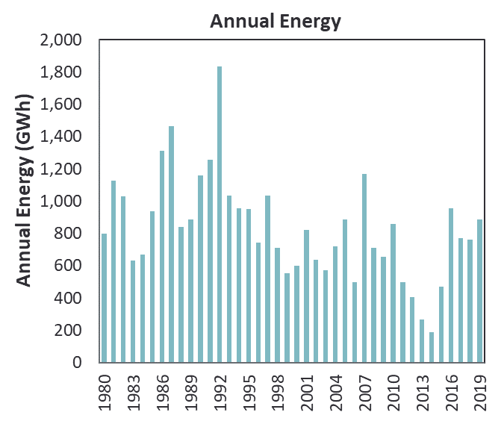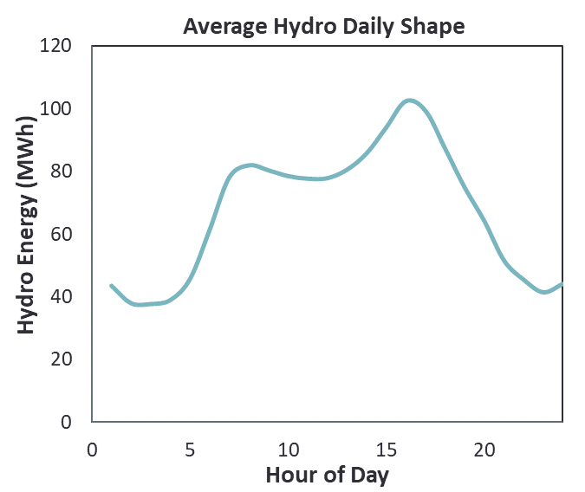
Sources and Notes:
Monthly and annual energy data from EIA form 923, peak shaving capability based on eight years of historical hourly data from ERCOT.

Fuel Prices
We use the 2020 Annual Energy Outlook Low Economic Growth case for our gas price future inputs. These gas prices are consistent with fuel prices used in other ERCOT analysis, and are comparable to gas price forwards, as shown in Figure A1-6. Alternative gas prices are explored as sensitivities, but do not make a substantial difference in results. We estimate monthly fuel prices for ERCOT coal units based on the average 2019 historical prices. For external coal units and all oil-fired plants, we use futures prices for the year 2024 and after applying a delivered fuel price basis. We use U.S. Gulf Coast and Powder River Basin as the market price points for historical and futures prices as shown in Figure A1-6. To estimate a delivered fuel price basis for each market, we calculated the historical difference between that market price point and prices as delivered to plants in that region and then escalated the delivered price basis with inflation to the year 2024. This locational basis is inclusive of both market price basis as well as a delivery charge and therefore may be positive or negative overall as shown in Table A1-5.
Figure A1-6. Historical and Futures Prices for Gas, Coal, and No. 2 Distillate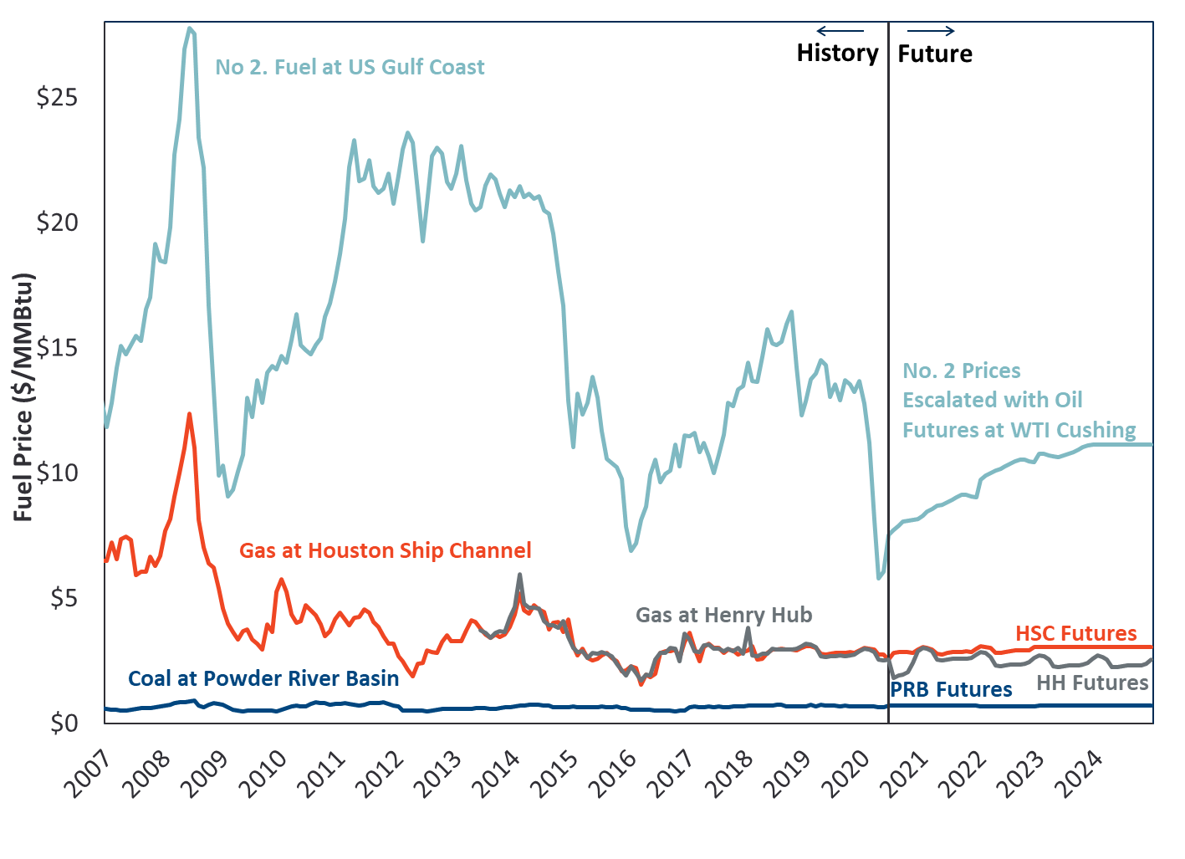
Sources and Notes:
No. 2 prices escalated using a linear relationship with WTI Cushing and escalated with WTI futures.
Prices for the base case are from the 2020 Annual Energy Outlook (AEO) Low Economic Growth Case,.
Natural gas and coal historical prices and coal futures prices from Bloomberg, SNL Energy, and EIA.

Table A1-5. ERCOT 2024 Delivered Fuel Prices
Coal Fuel Price ($/MMBtu) | Gas Fuel Price ($/MMBtu) | Diesel Fuel Price ($/MMBtu)
1.65 | 2.96 | 11.14

Sources and Notes:
Coal Fuel Price is averaged from 2019 EIA 923 and FERC Form 1 data.
Gas Fuel Price from the 2020AEO Low Economic Growth Case.

Demand-Side Resources
Several types of demand response participate directly or indirectly in ERCOT’s market, including: Emergency Response Service (ERS), Load Resources, and Price Responsive Demand. These various types differ from each other in whether they are triggered by price-based or emergency actions, and restrictions on availability and call hours. Below we describe the assumptions and modeling approach for each type of resource.

Emergency Response Service
Emergency Response Service (ERS) includes two types of products, 10-minute and 30-minute (weather sensitive and non-weather sensitive) ERS, with the quantity of each product available changing by time of day and season as shown in Table A1-6. The quantity of each product by time of day and season is proportional to the quantities most recently procured over the four seasons of year 2019, with the 2024 summer peak quantity assumption provided by ERCOT. Demand resources enrolled under ERS are dispatchable by ERCOT during emergencies, but cannot be called outside their contracted hours and cannot be called for more than twenty-four hours total per season.

Table A1-6. Assumed ERS Quantities Available in 2024
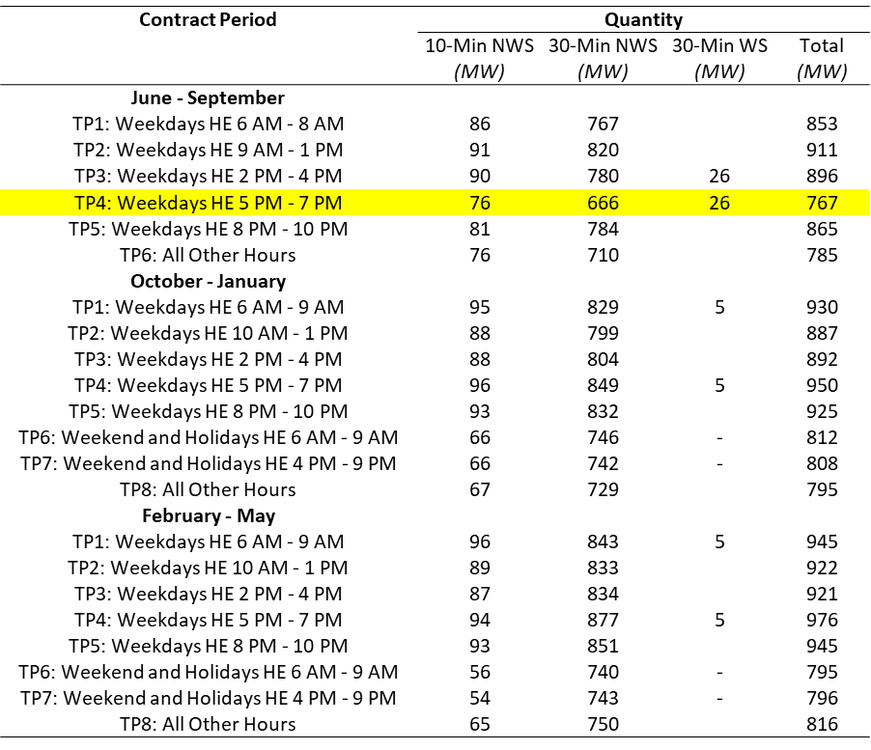
Sources and Notes:
Total available ERS MW for 2024 June-Sept. TP4 provided by ERCOT staff.
ERS 10-min and 30-min MW for other contract periods scaled proportionally to the 2024 LTRA summer quantity (767 MW), based on availability in 2019, from ERCOT (2020a).

Load Resources Providing Ancillary Services
Consistent with ERCOT’s published minimum Responsive Reserve Service (RRS) requirements, we model 1,172 MW of non-controllable load resources (LRs) that actively participate in the RRS market. All 1,172 MW are modeled as responsive to Energy Emergency Alert, Level 2.

Price Responsive Demand and 4 Coincident Peak
2019 historical demand response was used to develop modeling inputs to replicate stochastic demand-side response for price responsive and 4-coincident peak demands. A comparison of historical and synthetic PRD calls is shown in Figure A1-7 The aggregate of these shapes was used to gross up all 40 synthetic weather shapes.
To model the price responsive demand (PRD) in SERVM, a curtailable unit was be created that points to a price responsive demand curve. The demand curve has 4 pricing points based on the segments above ($200, $400, $800, and $1,500). For each of the 4 pricing points, 50 data points were created using the segment formulas specified. Within SERVM, whenever price reached one of the specified threshold points, SERVM randomly picked a DR value from that list of 50 data points. The Price Responsive Demand unit was available in all months.
Figure A1-7. Comparison of Historical and Synthetic PRD Calls
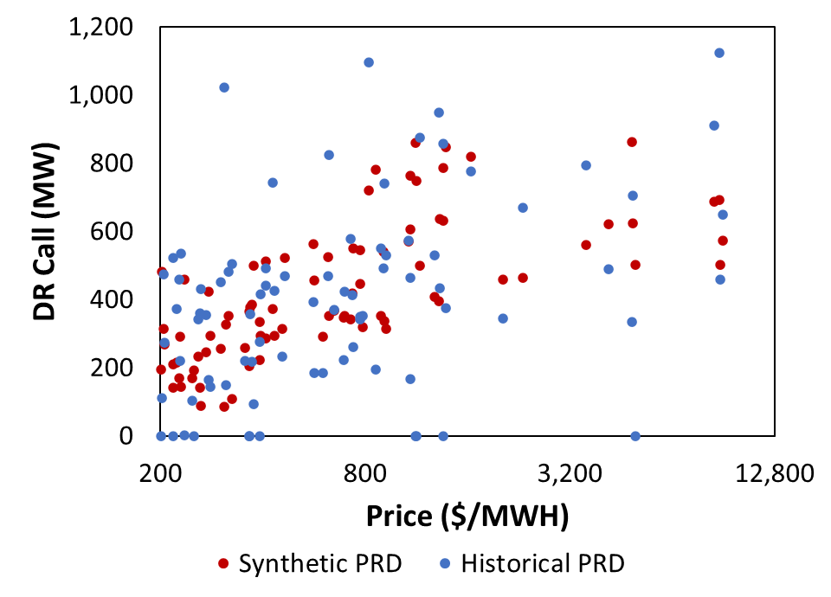
This stochastic representation in 2020 modeling differs from the discrete representation in the 2018 study, as shown in Figure A1-8.

Figure A1-8. PRD Modeling Comparison Between 2018 and 2020 Studies
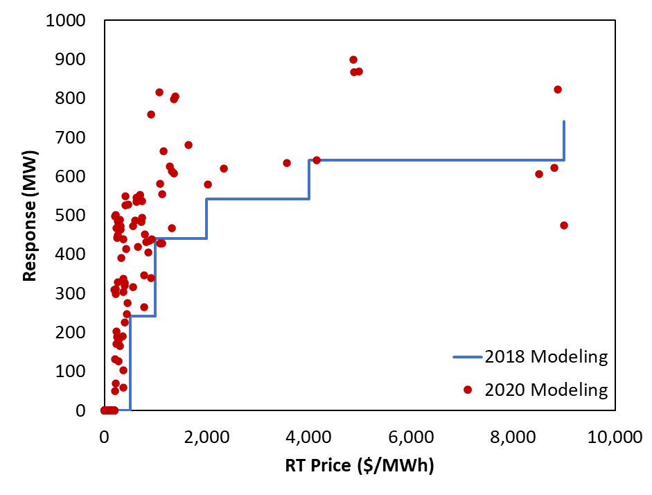
Similarly, 4CP was modeled as a load responsive unit. A comparison of historical and synthetic 4CP calls is provided below in Figure A1-9. Historical hourly 4CP was calculated as the sum of the following 4CP programs:
  - 4CP Competitive
  - 4CP NOIE
To model this unit in SERVM, a curtailable unit was created that pointed to a load responsive demand curve. The demand curve had 4 load points based on the segments above (66,000, 67,000, 72,000, and 74,000 MW). For each of the 4 load points, 50 data points were created using the segment formulas specified. Within SERVM, whenever load reached one of the specified threshold points, SERVM randomly picked a DR value from that list of 50 data points. The 4 CP unit was only available during the months of June to September.

Figure A1-9. Comparison of Historical and Synthetic 4CP Calls
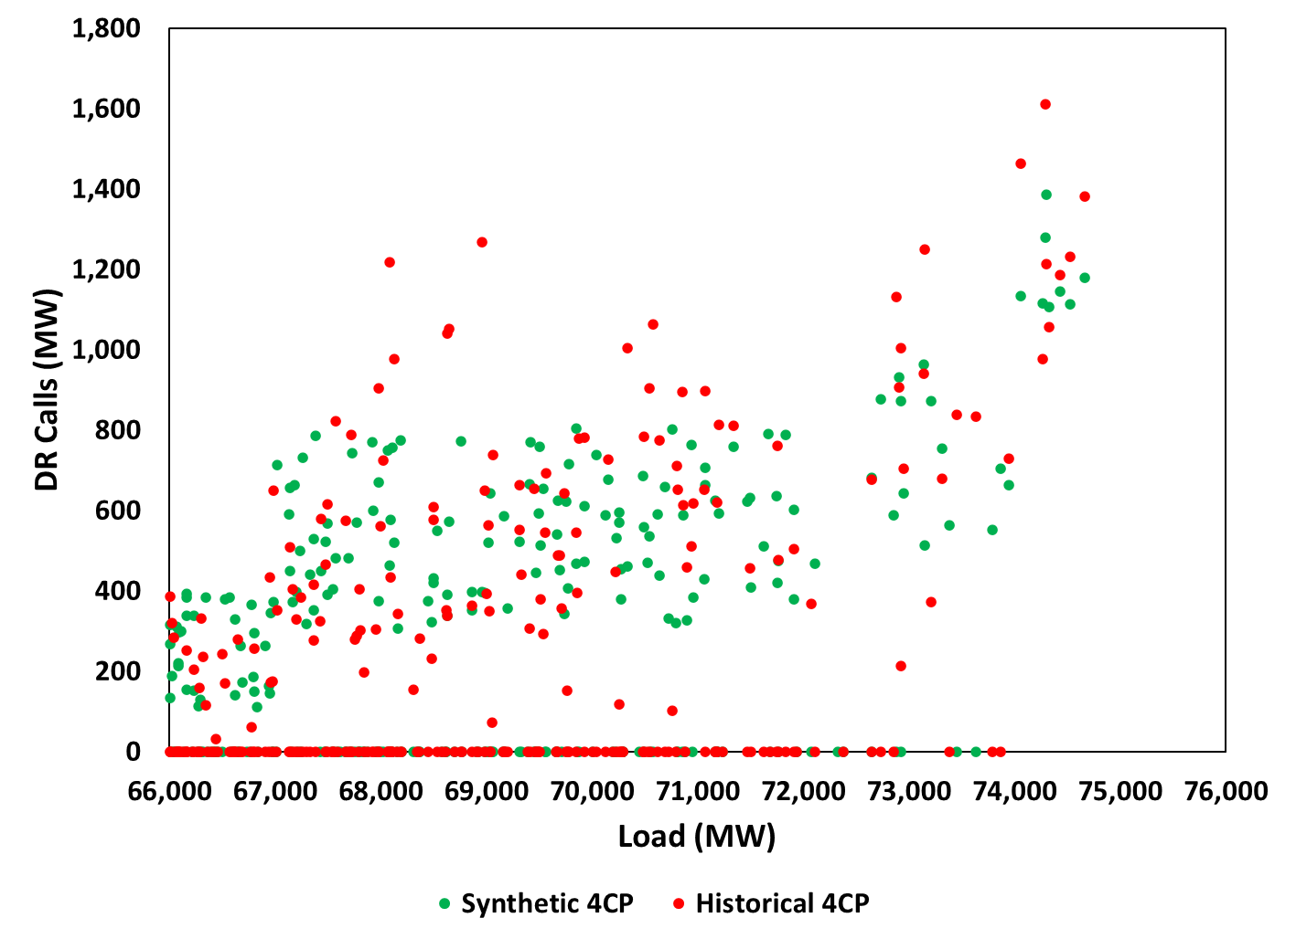

Transmission System Modeling and External Resource Overview
This section provides an overview of the system interconnection topology, intertie availability, ERCOT and neighboring regions’ supply curves.

Transmission Topology
ERCOT is a relatively islanded system with only 1,220 MW of high voltage direct current (HVDC) interties; the majority of that intertie capacity is with SPP. As described in Section II.A, SERVM runs a multi-area economic dispatch and will schedule imports or exports from ERCOT depending on the relative cost of production compared to the neighboring systems. During peaking conditions, ERCOT will generally import power due to the high internal prices, unless imports cannot be realized. ERCOT may not be able to import during peak conditions because either: (a) the neighboring system experiences a simultaneous scarcity and will prioritize meeting its own load, or (b) insufficient intertie capability exists to support the desired imports. The intertie capacities assumed for this study are shown in Figure A1-10 below.
Figure A1-10. System Topology and Modeled Interties
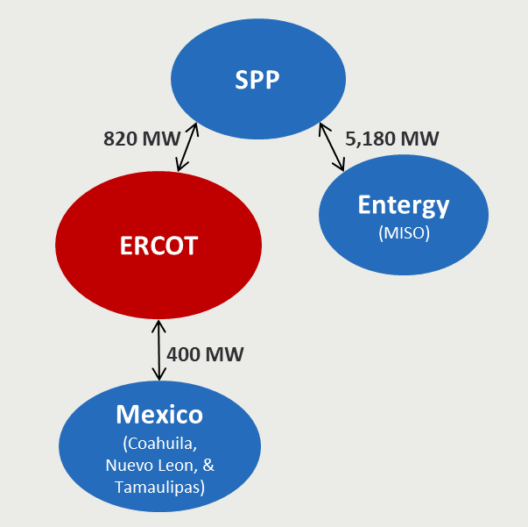
Sources and Notes:
ERCOT intertie ratings from ERCOT (2020e)

External Systems’ Resource Overview
This section of our report provides an overview of the neighboring regions resource mixes. Appendix A.1 summarizes the supply resource mix that we model in ERCOT, SPP, Entergy, and Mexico. For the neighboring regions, we rely on public data sources for the fleet makeup and demand-response penetrations. As shown in Figure A1-11, we model each external region at criterion, meaning that we treat them exactly at their respective reserve margin targets of 12.0%, 16.8%, and 15% for SPP, Entergy, and Mexico, respectively. Because these regions are currently capacity long, we adjusted their resource base downward by removing individual units of different resource types in order to maintain the current overall resource mix.

Figure A1-11. Resource Mix for ERCOT and Neighboring System
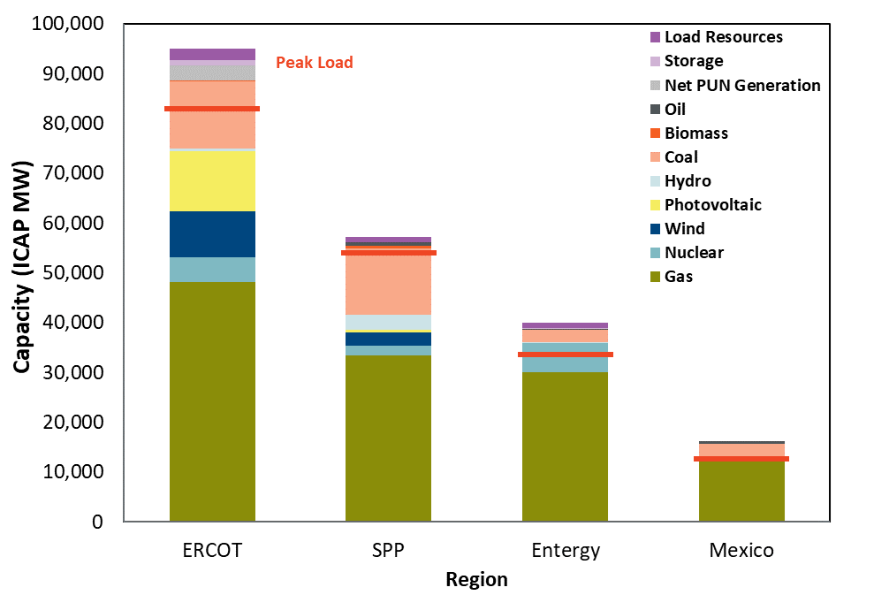

Availability of External Resources for ERCOT
Imports to ERCOT depend on the conditions in the neighboring systems; even if transmission is available, ERCOT may not be able to import in emergency situations if the external region is peaking at the same time. To provide intuition regarding anticipated prices and intertie flows during normal conditions, we summarize the ERCOT and neighboring regions’ supply curves in Figure A1-12. The curve reports energy dispatch costs consistent with year 2024, accounting for unit-specific heat rates, variable operations and maintenance (VOM) costs, and locational fuel prices from Appendix 1.0.6. For ERCOT, we gathered unit-specific information representing heat rate curves, VOM, ancillary service capabilities, ramp rates, startup fuel, non-fuel startup costs, and run-time restrictions from ERCOT. For external regions, we gathered unit-specific heat rates from public data sources, supplemented by class-average characteristics similar to those in ERCOT for other unit characteristics. For all thermal resources, we model a seasonal capacity value which results in increased available capacity from the fleet during colder periods.
Overall, ERCOT’s supply curve is similar to Mexico’s but is relatively tight compared to SPP and Entergy. However, interchange will be limited because of ERCOT’s relatively small quantity of HVDC interties, having only 820 MW of interties with SPP and 400 MW with Mexico. Some factors affecting the quantity and economic value of interchange include that: (a) SPP has more lower-cost coal that is somewhat cheaper than ERCOT-internal resources that are dominated by efficient but somewhat higher-cost gas combined-cycles, which will lead to ERCOT being a net importer, and (b) Mexico has a substantial proportion of relatively high-cost oil-fired peaking units, which will make such imports unlikely except at high prices in scarcity conditions. Further, the regions experience some amount of load diversity that will change the relative economics of supply in each region and lead to inter-regional flows.
Figure A1-12. 2024 System Supply Curves
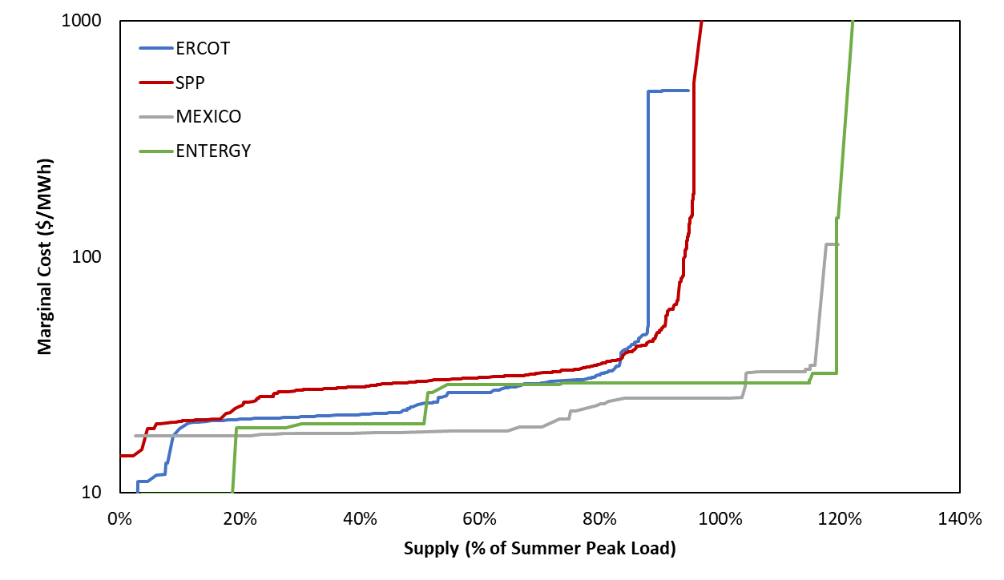
Sources and Notes:
ERCOT is shown at 9.57% reserve margin, with resource mix consistent with 2020 LTRA as explained in Appendix 1.B, using unit-specific heat rates, VOM, and other characteristics obtained from ERCOT.
External systems resource mix from publicly available data.
Supply curves reflect VOM and fuel costs, with fuel prices from Appendix 1.B.6 above.

Scarcity Conditions
Increasing the reserve margin provides benefits primarily by reducing the frequency and severity of high-cost emergency events. Calculating the economically optimal reserve margin requires a careful examination of the nature, frequency, trigger order, and cost of each type of market-based or administrative emergency action implemented during such events.

Administrative Market Parameters
We developed a representation of the 2024 ERCOT market using the parameters summarized in Table A1-7. We assume that the administrative Value of Lost Load (VOLL) is equal to the true market VOLL and the High System-Wide Offer Cap (HCAP) at $9,000/MWh. We also conduct a sensitivity analysis for a reasonable range of VOLL.
Consistent with current market rules, we tabulate the Peaker Net Margin (PNM) over the calendar year and reduce the System-Wide Offer Cap (SWOC) to the Low System-Wide Offer Cap (LCAP) of $2,000/MWh after the PNM threshold is exceeded. However, we stress that this mechanism will have a small impact on the MERM since the PNM is rarely exceeded at reserve margins near MERM. We ran a simulation scenario which did not adjust the SWOC after the PNM threshold was exceeded, and the MERM changed by less than .25% from the result in our base case. We further explain our implementation of the ORDC and PBPC in Sections IV.E.4 and IV.E.5 below.
Table A1-7. ERCOT Scarcity Pricing Parameters Assumed for 2024
Parameter | Value | Notes
Value of Lost Load (VOLL) | $9,000/MWh | Administrative and actual
High System-Wide Offer Cap (HCAP) | $9,000/MWh | Always applied to ORDC
Low System-Wide Offer Cap (LCAP) | $2,000/MWh | Applies only to PBPC
Peaker Net Margin (PNM) Threshold | $280,500/MW-yr | 3 x CT CONE
Sources and Notes:
HCAP, LCAP, and VOLL parameters consistent with PUCT (2019a).
PNM threshold is set at three times CT CONE consistent with current market rules and our updated CONE.
The offer cap and PNM parameters determine the maximum offer price for small suppliers in ERCOT’s market under its monitoring and mitigation framework. However, we do not explicitly model these dynamics and instead assume that suppliers always offer into the market at price levels reflective of their marginal costs, including commitment costs.

Emergency Procedures and Marginal Costs
Table A1-8 summarizes our modeling approach and assumptions under all scarcity and non-scarcity conditions depending on what type of marginal resource or administrative emergency procedure would be implemented to meet an incremental increase in demand. These marginal resources are listed in the approximate order of increasing marginal costs and emergency event scarcity, although in some cases the deployment order overlaps.
We distinguish between market-based responses to high prices in scarcity conditions and out-of-market administrative interventions triggered by emergency conditions. Among market-based responses, we include generation, imports, and price-responsive demand, including some very high-cost resources that will not economically deploy until prices are quite high. We also model reserve scarcity that is administrative in nature but triggered on a price basis consistent with the ORDC and PBPC as explained in the following sections.
A final category of emergency interventions encompasses out-of-market actions including ERS, LR, TDSP load management, and firm load shed deployments that are triggered for non-price reasons during emergency conditions. We implement each of these actions at a particular scarcity level as indicated by the quantity of reserves capability available according to the ORDC x-axis, a measure similar to the physical responsive capacity (PRC) indicator used by ERCOT to monitor system operations. To estimate the approximate ORDC x-axis at which each action would be implemented, we reviewed ERCOT’s emergency operating procedures, evaluated the PRC level coinciding with each action during historical emergency events, and confirmed these assumptions with ERCOT staff. These trigger levels are in line with historical emergency events, although actual emergency actions are manually implemented by the system operator based on a more complex evaluation of system conditions, including frequency and near-term load forecast.
We also describe in the table below the marginal system costs of each type of scarcity event as well as the prevailing market price during those events. In a perfectly-designed energy market, prices would always be equal to the marginal cost that would theoretically lead to optimal response to scarcity events and an optimal level of investments in the market. In ERCOT, prices are reflective of marginal costs in most cases but not all. Specifically, the ORDC curve is designed based on an assumption that load would be shed at X = 2,000 MW, while our review of historical events indicates that load shedding is more likely to occur at a lower level of X = 1,000 MW. This discrepancy results in prices above marginal costs during moderate scarcity events, as discussed further in Appendix 1.E.4 below.

Table A1-8. Emergency Procedures and Marginal Costs
Emergency Level | Marginal  Resource | Amount of Resource (MW) | Trigger | Price | Marginal  System Cost
n/a | Generation | Variable | Price | Approximately $20 - $250 | Same
n/a | Imports | Variable | Price | Approximately $20-$250  Up to $1,000 during load shed | Same
n/a | Non-Spin Shortage | 700 | ORDC x-axis =  3,000 MW | $4,627 (from ORDC)* | $1,025*
n/a | Price-Responsive Demand | Variable | Price | $500 - $9,000 | Same
n/a | Emergency Generation | 469.8 | ORDC x-axis =  2,300 MW | $5,850 (from ORDC) | $1,372
n/a | PBPC | 200 | Price | $1,000 - $9,000 | Same
EEA 1 | 30-Minute ERS | 691** | Spin ORDC x-axis =  2,300 MW | $5,850 (from ORDC) | $1,372
EEA1 | Spin Shortage A | 550 | Spin ORDC x-axis =  2,300 MW | $7,492 (from ORDC)* | $1,856*
EEA 2 | TDSP Load Curtailments | 262 | Spin ORDC x-axis =  1,750 MW | $9,000 (from ORDC) | $2,469
EEA 2 | Load Resources in RRS | 1,172*** | Spin ORDC x-axis =  1,750 MW | $9,000 (from ORDC) | $2,469
EEA 2 | 10-Minute ERS | 76** | Spin ORDC x-axis =  1,750 MW | $9,000 (from ORDC) | $2,469
EEA3 | Spin Shortage B | 750 | Spin ORDC x-axis =  1,750 MW | $9,000 (from ORDC) | $3,562*
EEA 3 | Load Shed | Variable | Spin ORDC x-axis =  1,000 MW | VOLL = $9,000 | Same
Sources and Notes:
*: Price reflects the average price between the upper and lower level of each resource.
**: 76 10NWS + 666 30NWS + 26 30WS = 767 total ERS (CDR Value). Both NWS and WS are included in the 30-Minute ERS.
***: 60% of RRS
Developed based on review of historical emergency event data, input from ERCOT staff, and ERCOT’s emergency procedure manuals; see ERCOT (2020d), Section 6.5.9, and ERCOT (2020f), Section 4.

Emergency Generation
During severe scarcity conditions, there are out-of-market instructions by ERCOT as well as strong economic incentives for suppliers to increase their power output to their emergency maximum levels for a short period of time. During these conditions, suppliers can output power above their normal capacity ratings, although doing so is costly because it may impose additional maintenance costs and may put the unit at greater risk of failure.
According to ERCOT’s emergency maximum ratings, the aggregate ERCOT fleet should be able to produce approximately 469.8 MW in excess of summer CDR ratings. We estimate the marginal cost of emergency output at approximately $2,752/MWh, consistent with ERCOT’s procedures for calling emergency generation.

Operating Reserves Demand Curve
The most important and influential administrative scarcity pricing mechanism in ERCOT is the operating reserves demand curve (ORDC) that reflects the willingness to pay for spinning and non-spinning reserves in the real-time market. Figure A1-13 illustrates our approach to implementing ORDC in our modeling, which is similar to ERCOT’s implementation, although with some simplifications. We implement distinct ORDC curves for each of the four seasons each year, and for each of two types of operating reserves.
Figure A1-13. Operating Reserve Demand Curves
Example: Summer Hours 15-18
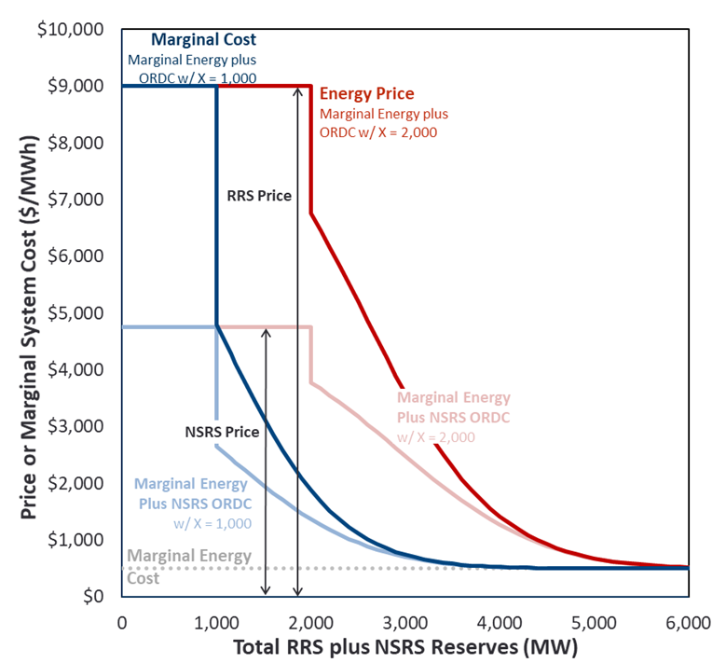
Sources and Notes:
ORDC curves developed consistent with ERCOT (2013).
The ORDC curves are calculated based on a loss of load probability (LOLP) at each quantity of reserves remaining on the system, multiplied by the value of lost load (VOLL) caused by running short of operating reserves. This curve reflects the incremental cost imposed by running short of reserves and is added to the marginal energy cost to estimate the total marginal system cost and price.
The x-axis of the curve reflects the quantity of operating reserves available at a given time, where: (a) the spin ORDC includes all resources providing regulation up or RRS, suppliers that are online but dispatched below their maximum capacity, hydrosynchronous resources, non-controllable load resources, and 10-minute quickstart; and (b) the spin + non-spin ORDC include all resources contributing to the spin x-axis as well as any resources providing NSRS and all 30-minute quickstart units. Table A1-9 provides a summary of the resources that are always available to contribute to the ORDC x-axis unless they have been dispatched for energy although the realized ORDC x-axis can be higher (if other resources are committed but not outputting at their maximum capability) or lower (during peaking conditions when some of the below resources are dispatched for energy).
Table A1-9. Resources Always Contributing to ORDC X-Axis Unless Dispatched for Energy
Spin X-Axis
Hydrosynchronous Resources | (MW) | 245
Non-Controllable Load Resources | (MW) | 1,172
Non-Spin X-Axis
30-Minute Quickstart | (MW) | 5,206
Total Spin + Non-Spin | (MW) | 6,623

The red and pink curves in Figure A1-13 show the ORDC curves used for price-setting purposes, calculated as if ERCOT would shed load at an ORDC x-axis of X = 2,000 MW. However, as we explained in Appendix 1.E.2 above, we assume that load shedding will actually occur at X = 1,000 MW based on our analysis of historical emergency events and consistent with the blue curves below. In other words, we model a discrepancy between marginal costs (blue) and market prices (red) that will create some inefficiency in realized market outcomes.
As in ERCOT’s ORDC implementation, we calculate: (a) non-spin prices using the non-spin ORDC; (b) spin prices as the sum of the non-spin and spin ORDC; and (c) energy prices as the sum of the marginal energy production cost plus the non-spin and spin ORDC prices. However, as a simplification we do not scale the ORDC curves in proportion to VOLL minus marginal energy in each hour. Instead, we treat the ORDC curves as fixed with a maximum total price adder of VOLL minus $500, which causes prices to rise to the cap of $9,000/MWh in scarcity conditions, because $500 is the cap placed on marginal energy prices in the model. Higher-cost demand-response resources will be triggered in response to high ORDC prices and therefore prevent prices from going even higher, but do not affect the “marginal energy component” of price-setting. We model the ORDC curves out to a maximum quantity of 8,000 MW where the prices are near zero, although they never drop all the way to zero.
These ORDC curves create an economic incentive for units to be available as spinning or non-spinning reserve, which influences suppliers’ unit commitment decisions. We therefore model unit commitment in three steps: (1) a week-ahead optimal unit commitment over the fleet, with the result determining which long-lead resources will be committed; (2) a four-hour ahead unit commitment (updated hourly) with an updated fleet outage schedule, with the result determining the preliminary commitment and decommitment schedules for combined cycle units; and (3) an hourly economic dispatch that dispatches online baseload units, and can commit 10-minute and 30-minute quickstart units if energy and spin prices are high enough to make it more profitable than remaining offline (similarly, if prices are not high enough these units will economically self-decommit). Note that 10-minute quickstart units can earn spin payments from an offline position while 30-minute quickstart units can earn non-spin payments from an offline position. These resources will not self-commit unless doing so would result in greater energy and spin payments (net of variable and commitment costs) than would be available from an offline position. We use a similar logic to economically commit or de-commit units until the incentives provided by the ORDC are economically consistent with the quantity of resources turned on.

Power Balance Penalty Curve
The Power Balance Penalty Curve (PBPC) is an ERCOT market mechanism that introduces administrative scarcity pricing during periods of supply scarcity. The PBPC is incorporated into the security constrained economic dispatch (SCED) software as a set of phantom generators at administratively-specified price and quantity pairs, as summarized in the blue curve in Figure A1-14. Whenever a PBPC is dispatched for energy, it reflects a scarcity of supply relative to demand in that time period that, if sustained for more than a moment, will materialize as a reduction in the quantity of regulating up capability. At the highest price, the PBPC will reach the system-wide offer cap (SWOC), which is set at the HCAP at the beginning of each calendar year but which will drop to the LCAP if the PNM threshold is exceeded as explained in Appendix 1.E.1 above.
We similarly model the PBPC as phantom supply that may influence the realized price, and that will cause a reduction in available regulating reserves whenever called. However, we model only the first 200 MW of the curve at prices below the cap, and assume that all price points on the PBPC will increase according to the scheduled SWOC. We also assume that the prices in the PBPC are reflective of the marginal cost incurred by going short of each quantity of regulating reserves. Consistent with current market design, we assume that once the PNM threshold is exceeded, the maximum price in the PBPC will be set at the LCAP + $1/MWh or $2,001/MWh. Note that even after the maximum PBPC price is reduced, ERCOT market prices may still rise to a maximum value of VOLL equal to $9,000/MWh during scarcity conditions because of the ORDC as explained in the following section.
Figure A1-14. Power Balance Penalty Curve
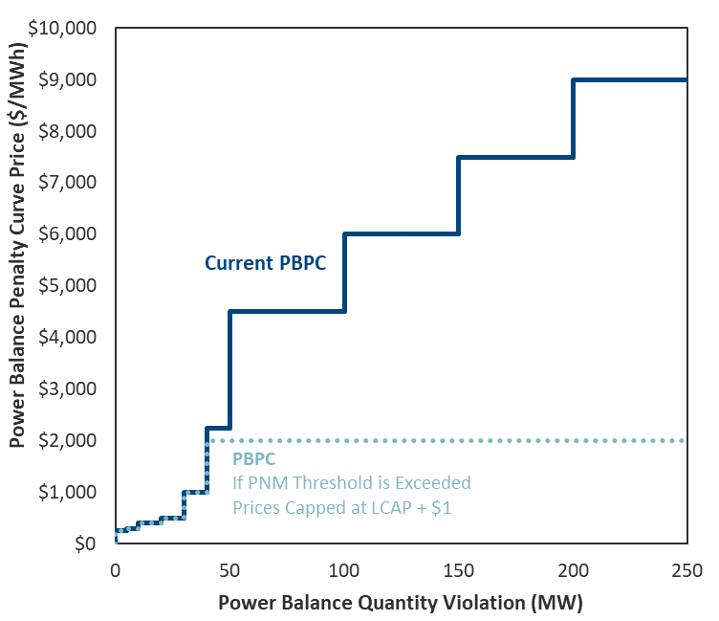
Sources and Notes:
PBPC numbers from ERCOT (2019b), p. 22-23.

APPENDIX 2: EFFECTIVE LOAD CARRYING CAPABILITY
The reserve margin is the sum of all dependable generating capacity divided by expected peak load. Dependable generating capacity varies for non-dispatchable or energy-limited resources and generally depends on simulations which calculate the comparable conventional capacity for the resource being evaluated. Very constrained resources such as 1-hour energy storage or low capacity factor wind would be expected to have ratios much lower than 100% while very dependable resources such as long duration storage would have ratios close to 100%.
The actual steps to determine these ratios are as follows:
- Calibrate system reliability to 0.1 LOLE by removing or adding conventional capacity.
- Remove the non-dispatchable or energy-limited resource portfolio in question. This will increase the frequency of LOLE events.
- Restore LOLE to 0.1 by adding conventional capacity.
- Calculate the ELCC by dividing the conventional capacity added in step 3.
Figure A2-1 contains a visual example of the process described above.
Figure A2-1. ELCC Visual Example
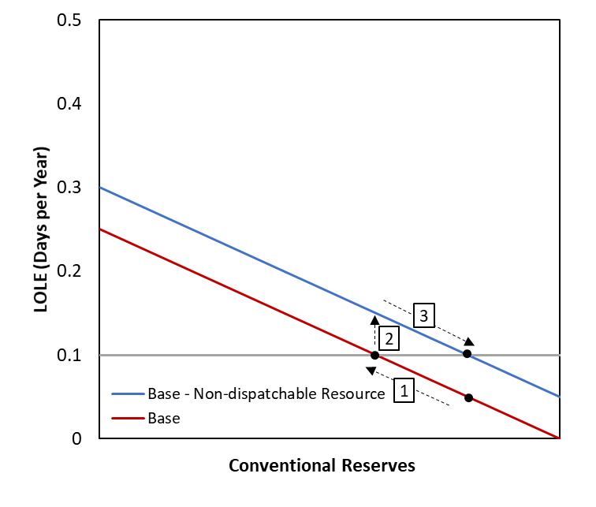

Average ELCC versus Incremental ELCC
The calculation steps explained above are for average ELCC. It determines the value of an entire portfolio. Calculations for incremental ELCC would typically be done in reverse. Add a small resource to a calibrated system and determine the capacity to remove to determine ELCC. Average ELCC would be used for reserve margin accounting. Incremental ELCC is used for procurement decisions.
In Figure A2-2, the average ELCC illustration on the left shows the reduction in net load which would approximately correspond to the average ELCC value. The illustration on the right shows the renewable profile of an incremental resource against the net load profile of a system with an existing penetration of renewable. The Incremental ELCC value would approximately correspond to the average output during the net load peak.
Figure A2-2. Average ELCC Versus Incremental ELCC
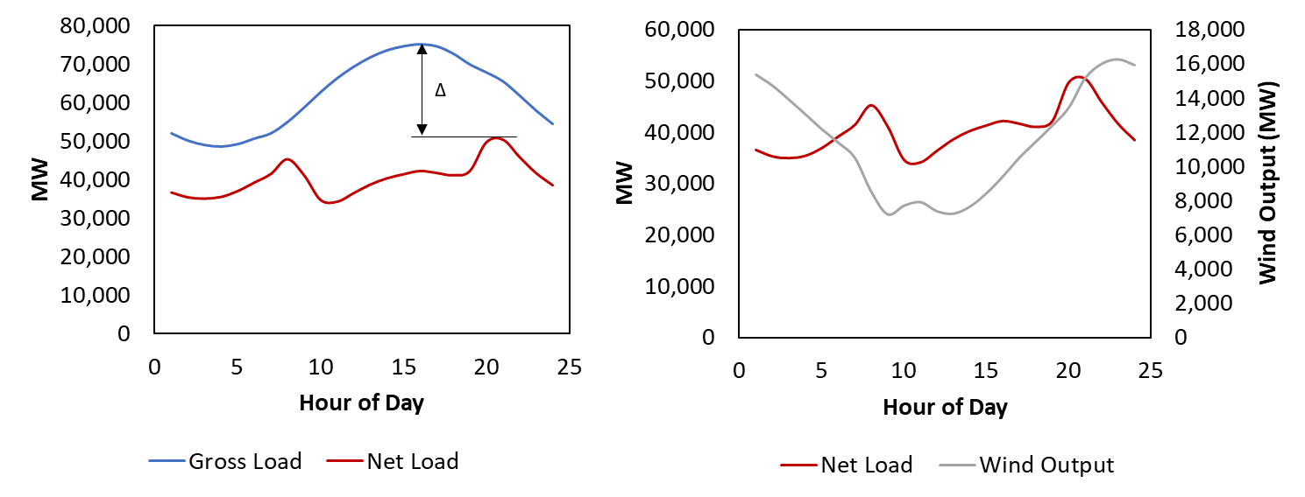
Average ELCC
Incremental ELCC
Both of these methods differ from the implicit ELCC calculations in the CDR accounting in ERCOT. The capacity credit given to wind and solar in CDR is based on the average of the top 20 gross load hours. Since this method doesn’t consider that the net load may have shifted due to the renewable output, it will overstate the ELCC of the renewable resources. Table A2-1 shows a comparison of methods of ELCC calculation using synthetic data for both wind and solar.

Table A2-1. Average Output and Net Load Reduction ELCC Comparison
 | Wind |  |  | Solar
 | Avg Output During Top 20 Load Hours (ERCOT Accounting Method) | Net Load Reduction (True Reliability Contribution) |  | Avg Output During Top 20 Load Hours (ERCOT Accounting Method) | Net Load Reduction (True Reliability Contribution)
2010 | 12% | 8% |  | 78% | 75%
2011 | 24% | 12% |  | 83% | 72%
2012 | 13% | 6% |  | 80% | 72%
2013 | 24% | 13% |  | 82% | 80%
2014 | 24% | 16% |  | 80% | 68%
2015 | 18% | 13% |  | 81% | 76%
2016 | 30% | 21% |  | 76% | 71%
2017 | 24% | 18% |  | 75% | 68%
2018 | 20% | 16% |  | 76% | 70%
2019 | 27% | 16% |  | 79% | 65%
Average | 22% | 14% |  | 79% | 72%

ELCC Results
The net load reductions in Table A2-1 indicate the true reliability contribution, but SERVM simulations are required to get precise values. Performing the average ELCC simulations results in ELCCs for the entire renewable portfolio in Table A2-2.
Table A2-2. Average ELCC Simulation Results for Entire Renewable Portfolio
 | 2020 | 2024 | 2024 High Renewable
All Renewable ELCC (MW) | 9,436 | 18,693 | 22,844
All Renewable Installed Capacity (MW) | 37,923 | 53,397 | 73,397
All Renewable ELCC (%) | 25% | 35% | 31%

These renewable portfolio totals will be used in later steps since the sum of individual technology or zonal ELCCs cannot exceed the renewable portfolio total. Technology specific ELCCs are calculated by removing only the study resource. Since wind and solar exhibit some synergy for reliability contribution, the sum of the raw ELCCs for wind and solar is greater than the entire portfolio ELCC. Figure A2-3 shows how the addition of solar pushes the net load to late in the day when the aggregate ERCOT wind output is expected to produce more energy. The higher energy translates to higher ELCC. In reverse, wind would push the net load peak to earlier in the day, increasing the ELCC for solar as well.

Figure A2-3. Effects of Addition of Solar to Net Load Shape
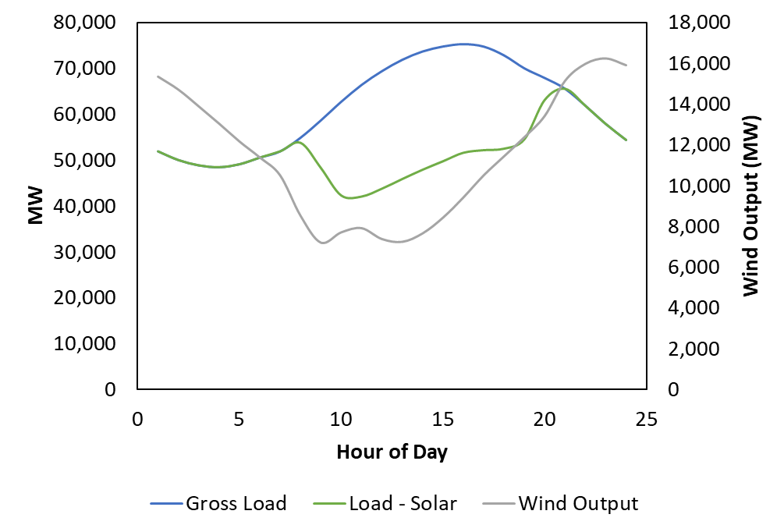
The resulting raw ELCCs for each technology are shown in Tables A2-3 and A2-4. As expected the sum of the individual technology ELCCs is larger than the entire portfolio ELCC, since the standalone analyses include the full synergistic benefits from the other technology. This would be double counting the benefit by assigning it to each of wind and solar.
Table A2-3. Wind Technology Raw ELCC Values
 | 2020 | 2024 | 2024 High Renewable
Wind Raw SERVM ELCC (MW) | 5,422 | 7,045 | 9,194
Wind Installed Capacity (MW) | 32,026 | 37,396 | 42,396
Wind ELCC (%) | 17% | 19% | 22%

Table A2-4. Solar Technology Raw ELCC Values
 | 2020 | 2024 | 2024 High Renewable
Solar Raw SERVM ELCC (MW) | 4,711 | 12,529 | 17,095
Solar Installed Capacity (MW) | 5,897 | 16,001 | 31,002
Solar ELCC (%) | 80% | 78% | 55%

Since the sum is larger, the total portfolio ELCC needs to be allocated to each respective technology according to the following formulas:
  - $Wind ELCC= \frac{Wind ELCC}{(Wind ELCC+Solar ELCC)}*Renewable ELCC$
  - $Solar ELCC= \frac{Solar ELCC}{(Wind ELCC+Solar ELCC)}*Renewable ELCC$
The results of these calculations are shown in Tables A2-5 and A2-6.
Table A2-5. Wind Technology Allocated ELCC Values
 | 2020 | 2024 | 2024 High Renewable
Wind Raw SERVM ELCC (MW) | 5,422 | 7,045 | 9,194
Wind Allocated ELCC (MW) | 5,049 | 6,728 | 7,989
Wind ELCC (%) | 16% | 18% | 19%

Table A2-6. Solar Technology Allocated ELCC Values
 | 2020 | 2024 | 2024 High Renewable
Solar Raw SERVM ELCC (MW) | 4,711 | 12,529 | 17,095
Solar Allocated ELCC (MW) | 4,387 | 11,965 | 14,855
Solar ELCC (%) | 74% | 75% | 48%

The synergy can be seen in both the allocation calculation as well as the change from year to year. The wind capacity value increases from 2020 to 2024 and to 2024 High Renewable as solar shifts the net load profile to later in the day. Solar ELCC doesn’t decline much between 2020 and 2024, but additions after the penetrations assumed in the 2024 portfolio have a rapidly declining ELCC. The average ELCC for solar increases from approximately 12 GW in 2024 to 15 GW 2024 with High Renewable. The 3 GW increase in ELCC corresponds to a 15 GW solar increase, so on a relative basis, the solar added between these scenarios only achieves a 20% ELCC.
We performed further calculations to isolate locational ELCCs for both wind and solar. Wind is divided into Wind Coastal (Wind-C), Wind Other (Wind-O), and Wind Panhandle (Wind-P). A typical summer profile is shown for each wind location in Figure A2-4.

Figure A2-4. Typical Daily Summer Profile for Each Wind Subcategory
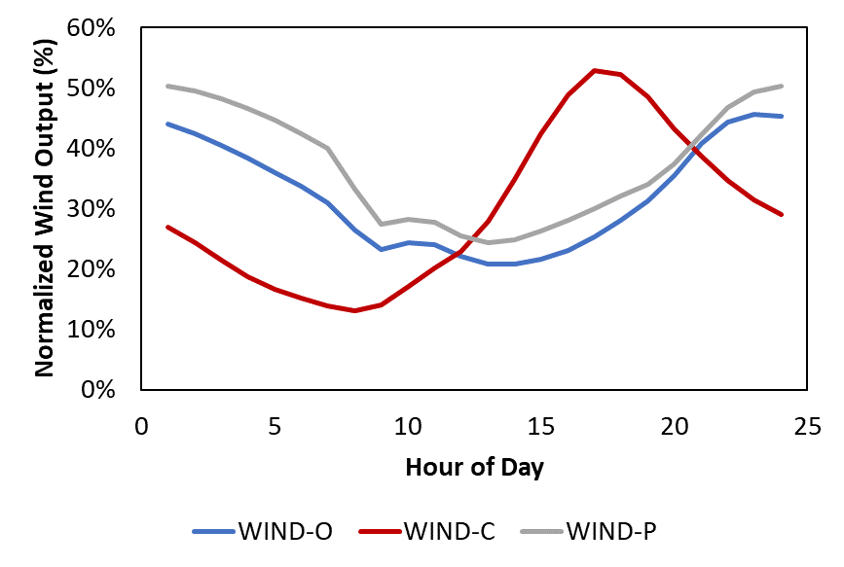
Solar is divided into West and Non-West according to the geographic grouping shown in the map in Figure A2-5.

Figure A2-5. Geographic Grouping for Solar West and Non-West
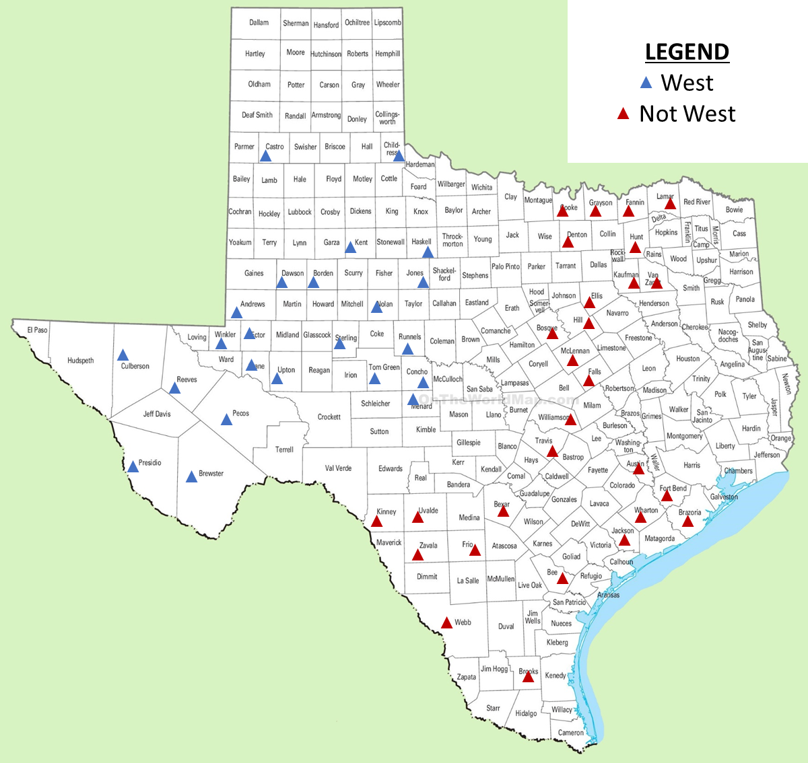
As expected, the coastal wind which exhibits higher capacity factor and higher diversity with load has a higher ELCC than the other two locational categories. However, it is not as high as suggested by the average output calculations performed by ERCOT. Table A2-7 compares the ELCCs for different years and portfolios and the ERCOT CDR methodology.

Table A2-7. Wind ELCC by Location
 | May 2020 CDR Summer Peak Average Capacity Contribution | 2020 | 2024 | 2024 High Renewable
Wind-C | 63% | 31% | 37% | 24%
Wind-O | 16% | 11% | 13% | 18%
Wind-P | 29% | 21% | 22% | 17%
All Wind |  | 16% | 18% | 19%
Solar ELCC is in part determined by longitude. Projects further to the west would be expected to have higher ELCCs in the summer since they would continue to produce output late into the afternoon. Since summer is the predominant reliability risk season, this effect drives the ELCC for solar, but in winter peaking regions across the country, eastern projects could produce higher ELCCs if early morning peaks are a reliability concern. The difference in ELCCs by location is 3-4%, as shown in Table A2-8, but more granular analysis comparing ELCCs for single locations in far West Texas vs far East Texas might show slightly larger disparities.
Table A2-8. Solar ELCC by Location
 | May 2020 CDR Summer Peak Average Capacity Contribution | 2020 | 2024 | 2024 High Renewable
Solar Non-West | 76% | 71% | 72% | 46%
Solar West | 76% | 75% | 76% | 49%
All Solar |  | 74% | 75% | 48%

Until 2024, the CDR accounting methodology roughly approximates the ELCC results from SERVM. However, further expansion of the solar fleet will sharply reduce ELCCs creating a disconnect with CDR methodology.

This estimate should not be interpreted as a precise forecast for 2024 or any other particular year, but as a reasonable expectation around which actual reserve margins may vary as market conditions fluctuate. To expect a persistently lower reserve margin would be to assume investors will forego profitable opportunities to add additional supply, and to expect a persistently higher reserve margin would be to assume investors will over-invest.
The 2018 Report can be found at Newell, et al. (2018b).
For the simulations, a loss-of-load (LOL) event occurs when the hourly load, plus a minimum operating reserve level of 1,000 MW, is greater than available resource capacity. A LOL event is recorded for each day of the simulation if one LOL hour occurs in the 24-hour span, or if there are more than one non-contiguous LOL hours during the day. For a given reserve margin level, the LOLE is the mean number of LOL events for 10,000 simulations (40 weather years, 5 load error levels, 50 outage draws).
CDR is the “Report on Capacity, Demand and Reserves for the ERCOT Region,” typically released in May of each year, with an update released in December.
Energy margins as referenced in this report are calculated as total revenue from energy and ancillary service markets minus variable operating costs.
The base case has 1,103 MW of batteries. Battery analysis is incremental to that capacity.
See PUCT (2019b).
40 weather years, each at 5 levels of non-weather-based load forecast error, with 50 generator outage draws, at 8 modeled reserve margins.
Two demand response categories – TDSP and ERS – have annual, seasonal, or daily call constraints.
See ERCOT (2017b). Note that the methodology described in the manual is derived from our 2014 study.
In developing our approach to calculating the economically optimal reserve margin, we draw upon a large body of prior work conducted by ourselves and others, although the majority or all of this prior work was relevant in the context of regulated planning rather than restructured markets. For example, see Poland (1988), p.21; Munasinghe and Sanghvi (1988), pp. 5–7, 12–13; and Carden, Pfeifenberger, and Wintermantel (2011).
See ERCOT (2017b).
SERVM software is a product of Astrapé Consulting, which authored this report. See Astrapé (2020).
The five discrete levels of load forecast error we model are equal to 0%, +/−2%, and +/−4% above and below the 50/50 ERCOT load forecast.
Similar to other reliability modeling exercises, our study is focused on resource adequacy as defined by having sufficient resources to meet peak summer load. As such, we have not attempted to model other types of outage or reliability issues such as transmission and distribution outages, common mode failures related to winter weather extremes, or any potential issues related to gas pipeline constraints or delivery problems.
We include or exclude new units and retirements starting in the specified year and completely exclude units that have been mothballed. We model switchable units as internal resources. Data was provided, as submitted to NERC, by ERCOT staff.
More detail on the reference technology can be found in Appendix 1.B.1.
The CONE value is based on the results from the 2018 PJM CONE study (Newell, et al. 2018a)
The modeled peak net load reduction represents the analytical reduction in annual net load peak between gross load and gross load minus modeled wind or solar output. Other factors can affect the simulated reliability benefits of wind and solar, so the peak net load reduction is only an approximation of the reliability contribution of the respective renewable portfolios, but it is more accurate than using an average output methodology.
Increase in counted wind capacity in CDR from values used in the 2018 study to those in this study was 2,728 MW. Increase in reliability contribution was approximately 950 MW, resulting in an incremental disconnect of 1,778 MW.
Our VOLL sensitivity adjusts the VOLL but it does not adjust the ORDC, which is set by the Public Utility Commission of Texas based on the system-wide offer cap and not directly set based on customer VOLL. Because the ORDC curve does not change, the VOLL sensitivity does not affect market prices and the MERM (which is solely based on market prices) does not change. The EORM is affected because the higher VOLL implies customers place a higher value on avoiding loss-of-load events and therefore prefer higher reserve margins, all else equal.
Marginal Unit Net Energy Revenues represent net revenues from added CTs.
However, generators are generally not fully exposed to spot markets, since they hedge by selling most of their output in forward markets. Forward prices reflect ex ante market expectations of all possibilities rather than spot realizations. Selling forward dramatically smooths revenues closer to the expected values we estimate.
For example, see Poland (1988), p.21; Munasinghe and Sanghvi (1988), pp. 5–7 and 12–13; and Carden, Pfeifenberger, and Wintermantel (2011).
Reliability across planning reserve margins is discussed in Section III.C.1.
The baseline level of external production costs is not included in our total system cost. This differs from our reporting of ERCOT-internal production costs, for which we do include baseline costs (that do not vary with reserve margin) in order to produce a meaningful total cost estimate for the ERCOT system.
These values are calculated as the difference between the weighted average and 90th percentile total system costs at 7% and 11% reserve margins.
Load, duration, and energy are calculated for each firm load shed event which occurs approximately once every two years. The LOLH and EUE in Figure 10 are annual metrics.
For our simulations, the reported reliability metrics are the mean for 10,000 simulations (40 weather years, 5 load error levels, 50 outage draws). A LOLE event is recorded for each day with at least one hour of lost load. LOLH is calculated as the total hours in the simulation with lost load, without accounting for persistence of a particular outage event. Normalized EUE is calculated as the expected quantity of unserved energy over the year divided by the net energy for load multiplied by 1,000,000.
LOLE standards refer only to loss-of-load events due to shortages of bulk power supplies. Customer outages caused by disturbances on distribution infrastructure are much more frequent and longer in duration.
See Newell, et al. (2018 a)
See Lazard (2020)
The ORDC is discussed in Appendix 1.E.4; varying the VOLL to range from $5,000 to $30,000 changes the EORM to range from 10.25% to 13.25%, respectively.
Provided by ERCOT staff.
This is different than the previous EORM study, which used 38 weather years (1980–2017).
Details on the load forecast model methodology in ERCOT (2019a).
This assumed LFE is a standard assumption that we developed in lieu of any ERCOT-specific analysis, which would require either a longer history of load forecasts in ERCOT or a new analysis developed out of ERCOT’s peak load forecast, neither of which are currently available.
See May 2020 CDR in ERCOT (2020a).
See NERC (2019).
See MISO (2019).
See FERC (2020) and NOAA (2020).
See Newell, et al. (2018a).
Capturing the possibility of such low-probability, high-impact events is an advantage of the unit-specific Monte Carlo outage modeling used in SERVM. The simpler convolution method, which is a common alternative outage modeling method, results in a distribution of outages that may under-estimate the potential for extreme events, especially in small systems.
Hourly net PUN output data gathered from ERCOT, hourly load data from Velocity Suite, ABB Inc.
Provided by ERCOT staff.
We aggregated location-specific output profiles for all units, including traditional and coastal units. ERCOT obtained the original wind profiles from UL (formerly AWS Truepower).
See ERCOT (2020a).
Individual county output profiles for 1980-2019 were provided by ERCOT, obtained through UL (formerly AWS Truepower).
See ERCOT (2020a). For the 2018 study, solar was given a 75% contribution to reserve margin consistent with ERCOT’s 2018 CDR accounting conventions.
See ERCOT (2020a).
See Form 923 in EIA (2020).
Oil futures at WTI Cushing were used to escalate No. 2 fuel oil prices into the future due to lack of data on No. 2 futures at U.S. Gulf Coast. Data from S&P Global Market Intelligence LLC and Bloomberg.
Fuel price basis varies by region by not among individual plants. Historical delivered fuel prices from Bloomberg, SNL Energy, and EIA.
For total ERS procurement quantities by product type and season, see ERCOT (2020b).
See ERCOT (2018a) and ERCOT (2020a-c).
Currently, 1,400 MW is the maximum quantity of non-controllable LRs that are allowed to sell responsive reserve service (RRS) and is the clearing quantity in the vast majority of hours.
In some ERCOT studies the South DC Tie between ERCOT and Mexico is modeled with a capacity of 36 MW. However, we retired the 30 MW South Tie (Eagle Pass Tie) on April 2020 consistent with the ERCOT DC-Tie Operations Manual. See ERCOT (2020e) and ERCOT (2020a).
More information on the ERCOT supply mix can be found in II.B.
Specifically, we take external regions’ resource mix from publicly available data and external regions’ demand-response penetrations from NERC (2019).
See MISO (2019), NERC (2019), SPP (2018). For Mexico we use an assumed reserve margin above the peak load.
Heat rates from ABB Velocity Suite (2018).
Based on several years of historical hourly intertie ratings supplied by ERCOT.
See PUCT (2019a).
See PUCT (2019a).
The PRC metric is calculated with some accounting nuances that make it a somewhat different number from the ORDC Spin x-axis, we do not consider these nuances in our modeling, for the formula for calculating PRC, see ERCOT (2020d), Section 6.5.7.
See Section 6.5.9, ERCOT 2020d.
This number excludes private use network resources, which we model separately as explained in Section IV.B.3 above.
For a detailed explanation of ERCOT’s ORDC implementation see their whitepaper on the methodology for calculating ORDC at ERCOT (2013).
See ERCOT (2013).
Note that the lost load implied by this function and caused by operating reserve scarcity is additive to the lost load that we report elsewhere in this study. This is because the LOLP considered in ERCOT’s ORDC curve is caused by sub-hourly changes to supply and demand that can cause short-term scarcity and outages that are driven only by small quantities of operating reserves, but are not caused by an overall resource adequacy scarcity, which is the type of scarcity we model elsewhere in this study. For simplicity and clarity, we refer to these reserve-related load-shedding events as “reserve scarcity costs” to distinguish them from the load shedding events caused by total supply scarcity. We do not independently review here ERCOT’s approach to calculating LOLP, but instead take this function as an accurate representation of the impacts of running short of operating reserves. We also do not change the ORDC when varying the VOLL in our model sensitivities.
We assume that the CT reference unit is capable of providing non-spin from an offline position.
See ERCOT’s implementation in ERCOT (2013).
Short-term resources are included in the week-ahead commitment algorithm, but their commitment schedule is not saved since it will be dynamically calculated in a shorter window. But using short-lead resources in the week-ahead commitment allows them to affect the commitment of long-lead resources.
These week-ahead and day-ahead commitment algorithms minimize cost subject to meeting load as well as ERCOT’s administratively-determined regulation up and spinning reserve targets, with non-spinning reserve targets not considered at the unit commitment phase.
See ERCOT (2019b).
See ERCOT (2019b).
Once the PNM is exceeded and the PBPC is reduced, these prices are no longer reflective of marginal cost but are instead lower than marginal cost at regulation shortage quantities greater than 40 MW.
See ERCOT (2019b).

